**Problem Statement:**

Evaluate the Performance of an E-learning Application Using Jmeter

**Project Screenshot:**

**Record the script using blaze meter for simplilearn webpage**

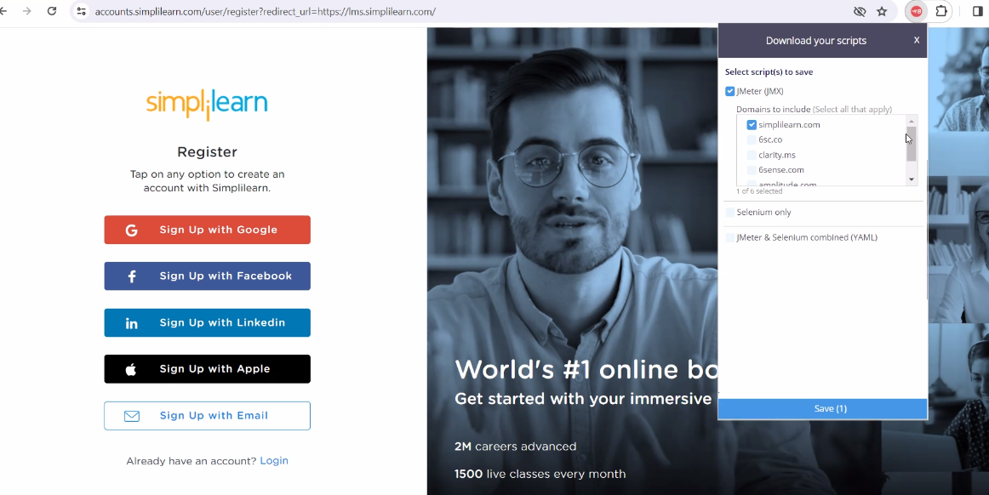

**Create thread group**

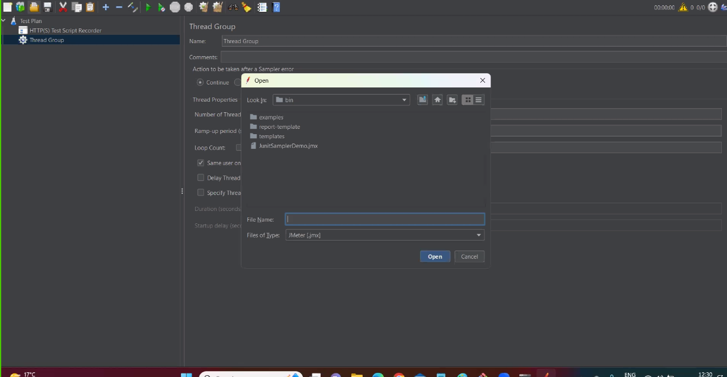

**Recorded test of Blaze**

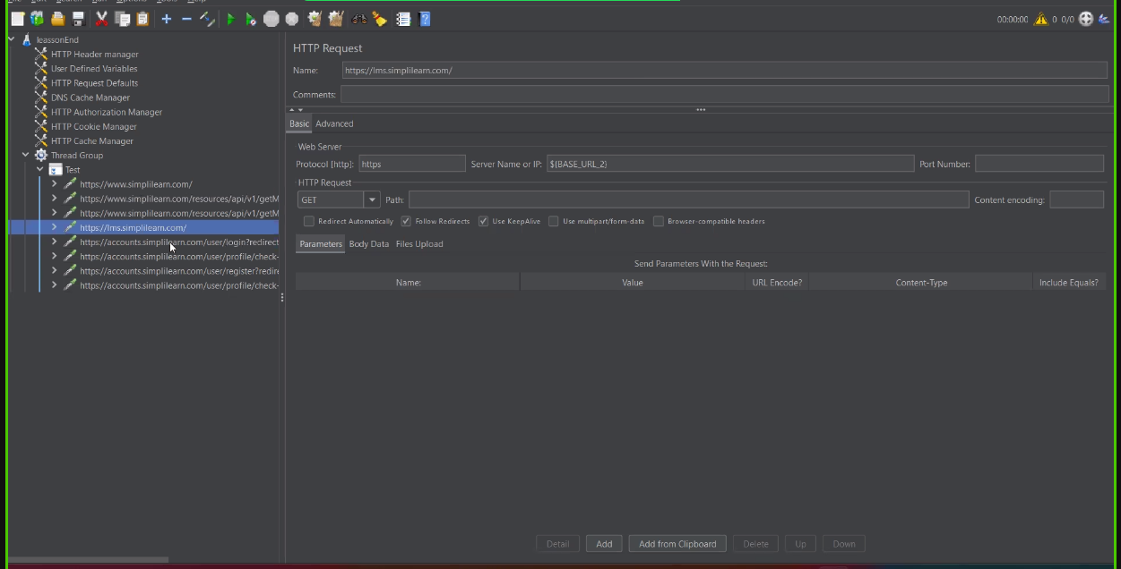

**Adding the Listerners**

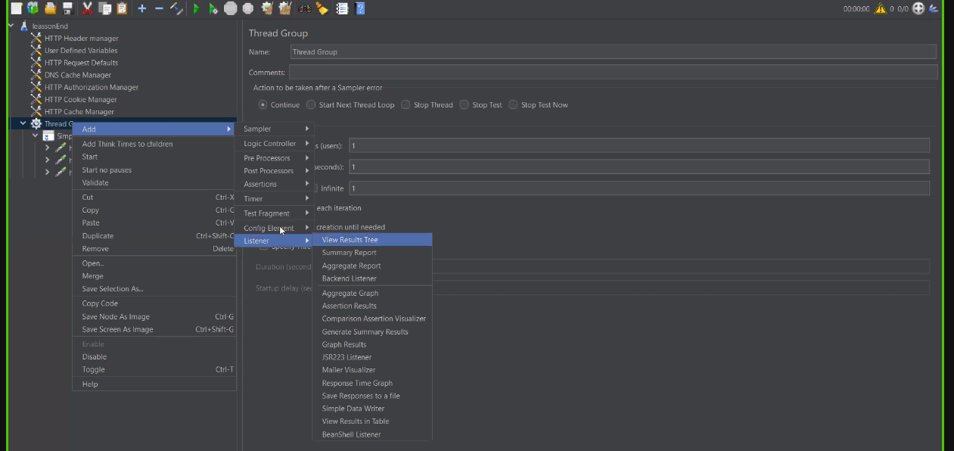

**Adding the Timmer After that Remote Start All**

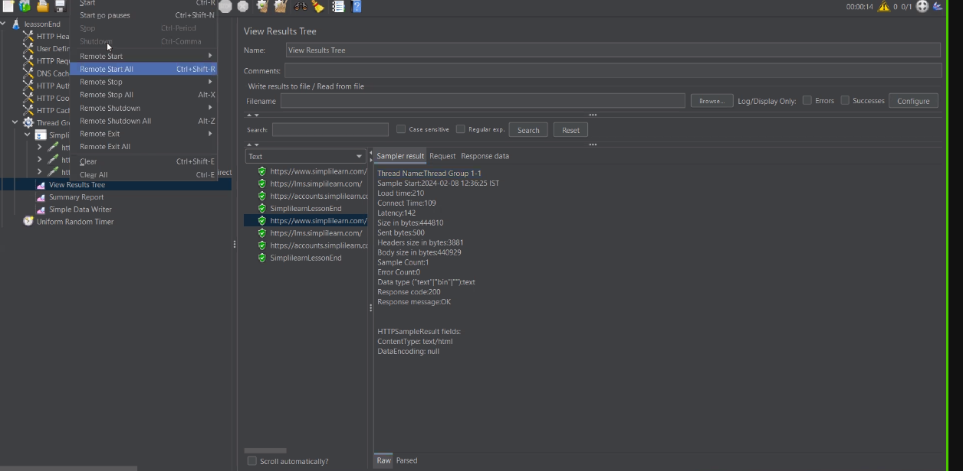

**Add listeners, timers on the test and run it on the Jmeter server**

