1.12 Random and Random Order Controllers



This section will guide you to understand:

* How to perform random and random order controllers

**Development Environment:**

* Apache JMeter 5.1.1 Version
* JDK Runtime Environment 11.0.2

This guide has six subsections, namely:

1.12.1 Recording the scripts

1.12.2 Adding random controller

1.12.3 Running the scripts in random controller

1.12.4 Adding random order controller

1.12.5 Running the scripts in random order controller

1.12.6 Pushing the code to GitHub repositories

**Step 1.12.1:** Recording scripts

* Open JMeter.
* Right click on Test Plan.
* Click on Thread(Users) -> Thread Group.

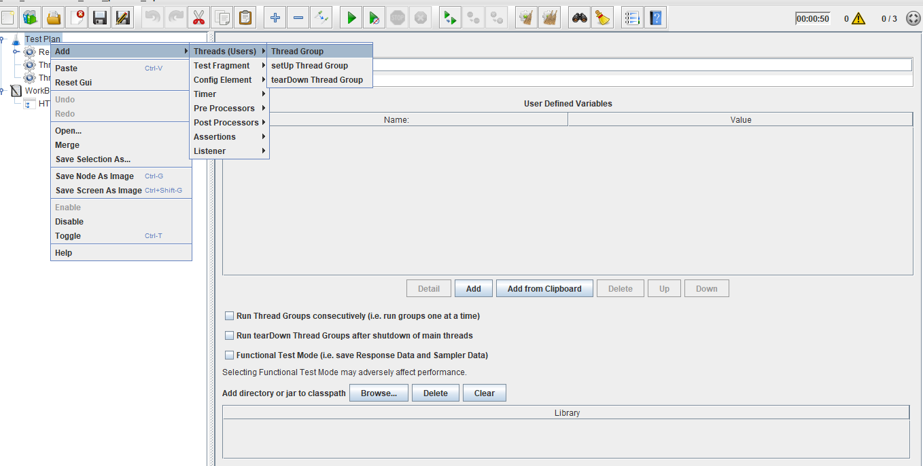

* Right click on WorkBench.
* Click on Add -> Non Test Elements ->HTTP(s) Test Script Recorder.

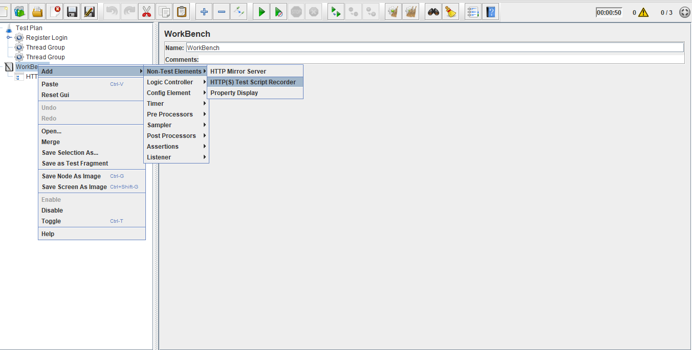

* Right click on Thread Group.
* Click on Add -> Logic Controller->Recording Controller.

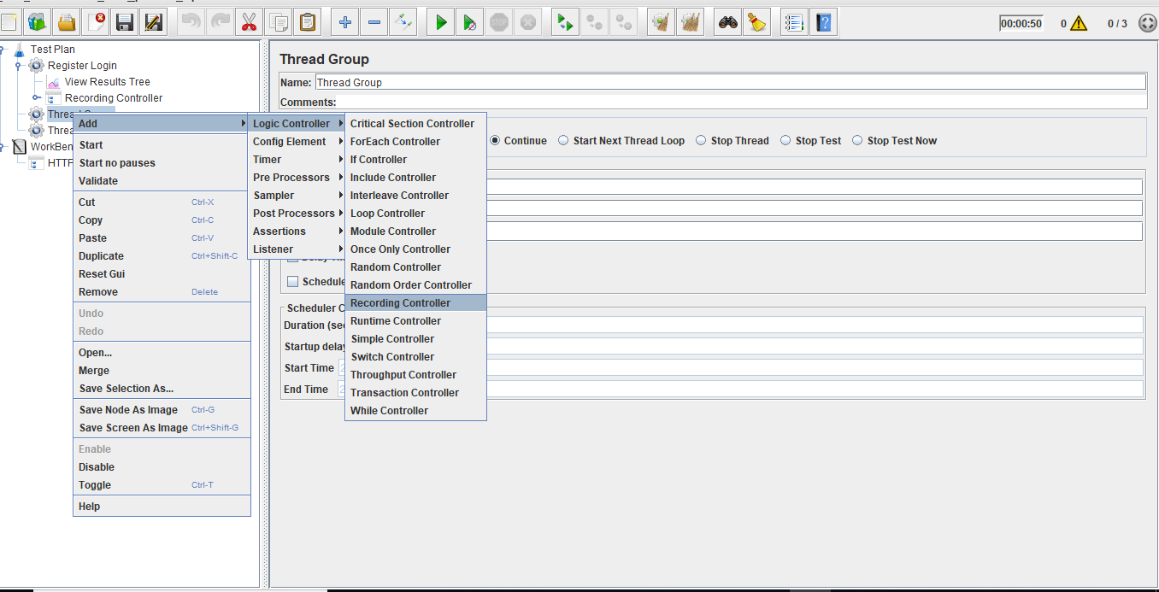

* Right click on Thread Group.
* Click on Add -> Listener->View Results Tree.

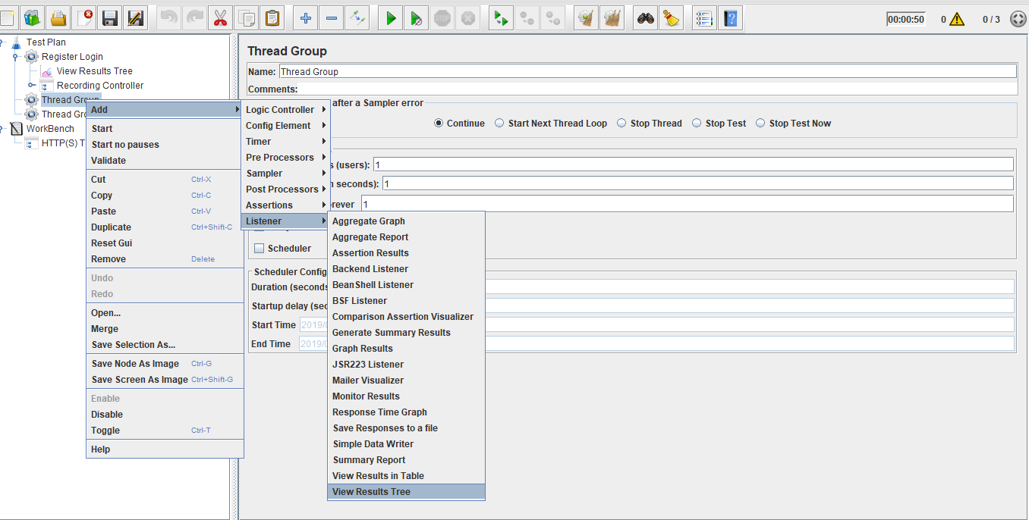

* Configure proxy settings in the browser.
* Run the scripts.
* Automatically JMeter records the scripts.

**Step 1.12.2:** Adding random controller

* Right click on the Recording Controller.
* Click on Add -> Logic Controller -> Random Controller.

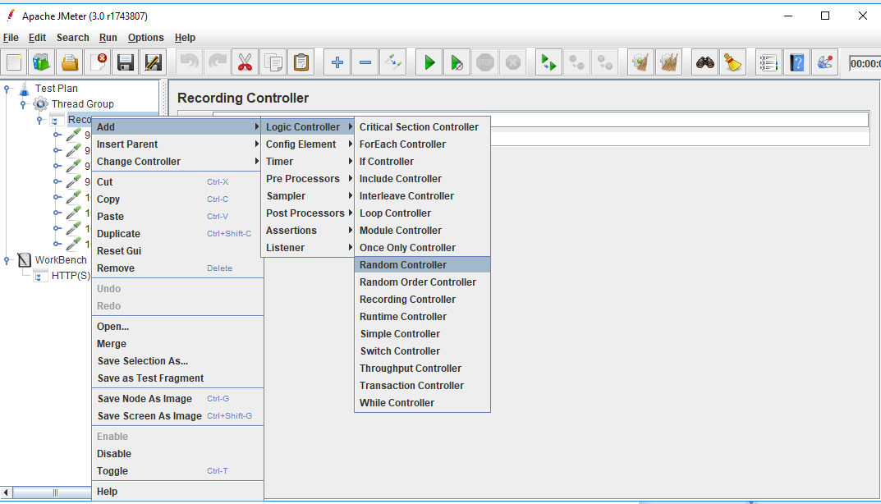

**Steps 1.12.3:** Running the scripts in random controller

* Recording scripts should be added as child scripts for the random controller.
* In a random controller, it will select only one script randomly and execute the selected script.

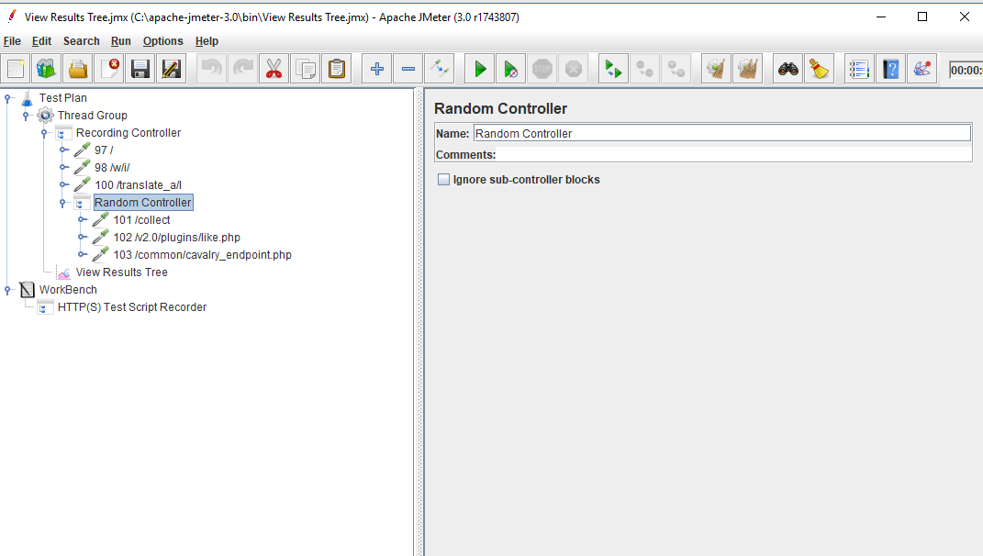

* After execution, in the output screen, it shows only one script which has been randomly picked by the random controller.

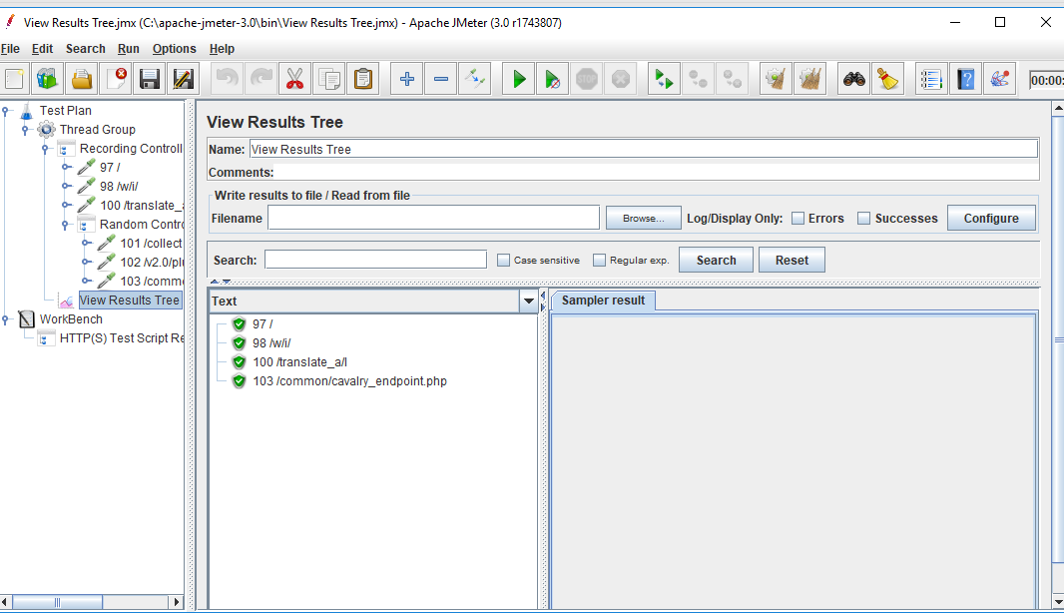

**Steps 1.12.4:** Adding random order controller

* Right click on the Recording Controller.
* Click on Add -> Logic Controller -> Random Order Controller.

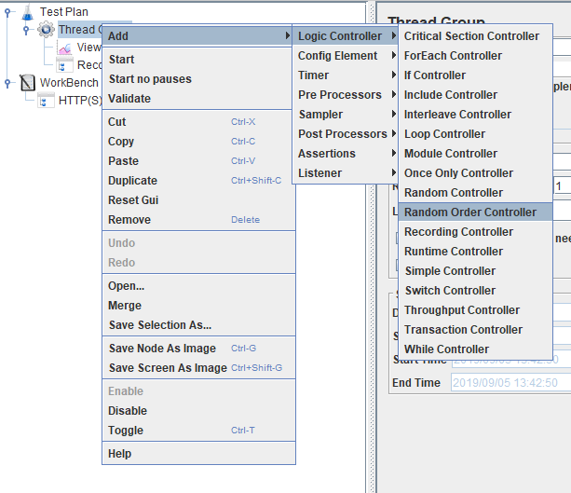

**Step 1.12.5:** Running the scripts in random order controller

* Recording scripts should be added as child scripts for the random order controller.
* In the random order controller, all the child scripts will be selected. By doing this, it executes all the scripts randomly and the output will also be in a random order.

