1.16 If and While Controllers



This section will guide you to understand:

* How to perform If and While controllers

**Development Environment:**

* Apache JMeter 5.1.1 Version
* JDK Runtime Environment 11.0.2

This guide has seven subsections, namely:

1.16.1 Recording scripts

1.16.2 Adding If controller

1.16.3 Running the scripts in If controller and viewing the results

1.16.4 Adding While controller

1.16.5 Adding CSV data set Config to While controller

1.16.6 Running the scripts in While controller

1.16.7 Pushing the code to GitHub repositories

**Step 1.16.1:** Recording scripts

* Open JMeter.
* Right click on Test Plan.
* Click on Thread Group -> Thread Users -> Thread Group.

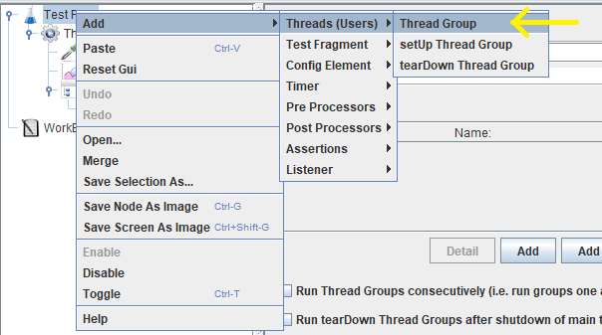

* Rename Thread Group as “Thread Group before If Controller”.
* Right click on “Thread Group before If Controller.
* Click on Add -> Sampler ->HTTP Request.

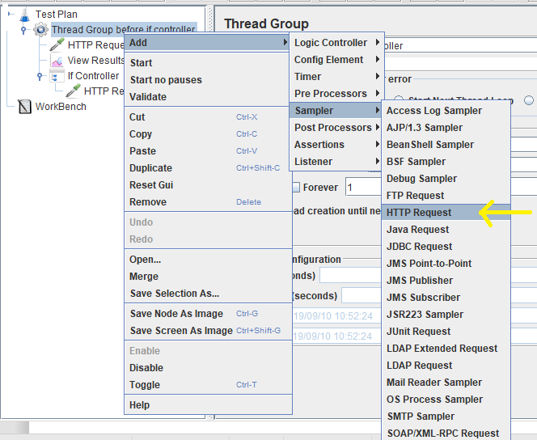

* Rename HTTP Request as “HTTP Request before If controller”.
* Provide an IP address and path.

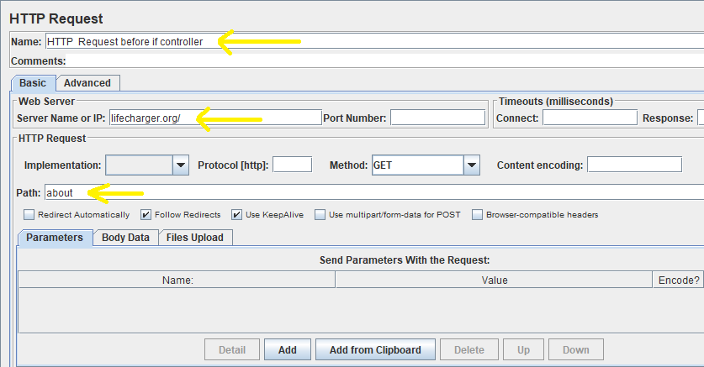

**Step 1.16.2:** Adding If controller

* Right click on “Thread Group before If Controller”.
* Click on Add -> Logic Controller -> If Controller.

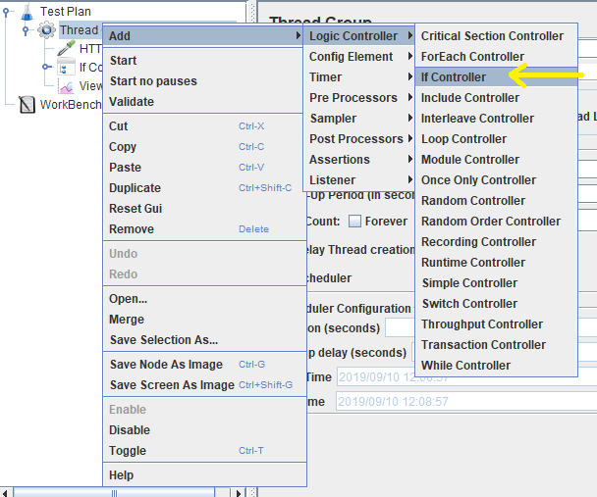

* Right click on “Thread Group Before If Controller”.
* Click on Add -> Sampler -> HTTP Request.

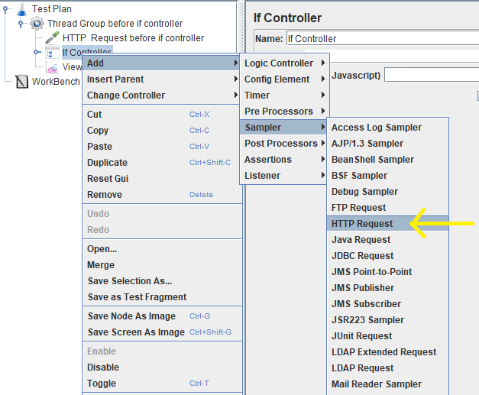

* Rename HTTP Request as “HTTP Request after If Controller”.
* Give the same IP address and path as HTTP Request before the if controller.

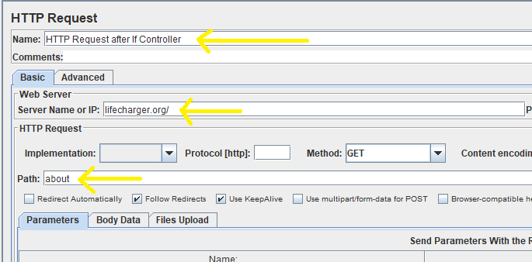

**Step 1.16.3:** Running the scripts in If controller and viewing the results

* Write the conditions in the If Controller.

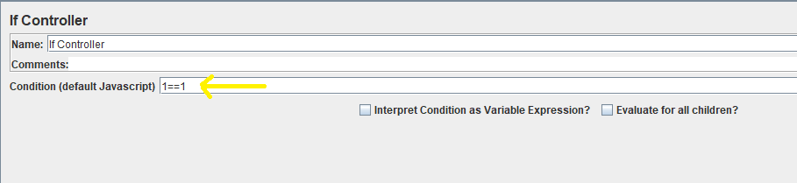

* If the condition is True, then it runs the script.

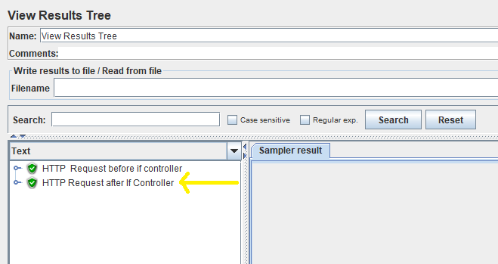

* If the condition is False, then it doesn’t run the script.

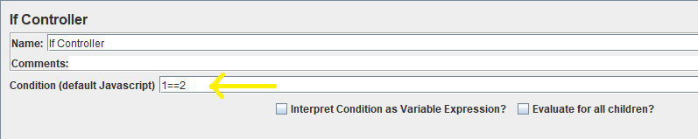

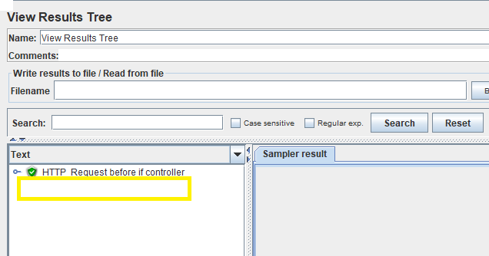

**Step 1.16.4:** Adding While controller

* Right click on Test Plan.
* Click on Add -> Thread Users -> Thread Group.

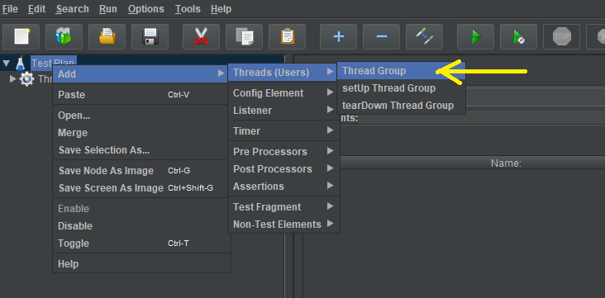

* Right click on Thread Group.
* Click on Add -> Logic Controller -> While Controller.

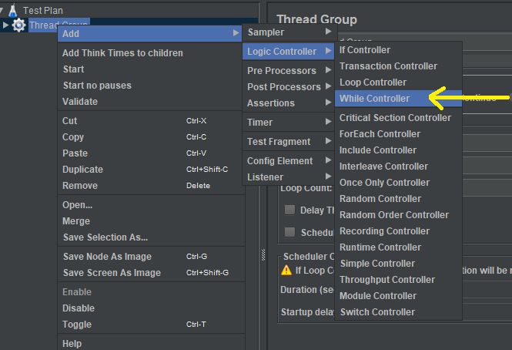

* Right click While loop Control.
* Click on Add -> Sampler -> HTTP Request.

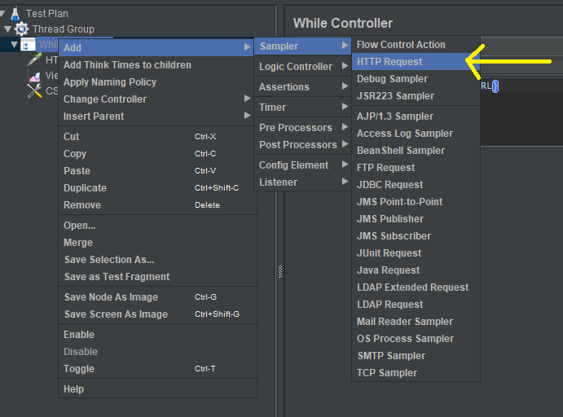

**Steps 1.16.5:** Adding CSV data set Config to While controller

* Right click on While controller.
* Click on Add -> Config Element -> CSV Data Set Config.

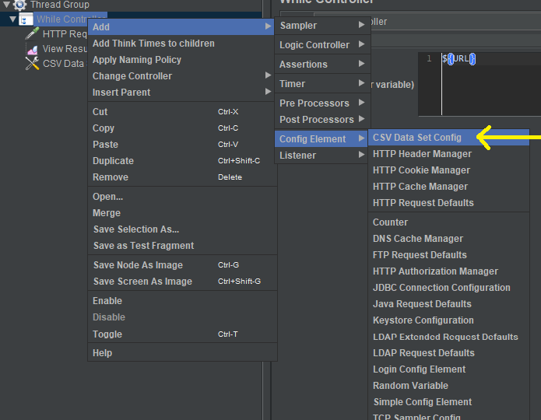

* Create CSV file.
* Write scripts in CSV file.

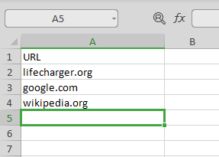

* Browse the CSV file in CSV data set Config.
* Allow the quoted data, recycle and stop thread on EOF. (true or false optional).

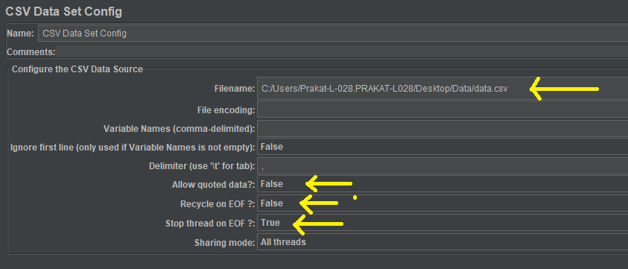

**Steps 1.16.6:** Running the scripts in While controller

* Open HTTP Request and give the IP address as head of column in CSV file.

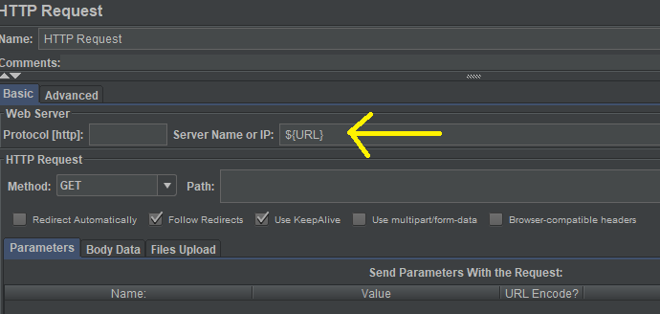

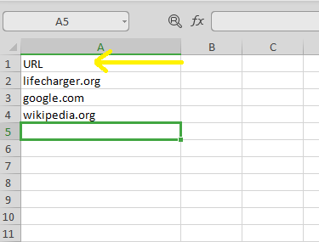

* Open While controller and input the function.

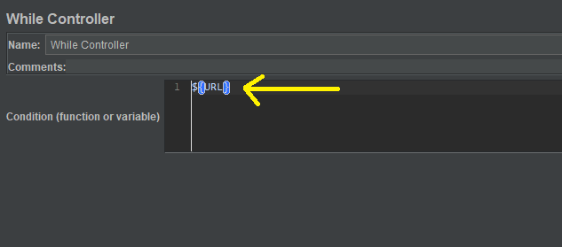

* Run the scripts and view the result.

