1.17 Switch, Module, and Include Controller



This section will guide you to understand:

* How to add module, and include controller to JMeter

**Development Environment:**

* Apache JMeter 5.1.1 Version
* JDK Runtime Environment 8.1

This guide has four subsections, namely:

1.17.1 Demonstrating Switch controller

1.17.2 Demonstrating module controller

1.17.3 Demonstrating include controller

1.17.4 Pushing the code to GitHub repositories

**Steps 1.17.1:** Demonstrating Switch controller

* Open JMeter.
* Right click on Test Plan-->Add-->Threads-->Thread Group.

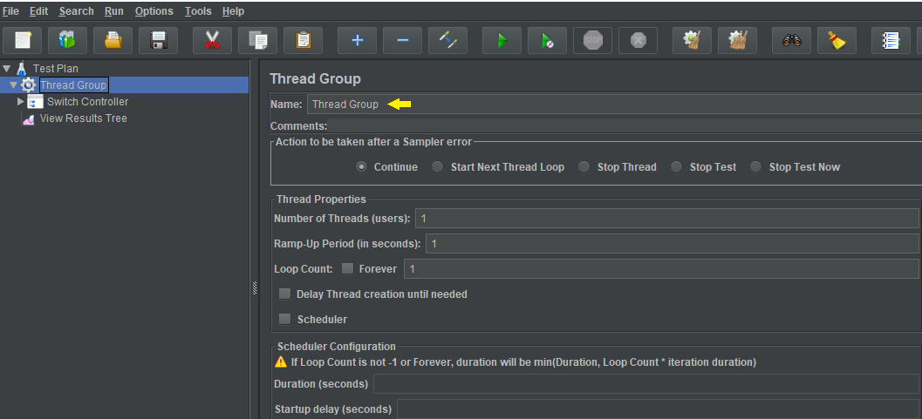

* Right click on Thread-->Add-->Logic Controllers -->Switch Controller.

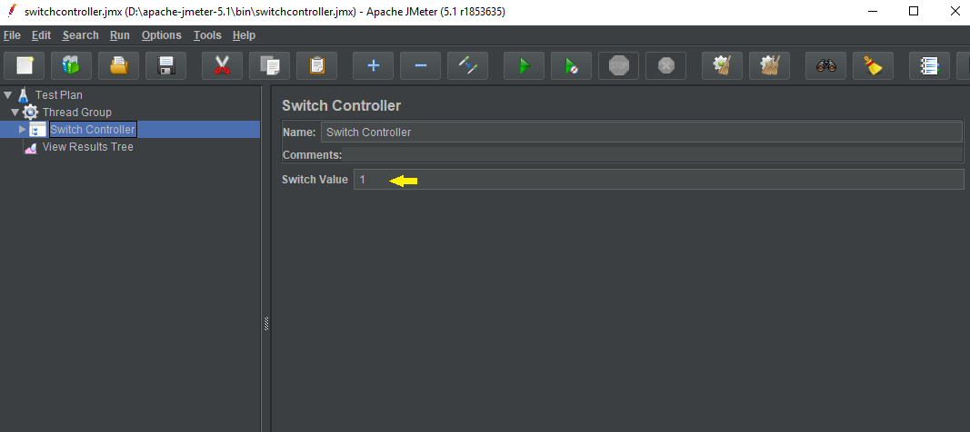

* Right click on Switch Controller-->Add -->Sampler-->HTTP Request Default.

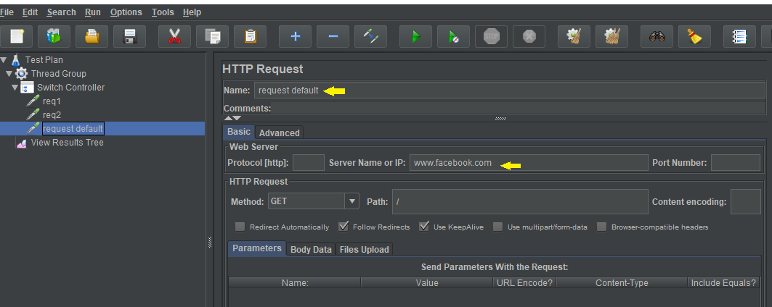

* Right click on Switch Controller-->Add -->Sampler-->HTTP Request_1.

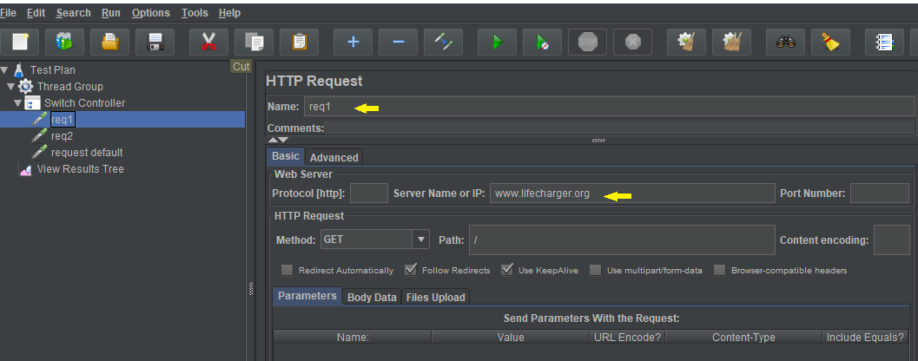

* Right click on Switch Controller-->Add -->Sampler-->HTTP Request _2.

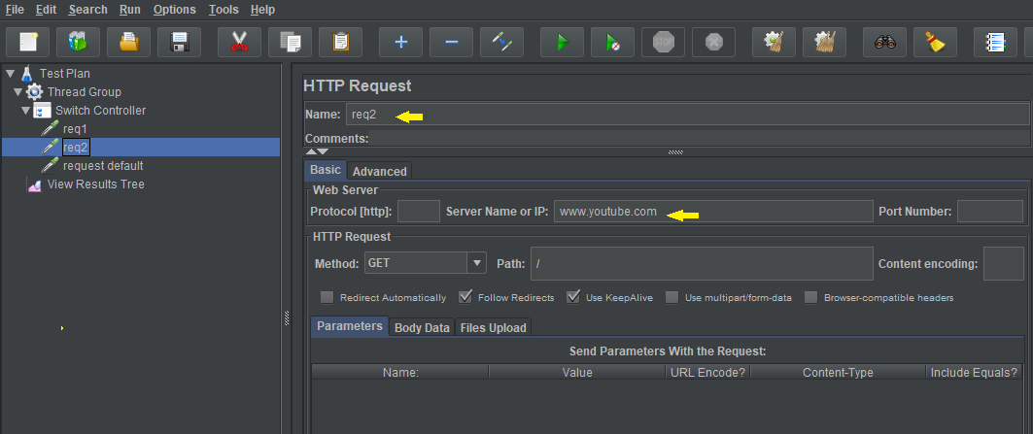

* Right click on Test Plan--> Add-->Listener-->View Result Tree.

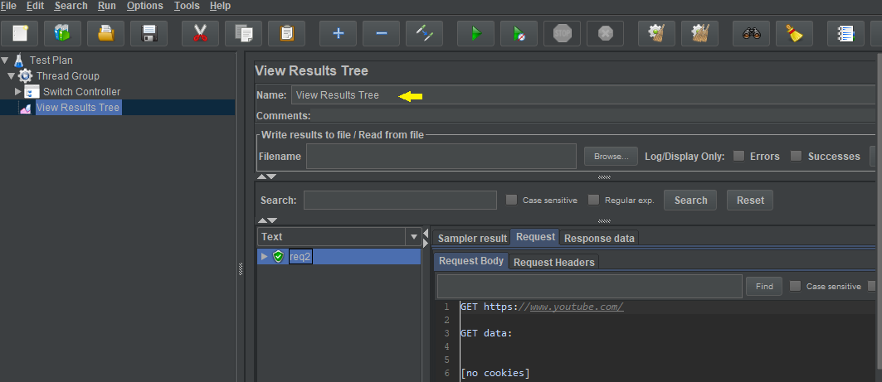

**Steps 1.17.2:**  Demonstrating the module controller

* Right click on Test Plan-->Add-->Threads-->Thread Group. 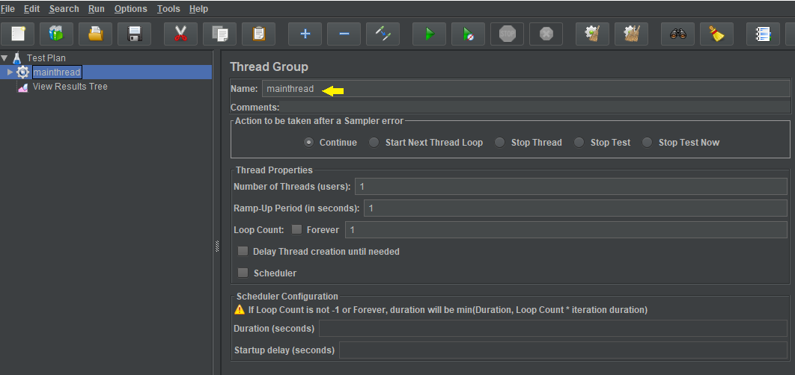
* Right click on Thread Group-->Add -->Logic Controller-->Module Controller.

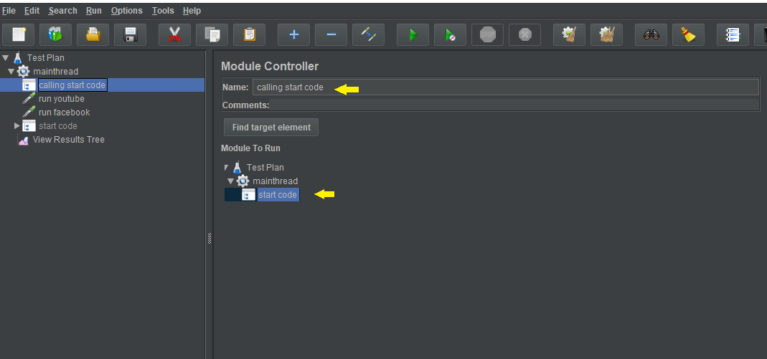

* Right click on Thread Group → Add → HTTP Request as shown below:

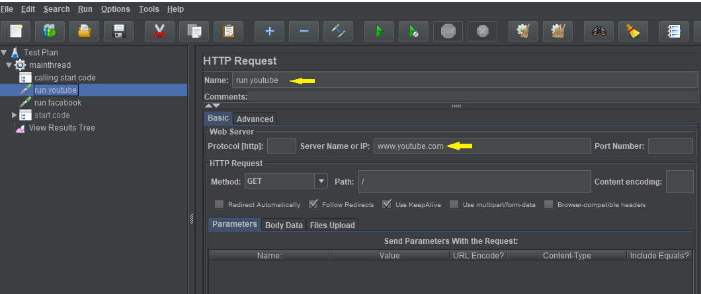

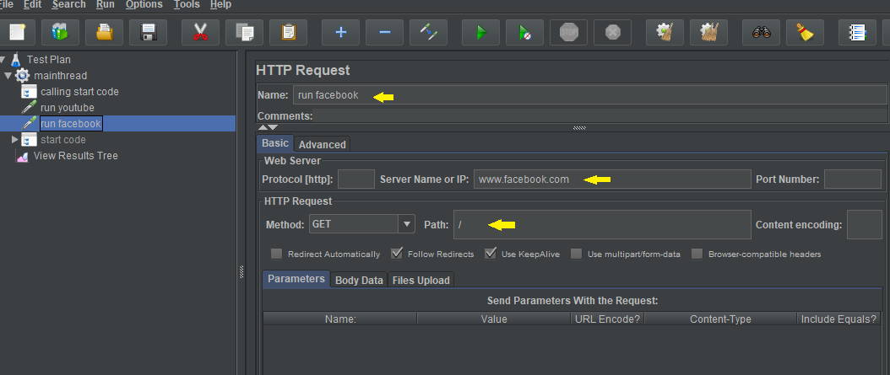

* Right click on Thread Group-->Add -->Logic Controller-->Simple Controller--> change name to **start code**. 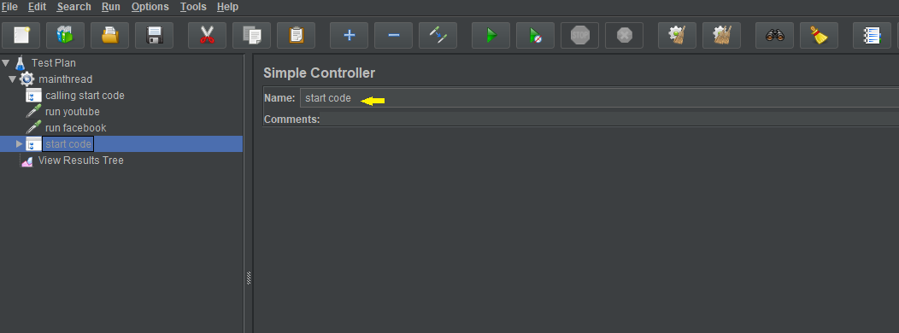
* Right click on start code -->Add-->Sampler-->Add two HTTP Requests. 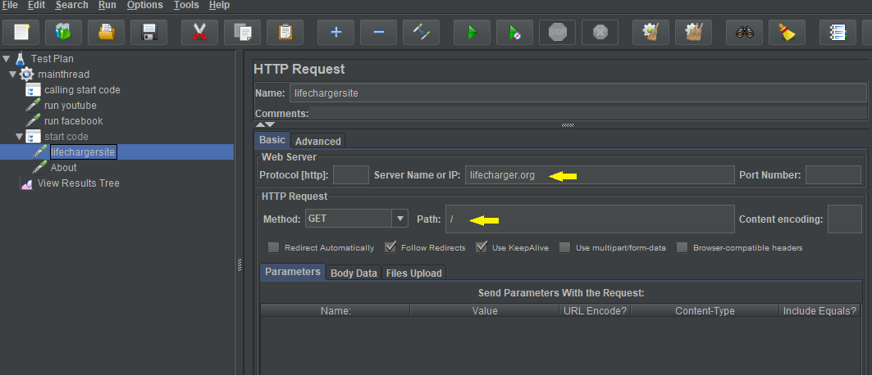 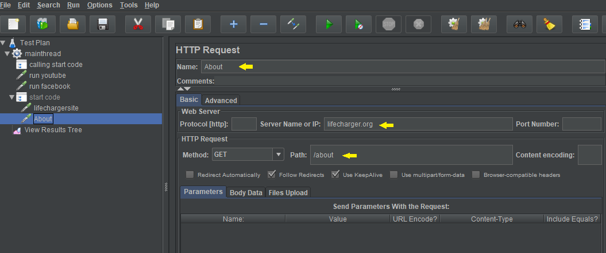
* Note: Now right click on start code and disable it. Click on the **Calling start code module controller.** Select **start code file** and run the **thread group**.
* Right click on Test Plan-->Add --> Listener-->View Result Tree-->Run.

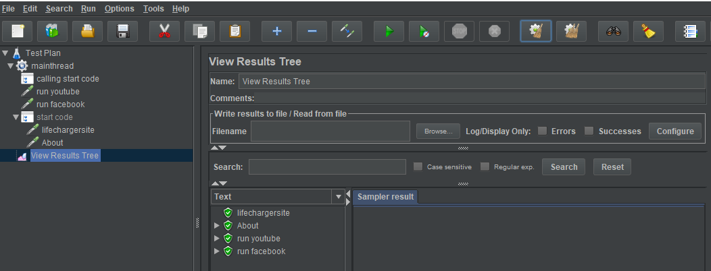

**Step 1.9.3:** Demonstrating include controller

* Right click on Test Plan-->Add-->Threads-->Thread Group.

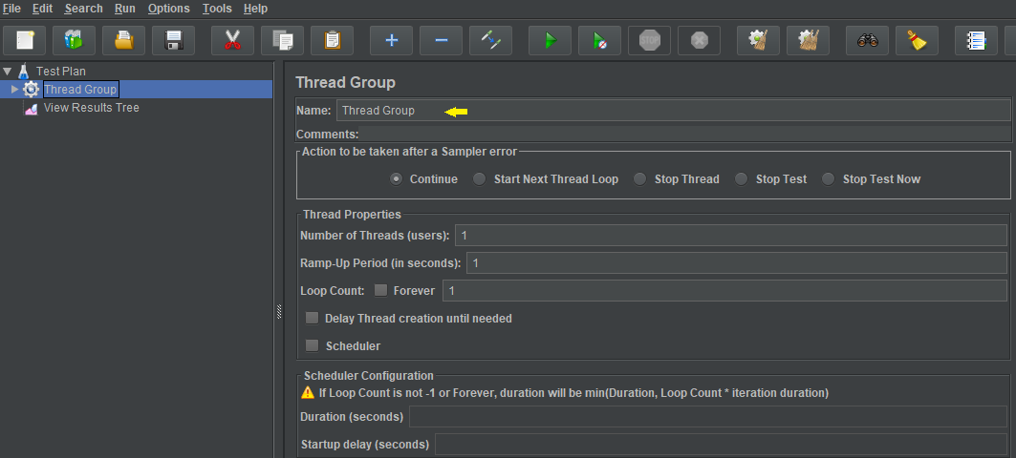

* Right click on Thread Group-->Add -->Sampler-->HTTP Request.

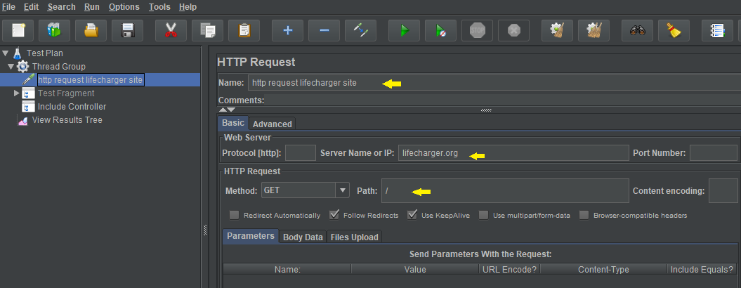

* Right click on Test Plan-->Add -->Test Fragment-->

-->Add-->HTTP Request under **Test Fragment**.

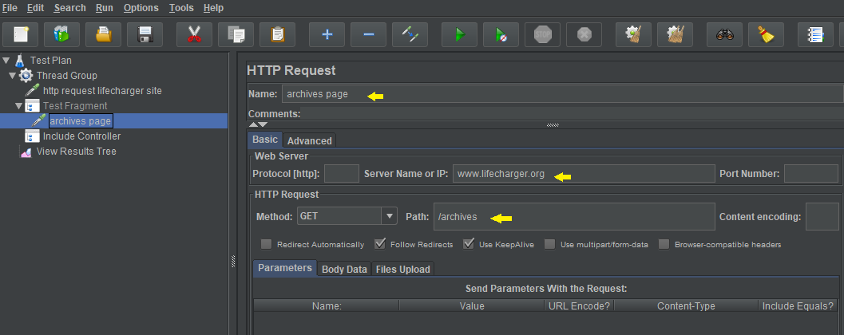

* Right click on Thread Group-->Add-->Logic Controller-->Include Controller-->load .jmx file in Include Controller.

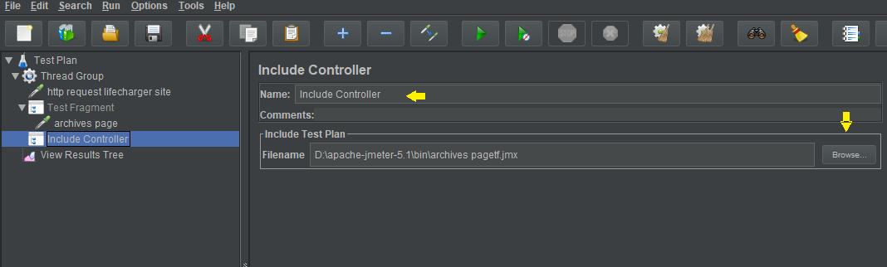

* Right click on Test Plan-->Add --> Listener-->View Result Tree-->Run. 