1.21 XML and XML Schema Assertion



This section will guide you to understand:

* How to add XML assertion
* How to add XML schema assertion

**Development Environment:**

* Apache JMeter 5.1.1 Version

This guide has three subsections, namely:

1.21.1 Adding XML assertion

1.21.2 Adding XML schema assertion

1.21.3 Pushing the code to GitHub repositories

**Step 1.21.1:** Adding XML assertion

The XML assertion is used to validate that the response follows a valid XML syntax. The steps to add XML Assertion in JMeter is given below:

* Open the Apache JMeter.
* Click on the Test Plan.
* Rename the Test Plan.
* Right click on Test Plan --->Add--->Thread(users)--->ThreadGroup.

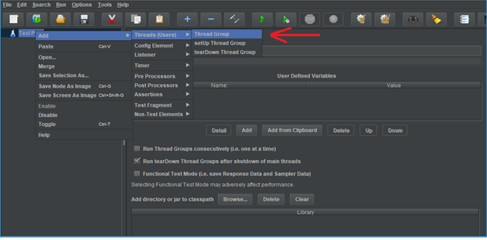

* Navigate through the given path Thread Group--->Name--->Comments---> Continue --->Thread Properties--->Number of Threads(users): ---> Ramp-Up Period (in seconds): ---> Loop Count --->Save.

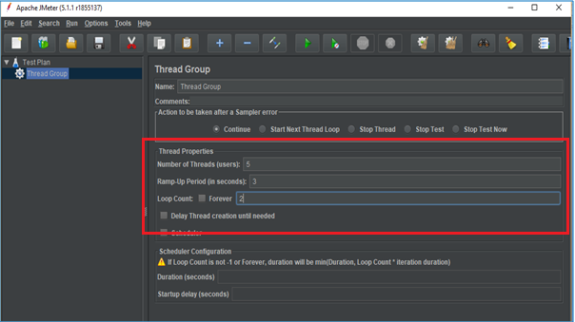

* Right click on Thread Group --->Add---> Sampler---> HTTP Request.

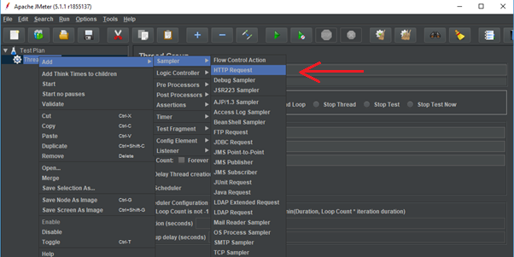

* Go to HTTP Request---> Server Name or IP :---> Path :/---> Save.

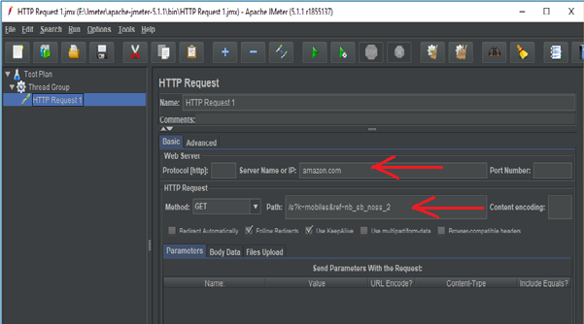

* Right click on Thread Group --->Add--->Listeners---> View Results Tree---> Run.

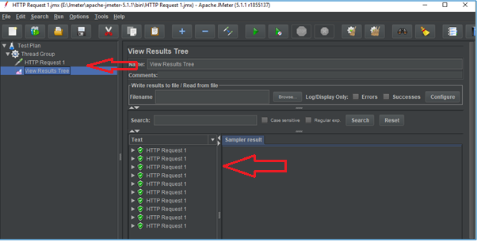

* Right click on Thread Group --->Add--->Listeners---> View Results in Table---> Clear All---> Save---> Run.

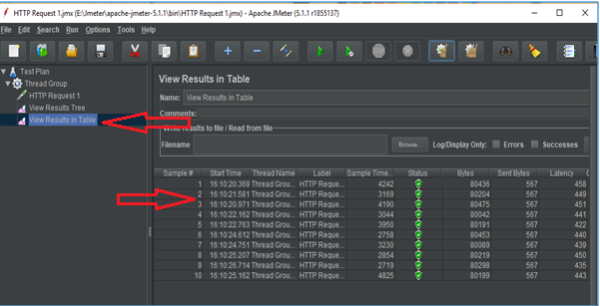

* Right click on Thread Group --->Add--->Listeners---> Assertions Results---> Clear All---> Save---> Run.

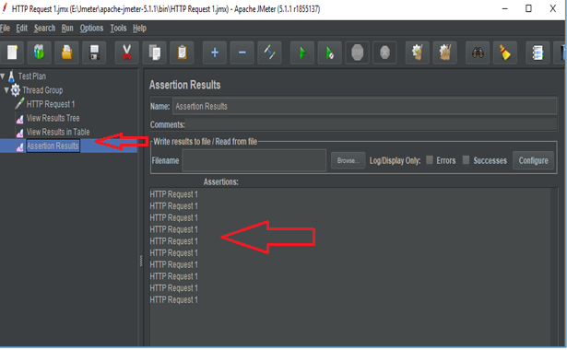

* Right click on Thread Group --->Add--->Assertions ---> XML Assertions.

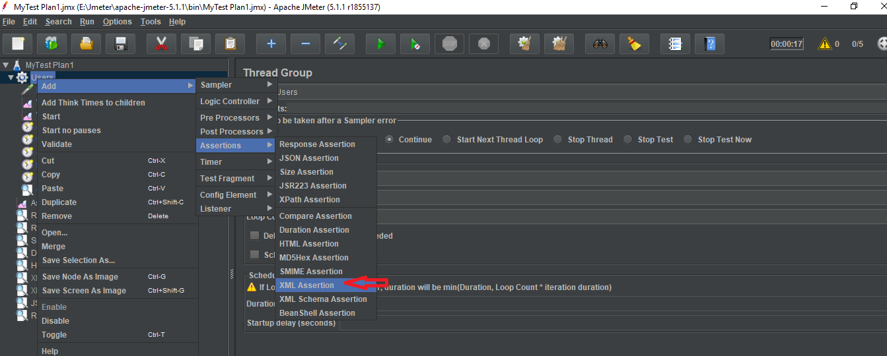

* Click on Save --->Clear All---> View Results in Table.

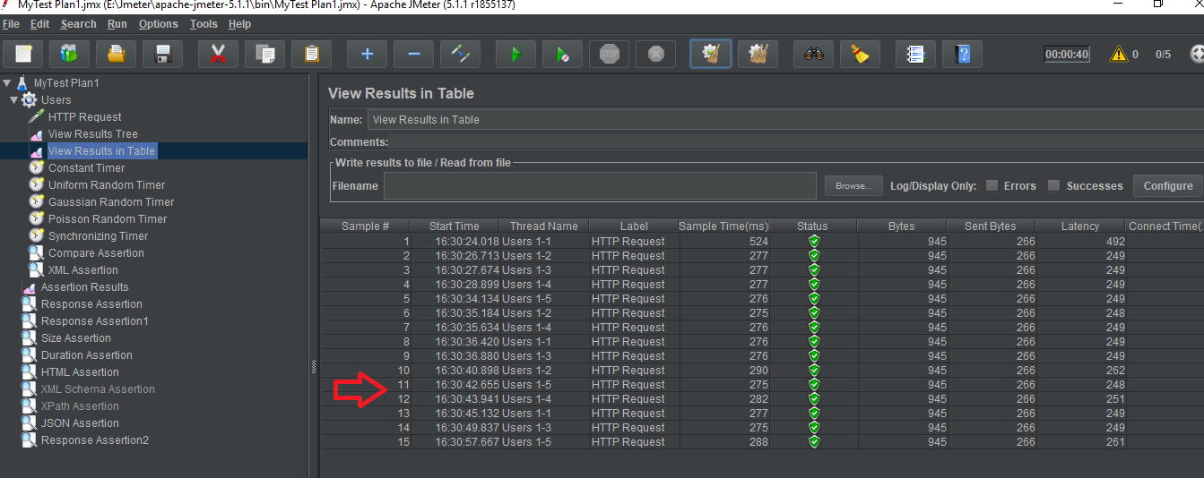

**Step 1.21.2**: Adding XML schema assertion

The XML schema assertion is used to validate the response against a specified XML schema. Steps to add XML schema assertion in JMeter is shown below:

* Open the Apache JMeter.
* Click on the Test Plan.
* Rename the Test Plan.
* Right click on Test Plan --->Add--->Thread(users)--->Thread Group.
* Right click on Thread Group --->Add--->Assertions ---> XML Schema Assertions.

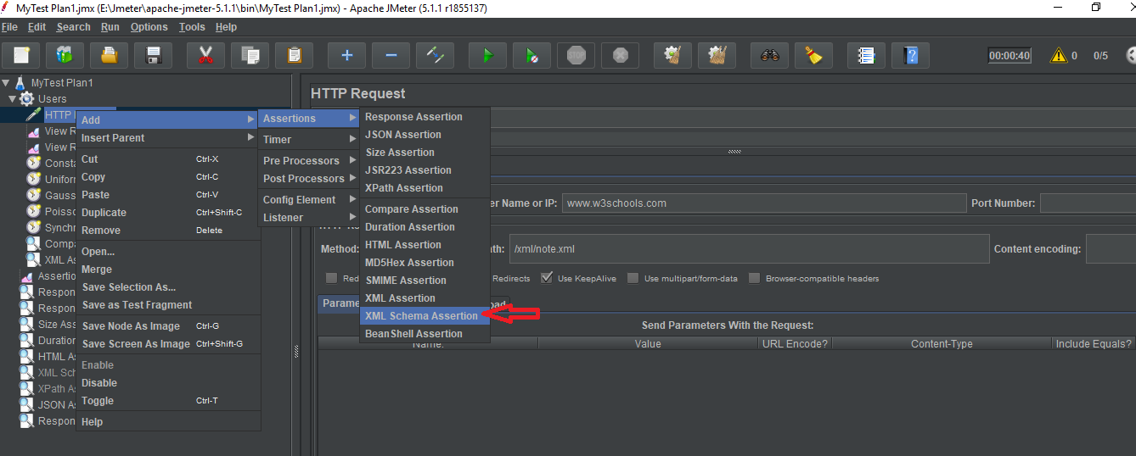

* Enter file name for XML schema---> Save.

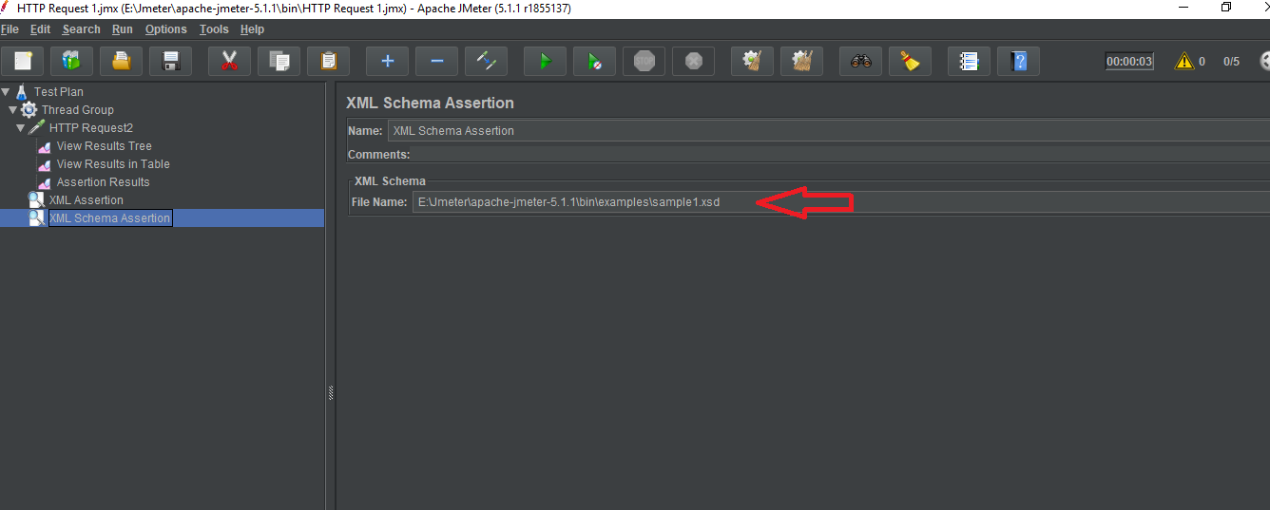

* Click on Clear All---> Run ---> View Results in Table.