1.22 HTML Assertions

This section will guide you to understand:

* How to add HTML assertions

**Development Environment:**

* Apache JMeter 5.1.1 version

This guide has two subsections, namely:

1.22.1 Adding HTML assertions in JMeter

1.22.2 Pushing the code to GitHub repositories

**Step 1.22.1:** Adding HTML assertions in JMeter

The HTML assertion is used to check the HTML syntax of the response.

* Open the Apache JMeter.
* Click on the Test Plan.
* Rename the Test Plan.
* Right click on Test Plan --->Add--->Thread(users)--->Thread Group.

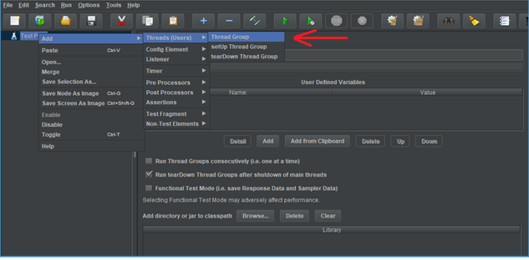

* Go to Thread Group--->Name--->Comments---> Continue --->Thread Properties--->Number of Threads(users): ---> Ramp-Up period (in seconds): ---> Loop Count --->Save.

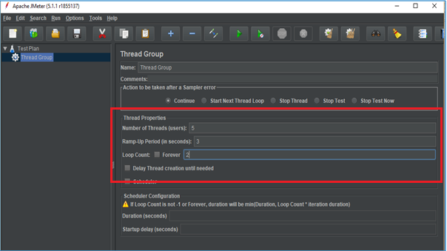

* Right click on Thread Group --->Add---> Sampler---> HTTP Request.

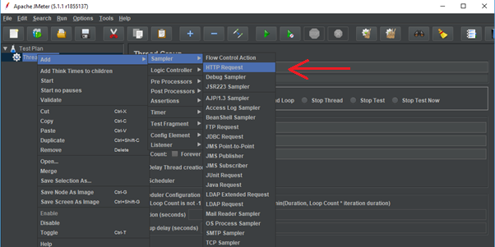

* HTTP Request---> Server Name or IP :---> Path :/---> Save.

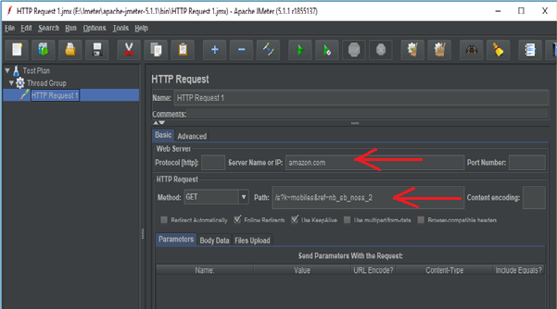

* Right click on Thread Group --->Add--->Listeners---> View Results Tree---> Run.

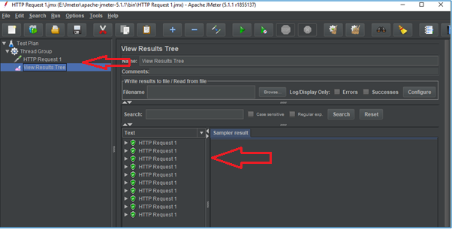

* Right click on Thread Group --->Add--->Listeners---> View Results in Table---> Clear All---> Save---> Run.

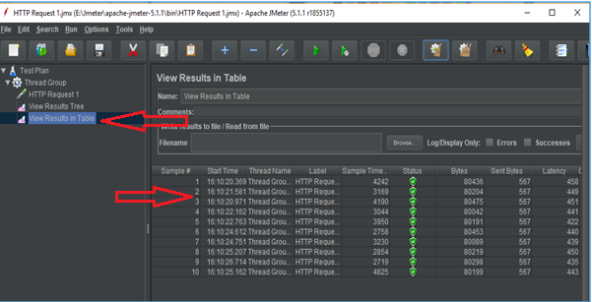

* Right click on Thread Group --->Add--->Listeners---> Assertions Results---> Clear All---> Save---> Run.

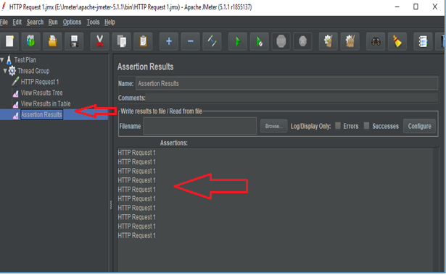

* Right click on Thread Group --->Add--->Assertions ---> HTML Assertions---> Error threshold---> Warning threshold--->Clear All---> Save.

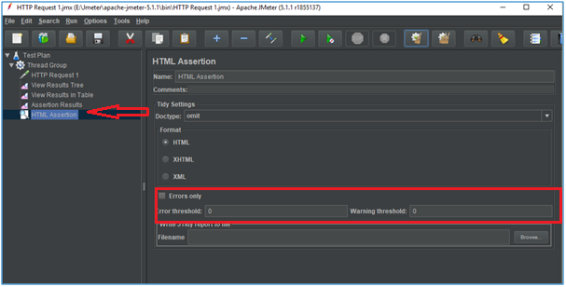

* Go to Assertion Results---> Run. This gives an error.

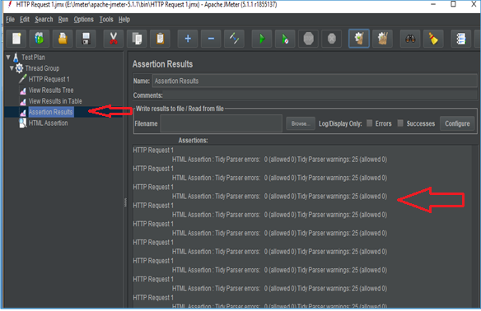

* Go to HTML Assertions---> Error threshold: 0---> Warning threshold: 25--->Clear All---> Save---> Assertion Results---> Run.

