1.25 Random Timers-Constant, Gaussian and Poisson Random Timers



This section will guide you to understand:

* How to add timers

**Development Environment:**

* Apache JMeter 5.1.1 Version

This guide has five subsections, namely:

1.25.1 Demonstrating Gaussian Random timer

1.25.2 Demonstrating Poisson Random timer

1.25.3 Demonstrating Uniform Random timer

1.25.4 Demonstrating Constant timer

1.25.5 Pushing the code to GitHub repositories

**Step 1.25.1**: Demonstrating Gaussian Random timer

Gaussian Random timer delays each user request for a random amount of time.

* Open the Apache JMeter.
* Click on the Test Plan.
* Rename the Test Plan.
* Right click on Test Plan --->Add--->Thread(users)--->Thread Group.

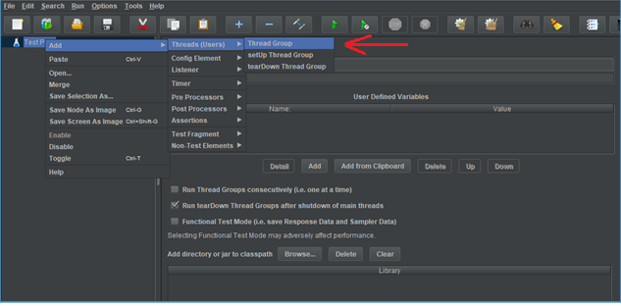

* Go to Thread Group--->Name--->Comments---> Continue --->Thread Properties--->Number of Threads(users): ---> Ramp-Up Period (in seconds): ---> Loop Count --->Save.

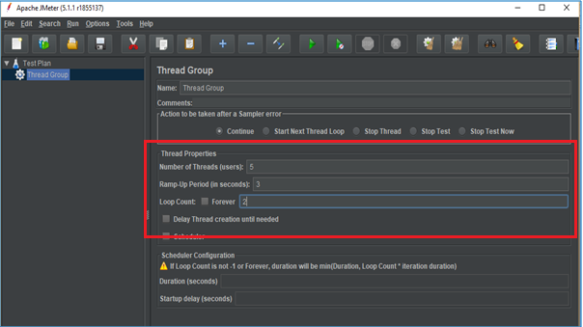

* Right click on Thread Group --->Add---> Sampler---> HTTP Request.

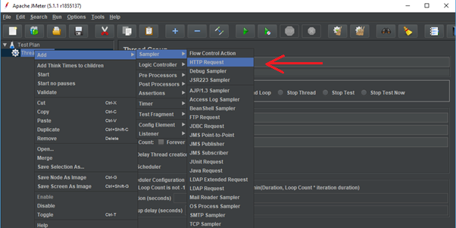

* Go to HTTP Request---> Server Name or IP :---> Path :/---> Save.

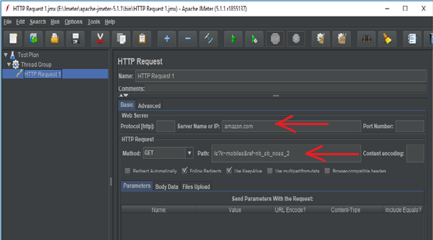

* Right click on Thread Group --->Add--->Listeners---> View Results Tree---> Run.

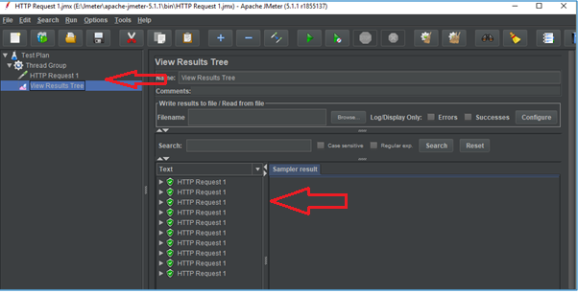

* Right click on Thread Group --->Add--->Listeners---> View Results in Table---> Clear All---> Save---> Run.

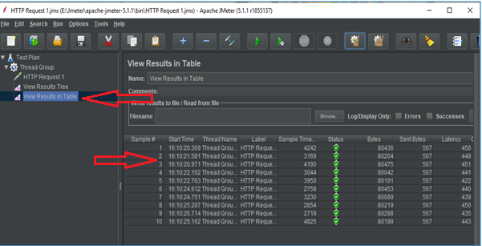

* Right click on Thread Group --->Add--->Listeners---> Assertions Results---> Clear All---> Save---> Run.

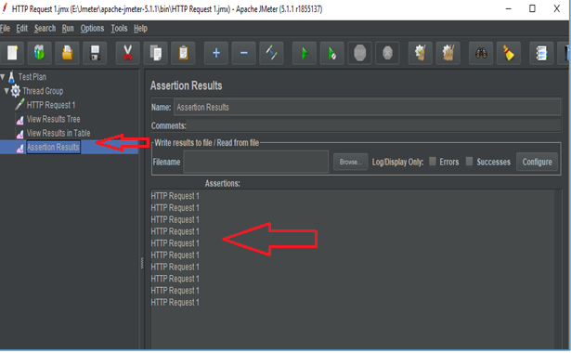

* Right click on Thread Group---> Add---> Timer---> Gaussian Random Timer.

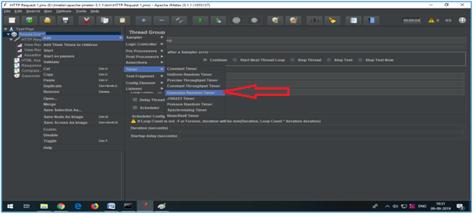

* Go to Gaussian Random Timer--->Deviation in ms---> Constant Delay Offset---> Save.

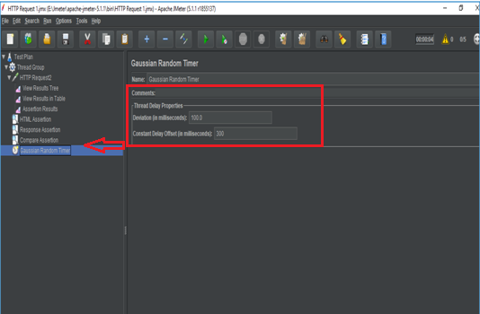

* Click on Clear All---> Run---> View Results in Table.

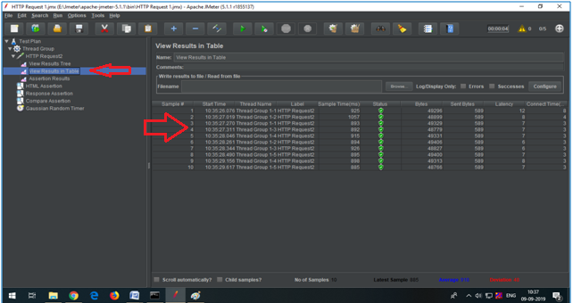

**Step 1.25.2:** Demonstrating Poisson Random timer

To pause each and every thread request for a random amount of time use Poisson Random timer.

* Right click on Thread Group---> Add---> Timer---> Poisson Random Timer--->Lambda in ms---> Constant Delay Offset---> Save.

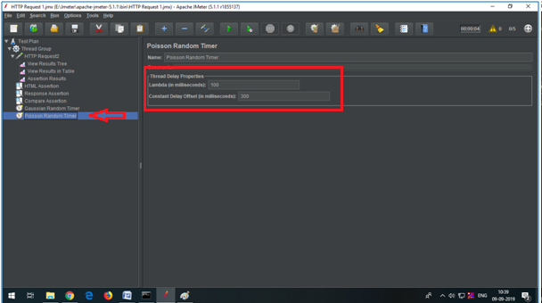

* Go to Clear all---> Run---> View Results in Table.

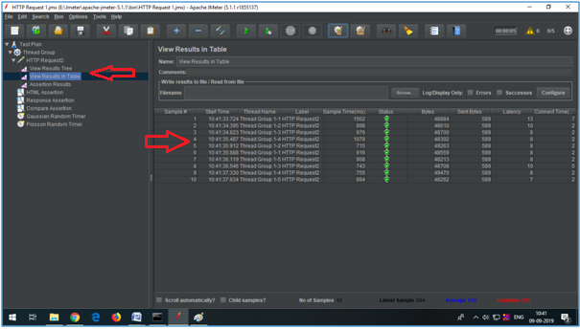

**Step 1.25.3:** Demonstrating Uniform Random timer

Uniform Random timer delays each user request for a random amount of time.

* Right click on Thread Group---> Add---> Timer---> Uniform Random Timer---Random Delay Maximum in ms---> Constant Delay offset---> Save.

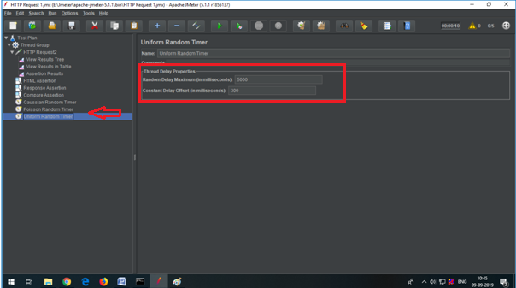

* Click on Clear all---> Run---> View Results in Table.

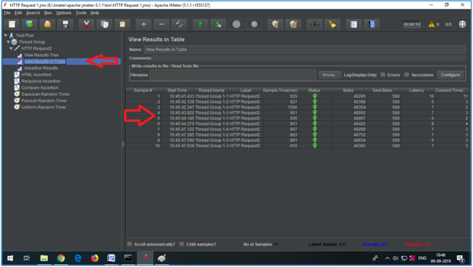

**Step 1.25.4:** Demonstrating Constant timer

Constant timer delays each user request for the same amount of time.

* Right click on Thread Group---> Add---> Timer---> Constant Timer---Thread Delay in ms---> Save.

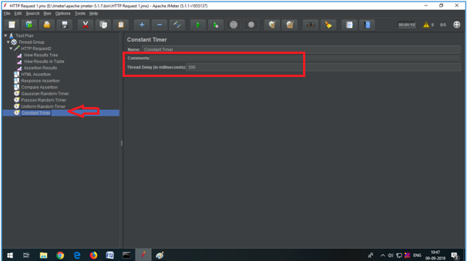

* Click on Clear all---> Run---> View Results in Table.

