1.30 JMeter Distributed

This section will guide you to understand:

* JMeter distributed

**Development Environment:**

* Apache JMeter 5.1.1 version

This guide has three subsections, namely:

1.30.1 Explaining prerequisites for JMeter distributed

1.30.2 Performing distributed testing with JMeter

1.30.3 Pushing the code to your GitHub repositories

**Step 1.30.1:** Explainingprerequisites for JMeter distributed

* Master and slave machines have JMeter installed with the same versions.
* Master and slave machines must have the same versions of Java.
* Master and slave should connect to a common subnet.
* Open JMeter properties file, ind remote host and edit remote_host to 192.168.95.1 as shown below:

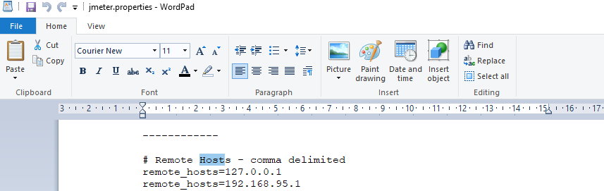

* Run create-rmi-keystore.bat and enter these fields, name:rmi, pwd : changeit.
* Rmi-keystore .jks will be generated automatically.
* Run jmeter-server.bat. 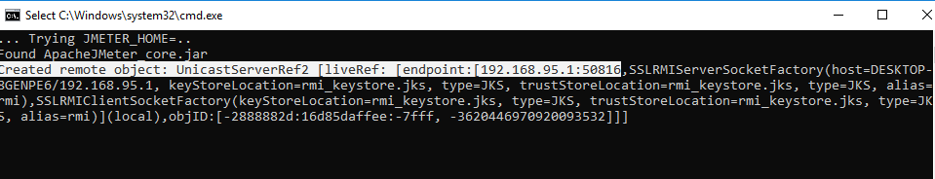

**Step 1.30.2:** Performing distributed testing with JMeter

* Right click on Test Plan.
* Click on Thread(Users)->Thread Group. 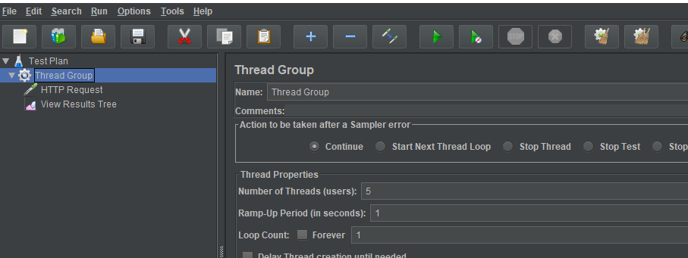
* Right click on Thread Group->Add->Samplers->HTTP Request-> Enter server name “www.google.com”. 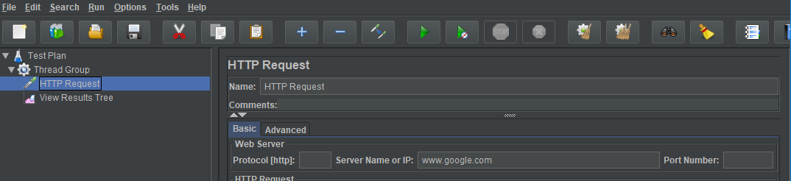
* Right click on Thread Group->Add->Listener->View Results Tree. 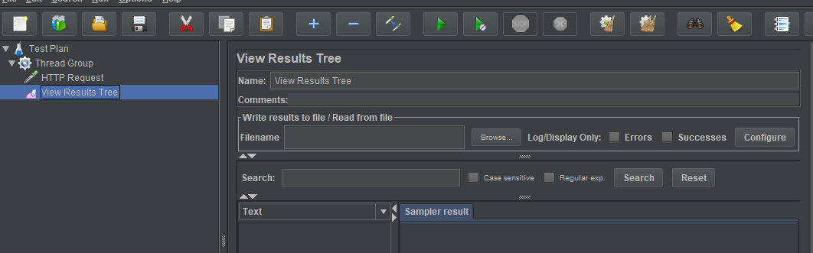
* Run Remote Server. 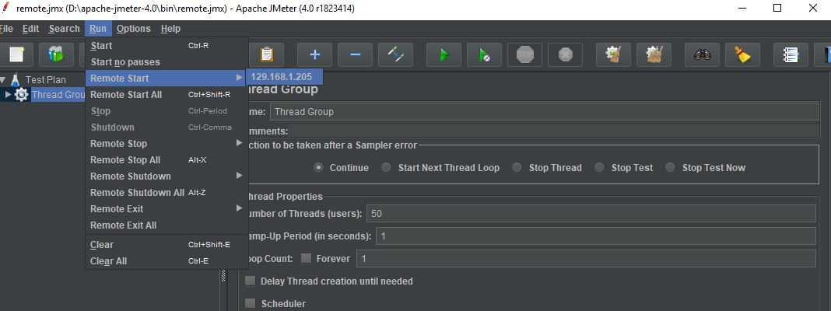
* The screenshot below shows the final result in the tree. 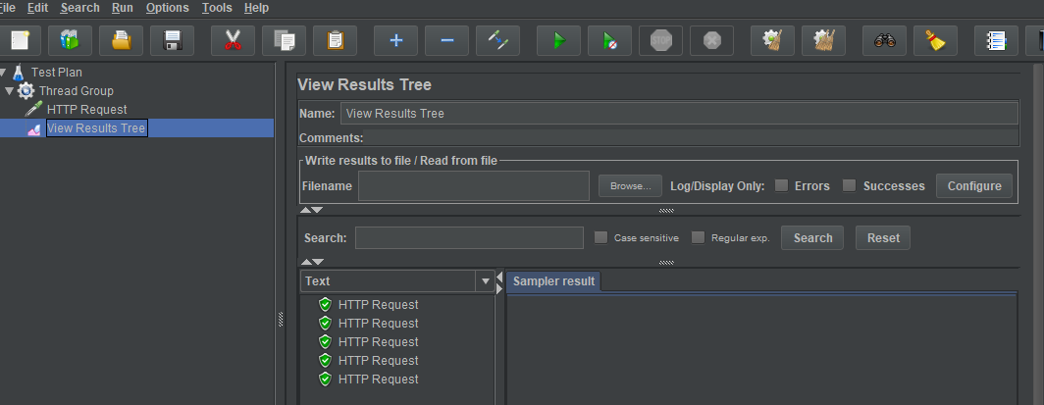
* The screenshot below shows the final result in the server. 