1.3 Processors, Assertions, and Timers

This section will guide you:

* To understand Processors, Assertions and Timers in JMeter

**Development Environment:**

* Apache JMeter 5.1.1 Version
* JDK Runtime Environment 8.1

This guide has three subsections, namely:

1.3.1 Problem statement for Processors, Assertions, and Timers

1.3.2 Solution for the problem statement

1.3.3 Pushing the code to GitHub repositories

**Step 1.3.1:** Problem statement for Processors, Assertions, and Timers

* Objective: Create Processors, Assertions, Timers in Jmeter for a particular domain.
* Steps involved:

1) Set up JMeter.

2) Create a test plan.

3) Add thread group.

4) Add HTTP request.

5) Record the scripts.

6) Add Listener and view the results.

**Step 1.3.2**: Solution for the problem statement

1. Adding Preprocessor:

* Right click on test plan-->Add-->Threads-->Thread Group.

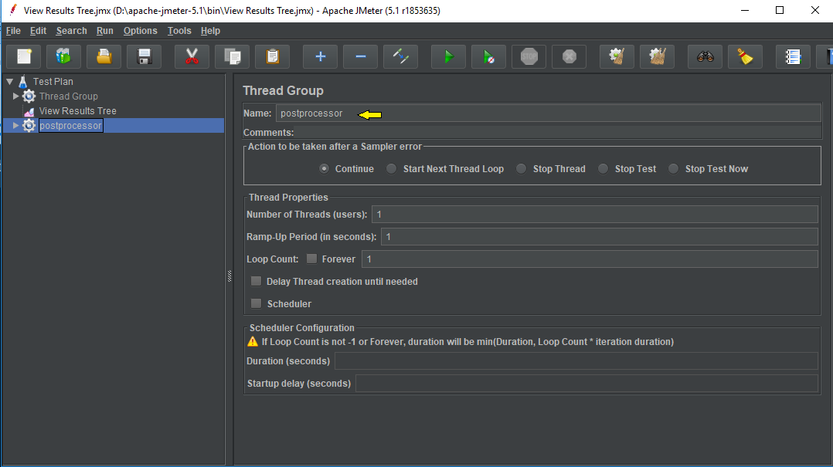

* Right click on Thread-->Add-->preprocessor -->User parameters.

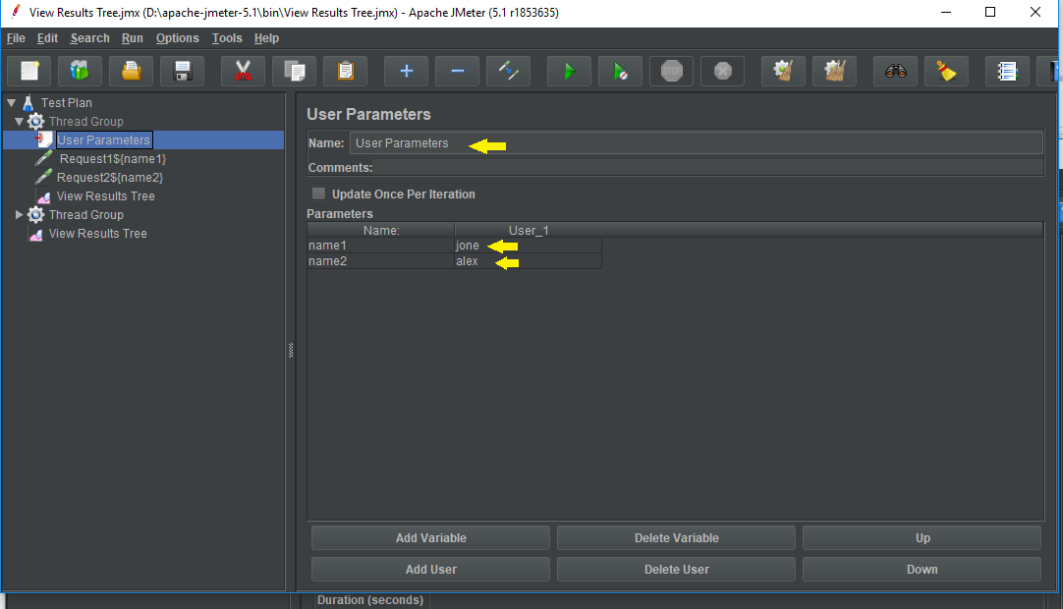

* Right click on Thread Group-->Add Two-->Sampler-->HTTP Request-->consider facebook.com domain.

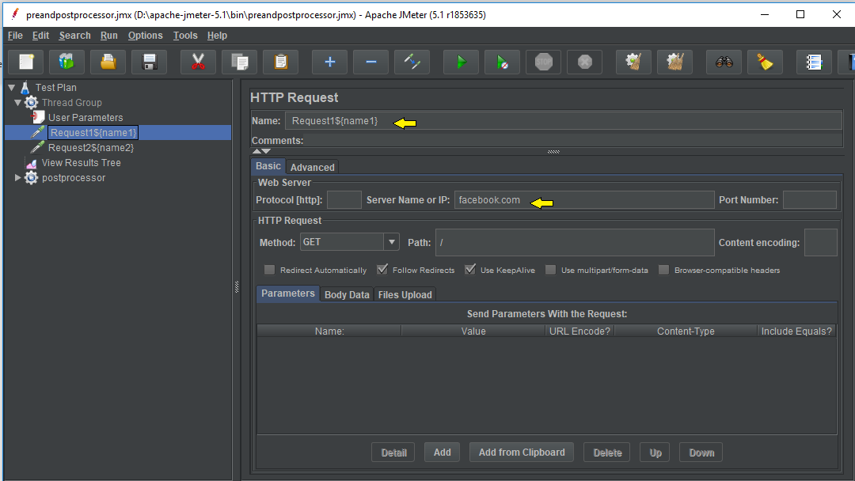

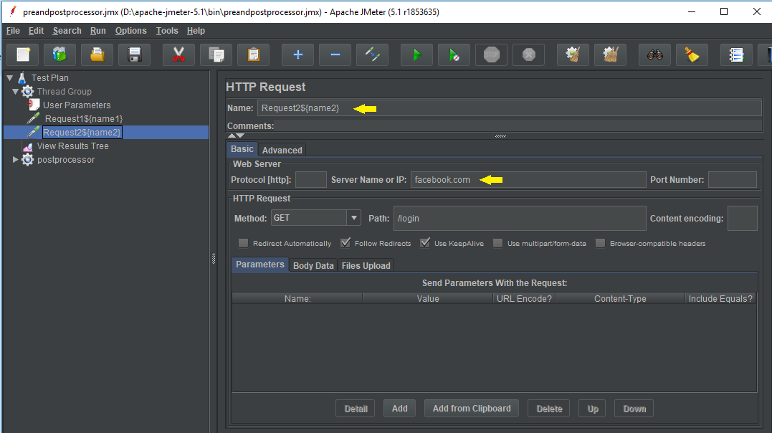

1. Adding Post Processor:

* Right click on test plan-->Add-->Threads-->Thread Group.



* Right click on Thread Group-->Add -->Sampler-->HTTP Request1.

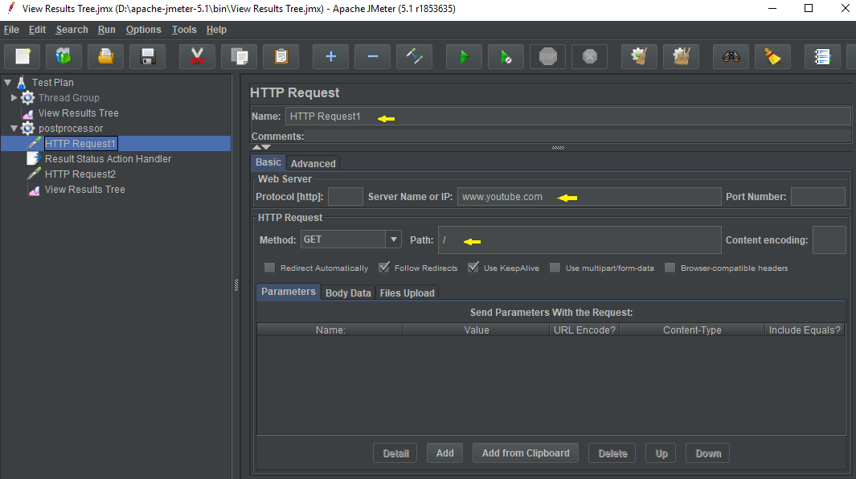

* Right click on post processor Thread Group-->Add-->post processor -->Result Status Action Handler.

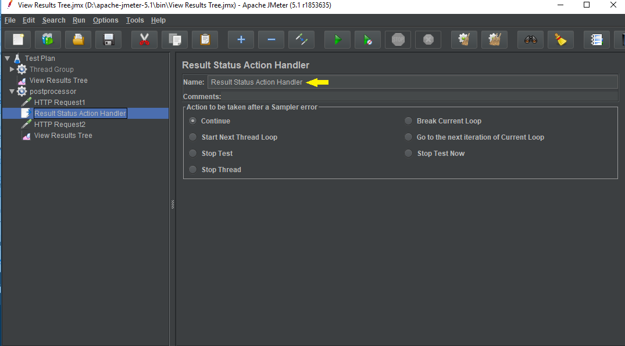

* Right click on Thread Group-->Add -->Sampler-->Another HTTP Request2 under Result Status Action Handler.

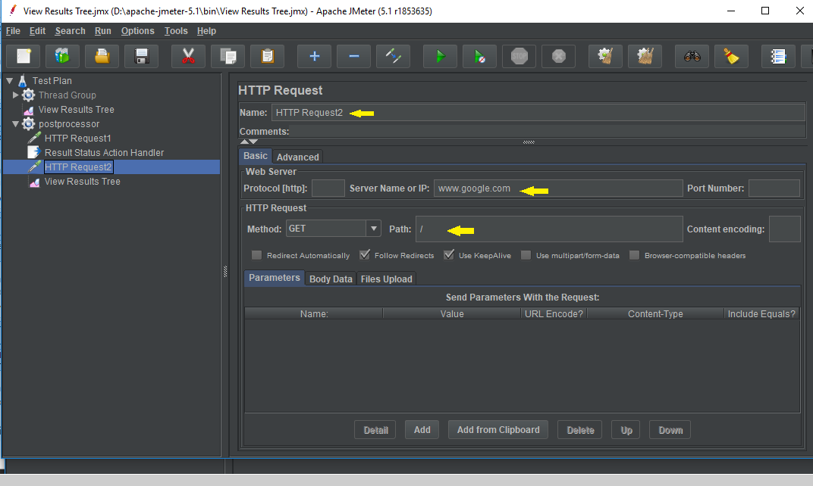

* Right click on postprocessor -->Add --> Listener-->Run result.

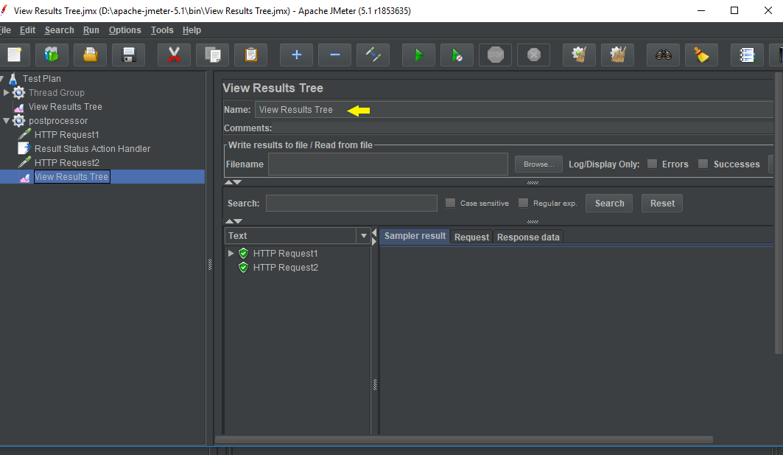

3) Response Assertion:

The Response assertion is used in test scripts to validate a pattern in the response body, header, code, message, etc.

* Open the Apache JMeter.
* Click on the Test plan.
* Rename the Test plan.
* Right click on Test plan --->Add--->Thread(users)--->Thread Group.

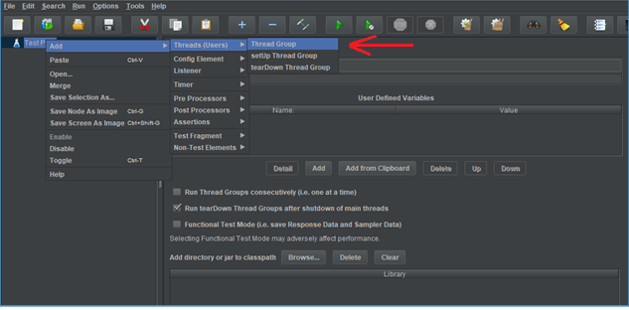

* Navigate through the path: Thread Group--->Name--->Comments---> Continue --->Thread properties--->Number of Threads(users): ---> Ramp-up period (in seconds): ---> Loop Count --->Save.

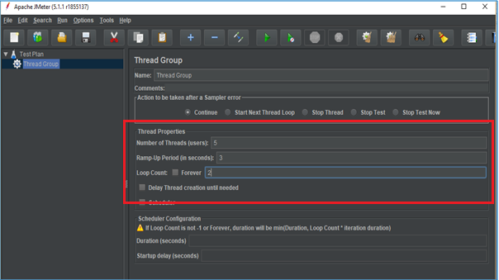

* Right click on Thread group --->Add---> Sampler---> HTTP Request.

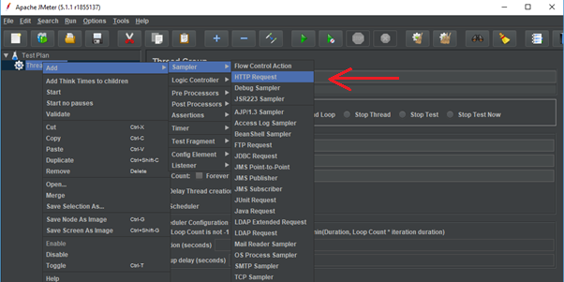

* Navigate through the given path: HTTP Request---> Server Name or IP :---> Path :/---> Save.

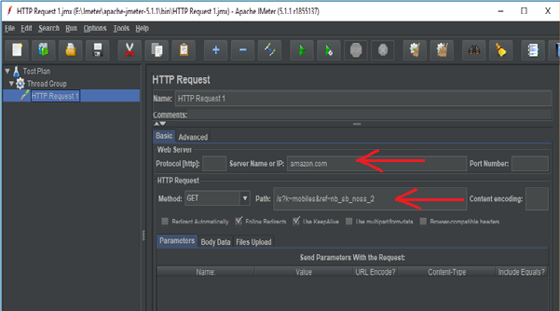

* Right click on Thread Group --->Add--->Listeners---> View Results Tree---> Run.

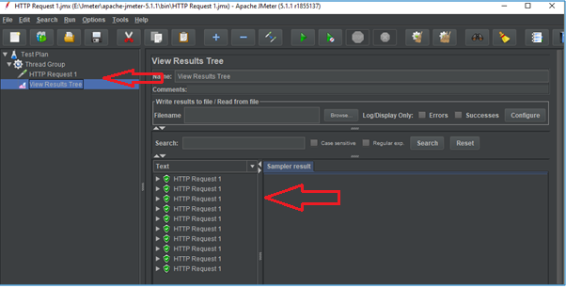

* Right click on Thread Group --->Add--->Listeners---> View Results in Table---> Clear All---> Save---> Run.

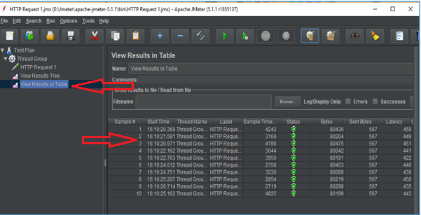

* Right click on Thread Group --->Add--->Listeners---> Assertions Results---> Clear All---> Save---> Run.

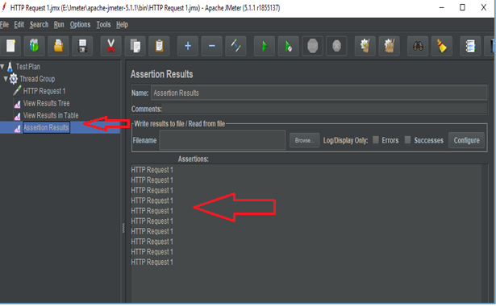

* Right click on Thread Group --->Add--->Assertions ---> Response Assertions---> Response Code---> Contains---> Add---> 201---> Save---> Clear All---> Run.

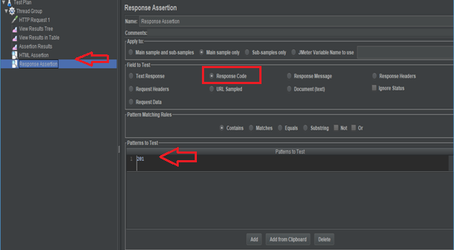

* Navigate through the given path: Assertion Result---> Run. It will show error

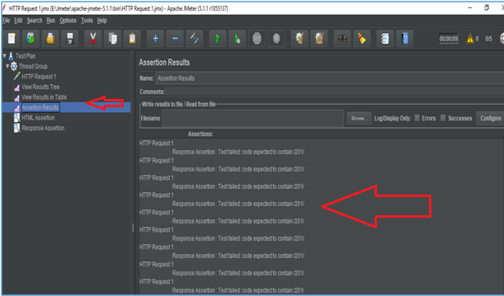

* Right click on Thread Group --->Add--->Assertions ---> Response Assertions---> Response Code---> Contains---> Add---> 200---> Save---> Clear All---> Run.

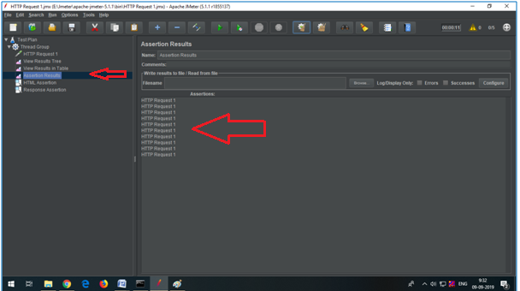

* Right click on Thread Group --->Add--->Assertions ---> Response Assertions---> Response Message---> Contains---> Add---> OK---> Save---> Clear All---> Run ---> View Results in Table.

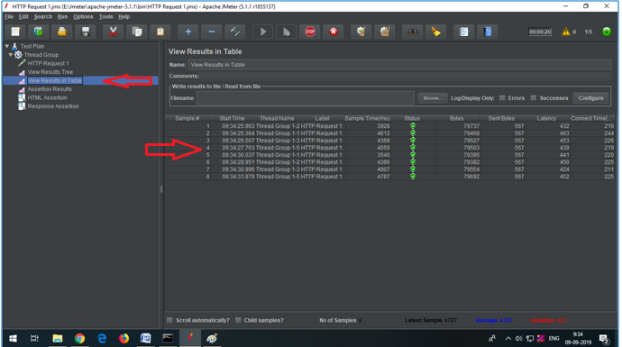

4) Constant Timer:

* Constant timer delays each user request for the same amount of time.
* Right click on Thread Group---> Add---> Timer---> Constant Timer---Thread delay in ms---> Save.

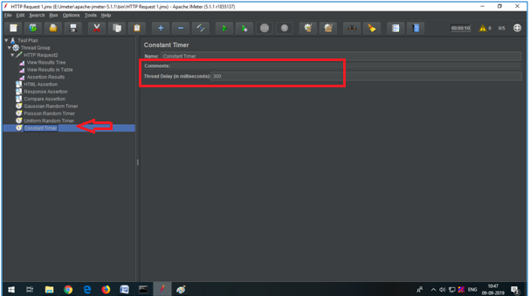

* Navigate through the given path: Clear all---> Run---> View Result in Table.

