1.2 Adding Load (Threads)

This section will guide you to:

* Add thread load

**Development Environment**

* Apache JMeter 5.1.1 Version
* Open JDK Runtime Environment 11.0.2

This guide has five subsections, namely:

* + 1. Adding thread load
    2. Doing proxy settings in JMeter
    3. Configuring JMeter in browsers (using Firefox browser here)
    4. Demonstrating an example of multi thread load
    5. Pushing the code to GitHub repositories

**Step 1.2.1:** Adding thread load

* Open JMeter.
* Right click on Test Plan.
* Click on Thread (Users) -> Concurrency Thread Group.

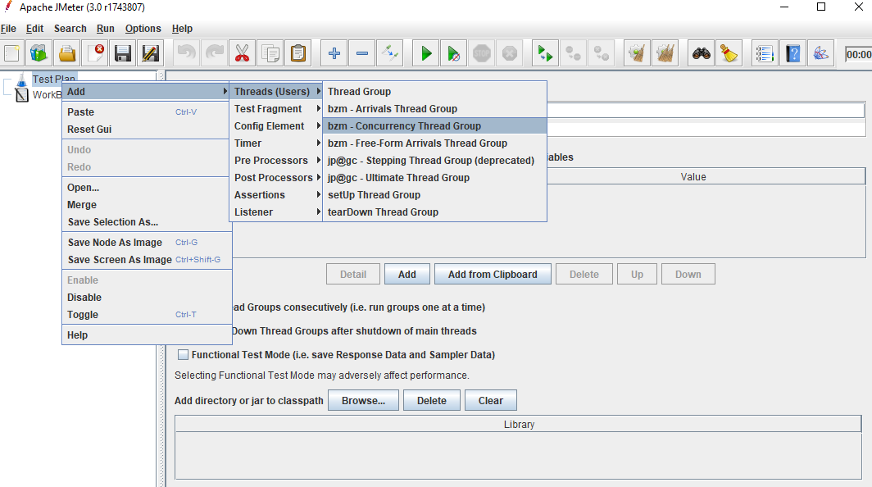

* Right click on Workbench.
* Click on Add -> Non Test Elements -> HTTP(S) Test Script Recorder.

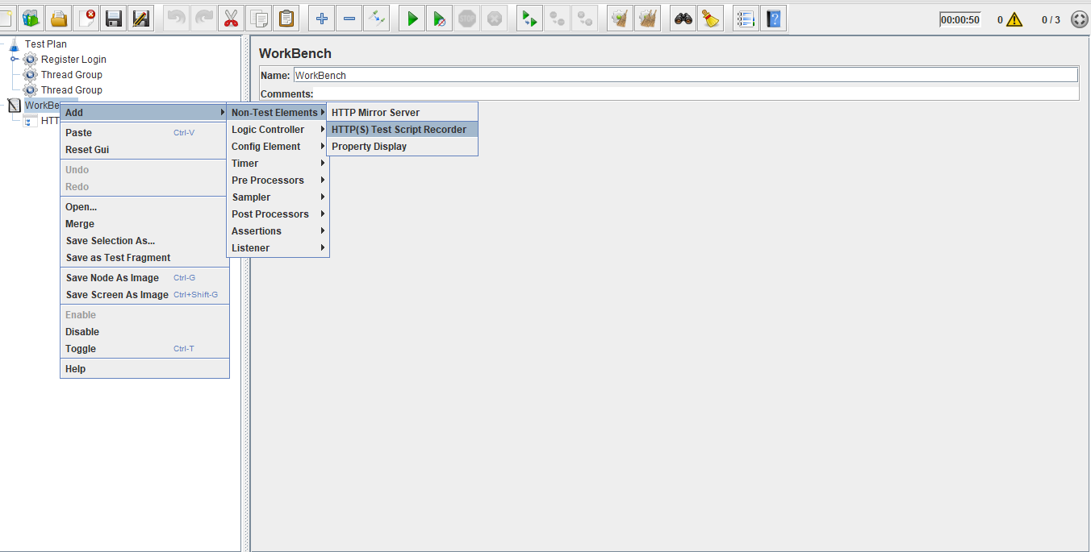

* Right click on Thread Group.
* Click on Add -> Logic Controller -> Recording Controller.

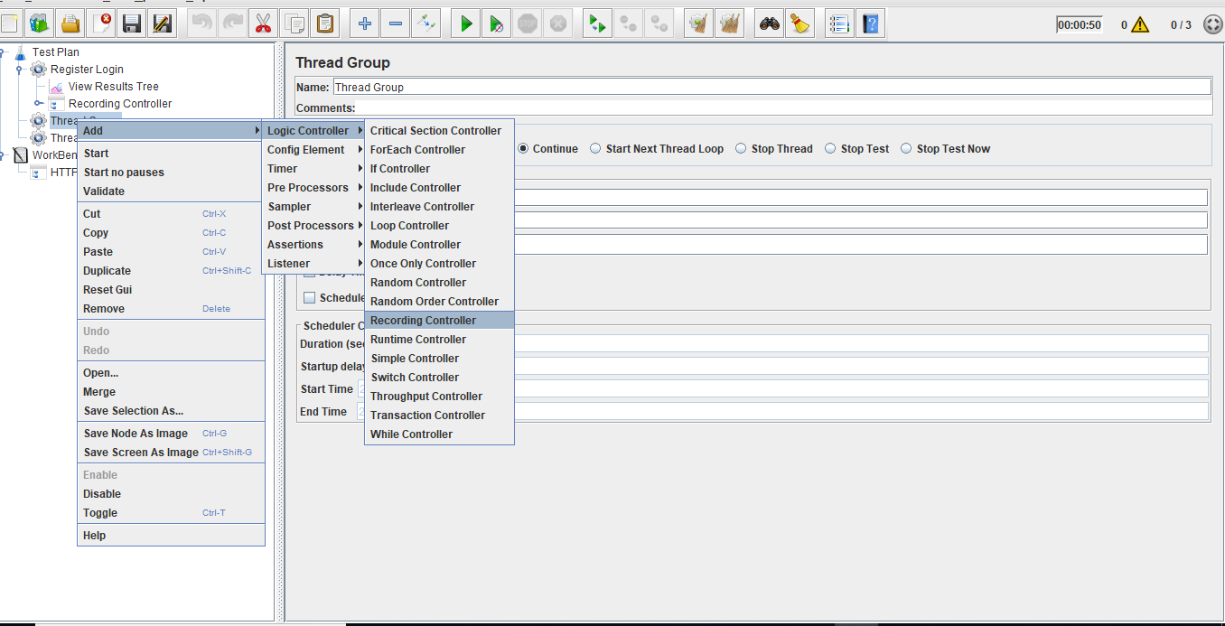

* Right click on Concurrency Thread Group.
* Click on Add -> Listener -> View Result Tree.

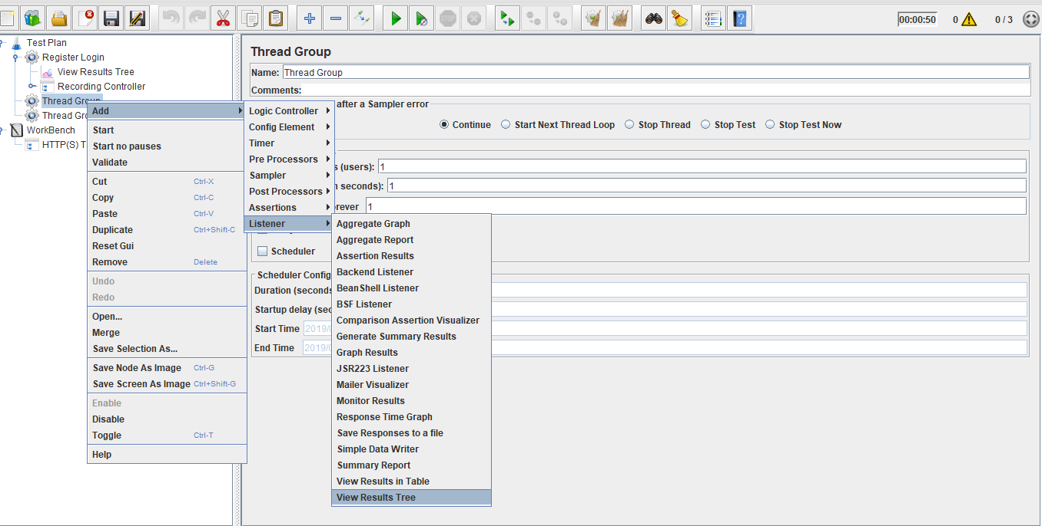

**Step 1.2.2:** Doing proxy settings in JMeter

* Click on HTTP(S) Script Recorder.
* Set port number (optional).
* Click on the Start button.

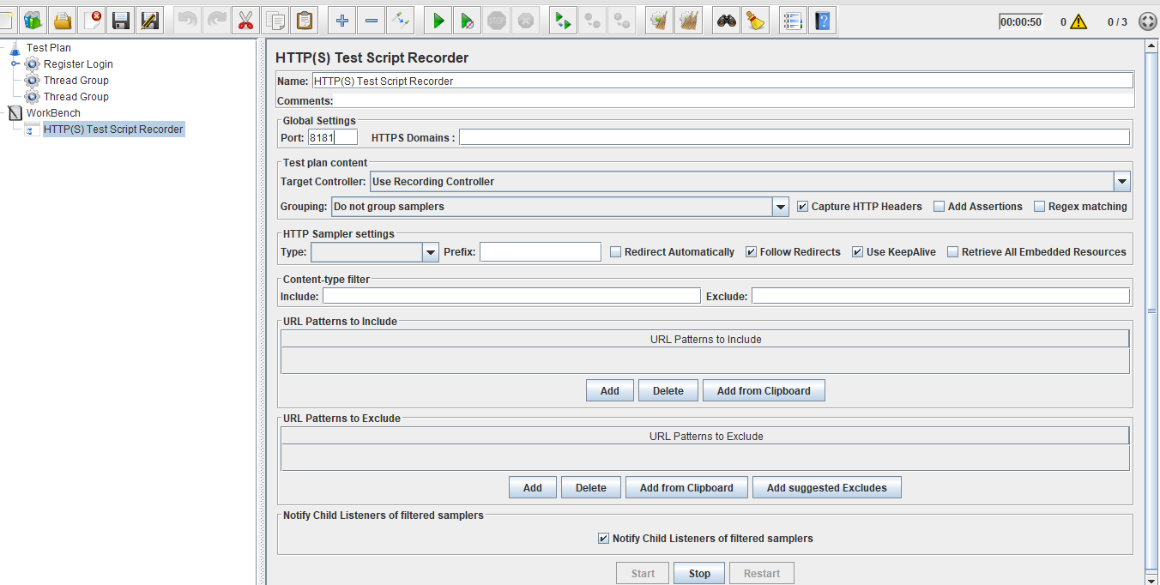

**Note:** ADefault Certificate will be generated in your local machine.

**Step 1.2.3:** Configuring JMeter in browsers (using Firefox browser here)

* Start Firefox, but do not close JMeter.
* From the toolbar, click *Edit* → *Preferences* (or *Tools* → *Preferences* or type about: preferences#advanced as the URL). This should show the options.

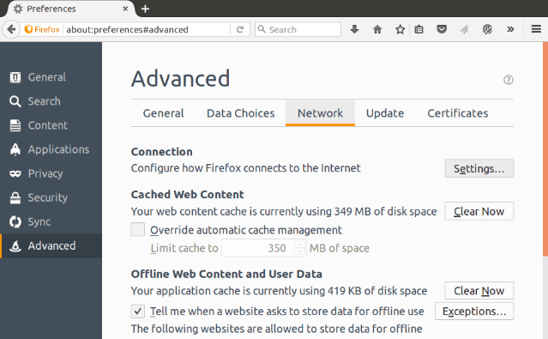

* Select the Advanced tab and Network tab.
* Click on **Settings**.
* On the new pop-up screen, check Manual Proxy Configuration. The address and port fields should be enabled now.

Address:

Enter localhost or the IP address of your system.

Port:

Enter 8181 (Samp port in HTTP(S) Script Recorder).

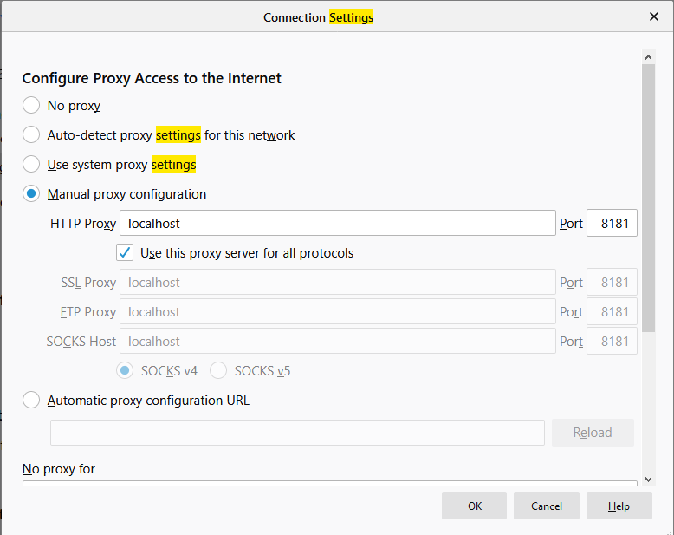

* Check the **Use this proxy server for all protocols** checkbox.
* Click on the **Ok** button and this should return you to the browser.

**Step 1.2.4:** Demonstrating anexample of multi thread load

* Right click on the Concurrency thread group.
* Add targeted threads (number threads).
* View the result of adding multiple thread loads.

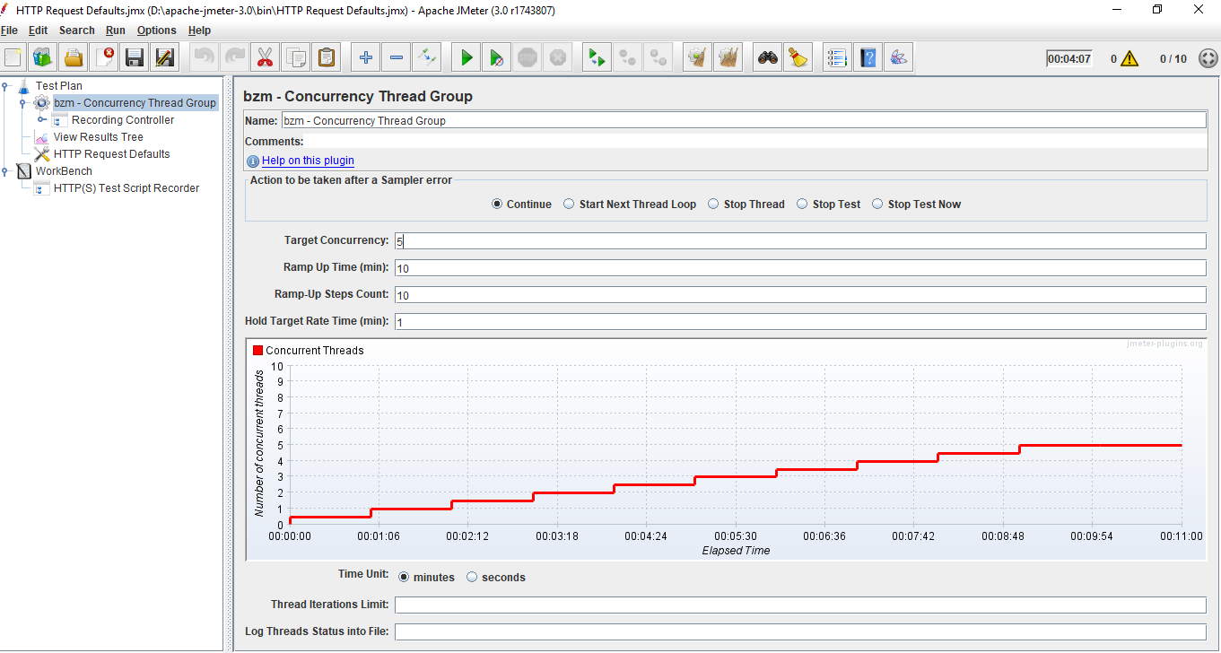

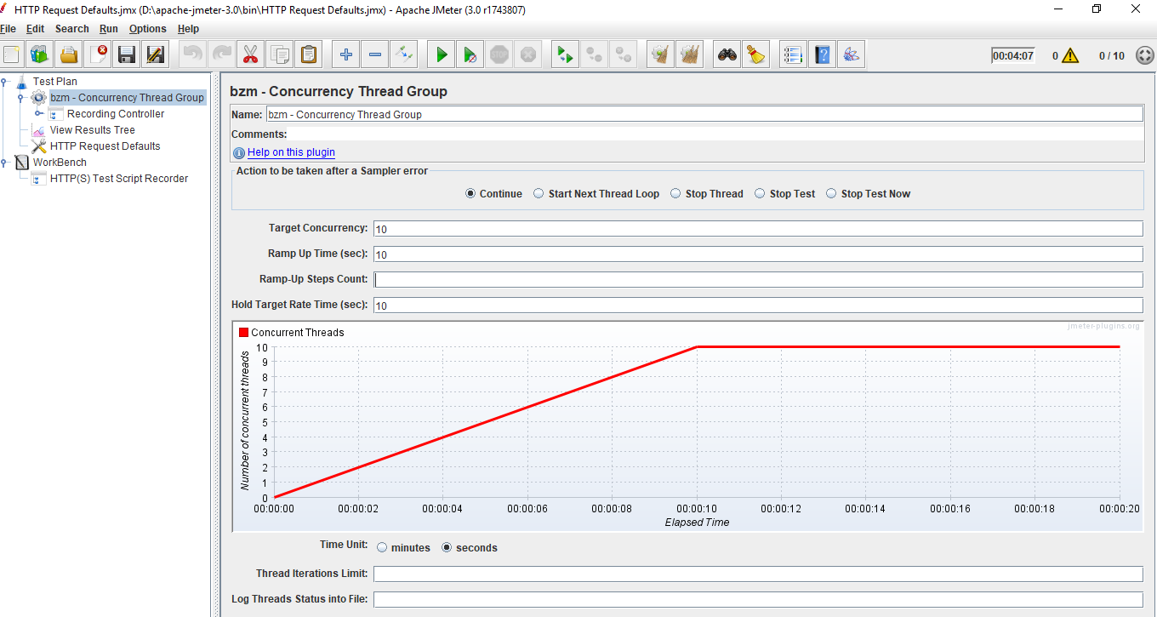

* Run any website in the Firefox browser and see the end result.
* View the end results in **View Result Tree**.

