1.3 Increasing Loads

This section will guide you:

* To increase the load

Development Environment

* Apache JMeter 5.1.1 Version

This guide has three sub-sections, namely:

1.3.1 Increasing the load

1.3.2 Demonstrating an example of increasing the load

1.3.3 Pushing the code to GitHub repositories

**Step 1.3.1:** Increasing the load

* Open JMeter.
* Right click on TestPlan.
* Click on Thread(Users)->Concurrency Thread Group.

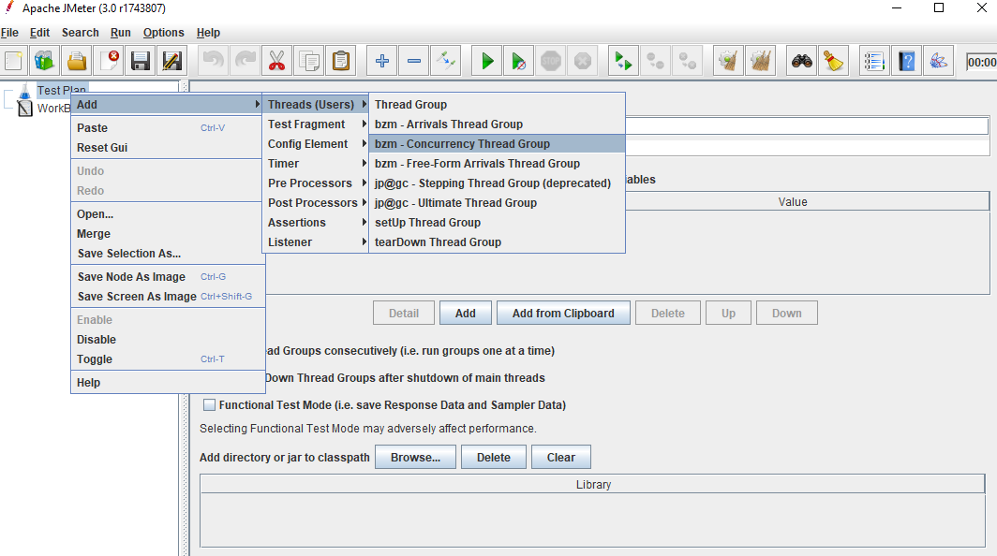

**Step 1.3.2:** Demonstrating an example of increasing the load

* + Minimum ramp up of 5 (increasing the load by step count)

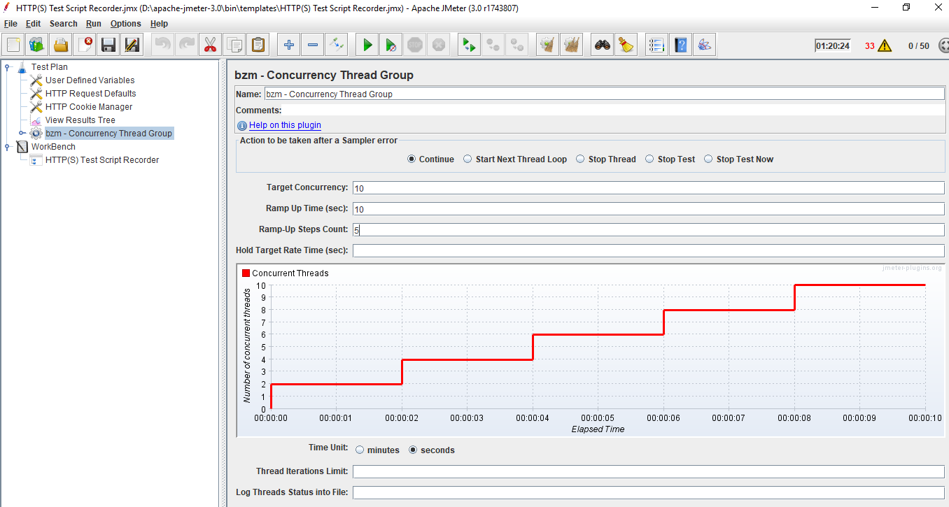

* + Maximum ramp up of 10 (increasing the load by step count)

