2.20 API Chaining | REST

This section will guide you to understand:

* How to chain API requests
* Get data from response of one API and refer in another API

**Development Environment**

* Postman
* Endpoint URL

This guide has five subsections, namely:

* + 1. Creating a Collection
    2. Creating two new requests
    3. Creating an environment
    4. Checking the API chaining response
    5. Pushing the code to GitHub repositories

**Step 2.20.1:** Creating a Collection

* Open Postman
* Click on **New**
* Select Collection

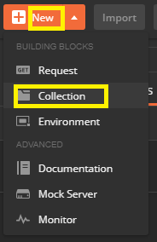

**Step 2.20.2:** Creating two new requests

* Go to New
* Select Request
* Create GET Request(“https://api.coindesk.com/v1/bpi/currentprice.json”)
* Create POST Request(“https://api.twilio.com/2010-04-01/Accounts/{{twilioAccountSID}}/Messages.json”)

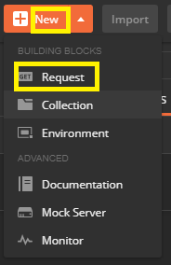

**Step 2.20.3:** Creating an Environment

* Go to the settings option
* Click on Add

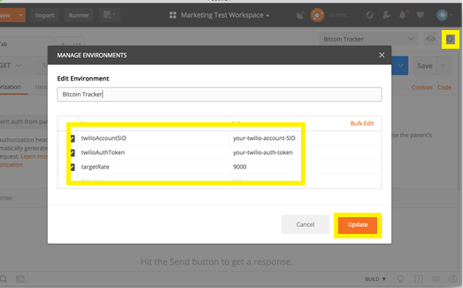

**Step 2.20.4:** Checking the API chaining response

* Go to **Test**
* Write the body of the request

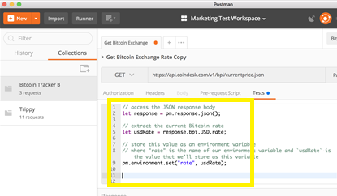

* + After we hit Send, click on the Quick Look icon to see that we’ve extracted the data from the response body, and saved it as an environment variable. Now, we can use this variable in our next request.

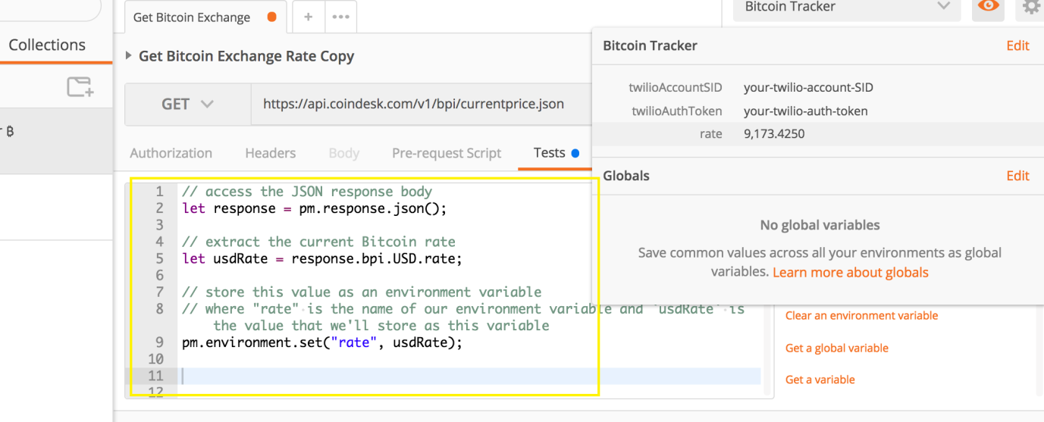

* + In the same manner, can you figure out how to extract the “time” from the response, and then save it as an environment variable?

Send a POST request using a stored environment variable**.**

* + For this second request, we will use the Twilio API to send an SMS. Send a **POST** to **https://api.twilio.com/2010-04-01/Accounts/{{twilioAccountSID}}/Messages.json**where **{{twilioAccountSID}}** is your own Twilio Account SID. Remember to also save this second request to our collection.
* String substitution: We can use the double curly braces syntax anywhere we would normally input text, like **{{variable-name}}**, to use a variable. Postman will access the variable’s value and swap in the value as a string. Use the double curly braces in the URL, parameters, or any of the other data editors.

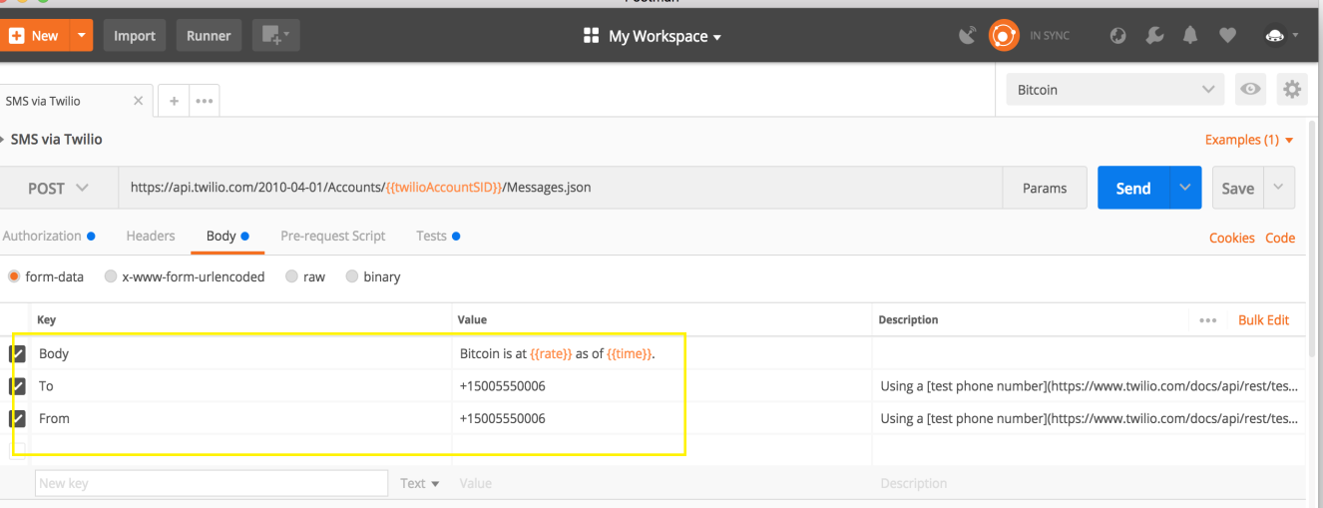

* + More String Substitution**:** This request requires the authentication credentials we saved to our environment in the first step. We can use the same double curly braces syntax in Postman’s auth helper to handle Basic Auth for the Twilio API. Authentication (and scripts) are [available for entire collections and folders](https://blog.getpostman.com/2017/12/13/keep-it-dry-with-collection-and-folder-elements/) too.

