2.11 Environments



This section will guide you to understand:

* How to create an Environment
* How to use an Environment

**Development Environment:**

* Postman Tool
* Endpoint URL

This guide has three subsections, namely:

2.11.1 Creating an environment

2.11.2 Running the request using environment

2.11.3 Pushing the code to GitHub repositories

**Steps 2.11.1:** Creating an environment

* Create a Collection

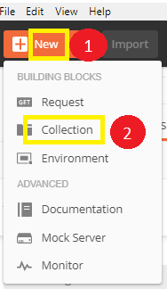

* Create two new Requests:

<https://reqres.in/api/users/2>

<https://reqres.in/api/users?page=2>

* Save it

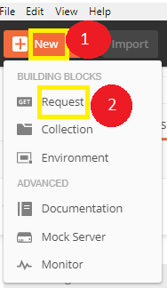

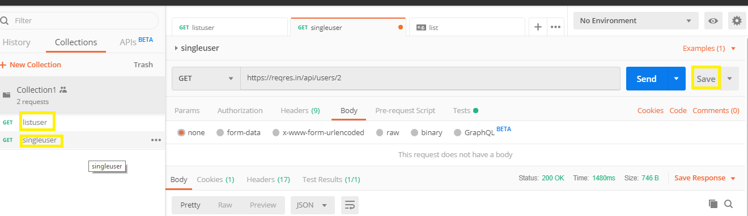

* Click on the gearicon which says Manage Environment

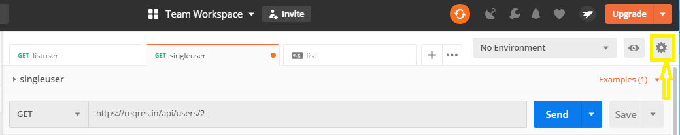

* Click on Add 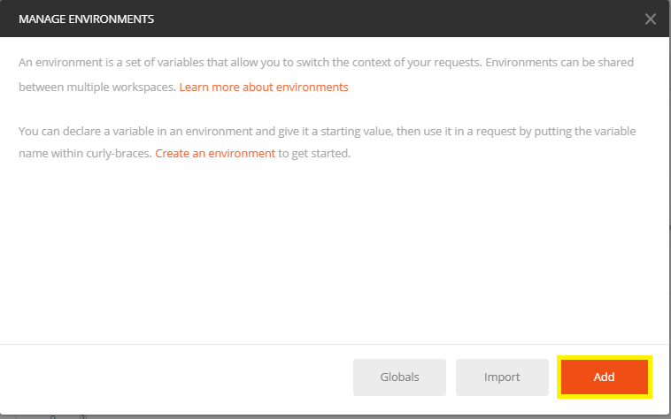
* Give a name to your environment

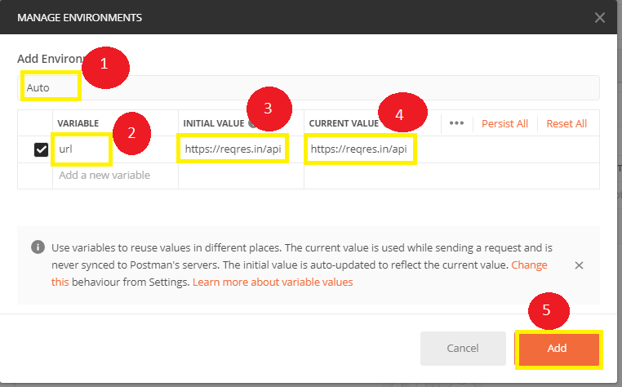

* After clicking Add, we get a new window
* Close that Environment window

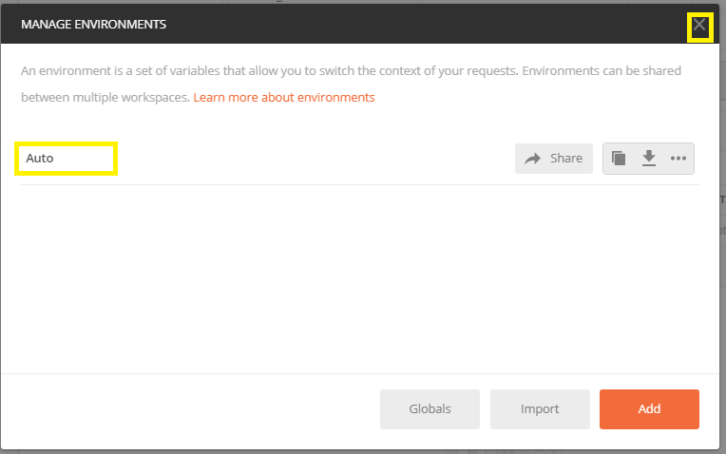

**Step 2.11.2:** Running the Request using Environment

* Open your Requests and write your URL like the below image and use your Environment

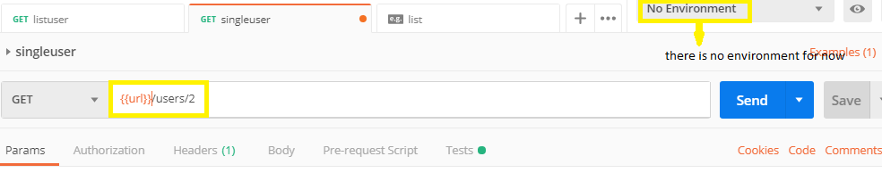

* Change your environment

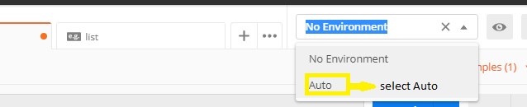

* Then run it and the output will look like this: 