2.2 First API Request

This section will guide you to:

* Create first API request on Postman
* Get response of a request

This guide has three sections, namely:

* + 1. Setting up API request on Postman
    2. Getting response of API request on Postman
    3. Pushing the code to GitHub repositories

**Step 2.2.1:** Setting upAPI request on Postman

* The screenshot below shows the Postman Workspace.

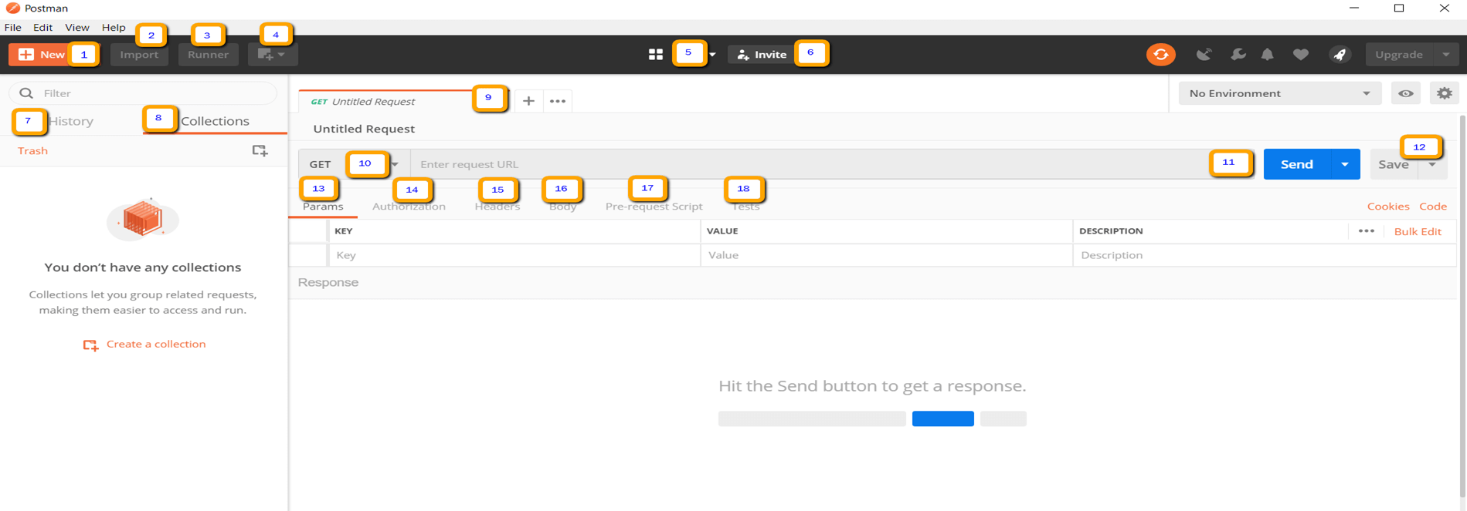

* Open Postman Workspace.
* On the top left corner, click on the **New option** button**.**

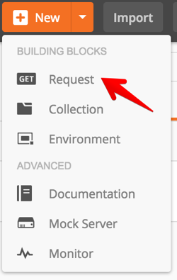

* In the drop-down options available, click on Request option.
* Adda name for the request.
* Scroll down and click on create a collection option and add a name for the collection.
* Click on the Save button.
* Your Request is ready now.

**Step 2.2.2:** Getting a response of API request on Postman

* Take one Sample URL as shown below.

<https://reqres.in/api/users?page=2>

* In the request URL field, input the above link.
* Click on the Send button.
* You will see 200 OK Messages.