2.6 How to Parameterize Requests



This section will guide you to understand:

* How to use variables with parameters
* Response of a parameterized request

Development Environment:

* Postman Tool
* Endpoint URL

This guide has four subsections, namely:

2.6.1 Checking response before creating Variable

2.6.2 Creating Variable

2.6.3 Getting the Response

2.6.4 Pushing the code to GitHub repositories

**Steps 2.6.1:** Checking response before creating Variable

* Set your HTTP request to GET
* Input this link: https://reqres.in/api/users?page=2. Replace the first part of the link with a parameter, such as {{url}}. Request url should now be {{url}}/users.
* Click **Send**

**Note:** There should be no response since we have not set the source of our parameter.

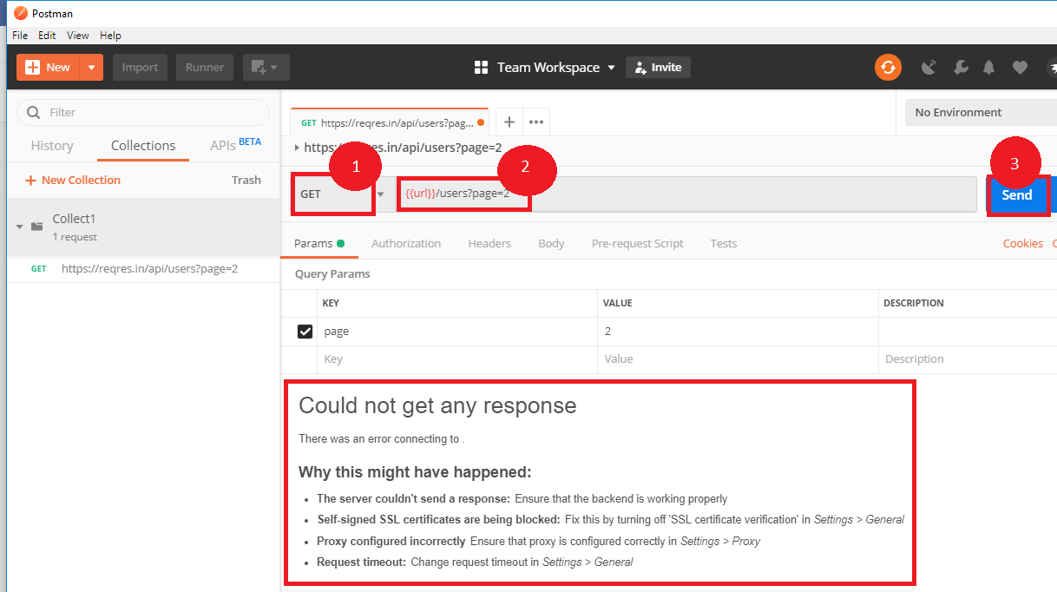

**Steps 2.6.2:** Creating a Variable

* Click the eye icon
* Click edit to set the variable to a global environment which can be used in all collections

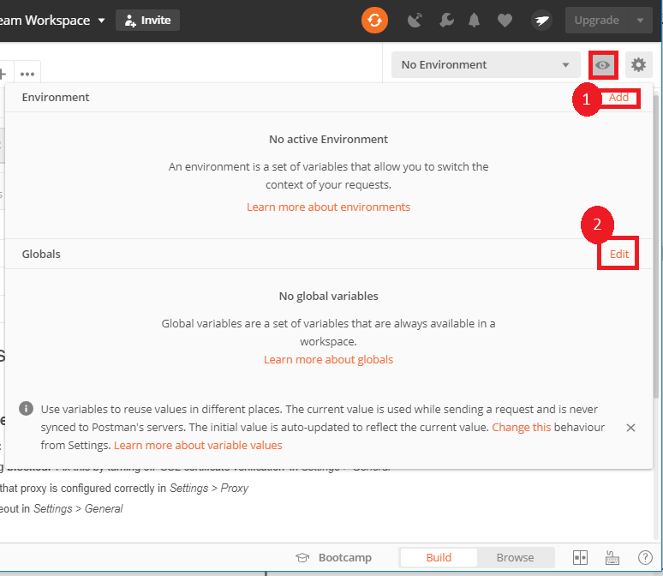

* Set the name to the URL, which is https://reqres.in/api
* Click Save

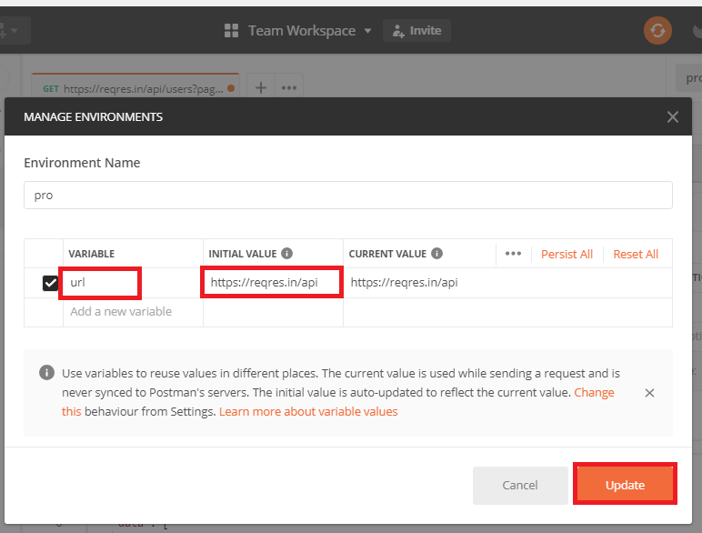

* Click **Close** if you see the next screen

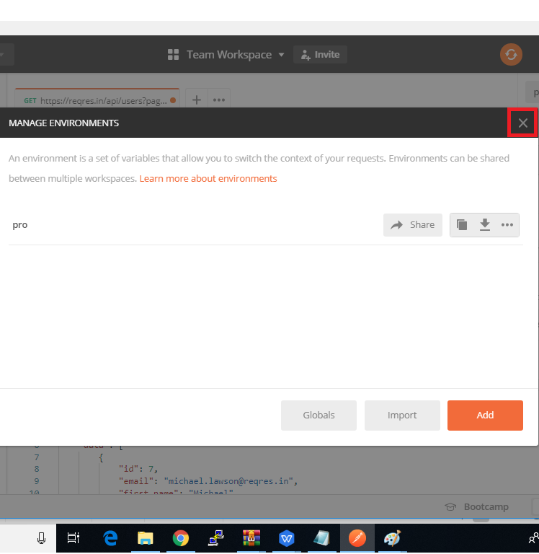

* Change the Environment

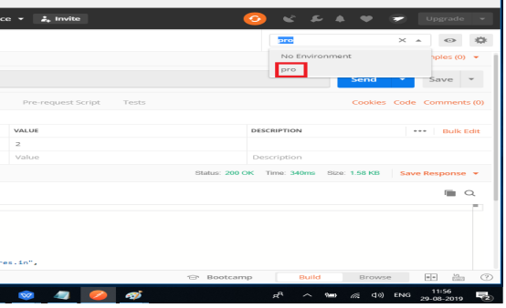

**Steps 2.6.3:** Getting the Response

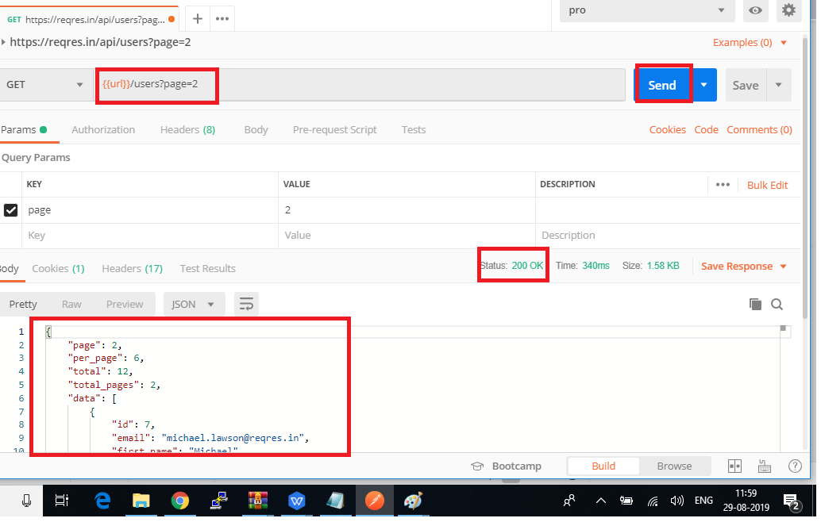

* Always ensure that your parameters have a source, such as an environment variable or data file to avoid errors