2.15 Monitors



This section will guide you to understand:

* How to manage the view
* How to manage workspace and environments

**Development Environment:**

* Postman Tool
* Endpoint URL

This guide has four subsections, namely:

2.15.1 Changing the View

2.15.2 Managing Collections

2.15.3 Managing environments and workspace

2.15.4 Pushing the code to GitHub repositories

**Step 2.15.1:** Changing the view

* Open Postman
* Go to the Setting option
* Click on Themes

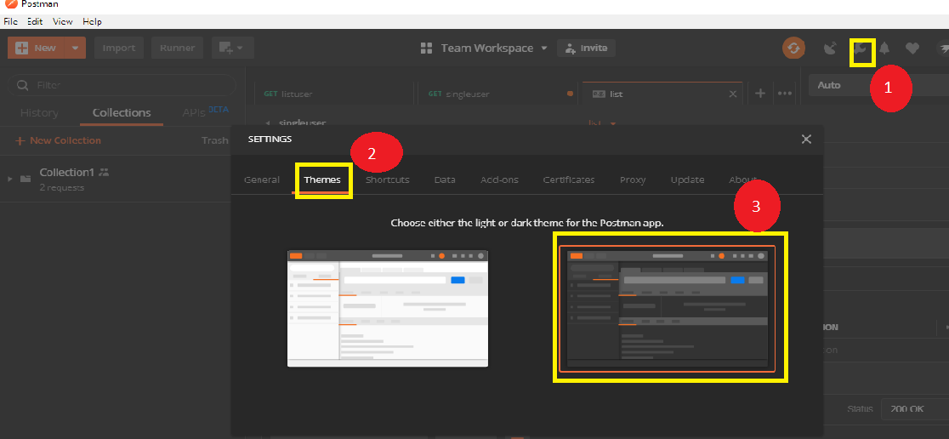

**Step 2.15.2:** Managing Collection

* Create a new Collection
* Scroll down and find the option Browse
* Click on Browse
* Click on Collections
* Click on Monitor Collection

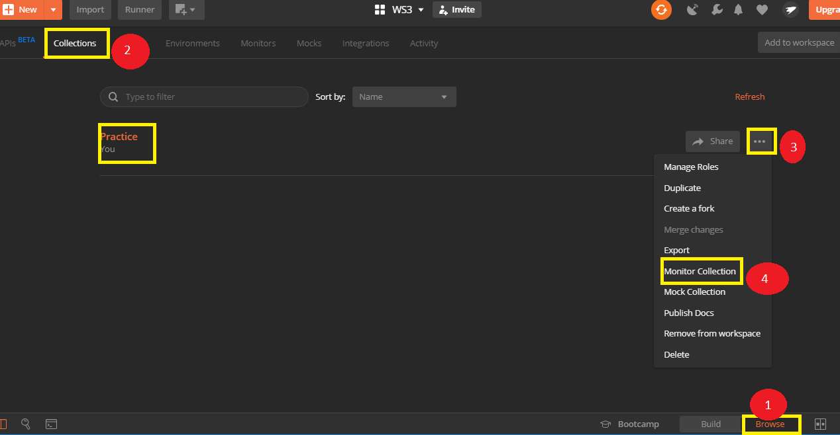

**Step 2.15.3:** Managing environments and workspace

* Click on **Add to workspace** option

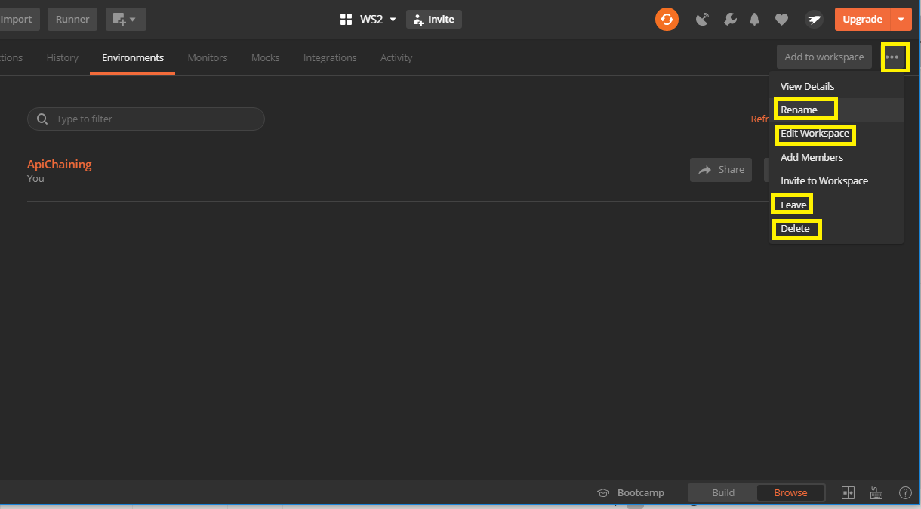

* Go to Environment

