2.1 Postman Request, Collections, and Variables

This section will guide you to understand:

* How to create request, collections, and variables using Postman

**Development Environment:**

* Postman Tool
* Endpoint URL

This guide has three subsections, namely:

1. Problem Statement for creating requests, collections, and variables using Postman.
2. Solution for the Problem Statement.
3. Pushing the code to Github repositories.

**Step 2.1.1:** Problem statement for creating requests, collections, and variables using Postman.

* Objective: Create a collection, add a request, create respective variables in Postman using any sample url, and check the response.
* Steps Involved:

1. Open Postman
2. Create a collection
3. Add requests by using sample url
4. Create variable
5. Validate the response

**Step 2.1.2:** Solution for the problem statement.

* Steps to create a collection

1. Open Postman
2. Go to **New** option
3. Create a collection

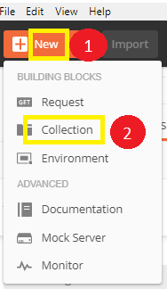

* Steps to set requests

1. Go to **New** option
2. Click on **Request**
3. Save it
4. Use the sample url:

<https://reqres.in/api/users/2>

<https://reqres.in/api/users?page=2>

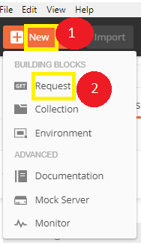

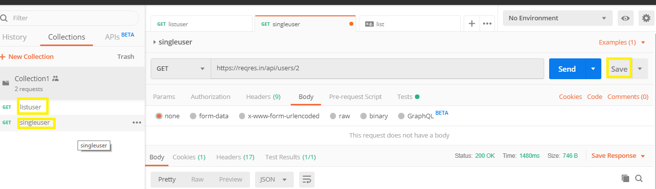

* Steps to set variables

1. Go to collection
2. Click on the Triple dot mark
3. Click **Edit**

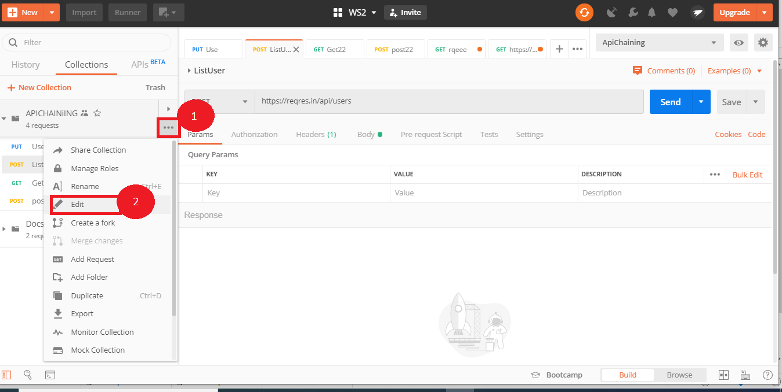

4. Click on **Variable**

5. Add variable

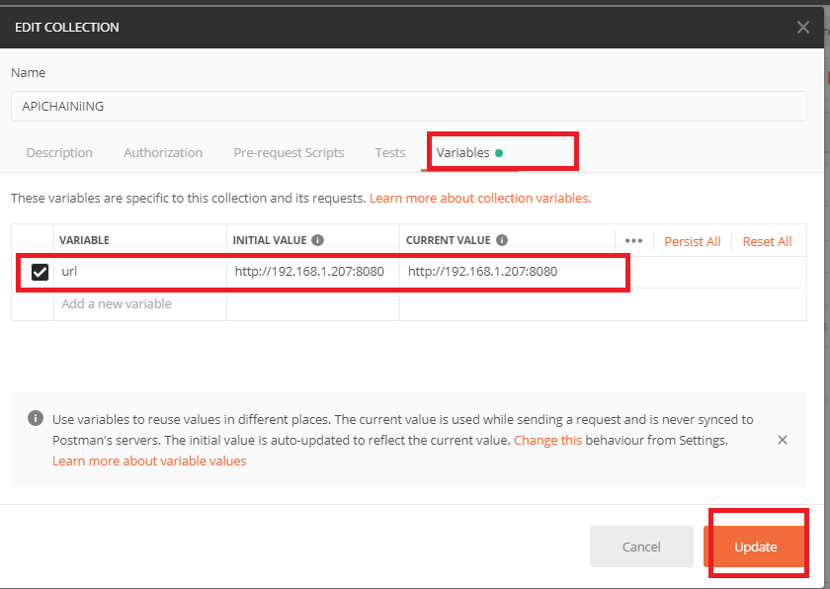

* Validate the response

1. Go to the request
2. Use the variable that was created earlier

