2.19 Run SOAP Requests in Postman

This section will guide you to understand:

* How to add SOAP request in Postman
* How to run and validate SOAP Requests

**Development Environment**

* Postman
* Endpoint url

This guide has five subsections, namely:

* + 1. Creating a Collection
    2. Creating a New Request as POST
    3. Providing request data in the body
    4. Validating the request
    5. Pushing the code to GitHub repositories

**Step 2.19.1:** Creating a collection

* Open Postman
* Click on **New**
* Select Collection

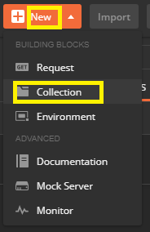

**Step 2.19.2:** Creating a New Request

* Go to New
* Select Request

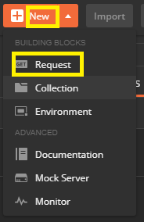

**Step 2.19.3:** Providing the Request data in body

* Go to Request body
* Click on raw
* Select **Xml(text/xml)**

<?**xml** version="1.0" encoding="utf-8"?>

<soap:Envelope xmlns:soap="http:**//**schemas.xmlsoap.org/soap/envelope/">

<soap:Body>

<CapitalCity xmlns="http:**//**www.oorsprong.org/websamples.countryinfo">

<sCountryISOCode>IN</sCountryISOCode>

</CapitalCity>

</soap:Body>

</soap:Envelope>

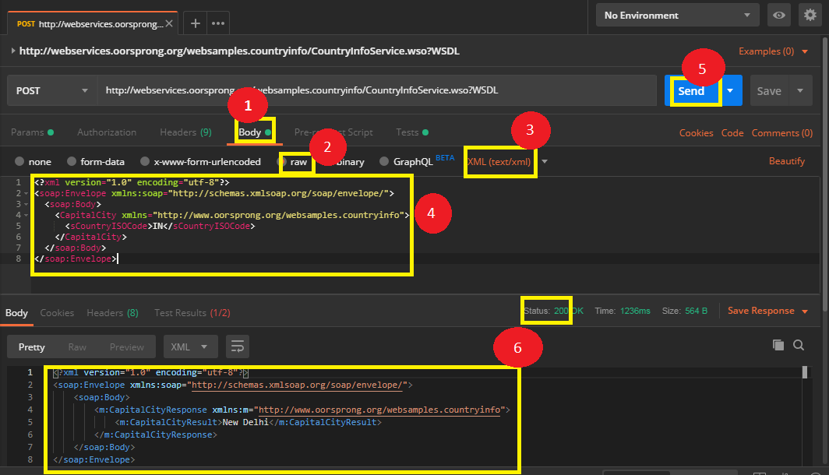

**Step 2.19.4:** Validating the request

* Go to **Test**
* Pass the snippet which shows status code as 200

