2.4 Working with GET Requests



This section will guide you to understand:

* How to send a GET request in Postman
* Responses of GET request

**Development Environment:**

* Postman Tool
* URL

This guide has two subsections, namely:

2.4.1 Working with GET Request

2.4.2 Pushing the code to your GitHub repositories

**Step 2.4.1:** Working with Get Request

* We will use the following sample URL for all examples in this tutorial:

[**https://reqres.in/api/users/2**](https://reqres.in/api/users/2)

* Set your HTTP request to GET
* In the request URL field, input link
* Click Send
* You will see the **200 OK** Message
* There should be 10 user results in the body 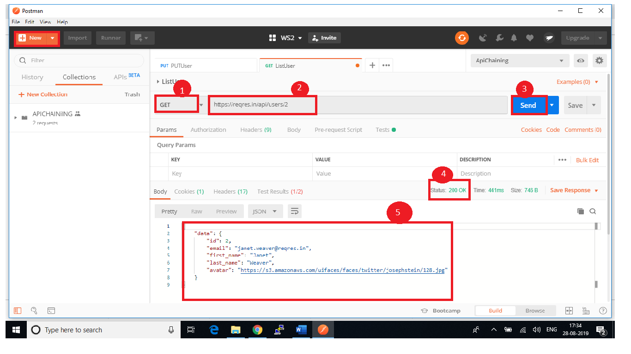
* There may be cases where the Get request will be unsuccessful. It can be due to an invalid request URL or missing authentication.