2.14 Workspaces



This section will guide you to understand:

* How to create workspace
* How to manage workspace

**Development Environment:**

* Postman Tool
* Endpoint URL

This guide has three subsections, namely:

2.14.1 Creating a workspace

2.14.2 Pushing the code to GitHub repositories

**Step 2.14.1:** Creating a workspace

* Open Postman
* Go to the top of the page of Postman
* Click on the arrow mark
* Click on Create

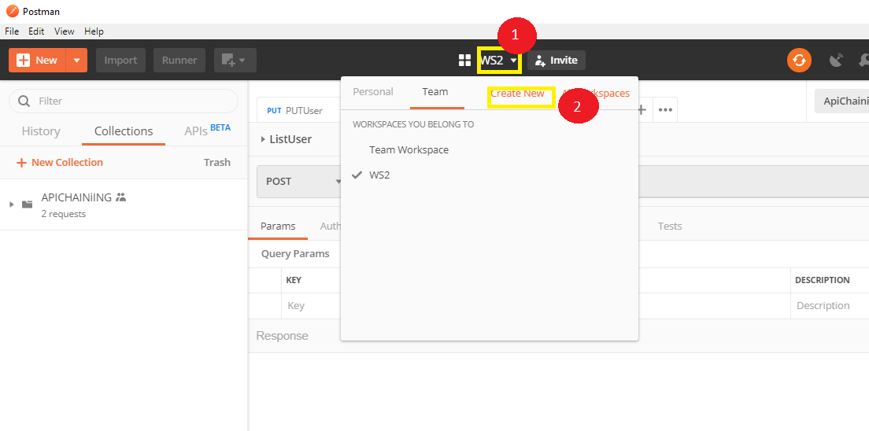

* Manage Workspace

