1. Write a Java program to convert an octal number to a binary number.

import java.util.Scanner;

public class OctalToBinary {

public static void main(String[] args) {

Scanner input = new Scanner(System.in);

int[] oct_binary = {0, 1, 10, 11, 100, 101, 110, 111};

long oct_num, temp, binary_num = 0, place = 1;

int rem;

System.out.print("Enter octal number");

oct_num = input.nextLong();

temp = oct_num;

while (temp != 0) {

rem = (int) (temp % 10);

binary_num = oct_binary[rem] * place + binary_num;

temp = temp / 10;

place = place * 1000;

}

System.out.print("Equivalent binary number: " + binary_num + "\n");

}

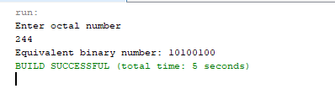

2. Write a Java program to compare two numbers.

// Octal to Decimal coverter

public class OctToDecimal {

public static void main(String[] args){

String octString = "255";

int decimal=Integer.parseInt(octString, 8);

System.out.println(decimal);

}

}

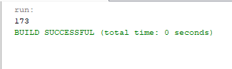

3. Write a Java program to convert an octal number to a decimal number.

import java.util.Scanner;

public class CompareNumbers {

public static void main(String[] args){

Scanner input = new Scanner(System.in);

int num1;

int num2;

System.out.println("Enter first no.");

num1= input.nextInt();

System.out.println("Enter second number");

num2= input.nextInt();

if(num1>num2)

System.out.println(num1 +" > "+ num2);

if(num1<num2)

System.out.println(num1 +" < "+ num2);

if(num1==num2)

System.out.println(num1 +" == "+ num2);

}

}

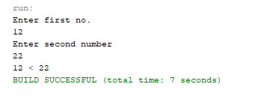

4. Write a Java program to create and display unique three-digit number using 1, 2, 3, 4 Also count how many three-digit numbers are there.

public class Premutations {

public static void main(String[] args) {

int count = 0;

for (int i = 1; i <= 4; i++) {

for (int j = 1; j <= 4; j++) {

for (int k = 1; k <= 4; k++) {

if (k != i && k != j && i != j) {

count++;

System.out.println(i + "" + j + "" + k);

}

}

}

}

System.out.println("Total number of the three digit numbers is " + count);

}

}

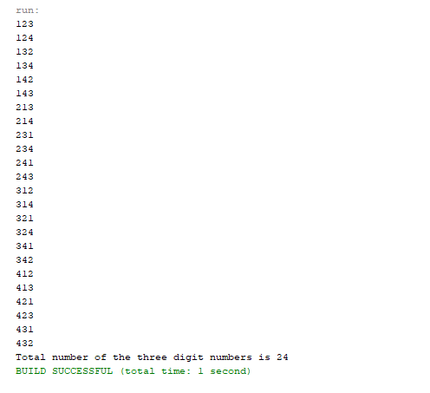

5. Write a Java program to find the size of a specified file.

import java.io.File;

public class FileSize {

public static void main(String[] args) {

File f= new File("xyz.txt");

System.out.println("Given file is of " + f.length() + " bytes");

}

}

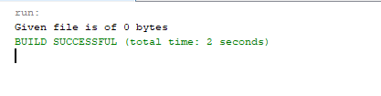

6. Write a Java program to display current date time in specific format.

import java.util.Calendar;

public class DateTime {

public static void main(String[] args) {

Calendar c = Calendar.getInstance();

System.out.println("Current Date and Time :");

System.out.format("%tB %te, %tY%n", c, c, c);

System.out.format("%tl:%tM %tp%n", c, c, c);

}

}

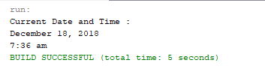

7. Write a Java program to calculate the sum of two integers and return true if the sum is equal to a third integer.

import java.util.*;

public class SumOfTwo {

public static void main(String[] args) {

Scanner in = new Scanner(System.in);

System.out.print("enter no. 1 ");

int x = in.nextInt();

System.out.print("enter no. 2 ");

int y = in.nextInt();

System.out.print("enter no. 3 ");

int z = in.nextInt();

System.out.print("The result is: " + sumoftwo(x, y, z));

}

public static boolean sumoftwo(int a, int b, int c) {

return ((a + b) == c || (b + c) == a || (c + a) == b);

}

}

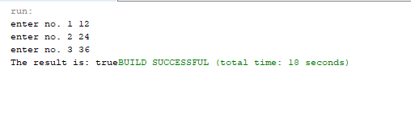

8. Write a Java program to calculate the sum of two integers and return true if the sum is equal to a third integer.

import java.util.*;

public class SumOfTwo {

public static void main(String[] args) {

Scanner in = new Scanner(System.in);

System.out.print("enter no. 1 ");

int x = in.nextInt();

System.out.print("enter no. 2 ");

int y = in.nextInt();

System.out.print("enter no. 3 ");

int z = in.nextInt();

System.out.print("The result is: " + sumoftwo(x, y, z));

}

public static boolean sumoftwo(int a, int b, int c) {

return ((a + b) == c || (b + c) == a || (c + a) == b);

}

}



9. Write a Java program to extract the first half of a string of even length.

import java.lang.*;

public class HalfString {

public static void main(String[] args)

{

String even_string = "Java";

int n = even_string.length()/2;

System.out.println(even_string.substring(0, n));

}

}

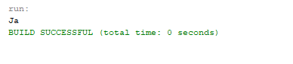

10. Write a Java program to create a new string taking first and last characters from two given strings. If the length of either string is use “#” for missing character.

Test Data: str1 = “Python”

str2 = “”

Sample Output: P#

public class StringProb {

public static void main(String[] args){

String first = "Python";

String last = "";

String str1;

String result = new String();

if(first.length()>0)

str1 = first.substring(0,1);

else{

str1 = "#";}

if(last.length()>0)

result = str1.concat(last.substring(0, 1));

else

result = str1.concat("#");

System.out.println(result);

}

}

