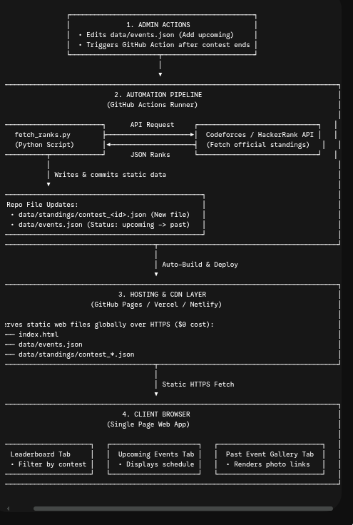

Architecture Style: Jamstack (JavaScript, APIs, Markup) powered by GitHub Infrastructure.
Database Strategy: Database-Free (Git-as-a-Database). Contest standings and event metadata are compiled into lightweight JSON files versioned directly in Git.
Core Components:
- Frontend: Single Page Web App (HTML/CSS/JS or React) hosted on CDN (GitHub Pages / Vercel).
- Automated Pipeline: Python script executed via GitHub Actions on-demand post-contest.
- Data Source: Codeforces / HackerRank REST APIs.

[ Contest Ends ]
│
▼
[ Admin Triggers GitHub Action ] ──► [ Python Script Fetches Ranks from Codeforces API ]
│
▼
[ Live Site Updated on CDN ] ◄── [ Generates contest_<id>.json & Commits to Git ]

