GCP BADGES

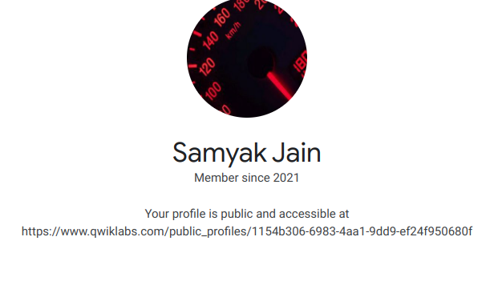

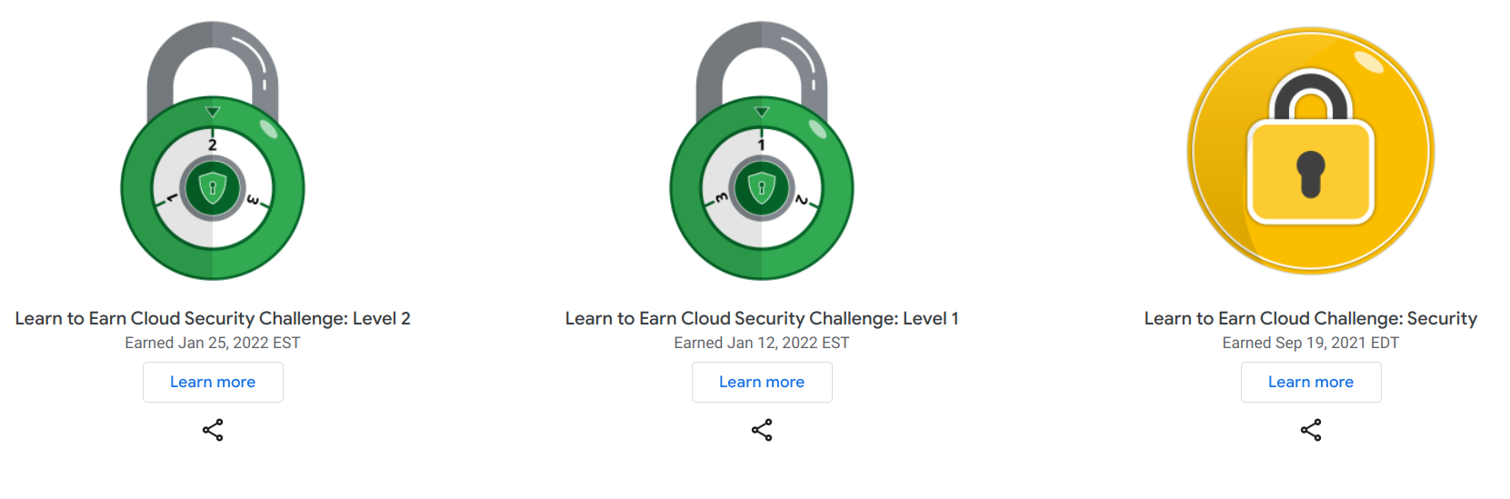

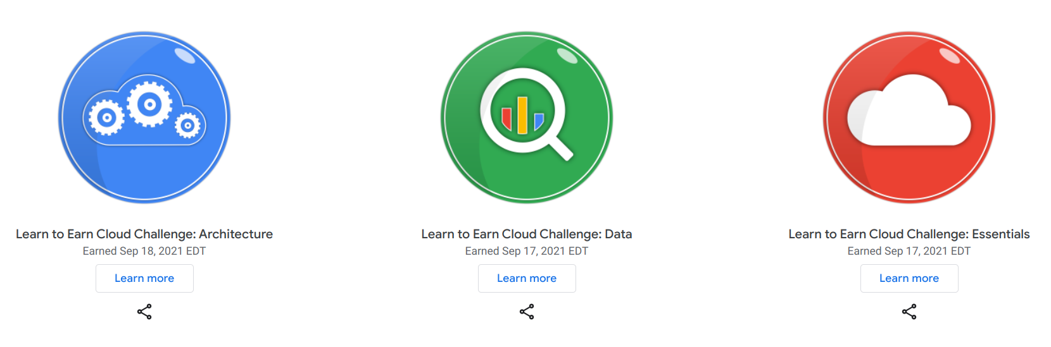

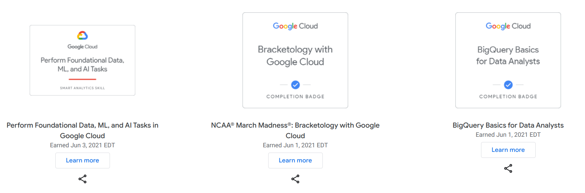

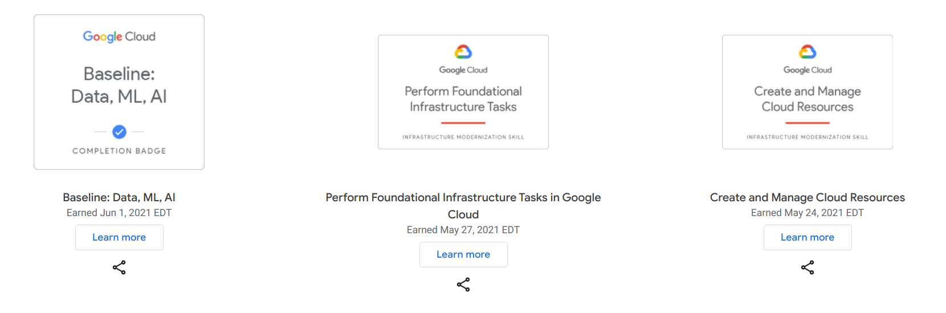

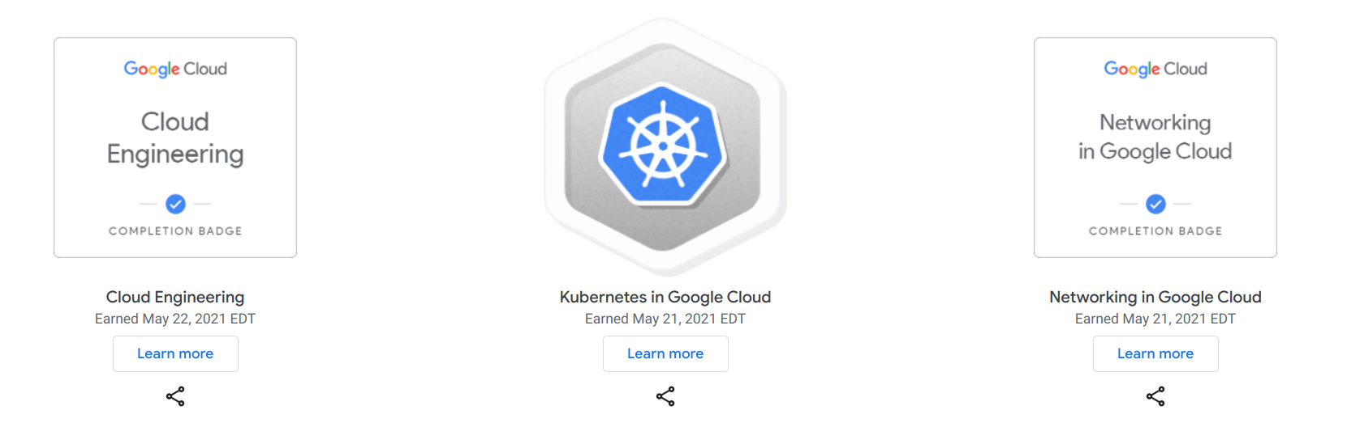

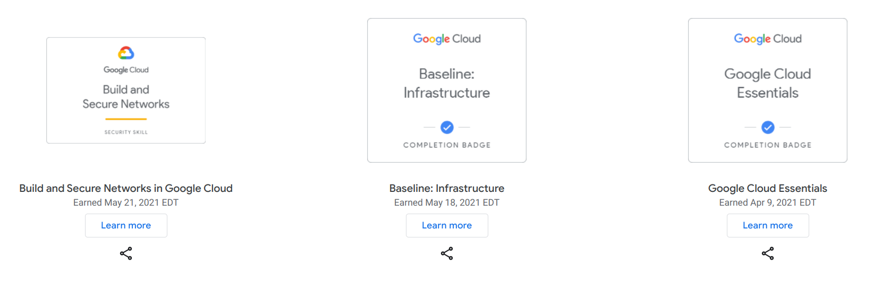

AWS Fundamentals Certificate

https://www.credly.com/badges/adf527e9-5dfb-4ceb-8ccf-12bbb99a0a63/public_url

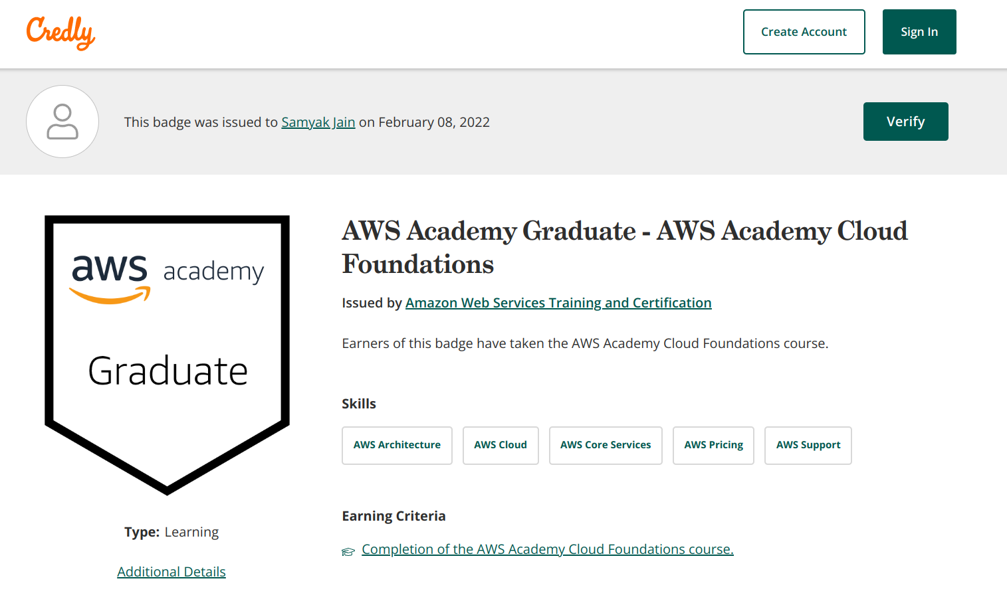

OPEN-SOURCE

https://dev.to/samyakjain2020

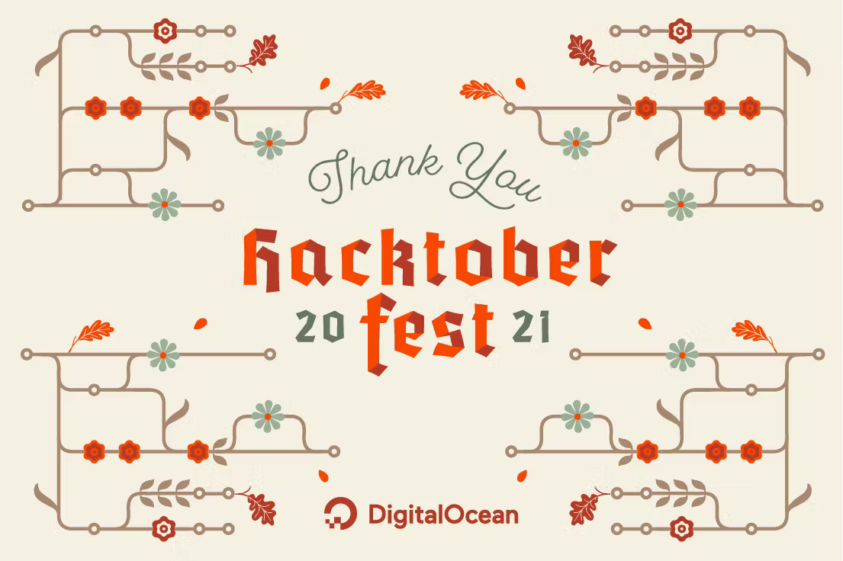

Cyber Security Fundamentals

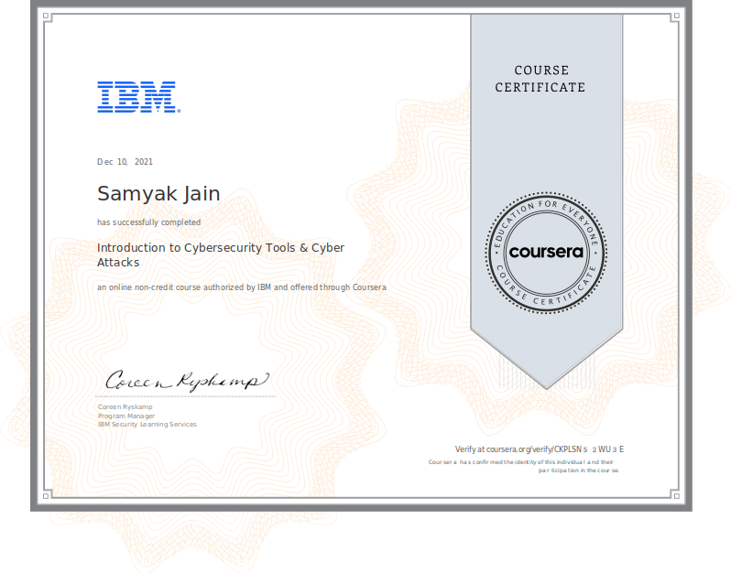

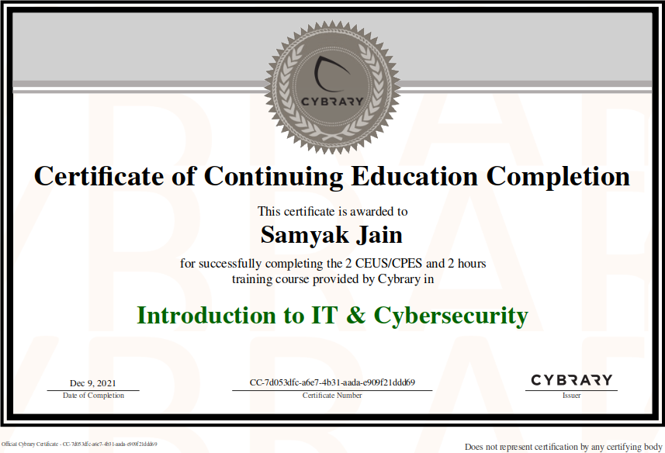

BLOCKCHAIN

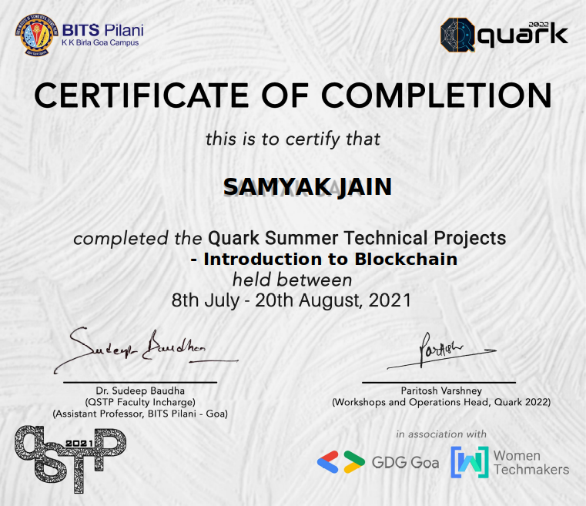

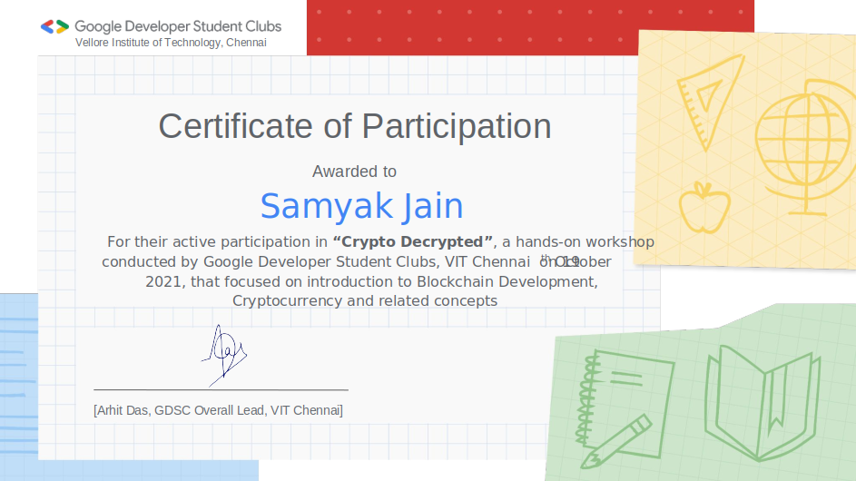

BACKEND-DEVELOPMENT

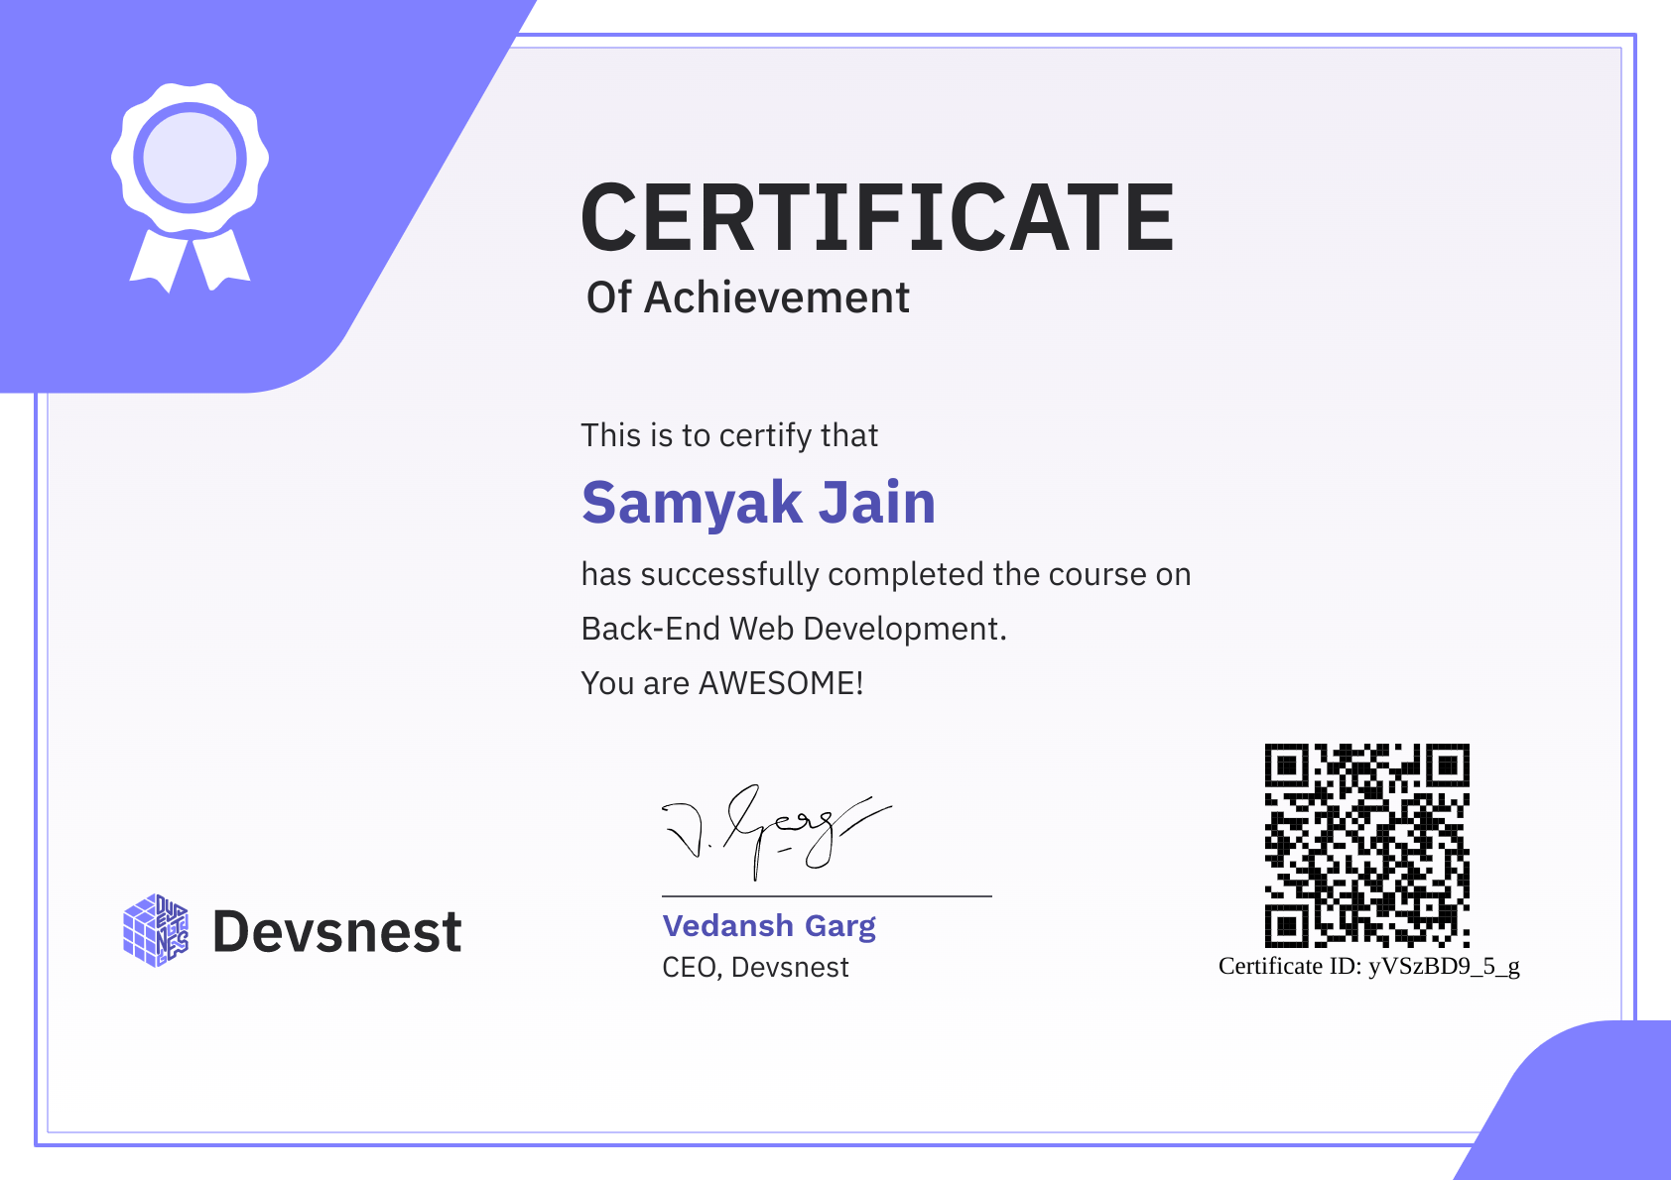

POSTMAN

https://badgr.com/public/assertions/R7Pq6mRgRlq5lfRrH8uXBA?action=download



**DEVFEST INDIA**

