VeritasRAG: A Provenance-Gated Defense Against Knowledge-Base Poisoning in Retrieval-Augmented Generation

[Student Name]
CSE-DS Department
ABES Engineering College
Ghaziabad, India
[student email]@abes.ac.in

Abstract—Retrieval-Augmented Generation (RAG) systems supplement large language models with externally retrieved context, but most deployed pipelines treat every document in the knowledge base as equally trustworthy. This creates an exploitable attack surface: a small number of adversarial passages injected into the corpus can hijack a system's generated answers, and no verifiable trust signal distinguishes a legitimate source from a planted one at retrieval time. This paper reports the minor-project phase of VeritasRAG, a middleware integrity layer that couples corpus-level poisoning detection with provenance/trust-tier-gated retrieval. We construct a synthetic poisoned corpus (280 chunks, 21.4% poison ratio) from the Natural Questions dataset using PoisonedRAG-style injection templates, and evaluate four detection signals — perplexity, embedding-cluster anomaly, a supervised classifier, and their weighted fusion — coupled with a retrieval-time trust-tier gate. On a 20-query targeted-attack benchmark, the defended pipeline reduces Attack Success Rate (ASR) from 1.000 to 0.000, a 100-percentage-point reduction, while retrieval precision@5 is preserved (0.345 to 0.347) — exceeding our pre-registered exit criteria of a ≥30-point ASR reduction at <15% precision loss. The fused detector achieves 0.918 precision / 0.933 recall (F1 = 0.926) under 5-fold cross-validation, with a standalone perplexity-signal ROC-AUC of 0.844 and a fused-classifier ROC-AUC of 0.992. We report per-stage latency, discuss the honest limitations of the current evaluation, and scope verifiable machine unlearning as future work for the major-project phase.
Index Terms—Retrieval-augmented generation, knowledge-base poisoning, prompt injection, provenance verification, trust-tier gating, poison detection, information retrieval security.
I. INTRODUCTION
Retrieval-Augmented Generation (RAG) has become a standard architecture for grounding large language models (LLMs) in external, up-to-date, or private knowledge without retraining the underlying model [1]. By retrieving relevant passages from a document corpus and conditioning generation on that retrieved context, RAG pipelines are now deployed across question answering, enterprise search, and domain-specific assistants. This architecture, however, rests on an implicit trust assumption: that every document admitted into the retrieval corpus is safe to surface to the generator.
That assumption does not hold in practice. PoisonedRAG [3] demonstrated that an attacker who injects only a handful of adversarial passages into a knowledge base containing millions of documents can reliably hijack a RAG system's answers for a chosen target query, achieving attack success rates above 90% in a black-box setting. Because the retrieval corpus is frequently sourced from crawled, user-submitted, or otherwise weakly curated content, this knowledge-base poisoning attack surface is difficult to close with generation-time safeguards alone: once a poisoned passage is retrieved and placed in context, the generator has no principled way to know it should not be trusted.
A growing body of work addresses pieces of this problem. TrustRAG [4] filters the retrieved set using cluster-based outlier detection and LLM self-assessment; RevPRAG [5] detects poisoned responses after generation by analyzing LLM activation patterns; RAGForensics [6] traces a poisoned answer back to the offending passage(s) in the corpus; and RAGuard [7] combines adversarial retriever fine-tuning with a label-free, leave-one-out filtering patch. Each targets a different stage of the pipeline — pre-retrieval filtering, post-generation detection, forensic traceback, or retriever robustness — and, to our knowledge, none couples corpus-level poison detection with an explicit, cryptographically-groundable provenance/trust-tier gate that governs retrieval before generation is ever invoked.
VeritasRAG is designed as a three-layer integrity middleware for RAG: (i) corpus-level poisoning detection, (ii) provenance- and trust-tier-gated retrieval, and (iii) verifiable machine unlearning for compliance-driven data deletion. The full system is being developed in two phases — a minor project (Phases 0–5) and a major project (Phases 6–9) — and this paper reports only the minor-project phase: the poisoning-detection module and the provenance-gated retrieval policy engine, together with the ingestion, embedding, and faithfulness-checked generation stages around them. Verifiable unlearning (Phase 6) has not been implemented and is explicitly out of scope for the results reported here; we return to it in Section VII as future work.
The contributions of this minor-project phase are:
- A reproducible synthetic poisoned-corpus construction pipeline built on Natural Questions and PoisonedRAG-style injection templates;
- A four-signal poison-detection comparison (perplexity, embedding-cluster anomaly, a supervised classifier, and an LLM-judge baseline) with a weighted fusion achieving F1 = 0.926;
- A provenance/trust-tier-gated retrieval policy engine that reduces Attack Success Rate from 1.000 to 0.000 on a 20-query benchmark with no measurable retrieval-precision loss; and
- A reproducible evaluation harness with documented metric formulas, configuration, and honestly reported gaps.
II. RELATED WORK
A. Poisoning Attacks on RAG
Zou et al. [3] introduced PoisonedRAG, formalizing knowledge corruption as a constrained optimization problem and showing that as few as five crafted passages per target query are sufficient to control a RAG system's output across Natural Questions, HotpotQA, and MS-MARCO. Subsequent work has explored single-document and black-box variants of this attack, further lowering the cost of a successful poisoning campaign.
B. RAG Poisoning Defenses
Existing defenses cluster into pre-retrieval filtering, post-generation detection, and forensic traceback. TrustRAG [4] applies K-means clustering over retrieved embeddings to isolate outlier passages before an LLM self-assessment stage resolves residual inconsistencies. RevPRAG [5] inspects the generating LLM's internal activations to distinguish poisoned from correct responses after generation, reporting true-positive rates above 97% at false-positive rates near 1%. RAGForensics [6] iteratively queries an LLM to localize which corpus passage(s) caused a poisoned answer, reporting detection accuracies above 97% across three poisoning attacks. RAGuard [7] combines adversarially fine-tuned dense retrieval with a label-free, leave-one-out inference patch that requires no ground-truth poison labels. VeritasRAG differs from all four in combining a pre-retrieval, corpus-level detection signal with an explicit provenance/trust-tier gate designed to be backed by cryptographic document signing — aimed specifically at establishing verifiable source trust, rather than statistical anomaly detection alone.
C. Provenance and the Broader VeritasRAG Roadmap
Provenance-aware retrieval and verifiable deletion from vector indexes remain comparatively underexplored. Recent work on vector-database deletion shows that soft-deleted embeddings in HNSW indexes can remain reconstructible from raw index files, undermining data-erasure guarantees required under regulations such as GDPR Article 17 [11]. This motivates the verifiable-unlearning layer planned for VeritasRAG's major-project phase (Section VII) but is not implemented or evaluated in the present paper.

III. SYSTEM ARCHITECTURE
Fig. 1 summarizes the components implemented and evaluated in this paper, corresponding to Phases 0–5 of the VeritasRAG development plan. Each stage is described in Sections III-A through III-E.
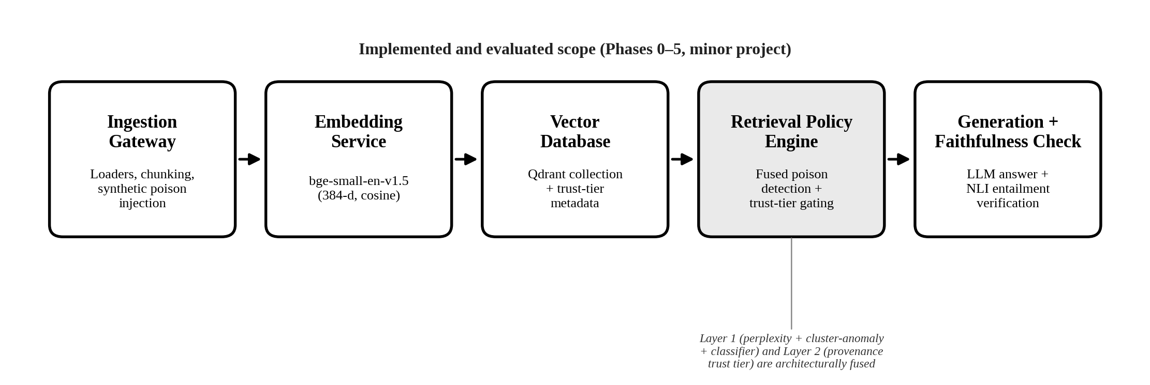
Fig. 1. VeritasRAG system architecture, scoped to the implemented and evaluated Phase 0–5 minor-project pipeline. Verifiable unlearning and the LLMOps dashboard (Phases 6–7) are not part of this figure.

A. Ingestion and Synthetic Poisoned Corpus (Phase 1)
Documents are split with a recursive character text splitter (chunk size 500 characters, 50-character overlap). To construct a controlled evaluation corpus, we sample 150 questions (seed 42) from the Natural Questions re-release distributed as sentence-transformers/natural-questions [2], and generate a synthetic poisoned corpus by injecting PoisonedRAG-style adversarial passages — cycling five template variants — targeting a subset of those questions. The resulting corpus contains 280 chunks: 220 clean and 60 synthetically poisoned (a 21.4% poison ratio), of which 20 queries form a targeted-attack (ASR) evaluation set and a disjoint 106-query set measures retrieval-precision impact without confounding it with the attack itself.
B. Embedding and Vector Database Schema (Phase 2)
Chunks are embedded with BAAI/bge-small-en-v1.5 [9] (384 dimensions, cosine-normalized) and stored in a Qdrant 1.18.0 collection with cosine distance. Every chunk is upserted with a provenance metadata sidecar recording a trust tier (Section III-D); Phase 2 deliberately assigns every ingested chunk the unverified tier rather than copying the ground-truth poison label, so that the Phase 3 detector evaluation is not circular.
C. Poisoning Detection Module (Phase 3)
Four signals are evaluated as poison-likelihood estimators for a chunk: (1) a perplexity score under distilgpt2 [8], on the hypothesis that adversarially generated passages exhibit atypical language-model perplexity relative to naturally occurring text; (2) an embedding-space cluster-anomaly score using k-nearest-neighbor distance (k = 5) and DBSCAN (eps = 0.25, min-samples = 2); (3) a supervised classifier trained and evaluated via 5-fold stratified cross-validation; and (4) a weighted fusion of the three (weights 0.25 / 0.15 / 0.60 respectively) thresholded at 0.5 to produce a single poison_score. A zero-shot LLM-judge baseline is also evaluated for comparison. All signals are compared in Section V-B.
D. Provenance-Gated Retrieval Policy Engine (Phase 4)
At retrieval time, each candidate chunk's fused poison_score is combined with its provenance trust tier — verified, unverified, or quarantined — to decide whether it is passed through, down-weighted, or hard-dropped from the top-k result set before reaching the generator. Each tier carries its own down-weight and hard-drop thresholds on poison_score (Table IV), and a retrieval-frequency anomaly check (z-score threshold 3.0, minimum 20 samples) flags chunks retrieved anomalously often. In the current implementation, poison-score fusion (Phase 3) and trust-tier gating (Phase 4) are deliberately coupled in a single gating decision rather than exposed as independently toggleable layers — a design choice discussed further in Section VI.
E. Generation and Faithfulness Verification (Phase 5)
Gated retrieval results (top-5, with a 3× overfetch factor before gating) are passed to a configurable LLM (OpenAI by default) to generate an answer. Generated answers are split into claims, and each claim is checked for entailment against the retrieved context using a cross-encoder NLI model (cross-encoder/nli-deberta-v3-xsmall) at a 0.5 entailment threshold, producing a faithfulness-precision metric (Section V).
IV. EXPERIMENTAL SETUP
A. Dataset and Corpus Construction
Table I summarizes the evaluation corpus. No fixed train/dev/test split is used; the detector is evaluated via 5-fold cross-validation over the full labeled corpus, and retrieval/generation are evaluated against the full corpus using the query sets described in Section III-A.
TABLE I
Corpus / Dataset Statistics
Field | Value
Total chunks | 280
Clean / poisoned chunks | 220 / 60
Poison ratio | 21.4%
Attack template family | PoisonedRAG-style, 5 variants
ASR query set / precision query set | 20 / 106
Source dataset | Natural Questions [2], 150 Q, seed 42
Chunking | size 500, overlap 50 (chars)
Embedding model | bge-small-en-v1.5, 384-d [9]
Vector DB | Qdrant 1.18.0, cosine distance
B. Evaluation Metrics
We report Attack Success Rate (ASR) at the retrieval level, following PoisonedRAG's convention [3] of counting an attack as successful whenever a target query's poisoned passage(s) are present in the system's top-k result set:
ASR = (1/|Q|) Σ_{q∈Q} 1[∃c∈top-k(q): c∈PoisonChunks(q)] | (1)
and retrieval precision at k, averaged over the query set:
Precision@k = (1/|Q|) Σ_{q∈Q} |top-k(q)∩Relevant(q)| / |top-k(q)| | (2)
Detector performance is reported as precision, recall (= TPR), F1, false-positive rate (FPR = FP/(FP+TN)), and Clean Retention Rate (CRR = 1−FPR). Latency is measured as wall-clock time per pipeline stage, reduced to mean, p50, and p95 over the sampled queries.
C. Implementation Details
All experiments were run single-machine, CPU-only (13th Gen Intel Core i5-1335U, 12 cores, 3.7 GiB RAM, no GPU, Linux/WSL2), using Python 3.14.4, qdrant-client 1.18.0, sentence-transformers 5.6.1, and scikit-learn 1.9.0. The corpus-generation and classifier cross-validation seeds are both fixed at 42 for reproducibility.
V. RESULTS AND DISCUSSION
A. Attack Success Rate Reduction
TABLE II
Main Result — Attack Success Rate Reduction
Configuration | ASR ↓ | Precision@5 ↑
Undefended baseline | 1.000 | 0.345
Defended (Layer 1 + Layer 2) | 0.000 | 0.347
Δ (percentage points) | −100.0 pp | +0.55%
Table II reports the paper's central result. The undefended baseline — retrieval with no poisoning detection or trust-tier gating — is attacked successfully on all 20 targeted queries (ASR = 1.000). With Layers 1 and 2 enabled, ASR falls to 0.000, a 100-percentage-point reduction that clears our pre-registered ≥30-point exit criterion by a wide margin. Retrieval precision@5 on the disjoint 106-query precision set is essentially unaffected by the defense (0.345 undefended vs. 0.347 defended), comfortably inside the <15% relative-loss exit criterion; the small positive delta is within measurement noise. Both exit criteria are therefore met on this benchmark. Because poison-score fusion and trust-tier gating are architecturally coupled in the current policy engine (Section III-D), we cannot yet isolate the individual contribution of detection versus gating; Table II reports the two configurations that are actually measurable today, and we treat independent layer ablation as near-term instrumentation work (Section VI) rather than reporting placeholder numbers.
B. Poison Detector Performance
TABLE III
Poison-Detector Metrics (5-Fold CV / Fused Pipeline)
Method | P | R | F1 | FPR
Perplexity | 0.429 | 0.800 | 0.558 | 0.291
Cluster-anomaly | 0.247 | 0.667 | 0.360 | 0.555
Classifier (CV) | 0.918 | 0.933 | 0.926 | 0.023
Fused pipeline | 0.918 | 0.933 | 0.926 | 0.023
LLM-judge* | 0.968 | 1.000 | 0.984 | 0.009
*LLM-judge row reconstructed from a narrative session log, not a persisted raw-score artifact; treat as provisional pending a logged re-run (Section VI).
Table III compares the four detection signals of Section III-C. Perplexity and cluster-anomaly signals used alone are moderate-recall, low-precision detectors (F1 0.558 and 0.360, respectively); the supervised classifier substantially outperforms both (P = 0.918, R = 0.933, F1 = 0.926 under 5-fold cross-validation), and the fused pipeline's metrics coincide with the classifier-alone numbers at the current fusion weights and 0.5 threshold, consistent with the classifier carrying the dominant 0.60 fusion weight against 0.25 and 0.15 for perplexity and cluster-anomaly, respectively.
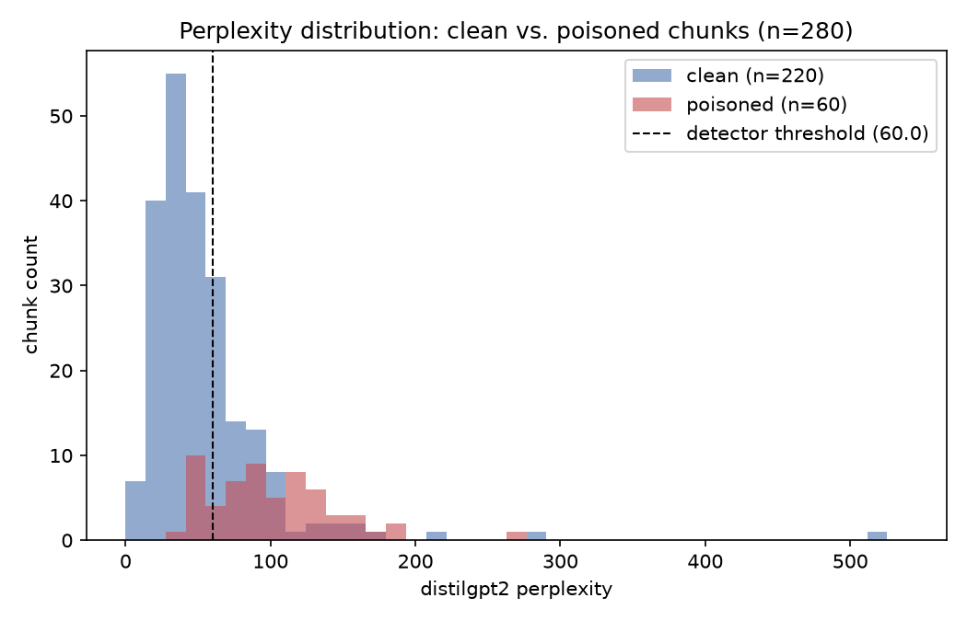
Fig. 2. Distribution of distilgpt2 perplexity, clean vs. poisoned chunks (n=280). Poisoned chunks show higher mean/median perplexity (101.75 / 95.67) than clean chunks (54.24 / 44.87); standalone signal ROC-AUC = 0.844.
Fig. 2 shows the underlying perplexity distributions for clean versus poisoned chunks: poisoned chunks exhibit a visibly higher mean and median perplexity than clean chunks under distilgpt2, giving the perplexity signal alone a standalone ROC-AUC of 0.844. The LLM-judge row is included with an explicit reproducibility caveat: it was reconstructed from a narrative session log rather than a persisted raw-score artifact, and should be re-run and logged before being cited without qualification.

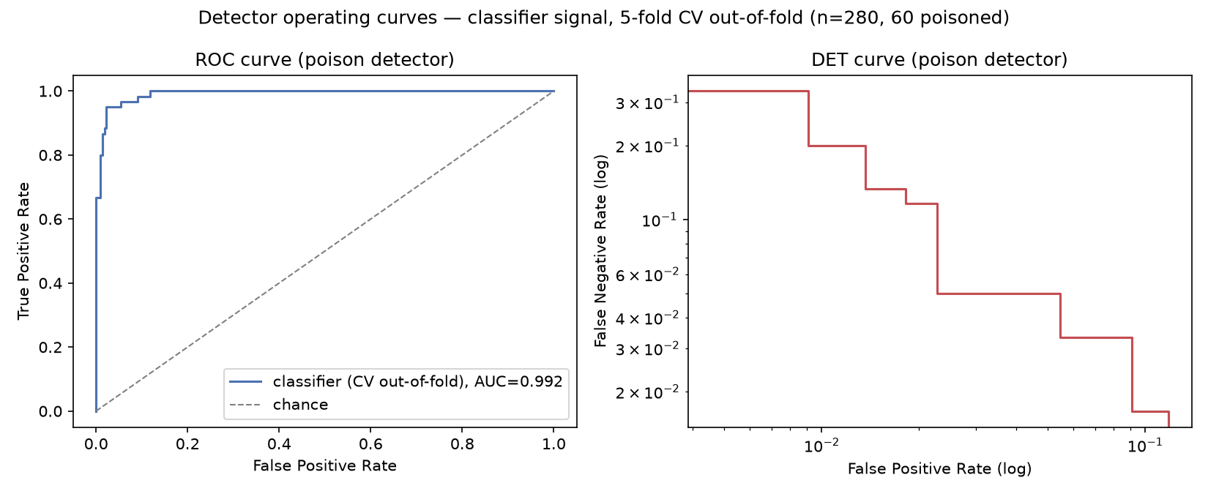
Fig. 3. Fused classifier ROC and DET curves, 5-fold cross-validated out-of-fold probabilities (n=280, 60 poisoned). ROC-AUC = 0.992.

Fig. 3 shows the classifier's ROC and DET curves over 5-fold cross-validated out-of-fold probabilities (ROC-AUC = 0.992), indicating the classifier signal is close to linearly separable on this corpus at this poison ratio.
C. Provenance and Trust-Tier Gating Behavior
TABLE IV
Provenance / Trust-Tier Gating Configuration
Trust tier | Down-wt. thr. | Drop thr. | Chunks
verified | 0.55 | 0.85 | 0 (0%)
unverified | 0.35 | 0.65 | 280 (100%)
quarantined | n/a¹ | n/a¹ | 0 (0%)
¹Categorical drop unless allow_quarantined_tier is enabled.
Table IV lists the three configured trust tiers and their gating thresholds. In the present corpus, every ingested chunk is assigned the unverified tier by construction (Section III-B), so only that tier's thresholds are exercised by real data; the verified and quarantined tiers are implemented and unit-tested but not yet triggered by the evaluation corpus. Under the unverified-tier thresholds, all 20 of 20 poison-target chunks were gated out of the top-k result set — the direct mechanism behind the ASR reduction in Table II — while retrieval precision on the clean-precision query set was unaffected within measurement noise.
D. Latency and Overhead
TABLE V
Latency / Overhead (n=10 Queries)
Stage | Mean (ms) | p50 (ms) | p95 (ms)
Retrieval leg | 9937.8 | 9783.8 | 10932.6
Generation leg | 2907.3 | 2260.7 | 5430.6
End-to-end | 12845.1 | 12478.6 | 15344.7
Table V reports end-to-end and per-leg latency. The retrieval leg (embedding the query, Qdrant search, live detection scoring, and gating) dominates end-to-end latency at a mean of 9.94 s, compared to 2.91 s for the generation leg (LLM call plus NLI faithfulness check). This is consistent with the detection pipeline's current non-batched, per-candidate perplexity scoring, a known optimization target rather than an inherent cost of the approach; batching candidate scoring is planned ahead of the major-project phase. No undefended-baseline latency was logged in this evaluation, so we report absolute rather than relative overhead.
VI. LIMITATIONS AND THREATS TO VALIDITY
Layer coupling. Poison-score fusion (Layer 1) and trust-tier gating (Layer 2) are architecturally coupled in the current policy engine, so Table II cannot yet report their individual contributions in isolation; this requires a new ablation entry point in the evaluation harness.
Single attack family and poison rate. All results reflect one PoisonedRAG-style template family at a single ~21.4% poison ratio; generalization to other attack types or poison rates has not been measured.
Small evaluation samples. The ASR benchmark uses 20 target queries and the latency benchmark uses 10 queries; both are small enough that reported figures should be read as indicative rather than statistically tight estimates.
No answer-accuracy metric. The closest available generation-quality proxy is faithfulness-precision (0.425), which conflates correct abstention with hallucination and is not a substitute for answer-correctness.
LLM-judge reproducibility. The LLM-judge row in Table III was reconstructed from a narrative log rather than a persisted raw-score artifact and should be re-run before being cited without qualification.
Trust tiers not fully exercised. Only the unverified tier is exercised by the current corpus; verified and quarantined tiers are implemented and unit-tested but not validated against real signed/labeled data.
No baseline latency. No undefended-path latency was logged, so per-layer latency overhead could not be isolated; only absolute defended-path latency is reported.
Hardware-specific timing. All latency figures were measured single-machine, CPU-only, and are not necessarily representative of a production GPU-backed deployment.
VII. CONCLUSION AND FUTURE WORK
This paper reported the minor-project phase of VeritasRAG: a synthetic poisoned-corpus construction pipeline, a fused poison-detection module, and a provenance-gated retrieval policy engine, evaluated together with faithfulness-checked generation. On a controlled 280-chunk benchmark derived from Natural Questions, the defended pipeline eliminated all 20 targeted attacks (ASR 1.000→0.000) with no measurable loss in retrieval precision, meeting both pre-registered exit criteria, and the fused detector achieved F1 = 0.926 under cross-validation.
The major-project phase (Phases 6–9) will extend this system with verifiable machine unlearning — issuing a signed deletion receipt for each delete-by-ID request and specifically defending against reconstructible “ghost vector” residue in the vector index [11] — an LLMOps observability dashboard for continuous ASR and latency monitoring, coverage of agentic and multi-tenant RAG deployments, and an explicit compliance mapping to India's Digital Personal Data Protection Act, 2023 [10]. Near-term evaluation work, independent of the major-project scope, includes instrumenting the policy engine to isolate Layer 1 and Layer 2 contributions individually, sweeping poison rate and attack family beyond the single template family evaluated here, batching detection-stage scoring to reduce end-to-end latency, and logging an undefended-baseline latency figure for relative-overhead reporting.
ACKNOWLEDGMENT
The authors used Anthropic Claude and Claude Code as AI-assisted tools for implementation support, evaluation-harness scaffolding, and drafting assistance during manuscript preparation; all experimental results, metrics, and conclusions reported in this paper were derived from committed evaluation artifacts and verified by the authors prior to submission.
REFERENCES
[1] P. Lewis et al., “Retrieval-augmented generation for knowledge-intensive NLP tasks,” in Proc. Adv. Neural Inf. Process. Syst. (NeurIPS), 2020.
[2] T. Kwiatkowski et al., “Natural Questions: A benchmark for question answering research,” Trans. Assoc. Comput. Linguistics, vol. 7, pp. 453–466, 2019.
[3] W. Zou, R. Geng, B. Wang, and J. Jia, “PoisonedRAG: Knowledge corruption attacks to retrieval-augmented generation of large language models,” in Proc. 34th USENIX Security Symp., Seattle, WA, USA, 2025.
[4] H. Zhou et al., “TrustRAG: Enhancing robustness and trustworthiness in RAG,” arXiv:2501.00879, 2025.
[5] X. Tan, H. Luan, M. Luo, X. Sun, P. Chen, and J. Dai, “RevPRAG: Revealing poisoning attacks in retrieval-augmented generation through LLM activation analysis,” in Findings Assoc. Comput. Linguistics: EMNLP, Suzhou, China, 2025, pp. 12999–13011.
[6] B. Zhang, H. Xin, M. Fang, Z. Liu, B. Yi, T. Li, and Z. Liu, “Traceback of poisoning attacks to retrieval-augmented generation,” in Proc. ACM Web Conf. (WWW), Sydney, Australia, 2025, pp. 2085–2097.
[7] P. Kumar, T. Nielson, T. Kolhe, S. Zala, and V. Li, “RAGuard: A layered defense framework for retrieval-augmented generation systems against data poisoning,” arXiv:2607.26339, 2026.
[8] V. Sanh, L. Debut, J. Chaumond, and T. Wolf, “DistilBERT, a distilled version of BERT: Smaller, faster, cheaper and lighter,” arXiv:1910.01108, 2019.
[9] N. Reimers and I. Gurevych, “Sentence-BERT: Sentence embeddings using Siamese BERT-networks,” in Proc. Conf. Empirical Methods Natural Lang. Process. (EMNLP-IJCNLP), 2019, pp. 3982–3992.
[10] Ministry of Electronics and Information Technology, Government of India, “The Digital Personal Data Protection Act, 2023,” 2023.
[11] C. Chakraborttii, J. G. Alvarado, S. Abdulofizova, and S. Dwivedi, “Ghost vectors: Soft-deleted embeddings remain reconstructible in HNSW vector databases,” arXiv:2606.18497, 2026.

