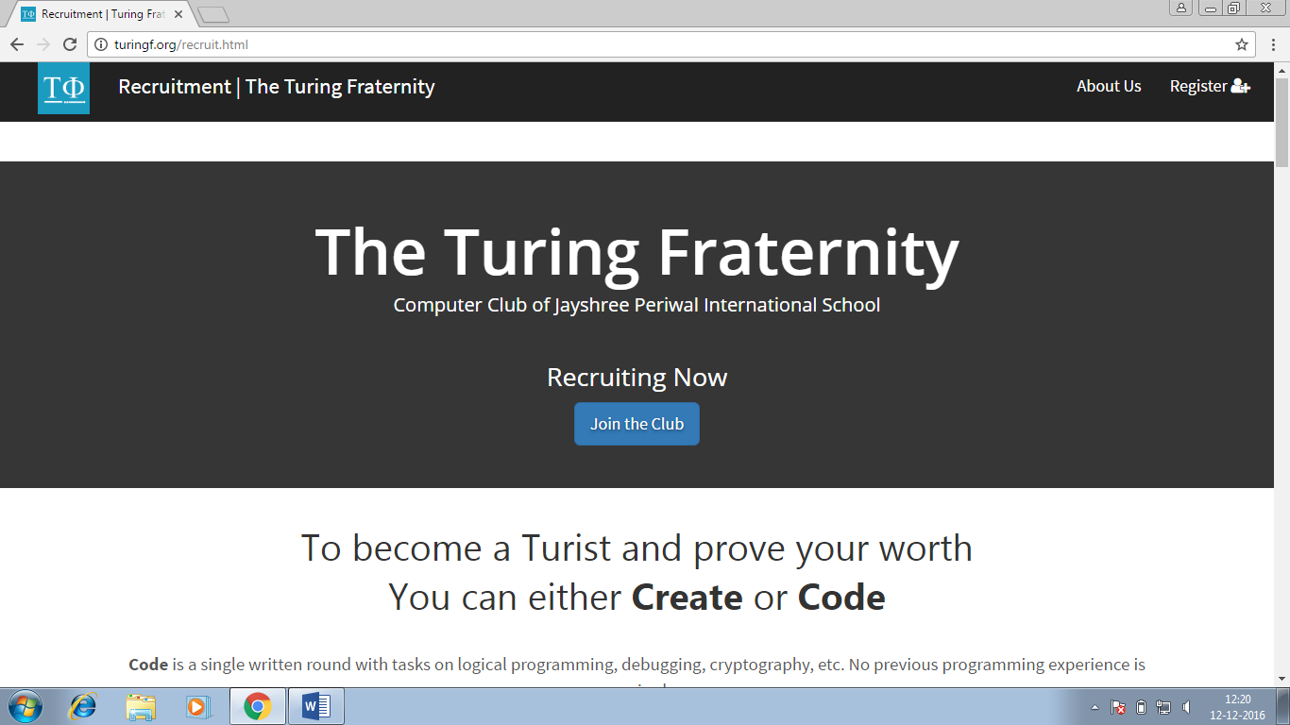

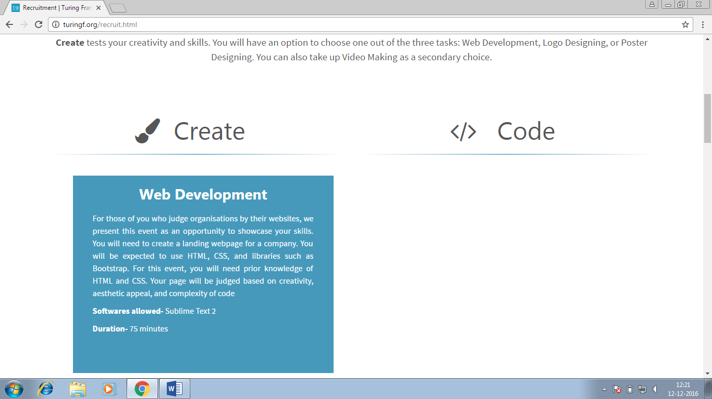

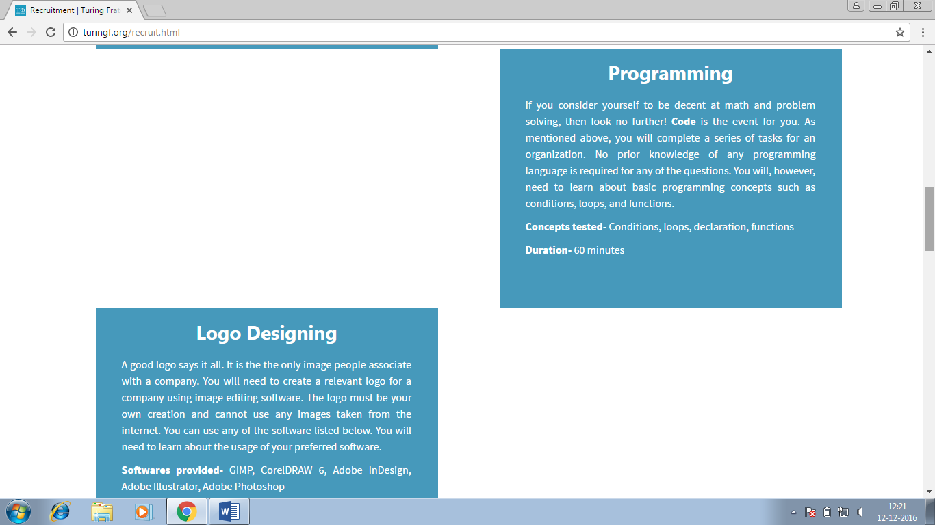

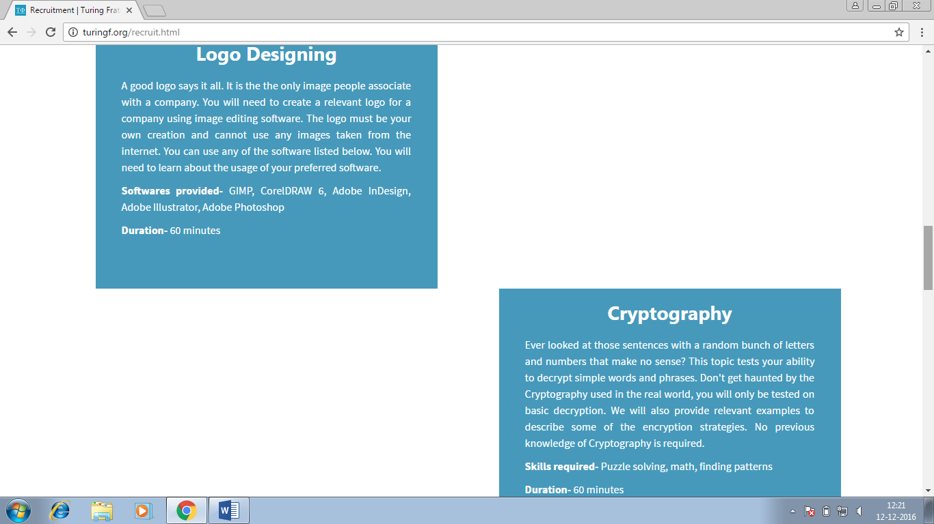

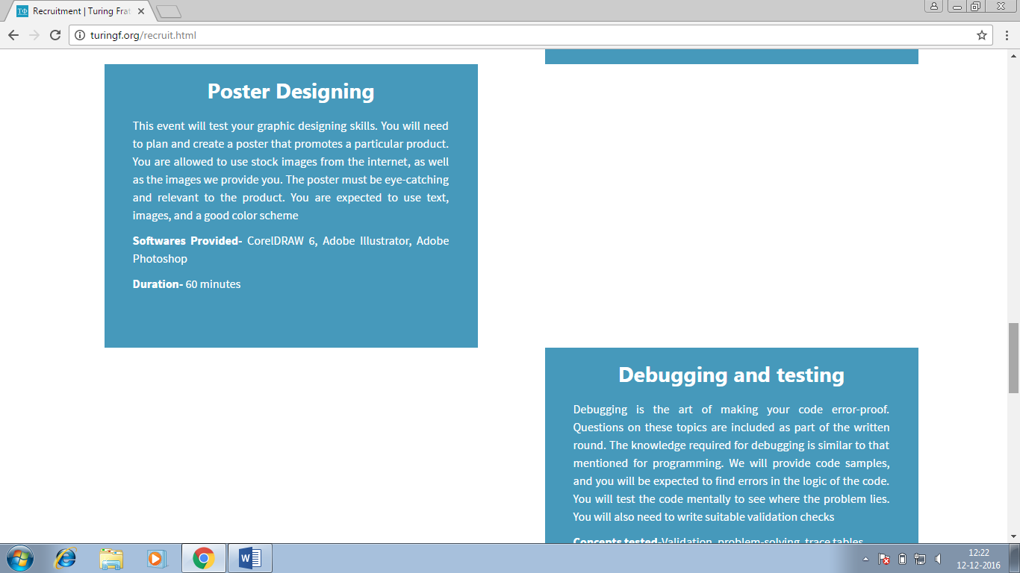

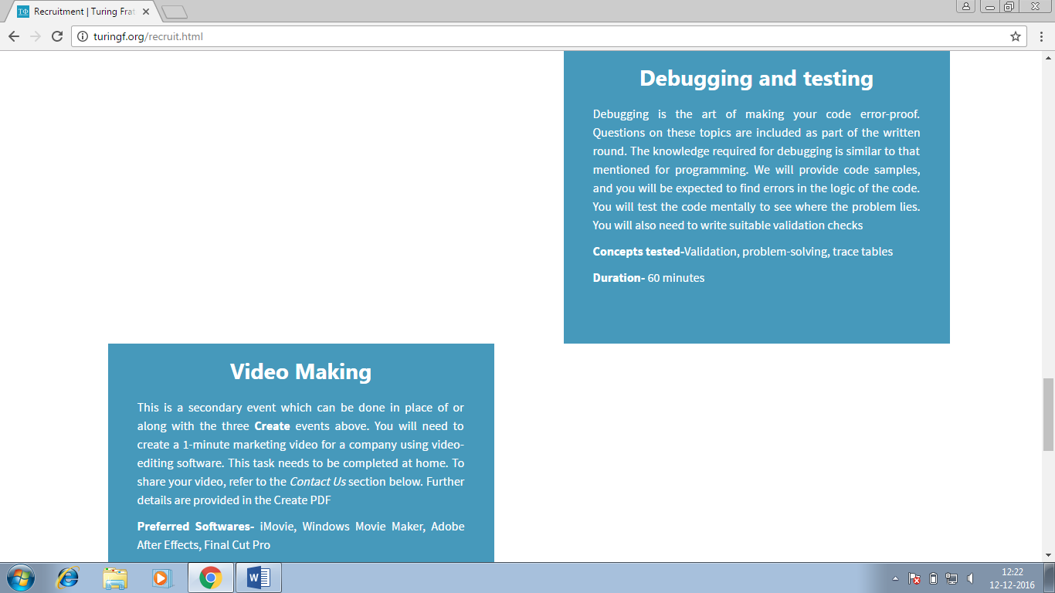

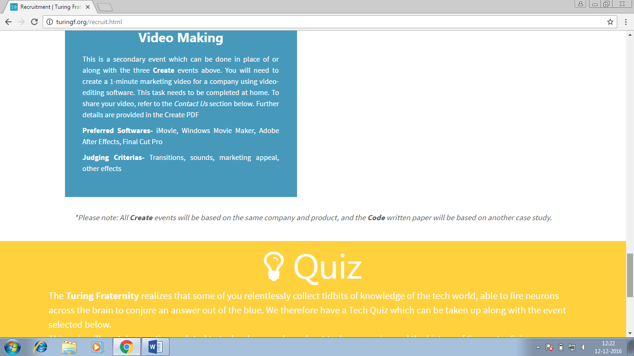

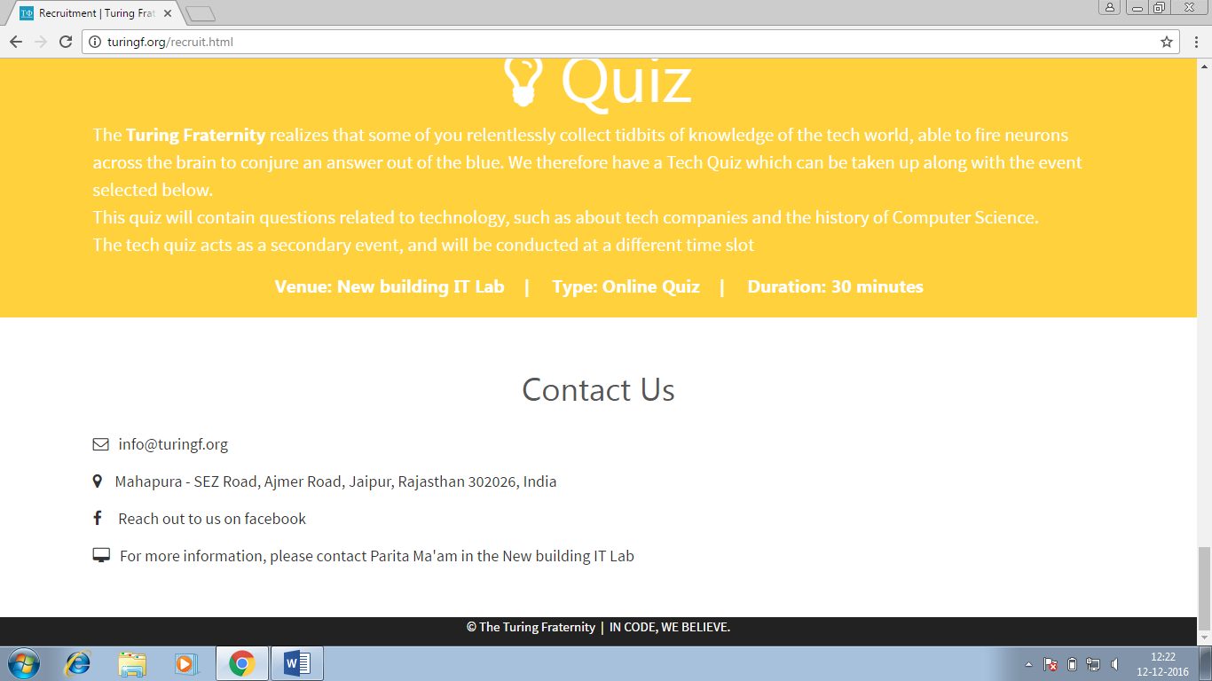

**Web Development**

If you are someone who judges companies by their websites, choose this task. You need to create a landing webpage for a company. You will be using HTML and CSS

**Software provided-** Sublime Text 2

**Duration-**75 minutes

**Programming**

If you consider yourself decent at math and problem solving, then look no further! Code is a written round with logical questions on programming. No prior knowledge of any programming language is required for any of the questions.

**Concepts tested-** Conditions, loops, declaration, functions

**Duration-**60 minutes

**Logo Designing**

A good logo says it all You will need to create a relevant logo for a company using image editing software. You can use any of the software listed below. You will need to learn about the usage of your preferred software.

**Softwares provided-**  CorelDRAW 6, Adobe InDesign, Adobe Illustrator, Adobe Photoshop

**Duration-**60 minutes

**Cryptography**

Ever looked at those sentences with a random bunch of letters and numbers that make no sense? This topic tests your ability to decrypt simple words and phrases No previous knowledge of Cryptography is required.

**Skills required-** Puzzle solving, math, finding patterns

**Duration-**60 minutes

**Poster Designing**

This event will test your graphic designing skills. You will need to plan and create a poster that promotes a particular product. You are expected to use text, images, and a good color scheme

**Softwares Provided-** CorelDRAW 6, Adobe Illustrator, Adobe Photoshop

**Duration-**60 minutes

**Debugging and testing**

Debugging is the art of making your code error-proof. You will need to be familiar . We will be providing code samples, and you will be expected to find errors in the logic of the code.

**Concepts tested-**Validation, problem-solving, trace tables

**Duration-**60 minutes

**Video Making**

This is a secondary event which can be done in place of or along with the three **Create** events above. You will need to create a 1-minute marketing video for a company using video-editing software. This task needs to be completed at home. Further details are provided in the Create PDF

**Preferred Softwares-** iMovie, Windows Movie Maker, Adobe After Effects, Final Cut Pro

**Judging Criterias-**Transitions, sounds, marketing appeal, other effects