Samyam Manandhar

Level 1 Sem 2

TASK 1)   
  
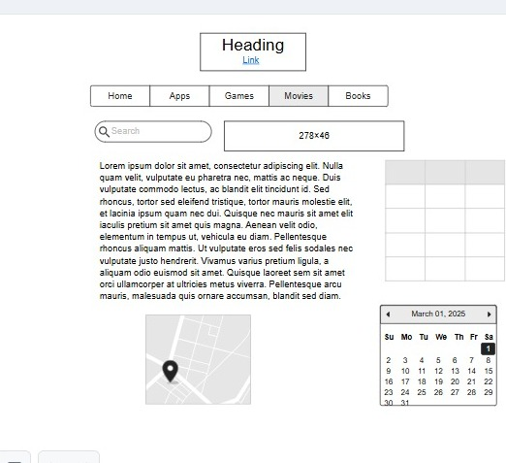

TASK 2)

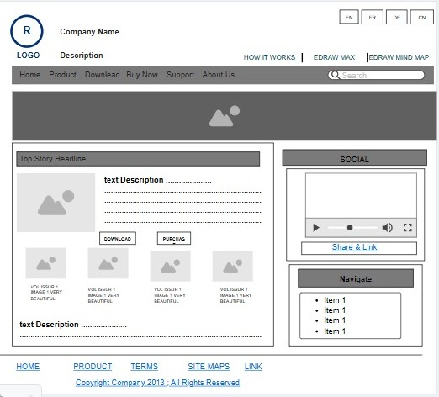

TASK 3)

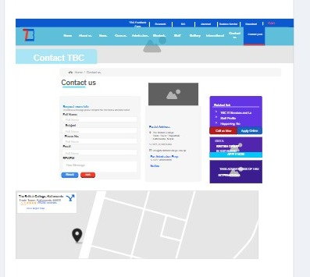

https://app.moqups.com/M9TUacBFXVydIxDYFGRzo5rxryFxKfYU/view/page/abe03d79e