**Sales Analysis**

* **What are the total sales for each product category?**
* **SELECT** product_category, **SUM**(total_bill) **AS** total_sales

**FROM** c

**GROUP BY** product_category

**ORDER BY** total_sales DESC;

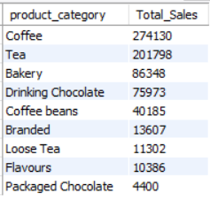

* **Which products are the 5 top sellers?**
* **SELECT** product_id, **SUM**(total_bill) **AS** top_sellers

**FROM** c

**GROUP BY** product_id

**ORDER BY** top_sellers DESC

**LIMIT** 10;

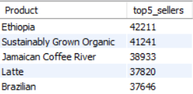

* **How do sales vary by location or store?**
* **SELECT** store_location, **SUM**(total_bill) **AS** total_sales

**FROM** c

**GROUP BY** store_location

**ORDER BY** total_sales **DESC** ;

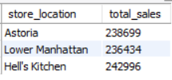

* **Which size was sold the most in the month of June?**
* **SELECT** size, **COUNT**(transaction_id) **AS** most_sold

**FROM** c

**WHERE** month_name = 'June'

**GROUP BY** size

**ORDER BY** most_sold **DESC;**

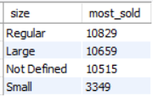

**Trend Analysis**

* **What is the monthly sales trend over time?**
* **SELECT** month_name, **SUM**(Total_Bill) **AS** monthly_sales

**FROM** c

**GROUP BY** month_name

**ORDER BY** **STR_TO_DATE**(month_name, '%M');

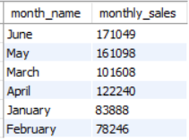

* **What is the highest sales of the month of June by product type?**
* **SELECT** product_type, **SUM**(total_bill) **AS** highest_sales_of_June

**FROM** c

**WHERE** month_name = 'June'

**GROUP BY** Product_type

**ORDER BY** highest_sales_of_june **DESC**

**LIMIT** 1**;**



* **What is the lowest sales of the month of March by Store Location?**
* **SELECT** Store_location, **SUM**(total_bill) **AS** Lowest_sales_of_March

**FROM** c

**WHERE** month_name ='march'

**GROUP BY** store_location

**ORDER BY** Lowest_sales_of_March

**LIMIT** 3;

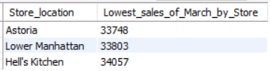

**Customer Analysis**

* **How many customers visit the coffee shop?**

**SELECT COUNT(DISTINCT** transaction_id) **AS** total_customers

**FROM** c;

* **How many customers visit the coffee shop month wise?**

**SELECT** month_name, **COUNT(DISTINCT** transaction_id) **AS** Total_customers

**FROM** c

**GROUP BY** month_name

**ORDER BY** month_name;

**Location Analysis**

* **Which locations or stores have the highest sales?**

**SELECT** store_location, **SUM**(total_bill) **AS** highest_sales

**FROM** c

**GROUP BY** Store_location

**ORDER BY** Highest_sales **DESC**

* **Which locations or store have the hightest sales in the month of June?**

**SELECT** store_location, **SUM**(total_bill) **AS** highest_june_sales

**FROM** c

**WHERE** month_name **= ‘**June’

**GROUP BY** Store_location

**ORDER BY** Highest_june_sales **DESC**

**Additional Analysis**

* **Sales difference between weekdays and weekends?**

**SELECT**

**CASE WHEN** Day of Week IN (0, 6) **THEN** 'Weekend'

**ELSE** 'Weekday'

**END AS** day_type,

**SUM**(Total_Bill) AS total_sales

**FROM** c

**GROUP BY** day_type;

* **What are the peak hours for sales each day?**

**SELECT HOUR**(transaction_time) **AS** hour_of_day, **SUM**(total_bill)

**AS** sales_count

**FROM** c

**GROUP BY** hour_of_day

**ORDER BY** sales_count **DESC**

LIMIT 5;