RESEARCH ARTICLE · SYNTHETIC BENCHMARK

Hypothesis-State Computing Under Causal Shift
A falsification-led study of complex evidence dynamics for synthetic diagnostic reasoning
Samyar Shafiee
Independent Researcher · Toronto, Canada
Research manuscript · v0.1.0 · 13 August 2026
EVIDENCE BOUNDARY · Synthetic experiments only. No patient data, clinical validity, physical quantum computation, or claim of universal model superiority.
26 REGISTERED STUDIES · 20 DATA FIGURES · 9 GENERATED TABLES

Contents
A structured map of the manuscript. Word's Navigation pane uses the same semantic heading hierarchy throughout the document.
01 Abstract | 09 Results
02 Introduction | 10 Ablations
03 Related work | 11 Interpretability and state audit
04 Mathematical framework | 12 Limitations
05 Architecture | 13 Safety and responsible use
06 Training laws | 14 Discussion
07 NeuroWorld | 15 Conclusion
08 Experiments | 16 Extended methods and supplementary results
References follow the supplementary results. Figures and tables are numbered in order of appearance and are generated from registered artifacts.

Abstract
Clinical reasoning is sequential: evidence arrives with sign, absence, timing, and context, while a differential diagnosis should remain revisable until the evidence is sufficient. We investigate whether representing diagnostic hypotheses as an explicitly evolving complex state offers a useful inductive bias for this setting. Q-Neuro maps each observed finding to a low-rank evidence-conditioned operator, composes those operators in observed order, and measures diagnosis probabilities from squared complex amplitudes. The construction is quantum-inspired mathematics implemented on ordinary hardware; it is neither a quantum computer nor a physical model of cognition or disease.
We introduce NeuroWorld, a fully synthetic causal benchmark with chronology twins, factorial disease mechanisms, explicit missingness, unseen generator worlds, irreducible ambiguity, active evidence acquisition, omitted diseases, hidden syndromes, and counterfactual pairs. Across 26 registered studies—25 complete and one preserved failure—we compare Q-Neuro with unordered, recurrent, attention, state-space, associative, graph, real-operator, two-channel real, Hamiltonian-style, dissipative, attractor, tensor, and density-state controls. In a five-world severity sweep at 1,000 training cases, the complex operator exceeds the strongest tested two-channel real control by 0.054–0.063 absolute top-1 accuracy, with world-level 95% intervals above zero. Critical ablations show that noncommutative order, phase-sensitive readout, and observed-negative evidence each contribute to this result.
The same program identifies decisive boundaries. A tuned GRU is substantially more sample-efficient in the source world; a real operator represents irreducible ambiguity far better; source-fitted temperature scaling worsens shifted calibration; hidden-syndrome and omitted-disease separation are not uniquely complex; phase-coded gradient optimization does not improve the frontier; and a velocity-based hard exit collapses to fixed two-step truncation rather than adaptive reasoning. Frozen-state probes recover simulator factors, but conventional recurrent controls recover them as well or better. The principal contribution is therefore not a claim of clinical or quantum advantage. It is a falsification-led, reproducible framework for testing hypothesis-state computation under causal shift, together with a bounded empirical finding: under the tested synthetic worlds, ordered complex dynamics improve robustness while paying measurable costs in calibration, compute, and ambiguity.
Keywords: complex-valued neural networks; diagnostic reasoning; causal simulation; distribution shift; noncommutative operators; uncertainty; reproducible machine learning

Introduction
Many machine-learning systems for diagnosis are trained as static mappings from a completed record to a label. The abstraction is useful, but it removes three features that make diagnostic reasoning difficult. First, evidence is ordered: a deficit followed by recovery is not equivalent to recovery followed by a deficit. Second, negative and missing findings are not interchangeable. Third, several hypotheses may remain live until a late observation changes their relative support. A model can score well on an ordinary held-out set while using the wrong temporal cue, collapsing under a new observation process, or becoming confidently wrong when the evidence is genuinely ambiguous.
Q-Neuro asks a deliberately narrow question: can a diagnosis-indexed state, updated by evidence-conditioned operators and read through interacting amplitudes, provide a useful computational bias for sequential differential diagnosis? The state is complex-valued, but the implementation is conventional PyTorch on a CPU. The word “quantum-inspired” refers only to mathematical motifs—complex amplitudes, noncommuting transformations, Hermitian actions, and density matrices—that already have substantial prior art. It does not imply quantum hardware, biological quantum effects, or a physical measurement process. Complex-valued networks and unitary recurrence are established machine-learning methods [1,2,3], and quantum-probability models have long represented order effects in judgment [5,6].
The scientific risk is obvious. A sufficiently expressive complex model can fit a synthetic benchmark, and a benchmark designed alongside a model can inadvertently reward that model. The project therefore treats every attractive mechanism as a hypothesis to be broken. The sequence begins with an unordered impossibility control, then adds parameter-matched real and two-channel controls, a validation-tuned GRU, multiple unseen generator worlds, ambiguity pairs, held-out compositions, active acquisition, eighteen dynamical laws, critical ablations, frozen probes, unconventional training laws, hard execution measurements, and evidence-level trajectories. The registry preserves superseded and failed runs rather than deleting them.
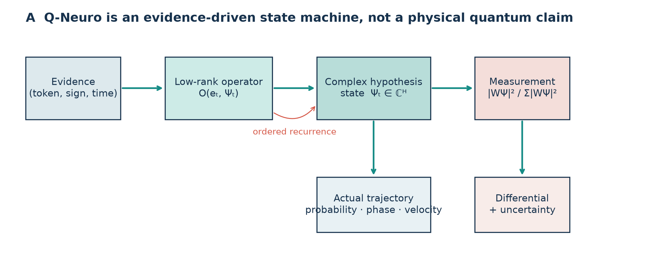
Figure 1 | Q-Neuro represents evidence as an ordered sequence of low-rank operators acting on a diagnosis-oriented complex hypothesis state. Measurement yields a differential, while the actual recurrent trajectory is available for audit. The architecture is a mathematical state machine on ordinary hardware, not a physical quantum claim.
This design makes the central comparison sharper than “complex versus real.” A two-channel real network can store the same number of real scalars as a complex state and can use a paired sum-of-squares readout. A real operator state can preserve order without phase. A Hamiltonian-style model can retain coherent rotation while changing the parameterization. A density factor can guarantee a positive semidefinite, unit-trace diagnostic state. A GRU and a diagonal state-space model can test whether generic recurrence explains the effect. An MLP is intentionally unable to solve chronology twins whose aggregate evidence is identical. These controls turn a visually unusual architecture into a set of falsifiable contrasts.
The strongest positive result is a repeated within-simulator robustness effect. At 1,000 cases, complex dynamics are better than the two-channel real control across five unseen world seeds and four shift severities; the absolute paired advantage is 0.0627 under nuisance shift, 0.0609 under mild shift, 0.0602 under moderate shift, and 0.0538 under severe shift. The intervals use world seed as the replication unit after averaging training seeds. The critical ablation suite further shows that removing order composition, phase-sensitive measurement, or observed-negative evidence degrades the moderate-shift result. Those observations are consistent with a useful interaction among ordered recurrence, signed evidence, and complex measurement.
The negative results are equally important. At 250 source-world cases, the tuned GRU reaches 0.920 top-1 accuracy, compared with 0.774 for the real operator and 0.699 for the complex operator in the stronger-control study. On observationally identical ambiguity twins, the real operator assigns 0.836 probability mass to the two valid labels and obtains 1.148 pair NLL; the complex model assigns only 0.212 mass and obtains 2.581 NLL. Calibration fitted on the source world does not transport to shifted worlds. The hard-halting law saves executed states and latency only by sending every case through exactly two steps. The phase-gradient optimizer is slower than ordinary multi-objective AdamW without improving shifted accuracy. These failures rule out the broader story that complex hypothesis states are uniformly better, intrinsically uncertain, naturally adaptive, or unusually interpretable.
The contribution is best understood as an experimental instrument. NeuroWorld exposes causal chronology, factor structure, missingness, observation noise, and world shifts in a form that allows exact counterfactuals and leakage checks. The registry links each claim to configuration, seeds, environment, metrics, paired analysis, and figures. A claim ledger records supporting and counterevidence; a failure ledger records why plausible mechanisms did not work. The manuscript, tables, figures, dashboard, and Word/PDF artifacts are regenerated from the repository.
We make four bounded contributions. First, we provide a causal synthetic task family for sequential differential reasoning, including counterfactual chronology twins and independently seeded unseen worlds. Second, we implement a broad hypothesis-state comparison spanning conventional and quantum-inspired dynamics under approximately matched parameter budgets. Third, we report a replicated synthetic robustness effect for the complex operator together with ablations that identify necessary components under the tested design. Fourth, we show where the attractive interpretation fails: ambiguity, calibration transport, source-world sample efficiency, optimizer novelty, adaptive depth, and unique interpretability.
No patient data are used. No result establishes diagnostic safety, clinical utility, novelty in the legal or priority sense, or superiority over contemporary medical AI. The phrase “diagnosis” throughout refers to labels in a simulator. The work should be read as a rigorous model-development and hypothesis-testing study whose next scientific step is independent replication on generators not designed by the authors, followed—only if the effect survives—by privacy-preserving evaluation on governed real data.

Related work

Complex and norm-preserving recurrent computation
Complex-valued networks provide native representations of magnitude and phase and require careful treatment of initialization, normalization, and nonlinearities [1]. Unitary and orthogonal recurrent networks use constrained evolution to stabilize long-range dynamics [2,3,4]. Q-Neuro belongs to this broad lineage. Its distinguishing engineering choice is an evidence-indexed low-rank operator acting on a diagnosis-oriented state, followed by a magnitude-squared readout. That combination is useful for controlled testing, but none of its ingredients justifies a claim that complex neural computation is new.
Question-order and causal-judgment models based on quantum probability demonstrate that noncommuting projections can encode order effects without asserting a quantum brain [5,6]. Hidden quantum Markov models similarly evolve a quantum-probabilistic latent state across observations [9]. The present work differs in optimization objective, benchmark, and controls: its operators are discriminatively trained, the hypothesis coordinates map to synthetic diagnoses, and chronology is evaluated with paired cases that differ only by event order. This is a new experimental combination, not a priority claim for noncommutativity.

Density, energy, and continuous state models
Density matrices have represented lexical ambiguity, and more recent quantum-inspired language models combine density evolution with interference-style measurement [7,8]. Q-Neuro’s Diagnostic Density Dynamics therefore cannot be presented as a new law. Its value here is as an invariant-preserving control: the factorization rho = L L† / tr(L L†) guarantees Hermiticity, positive semidefiniteness, and unit trace up to numerical precision. Varying the factor rank tests whether off-diagonal capacity improves ambiguity or shift robustness. It does not.
Hamiltonian neural networks learn conservation-inspired vector fields, neural ordinary differential equations parameterize continuous hidden dynamics, and deep equilibrium models define representations as fixed points [10,11,12]. Modern Hopfield networks recover associative and metastable behavior with contemporary attention-like updates [13]. Q-Neuro includes Hamiltonian-style, dissipative, hybrid, energy-attractor, adaptive-attractor, and associative controls. These implementations intentionally reduce each idea to a tractable CPU experiment; they are not substitutes for the full cited methods.
Diagonal state-space models provide another relevant control because structured recurrence can preserve long histories with favorable compute [14]. The NeuroWorld sequences are short, so this experiment cannot speak to long-context scaling. It can answer a narrower question: whether generic learned state-space recurrence already explains order sensitivity and factor decodability. The answer is often yes for source-world and chronology metrics, but no for the tested moderate-shift robustness frontier.

Adaptive inference, active acquisition, and learning laws
Adaptive Computation Time and early-exit networks learn or select input-dependent computation [15,16]. Q-Neuro first implements a soft ACT-style mixture and then a hard active-index exit based on state velocity. The distinction matters. Soft expected depth is not executed depth when all states are still evaluated. The hard implementation does remove halted cases, but validation selects step two for every example. Its latency reduction is real; its adaptivity claim is false.
Active feature acquisition chooses which observation to request under a budget [17]. NeuroWorld compares random order, a fixed mutual-information ranking, and predictor-conditioned expected information gain. The experiment shows that policy and predictor form a coupled system: the expected-information rule helps the complex model and MLP relative to fixed order, but harms the Transformer. This failure prevents a generic claim that entropy-minimizing queries are better.
For multi-objective training, Projected Conflicting Gradients modifies gradients that oppose one another [18]. Q-Neuro compares ordinary multi-objective AdamW, PCGrad, and a phase-coded rotation in explicit real/imaginary parameter planes. Measured task-gradient cosines are weakly positive, and the phase method does not improve the accuracy–compute frontier. Local learning experiments are interpreted against work showing that alternatives to exact global weight transport can learn useful representations [19,20]. The tested transition-local rule obtains nontrivial performance without a backward call, but remains far below globally trained models.

Uncertainty, distribution shift, and medical diagnosis
Temperature scaling can improve in-distribution calibration, and maximum softmax probability is a standard baseline for misclassification and OOD detection [21,22]. The present study adds an explicit transport test. A temperature fitted only on source validation data worsens moderate-shift ECE for every operator family. Omitted-disease and hidden-syndrome AUROC can be high while ambiguity calibration remains poor, showing that anomaly separation and calibrated differential reasoning are distinct properties.
Clinical diagnostic models have been evaluated on electronic records and large pediatric cohorts [23,24], while tensor methods have also appeared in medical machine learning [25]. Those studies operate on clinical data and clinically meaningful endpoints. NeuroWorld does not. It exists to isolate causal mechanisms without privacy risk and to make counterfactual construction exact. Consequently, high synthetic accuracy cannot be compared numerically with clinical systems, and the model must not be used for patient decisions.

Novelty audit
The literature review was primary-source-led but not systematic. It covered official proceedings, publisher pages, and archival records across complex networks, quantum cognition, density models, dynamical systems, adaptive compute, active acquisition, local learning, calibration, OOD detection, and diagnostic modeling. It did not include dual screening, patent literature, every thesis, non-English sources, or unpublished industrial work. “No exact match located” would not establish priority even if true.
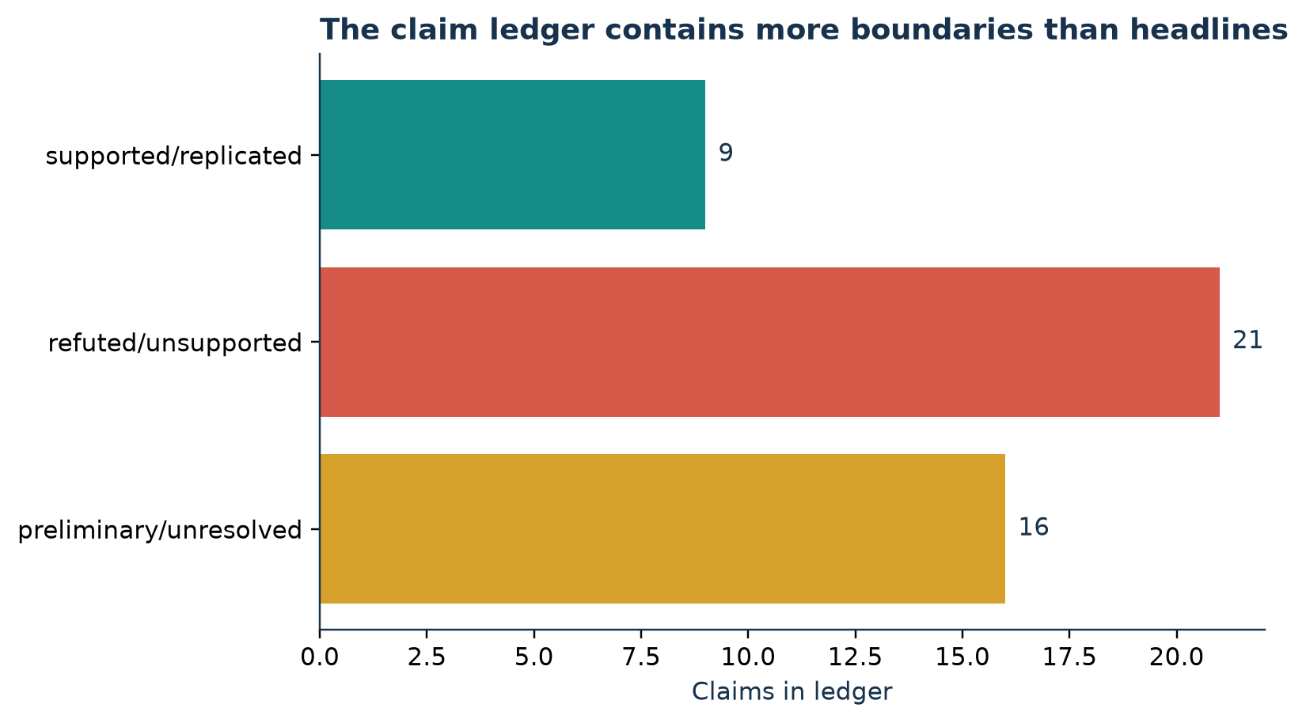
Figure 2 | The internal claim ledger contains substantially more refuted, unsupported, preliminary, or unresolved statements than supported statements. This asymmetry is intentional: the repository records boundaries rather than deleting them.
The defensible novelty is therefore the evidence package: one registry connects chronology, unseen-world robustness, ambiguity, active acquisition, hidden syndromes, dynamical laws, critical ablations, probes, training laws, executed compute, and trajectories. The potentially closest-to-new mechanism, phase-gradient rotation, carries low novelty confidence and no performance advantage. This manuscript makes no first-in-literature claim. Independent peer review and a formal systematic search would be required before stronger novelty language.

Mathematical framework

Problem definition
Let a case be a sequence x = ((e1, s1, t1), …, (eT, sT, tT), c), where et identifies a finding, st records observed-positive or observed-negative sign, tt is a normalized time, and c contains demographic context. Missing findings do not appear in the sequence. The target y belongs to D synthetic diagnostic classes. A model returns a categorical differential p(y | x), optional intermediate states, and—when enabled—query or halt decisions. The core causal test constructs twin cases xAB and xBA with identical multisets of observations and contexts but reversed order for two chronology-defining markers.
An unordered predictor receives a signed vector with explicit missingness channels. It has no information that distinguishes xAB from xBA and therefore cannot solve both twins above chance without leakage. An ordered predictor receives the evidence tokens and timestamps. Counterfactual pair accuracy requires both members of a twin pair to be correct, making it stricter than ordinary case accuracy. This provides an impossibility-style control for chronology rather than a generic benchmark advantage.

Complex hypothesis state
Q-Neuro maintains zt in C^H. Each evidence token selects a learned diagonal term de, low-rank factors Le and Re, and injection be. A residual update is
zₜ₊₁ = N_C[zₜ + b(eₜ,t,c) + dₑₜ ⊙ zₜ + Lₑₜ(Rₑₜᴴzₜ)]
where NC denotes norm control and padding tokens leave the state unchanged. The low-rank form avoids materializing an H by H matrix for every evidence type. Operator composition is generally noncommutative: Oa(Ob(z)) need not equal Ob(Oa(z)). The model can therefore distinguish chronology twins even when their aggregate signed features are identical.
A complex readout W produces amplitudes ad = wdᴴ zT and diagnosis probabilities
p(d ∣ x) = ∣a_d∣² / Σⱼ∣a_j∣²
This measurement is a learned normalized classifier. It is not a physical Born measurement. Its inductive bias differs from an unconstrained linear softmax because real and imaginary components interact through squared magnitude, allowing constructive and destructive readout effects. A trained model’s dependence on phase is tested by setting relative phase to zero or random values at evaluation; functional dependence does not by itself establish comparative benefit.

Matched real controls
The ordinary real operator replaces complex vectors and conjugate products with real-valued counterparts while retaining sequential evidence-conditioned low-rank updates. It tests whether operator order alone explains performance. The two-channel real control stores paired real channels and uses a sum-of-squares measurement. It approximately matches the real scalar budget and output nonlinearity of the complex model while removing complex multiplication and conjugation. This is a stronger control than comparing against an MLP, but it is not an exhaustive real reparameterization theorem.
The commutative accumulator removes composition entirely:
z = N_C[z₀ + Σₜb(eₜ) + W_c c]
Because addition commutes, chronology is absent by construction. The phase-insensitive readout retains complex evolution but replaces the inner product with a constructive magnitude sum. The negative-evidence ablation removes observed-negative tokens while keeping missingness and observation rates unchanged. Together these interventions test order, measurement, and signed evidence separately.

Hamiltonian and dissipative dynamics
For a Hermitian low-rank evidence action He, the Hamiltonian-style update is
z′ = N_C[z + Δt(bₑ − iHₑz − softplus(γₑ) ⊙ z)]
Pure Hamiltonian, pure dissipative, and hybrid variants remove terms before training while preserving injection and readout. The normalization limits numerical drift under explicit discretization; it is not an exact unitary integrator. “Hamiltonian” and “dissipative” describe parameterizations, not physical claims. A useful comparison must therefore ask whether the coherent term changes held-out behavior relative to matched controls, not whether the state has visually rotating trajectories.

Diagnostic density dynamics
Diagnostic Density Dynamics represents a rank-K factor L in C^(D×K) and constructs
ρ = LLᴴ / tr(LLᴴ)
The measured differential is diag(rho). Evidence-specific Hermitian action, damping, and injection update L before renormalization. The factorization enforces valid-state invariants, but it does not make off-diagonal coherence predictive. The experiment varies K = 1, 2, and 4. If additional relational capacity matters, rank should improve ambiguity or robustness under a matched objective. The observed rank sweep does not show that pattern.

Attractors and inference time
Energy-attractor models maintain a real state h and disease prototypes ad. Soft assignment q(d) is proportional to exp(−||h−ad||²/T), and the state moves toward a mixture of prototypes plus evidence force. An ACT-style head observes velocity, entropy, and the top-two margin to allocate soft weights across steps. Because the complete trajectory must be evaluated before mixing, soft expected depth is only a diagnostic.
The hard follow-up maintains an active index set. At step t, a case exits when t is at least a declared minimum and normalized state velocity falls below a threshold selected on source validation data subject to accuracy and NLL tolerances. Halted cases are removed from later operator calls. The sum of per-case steps is therefore executed computation. Case-dependent reasoning would require a non-degenerate halt distribution associated with difficulty. If every example exits at the same step, the result is fixed truncation even if the code supports adaptivity.

Observables and trajectory quantities
The true recurrent path z0,…,zT supports diagnosis amplitudes, probabilities, entropy, state velocity, and normalized path length. For a chronology pair, state distance at matched step t measures how far reversed evidence order separates the computation. A contradiction drop is defined before analysis as an observed-negative step that lowers true-label probability by more than 0.05. Revival occurs only if a later step returns to the pre-drop probability. These operational definitions prevent visual anecdotes from becoming post hoc mechanisms.
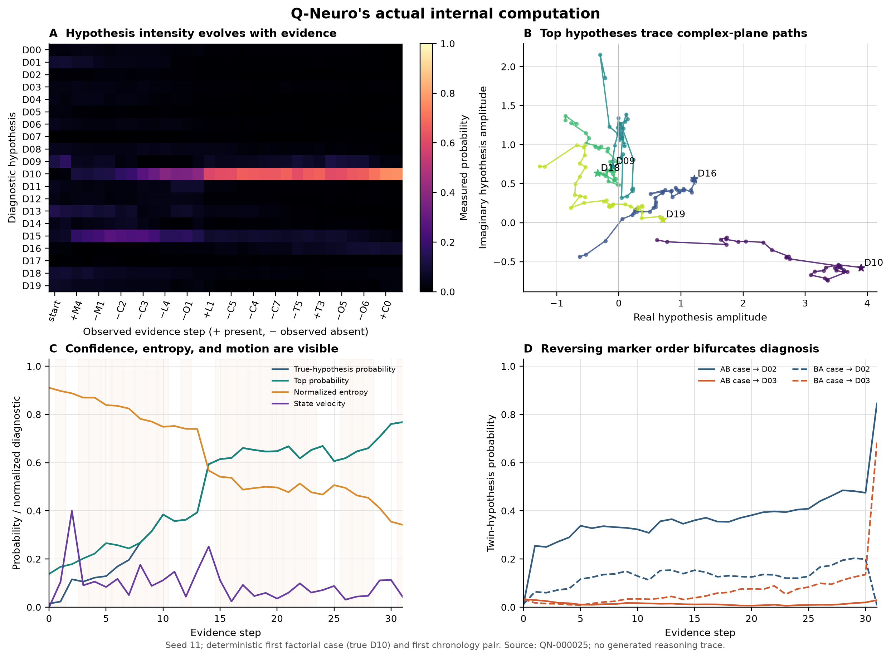
Figure 3 | Actual complex-operator trajectories expose changes in probability, entropy, velocity, and paired-state separation across evidence. The plotted path is not a fitted explanatory projection.
Frozen linear probes test whether mechanism, localization, temporality, and context can be decoded from a final state. Complex states also admit Hermitian quadratic probes. High probe accuracy establishes accessibility to that probe family, not disentanglement, causal use, or human interpretability. Comparing probes across conventional and complex states is essential because the simulator’s factors are broadly predictive.

Statistical estimands
Most model-level summaries average three training seeds. Paired differences reuse the same data and initialization seeds. Unseen-world intervals first average training seeds within each world and then treat world seed as the replication unit, avoiding case-level pseudoreplication. The repository reports arithmetic means, sample standard deviations, and two-sided Student-t 95% intervals. With three seeds, these intervals are descriptive and low-powered; the smallest two-sided exact sign-flip p-value is 0.25. Consequently, the manuscript uses “replicated within NeuroWorld” for world-level consistency and avoids population-level significance claims.
The primary metrics are top-1 and top-3 accuracy, counterfactual pair accuracy, negative log-likelihood, expected calibration error, OOD AUROC, parameter count, CPU training time, process RSS, executed state count, and per-case latency. Pareto status is evaluated over several objectives rather than a single accuracy number. An architecture that improves shifted ranking while degrading calibration, ambiguity, or runtime is reported as a tradeoff, not a winner.

Architecture

Evidence representation
NeuroWorld emits 40 binary findings, demographic context, explicit observation masks, and an observed sequence. A positive observation and a negative observation use distinct token identities; a missing finding supplies no token. Each token carries normalized time and may be accompanied by a context-conditioned injection. This representation prevents the common leakage-prone shortcut of coding “not observed” as “observed absent.” Unordered baselines receive the same information content through separate positive, negative, and missing channels, but not the chronology needed to solve order twins.
The complex operator state uses a learned initial vector, evidence embeddings, evidence-specific diagonal actions, and factorized low-rank transformations. Low-rank factors keep the parameter count near 20,000 real scalars, comparable to the small baselines. The real operator uses the same sequence interface. The two-channel real model receives paired state channels and a quadratic readout so that extra width and squared measurement are not mistaken for a uniquely complex effect.

Conventional controls
The comparison suite includes logistic regression, an unordered MLP, a tiny Transformer, a validation-tuned GRU, and a diagonal state-space model. Logistic regression and the MLP establish performance available from aggregated evidence. The Transformer tests attention over observed order at a similar scale. The GRU supplies a strong recurrent inductive bias and is tuned only on source validation NLL. The diagonal state-space model tests compact linear recurrence with learned input and nonlinear readout.
The full-data chronology task saturates for all ordered controls, so it is treated as a correctness check. The low-data and shifted worlds carry the architectural comparison. This distinction was introduced after the original baseline set proved too weak: the tuned GRU reverses the apparent source-world sample-efficiency advantage of the operator models, while becoming fragile under generator shift. Preserving that reversal is central to the architecture story.

Mechanism families
Eighteen laws are evaluated in the broad mechanism suite. In addition to the conventional and operator models, these include a complex MLP, modern-Hopfield-style retrieval, a declared factor-graph network, a multiplicative coupled-tensor model, energy and adaptive attractors, Hamiltonian-style evolution, elementwise dissipation, their hybrid, and low-rank density dynamics. The graph control uses the simulator’s coarse factor grouping but not label-specific causal probabilities; its poor result warns that broad causal alignment is not equivalent to learning the generator.
Associative and attractor models intentionally sum or pool evidence before iterative inference, so failure on chronology pairs is expected. That failure is useful: it verifies that the counterfactual task reacts to an architectural invariance rather than merely rewarding model size. Hamiltonian and complex operator laws retain order. Density dynamics also retain a sequential state, but its diagnosis-space factorization and diagonal measurement create a different ambiguity–robustness compromise.
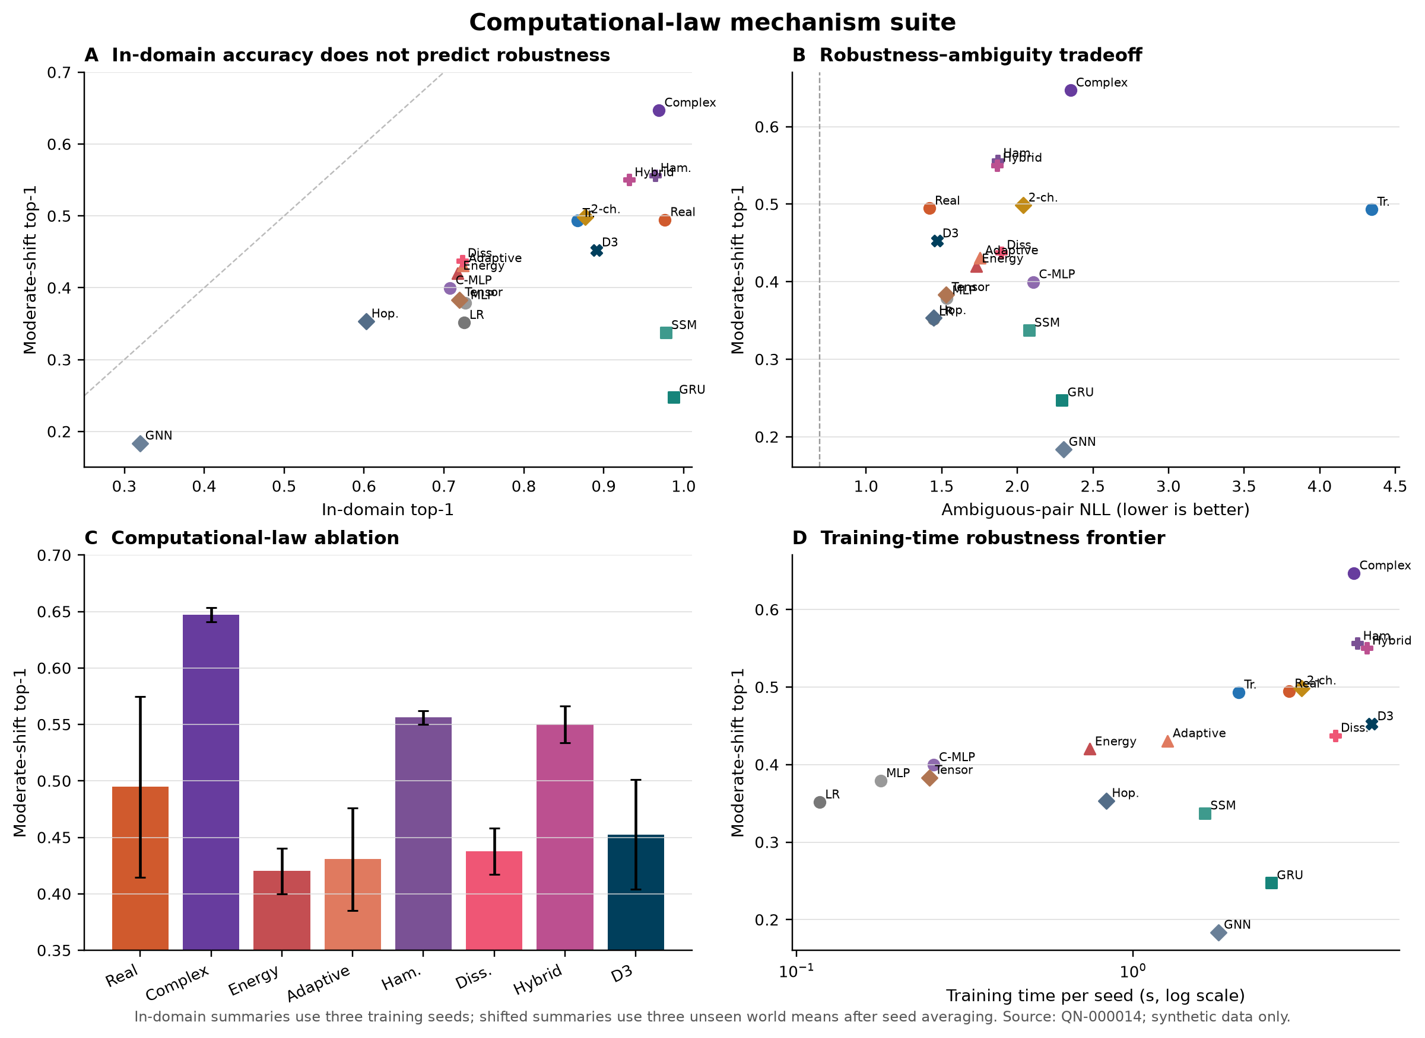
Figure 4 | Eighteen computational laws occupy different positions in source accuracy, unseen-world robustness, ambiguity, and chronology-pair performance. No single family dominates every objective.

Parameter and compute matching
Most neural architectures are configured near 20,000 trainable real scalars. Complex parameters count as two real scalars. Some controls are smaller by design: logistic regression has 1,660 parameters, while the density model is approximately 16,240. Parameter matching does not imply compute matching. Complex multiplication and evidence-specific operators are slower than the MLP and often slower than the real control on CPU. Training time, process memory, and inference latency are therefore measured separately.
Peak RSS values are interpreted cautiously because sequential in-process runs can reuse allocator caches. Wall-clock times are machine-specific and only compare runs on the same hardware and code path. The public artifacts include environment and configuration records so that external replication can distinguish algorithmic trends from one-machine timing.

Architectural invariants
Unit tests and experiment-time checks enforce that padding does not evolve a state, complex probabilities are finite and normalized, state norms remain bounded, counterfactual pairs differ only in the declared causal factor, and density matrices are Hermitian, positive semidefinite, and unit trace within tolerance. A synthetic nonzero-commutator test confirms that swapping two learned operators can change state. These checks validate implementation properties; they do not show that the learned noncommutativity is causally responsible for every performance difference.

Architecture selection after falsification
The most defensible architectural object at the end of the study is the simple complex operator, not the most elaborate dynamical proposal. Pure Hamiltonian evolution is competitive under shift, but remains below the complex operator. Adding generic dissipation does not help. Increasing density rank does not help. The adaptive attractor does not produce meaningful case-dependent depth. The coupled tensor and graph controls do not approach the robustness frontier. This result argues for retaining the smallest law that survives the declared ablations while treating more ornate mechanisms as negative evidence.
The selected architecture should still not be called “the best model.” The GRU is better at extreme source-world sample efficiency, the real operator is much better on irreducible ambiguity, and several conventional states support stronger linear factor probes. Q-Neuro’s value is conditional: within the tested synthetic family, it combines high chronology accuracy with the strongest moderate-shift top-1 result. Its costs remain visible in every summary.

Training laws

Global optimization
The reference training law is AdamW on diagnosis cross-entropy. Data splits, training seeds, batch sizes, epoch budgets, and learning rates are configuration-controlled and written to the experiment artifact. Model selection uses source validation data only. Shifted worlds, ambiguity twins, omitted diagnoses, and hidden syndromes are never used for optimizer or hyperparameter selection. The training-law suite fixes the complex architecture and changes only how updates are constructed.
Ordinary SGD is included as an optimizer control. Gradient accumulation changes the number of optimizer steps while preserving the effective batch. Multi-objective AdamW adds mechanism and localization losses only where those factor labels are defined. PCGrad supplies a direct established control for modifying conflicting task gradients [18]. All auxiliary heads are discarded at deployment, and both training and deployment parameter counts are recorded.

Phase Gradient Optimization
Phase Gradient Optimization begins with the cosine ck between the diagnosis gradient g0 and an auxiliary gradient gk. It maps ck to an angle phik = 0.5 arccos(ck). For each explicit real/imaginary parameter pair, the two real gradients form a complex update and each task contribution is rotated before averaging. Agreement stays aligned; full opposition moves the auxiliary contribution into quadrature instead of allowing direct cancellation.
G = (1/K) Σₖ exp(iφₖ)Gₖ, φₖ = ½ arccos(cₖ)
This law was worth testing because it makes a falsifiable prediction: if auxiliary gradients conflict and phase rotation preserves complementary information, it should improve shifted accuracy or the multi-objective Pareto frontier relative to ordinary averaging and PCGrad. The observed gradient cosines are weakly positive. Multi-objective AdamW and PCGrad both reach 0.635 shifted top-1, while phase rotation reaches 0.633 and roughly doubles training time relative to diagnosis-only AdamW. The mechanism is therefore solving little measured conflict and does not earn a performance claim.

Transition-local plasticity
The local rule assigns each diagnosis a fixed normalized complex prototype. At an evidence transition, a locally available prototype error updates the token injection and low-rank factors from pre- and post-state terms. Updates are averaged over active tokens and norm-clipped. The implementation deliberately builds no autograd graph and makes no backward call. It is supervised local credit, not a biologically validated synaptic rule.
At 1,000 cases, transition-local plasticity reaches 0.642 source top-1 but only 0.137 shifted top-1 and 0.213 chronology-pair accuracy. This is substantially above the frozen ZeroBackprop construction, yet far below global optimization. The hybrid that performs local pretraining and then AdamW reaches 0.998 source top-1 but only 0.419 shifted top-1, worse than AdamW from scratch. The local stage therefore imprints a source-specific solution rather than providing a benign initialization.
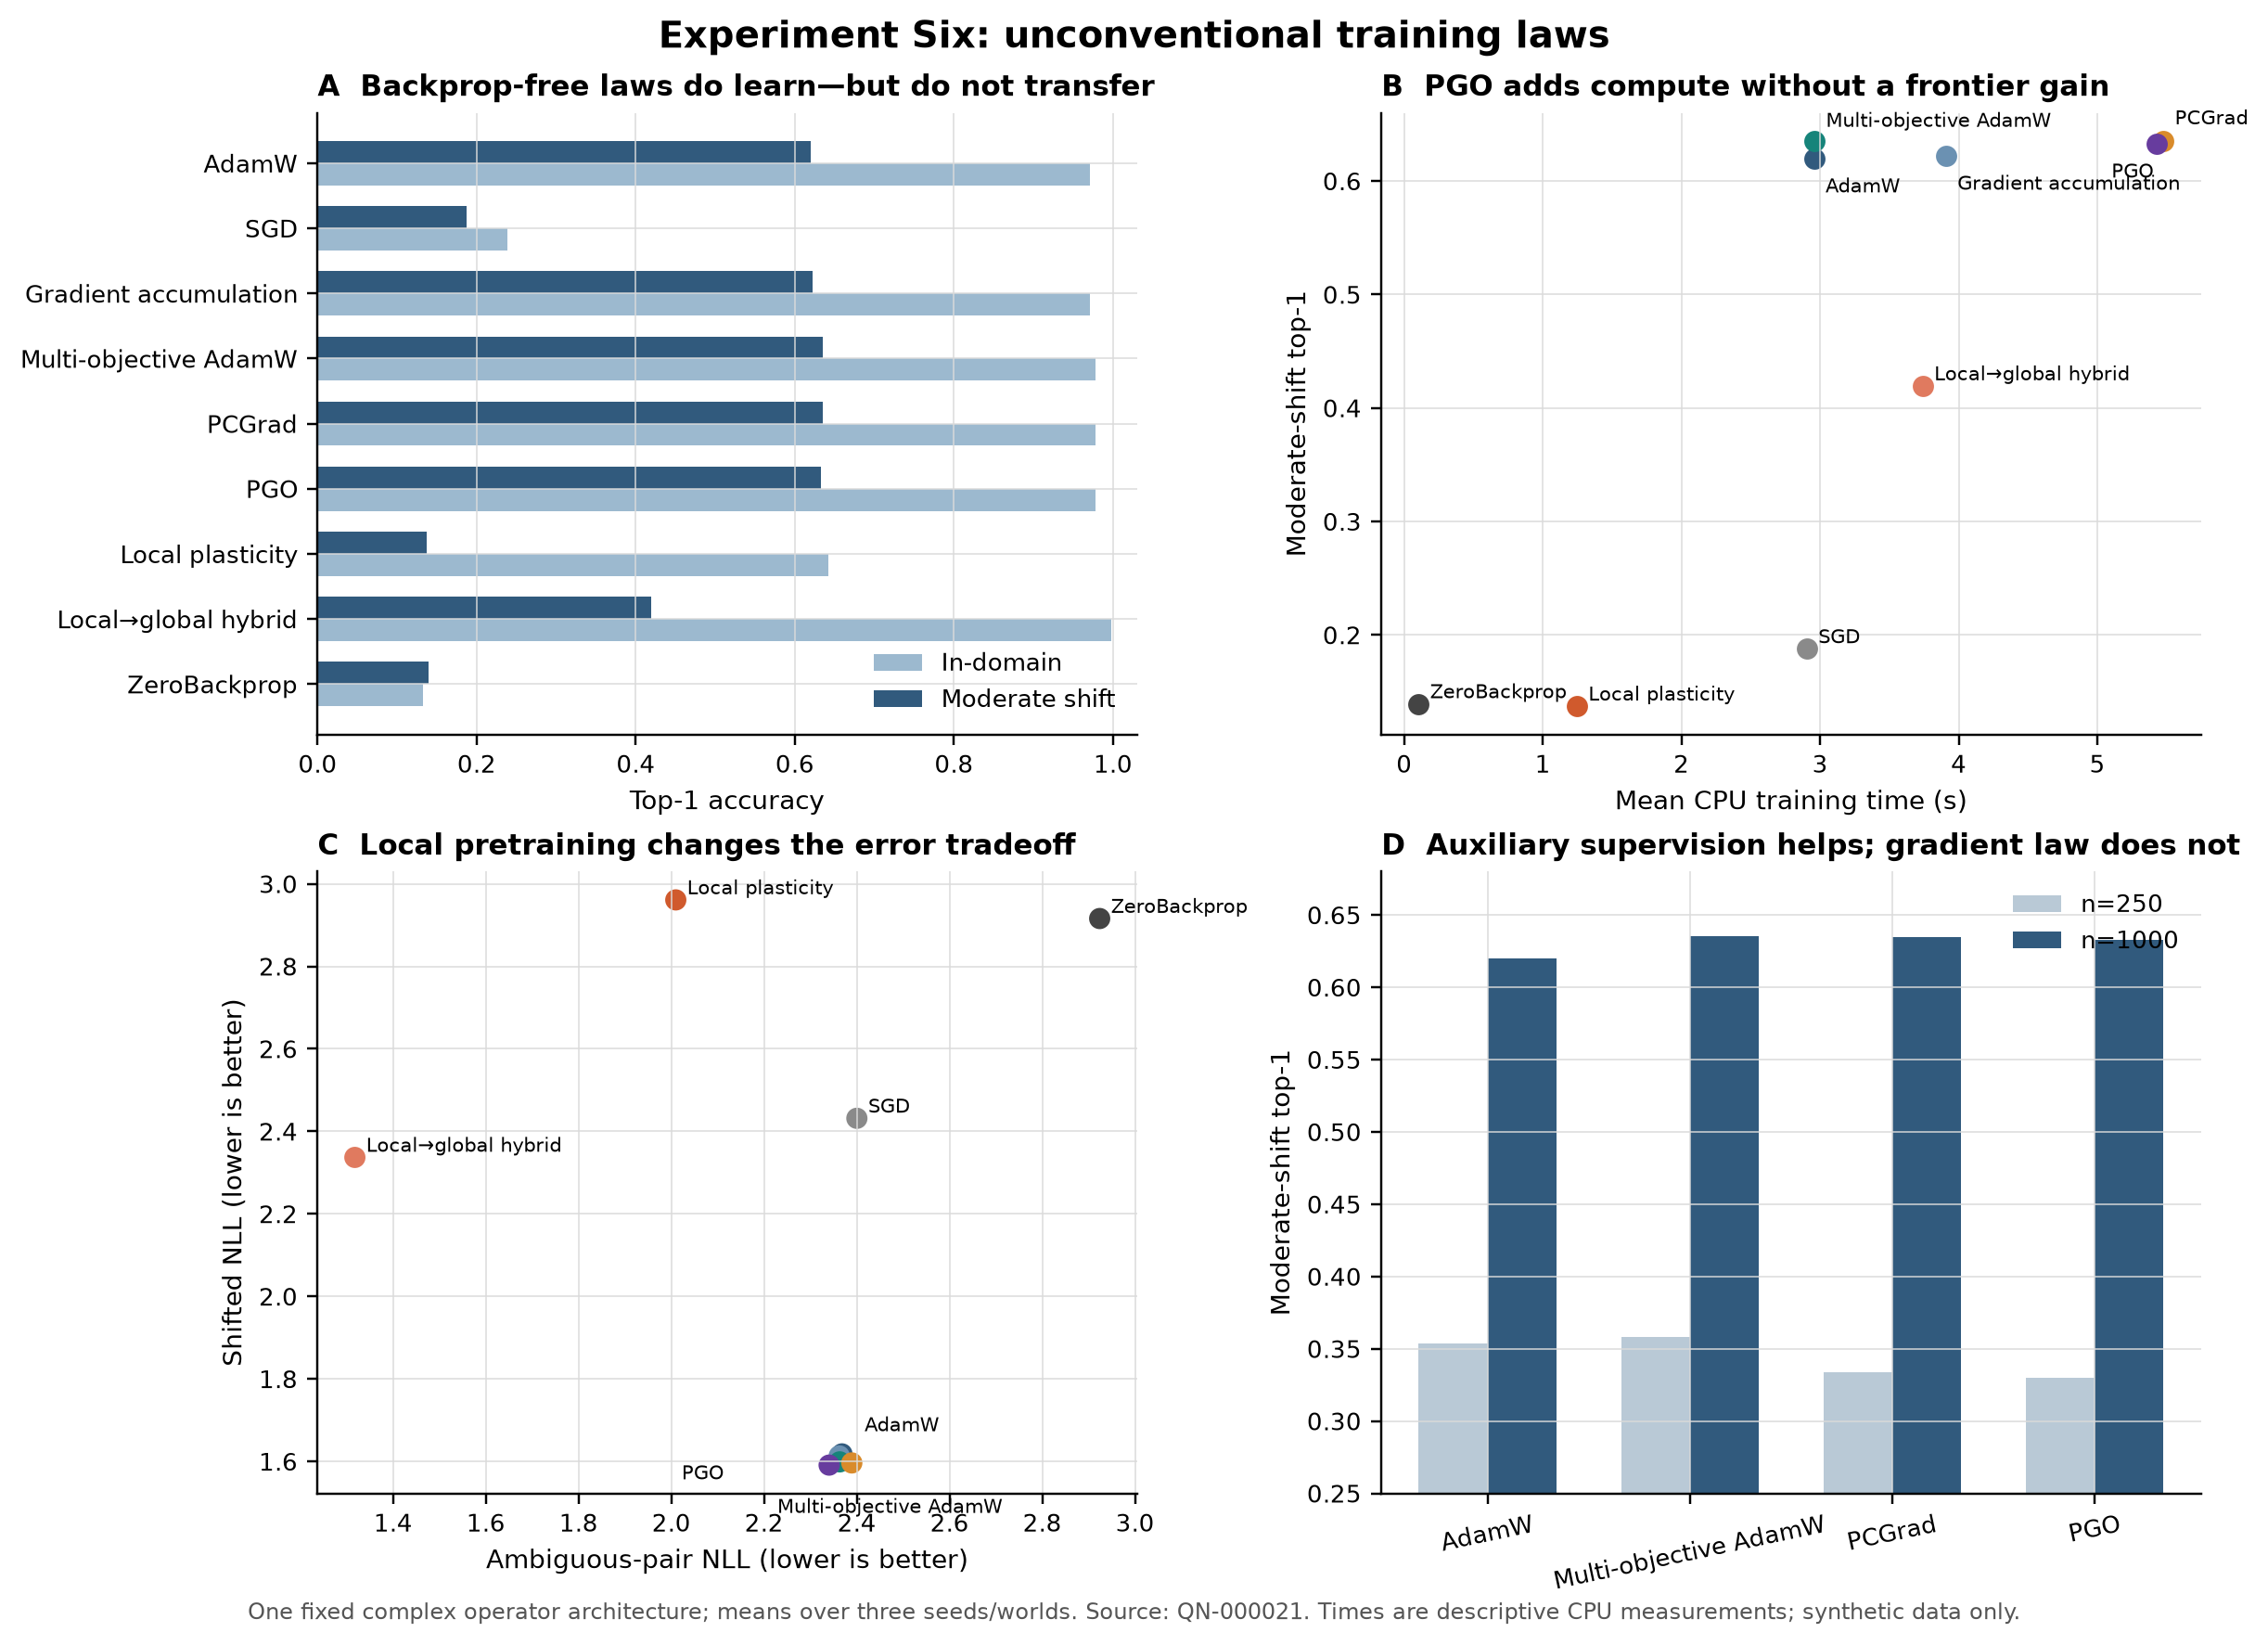
Figure 5 | Unconventional training laws do not create a new accuracy–compute frontier. Multi-objective AdamW and PCGrad slightly improve shifted top-1; phase rotation matches them within noise at higher cost, while local and zero-backprop rules fail strongly under shift.
Table 1 | Training-law comparison for the complex operator at 1,000 cases.
Training law | ID top-1 | Shift top-1 | Ambiguity NLL ↓ | Train s | Reverse-mode calls
AdamW | 0.971 | 0.620 | 2.368 | 2.96 | 120
SGD | 0.238 | 0.188 | 2.400 | 2.91 | 120
Gradient accumulation | 0.971 | 0.622 | 2.362 | 3.91 | 240
Multi-objective AdamW | 0.978 | 0.635 | 2.363 | 2.96 | 120
PCGrad | 0.978 | 0.635 | 2.389 | 5.48 | 360
Phase Gradient Optimization | 0.978 | 0.633 | 2.340 | 5.43 | 360
Transition-local plasticity | 0.642 | 0.137 | 2.010 | 1.25 | 0
Local + global hybrid | 0.998 | 0.419 | 1.317 | 3.74 | 120
ZeroBackprop | 0.133 | 0.139 | 2.924 | 0.11 | 0
Shift top-1 is averaged across the declared unseen worlds; timing is CPU wall time.

Calibration
Raw model probabilities are retained as the primary output. A scalar temperature is fitted by minimizing source validation NLL and then frozen for all shifted evaluations, following the standard calibration setting [21]. This protocol tests transport rather than allowing post hoc access to shifted labels. It fails: under moderate shift, the complex operator’s NLL worsens from 1.459 to 4.341, and ECE increases from 0.204 to 0.257. The same direction occurs for the real and two-channel operators.
The failure is mechanistically plausible. A single source temperature corrects one global sharpness distortion, whereas the evidence distribution and class-conditional confidence geometry both change under causal shift. Magnitude-squared readout may amplify those changes, but the real controls show that the problem is not exclusively complex. Future work requires shift-aware calibration validated without target labels; the current study makes no claim that temperature scaling solves uncertainty.

Hard execution versus soft pondering
The soft attractor learns an expected depth of approximately 5.25 of eight states, but all states are evaluated. The hard follow-up chooses a velocity threshold on source validation and physically removes halted cases from the active batch. Hard inference executes two states instead of eight and reduces in-domain per-case latency from approximately 0.0171 ms for the soft path to 0.00346 ms. Accuracy is essentially unchanged.
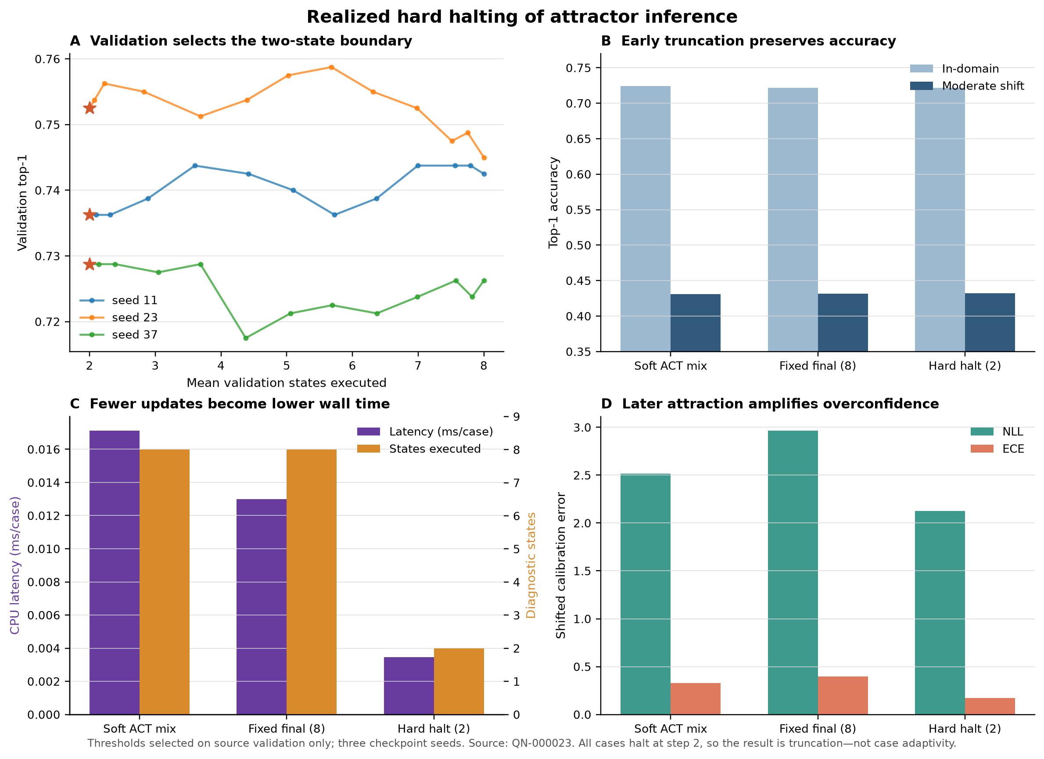
Figure 6 | Hard velocity exit reduces executed states and measured latency, but the halt distribution is degenerate: every case exits at step two. The result is fixed truncation, not adaptive reasoning.
Table 2 | Hard-halting audit of executed states and measured inference latency.
Inference law | ID top-1 | Shift top-1 | Shift NLL | Shift ECE | States | ms/case
Soft ACT | 0.724 | 0.431 | 2.518 | 0.330 | 8.00 | 0.0171
Fixed eight states | 0.722 | 0.431 | 2.965 | 0.396 | 8.00 | 0.0130
Hard velocity exit | 0.722 | 0.432 | 2.127 | 0.172 | 2.00 | 0.0035
The hard exit removes halted examples from subsequent computation; it selected two states for every case.
The same result refutes the motivating adaptive-time claim. No case-dependent compute allocation emerges, and later steps worsen calibration without improving top-1. The correct engineering action is to replace the eight-state attractor with a fixed two-state version on this task. Adaptive inference should be revisited only when difficulty predicts depth and a preregistered validation criterion selects a non-degenerate exit distribution.

NeuroWorld

Causal simulator
NeuroWorld is a synthetic environment for testing diagnostic reasoning mechanisms without patient data. It defines 20 diagnosis archetypes and 40 findings organized around mechanism, localization, temporality, and context. Each diagnosis specifies factor-dependent finding probabilities, demographic tendencies, and an observation process. Cases are sampled from the causal template, then findings are observed, signed, timestamped, and possibly omitted. The generator emits latent factors so that representation probes and exact interventions are possible.
The simulator is not intended to mimic epidemiology, coding practice, or the full complexity of neurology. Disease names are abstract labels and findings are synthetic variables. “Neurological” describes the structure of the reasoning problem—mechanism, localization, time course, context, and differential competition—not clinical fidelity. The benefit is control: chronology, missingness, nuisance evidence, ambiguity, and new syndromes can be manipulated without harming people or leaking protected data.

Chronology twins
Four labels form two chronology-twin pairs. Members of a pair share aggregate evidence and demographics; two marker events occur in opposite order. Standard random cases may hide one or both markers under the observation process. A separate counterfactual set exposes both markers and varies only order. An unordered model should average the twins and obtain zero pair accuracy in expectation, whereas a valid ordered model can solve both.
Unit tests verify that paired records have equal signed evidence multisets, identical non-temporal covariates, and only the declared ordering difference. Complete-order accuracy is reported separately from all-case top-1. This prevents an architecture from receiving credit for predicting easier factorial cases while ignoring chronology.

Factorial diagnoses and held-out composition
The remaining diagnoses combine mechanism, localization, temporality, and context factors. A held-out composition split removes selected positive-finding conjunctions from training and requires one at test time. The task checks whether a model can recombine familiar individual factors. At 3,000 cases it saturates for several architectures and therefore fails as a discriminator. A stronger future version should reduce data and introduce inseparable tensor or XOR-like interactions with parameter-matched multiplicative controls.

Missingness and signed evidence
Observation is generated explicitly rather than imputing every unobserved finding as negative. Positive findings and observed absences are separate tokens; unobserved findings are omitted. Shift worlds can reduce observation rate, add timestamp jitter, mix probabilities toward 0.5, change nuisance findings, and lower the chance that chronology markers appear. The model is therefore tested both when the causal relation is visible and when the observation process obscures it.

Unseen worlds
The initial shift replication uses a nuisance-seed world and a noisy/sparse world. The confirmation suite declares five unseen world seeds at four severities: nuisance, mild, moderate, and severe. The disease-factor scaffolding remains related, but secondary findings, nuisance evidence, probability noise, sparsity, and temporal jitter vary. These are genuine held-out generator instantiations, though not independently designed simulators.
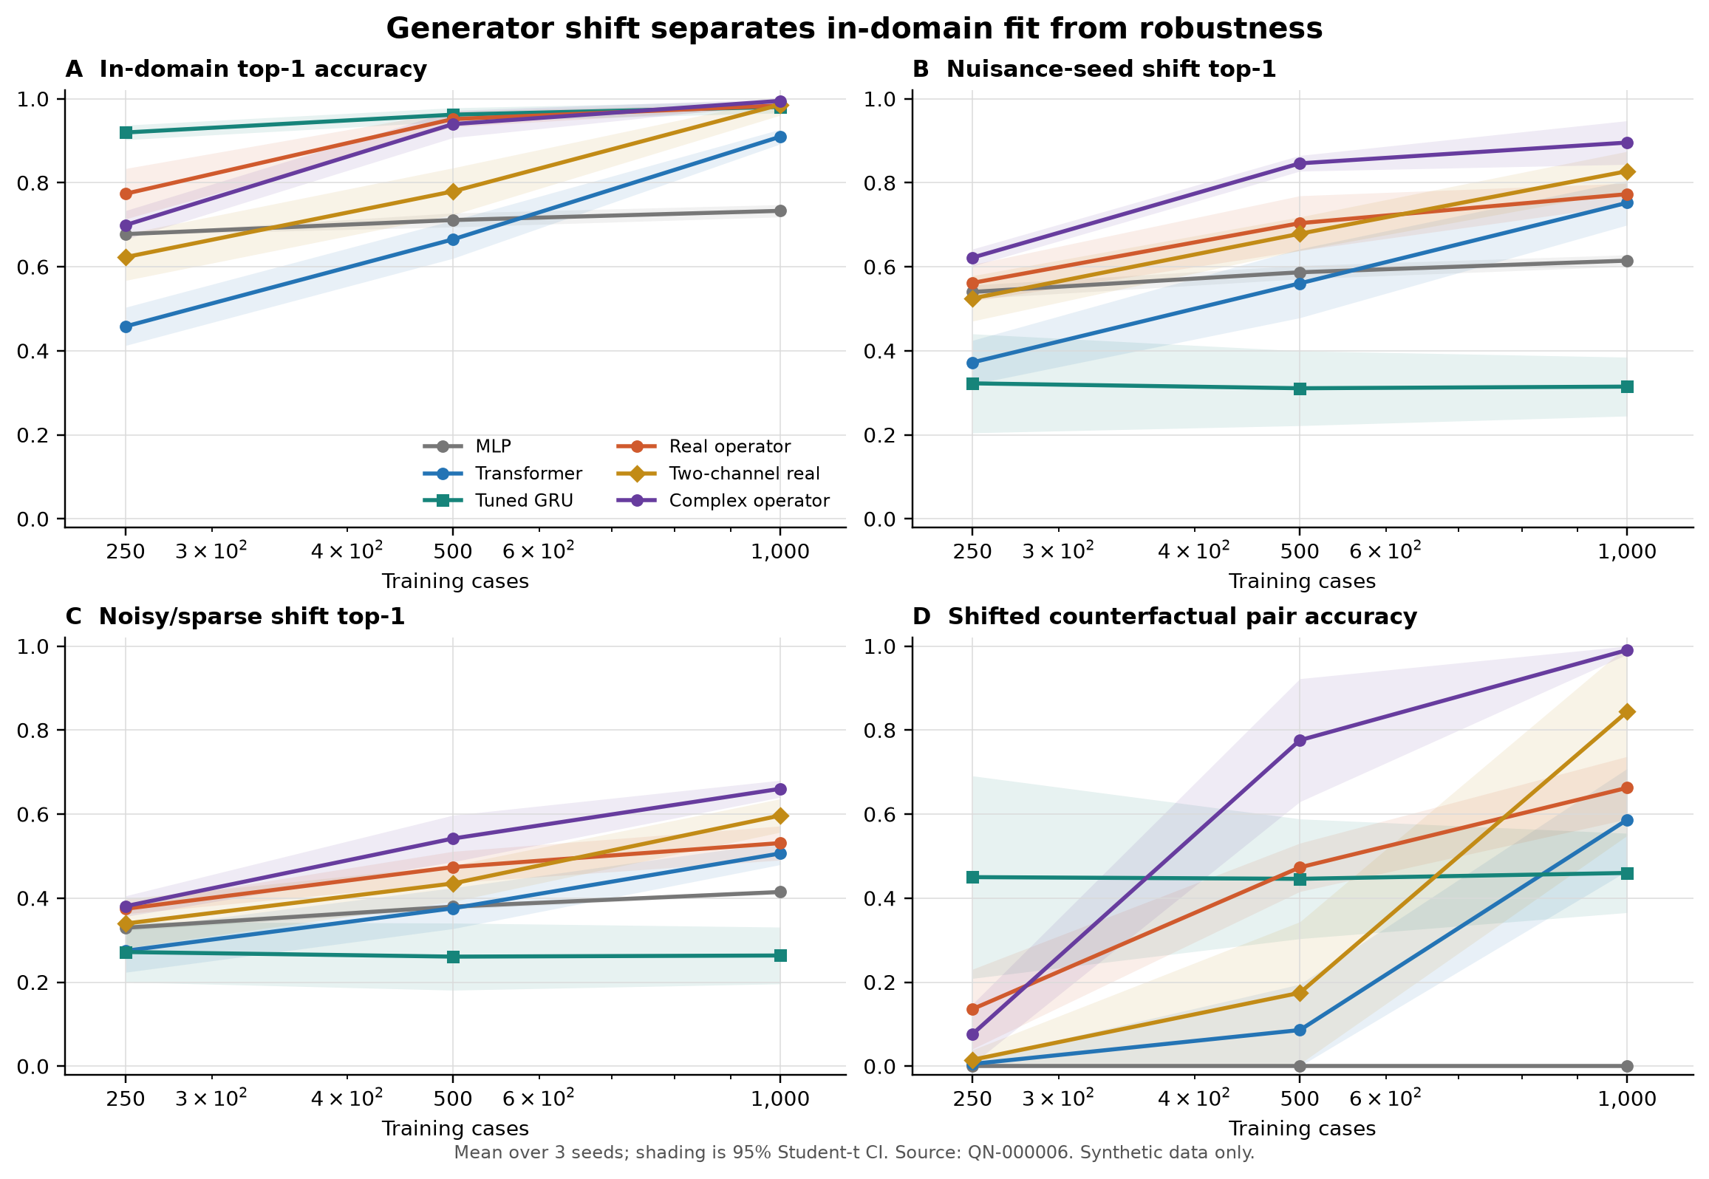
Figure 7 | The stronger-control replication separates source-world fit from robustness. A tuned GRU is strongest at very low source data but collapses under the declared generator shifts; the complex operator becomes strongest under nuisance and noisy/sparse shift at 1,000 cases.

Ambiguity, omitted labels, and hidden syndromes
Irreducible ambiguity pairs present identical observations with two valid chronology labels. The ideal prediction assigns all mass equally to the twins, giving pair NLL log(2). This benchmark tests whether a differential remains calibrated when the label is unidentifiable. It is distinct from standard uncertainty on difficult but identifiable cases.
The omitted-disease task removes one label entirely during training and evaluates whether confidence or representation distance separates it from known cases. The hidden-syndrome task creates an unlabeled cross-factor signature and measures representation separation. Neither task claims disease discovery. High AUROC only shows that a synthetic construct lies away from known examples under a declared score.
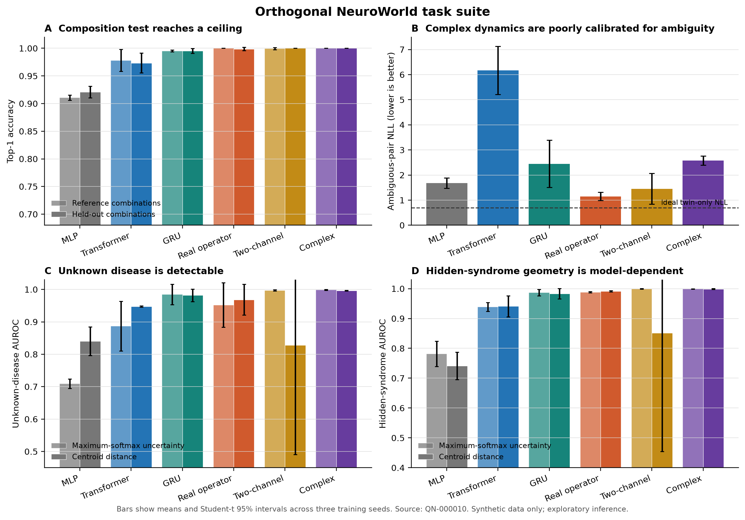
Figure 8 | The orthogonal task suite separates composition, ambiguity, omitted-disease rejection, and hidden-syndrome representation tests. Success on one axis does not imply success on the others.

Active evidence acquisition
For active acquisition, the complete set of 40 binary outcomes exists but a policy reveals one at a time. Query costs are equal. Random order, fixed mutual-information order, and model-conditioned expected entropy reduction are evaluated from one to twelve queries. Accuracy AUC is the average top-1 across those budgets, not receiver-operating-characteristic area. This task excludes chronology twins so that a set-based query policy is not asked to infer event order from unordered acquisition.
The simulator does not model the causal dependence among requested tests, the semantics of asking a patient a question, or unequal cost and risk. It is a controlled partial-information benchmark. A clinically meaningful extension would need conditional outcome models, governed cost definitions, and prospective policy evaluation.

Leakage and scope controls
Train, validation, and test cases use disjoint random streams. Model selection never reads shifted test metrics. World seeds are held out before training. Counterfactual pairs are generated separately. The registry stores dataset fingerprints, configuration hashes, seeds, hardware/software environment, and result paths. One early asymmetric-input study is retained but superseded because only the MLP received demographic context; the corrected study equalizes inputs.
NeuroWorld remains a single simulator family built by the same project that proposes Q-Neuro. That is the largest external-validity limitation. Multiple seeds reduce sensitivity to one random template but do not create an independent scientific replication. The benchmark is best viewed as a causal wind tunnel: valuable for mechanism stress tests, insufficient for claims about real patients.

Experiments

Registered sequence
The registry contains 26 experiment records, 25 completed and one failed run preserved for audit. Each record stores an immutable identifier, configuration, result directory, timestamps, environment information, and status. Follow-up experiments are introduced when a previous result leaves a specific alternative explanation. The sequence progresses from task sanity checks to corrected baselines, stronger controls, unseen-world confirmation, orthogonal tasks, active acquisition, computational laws, critical ablations, observables, training laws, hard execution, trajectories, and automated discovery.
The primary confirmatory-style comparisons within this exploratory program are predefined paired effects. Training seeds are shared across models; world seeds are shared across architectures; counterfactual pairs share every variable except the intervention. The broad discovery scan is explicitly hypothesis-generating. It searches stored architecture, training, and halting summaries against declared surprise rules and Pareto objectives, then emits proposals rather than silently converting selected results into confirmation.
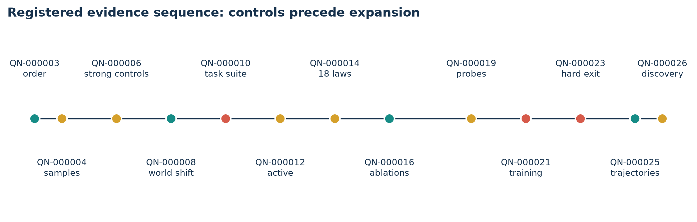
Figure 9 | Registered studies are ordered so that baseline validity and strong controls precede mechanism expansion. The failed QN-000024 run remains in the registry rather than being erased.

Experiment Zero
The corrected full-data comparison trains on 14,000 cases, validates on 3,000, and tests on 3,000, with 500 independent counterfactual chronology pairs and three seeds. Four approximately 20,000-parameter models receive identical evidence and demographics. The MLP is unordered; the Transformer and operator models receive the observed sequence. This experiment establishes task correctness and phase functionality, but saturation prevents comparative conclusions.
The sample-efficiency study uses nested training sets of 250, 500, 1,000, 2,000, and 5,000 cases with shared validation/test data. A stronger-control replication adds validation-tuned GRU and two-channel real models at 250–1,000 cases, then evaluates nuisance-seed and noisy/sparse shifts. A five-world sweep at fixed 1,000 cases tests whether the apparent complex-versus-two-channel effect persists across held-out world seeds and severities.

Orthogonal tasks and acquisition
Separate models are trained for standard/ambiguity evaluation, held-out composition, and omitted-disease evaluation. The hidden syndrome is generated independently and never used for model selection. The active-acquisition study trains on 3,000 factorial cases and evaluates 200 cases per seed across budgets one through twelve. Policy runtime is measured because expected-information queries require multiple counterfactual forward passes.

Computational-law and ablation suites
The mechanism suite trains eighteen architectures on the same 1,000-case split with three seeds. Evaluation covers source accuracy, ambiguity, chronology pairs, and three moderate unseen worlds. The critical ablation suite then intervenes on the leading mechanisms: commutativity, phase-sensitive readout, negative evidence, Hamiltonian versus dissipative terms, and density rank. Paired effects are reported relative to the full complex operator or the relevant nested control.

Probe, training-law, and trajectory studies
The observable study freezes trained representations and selects linear-probe regularization using validation data. It evaluates mechanism, localization, temporality, and context. For complex states, Hermitian quadratic probes are compared with linear probes. Diagnostic models are never fine-tuned by probe losses.
The training-law study evaluates nine optimizers or update laws at 250 and 1,000 cases. It records diagnosis and auxiliary metrics, gradient cosines, reverse-mode gradient-call counts, deployment parameters, time, and memory. The hard-halting study measures actual active-index computation rather than soft depth. The trajectory study stores per-step states for held-out cases, computes predeclared summaries, and evaluates chronology twins under matched steps.

Metrics and multiplicity
Accuracy is never the sole endpoint. Every principal comparison includes NLL and ECE; chronology studies include pair accuracy; anomaly studies include AUROC and FPR at 95% true-positive rate; efficiency studies include parameters, CPU time, memory, executed states, and latency. The discovery engine uses six objectives when marking architecture Pareto status. Because the study explores many laws and metrics, isolated favorable values are not treated as confirmatory. The claim ledger records counterevidence, and the paper emphasizes effects that repeat across worlds or survive targeted ablation.

Reproducibility
All experiments use deterministic configuration files and explicit seeds. Raw registered JSON artifacts are committed; analysis scripts regenerate paired effects; figure scripts read artifacts and emit PNG plus vector PDF; table scripts read the same artifacts; the manuscript builder emits synchronized modular LaTeX, Word, and PDF. Cached results permit paper regeneration without retraining, while individual Make targets expose the full training commands.
The test suite checks simulator invariants, models, learning rules, observables, evaluation, active acquisition, registry behavior, discovery logic, and task construction. Continuous integration installs from the locked environment, runs lint and tests, rebuilds dashboard data, and rejects a dirty dashboard artifact. A complete reproduction on different hardware should expect timing variation but not a change in the registered data or figure values unless experiments are rerun intentionally.

Hardware and resource scope
The reported studies were designed for a consumer MacBook CPU and small memory footprint. Peak process RSS remained below approximately 0.36 GiB in the principal runs, although allocator reuse makes small cross-model deltas approximate. This resource constraint shaped the benchmark scale and the use of low-rank operators. It is a reproducibility feature, not evidence that the method is globally compute-optimal.

Results

Ordered computation passes the impossibility control
In the corrected full-data study, the unordered MLP reaches 0.752 source top-1 but zero counterfactual pair accuracy. Its aggregate input is identical for the two members of a chronology pair, so this failure is expected. The tiny Transformer reaches 0.995 top-1 and perfect pair accuracy; real and complex operators reach 0.999 and 1.000 top-1 with perfect pairs. Ordered computation therefore solves the causal chronology rule, but the task is saturated among ordered models.
Table 3 | Corrected full-data Experiment Zero comparison.
Model | Parameters | Top-1 | Order pairs | NLL | ECE | Train s
MLP | 20,002 | 0.752 | 0.000 | 0.437 | 0.037 | 1.07
Tiny Transformer | 18,980 | 0.995 | 1.000 | 0.017 | 0.003 | 12.69
Real operator | 19,901 | 0.999 | 1.000 | 0.003 | 0.002 | 14.65
Complex operator | 20,304 | 1.000 | 1.000 | 0.035 | 0.033 | 24.47
Four matched models, 14,000 training cases, 3,000 validation cases, 3,000 test cases, and three seeds.
Phase scrambling shows that the trained complex solution uses its phase. Setting relative phase to zero or replacing it randomly lowers top-1 to 0.205 and 0.216. This is a functional ablation of one fitted model, not a comparison against an equally expressive real parameterization. The real operator obtains nearly the same full-data accuracy with better NLL, better ECE, and lower training time. The result supports “phase is used,” not “phase is superior.”

Source-world sample efficiency is not a complex advantage
Under nested training sets, the operator models learn chronology with fewer cases than the tiny Transformer. At 250 cases, the real operator is stronger than the complex operator; from 500 to 5,000 cases, the complex operator has the highest source top-1 in the four-model comparison. Complex calibration is worse than real at every size. At 1,000 cases, complex ECE is 0.176 versus 0.028 for real, and mean CPU training time is 6.88 s versus 4.29 s.
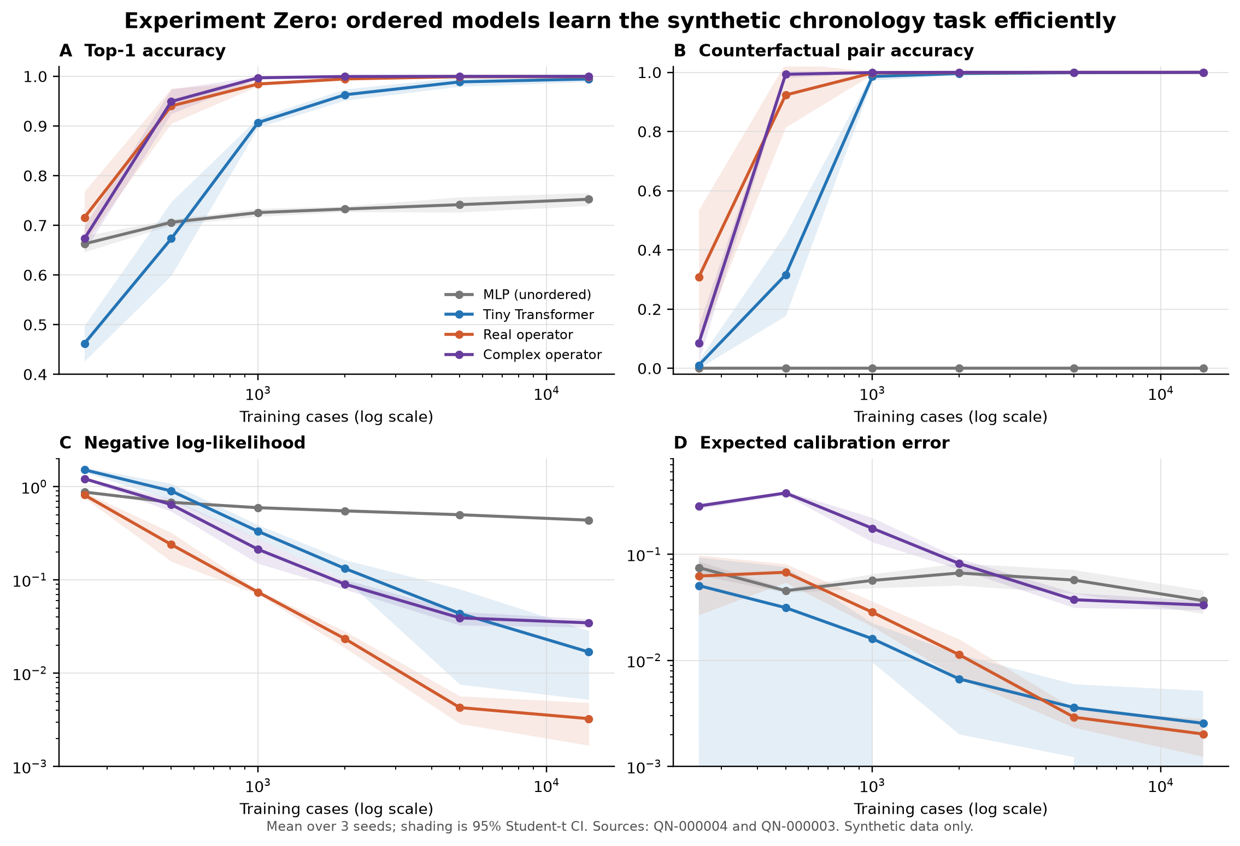
Figure 10 | Nested learning curves show that real and complex operator states learn the chronology task before the tested tiny Transformer, while the complex model pays a calibration and runtime cost.
Table 4 | Source-world top-1 accuracy under nested training-set sizes.
Cases | MLP | Transformer | Real operator | Complex operator
250 | 0.663 | 0.462 | 0.716 | 0.673
500 | 0.706 | 0.673 | 0.940 | 0.949
1,000 | 0.726 | 0.907 | 0.985 | 0.997
2,000 | 0.733 | 0.963 | 0.995 | 1.000
5,000 | 0.742 | 0.989 | 0.999 | 1.000
The same validation/test generator and seed set is reused across sizes.
Adding a tuned GRU changes the conclusion. At 250 cases in the stronger-control study, the GRU reaches 0.920 source top-1, compared with 0.774 for the real operator and 0.699 for the complex operator. The initial suggestion that hypothesis-state operators are intrinsically the most data-efficient is therefore refuted. The GRU’s subsequent collapse under shift demonstrates that source efficiency and causal robustness are different estimands.

Complex robustness repeats across unseen worlds
In the first strong-control replication at 1,000 cases, the complex operator reaches 0.995 source top-1, 0.896 on nuisance-seed shift, and 0.660 on noisy/sparse shift. The two-channel real control reaches 0.986, 0.828, and 0.597. The paired complex-minus-two-channel effects are +0.068 for nuisance shift and +0.064 for noisy/sparse shift; three-seed intervals are [+0.006, +0.130] and [+0.016, +0.112]. The ordinary real operator is lower on both shifts.
The five-world confirmation holds training data at 1,000 cases and evaluates nuisance, mild, moderate, and severe shifts. Complex top-1 is 0.909, 0.806, 0.645, and 0.468; two-channel top-1 is 0.846, 0.745, 0.585, and 0.414. Paired world-level differences are +0.0627 [0.0552, 0.0702], +0.0609 [0.0502, 0.0715], +0.0602 [0.0529, 0.0674], and +0.0538 [0.0471, 0.0606]. Every unseen world favors the complex parameterization under these definitions.
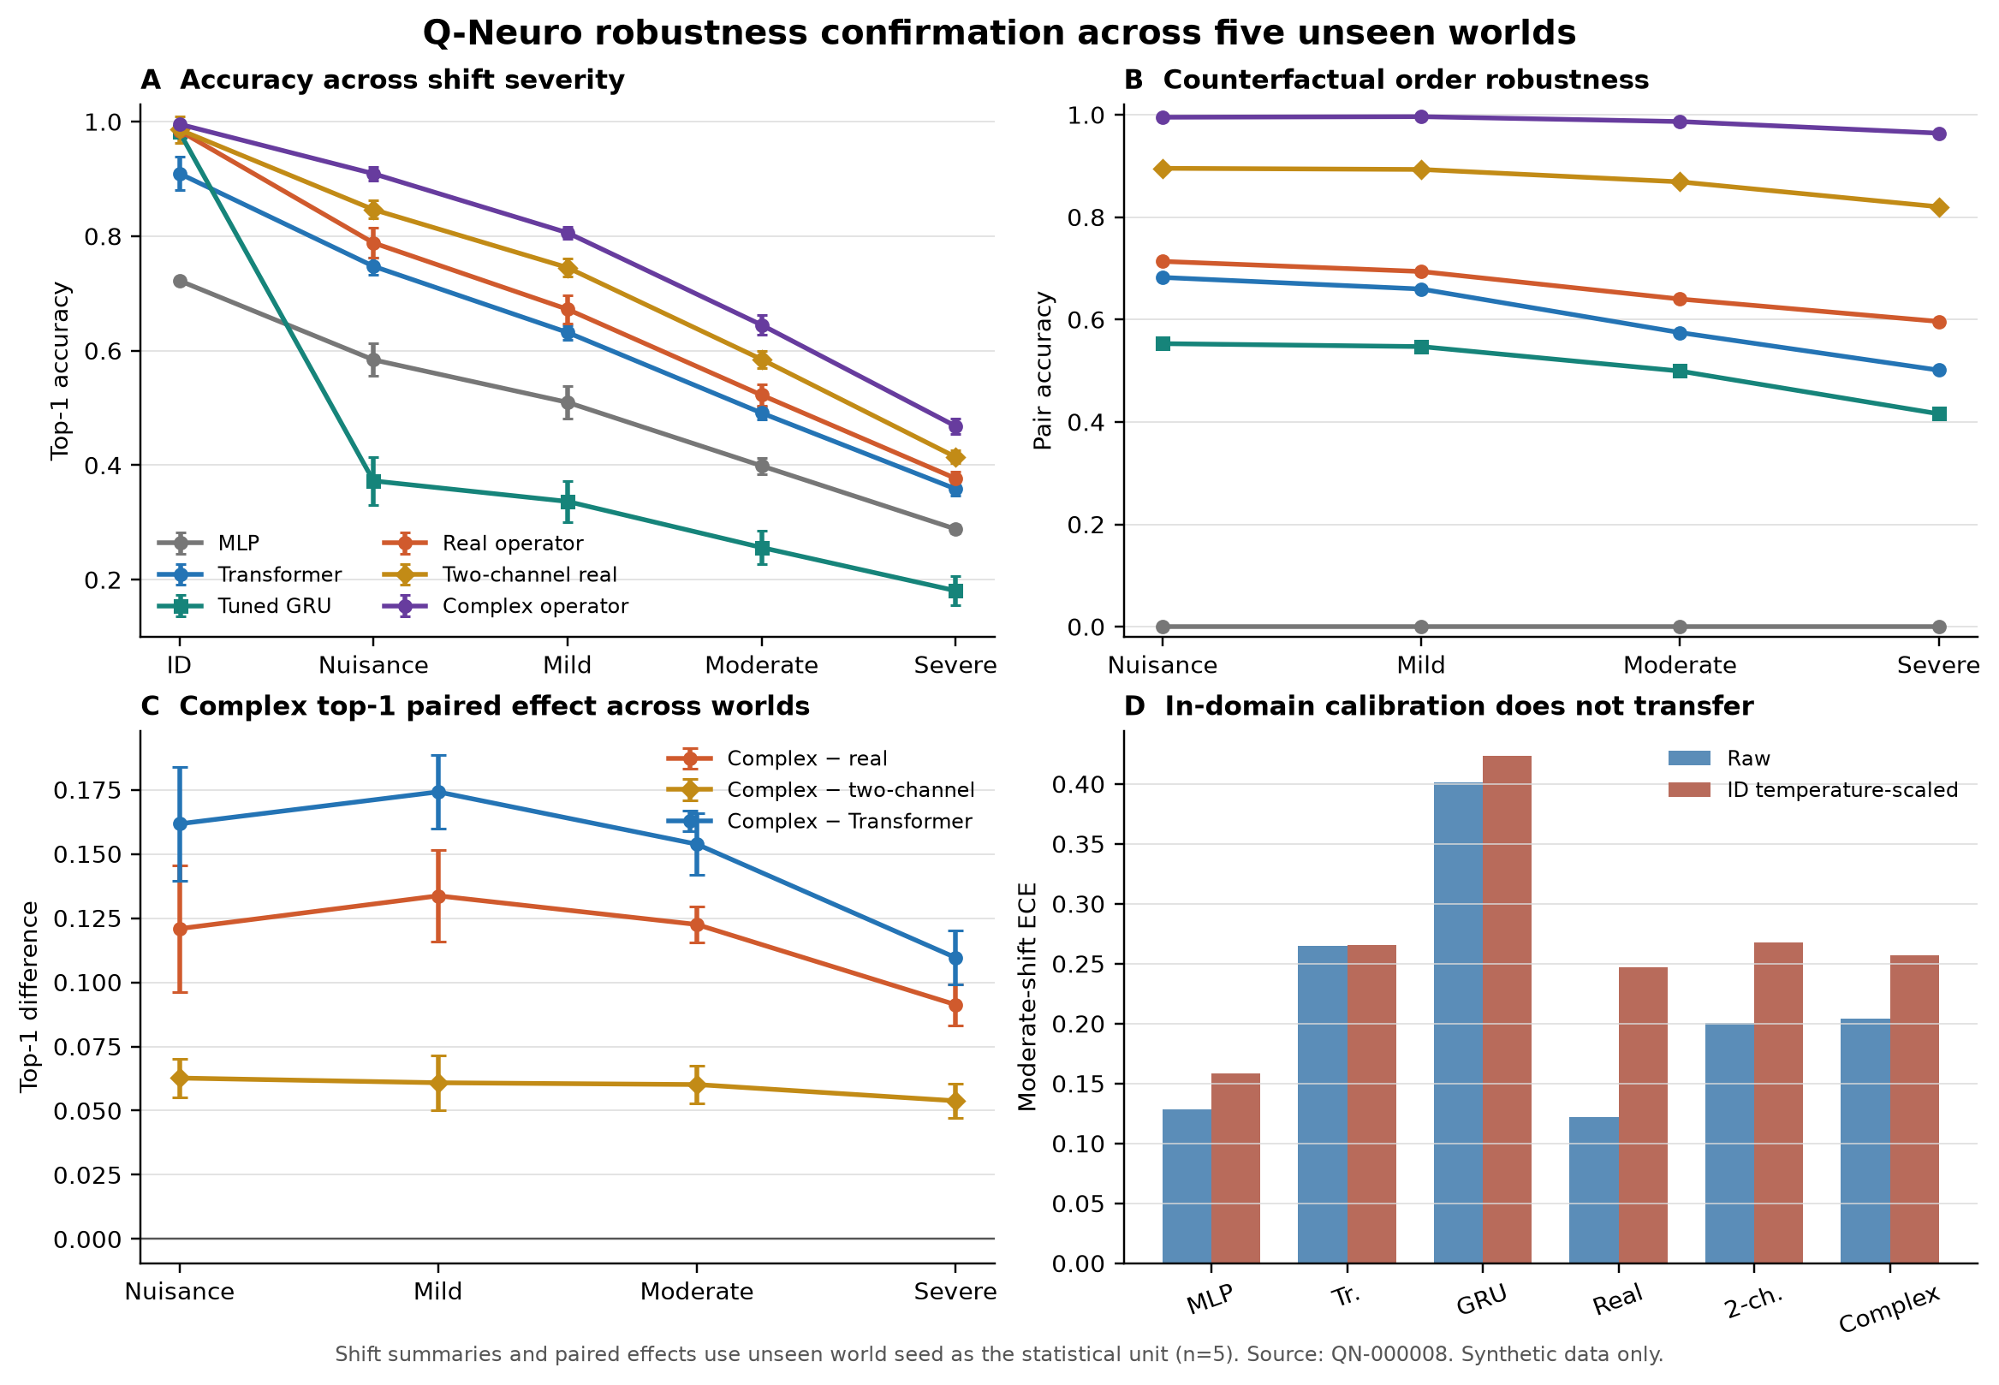
Figure 11 | Across five unseen simulator seeds and four shift severities, the complex operator retains an approximately five- to six-point top-1 advantage over the two-channel real control. Accuracy declines for every model as shift increases.
Table 5 | Top-1 accuracy across the preregistered unseen-world severity sweep.
Model | In-domain | Nuisance | Mild | Moderate | Severe
MLP | 0.722 | 0.584 | 0.510 | 0.399 | 0.288
Tiny Transformer | 0.910 | 0.747 | 0.632 | 0.491 | 0.359
Tuned GRU | 0.982 | 0.373 | 0.337 | 0.256 | 0.181
Real operator | 0.984 | 0.788 | 0.672 | 0.523 | 0.377
Two-channel real | 0.986 | 0.846 | 0.745 | 0.585 | 0.414
Complex operator | 0.996 | 0.909 | 0.806 | 0.645 | 0.468
World intervals treat the unseen simulator seed as the replication unit after averaging training seeds.
This is the most repeatable positive result in the project, but its scope is narrow. The worlds share one simulator family and were designed within the project. The two-channel model is a strong control, not a proof that no real network can reproduce the computation. The result is therefore a synthetic within-family robustness effect, not a universal complex-arithmetic advantage.

The broad law suite reveals a multi-objective frontier
Across eighteen laws, the complex operator reaches the best moderate-shift top-1 at 0.647 and perfect chronology-pair accuracy. The Hamiltonian-style model reaches 0.556 shift accuracy and 0.983 pair accuracy; the hybrid reaches 0.550 and 0.923; the dissipative model reaches 0.438 and 0.008. The coherent term carries useful signal under this parameterization, while generic damping erases order without improving robustness.
The GRU is best in-domain at 0.987 but falls to 0.247 under moderate shift. The diagonal state-space model reaches 0.978 in-domain and perfect chronology pairs but only 0.337 under shift. The real operator obtains the best ambiguity NLL among the larger sequential controls at 1.418, while reaching 0.495 shift accuracy. Density dynamics reaches 1.468 ambiguity NLL and 0.453 shift top-1, a compromise but not a frontier improvement.
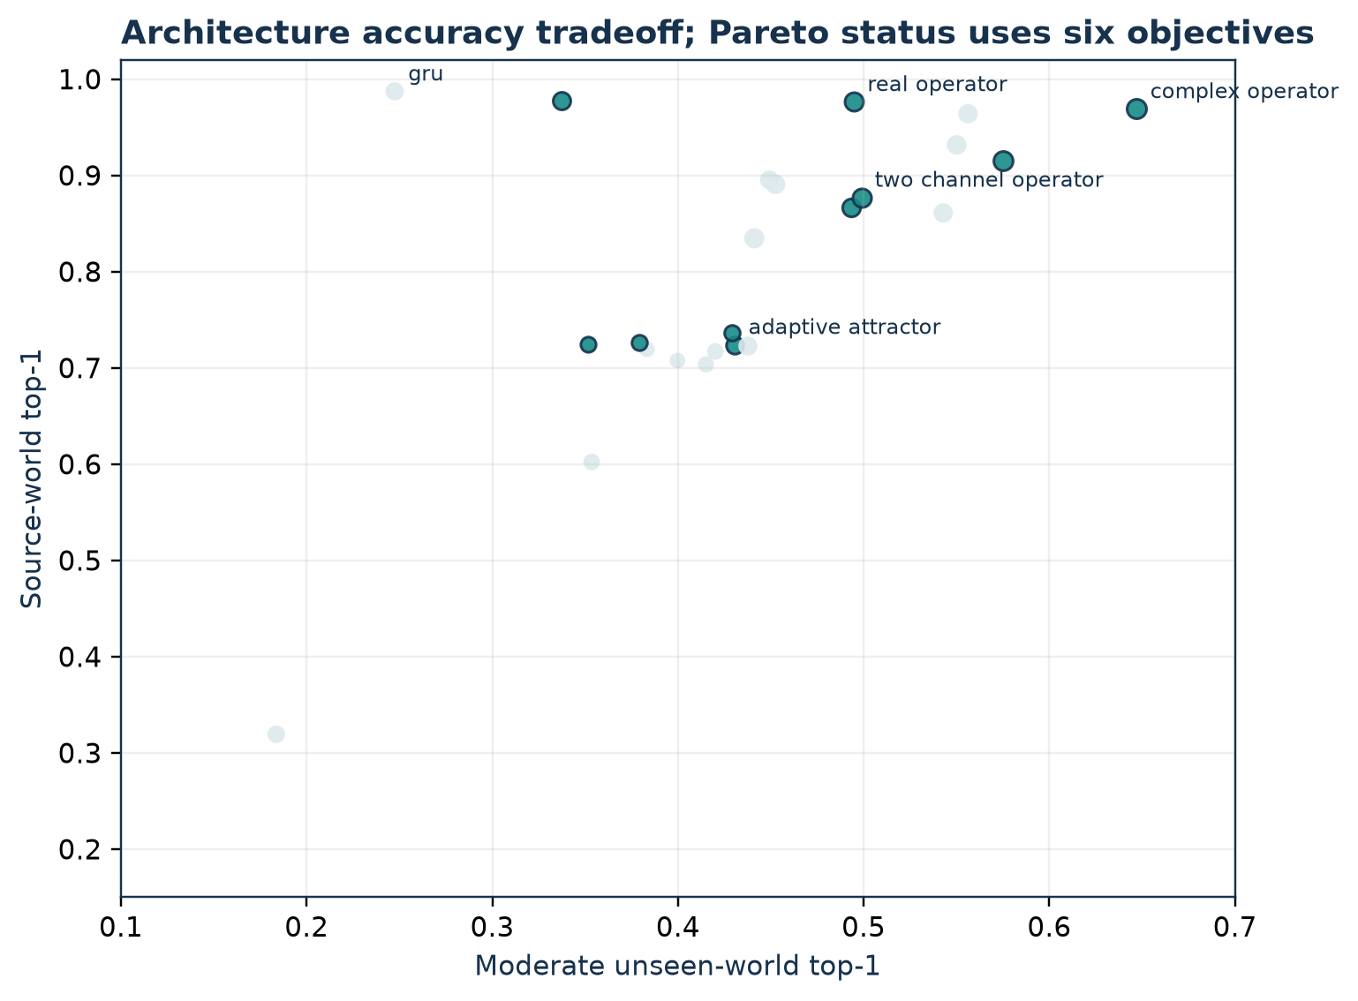
Figure 12 | Architecture families occupy a broad Pareto field when source accuracy, shifted accuracy, ambiguity, chronology, calibration, and compute are considered together. Highlighted points are nondominated under the six-objective registry rule.
Table 6 | Matched architecture comparison at 1,000 training cases.
Model | Parameters | ID top-1 | Shift top-1 | Ambiguity NLL ↓ | Order pairs
Logistic regression | 1,660 | 0.725 | 0.352 | 1.445 | 0.000
MLP | 20,002 | 0.726 | 0.379 | 1.533 | 0.000
Tiny Transformer | 18,980 | 0.867 | 0.493 | 4.345 | 0.843
Tuned GRU | 19,656 | 0.987 | 0.247 | 2.296 | 0.997
Diagonal state-space | 19,970 | 0.978 | 0.337 | 2.077 | 1.000
Real operator | 19,901 | 0.976 | 0.495 | 1.418 | 0.998
Two-channel real | 19,975 | 0.877 | 0.499 | 2.037 | 0.663
Complex operator | 20,304 | 0.969 | 0.647 | 2.352 | 1.000
Hamiltonian-style | 19,998 | 0.964 | 0.556 | 1.870 | 0.983
Dissipative | 20,020 | 0.723 | 0.438 | 1.894 | 0.008
Hamiltonian-dissipative | 19,894 | 0.932 | 0.550 | 1.867 | 0.923
Density dynamics (rank 2) | 16,240 | 0.891 | 0.453 | 1.468 | 0.635
Means over three training seeds; shift values average three unseen moderate worlds.
The Pareto analysis explains why a single “best architecture” headline would be misleading. Complex operators lead the chosen shift axis, GRU leads source fit, real operators lead ambiguity and calibration, and inexpensive unordered models occupy low-compute regions. The scientific result is a structured tradeoff.

Efficiency trades against accuracy
The sample-efficiency curve appears favorable when plotted only against case count. Against CPU time, the operator models move rightward: complex training is slower than real, which is slower than the MLP. At large sample sizes, several ordered models approach ceiling accuracy with different costs. The tested complex model does not establish a general compute Pareto frontier.
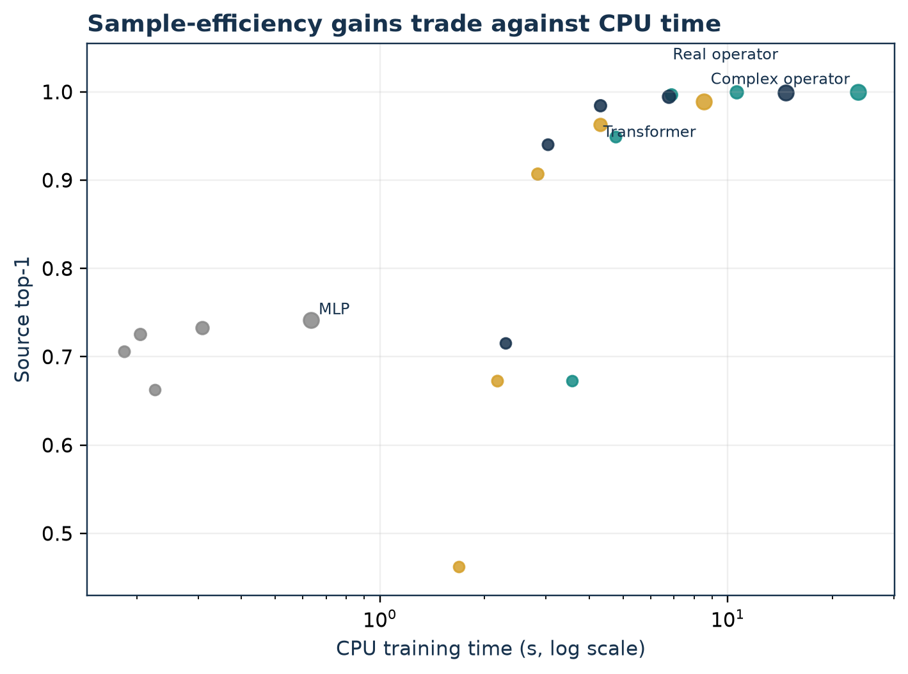
Figure 13 | The source-world sample-efficiency gain of operator states trades against CPU training time. Point size increases with training cases; labels mark the largest training set for each architecture.
Measured peak RSS remains small on the test machine, but differences of a few megabytes are not treated as reliable because allocator caches persist across sequential runs. Parameter counts are exact. Timing is a reproducible relative observation on one consumer CPU, not a hardware-independent throughput claim.

Calibration fails to transport
Raw moderate-shift ECE is 0.122 for the real operator, 0.201 for two-channel real, and 0.204 for complex. Applying a scalar temperature fitted only on source validation increases these values to 0.247, 0.267, and 0.257. Complex moderate-shift NLL increases from 1.459 to 4.341. Rankings are unchanged, but probabilistic quality deteriorates.
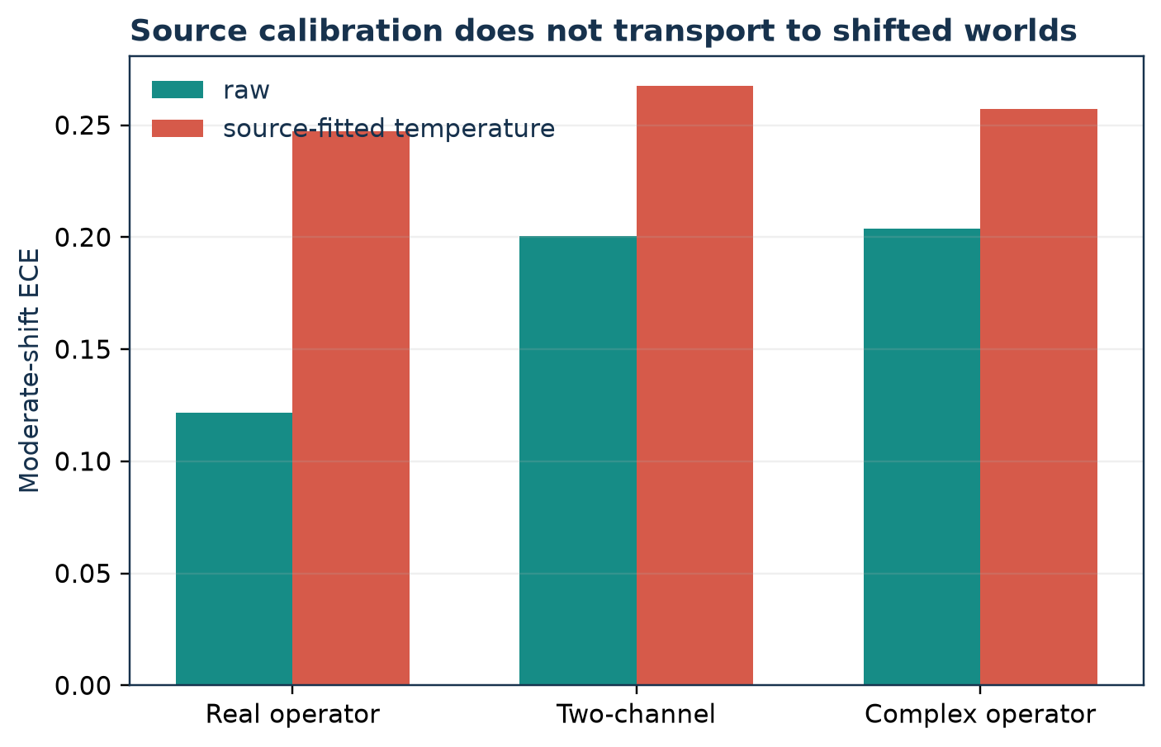
Figure 14 | A scalar temperature fitted on source validation data worsens moderate-shift ECE for real, two-channel, and complex operator models.
The failure has practical significance even in a synthetic study. A differential diagnosis is not only a ranking; probability mass communicates residual uncertainty. Improvements in top-1 under shift cannot compensate for a calibration method that becomes anti-corrective. All primary results therefore report raw NLL and ECE, and calibrated values are labeled as a failed intervention.

Orthogonal tasks separate competence from uncertainty
Held-out composition saturates: complex and two-channel real reach 1.000, real reaches 0.999, and GRU reaches 0.995. The task verifies recombination but does not isolate a mechanism. Irreducible ambiguity produces the opposite pattern. The real operator obtains 1.148 pair NLL and assigns 0.836 mass to the two valid labels; two-channel obtains 1.453 and 0.559; complex obtains 2.581 and 0.212. The ideal pair NLL is log(2) = 0.693.
For a completely omitted label, maximum-softmax AUROC is 0.9988 complex, 0.9974 two-channel, 0.9847 GRU, and 0.9521 real. The complex-minus-two-channel interval crosses zero. For the hidden syndrome, representation-distance AUROC is 0.9990 complex and 0.9918 real, while two-channel is seed-unstable. These results show strong synthetic separability but not a uniquely complex anomaly detector.
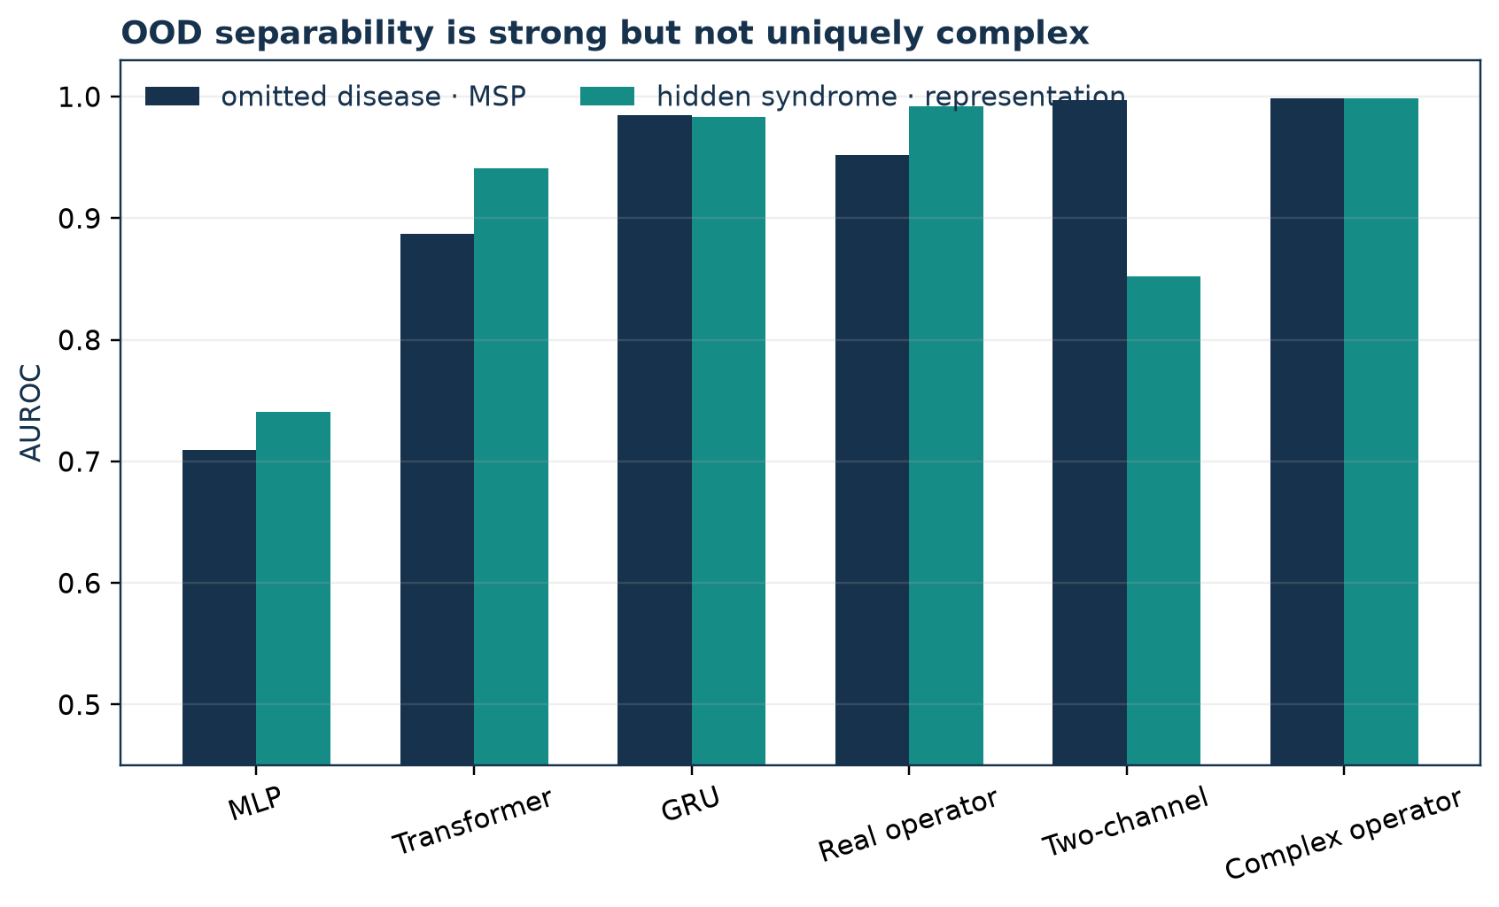
Figure 15 | Omitted-disease and hidden-syndrome AUROC are high for several sequential models. Strong separation is not uniquely complex and must not be described as discovery of a disease.
Table 7 | Irreducible ambiguity and out-of-distribution separation.
Model | Ambiguity NLL ↓ | Valid-twin mass | Omitted-disease AUROC | Hidden-syndrome AUROC
MLP | 1.681 | 0.547 | 0.709 | 0.741
Tiny Transformer | 6.171 | 0.188 | 0.887 | 0.941
Tuned GRU | 2.450 | 0.532 | 0.985 | 0.983
Real operator | 1.148 | 0.836 | 0.952 | 0.992
Two-channel real | 1.453 | 0.560 | 0.997 | 0.852
Complex operator | 2.581 | 0.212 | 0.999 | 0.999
OOD AUROC measures separation on synthetic held-out constructs, not clinical disease discovery.
The tension is informative: a model can reject a far-away synthetic construct while mishandling two observationally identical valid hypotheses. OOD detection and differential calibration test different geometries. The latter is the more direct warning for any future diagnostic use.

Active acquisition is predictor-dependent
Across query budgets one through twelve, expected-information acquisition gives the complex model the highest mean accuracy AUC at 0.590, followed by MLP at 0.585 and two-channel real at 0.568. The complex effect over MLP is +0.005 with an interval crossing zero; over two-channel it is +0.022 with an interval crossing zero; over ordinary real it is +0.085 with interval [0.032, 0.138]. At twelve queries, complex reaches 0.833.
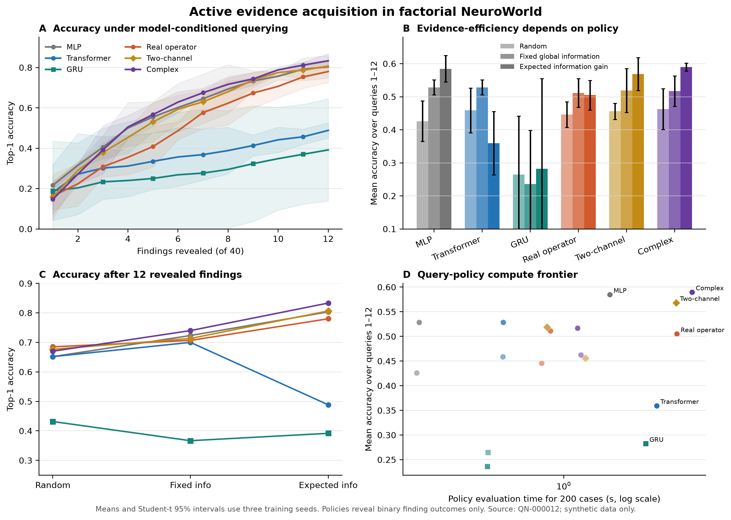
Figure 16 | Expected-information acquisition helps some predictors and harms others. Full-case accuracy does not predict partial-evidence competence, and policy runtime is substantially higher than fixed ordering.
The same policy reduces Transformer AUC from 0.528 under fixed information order to 0.359. Its counterfactual entropy calculation trusts a predictor whose partial-evidence geometry is poorly calibrated. The result argues against separating an acquisition heuristic from the model it queries. It does not show that complex models are uniquely suited to active diagnosis.

Claim summary
Three results survive the strongest internal checks: ordered computation is necessary for chronology twins; the complex operator’s robustness advantage over the tested two-channel real control repeats across the declared NeuroWorld worlds; and order composition, phase-sensitive measurement, and observed-negative evidence each contribute to that result. Several attractive extensions do not survive: universal sample efficiency, intrinsic ambiguity handling, calibration transport, unique OOD separation, universal expected-information acquisition, generic dissipation, adaptive depth, phase-gradient optimization, and unique factor interpretability.
The resulting claim is deliberately conditional. Under the tested synthetic causal shifts, ordered complex hypothesis dynamics improve classification robustness relative to a broad but finite control set. They do not dominate accuracy, uncertainty, compute, or interpretability simultaneously.

Ablations

Noncommutative order
The commutative complex accumulator retains a complex state and magnitude-squared readout but sums evidence injections. Its in-domain top-1 is 0.704, moderate-shift top-1 is 0.415, and chronology-pair accuracy is zero. The full complex operator reaches 0.969, 0.647, and 1.000. The paired shift effect is +0.232 with its three-world interval above zero. This is the largest critical ablation and confirms that ordered operator composition, not complex storage alone, is necessary for the leading result.
The control is intentionally algebraic. Because addition commutes, it cannot encode the marker order. A performance collapse on pairs is therefore expected, while the moderate-shift loss shows that chronology-related sequential structure also contributes to the broader shifted set. It remains possible that a different ordered real architecture could reproduce the result; the ablation establishes necessity within Q-Neuro, not exclusivity across all computation.

Phase-sensitive measurement
The two-channel real control reaches 0.499 moderate-shift top-1 and 0.663 pair accuracy. The complex operator adds +0.148 shift accuracy. The phase-insensitive magnitude readout retains the full complex recurrence but forbids destructive readout interference; it reaches 0.543 shift top-1 and 0.825 pairs, leaving a +0.104 gap to the full model. Phase-sensitive measurement is therefore functionally important under the trained law.
This result is stronger than post hoc phase scrambling because the ablated model is retrained. It is still not a theorem about complex arithmetic. A sufficiently general real network can represent complex multiplication using paired channels. The finding is that the tested complex parameterization provides a useful bias relative to the declared controls at this scale.

Observed-negative evidence
Removing the negative-evidence channel reduces shift top-1 from 0.647 to 0.575 and chronology-pair accuracy from 1.000 to 0.972. The +0.072 shift effect has an interval above zero. The ablation also worsens ambiguity NLL to 3.274. Negative findings therefore provide more than missingness; they shape both elimination and uncertainty.
Observed-negative tokens are not yet diagnosis-conditional contradiction operators. They are learned tokens whose effects emerge through supervised training. A stronger causal study would intervene on matched positive/negative evidence for each latent factor and test monotonicity at the state and probability levels.
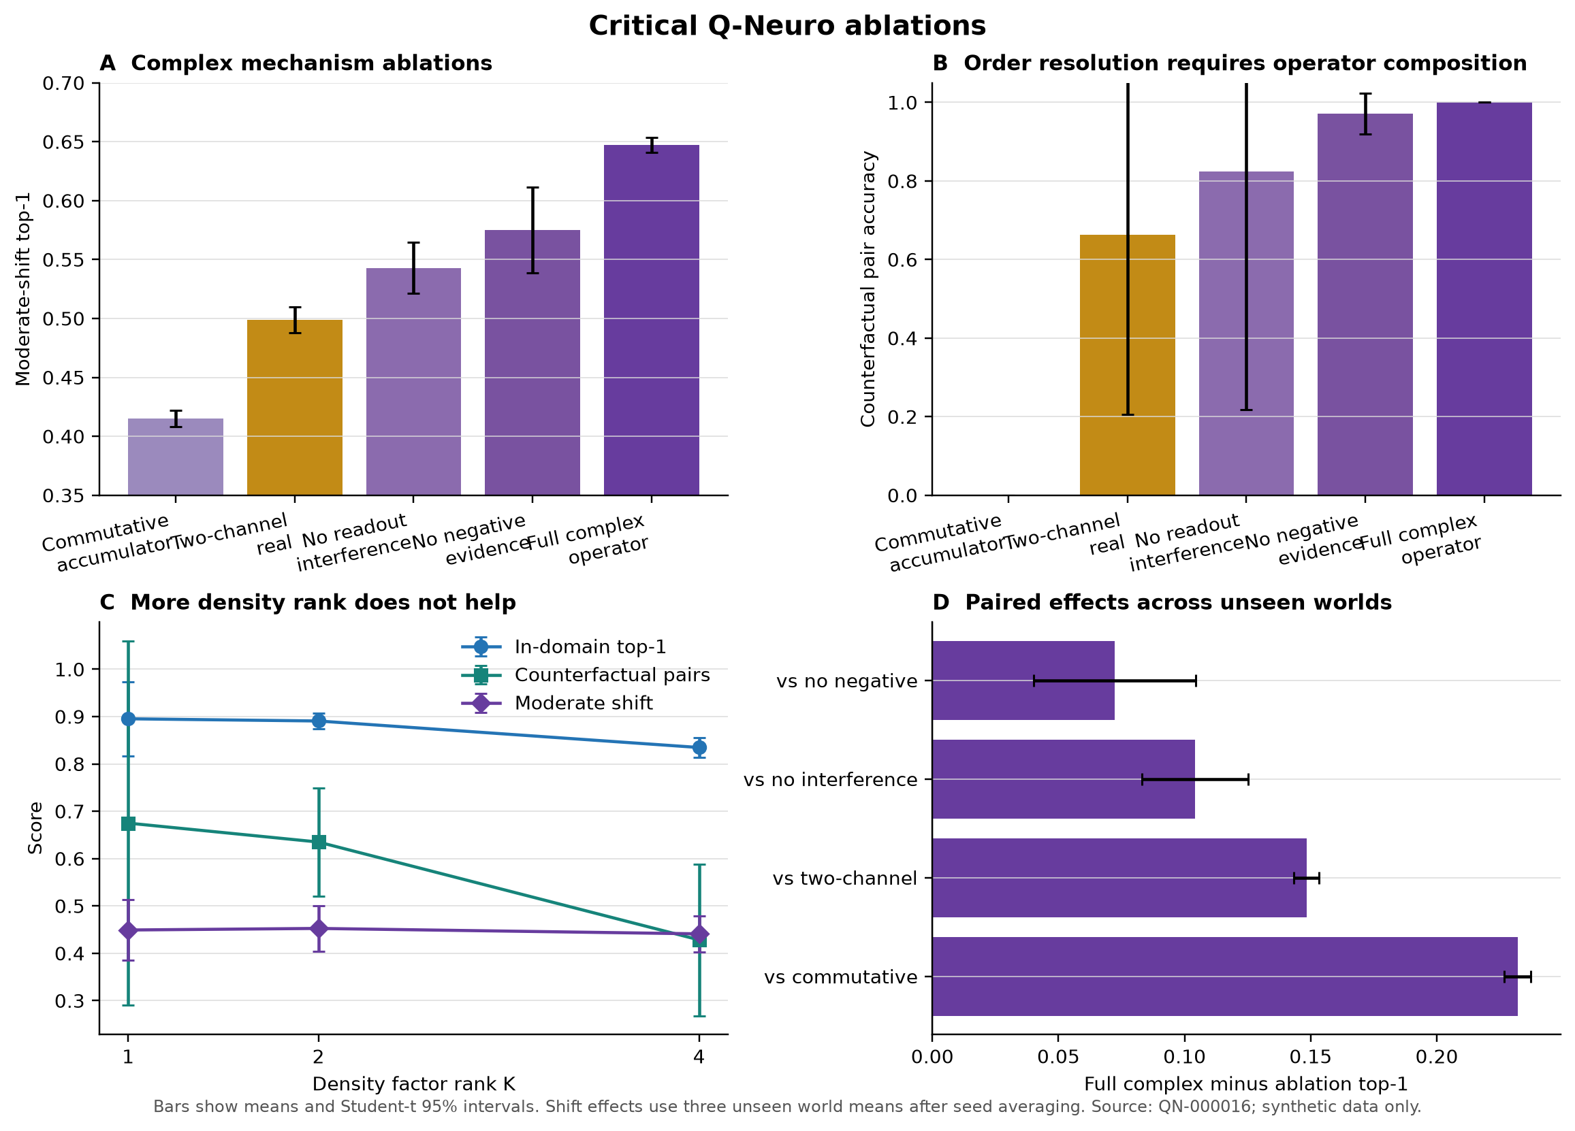
Figure 17 | Removing ordered composition produces the largest robustness and chronology loss. Phase-insensitive measurement and removal of observed-negative evidence also degrade the full complex model. Density rank does not improve the tested frontier.
Table 8 | Critical ablations of order, phase-sensitive measurement, negative evidence, and density rank.
Law | ID top-1 | Shift top-1 | Ambiguity NLL ↓ | Order pairs
Commutative accumulator | 0.704 | 0.415 | 2.422 | 0.000
Two-channel real | 0.877 | 0.499 | 2.037 | 0.663
Magnitude-only readout | 0.861 | 0.543 | 2.467 | 0.825
No observed-negative channel | 0.915 | 0.575 | 3.274 | 0.972
Complex operator | 0.969 | 0.647 | 2.352 | 1.000
Density dynamics (rank 1) | 0.895 | 0.449 | 1.435 | 0.675
Density dynamics (rank 2) | 0.891 | 0.453 | 1.468 | 0.635
Density dynamics (rank 4) | 0.835 | 0.441 | 1.513 | 0.428
Each row is retrained from scratch with the same data split and three seeds.

Coherence and dissipation
The Hamiltonian-style model reaches 0.556 moderate-shift top-1 and 0.983 chronology-pair accuracy. Dissipative-only evolution reaches 0.438 and 0.008. Their hybrid reaches 0.550 and 0.923. Hybrid-minus-dissipative is +0.112 with a narrow three-world interval, while hybrid-minus-Hamiltonian is −0.006 with an interval crossing zero. Generic learned damping is not an automatic model of diagnostic elimination.
The most plausible explanation is architectural: elementwise damping plus normalization can erase path information without targeting a contradicted hypothesis. The result does not reject all dissipative or Lindblad-like laws. It rejects this generic parameterization under this objective and suggests that future dissipation must be diagnosis-conditional and compared against a matched removal operator.

Density rank
Density ranks one, two, and four reach 0.449, 0.453, and 0.441 moderate-shift top-1. Rank four uses more parameters but lowers source accuracy, worsens ambiguity NLL, and reduces chronology-pair accuracy. Off-diagonal capacity is therefore not automatically useful when supervision sees only the diagonal diagnosis measurement.
The invariant checks still matter: every tested density state is Hermitian, positive semidefinite, and unit trace within numerical tolerance. What fails is the predictive hypothesis. A later-resolution task or multi-observable objective could make off-diagonal structure identifiable; the present benchmark does not.

Ambiguity differential
The real operator’s advantage on ambiguity is not a small calibration detail. It assigns nearly four times as much mass to the valid twin set as the complex model and is much closer to the theoretical pair NLL floor. Meanwhile, the complex model leads source and shifted top-1. The result exposes a central design tension between sharp order discrimination and calibrated coexistence of unresolved hypotheses.
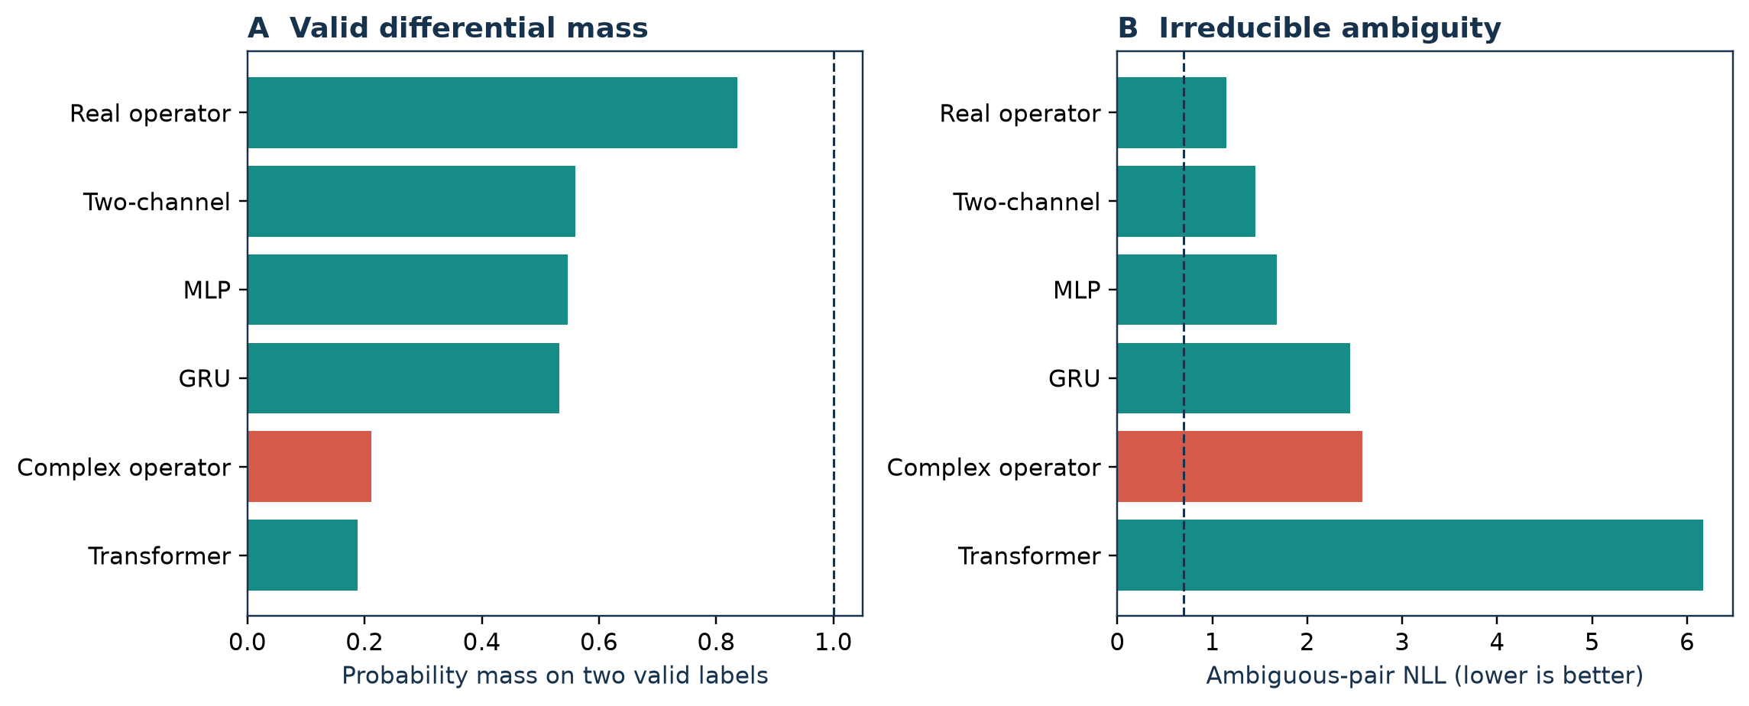
Figure 18 | The real operator retains substantially more probability mass on the two valid ambiguity labels, while the complex operator has worse pair NLL despite stronger shifted classification accuracy.
An ambiguity-aware loss could directly supervise a valid label set or impose a distribution over equivalence classes. Such a loss would change the problem and must be evaluated for accuracy tradeoffs. The architecture alone does not guarantee metastable differentials.

Ablation interpretation
The ablations support a constrained mechanism chain: signed evidence enters in order; noncommuting composition preserves chronology; complex phase participates in the readout; and the resulting parameterization is robust to the declared shifts. They do not support a physical quantum interpretation, a unique representation theorem, or a claim that coherence is inherently beneficial. The density and dissipation failures are especially important because they show that adding more quantum-inspired structure can make the system worse.

Interpretability and state audit

Frozen factor probes
Linear probes recover mechanism, localization, temporality, and context from the final complex state with accuracies approximately 0.932, 0.933, 0.907, and 0.918. This confirms that simulator factors remain accessible after diagnosis training. It does not show disentanglement or causal use. A factor can be linearly decodable because it correlates with the label even if the diagnosis head ignores that direction.
Conventional states provide the necessary comparison. GRU probes are stronger on all four factors, and the diagonal state-space model is also highly decodable. Complex-minus-GRU probe effects are negative throughout. Across architectures, factor-probe strength correlates only moderately with shift robustness, around r = +0.45. The complex model’s robustness cannot therefore be explained by uniquely transparent factor coordinates.
Hermitian quadratic probes provide a complex-native observable, but they do not uniformly improve generalization and can worsen NLL. Hermiticity guarantees real scores; it does not guarantee an interpretable observable. Probe selection remains validation-only and the diagnosis model remains frozen.
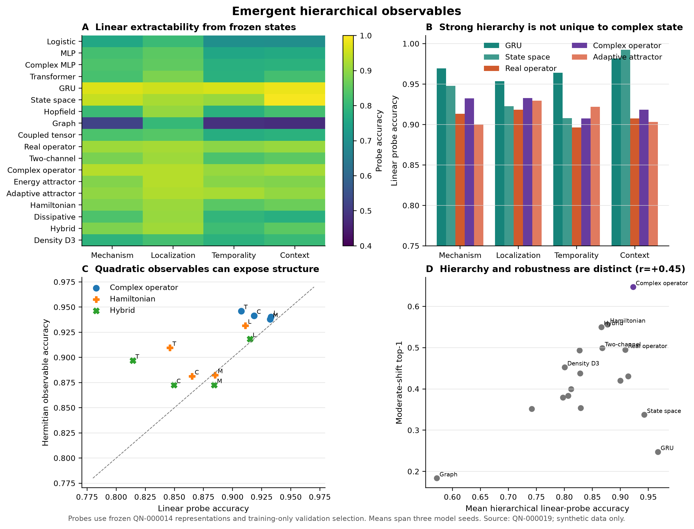
Figure 19 | Mechanism, localization, temporality, and context are decodable from several frozen states. GRU and state-space controls are at least as strong as the complex operator, refuting unique hierarchical interpretability.

Evidence-level trajectories
For held-out cases, the final complex model reaches 0.969 top-1. Mean entropy decreases by 1.266, normalized path length is 2.956, and final state velocity is 0.175. Chronology twins end 0.841 normalized state units apart and reach a maximum separation of 0.868. These are direct measurements of the recurrent path, not a post hoc embedding.
Positive evidence increases true-label probability by 0.0467 on average. Observed-negative evidence produces a small positive mean change, 0.0109, because many negative findings rule out competing labels rather than directly contradicting the true label. The positive-minus-negative paired difference is 0.0358 with interval [0.0270, 0.0447]. A simplistic monotonic rule—positive always raises and negative always lowers the target—is therefore inappropriate for differential reasoning.
Only 4.97% of cases contain an observed-negative step that lowers true-label probability by more than the preregistered 0.05 threshold. Among those qualifying drops, 75.9% later recover to the pre-drop level. “Revival” is thus a real but conditional behavior. It should not be generalized to every case or described as human-like reconsideration.
Table 9 | Evidence-level trajectory diagnostics for the trained complex operator.
Quantity | Mean | 95% Student-t interval
Final top-1 | 0.969 | [0.958, 0.980]
Entropy change | -1.266 | [-1.303, -1.229]
Normalized path length | 2.956 | [2.567, 3.345]
Final state velocity | 0.175 | [0.109, 0.241]
Positive-token Δ true probability | 0.047 | [0.039, 0.055]
Observed-negative Δ true probability | 0.011 | [0.009, 0.013]
Chronology-twin final distance | 0.841 | [0.715, 0.967]
Contradiction drops >0.05 | 0.050 | [0.012, 0.088]
Recovery after a qualifying drop | 0.759 | [0.534, 0.983]
Trajectories are actual recurrent states; they are diagnostics, not textual explanations.

Failure-case interpretation
The trajectory tools expose where a state changes, but not why in clinical language. An amplitude curve can show that two labels exchange probability after a token, and paired-state distance can show when order begins to matter. Neither proves that the network represents a named mechanism. The safest interpretation is computational: the model preserves and revises a distributed state in a way that can be measured at each evidence transition.
Useful future interventions include token deletion, time reversal, factor swaps, head ablation, and state-direction editing followed by diagnosis measurement. Those experiments could connect decodable factors to causal use. Until then, the repository calls these outputs state audits rather than explanations.

Interpretability boundary
The model has an advantage over opaque one-shot classification in observability: it exposes a real recurrent trajectory, amplitudes, probabilities, entropy, phase, and velocity. This is engineering transparency. It is not clinical interpretability, because the state dimensions and operators do not map to validated medical concepts. Any user-facing explanation would require a separate grounded language layer and expert evaluation.

Limitations

Synthetic-only evidence
Every case in this work is generated. NeuroWorld provides exact counterfactuals and eliminates privacy risk, but it cannot reproduce the prevalence, comorbidity, documentation noise, institutional practice, measurement process, or harm asymmetry of clinical neurology. The labels are simulator archetypes rather than diseases. A model that reaches 1.000 synthetic top-1 may still be useless or dangerous on a patient. No reported number is a clinical accuracy estimate.
The generator and architecture were developed in the same project. Five unseen world seeds measure robustness to declared variations, not to an independently conceived causal process. Shared scaffolding may privilege the operator representation. The strongest result must therefore be replicated on generators built by independent teams, ideally with blinded model selection and locked analysis.

Small replication counts
Most studies use three training seeds because the project targets consumer hardware. World-level effects use five unseen worlds in the confirmation sweep and three worlds in several later suites. Student-t intervals summarize the observed variation but are unstable at these sample sizes. They do not quantify uncertainty over all plausible simulators, implementations, or clinical populations.
The experimental program evaluates many architectures, tasks, and metrics. Even with preregistered pairings and a claim ledger, selection pressure remains. The discovery engine is explicitly exploratory, and no proposal it emits should be treated as confirmed by the data that generated it. A future confirmatory study needs a frozen primary endpoint, independent code review, and a separately generated benchmark.

Baseline and optimization scope
The control set is broad for a small CPU study but not exhaustive. It does not include large pretrained clinical language models, modern long-context architectures at production scale, Bayesian neural networks, ensembles, conformal predictors, or every real-valued reparameterization of complex multiplication. Hyperparameter searches are intentionally small. The statement that the complex operator leads tested shift accuracy is not a claim that it would beat a fully tuned contemporary model.
The two-channel real operator matches width and quadratic measurement but may not match every complex inductive constraint. Complex multiplication can always be written as structured real arithmetic. The empirical question is whether the chosen parameterization helps optimization or generalization at the tested scale, not whether it computes functions inaccessible to real networks.

Calibration and ambiguity
The complex model is poorly calibrated in several regimes and markedly inferior to the real operator on irreducible ambiguity. Source temperature scaling worsens shifted calibration. These are not peripheral metrics: a differential system must preserve uncertainty when evidence is insufficient. Until an ambiguity-aware objective and shift-valid calibration method succeed without erasing robustness, the architecture is unsuitable for decision support even before considering data validity.
ECE itself depends on binning and can hide class-conditional errors. The repository also reports NLL, but does not yet include Brier decomposition, adaptive calibration error, conformal coverage, or decision-curve analysis. Omitted-disease AUROC is measured on one synthetic held-out class and may overstate performance when unknowns lie closer to known diagnoses.

Compute measurement
Training and latency are measured on one consumer MacBook CPU. Wall-clock variation, library versions, thermal conditions, and allocator caching can affect results. Peak RSS deltas are approximate. FLOPs are not analytically normalized across custom complex operations. Parameter counts are reliable; fine-grained hardware efficiency claims are not.
Hard halting shows a real reduction in executed states and latency, but all cases stop after two steps. The result is fixed truncation. The adaptive attractor never demonstrates case-dependent compute, and the sequence lengths are too short to establish long-context scaling behavior.

Interpretability and novelty
Factor probes show decodability, not causal use. State trajectories show computational change, not a validated medical rationale. The terms “hypothesis,” “interference,” “Hamiltonian,” and “density” are mathematical descriptions and may invite anthropomorphic or physical interpretations. The manuscript repeatedly limits those readings because attractive vocabulary can outrun evidence.
The prior-art search is extensive but non-systematic. It was performed by one investigator and one coding agent, without dual screening or a registered review protocol. Patent literature, theses, non-English work, and unpublished systems were not exhaustively searched. The paper claims a reproducible combination and evidence framework, not invention of complex networks, density states, adaptive inference, active acquisition, or local learning.

Authorship and automation disclosure
The project was developed by an independent researcher with assistance from an AI coding and writing agent. The agent helped implement code, run tests, structure experiments, generate figures, search prior art, and draft text. The human author remains responsible for the scientific claims, repository publication, and any future submission. Automated assistance is disclosed because provenance matters, especially in a paper about AI.
The manuscript has not undergone peer review, clinician review, independent statistical audit, or external replication. “Publication-ready” in this repository means structurally complete, reproducible, and conservatively written—not accepted, clinically validated, or award-worthy.

Safety and responsible use

Intended use
Q-Neuro is intended for research on sequential representations, causal synthetic benchmarks, uncertainty, and reproducibility. NeuroWorld may be used to test whether an architecture respects chronology, explicit missingness, counterfactual invariance, and generator shift. The code may also serve as a compact teaching example for complex-valued recurrence and falsification-led model development.

Prohibited clinical use
The model must not be used to diagnose, triage, recommend treatment, rank real patients, replace professional judgment, or generate medical advice. It has never seen patient data. Its output labels do not correspond to validated disease definitions, and its probability calibration fails under synthetic shift. Integrating it into a clinical workflow would create foreseeable risks of automation bias, false reassurance, delayed care, and inequitable error.
The repository’s model card, README, dashboard, manuscript, and release notes repeat this boundary. Example interfaces use synthetic terminology and do not invite entry of personal health information. No pretrained checkpoint is presented as a medical product.

Data governance path
Any future real-data evaluation would require a separate protocol: institutional oversight where applicable, lawful data access, privacy review, data minimization, security controls, subgroup analysis, clinician-defined endpoints, prospective validation, and a plan for incident reporting. De-identification alone would not resolve governance or representativeness. Real data should not be copied into this public repository.
Model development and evaluation sets would need institutional and temporal separation. Hyperparameters and thresholds should be locked before external testing. Missingness mechanisms must be analyzed because clinical absence can reflect access, documentation, or workflow rather than biological absence. Chronology extracted from records may be timestamped by documentation rather than event onset.

Uncertainty and abstention
A safe diagnostic research system must know when its evidence is insufficient. The ambiguity experiment shows that the current complex readout does not. OOD AUROC does not solve this problem: a model can separate an omitted syndrome while assigning too little mass to two valid known hypotheses. Future development should prioritize set-valued supervision, coverage guarantees, and explicit abstention over small gains in top-1.
Calibration must be evaluated under the deployment distribution. The source-temperature failure demonstrates that a standard post hoc correction can worsen shifted probabilities. No confidence value from the current model should be interpreted as clinical risk.

Dual-use and communication risk
The primary misuse risk is exaggerated communication rather than autonomous capability. Terms such as “quantum,” “medical AI,” and “diagnostic reasoning” can produce unwarranted authority. Repository language therefore avoids “revolutionary,” “most powerful,” “Nobel-level,” and “clinically accurate.” The central positive claim always includes the qualifiers synthetic, tested, and within NeuroWorld.
The code is released under a permissive license to support scrutiny. Security issues should be reported privately according to SECURITY.md. Scientific disagreements and replication failures should be filed publicly when they do not expose sensitive information. Corrections should update the claim and failure ledgers, not only the paper narrative.

Release criteria
A release is warranted when the locked environment installs, tests pass, generated source artifacts reproduce without a dirty tree, the verification render matches the audited layout, secrets and large private files are absent, and the manuscript visibly states its limitations. A release does not imply clinical readiness. Version 0.1.0 represents a reproducible synthetic research milestone.

Discussion

What the result changes
The experiments support a modest but meaningful update. Treating a differential as an evolving, ordered hypothesis state can matter under causal shift, and the tested complex parameterization is more robust than its matched two-channel real control across the declared worlds. The effect survives interventions on commutativity, phase-sensitive measurement, and negative evidence. This makes the architecture worth independent study.
The result does not support the maximal story that began the project. Q-Neuro is not uniformly more data-efficient, calibrated, uncertain, adaptive, interpretable, or compute-efficient. A tuned GRU dominates the source low-data regime. A real operator dominates irreducible ambiguity. Conventional recurrent states expose simulator factors at least as well. Hard halting degenerates to fixed truncation. Phase-gradient optimization adds cost without frontier gain. The “revolution” is therefore methodological if anything: build a system that can efficiently disprove its own attractive mechanisms.

Why complex dynamics may help under these shifts
One plausible explanation is parameter sharing across sign, order, and measurement. Evidence-specific complex actions rotate and scale a bounded state, while the quadratic readout couples real and imaginary channels. Under nuisance changes, this structure may preserve relational features that a GRU fits more opportunistically. The phase-insensitive and commutative ablations support this interpretation within the model.
Several alternatives remain. The complex optimizer geometry may simply regularize training; the real controls may be insufficiently matched; the simulator may encode temporal symmetries aligned with complex rotation; or the chosen hyperparameter budget may favor one family. None can be resolved by adding more worlds from the same generator. An independent reimplementation with real block-matrix equivalence controls and separately designed causal templates is the decisive next experiment.

Accuracy–ambiguity tension
The most important conceptual failure is that high order discrimination does not imply a well-formed differential. The complex model learns sharp boundaries that are robust to the declared shifts, yet assigns little probability to the valid pair when observations are indistinguishable. This suggests that the magnitude-squared head and cross-entropy objective reward decisive classification more strongly than calibrated coexistence.
A revised model could separate evidential state from decision state. One branch would preserve a distribution over observational equivalence classes; another would resolve order when sufficient evidence appears. Density states might help only if off-diagonal structure receives a learning signal. Set-valued labels, proper scoring rules for partial identification, or conformal prediction could supply that signal. Any improvement must be evaluated against the real operator, which already performs much better on ambiguity.

From observation to intervention
The trajectory audit shows measurable state revision and chronology-dependent separation, but it remains correlational. The next mechanism study should intervene. Candidate tests include reversing only event times, editing the negative-evidence operator, rotating a specific phase direction, clamping a probed factor, or ablating a readout component. A successful mechanism claim would predict how those interventions change probability and then verify the prediction on unseen worlds.
Active acquisition creates another intervention path. Rather than querying the feature that minimizes the model’s own entropy, a policy could estimate expected causal discrimination between the current top hypotheses and account for query cost. This requires a calibrated outcome model. The Transformer failure shows that expected information gain can amplify a misspecified predictor.

Discovery engine findings
The automated discovery stage evaluates 36 candidates across architecture, training, and halting studies. It applies declared surprise rules and six-objective Pareto tests, yielding 26 flags and five proposals. The dominant surprises are not hidden wins: order-blind success, accuracy–ambiguity tension, generator-shift reversal, lack of a phase-optimizer frontier gain, and hard-halting degeneracy.
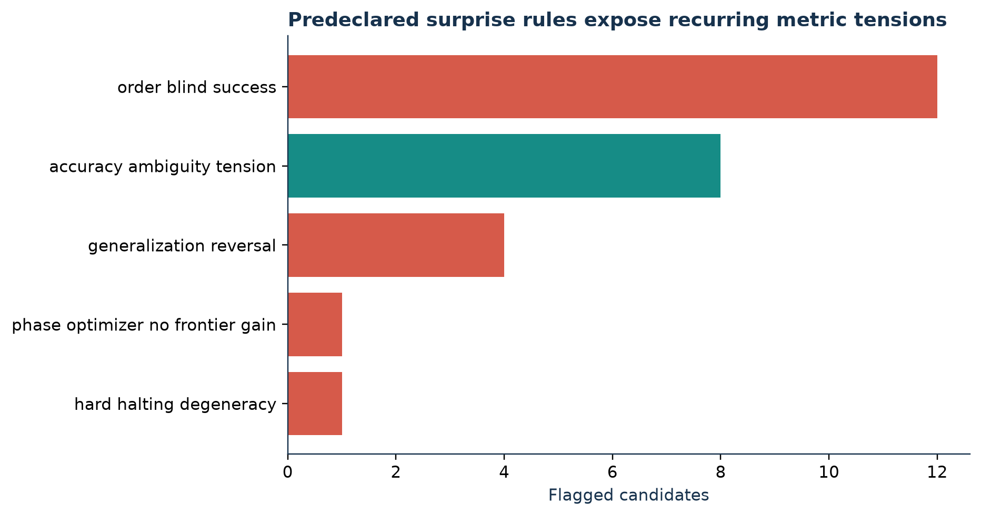
Figure 20 | Predeclared surprise rules identify recurring tensions rather than a single breakthrough law. Order blindness and accuracy–ambiguity conflict dominate; optimizer and halting proposals are rejected by their controls.
This is a healthier role for automated discovery than searching a large result table for the largest favorable number. The engine emits candidate proposals with counterevidence and confidence, but the data that select a proposal cannot confirm it. Its output is a queue for new preregistered studies.

Near-term research program
The highest-priority experiment is independent causal replication. A second generator should preserve only the abstract requirements—signed evidence, temporal interventions, missingness, and ambiguous equivalence classes—while changing factor definitions, observation mechanics, and code ownership. The primary endpoint should be complex-minus-strongest-real moderate-shift top-1, with ambiguity NLL and calibration as co-primary safety metrics.
The second priority is ambiguity-aware learning. Compare set-valued cross-entropy, proper partial-identification scores, density-state supervision, and a real operator baseline. Success requires moving probability mass toward the valid set without materially reducing shifted accuracy.
The third priority is real-equivalence stress testing. Implement explicit block-real versions of every complex operation, match initialization and optimizer statistics, and test whether constraints rather than arithmetic produce the effect. If block-real equivalence erases the difference, the useful contribution becomes the structural constraint. If a gap remains under matched optimization, it deserves closer theoretical analysis.
Only after those steps should the project consider governed real-world data. The present repository supplies the reproducible baseline against which such work can fail clearly.

Conclusion
Q-Neuro tests whether an ordered complex hypothesis state is a useful computational bias for sequential synthetic diagnosis. Across a registered program of corrected baselines, unseen worlds, orthogonal tasks, eighteen dynamical laws, ablations, probes, training laws, hard execution, and trajectories, one result persists: the complex operator is more robust than the tested real and conventional controls under the declared NeuroWorld shifts, and order, phase-sensitive measurement, and negative evidence each contribute.
The same evidence rejects a general superiority claim. GRU is more source-data-efficient, real operators are much better on irreducible ambiguity, source calibration does not transport, OOD separation is not unique, adaptive depth degenerates, and unconventional learning laws do not improve the frontier. Complex dynamics are a conditional tradeoff, not a universal replacement for neural networks.
The scientific contribution is a reproducible way to ask the question without hiding the answer’s boundaries. Every table and figure is generated from registered artifacts; failed ideas and superseded runs remain visible; the paper, Word document, PDF, dashboard, and repository are synchronized. The next claim must come from independent causal replication, not stronger language applied to the same simulator.

Extended methods and supplementary results

A. Repository and registry design
The repository separates simulator code, model implementations, experiment runners, configurations, registered artifacts, paired analyses, figure scripts, dashboard assets, paper sources, and tests. Every runner writes to a unique QN identifier. The SQLite registry is an index; the JSON artifact is the portable record. A failed QN-000024 run is retained with its status so that sequential numbering and debugging history remain auditable.
Configurations are YAML and include generator parameters, split sizes, seeds, model hyperparameters, optimizer settings, and evaluation worlds. Artifacts contain aggregate summaries and per-run metrics with sample standard deviation and Student-t intervals. Analysis files record paired contrasts separately from headline metrics. The discovery stage reads those artifacts and cannot modify experimental results.

B. Reproduction commands
The locked Python environment is installed with make sync. make test runs the test suite and make lint checks repository formatting. Individual Make targets rerun Experiment Zero, sample efficiency, generator shift, robustness, task suite, active evidence, dynamics, ablations, observables, training laws, hard halting, trajectories, and discovery. make figures regenerates every PNG and vector PDF from result files. make paper rebuilds tables, modular LaTeX, DOCX, and the PDF; make reproduce-paper verifies cached artifacts and performs the complete publication build.
Full retraining is intentionally not part of the default paper target because it is slower and can produce hardware-dependent timing. Cached registered results are source artifacts, not manually transcribed numbers. Researchers who rerun training should use a new experiment identifier or preserve the existing directories before comparison.

C. Full-data saturation
The full-data study is useful primarily as a leakage and order sanity check. All ordered models solve the chronology pairs. Differences among 0.995, 0.999, and 1.000 source top-1 are not a sound basis for an architectural claim. The unordered MLP’s zero pair accuracy validates the construction.
The phase-scramble result is similarly bounded. A fitted complex network can distribute information across phase and magnitude, so perturbing phase should hurt. Comparative evidence requires retrained controls, which are provided by the two-channel and magnitude-only ablations.

D. Strong-control generator shift
At 1,000 cases under the noisy/sparse shift, both chronology markers are observed in 49.1% of twin cases. The complex model scores 0.998 when the marker evidence is complete and 0.380 when incomplete. Counterfactual pairs expose both markers and vary only order; complex solves 0.991 of pairs, compared with 0.844 for two-channel real. The model cannot infer absent causal evidence reliably, even when its ordered rule is strong.
Generator shifts are constructed without model-specific optimization, but they share causal code. The five-world hierarchy is used to avoid treating thousands of cases from one generator instance as independent evidence. A true external replication requires new causal code.

E. Active acquisition details
Expected information gain evaluates positive and negative counterfactual outcomes for every unqueried finding, weights them by a diagnosis-conditioned outcome model, and selects the lowest expected posterior entropy. This adds substantial forward-pass cost: for the complex model, evaluating 200 cases takes approximately 5.43 s, compared with 1.20 s for fixed order. Query costs are otherwise assumed equal.
The fixed policy ranks findings by mutual information computed on training data. It is competitive for several models and much better than expected information for the Transformer. This demonstrates that a simpler policy can be safer when model probabilities under partial evidence are misspecified.

F. Unconventional dynamics
The energy and adaptive attractors use averaged evidence force and therefore cannot represent chronology. Their failure on pair accuracy is a specification consequence rather than an optimization surprise. The adaptive model’s soft expected depth is logged but never converted into a compute claim.
The Hamiltonian-style operator uses a real diagonal plus complex low-rank Hermitian action. Pure and hybrid variants share injection and readout. The discrete update is normalized, so conservation is approximate. The dissipative-only failure suggests that elimination needs structured, hypothesis-dependent damping.
Density dynamics factorizes the diagnosis-space state. Numerical invariant tests pass across ranks. Rank two is selected for the main suite before the rank ablation; the rank sweep provides no evidence for added relational capacity.

G. Training-law diagnostics
At 1,000 cases, diagnosis-only AdamW obtains 0.971 source top-1 and 0.620 shift top-1 in the training-law configuration. Multi-objective AdamW and PCGrad reach 0.978 source and 0.635 shift. Phase Gradient Optimization reaches 0.978 and 0.633 while taking 5.43 s versus 2.96 s for AdamW. Weakly positive task-gradient cosines explain why conflict-specific rotation has little opportunity.
Transition-local plasticity makes zero backward calls and trains in 1.25 s, reaching 0.642 source and 0.137 shift top-1. ZeroBackprop reaches 0.133 and 0.139. The local rule learns something, but not a robust diagnostic state. Hybrid local-plus-global training reaches 0.998 source and 0.419 shift, consistent with source locking.

H. Hard-halting threshold selection
Candidate velocity thresholds are evaluated on source validation under predefined accuracy and NLL tolerances. The selected threshold causes every case to exit at the minimum step two. Compared with soft eight-state evaluation, this reduces state computations by 75% and measured latency by roughly 80%. Because the distribution is degenerate, difficulty-conditioned execution is not established.
Later attractor steps reduce confidence quality without improving accuracy. The correct baseline for future work is therefore fixed depth two, not the original eight-step or soft ACT model.

I. Statistical cautions
Student-t intervals are reported because seed and world counts are small and variance is estimated. They are not corrected for the large number of explored comparisons. Exact sign-flip tests cannot resolve conventional significance thresholds with only three paired seeds. The analysis prioritizes repeated direction across unseen worlds and targeted ablations.
Case-level bootstrap intervals would be misleading for generator robustness because cases share one world. The hierarchy averages training seeds within world and uses world means as observations. A future study should preregister at least twenty independently generated worlds or use a hierarchical model with enough top-level units.

J. Failure inventory
The repository’s failure ledger records why each plausible idea was tested, what happened, why it likely failed, and whether it is worth revisiting. It includes full-data saturation, asymmetric inputs, GRU source dominance, calibration transport, easy composition, ambiguity collapse, model-conditioned acquisition failure, generic dissipation, soft-depth accounting, graph oversmoothing, density-rank non-benefit, non-unique probes, phase-gradient non-benefit, local source locking, and hard-halting degeneracy.
Preserving these outcomes changes the research program. It redirects work from adding architectural ornament toward independent generators, ambiguity-aware objectives, real-equivalence controls, and causal state interventions.

K. Artifact integrity
Figures read the registered metrics and emit PNG plus vector PDF. Tables read the same JSON and emit machine-readable JSON plus LaTeX. The Word and PDF builders consume those outputs. The dashboard uses a generated JavaScript data bundle. Continuous integration rebuilds the dashboard and checks for an unexpected diff.
The paper source deliberately avoids external patient data, secrets, checkpoints, and large binaries. The Git history separates experiments, analyses, dashboard, literature audit, figures, and manuscript. A release artifact can therefore be inspected at the level of both claim and commit.

L. AI-assistance disclosure
An OpenAI Codex agent assisted with code implementation, experiment orchestration, documentation, figure and document generation, prior-art retrieval, and manuscript drafting. The agent was instructed to preserve negative results and refuse unsupported claims. The human author should independently verify every scientific statement before submission and obtain any journal-specific disclosure language required at the time of submission.

M. Checklist for external replication
- Freeze the primary and co-primary endpoints before model training.
- Implement a separately authored causal generator with new factor and observation mechanics.
- Include tuned GRU, state-space, real operator, two-channel, block-real-equivalent, and complex controls.
- Use enough independent world seeds for stable top-level uncertainty.
- Report ambiguity NLL, valid-set mass, calibration, and compute alongside accuracy.
- Select hyperparameters without shifted test labels.
- Preserve failed and superseded runs in a public registry.
- Release code, configurations, raw summaries, and generated artifacts.
- Prohibit clinical interpretation unless a separate governed validation program succeeds.

References
1. Trabelsi, C. et al. Deep complex networks. International Conference on Learning Representations (2018).
2. Arjovsky, M., Shah, A. & Bengio, Y. Unitary evolution recurrent neural networks. Proceedings of ICML 48, 1120–1128 (2016).
3. Jing, L. et al. Tunable efficient unitary neural networks. Proceedings of ICML 70, 1733–1741 (2017).
4. Helfrich, K., Willmott, D. & Ye, Q. Orthogonal recurrent neural networks with scaled Cayley transform. Proceedings of ICML 80, 1969–1978 (2018).
5. Wang, Z. et al. Context effects produced by question orders reveal quantum nature of human judgments. Proceedings of the National Academy of Sciences 111, 9431–9436 (2014).
6. Trueblood, J. S. & Busemeyer, J. R. A quantum probability model of causal reasoning. Frontiers in Psychology 3, 138 (2012).
7. Meyer, F. & Lewis, M. Modelling lexical ambiguity with density matrices. Proceedings of CoNLL, 276–290 (2020).
8. Yan, H. et al. LI-QiLM: A quantum-inspired language model for text classification. Proceedings of NAACL, 1864–1878 (2024).
9. Srinivasan, S., Gordon, G. & Boots, B. Learning hidden quantum Markov models. Proceedings of AISTATS 84, 1979–1987 (2018).
10. Greydanus, S., Dzamba, M. & Yosinski, J. Hamiltonian neural networks. Advances in Neural Information Processing Systems 32 (2019).
11. Chen, R. T. Q. et al. Neural ordinary differential equations. Advances in Neural Information Processing Systems 31 (2018).
12. Bai, S., Kolter, J. Z. & Koltun, V. Deep equilibrium models. Advances in Neural Information Processing Systems 32 (2019).
13. Ramsauer, H. et al. Hopfield networks is all you need. International Conference on Learning Representations (2021).
14. Gu, A., Goel, K. & Ré, C. Efficiently modeling long sequences with structured state spaces. International Conference on Learning Representations (2022).
15. Graves, A. Adaptive computation time for recurrent neural networks. arXiv:1603.08983 (2016).
16. Bolukbasi, T. et al. Adaptive neural networks for efficient inference. Proceedings of ICML 70, 527–536 (2017).
17. Li, Y. & Oliva, J. B. Active feature acquisition with generative surrogate models. Proceedings of ICML 139, 6450–6459 (2021).
18. Yu, T. et al. Gradient surgery for multi-task learning. Advances in Neural Information Processing Systems 33, 5824–5836 (2020).
19. Lillicrap, T. P. et al. Random synaptic feedback weights support error backpropagation for deep learning. Nature Communications 7, 13276 (2016).
20. Scellier, B. & Bengio, Y. Equilibrium propagation: bridging the gap between energy-based models and backpropagation. Frontiers in Computational Neuroscience 11, 24 (2017).
21. Guo, C. et al. On calibration of modern neural networks. Proceedings of ICML 70, 1321–1330 (2017).
22. Hendrycks, D. & Gimpel, K. A baseline for detecting misclassified and out-of-distribution examples in neural networks. International Conference on Learning Representations (2017).
23. Thiagarajan, J. J. et al. DDxNet: a deep learning model for automatic interpretation of electronic health records. Scientific Reports 10, 16954 (2020).
24. Liang, H. et al. Evaluation and accurate diagnoses of pediatric diseases using artificial intelligence. Nature Medicine 25, 433–438 (2019).
25. Selvan, R. & Dam, E. B. Tensor networks for medical image classification. Proceedings of MIDL 121, 721–732 (2020).

