Bluestock Mutual Fund Analytics Capstone Project
Executive Summary
The Mutual Fund Analytics Capstone Project aims to develop a comprehensive analytics platform for analyzing mutual fund industry data. The project covers the complete data analytics lifecycle, including data ingestion, cleaning, database design, exploratory data analysis, performance analytics, risk analytics, investor behavior analysis, and dashboard development.
The solution was developed using Python, SQLite, Jupyter Notebooks, and Streamlit. Multiple datasets related to mutual funds, investor transactions, assets under management (AUM), SIP inflows, portfolio holdings, and benchmark indices were integrated into a unified analytics framework.
The project provides valuable insights into fund performance, investor behavior, risk metrics, and industry trends. Advanced analytical techniques such as Sharpe Ratio, Sortino Ratio, Alpha-Beta Analysis, Value at Risk (VaR), Conditional Value at Risk (CVaR), and portfolio concentration measures were implemented to support investment decision-making.

1. Introduction
The Indian mutual fund industry has experienced significant growth over the past decade due to increasing investor awareness, digital accessibility, and systematic investment plans (SIPs). Investors require reliable analytics tools to evaluate fund performance, assess risks, and identify suitable investment opportunities.
The objective of this project is to build a complete mutual fund analytics solution capable of processing large datasets and generating meaningful insights through statistical analysis and visualization.

2. Project Objectives
The key objectives of this project are:
- Build a robust data ingestion pipeline.
- Clean and validate mutual fund datasets.
- Design a relational database for storing analytics data.
- Perform exploratory data analysis.
- Calculate performance metrics for mutual funds.
- Conduct advanced risk analysis.
- Develop an interactive dashboard.
- Generate actionable business insights.

3. Data Sources
The project utilizes multiple datasets including:
Fund Master
Contains scheme information such as AMFI code, scheme name, category, sub-category, and risk grade.
NAV History
Historical Net Asset Value records for multiple mutual fund schemes.
Investor Transactions
Contains SIP, lumpsum, and redemption transactions.
AUM Dataset
Assets under Management data across various fund houses.
SIP Inflows
Monthly SIP investment trends.
Category Inflows
Net inflows by mutual fund category.
Portfolio Holdings
Portfolio sector allocation and stock-level holdings.
Benchmark Indices
Historical NIFTY 50 and NIFTY 100 index data.

4. Technology Stack
The project was implemented using:
- Python
- Pandas
- NumPy
- SQLite
- SQLAlchemy
- Matplotlib
- Seaborn
- Plotly
- Streamlit
- Jupyter Notebook
- Git & GitHub

5. ETL Design
Data Ingestion
Raw CSV datasets were imported into Python using Pandas. Additional NAV information was fetched through API integration.
Data Cleaning
The following cleaning activities were performed:
- Missing value handling
- Duplicate removal
- Date standardization
- Data type correction
- Transaction validation
- AMFI code verification
Data Storage
Cleaned datasets were stored in SQLite for efficient querying and analysis.

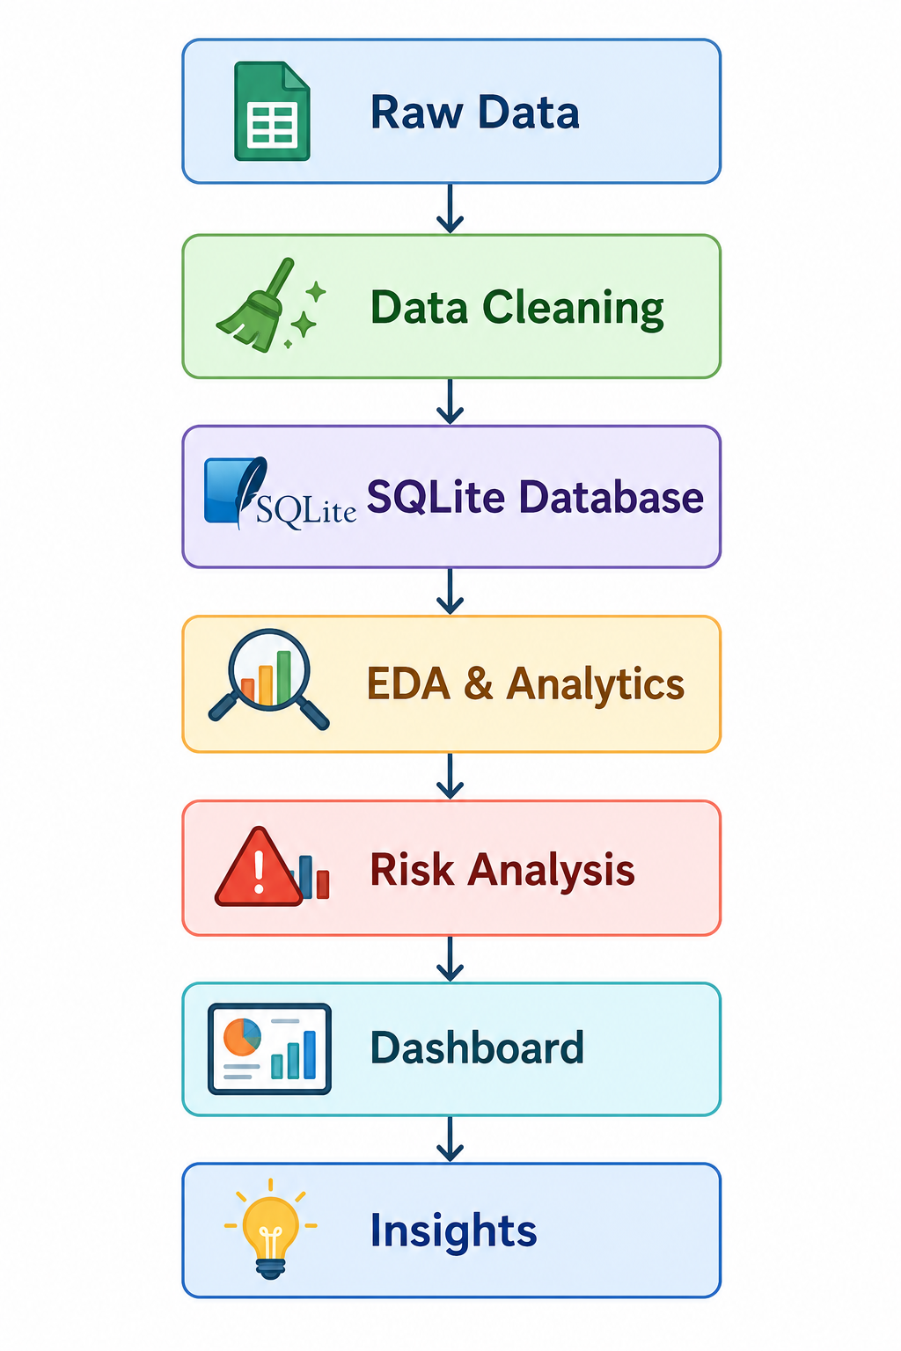

6. Database Design
A star schema approach was adopted.
Dimension Tables
- dim_fund
- dim_date
Fact Tables
- fact_nav
- fact_transactions
- fact_performance
- fact_aum
Primary and foreign keys were used to establish relationships between dimensions and facts.

7. Exploratory Data Analysis
EDA was conducted to identify industry trends and investment patterns.
Key Findings
Finding 1
Industry AUM showed steady growth between 2022 and 2025.
(Insert AUM Growth Chart)
Finding 2
SBI Mutual Fund maintained the highest AUM among all fund houses.
(Insert AUM by AMC Chart)
Finding 3
Monthly SIP inflows reached an all-time high of ₹31,002 crore in December 2025.
(Insert SIP Trend Chart)
Finding 4
Retail participation increased significantly as reflected in folio growth.
(Insert Folio Growth Chart)
Finding 5
Small-cap, flexi-cap, and mid-cap categories attracted substantial investor inflows.
(Insert Category Heatmap)

8. Fund Performance Analytics
Performance analytics were computed for all mutual fund schemes.
Daily Returns
Daily returns were calculated using:
Daily Return = (NAV_t / NAV_(t-1)) - 1
CAGR Analysis
1-Year and 3-Year CAGR values were calculated to evaluate long-term growth.
Sharpe Ratio
Sharpe Ratio was used to measure risk-adjusted returns.
Sharpe Ratio = (Rp − Rf) / σ
where:
- Rp = Portfolio Return
- Rf = Risk-Free Rate
- σ = Standard Deviation
Sortino Ratio
Sortino Ratio focuses only on downside volatility.
Alpha and Beta
Regression analysis against the NIFTY 100 benchmark was performed.
Maximum Drawdown
Maximum drawdown measured the largest peak-to-trough decline.
(Insert Benchmark Comparison Chart)

9. Advanced Risk Analytics
Value at Risk (VaR)
Historical VaR at the 95% confidence level was calculated.
Conditional VaR (CVaR)
CVaR estimates the average loss beyond the VaR threshold.
Rolling Sharpe Ratio
90-day rolling Sharpe Ratio was analyzed to evaluate consistency of fund performance.
(Insert Rolling Sharpe Chart)
Sector Concentration (HHI)
Portfolio concentration was measured using the Herfindahl-Hirschman Index (HHI).

10. Investor Analytics
Investor transaction data was analyzed to understand behavior patterns.
Cohort Analysis
Investors were grouped by their first investment year.
SIP Continuity Analysis
Investors with irregular SIP patterns were identified.
Geographic Analysis
State-wise investment contributions were analyzed.
Demographic Analysis
Age-group and gender-wise investment patterns were evaluated.

11. Fund Recommendation Engine
A rule-based recommendation system was developed.
Inputs
- Low Risk
- Moderate Risk
- High Risk
Output
Top three funds ranked by Sharpe Ratio within the selected risk category.
This module demonstrates how analytics can support investment decision-making.

12. Dashboard Development
An interactive dashboard was created to visualize industry trends and fund performance.
Dashboard Pages
- Industry Overview
- Fund Performance
- Investor Analytics
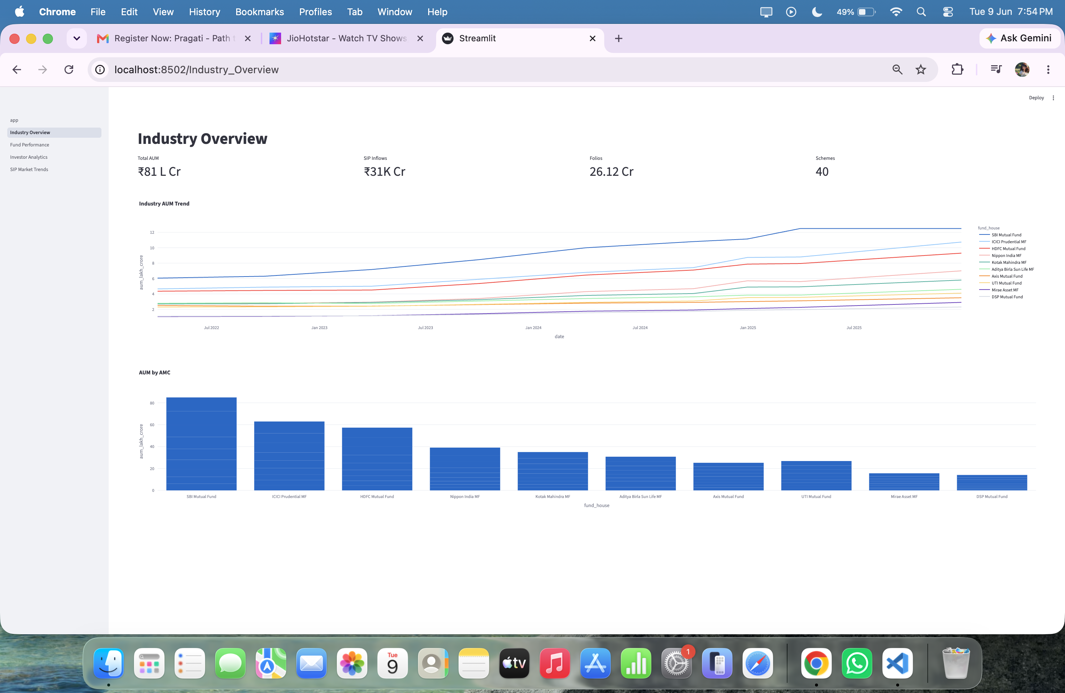
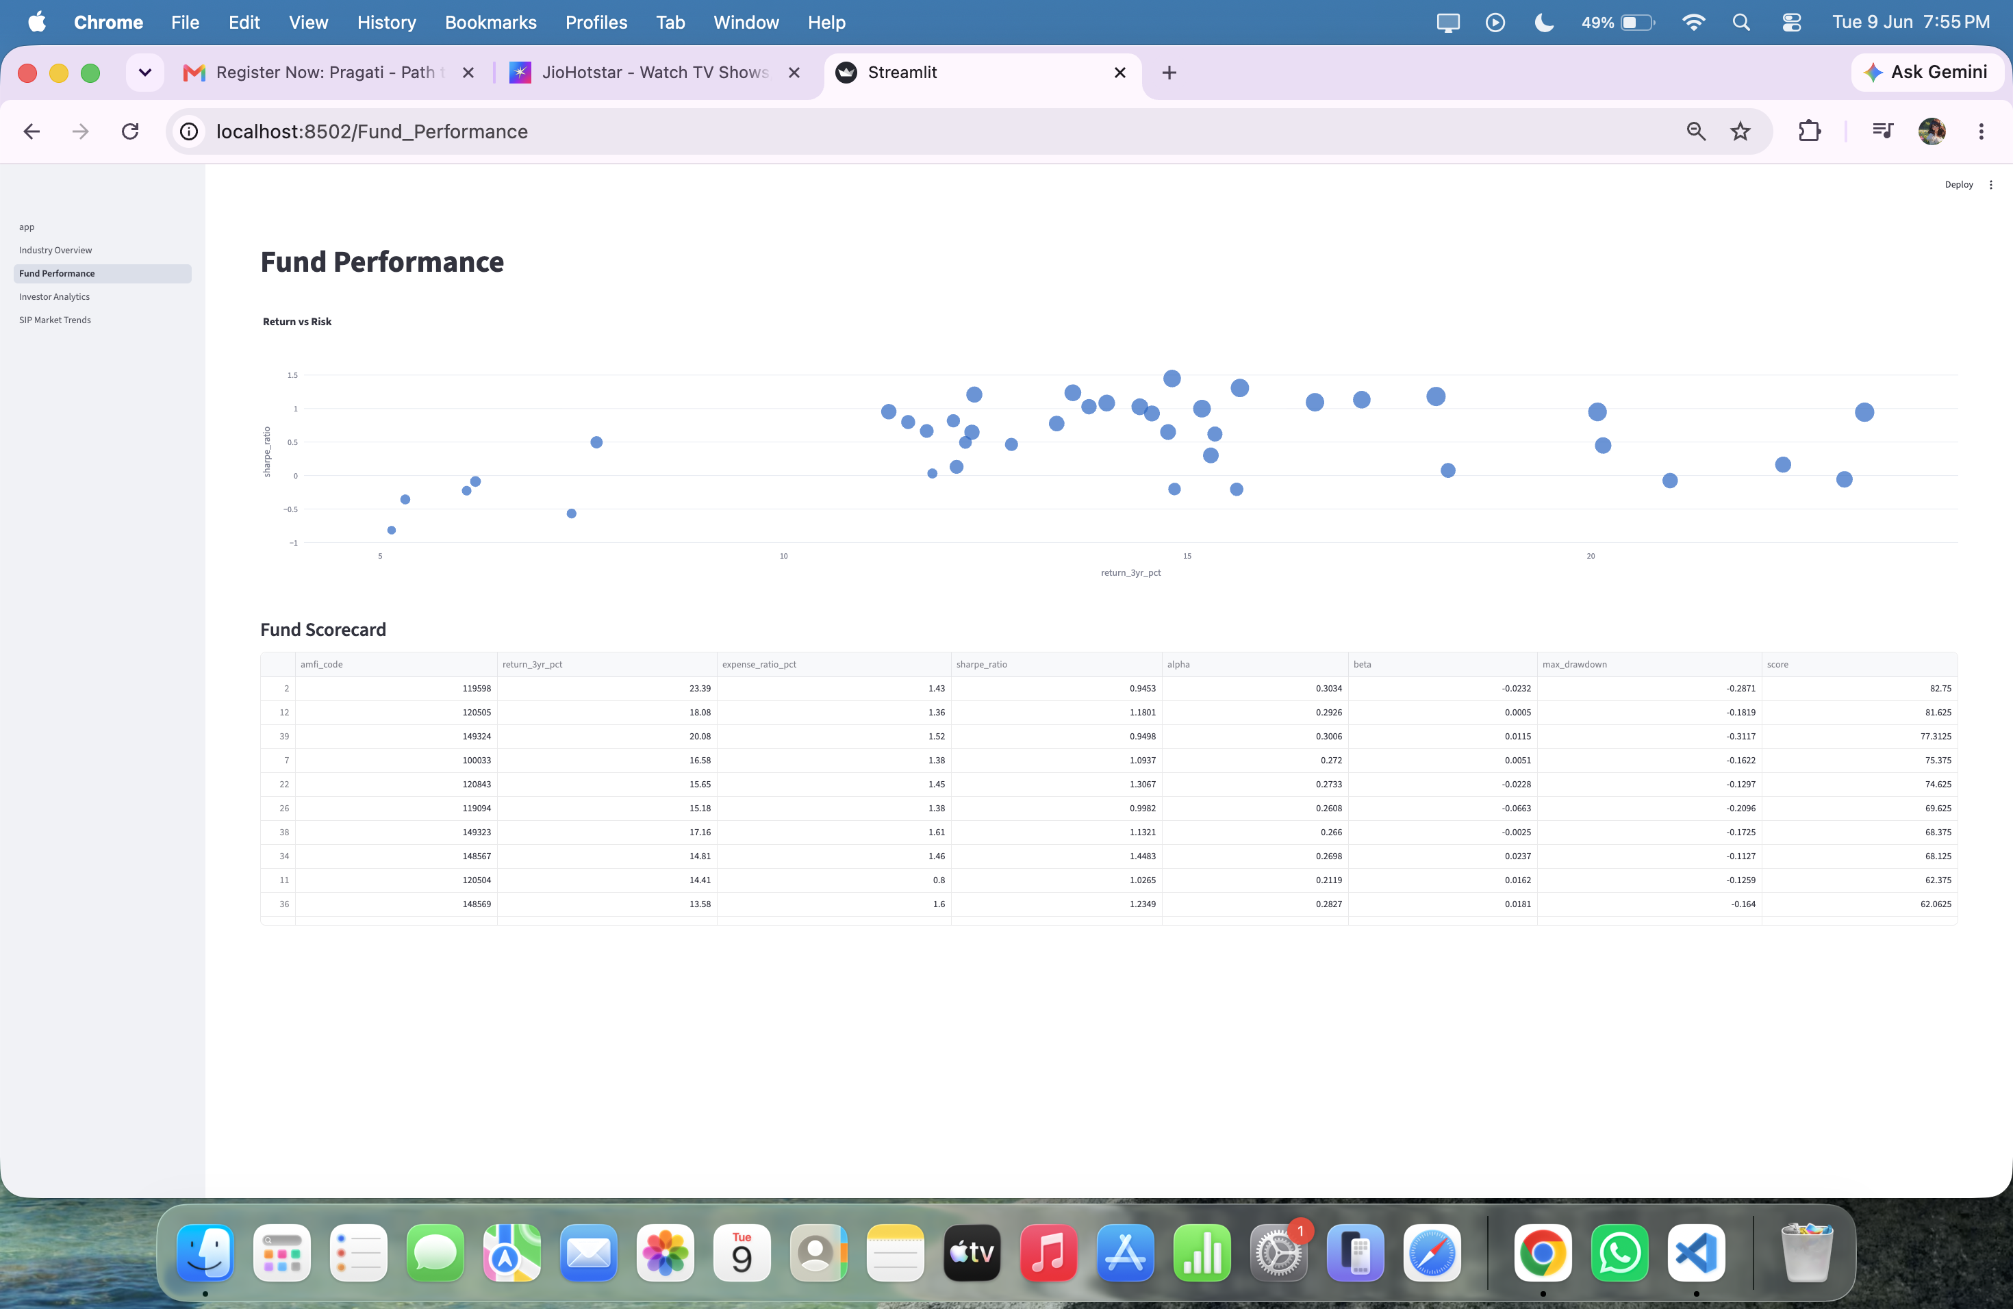
- SIP & Market Trends
(Dashboard Screenshot 1)

(Dashboard Screenshot 2)

(Dashboard Screenshot 3)
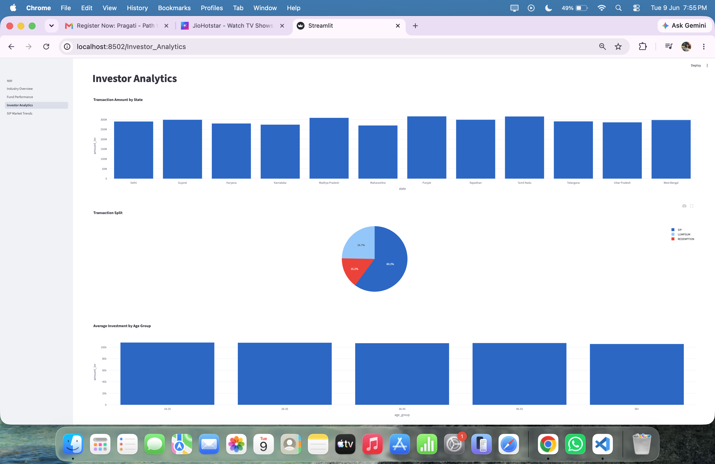
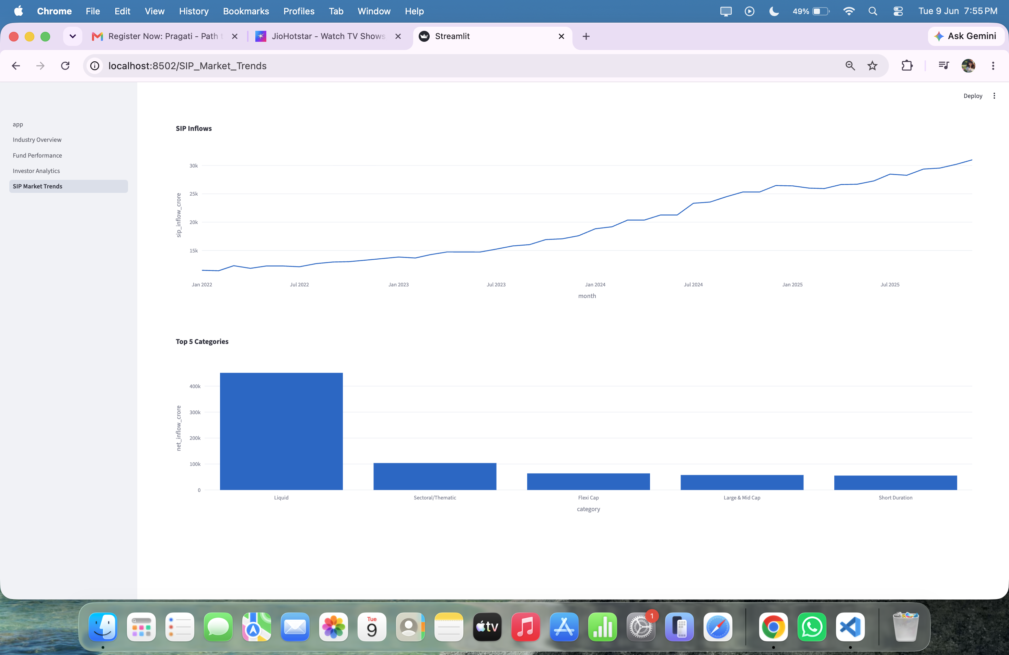
(Dashboard Screenshot 4)
Charts
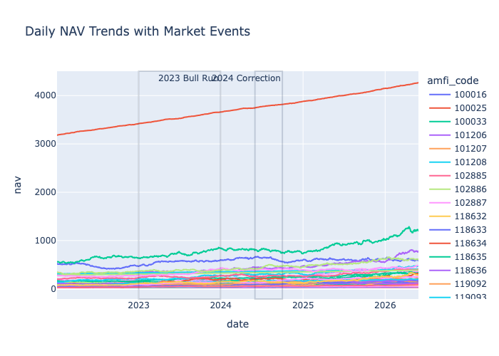
NAV Trends
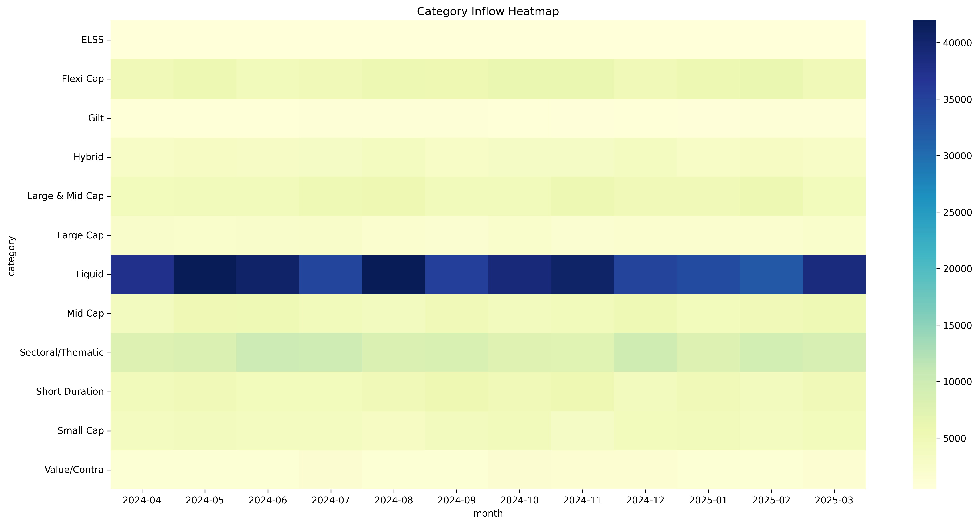
Category heat map
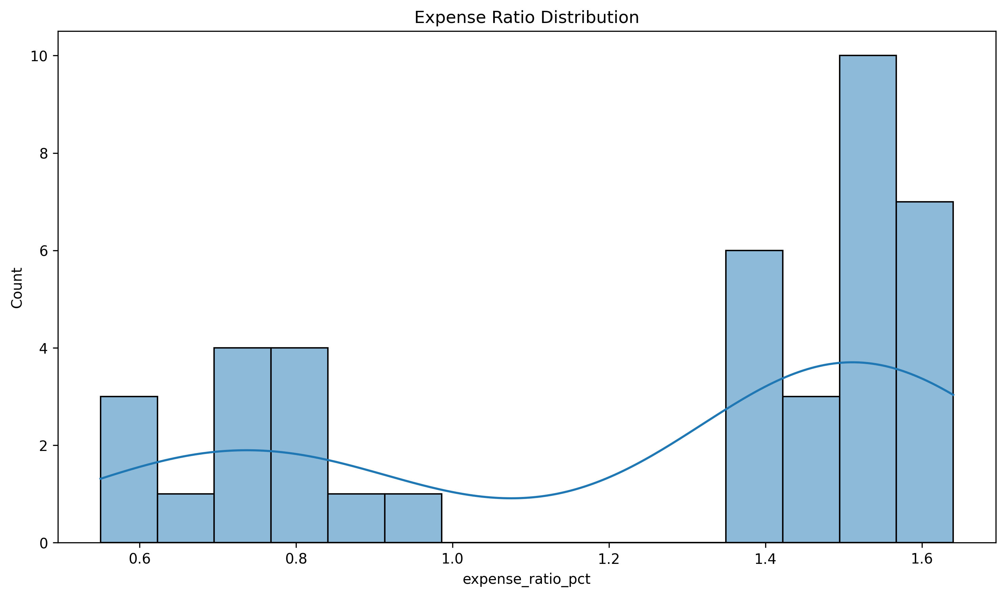
Expense ratio
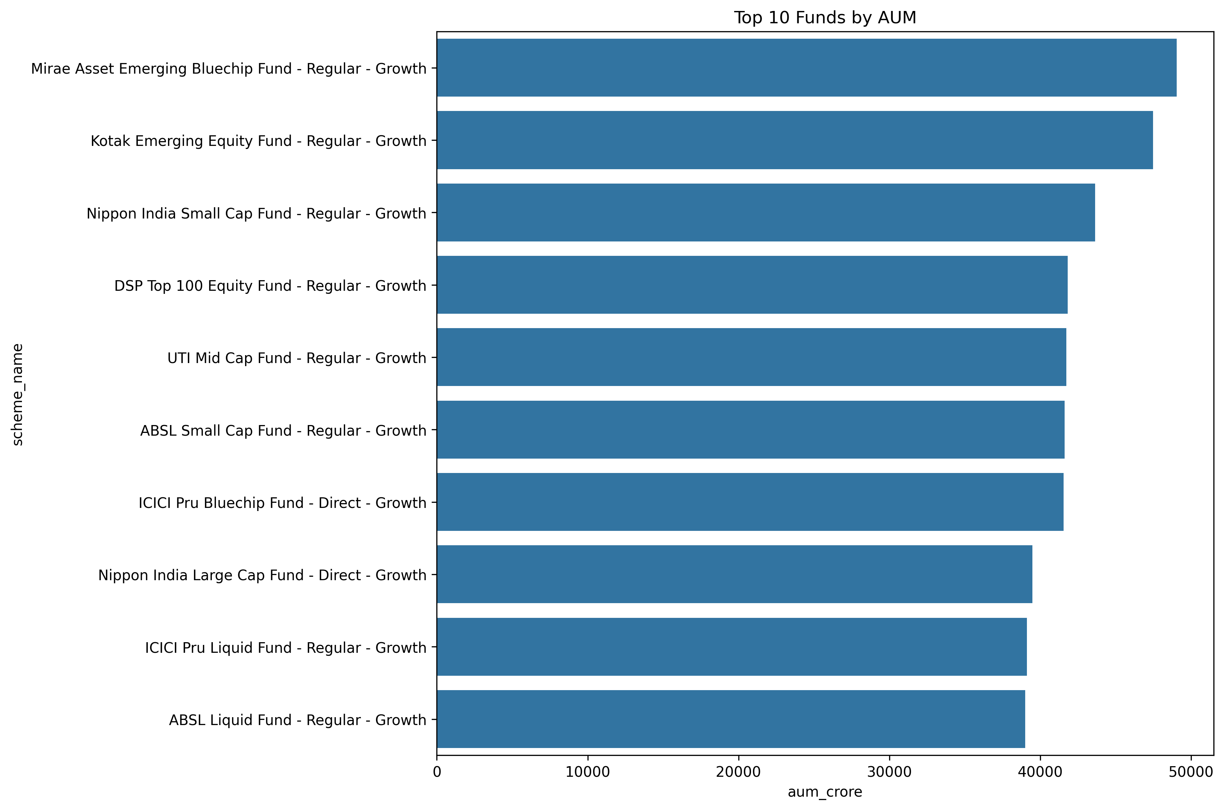
Top Funds

13. Limitations
The project has the following limitations:
- Historical NAV data does not cover a complete five-year period.
- Dashboard implementation was completed using Streamlit due platform constraints.
- Real-time market feeds are not integrated.
- Predictive analytics are outside the current project scope.

14. Recommendations
Future enhancements may include:
- Real-time NAV updates.
- Machine learning-based fund recommendations.
- Portfolio optimization models.
- Cloud deployment.
- Investor personalization features.
- Advanced forecasting models.

15. Conclusion
The Bluestock Mutual Fund Analytics Capstone successfully demonstrates an end-to-end analytics solution for the mutual fund industry. The project integrates data engineering, database management, exploratory analysis, risk analytics, performance measurement, and dashboard reporting into a unified platform.
The developed solution enables investors and analysts to evaluate mutual fund performance, understand market trends, assess risk exposure, and make data-driven investment decisions. The project showcases practical applications of data analytics and business intelligence techniques in the financial services domain.

