NOVACART
AI Customer Support and Ticket Automation System
Project Report
Internship Duration: July 6, 2026 – September 30, 2026

Prepared by:
Mullapudi Samyuktha

Table of Contents:
1. Abstract
2. Introduction
3. Problem Statement
4. Objectives
5. Scope of the Project
6. Functional Requirements
7. System Architecture
8. Technology Stack
9. Knowledge Base and RAG Pipeline
10. AI Agent and Tool Calling
11. Backend Implementation
12. Application Database
13. Conversation Memory
14. React Frontend and User Interface
15. Human Escalation and Ticket Automation
16. Error Handling and Reliability
17. Testing and Validation
18. Results
19. Security and Configuration
20. Limitations
21. Future Enhancements
22. Conclusion
1. Introduction
Customer-support systems need to answer repetitive questions while also handling transactional requests that require access to structured business information. A simple conversational model is insufficient when the system must retrieve an order, check a payment, create a support ticket, preserve context, and transfer complex cases to human support.
This requirement can be addressed by combining generative AI with retrieval, tools, APIs, persistent application data, and a React-based user interface. The result is an integrated customer-support application in which conversational responses are connected to operational capabilities.
NovaCart is an AI-powered customer support and ticket automation application designed to handle common customer-service requests through a conversational interface. The system combines a React frontend, FastAPI backend, retrieval-augmented generation (RAG), an AI agent, functional support tools, conversation memory, an application database, and human escalation.
The application can answer knowledge-base questions, retrieve order information, retrieve payment information, create or identify support tickets, handle escalation requests, and preserve the active conversation. The frontend presents these capabilities as an application rather than a basic chatbot, with order and payment information panels, ticket information, quick actions, timestamps, copy and feedback interactions, retry behavior, and conversation-management controls.
Testing was performed for normal queries, tool execution, invalid inputs, escalation, complex workflows, and API behavior. The completed implementation demonstrates an end-to-end AI customer-support workflow from customer interaction through retrieval, agent reasoning, tool execution, database access, and ticket escalation.

2. Problem Statement
The project addresses the problem of building an AI customer-support system that can understand customer queries, retrieve information from a knowledge base, use tools to perform support actions, maintain conversation context, create and manage support tickets, and escalate issues that require human intervention.
The system must also provide a usable frontend, reliable backend APIs, error handling, testing, and documentation suitable for an end-to-end application.

3. Objectives
- Build a working AI-powered customer-support application.
- Implement retrieval-augmented generation using a knowledge base and vector retrieval.
- Use an AI agent capable of deciding when tools are required.
- Provide functional tools for order, payment, ticket, and escalation workflows.
- Maintain conversation context through conversation memory.
- Expose backend capabilities through FastAPI APIs.
- Provide human escalation and ticket automation.
- Build a polished React user interface for real customer-support interaction.
- Implement error handling, testing, documentation, and evidence of functionality.

4. Scope of the Project
The system covers customer-support interactions involving orders, payments, refunds, shipping, account/support questions, support tickets, and human escalation. It is implemented as a local-stage application and is not dependent on deployment to a production cloud environment for the project submission.
The frontend and backend communicate through HTTP APIs. Structured business information is stored in the application database, while support knowledge is made available through the RAG pipeline.

5. Functional Requirements
- Customer chat interface for submitting support questions.
- Knowledge-base retrieval for informational questions.
- Order lookup using an order identifier.
- Payment-status lookup using an order identifier.
- Support-ticket creation and ticket visibility.
- Human escalation for explicit or automatically detected escalation cases.
- Conversation memory and persistent current-chat display after page refresh.
- Error handling for unavailable or invalid operations.
- Frontend support actions such as Order Lookup, My Tickets, Help Center, Track an order, Check payment, and Contact human support.
- User-interface feedback including loading state, retry behavior, copy actions, timestamps, response feedback, and clear-conversation confirmation.

6. System Architecture
- NovaCart follows a layered architecture.
- The customer interacts with the React frontend.
- The frontend communicates with the FastAPI backend.
- The backend coordinates the AI agent, RAG pipeline, conversation memory, application services, and APIs.
- The RAG pipeline retrieves relevant information from the knowledge base through vector search.
- The AI agent uses the retrieved context and available tools to determine how to respond.
- Tools access structured application data such as orders, payments, and tickets.
- Human escalation is represented through the ticket system.
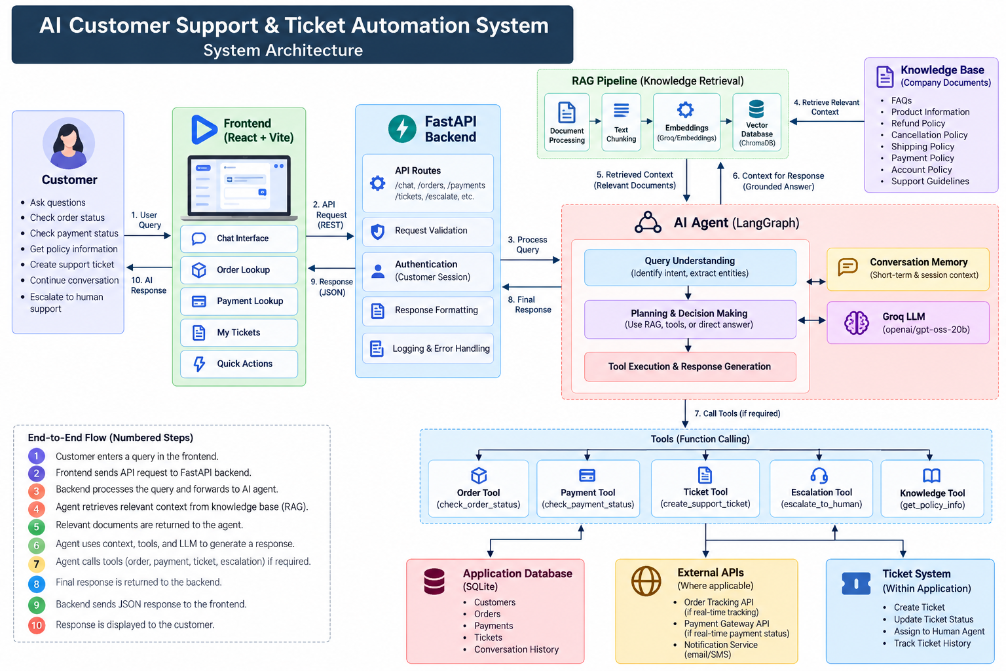
7. Technology Stack
- Frontend: React 19 with Vite and lucide-react icons.
- Backend: Python with FastAPI.
- AI/LLM: Groq-hosted language model configuration.
- Agent/RAG orchestration: LangChain/LangGraph components used within the implementation.
- Vector retrieval: vector database/retrieval layer used by the RAG pipeline.
- Database: SQLite with SQLAlchemy-based application services.
- Testing: Python test scripts and API/application validation.
- Configuration: environment variables using local .env files, with .env.example files committed without credentials.

8. Knowledge Base and RAG Pipeline
8.1 Knowledge Base
The NovaCart knowledge base provides the factual information required to answer customer-support questions. It contains support-oriented information covering areas such as frequently asked questions, products, shipping, refunds, cancellations, payments, and account-related policies.
The knowledge base is used for informational queries where the answer should be grounded in the organization's available support information rather than generated solely from the language model's internal knowledge.

8.2 RAG Pipeline
The system implements a Retrieval-Augmented Generation (RAG) pipeline to connect the language model with the support knowledge base.
The implemented workflow consists of the following stages:
- Document processing – Support documents are prepared for retrieval.
- Text extraction and chunking – Documents are divided into smaller meaningful sections.
- Embedding generation – Text chunks are converted into vector representations.
- Vector storage – The generated vectors are stored in the vector retrieval layer.
- Query processing – The customer's question is processed as a retrieval query.
- Similarity-based retrieval – Relevant knowledge-base chunks are retrieved.
- Context construction – Retrieved information is provided as contextual information to the AI workflow.
- Response generation – The language model generates a response using the retrieved context.
This architecture reduces dependence on the language model's internal knowledge and provides a mechanism for producing responses grounded in the application's support information. The report already describes this implemented flow as document processing, embeddings, vector retrieval, contextual prompt construction, and response generation.

8.3 Role of RAG in the Application
RAG is primarily used for questions involving policies and general support information. Transactional requests such as order and payment queries are handled through application tools that access structured operational data.
This separation allows the system to use:
- RAG for knowledge-based information.
- Tools for structured business information.
- AI agent reasoning to determine which capability should be used.

9. AI Agent and Tool Calling
9.1 AI Agent
The AI agent acts as the decision-making layer between the customer's request and the application's available capabilities.
Instead of treating every query as a simple text-generation request, the agent determines the appropriate processing path based on the user's request.

The possible processing paths include:
- Direct conversational response.
- Knowledge-base retrieval.
- Order lookup.
- Payment lookup.
- Ticket-related operation.
- Human escalation.
- Request for additional information.
This architecture separates language understanding from deterministic business operations.

9.2 Functional Tools
The application provides tools for operational support workflows, including:
- Order-status lookup.
- Payment-status lookup.
- Support-ticket operations.
- Human escalation.
- Knowledge retrieval.
When an operational query is received, the agent can invoke the appropriate tool rather than attempting to generate the information itself.
For example:
Customer:
"Where is my order 45821?"
Processing flow:
Customer Query → AI Agent → Order Lookup Tool → Application Database → Tool Result → AI Response
Similarly:
Customer Query → AI Agent → Payment Tool → Application Database → Payment Result → AI Response

9.3 Tool Results and Response Generation
The result returned by a tool is passed back into the AI workflow. The language model then converts the structured result into a natural-language response suitable for the customer.
This allows the system to combine:
- Natural-language interaction.
- Deterministic database operations.
- AI-generated explanations.

9.4 Escalation Decision
The agent also supports human escalation. An explicit request such as "I need to speak to a human" can trigger the escalation workflow. Configured escalation logic can also identify situations where human intervention is appropriate.

10. Backend Implementation
10.1 FastAPI Backend
The backend is implemented using Python and FastAPI. It acts as the central service layer between the React frontend, AI workflow, application services, database, and support tools.
The backend provides HTTP endpoints for the major application capabilities.
The implemented API surface includes:
- Chat processing.
- Health/status checking.
- Order lookup.
- Payment lookup.
- Ticket operations.
- Human escalation.

10.2 Request Processing
The general request flow is:
React Frontend
↓
FastAPI Endpoint
↓
Request Validation
↓
Application / Agent Workflow
↓
RAG / Tool / Escalation Logic
↓
Service Layer
↓
Database / Knowledge Base
↓
Response
↓
React Frontend

For a conversational request, the frontend sends the customer's message and conversation/thread information to the backend.
The backend validates the request and passes it to the AI support workflow.
The AI workflow determines whether the request requires:
- Knowledge retrieval.
- Tool execution.
- Direct response.
- Ticket creation.
- Human escalation.
The resulting response is returned to the frontend.

10.3 API Layer
The backend separates individual capabilities into API routes. This provides a clear HTTP interface for the frontend and allows individual services to be tested independently.
The main API groups are:
API area | Purpose
/chat | Processes customer conversations
/health | Checks backend availability
/orders/... | Retrieves order information
/payments/... | Retrieves payment information
/tickets/... | Handles ticket operations
/escalate/... | Handles human escalation

10.4 Service Layer
The API routes do not directly contain all business logic. They interact with application services responsible for performing operations such as retrieving orders and payments.
This separation allows business operations to be reused by both API routes and AI-agent tools. The report specifically notes that SQLAlchemy models and service classes separate database persistence from API and agent logic.

10.5 Validation and Error Handling
The backend validates incoming parameters and returns appropriate HTTP responses when operations cannot be completed.
Examples include:
- Invalid order identifiers.
- Orders that do not exist.
- Missing payment records.
- Tool execution failures.
- Unsuccessful API operations.
Instead of exposing raw internal exceptions to the customer, the backend converts failures into controlled responses.
10.6 API Documentation
FastAPI automatically provides interactive API documentation through Swagger/OpenAPI.
This allows the implemented endpoints to be inspected and tested independently of the React frontend.

11. Application Database
11.1 Database Technology
The application uses SQLite with SQLAlchemy for structured application data.
The database stores operational information required by the support application.

11.2 Database Usage
The database supports workflows including:
- Customer/order information.
- Order status.
- Product information.
- Payment information.
- Payment status.
- Support tickets.
- Ticket status.
- Escalation-related information.
The database therefore acts as the source of structured transactional information for the application's operational tools.

11.3 Database and AI Tools
The relationship between the agent and database can be represented as:
Customer Query
↓
AI Agent
↓
Appropriate Tool
↓
Application Service
↓
SQLAlchemy
↓
SQLite Database
↓
Structured Result
↓
AI Agent
↓
Customer Response
This architecture prevents the language model from inventing transactional information. Instead, operational information is obtained from the application database through deterministic application logic.

12. Conversation Memory
Conversation memory allows the system to maintain context across multiple messages rather than processing every customer message as an independent conversation. The application uses a thread identifier to associate messages with the active conversation.
12.1 Conversation Flow
For example:
User: Where is my order 45821?
↓
Assistant: Your order 45821 is currently shipped...
↓
User: When will it arrive?
↓
Conversation Thread
↓
Previous Context
↓
Assistant understands the reference
The thread identifier allows messages belonging to the same interaction to remain associated with one another.
12.3 Browser Refresh Persistence
In addition to conversational context, the frontend preserves the current chat state so that the active conversation remains visible after the browser is refreshed.
This improves the application experience by making the interface behave like a persistent support workspace rather than a temporary chat page.

13. React Frontend and User Interface
The React frontend provides the main customer-facing application. The interface is organized into :
- a header
- left navigation and quick-action area
- central conversation workspace
- right-side support-information panel.
The interface displays order information and payment information when relevant, and shows support-ticket status after escalation. Quick actions allow customers to start common workflows without manually composing every query.
Additional usability features include:
- formatted AI responses
- copy controls
- timestamps
- retry handling for failed responses
- response feedback and escalation feedback
- conversation clearing with confirmation
- persistent current-chat display.

14. Human Escalation and Ticket Automation
14.1 Purpose
Human escalation provides a controlled transition from automated AI support to human support when the AI system should not handle the issue independently.
Escalation can occur when:
- The customer explicitly requests human support.
- The configured escalation logic determines that human intervention is required.
- A complex or exceptional support situation requires additional assistance.

14.2 Escalation Workflow
The implemented workflow can be represented as:
Customer Request
↓
AI Agent
↓
Escalation Required?
↓
Yes
↓
Create / Reference Support Ticket
↓
Ticket ID Generated
↓
Escalation Status Returned
↓
Frontend Displays Ticket Information
↓
Customer Informed
The system creates or references a support ticket and communicates the ticket identifier to the customer.

14.3 Frontend Escalation Feedback
After escalation, the right-side support panel displays relevant information such as:
- Ticket ID.
- Ticket status.
- Confirmation that human support has been notified.
This provides visible confirmation that the customer's request has moved beyond the automated support workflow.

14.4 Example Workflow
For example:
Customer: "I need help from a human agent."
System:
- Detects explicit human-support request.
- Activates escalation workflow.
- Creates/references the support ticket.
- Returns the ticket ID.
- Displays the ticket in the support panel.
- Informs the customer that human support has been notified.
This demonstrates that escalation is integrated into the application rather than being a separate manual process

15. Error Handling and Reliability
Error handling was implemented at both the backend and frontend levels.
The backend validates incoming requests and handles situations such as:
- Invalid order identifiers
- Missing records
- Invalid operations
- Tool failures
- Unsuccessful API operations
Appropriate HTTP error responses are returned instead of allowing failures to propagate as unhandled application errors.
The frontend also handles unsuccessful requests and provides user-visible feedback. For failed AI responses or applicable failed operations, the interface provides a retry mechanism.

16. Testing and Validation
Testing covered API endpoints, agent behavior, RAG retrieval, tool execution, escalation, failure scenarios, and frontend integration. Representative tests included:
- knowledge-base questions
- valid order lookup
- invalid order lookup
- payment-status queries
- explicit human-support requests
- tool failure scenarios
- complex order/payment escalation workflows.
17. Results
The completed system demonstrates an end-to-end AI customer-support application rather than a basic chatbot. Customers can ask knowledge-base questions, retrieve operational information, interact with support tools, view structured information in the UI, and escalate cases to human support. The final interface presents the conversational response together with contextual support information, including order, payment, and ticket details. The system therefore combines generative responses with deterministic application functionality.

17.1. Overall System Result
The final system consists of a React-based frontend, FastAPI backend, AI agent, retrieval-augmented generation (RAG) pipeline, vector retrieval layer, application database, functional support tools, conversation memory, and ticket escalation mechanisms.
The final implementation therefore demonstrates the integration of generative AI with practical customer-support operations. The system can process a customer request, determine whether knowledge retrieval or a functional tool is required, obtain the required information, and return the result through the customer-facing interface.

17.2. Knowledge Base and RAG Results
The implemented RAG pipeline successfully supports informational customer queries using the project's knowledge base. The pipeline processes the available support information, generates embeddings, performs vector-based retrieval, and supplies relevant retrieved context to the response-generation stage.
It allows the AI system to answer knowledge-based questions using information retrieved from the configured knowledge base rather than treating every question as a purely generative task. The knowledge-base/RAG screenshot evidence is attached below.
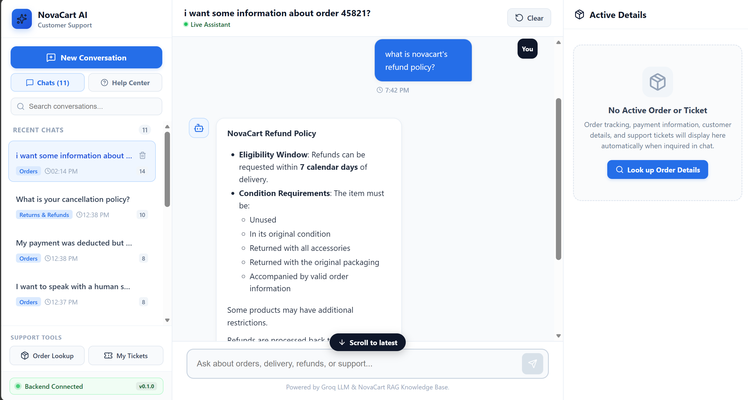

17.3. AI Agent and Tool-Calling Results
The AI agent successfully acts as the decision-making layer between customer queries and the available support functionality.
The agent is capable of distinguishing between informational questions and requests requiring operational data. When structured business information is required, the appropriate support tool can be invoked instead of generating an unsupported response.
For example, when a customer asks about an order, the system can use the order-support functionality to retrieve the corresponding information from the application database. Similarly, payment-related requests can be processed through the payment workflow.
This demonstrates that the AI component is not being used only for text generation. It is integrated with functional application services and structured data.
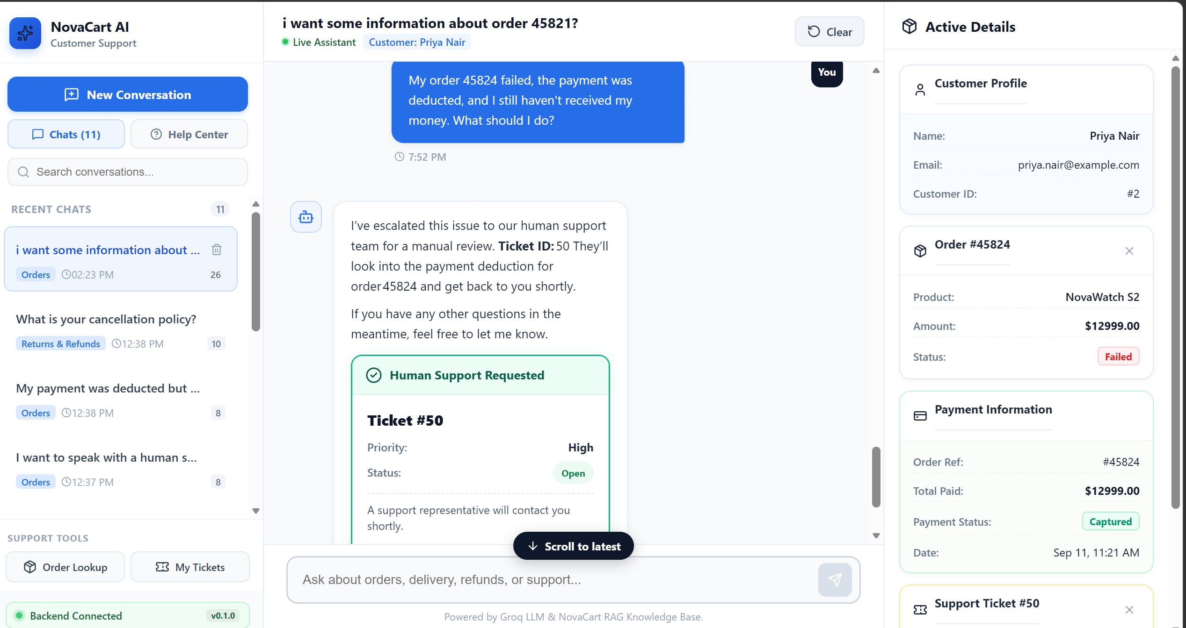

17.4. Order Lookup Results
The Order Lookup workflow was successfully implemented and validated.
A customer can enter an order-related query through the conversational interface or use the Track an Order / Order Lookup functionality provided by the frontend.
The workflow performs the following operations:
- Receives the customer's order-related request.
- Identifies the order identifier from the request.
- Routes the request through the backend and support service.
- Retrieves the corresponding order information from the application database.
- Returns the structured result to the AI workflow.
- Displays the response to the customer.
- Displays relevant order information in the right-side support-information panel.
The frontend can display information such as the order identifier, product, amount, status, tracking information, and expected delivery information when available.
This validates the integration between the conversational interface, AI agent/tool workflow, FastAPI backend, service layer, database, and React frontend.
Order Lookup screenshot is attached below:
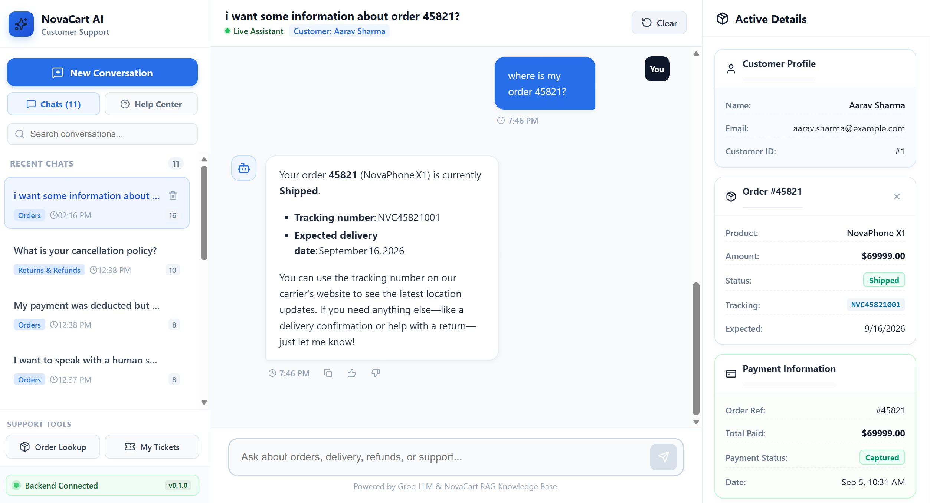

17.5. Payment Information Results
The Payment Information workflow was also successfully implemented and tested.
When a customer asks about the payment status of an order, the system identifies the relevant order and retrieves the corresponding payment information through the payment-support workflow.
The retrieved information is presented through both the conversational response and the frontend support-information panel when applicable.
The workflow demonstrates the following integration:
Customer Query → React Frontend → FastAPI Backend → AI Agent/Payment Tool → Application Database → Payment Result → Frontend
The implementation allows the customer to obtain payment-related information without requiring direct interaction with the underlying database.
This demonstrates the ability of the application to connect conversational AI with structured financial transaction information stored within the application's demonstration database.

Screenshot is attached below:
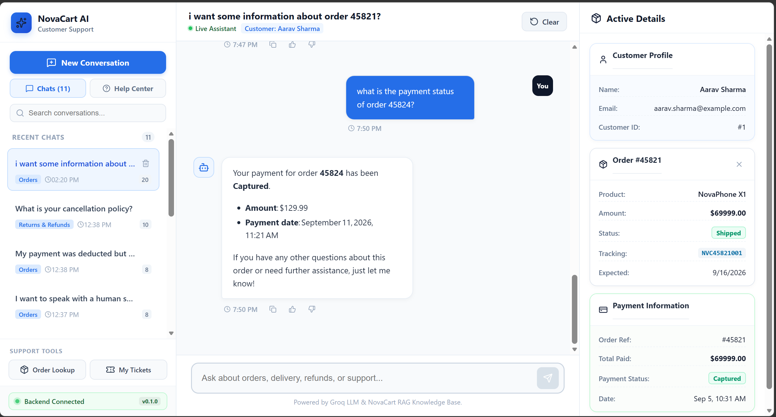
17.6. My Tickets and Ticket Management Results
The My Tickets functionality was implemented as part of the application's ticket-management workflow.
The system can create or reference support tickets associated with customer-support interactions. Ticket information can subsequently be displayed through the frontend.
The ticket workflow provides visibility into:
- Ticket identifier
- Ticket status
- Support-ticket information
- Escalation-related ticket information
The implementation provides a structured mechanism for moving from an AI-supported conversation to a trackable support request.
This is particularly important for cases where the customer requires assistance beyond the capabilities of automated support.
Screenshot is attached below:
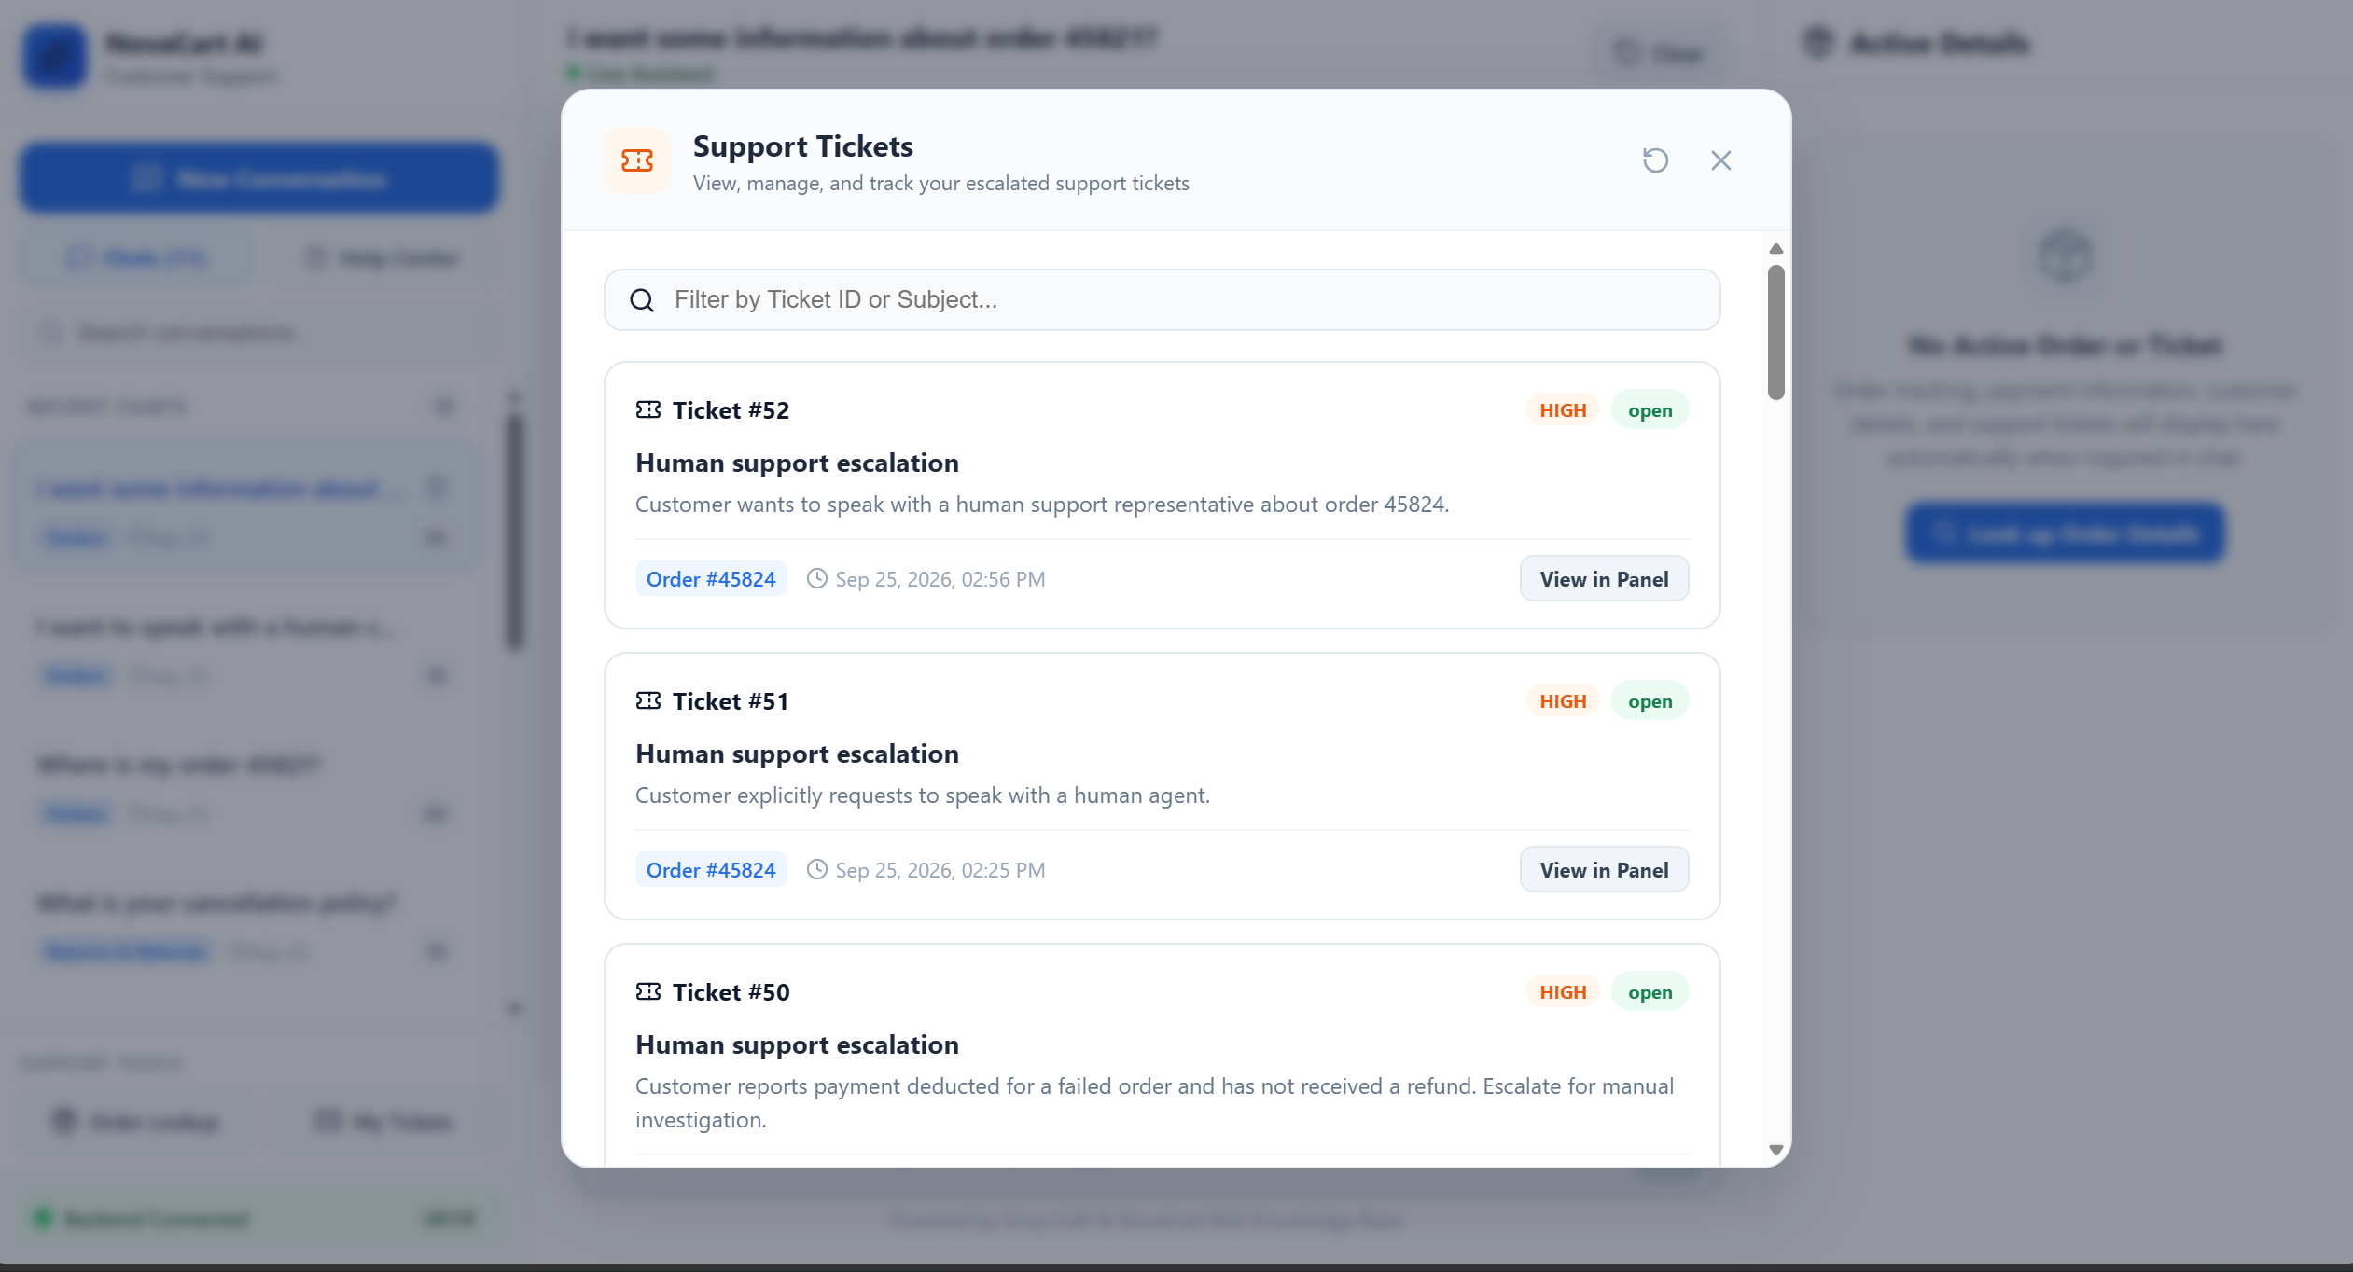

17.7. Human Escalation and Ticket Creation Results
Human escalation was successfully implemented as an integral component of the support application.
The system supports explicit requests for human assistance and configured escalation scenarios. When escalation occurs, the system can create or reference a support ticket and return the ticket identifier to the customer.
The resulting frontend experience provides visible escalation feedback, including:
- Ticket identifier
- Ticket status
- Confirmation that human support has been notified
The escalation workflow therefore connects the AI agent with the ticket-management functionality instead of simply responding that the customer should contact support separately.
Screenshot is attached below:
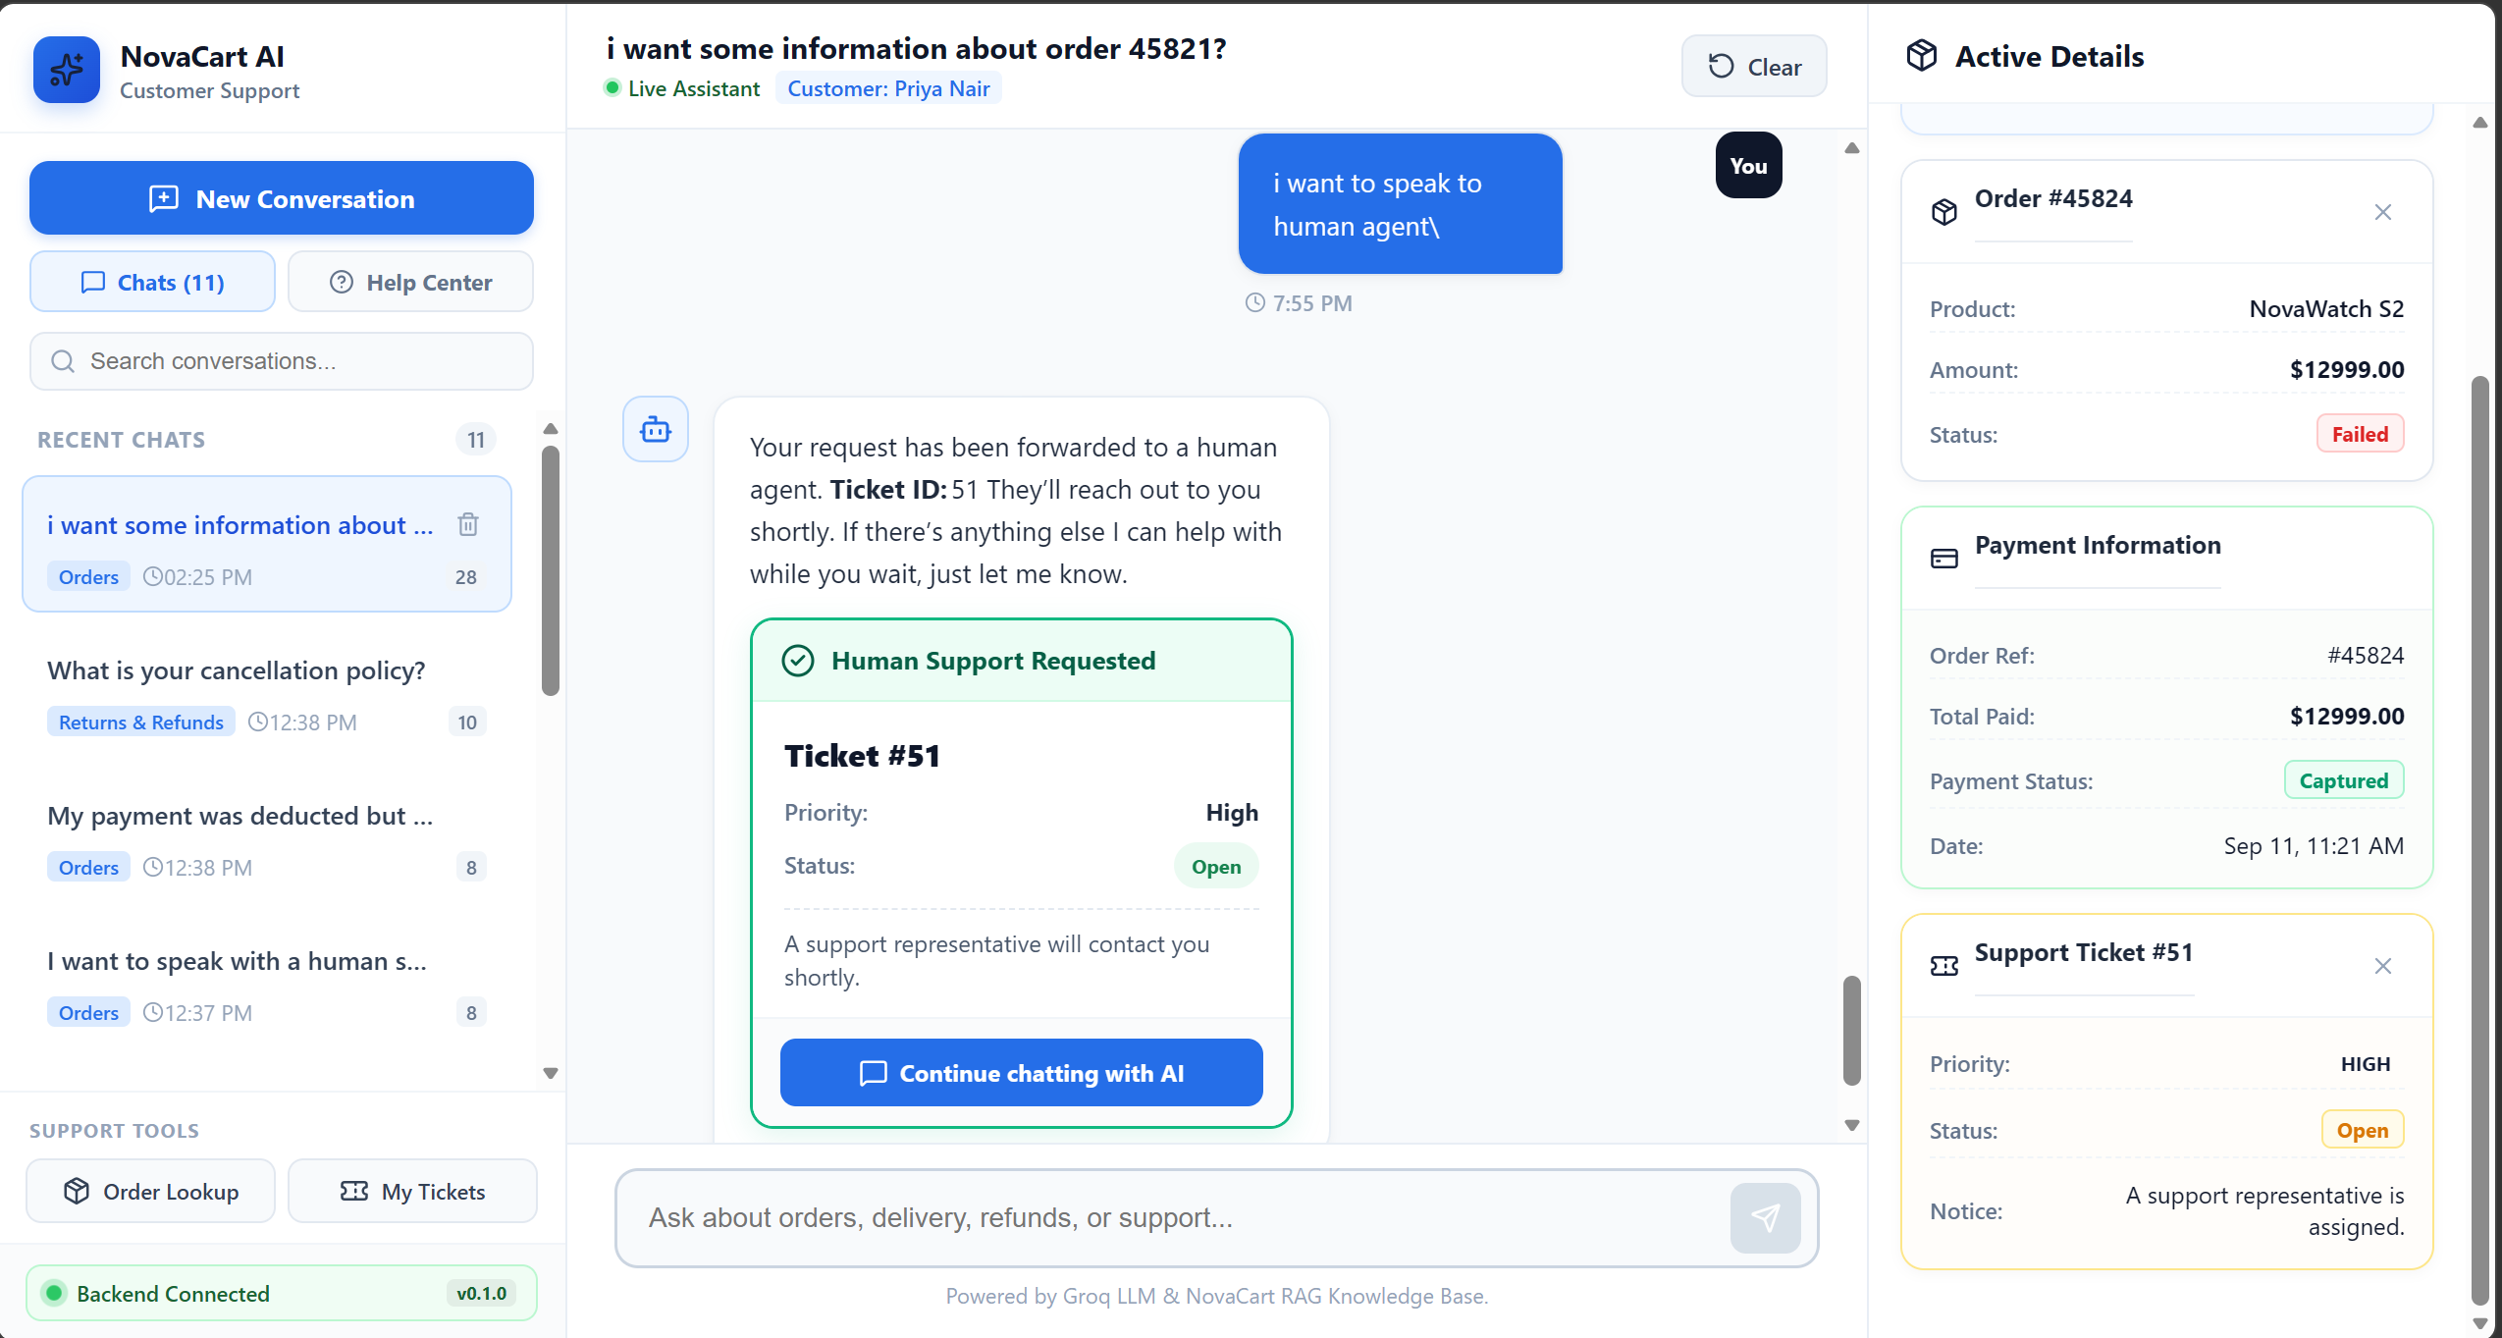

17.8. Conversation Memory and Persistence Results
Conversation memory was implemented to maintain the context of the active customer interaction.
A thread identifier is used to associate messages with the corresponding conversation. This allows the application to treat the interaction as an ongoing support conversation rather than a sequence of unrelated individual requests.
The implemented behavior was validated by:
- Starting a customer conversation.
- Sending multiple messages.
- Receiving AI responses.
- Refreshing the browser.
- Verifying that the current conversation remains visible.
This behavior makes the system function more like a persistent support workspace rather than a temporary chatbot page and also ensures customers do not lose their chats.
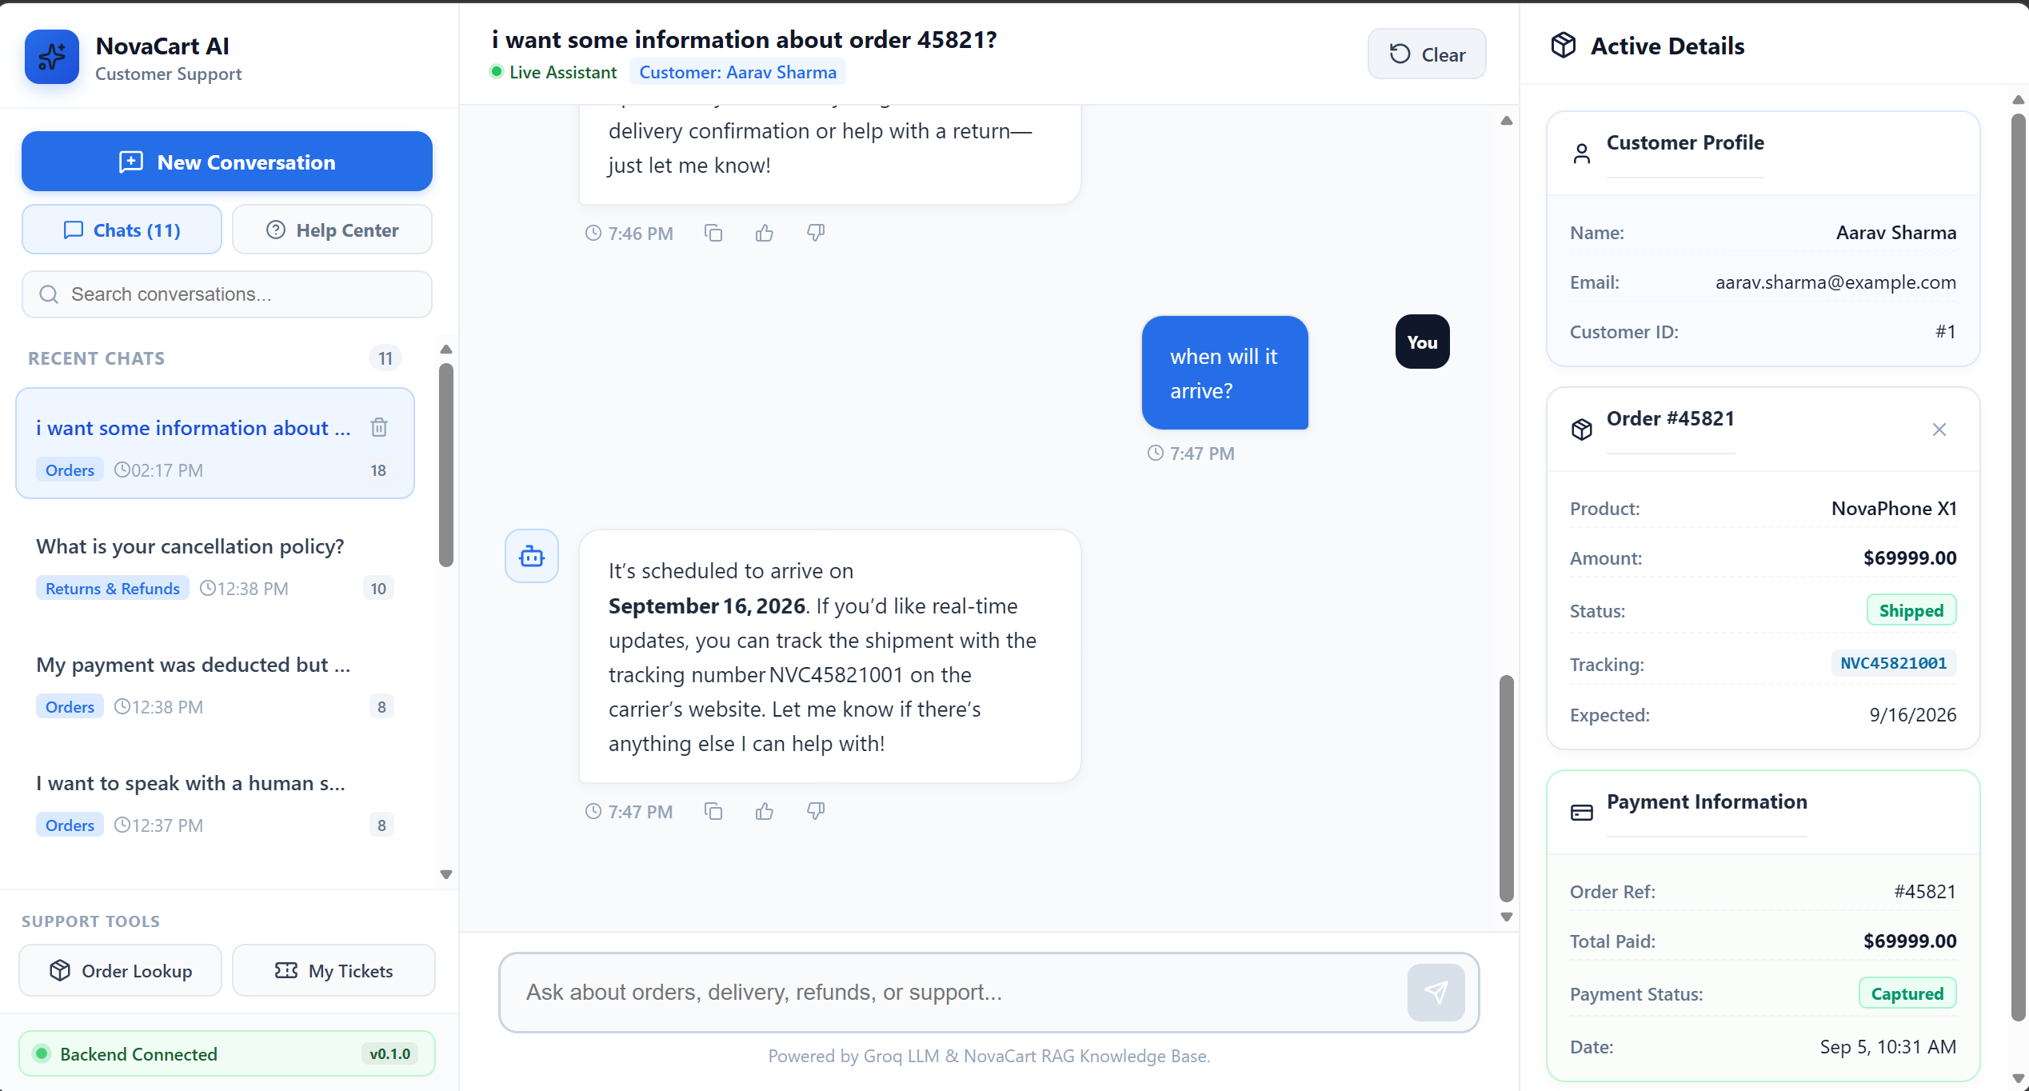

17.9 React Frontend and User Interface Results
The final React frontend provides an application-oriented customer-support workspace. The interface is divided into three primary areas:
Left Navigation Panel
The left panel provides:
- New Conversation
- Order Lookup
- My Tickets
- Help Center
- Track an Order
- Check Payment
- Contact Human Support

Central Conversation Workspace
The central area provides:
- Customer and AI messages
- AI response formatting
- Loading/typing feedback
- Message timestamps
- Copy controls
- Response feedback
- Retry interaction
- Message composer
- Conversation controls

Right Support Information Panel
The right panel provides contextual information such as:
- Order Information
- Payment Information
- Support Ticket Information
- Ticket status
- Escalation notification
These components allow operational information to be displayed alongside the conversation instead of forcing the customer to rely entirely on the textual AI response.
The resulting interface demonstrates that the project has evolved into a functional customer-support application rather than a simple conversational interface.
Screenshot is attached below:
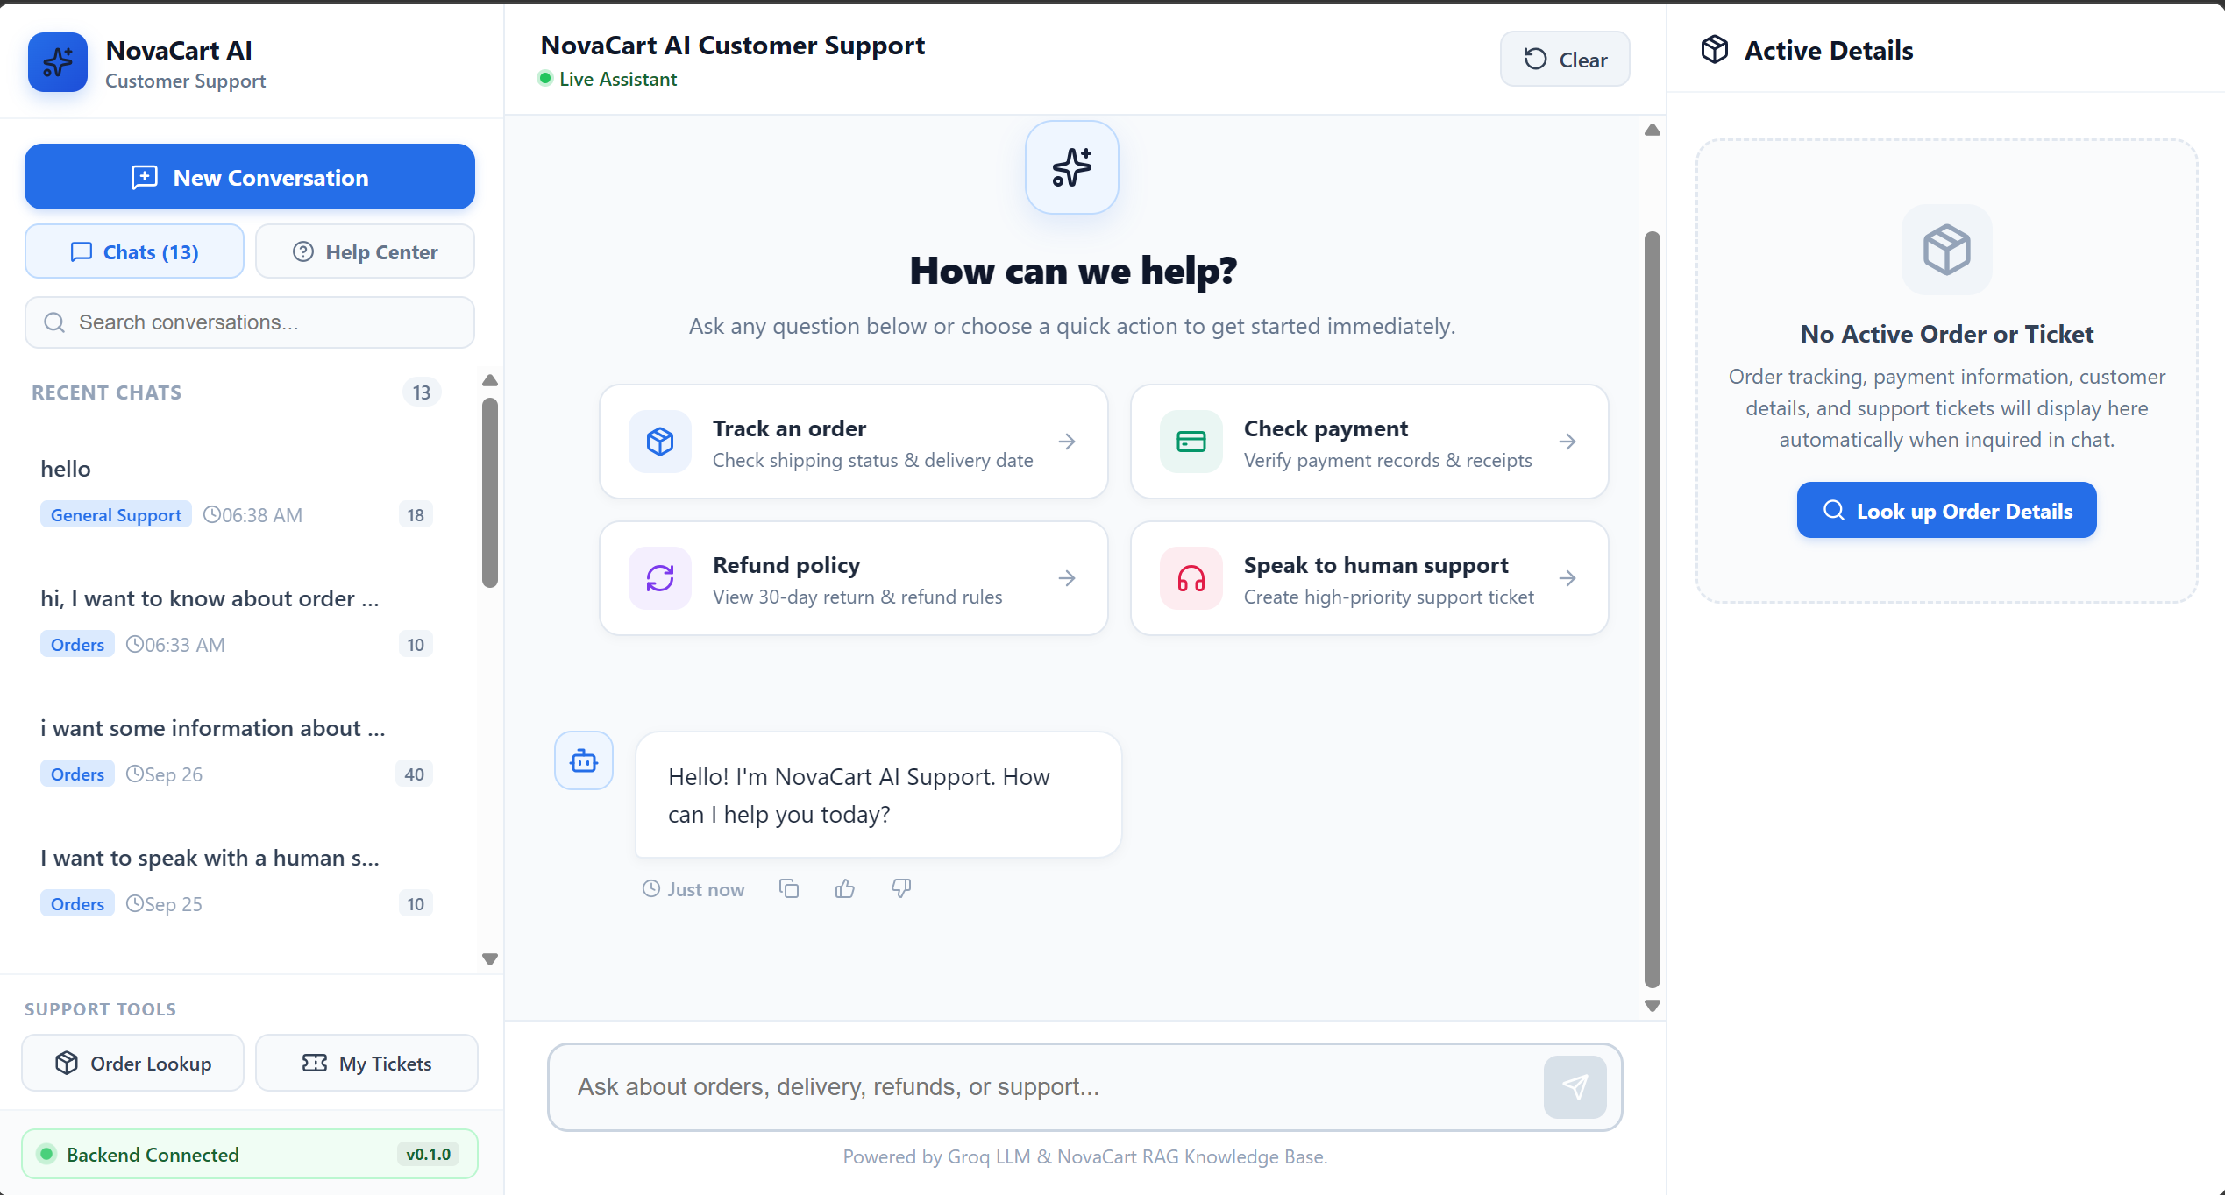

17.10 Error Handling and Reliability Results
Representative failure scenarios tested during validation included:
Test Scenario | Expected Behavior
Invalid order identifier | Meaningful error response
Non-existent order | Appropriate not-found response
Tool Failure | Failure handled without crashing the application
Failed backend/API request | User receives failure feedback
Failed AI response | Retry option is available
Escalation-related failure | User receives appropriate feedback

These tests demonstrate that the application has been designed to handle failure conditions rather than assuming that every request will succeed.

Invalid order ID:
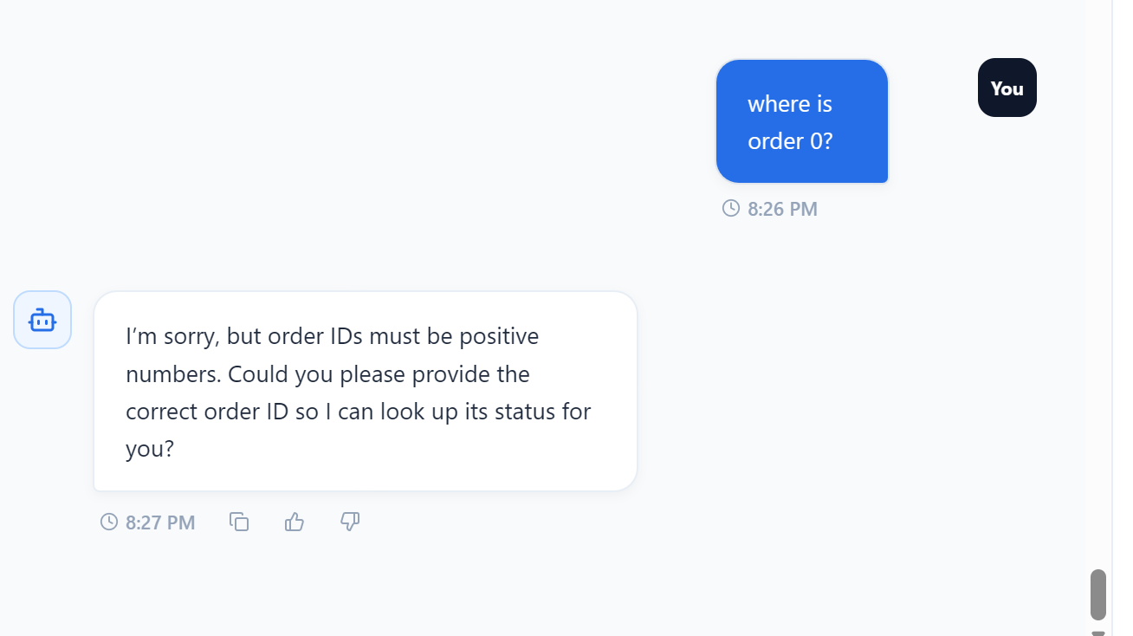

Knowledge Base Failure:
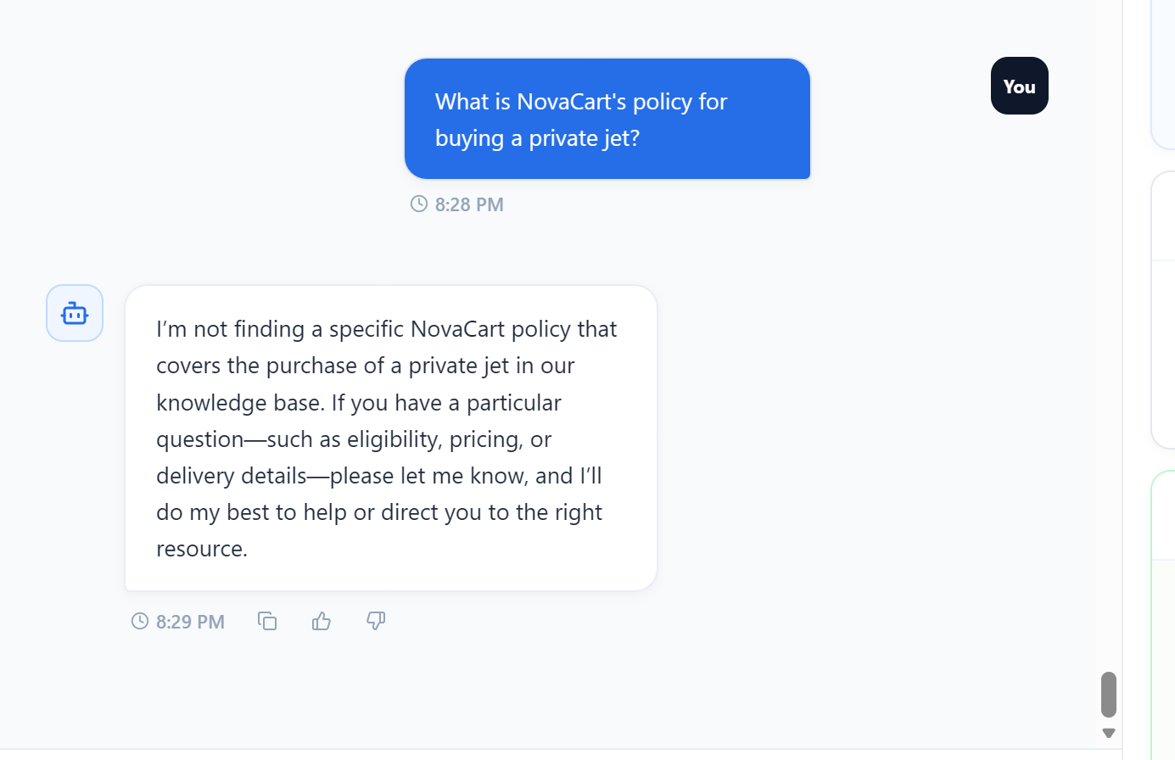

Wrong Order ID:
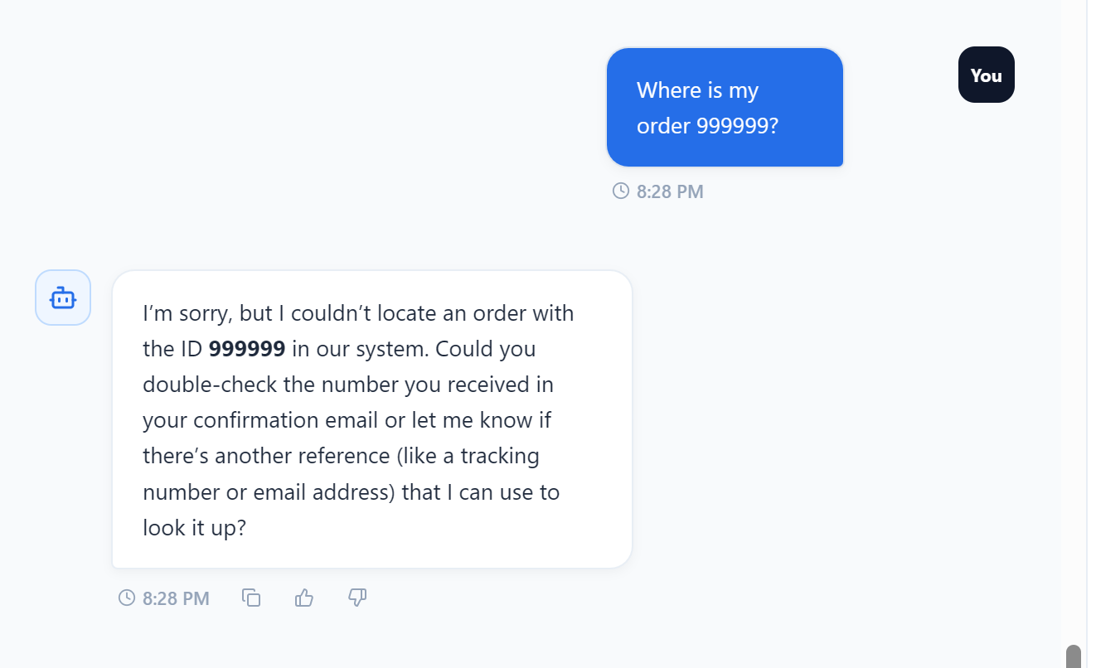

17.11 Testing and Validation Results
Comprehensive testing was performed across the major layers of the application.
Testing covered:
- FastAPI endpoints
- AI agent behavior
- RAG retrieval
- Tool execution
- Order workflows
- Payment workflows
- Ticket workflows
- Human escalation
- Failure scenarios
- Conversation behavior
- Frontend integration
Representative scenarios included:
- Knowledge-base question
- Valid order lookup
- Invalid order lookup
- Payment-status query
- Explicit human-support request
- Tool failure scenario
- Complex order/payment workflow
- Ticket creation and escalation
- Frontend retry behavior
- Conversation persistence after refresh
Test results screenshot is attached:
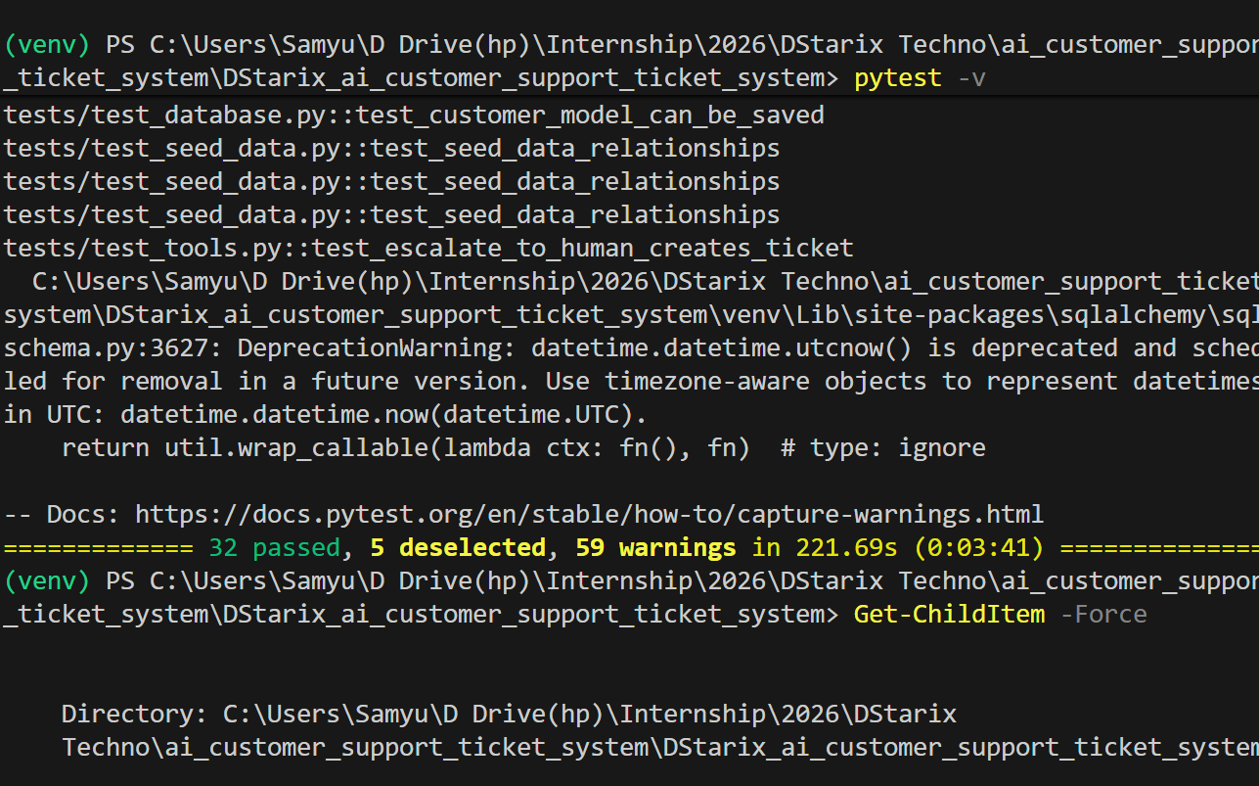

17.12 Application Database Results
The application database successfully provides the structured data required by the support workflows.
Database-backed functionality was validated for:
- Orders
- Payments
- Tickets
The database is accessed through SQL Alchemy-based services, while the agent tools and API routes interact with these services rather than directly embedding database operations into the frontend.
This separation allows the same business functionality to be accessed from both the API layer and AI-agent tool layer. Your report already describes this separation in the Application Database section.
Databases screenshot are attached below:
1. Order Database:
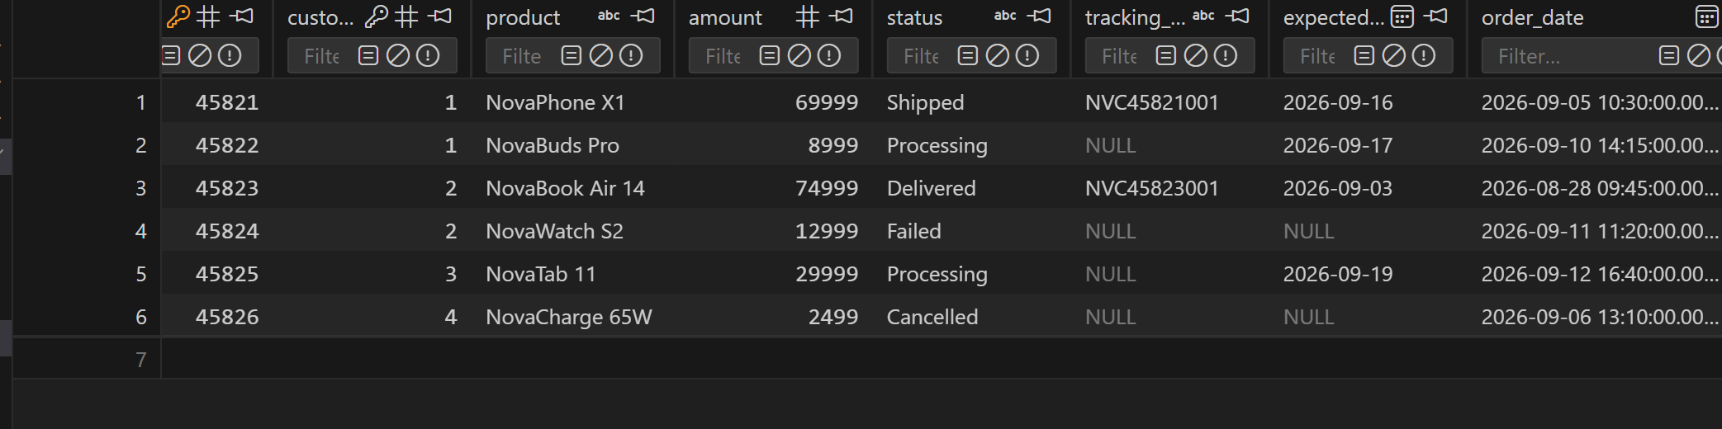
2. Payment Database:
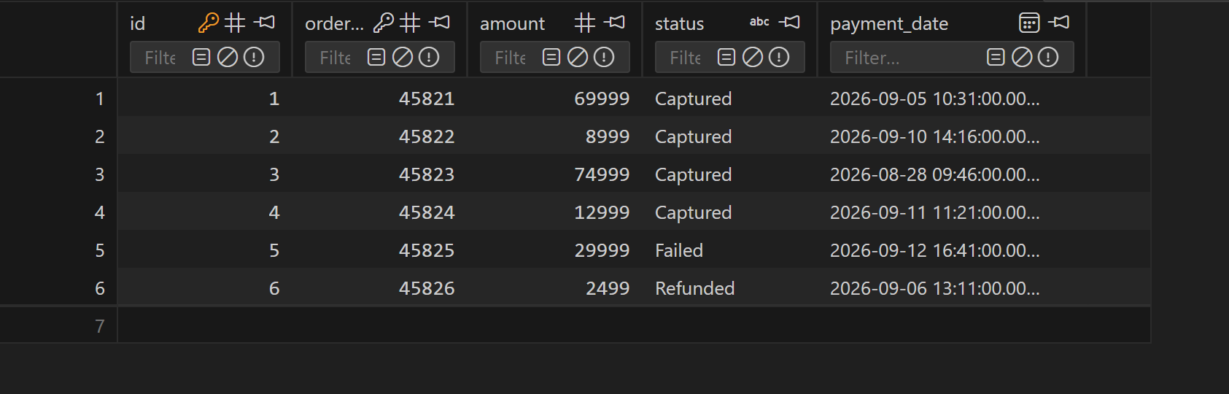
3. Tickets Database:
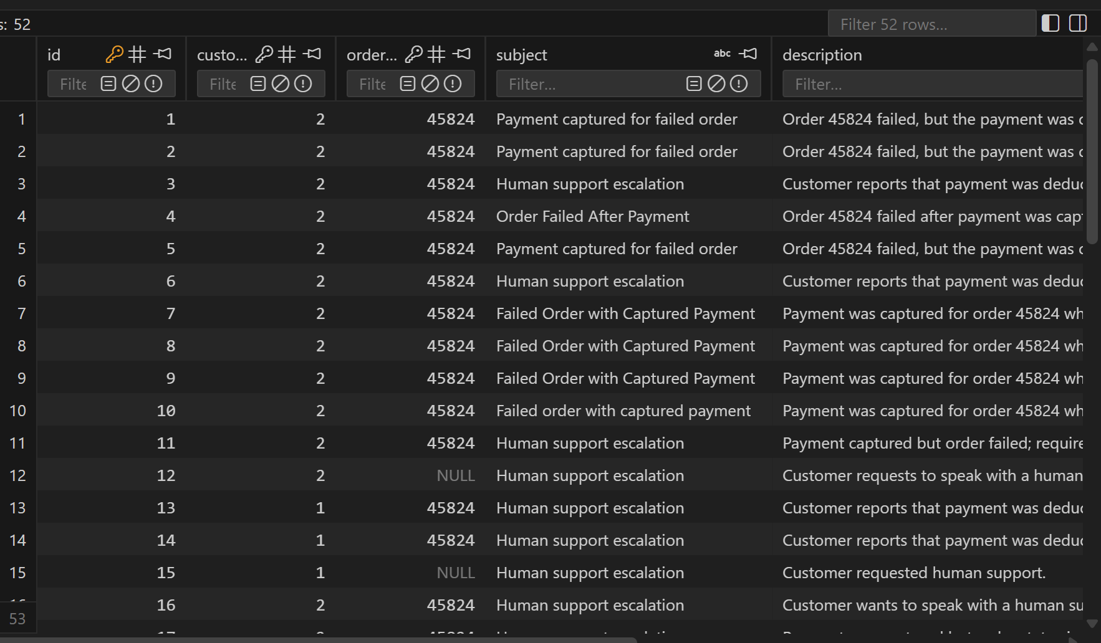

17.13 FastAPI Backend and API Results
The implemented API functionality includes endpoints for:
- Chat
- Health
- Orders
- Payments
- Tickets
- Escalation
The API routes validate inputs, invoke the corresponding services, return structured responses, and provide appropriate error responses when required.

Screenshots are attached below:
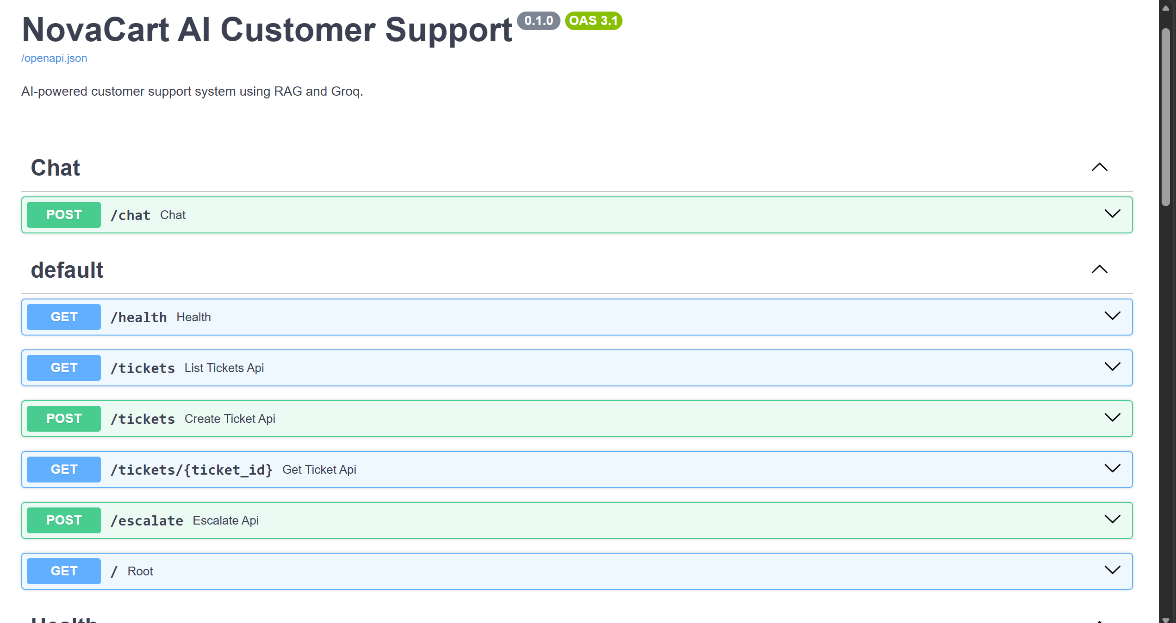
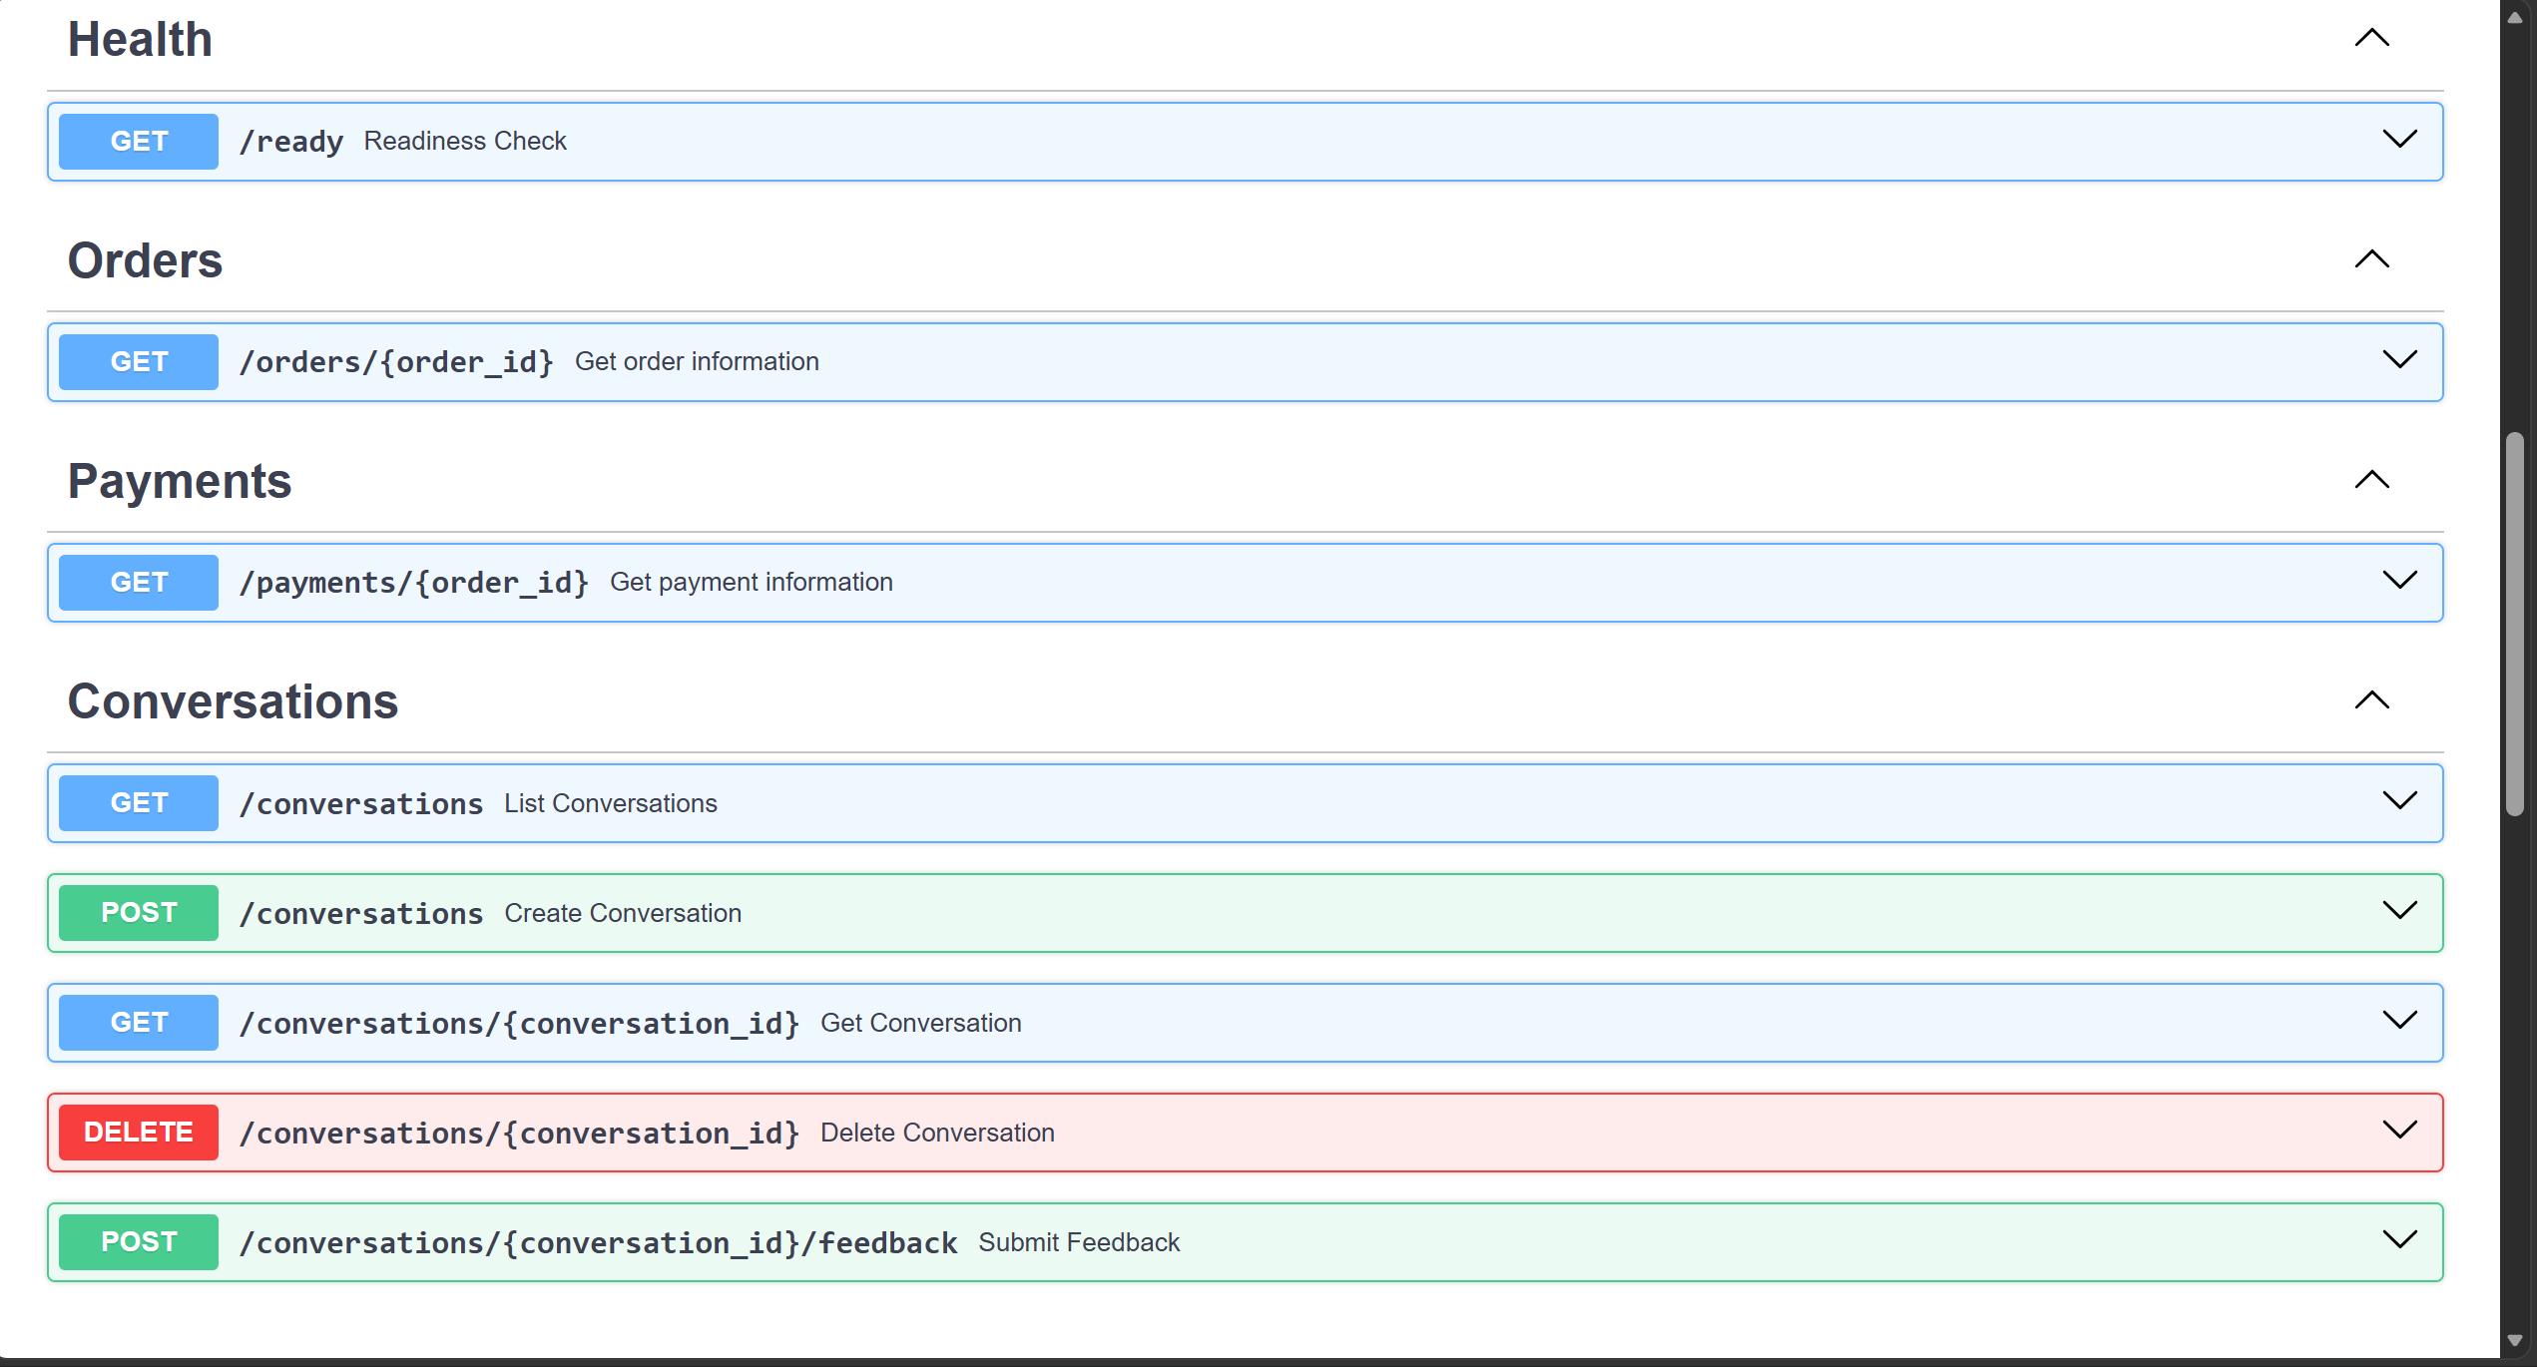

17.14 Final System Outcome
The final outcome of the project is a functional AI-powered customer-support application that combines conversational AI with deterministic application services.

The completed workflow can be represented as:
Customer → React Frontend → FastAPI Backend → AI Agent → RAG / Tools → Knowledge Base / Application Database → Response → Frontend

When human intervention is required, the workflow additionally becomes:
Customer → AI Agent → Escalation → Ticket System → Human Support

The system therefore demonstrates an end-to-end implementation in which conversational AI is connected to operational application functionality.
The final application successfully demonstrates:
- AI-powered knowledge retrieval
- Agent-based decision making
- Functional tool calling
- Database-backed business operations
- Ticket automation
- Human escalation
- Persistent conversation handling
- Error handling and recovery
- API-based backend integration
- A polished React customer-support interface
Overall, the results demonstrate that NovaCart satisfies the project's objective of developing an AI-powered customer-support and ticket-automation application rather than a basic question-answering chatbot.

18. Security and Configuration
API credentials are stored locally in environment files and are excluded from version control. The repository contains .env.example files containing placeholders rather than actual credentials.
Backend and frontend configuration are separated. The frontend uses a configurable API base URL, while the backend uses environment variables for the LLM key, database URL, model configuration, and application settings.

19. Limitations
The project is configured for local-stage execution and is not presented as a production deployment.
The support knowledge base and transactional data are demonstration/application data rather than a live enterprise customer database.
Production deployment would require additional authentication, authorization, monitoring, rate limiting, secure secret management, stronger privacy controls, and production-grade observability.

20. Future Enhancements
- Add authenticated customer accounts and role-based access.
- Integrate real shipping-carrier APIs for live tracking.
- Integrate production payment-provider APIs.
- Add administrator and human-agent dashboards.
- Introduce production vector-store infrastructure and scalable document ingestion.
- Add richer analytics for ticket categories, resolution time, escalation rates, and customer feedback.
- Deploy the backend and frontend using production infrastructure with secure secret management.

21. Conclusion
NovaCart successfully implements an AI-powered customer-support and ticket-automation workflow combining RAG, an AI agent, functional tools, conversation memory, a FastAPI backend, application database, ticket escalation, and a React frontend.
The completed implementation demonstrates how generative AI can be integrated with deterministic business services to create a practical support application. The project goes beyond question answering by connecting conversational AI to operational data, support workflows, and a structured user interface.

