LAB 1: REQUIREMENTS ENGINEERING & UML USE-CASE MODELLING
Blood Bank Inventory & Emergency Donor Matcher
Name: Samyuktha Vadrevu
SRN: PES1UG24AM312
1. REQUIREMENTS TABLE
Req ID | Type | Description | Priority | Acceptance Criteria | Rationale
FR-001 | Functional | The system shall cross-reference emergency blood unit requests against real-time blood bank inventory and broadcast SMS alerts to compatible donors within a 10 km radius. | High | Pass: Compatible donors notified within 30 seconds of emergency flag. Fail: Incompatible blood group alerted. | Core emergency-matching function of the system.
FR-002 | Functional | The system shall allow a Blood Bank Manager to manually update inventory levels for each blood component. | High | Pass: Manager updates a stock count and the change reflects on the dashboard within 5 seconds. Fail: Update not reflected or lost. | Keeps inventory data accurate for matching decisions.
FR-003 | Functional | The system shall allow a Donor to confirm or decline a donation request via app or SMS. | Medium | Pass: Donor response is logged within 2 minutes of tapping confirm/decline. Fail: Response not recorded. | Confirms real donor availability before dispatch.
FR-004 | Functional | The system shall automatically flag blood units nearing expiry (within 48 hours) for priority use. | Medium | Pass: Units with less than 48 hours shelf life are auto-tagged 'Expiring Soon'. Fail: Expiring unit not flagged. | Reduces wastage of perishable blood units.
FR-005 | Functional | The system shall log every donor-match attempt with a timestamp, donor ID, and outcome. | Low | Pass: Every match attempt creates a corresponding audit log entry. Fail: Match occurs with no log entry. | Needed for traceability and post-incident audit.
NFR-001 | Nonfunctional | The inventory ledger must maintain strict transactional consistency, preventing simultaneous allocation of the same blood bag. | High | Pass: Benchmarking tests confirm target latency and security standards under simulated peak load, with zero duplicate allocations. | Prevents double-booking of a single unit during concurrent emergency requests.
NFR-002 | Nonfunctional | The system shall encrypt all donor personal and medical data at rest and in transit using industry-standard encryption (e.g., AES-256, TLS 1.2+). | High | Pass: Independent security audit confirms all donor data stores and transmissions are encrypted. Fail: Any unencrypted data channel found. | Protects sensitive donor health and location data, and supports regulatory compliance.
Actors: Emergency Requester, Blood Bank Manager, Donor.

2. UML USE-CASE DIAGRAM
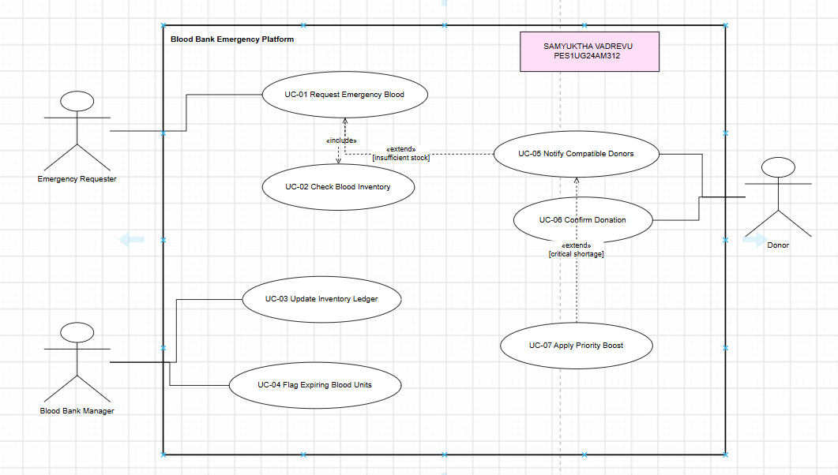
3. USE-CASE FLOW SPECIFICATION
Use Case: UC-01 — Request Emergency Blood
Actors: Emergency Requester (primary), Blood Bank Manager, Donor
Preconditions: 1. The Emergency Requester is verified and logged into the system.
2. The blood inventory system and donor database are online and reachable.
Postconditions: 1. The requested blood component is allocated and reserved, or compatible donors have been notified and a match is pending.
2. An audit log entry exists for the request.
Main Success Scenario
1. The Emergency Requester submits a blood request specifying blood type, component, quantity, and location.
2. The system checks real-time blood bank inventory for a matching, unexpired unit (includes UC-02: Check Blood Inventory).
3. The system finds sufficient matching stock and reserves/allocates the unit(s) to this request.
4. The system updates the inventory ledger to prevent duplicate allocation of the same unit.
5. The system sends a confirmation to the Emergency Requester with pickup/dispatch details.
6. The use case ends successfully.
Alternate Flow — 3a. Insufficient Stock Found
3a1. The system detects that no matching unit is available in inventory.
3a2. The system broadcasts SMS alerts to all compatible Donors within a 10 km radius. If the shortage is critical, the system invokes UC-07: Apply Priority Boost.
3a3. If a Donor confirms availability within 30 seconds, the system logs the match and proceeds to Main Success Scenario step 4.
3a4. If no Donor responds within 5 minutes, the system escalates the request to the Blood Bank Manager and notifies the Emergency Requester of the delay.

