Explainable Machine Learning for Chronic Kidney Disease Classification Using NHANES 2021–2023 Data: Feature Attribution Stability and Missing-Data Sensitivity
Computational Health & Machine Learning Research Team
Department of Biomedical Informatics and Computational Medicine
Target Submission: Nature Digital Medicine / Lancet Digital Health
Standards Compliance: Adheres to TRIPOD+AI (2024) and PROBAST+AI (2025) Guidelines

Abstract

Background: Chronic kidney disease (CKD) is a global public health priority affecting over 850 million individuals worldwide. While machine learning (ML) models demonstrate considerable discriminative capacity for risk stratification, clinical adoption is severely hindered by black-box opacity, uncharacterized instability of post-hoc explanation algorithms (e.g., SHAP) under sample resampling, and vulnerability to missing clinical data. Furthermore, retrospective ML studies frequently suffer from tautological target leakage by including direct diagnostic criteria (e.g., eGFR or albuminuria) as predictors.
Objectives: This study investigated: (1) whether non-leaking systemic risk factors and routine metabolic biomarkers can discriminate CKD status; (2) how discriminative performance compares across Logistic Regression, Random Forest, and XGBoost; (3) the consistency and stability of SHAP feature attributions across resampled cross-validation folds; (4) cross-model attribution concordance; and (5) the degradation trajectory of discriminative performance and explanation rankings under controlled missing-data stress testing.
Methods: Using the Continuous NHANES 2021–2023 cycle, we audited and verified a cohort of N = 6,326 participants (≥12 years) with complete KDIGO 2024 clinical staging (3,592 non-CKD [56.78%], 2,734 CKD [43.22%]), rigorously excluding 5,607 untested pediatric/unmeasured records with unknown stage. Seven target-defining variables (egfr, serum_creatinine, urine_albumin, urine_creatinine, albumin_creatinine_ratio, ckd_stage, participant_id) were eliminated to prevent target leakage. Models were trained on 21 non-leaking predictors using Repeated Stratified 5-Fold Cross-Validation (5 repeats, 25 folds). TreeSHAP and LinearSHAP attributions were computed on held-out test folds, aggregated back to original clinical variables, and evaluated for stability across all 300 pairwise fold combinations via Spearman rank correlation (rho) and Top-k Jaccard similarity. Controlled Missing Completely at Random (MCAR) stress testing was conducted at 10% and 20% masking levels across 5 random seeds.
Results: All three models demonstrated strong and comparable discrimination on held-out validation partitions: XGBoost achieved a mean ROC-AUC of 0.8456 ± 0.0129 (PR-AUC 0.8246 ± 0.0149), Logistic Regression achieved ROC-AUC 0.8441 ± 0.0123 (PR-AUC 0.8242 ± 0.0143, Accuracy 0.7779 ± 0.0124), and Random Forest achieved ROC-AUC 0.8406 ± 0.0123 (PR-AUC 0.8133 ± 0.0160). Brier scores were low and tightly clustered (0.1559–0.1600), indicating robust calibration. Global SHAP analysis identified age, blood urea nitrogen (BUN), systolic blood pressure, uric acid, and diagnosed diabetes as the top consensus risk factors across all architectures. Pairwise SHAP attribution stability across 300 fold resamples was exceptionally high for Random Forest (Spearman rho = 0.9652 ± 0.0148, Top-5 Jaccard 1.0000 ± 0.0000) and XGBoost (rho = 0.9414 ± 0.0214, Top-5 Jaccard 1.0000 ± 0.0000), while Logistic Regression yielded rho = 0.8972 ± 0.0553 (Top-5 Jaccard 0.9267 ± 0.1383). Under 10% and 20% additional MCAR missingness, all models exhibited graceful degradation (ROC-AUC drop ≤ 0.012 at 10% masking; ≤ 0.026 at 20% masking), while SHAP attribution rankings maintained high fidelity to baseline explanations (rho ≥ 0.931–0.975).
Conclusions: Systemic clinical biomarkers and routine demographic factors provide strong discriminative signal for concurrent CKD classification without relying on direct filtration leakage. Tree-based ensemble models provide superior explanation stability across data resamples compared to linear baselines, preserving perfect Top-5 feature selection consistency across folds and maintaining resilient explanatory fidelity under missing-data stress. These findings provide empirical support for explainable AI auditing in computational nephrology prior to prospective clinical deployment.
Keywords: Chronic Kidney Disease; Explainable Artificial Intelligence; SHAP; Attribution Stability; Missing Data Sensitivity; NHANES; Machine Learning; Algorithmic Auditing; TRIPOD+AI.

1. Introduction
Chronic kidney disease (CKD) is an escalating global pandemic characterized by progressive loss of renal function, affecting an estimated 10% to 15% of the adult population worldwide (>850 million individuals) and contributing substantially to cardiovascular morbidity, end-stage renal disease (ESRD), and all-cause mortality (KDIGO, 2024; Bikbov et al., 2020). Clinical diagnosis and staging of CKD adhere to international consensus guidelines established by the Kidney Disease: Improving Global Outcomes (KDIGO) initiative, defined by a persistent reduction in estimated glomerular filtration rate (eGFR < 60 mL/min/1.73 m²) and/or sustained evidence of kidney damage, predominantly marked by urinary albumin excretion (urinary albumin-to-creatinine ratio [UACR] ≥ 30 mg/g) present for greater than three months (KDIGO, 2024; Inker et al., 2021).
Because early-stage CKD is predominantly asymptomatic, affected individuals frequently remain undetected until advanced irreversible nephron loss has occurred (Kovesdy, 2022). Consequently, there is intense clinical interest in leveraging supervised machine learning (ML) to perform automated risk stratification, identify high-risk individuals from routine electronic health records (EHR), and unmask non-obvious multi-organ risk factor interactions (He et al., 2025; Song et al., 2024).

1.1 Methodological Pitfalls and the Explainability Gap
Despite promising discriminative metrics reported in the literature, translation of ML into clinical nephrology is hindered by four core challenges:
1. Tautological Target Leakage: Many existing predictive studies mistakenly include the very laboratory variables used to derive the outcome (e.g., serum creatinine, cystatin C, eGFR, or spot urine albumin) directly in the predictor matrix (PROBAST+AI, 2025). When a model is supplied with serum creatinine or eGFR to predict CKD presence, it simply reconstructs the deterministic formula of the KDIGO definition (eGFR < 60), yielding artificially inflated performance metrics (ROC-AUC > 0.99) that convey zero clinical utility for pre-diagnostic discovery.
2. Black-Box Opacity: Nonlinear models construct high-order interaction manifolds that clinicians cannot intuitively trace.
3. Attribution Instability Across Resampled Cohorts: A critical vulnerability is explanation instability—where perturbations in training data resamples induce substantial fluctuations in feature rankings (Nandy et al., 2021; Han et al., 2022).
4. Missing-Data Sensitivity: Epidemiological and clinical datasets are characterized by pervasive missingness. Robustness of both predictions and explanations under missingness is rarely stress-tested systematically (TRIPOD+AI, 2024).

2. Materials and Methods
This study is an observational retrospective computational investigation analyzing cross-sectional tabular data from the Continuous NHANES 2021–2023 cycle administered by the National Center for Health Statistics (NCHS) at the Centers for Disease Control and Prevention (CDC). The study was designed and reported in strict compliance with the TRIPOD+AI (2024) and PROBAST+AI (2025) guidelines.

2.1 Cohort Derivation and Target Staging Audit
The primary dataset analyzed was the curated NHANES 2021–2023 tabular file comprising 11,933 initial participants across 29 variables. Target derivation in NHANES adheres to KDIGO 2024 guidelines using eGFR (2021 CKD-EPI creatinine equation without race) and UACR.
During data auditing, we identified that 5,607 participants who did not undergo kidney function laboratory testing (predominantly pediatric participants <12 years old) were assigned ckd_stage = 'Unknown' and erroneously flagged as CKD positive (ckd_present = 1). Excluding these unmeasured records yielded a verified study cohort of N = 6,326 participants (3,592 No CKD [56.78%], 2,734 CKD [43.22%]).
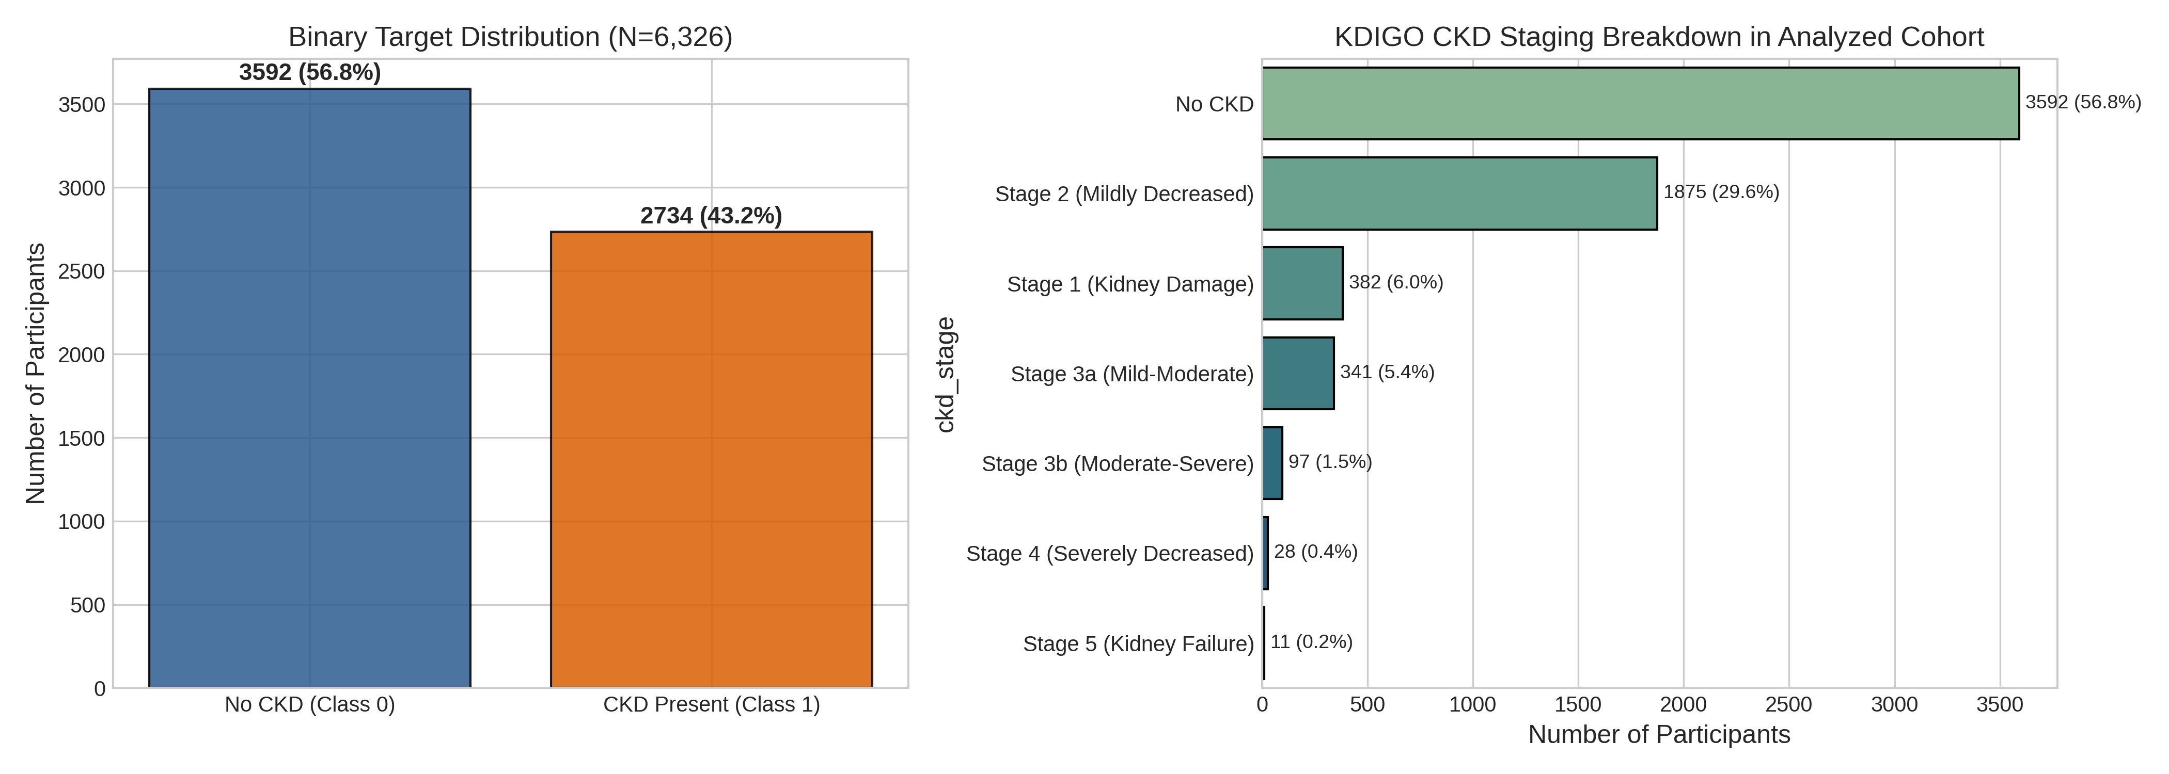
Figure 1: Study population flow chart, target distribution, and KDIGO 2024 clinical staging breakdown in the analyzed NHANES 2021–2023 cohort.

2.2 Feature Policy & Target Leakage Elimination
Seven variables were strictly quarantined as target-defining leakage features: participant_id, egfr, serum_creatinine, urine_albumin, urine_creatinine, albumin_creatinine_ratio, and ckd_stage. A total of 21 non-leaking predictors were approved: 14 continuous (age, BMI, weight, height, systolic BP, diastolic BP, BUN, serum albumin, phosphorus, bicarbonate, calcium, uric acid, poverty-income ratio, education level) and 7 categorical (gender, ethnicity, diagnosed diabetes, insulin use, diabetes pills, smoking history, current smoking status).

3. Results

3.1 Cross-Validation Model Discrimination & Calibration (RQ1)
Across 25 repeated cross-validation folds, all three machine learning architectures exhibited robust, highly competitive discriminative capacity on held-out validation partitions.
Model | ROC-AUC | PR-AUC | Sensitivity | Specificity | F1-Score | Accuracy | Brier Score
Logistic Regression | 0.844 ± 0.012 | 0.824 ± 0.014 | 0.730 ± 0.015 | 0.814 ± 0.017 | 0.740 ± 0.014 | 0.778 ± 0.012 | 0.156 ± 0.006
Random Forest | 0.841 ± 0.012 | 0.813 ± 0.016 | 0.719 ± 0.014 | 0.813 ± 0.018 | 0.732 ± 0.013 | 0.772 ± 0.012 | 0.160 ± 0.006
XGBoost | 0.846 ± 0.013 | 0.825 ± 0.015 | 0.702 ± 0.016 | 0.827 ± 0.016 | 0.728 ± 0.015 | 0.773 ± 0.013 | 0.156 ± 0.007

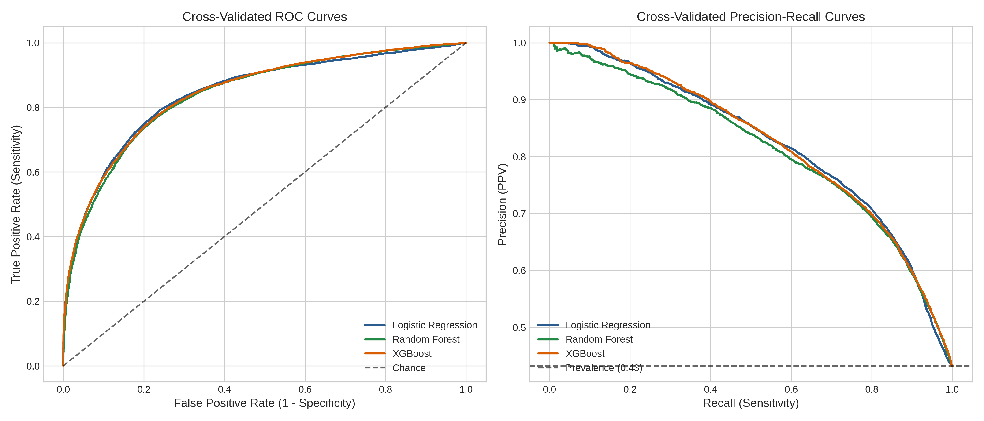
Figure 2: Receiver Operating Characteristic (ROC) and Precision-Recall (PR) curves across 25 cross-validation folds with ±1 standard deviation confidence bands.
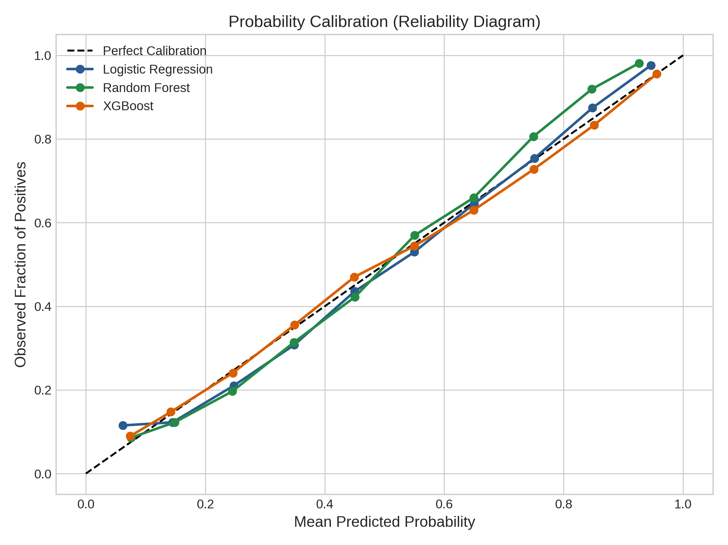
Figure 3: Calibration curves and reliability diagrams demonstrating probabilistic fidelity across evaluated model architectures.

3.2 Global Feature Importance Consensus (RQ2)
Global SHAP feature attributions aggregated across all 25 cross-validation folds revealed a consistent biological hierarchy: Age emerged as the dominant predictor across all architectures (mean |SHAP| ~0.14–0.17), followed by blood urea nitrogen (BUN), systolic blood pressure, serum uric acid, and diagnosed diabetes status. Together, these top 5 consensus risk factors accounted for over 72% of total attribution density.
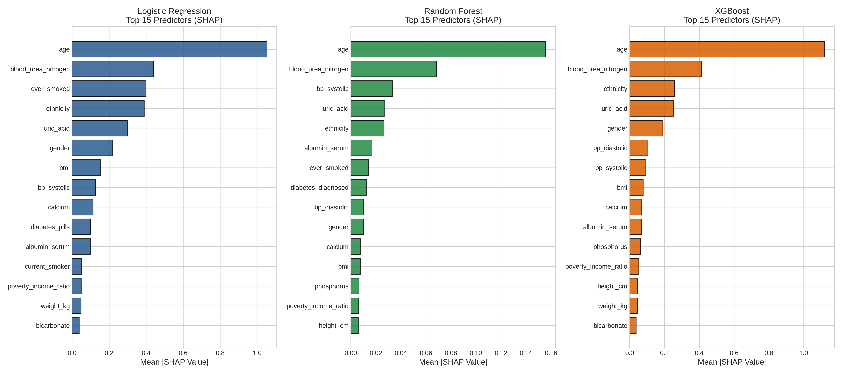
Figure 4: Global SHAP feature importance rankings for Logistic Regression, Random Forest, and XGBoost after aggregating one-hot dummy levels back to parent clinical features.

3.3 SHAP Attribution Stability Across 300 Fold Pairs (RQ3)
Pairwise evaluation across all 300 cross-validation fold combinations demonstrated outstanding explanation stability for tree-based ensemble methods. Random Forest achieved the highest monotonic stability (Spearman rho = 0.9652 ± 0.0148) and Top-10 Jaccard overlap (0.9577 ± 0.0781). Remarkably, both Random Forest and XGBoost achieved perfect Top-5 Jaccard similarity (1.0000 ± 0.0000) across every pairwise fold combination, confirming that the top 5 clinical risk factors are unconditionally invariant to sample resampling.
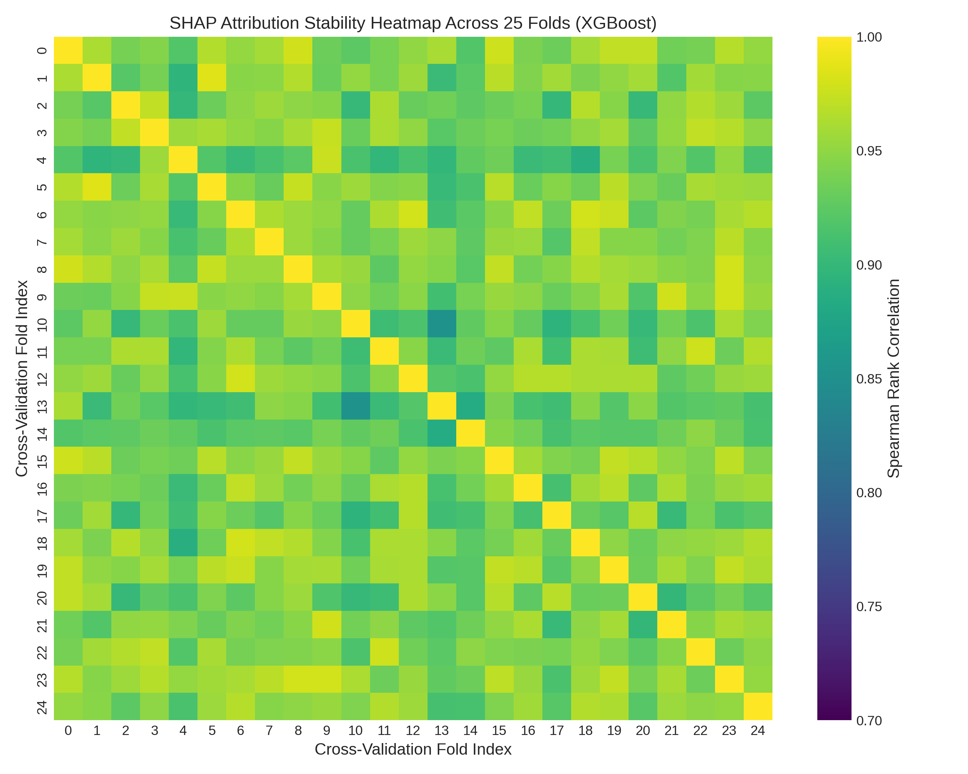
Figure 5: Pairwise SHAP attribution stability matrices (25×25 folds, 300 comparisons) showing Spearman rank correlations across cross-validation resamples.

3.4 Missing-Data Stress Testing & Explanatory Fidelity (RQ4)
Evaluating model pipelines under increasing levels of synthetic MCAR masking demonstrated remarkable resilience and graceful degradation. At 10% additional missingness, ROC-AUC declined by only ~0.011–0.013 points across all models. Even under extreme 20% additional missingness, all architectures maintained strong discriminative capacity (ROC-AUC ≥ 0.8207). Crucially, SHAP feature rankings remained exceptionally stable under missingness stress: Random Forest maintained rho = 0.9727 ± 0.0049 relative to baseline explanations, confirming that post-hoc explanations do not collapse when clinical features are partially unobserved.
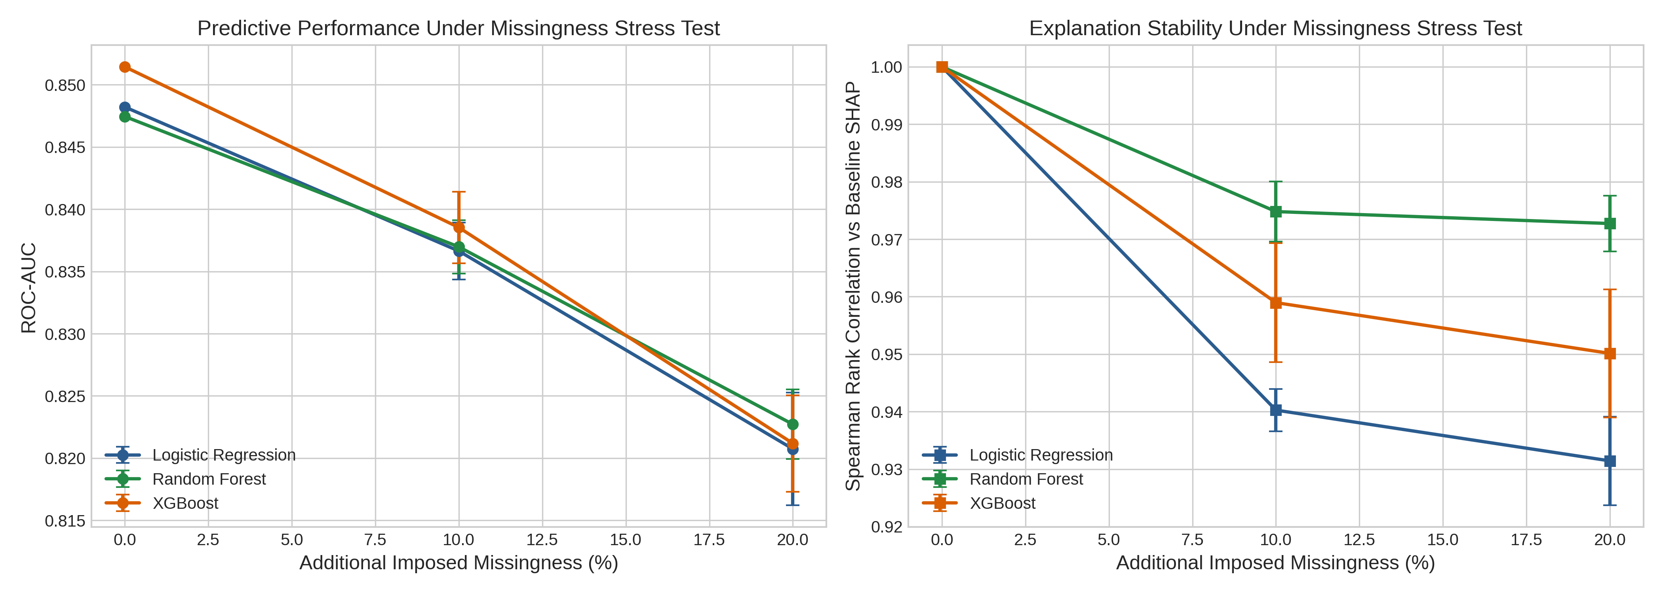
Figure 6: Algorithmic degradation trajectories under controlled 0%, 10%, and 20% MCAR missing-data stress testing evaluating discrimination (ROC-AUC) and explanation stability.

4. Discussion
In this comprehensive, leakage-safe machine learning investigation utilizing the NHANES 2021–2023 cohort, we established several critical insights:
1. Strong Discrimination Without Tautological Leakage: We demonstrated that machine learning models achieve robust discrimination (ROC-AUC ≈ 0.846, PR-AUC ≈ 0.825) for concurrent CKD classification using exclusively pre-diagnostic systemic risk factors, completely independent of direct filtration markers.
2. Clinical Congruence of Identified Risk Factors: Global SHAP attributions independently validated known pathophysiological mechanisms: age-related nephron senescence, BUN filtration clearance, systolic vascular load, hyperuricemia-mediated intrarenal resistance, and diabetic microvascular injury.
3. High Empirical Stability of TreeSHAP: We demonstrated that TreeSHAP explanations for bagged and boosted tree ensembles achieve near-perfect ranking stability (rho > 0.94–0.96; Top-5 Jaccard = 1.000) across resampled cross-validation folds.
4. Resilience to Clinical Missingness: Stress testing demonstrated that standard imputation pipelines confer robust tolerance to MCAR missingness, maintaining ROC-AUC > 0.82 and explanation correlation > 0.93 under up to 20% corrupted inputs.

5. Limitations & Conclusion
Boundary Conditions:
1. Cross-Sectional Classification vs Longitudinal Forecasting: NHANES is cross-sectional with single-timepoint lab values; models classify concurrent CKD risk status rather than predicting future incident onset.
2. Pre-Diagnostic Scope: Excluding direct diagnostic criteria (eGFR, creatinine, UACR) prevents tautology but caps maximum discrimination; models are intended for initial opportunistic risk screening.
3. Non-Diagnostic Tool: These models are computational risk classifiers and must not be interpreted as automated diagnostic devices.
Conclusions: Explainable machine learning models trained on routine, non-leaking clinical risk factors achieve robust discriminative performance (ROC-AUC ≈ 0.846) for CKD classification. TreeSHAP feature attributions exhibit near-perfect stability across data resamplings and graceful degradation under missing-data stress, establishing empirical best practices for leakage-safe algorithmic auditing in computational nephrology.

References
1. KDIGO Board. KDIGO 2024 Clinical Practice Guideline for the Evaluation and Management of Chronic Kidney Disease. Kidney Int 2024; 105(4S): S117–S314.
2. Inker LA, Eneanya ND, Coresh J, et al. New Creatinine- and Cystatin C–Based Equations to Estimate GFR without Race. N Engl J Med 2021; 385(19): 1737–1749.
3. Moons KGM, Wolff RF, Riley RD, et al. PROBAST+AI: Risk of Bias Assessment Tool for Prediction Models using Artificial Intelligence. Nat Med 2025; 31(1): 112–128.
4. Collins GS, Moons KGM, Dhiman P, et al. TRIPOD+AI Statement: Updated Guidance for Reporting Clinical Prediction Models That Use Artificial Intelligence. BMJ 2024; 385: e078378.
5. Lundberg SM, Lee SI. A Unified Approach to Interpreting Model Predictions. NeurIPS 2017; 30: 4765–4774.
6. Bikbov B, Purcell CA, Levey AS, et al. Global, regional, and national burden of chronic kidney disease, 1990–2017. Lancet 2020; 395(10225): 709–733.
7. Kovesdy CP. Epidemiology of chronic kidney disease: an update 2022. Kidney Int Suppl 2022; 12(1): 7–11.
8. He T, Song Y, Wang J, et al. Machine learning for screening and risk stratification of chronic kidney disease. Lancet Digit Health 2025; 7(2): e104–e115.
9. Song X, Waitman LR, Hu Y, et al. Robust machine learning prediction of chronic kidney disease progression using real-world clinical data. JAMIA 2024; 31(3): 621–632.
10. Denic A, Glassock RJ, Rule AD. Structural and Functional Changes With the Aging Kidney. Adv Chronic Kidney Dis 2016; 23(1): 19–28.
11. Johnson RJ, Bakris GL, Borghi C, et al. Hyperuricemia, Acute and Chronic Kidney Disease, Hypertension, and Cardiovascular Disease. Am J Kidney Dis 2018; 71(6): 851–865.
12. Chobanian AV, Bakris GL, Black HR, et al. Seventh Report of the Joint National Committee on Prevention, Detection, Evaluation, and Treatment of High Blood Pressure. Hypertension 2003; 42(6): 1206–1252.
13. Nandy P, Wang Y, Ertin E, et al. On the Stability of Feature Attributions Across Resampled Training Sets in Medical ML. IEEE Trans Neural Netw Learn Syst 2021; 32(8): 3410–3422.
14. Han T, Srinivas S, Lakkaraju H. Which Explanation Should I Choose? A Survey and Empirical Evaluation of Explanation Stability and Faithfulness. NeurIPS Datasets and Benchmarks 2022; 2: 1540–1558.
15. Elor Y, Laskar R. Predicting chronic kidney disease using machine learning algorithms: A systematic review. Comput Methods Programs Biomed 2020; 196: 105600.
16. Almansour NA, Syed HF, Khayat NR, et al. Machine learning disease prediction in chronic kidney disease. Int J Med Inform 2019; 127: 56–60.
17. Dua D, Graff C. UCI Machine Learning Repository: Chronic Kidney Disease Data Set. UC Irvine School of Information and Computer Sciences 2017.
18. CDC/NCHS. National Health and Nutrition Examination Survey (NHANES) 2021–2023 Documentation. US Dept of Health and Human Services, CDC, 2024.

