BA Assignment 1 - Setting up R

# Loading the ISLR package  
library(ISLR)

## Warning: package 'ISLR' was built under R version 4.2.3

# Summarizing the Carseats Dataset  
summary(Carseats)

## Sales CompPrice Income Advertising   
## Min. : 0.000 Min. : 77 Min. : 21.00 Min. : 0.000   
## 1st Qu.: 5.390 1st Qu.:115 1st Qu.: 42.75 1st Qu.: 0.000   
## Median : 7.490 Median :125 Median : 69.00 Median : 5.000   
## Mean : 7.496 Mean :125 Mean : 68.66 Mean : 6.635   
## 3rd Qu.: 9.320 3rd Qu.:135 3rd Qu.: 91.00 3rd Qu.:12.000   
## Max. :16.270 Max. :175 Max. :120.00 Max. :29.000   
## Population Price ShelveLoc Age Education   
## Min. : 10.0 Min. : 24.0 Bad : 96 Min. :25.00 Min. :10.0   
## 1st Qu.:139.0 1st Qu.:100.0 Good : 85 1st Qu.:39.75 1st Qu.:12.0   
## Median :272.0 Median :117.0 Medium:219 Median :54.50 Median :14.0   
## Mean :264.8 Mean :115.8 Mean :53.32 Mean :13.9   
## 3rd Qu.:398.5 3rd Qu.:131.0 3rd Qu.:66.00 3rd Qu.:16.0   
## Max. :509.0 Max. :191.0 Max. :80.00 Max. :18.0   
## Urban US   
## No :118 No :142   
## Yes:282 Yes:258   
##   
##   
##   
##

# From the above summary statistics we can conclude that the Maximum of Advertising attribute is 29.

# Dimensions of the Carseats Dataset  
dim(Carseats)

## [1] 400 11

# Calculate the IQR of the "Price" attribute  
price_iqr <- IQR(Carseats$Price)  
  
# Print the calculated IQR  
cat("IQR of Price:", price_iqr, "\n")

## IQR of Price: 31

# Create a scatter plot of Sales against Price  
plot(Carseats$Price, Carseats$Sales, xlab = "Price", ylab = "Sales", main = "Sales vs. Price")

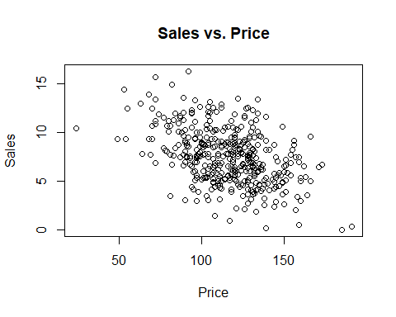

# Calculate the correlation between Price and Sales  
correlation <- cor(Carseats$Price, Carseats$Sales)  
  
# Print the correlation coefficient  
cat("Correlation between Price and Sales:", correlation, "\n")

## Correlation between Price and Sales: -0.4449507