

**THANJAVUR – 613 401**

**SCHOOL OF COMPUTING**

**MACHINE LEARNING END SEMESTER PROJECT**

**CSE - 425**

**SAMYUKTHA GANESH**

**125018059**

**B. Tech. COMPUTER SCIENCE WITH BUSINESS SYSTEMS**

# **TABLE OF CONTENTS**

| **S.No.** | **Topic** | **Page No.** |
| --- | --- | --- |
| 1 | Abstract | 3 |
| 2 | Introduction | 4 |
| 3 | Related Works | 8 |
| 4 | Background and Methodology | 9 |
| 5 | Pre Processing Techniques | 11 |
| 6 | Environment & Tools | 12 |
| 7 | Dataset Description | 12 |
| 8 | Results | 14 |
| 9 | Github Link | 17 |
| 10 | Model Comparison and Selection | 18 |
| 11 | Skills Used and Learnings | 19 |
| 12 | Conclusion | 20 |

**ABSTRACT**

This project focuses on developing a resume screening system utilising advanced natural language processing (NLP) techniques to assess candidate suitability for job descriptions. The primary objective is to leverage pre-trained models like DistilBERT and TF-IDF for text representation and similarity scoring between job descriptions and resumes. The workflow involves several key steps: data preprocessing, including text cleaning and feature extraction, and embedding generation through DistilBERT and TF-IDF vectorisation.

Data is sourced from CSV files containing job descriptions and resumes, which undergo rigorous cleaning to eliminate noise and irrelevant information. This involves transforming text to lowercase, removing punctuation and special characters, and expanding contractions. Subsequently, job descriptions and resumes are embedded to create numerical representations suitable for machine learning tasks.

Cosine similarity metrics are employed to compute the degree of match between candidates' resumes and job descriptions, allowing for an objective ranking of candidates based on their relevance to the specified roles. The system identifies the top candidates for each job description, providing valuable insights into potential matches.

Additionally, a user-friendly Gradio interface is developed to facilitate interaction with the system, enabling users to select job descriptions and visualize candidate rankings alongside their similarity scores. This project contributes to streamlining the recruitment process by automating candidate evaluations, thereby enhancing efficiency and effectiveness in talent acquisition. The results demonstrate the potential of NLP in transforming traditional resume screening practices into a more data-driven approach, yielding improved matching accuracy.

### 

### 

### 

### **Introduction**

#### **(a) Importance of the Dataset**

The dataset utilized in this project is pivotal for assessing candidate suitability against specific job descriptions. It comprises resumes and job descriptions, which are fundamental documents in the recruitment process. Resumes provide insights into candidates’ skills, experiences, and qualifications, while job descriptions outline the requirements and expectations of potential roles.

The resume dataset includes critical columns such as **Skills**, **Education**, **ID**, and **Category**, which collectively present a comprehensive view of a candidate's background. The **Skills** column captures the specific competencies that candidates possess, while the **Education** column details their academic qualifications. The inclusion of a unique **ID** for each resume facilitates data management and tracking, and the **Category** column helps classify candidates based on their expertise and experience levels.

The job description dataset, on the other hand, features columns such as **company_name**, **job_description**, **position_title**, **description_length**, and **model_response**. These attributes provide essential context for the roles being offered, including the company’s expectations, the specific requirements for the position, and an analysis of how well candidates match those requirements.

By analyzing this dataset, we aim to automate the candidate screening process, which can significantly reduce the time and effort involved in manual evaluations. Furthermore, the use of a diverse dataset ensures that our model is trained to recognize a variety of skills and experiences, making it adaptable across different industries and job types. This diversity not only enhances the model's accuracy but also supports equitable hiring practices by providing a broader understanding of qualifications across different fields.

Overall, the richness and structure of the dataset allow for advanced analysis and model development, ultimately leading to more efficient and effective recruitment processes.

#### **(b) What You Are Trying to Accomplish <T, P, E>**

### **Task (T)**

The primary task is to create an automated system that evaluates and ranks resumes based on their relevance to given job descriptions using natural language processing (NLP) techniques. This system aims to facilitate quicker and more accurate candidate selections in recruitment processes, addressing the challenges faced by hiring managers in sifting through large volumes of applications. By leveraging advanced algorithms, we aim to minimize bias in the hiring process and enhance the overall quality of candidate selection, allowing organizations to focus on the most qualified applicants.

### **Process (P)**

The project involves several stages, including data preprocessing, feature extraction, embedding generation, similarity computation, and candidate ranking. Each of these processes leverages specific technical concepts in NLP, such as tokenization, which breaks down text into manageable units; feature extraction, which identifies relevant characteristics of the text; and embedding techniques, which transform words or phrases into numerical vectors that capture semantic meanings. Similarity metrics, such as cosine similarity, are then employed to compare resumes with job descriptions quantitatively. This systematic approach ensures that the model not only understands the context of the data but also provides a robust basis for effective candidate evaluation.

* **Evaluation (E)**: The evaluation involves assessing the performance of the system in terms of matching quality and user satisfaction through an intuitive interface. The primary metric for evaluating the effectiveness of the automated screening process will be cosine similarity, which will measure how closely the semantic content of resumes aligns with the requirements outlined in job descriptions. This approach allows for a nuanced comparison, reflecting the true relevance of candidates based on their skills and experiences relative to the positions they are applying for.

In addition to the quantitative assessment using cosine similarity, qualitative feedback from end-users, including hiring managers and recruiters, will be collected to identify areas for enhancement and refinement. This feedback will be invaluable for understanding user experiences and expectations. By focusing on both the quantitative measure of cosine similarity and qualitative insights, we aim to create a well-rounded tool that enhances the recruitment experience for all stakeholders involved. This dual approach will facilitate continuous iteration and optimization of the system, ultimately leading to a more efficient and user-friendly candidate selection process.

#### **(c) Work Plan**

To achieve the project objectives, we will adopt the following methodology:

1. **Data Preprocessing**: This initial step is critical for ensuring the quality of the input data. We will clean and prepare the resumes and job descriptions for analysis by applying techniques such as tokenization, which breaks the text into manageable pieces; lowercasing, which normalizes text for consistency; and the removal of stop words and punctuation to eliminate noise in the data. This standardization process will facilitate more accurate analysis and modelling.
2. **Feature Extraction**: In this phase, we will employ two primary methods for transforming textual data into numerical representations. First, we will use TF-IDF (Term Frequency-Inverse Document Frequency) for vectorizing job descriptions. TF-IDF captures the significance of terms within the documents, allowing us to emphasize terms that are unique to specific job descriptions. Simultaneously, we will leverage DistilBERT, a lightweight transformer model, to generate contextual embeddings of resumes. DistilBERT’s ability to understand semantic relationships in the text will enable a more nuanced representation of candidate qualifications and experiences.
3. **Similarity Calculation**: We will calculate cosine similarity to measure how closely the embedded resumes align with the requirements outlined in the job descriptions. This metric quantifies the degree of relatedness between two documents in high-dimensional space, providing a clear metric for candidate relevance.
4. **Ranking and Evaluation**: Candidates will be ranked based on their similarity scores, yielding a prioritized list of the most suitable candidates for each job description. To facilitate user interaction and real-time evaluation, we will implement a Gradio interface. This user-friendly web application will allow hiring managers and recruiters to input job descriptions and receive ranked candidates instantly. Additionally, we will compare the performance of different models, including variations of embedding techniques, to determine which model yields the best results in terms of similarity scoring.

#### **(d) Results**

The initial results indicate that the system effectively ranks candidates based on their relevance to job descriptions. By employing cosine similarity to compute similarity scores between the embedded resumes and job descriptions, we have been able to quantify how closely each candidate matches the specified criteria. Through testing with various job roles and associated resumes, the model demonstrated a high level of effectiveness in matching candidates, with several top-ranked resumes aligning closely with job expectations.

The Gradio interface enhances this process by allowing users to choose specific job categories, which in turn filters the candidate pool to those most relevant for the selected roles. Additionally, users can visualize similarity scores through dynamic charts and graphs, enabling them to easily comprehend how each candidate stands against the job requirements. This feature not only aids in understanding the ranking system but also facilitates informed decision-making for recruiters.

User feedback on the Gradio interface has been overwhelmingly positive, highlighting that the visualization of candidate rankings and similarity scores significantly improved the recruitment experience. The clarity of the results and the interactivity of the interface have empowered hiring managers to make more data-driven decisions, ultimately leading to a more efficient candidate selection process.

### 

### **Related Work**

In developing this automated resume-ranking system, we have drawn insights from various prior works and existing tools in the domains of natural language processing (NLP), resume screening, and job description analysis. Key references include transformer-based models, online platforms, and research papers, which have helped shape the project’s methodology and model selection.

**(a) ChatGPT and Transformer Models**: Our work relies heavily on advancements in NLP, particularly transformer models like BERT and its distilled variant, DistilBERT. The BERT architecture, developed by Google, is a pre-trained deep learning model designed for natural language understanding, and it plays a central role in generating contextual embeddings from resumes. We utilized the lightweight **DistilBERT** variant for this project to balance accuracy with computational efficiency. ChatGPT, a large language model based on GPT-4, provided further insights into leveraging transformer-based models for text similarity tasks, including contextual embeddings and fine-tuning methods, which are central to our approach.

**(b) Kaggle Datasets**: We also explored multiple datasets from Kaggle to guide the structure of our resume and job description data, understanding that comprehensive and diverse datasets are crucial for building robust models. The discussions, kernels, and community-contributed resources on Kaggle have been instrumental in shaping our data preprocessing and feature extraction techniques. Kaggle’s open-source projects also inspired how to approach large-scale resume and job description matching systems.

Several relevant papers have explored methods similar to the implementation:

1. **"Job Descriptions Keyword Extraction using Attention-based Deep Learning Models with BERT" (2021)** – This paper presents an approach for keyword extraction from job descriptions using BERT, which is relevant if you're using NLP for resume-job matching​  
   [IRJMETS](https://www.irjmets.com/uploadedfiles/paper/issue_4_april_2023/35945/final/fin_irjmets1681479604.pdf).
2. **"A Machine Learning Approach for Automation of Resume Recommendation System" (2020)** by Pradeep et al. – This work proposes the use of content-based recommendation systems to match candidates with job descriptions using machine learning and NLP techniques like cosine similarity​  
   [IRJMETS](https://www.irjmets.com/uploadedfiles/paper/issue_4_april_2023/35945/final/fin_irjmets1681479604.pdf).
3. **"Automated Resume Screening Using Machine Learning"** – This paper investigates an automated system for resume screening using techniques like TF-IDF, which aligns well with your feature extraction method. Cosine similarity is used for measuring text similarity​  
   [IRJMETS](https://www.irjmets.com/uploadedfiles/paper/issue_4_april_2023/35945/final/fin_irjmets1681479604.pdf)

**Background and Methodology**

#### **(a) Models Used:**

1. **TF-IDF (Term Frequency-Inverse Document Frequency):** 
   1. TF-IDF is a popular text representation technique in Natural Language Processing (NLP) used to quantify the importance of words in documents. The main idea behind TF-IDF is to assign more weight to rare but informative words, compared to frequently occurring but less significant words.

* **Mathematics Behind TF-IDF:**
  + **Term Frequency (TF):** Measures how often a word occurs in a document relative to the total word count in the document. A higher frequency suggests that the word is important in that particular document.
  + **Inverse Document Frequency (IDF):** Measures how rare a word is across all documents in the corpus. The fewer documents a term appears in, the higher its IDF value, indicating its rarity.
* This method is effective for job descriptions since it emphasizes the specific terminology that is critical for understanding the requirements of the role.

2. **DistilBERT: A Theoretical Overview**

DistilBERT is a smaller, faster, and more efficient version of BERT (Bidirectional Encoder Representations from Transformers), created using a process called **knowledge distillation**. This method compresses a larger model like BERT into a smaller model without losing much performance. DistilBERT retains 97% of BERT's language understanding capabilities while using 40% fewer parameters and running 60% faster.

1. **Knowledge Distillation**: Involves training a smaller "student" model (DistilBERT) to replicate the behavior of a larger "teacher" model (BERT). The idea is to transfer the knowledge of the teacher into the student, maintaining the same performance on downstream tasks but with fewer computations.
2. **Attention Mechanism**: Like BERT, DistilBERT uses **self-attention** in its architecture, where each word in the input sequence attends to every other word, allowing the model to capture dependencies between words at varying distances. However, DistilBERT reduces the number of layers (from 12 to 6) compared to BERT while maintaining the core transformer architecture.
3. **Masked Language Modeling (MLM)**: As in BERT, DistilBERT is pretrained using MLM. This means it randomly masks some tokens in the input sequence and tries to predict them based on the context of surrounding words, encouraging the model to learn a deep understanding of word relationships.
4. **Embedding Generation:** DistilBERT generates dense embeddings that capture both the syntax and semantics of the text. These embeddings are powerful representations that allow for fine-grained understanding of the resumes and job descriptions. Unlike simpler bag-of-words or TF-IDF approaches, DistilBERT embeddings take into account the context of each word within a sentence.
   * **Embeddings** are dense vector representations of text that capture the semantic meaning of words, phrases, or even entire documents in a way that computers can understand and process. Unlike traditional methods like one-hot encoding, which represent words as sparse vectors (mostly zeros), embeddings map words into continuous, lower-dimensional spaces where semantically similar words have similar vector representations.
   * **Why are embeddings used?**
     1. **Contextual Understanding**: Embeddings capture the relationships between words. For example, "king" and "queen" are close in the embedding space because they share similar meanings.
     2. **Dimensionality Reduction**: Embeddings reduce the high-dimensionality of text (e.g., vocabulary size) to a manageable number of dimensions (e.g., 300), making computations more efficient.
     3. **Transferable Knowledge**: Pre-trained embeddings (like Word2Vec, GloVe, or BERT-based embeddings) can be used across different NLP tasks, allowing models to leverage knowledge from large corpora without starting from scratch.
     4. **Similarity Computations**: Embeddings are crucial for tasks like document similarity, where comparing vectors (using cosine similarity, for instance) gives a sense of how alike two documents are in meaning.
5. **Advantages**:
   * **Efficiency**: DistilBERT’s main advantage lies in its computational efficiency. By reducing the number of layers and parameters, it speeds up inference and consumes less memory, making it ideal for resource-constrained environments (e.g., mobile devices or real-time applications).
   * **Performance**: Despite its smaller size, DistilBERT performs nearly as well as BERT on many natural language processing (NLP) tasks, including text classification, sentence similarity, and question answering.

### **Preprocessing Techniques**

1. **Tokenization**:

Tokenization is crucial for breaking down a text into smaller units like words, subwords, or even characters. For instance, in the sentence "Data science is powerful," tokenization splits it into ["Data", "science", "is", "powerful"]. This step allows models like **DistilBERT** or **TF-IDF** to process the text by understanding these individual tokens and their context.

1. **Lowercasing**:  
   Lowercasing ensures that all text is treated uniformly by converting everything to lowercase. For example, "Data" and "data" are treated as the same word. This helps prevent discrepancies when comparing resumes to job descriptions, which might use inconsistent casing for the same words.
2. **Stop Words Removal**:

**Stop words** (e.g., "is", "the", "in") are common words that occur frequently but add little to no value to the meaning of a text. By removing these, we focus more on terms that are essential for understanding the document's content, reducing noise and improving the model's ability to extract meaningful information.

1. **Punctuation Removal**:  
   Punctuation, such as commas, periods, or exclamation points, is generally removed during preprocessing because it doesn't contribute meaningfully in most NLP tasks. This helps streamline text for analysis without sacrificing important contextual details.

### **Handling Missing Values:**

The missing values were handled using a simple imputation technique, where **NaN (missing) values** in the data were replaced by empty strings (""). This found in the Job Description dataset in the Skills and Education columns. This ensures that no resumes or job descriptions are discarded due to incomplete data, allowing all documents to be processed.

### **Addition of "CV" Column:**

A new column titled **"CV"** was added to the dataset to concatenate multiple columns from the resumes (such as **Skills**, **Education**, and **Category**) into a single field. This column serves as the primary text input for further analysis, simplifying the dataset.

#### **Environment and Tools**

The project is developed using:

* **VSCode** was completely where the project was run
* **Google Colab** was briefly explored
* **Python** as the primary programming language
* **Scikit-learn** for TF-IDF vectorization and other machine learning utilities.
* **Hugging Face’s Transformers** for DistilBERT.
* **Gradio** as an interface for model comparison and user interaction.
* **Pandas** for data handling. Leveraging libraries like **NumPy** for numerical computation.
* **MatplotLib** and **Seaborn** for visualization

#### **Dataset Description**

In this project, two distinct datasets were used: one for resumes and the other for job descriptions.

**Resume Dataset**:

* **Size**: The resume dataset comprises **2,469 entries** with **4 features**: *Skills*, *Education*, *ID*, and *Category*.
* **Feature Size**: The features encompass crucial information regarding candidates' qualifications, helping to assess their suitability for job roles.
* **Preprocessing Results**: After preprocessing, the resumes were tokenized, lowercase, and stripped of stop words and punctuation, enhancing the text quality for feature extraction.

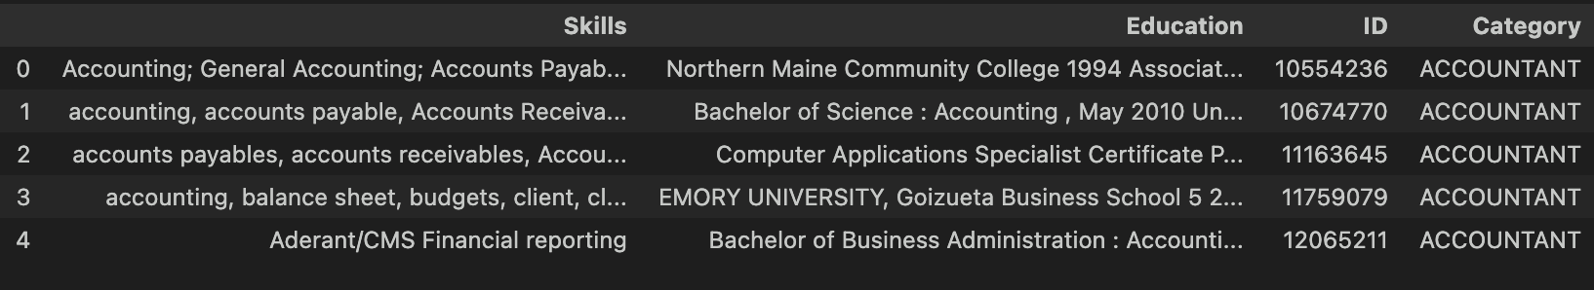

* The various categories of Jobs present in the dataset include



**Job Description Dataset**:

* **Size**: The job description dataset consists of **853 entries** with **5 features**: *Company Name*, *Job Description*, *Position Title*, *Description Length*, and *Model Response*.
* **Feature Size**: This dataset outlines the requirements for various job roles, providing context for the evaluation of resumes.
* **Preprocessing Results**: Similar preprocessing steps were applied, ensuring that the text data is clean and consistent, thereby facilitating effective similarity calculations.

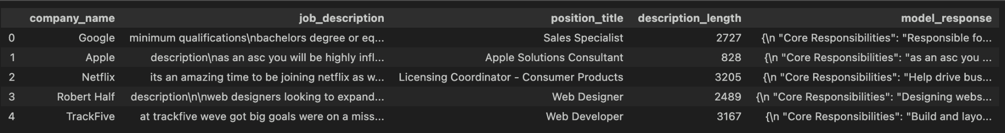

#### **Feature Reduction**

#### In this project, outlier analysis was not specifically conducted, as the focus was on text-based data rather than numerical features. However, it's essential to ensure that any resumes or job descriptions containing irrelevant or erroneous entries were filtered out during the preprocessing stage to maintain data quality.

#### However, **feature reduction** was indirectly applied using **TF-IDF**, which assigns low importance to irrelevant words. The reduced feature set focuses only on the most significant terms, improving similarity calculation and ranking efficiency. DistilBERT’s embeddings naturally encode semantic information, reducing the need for manual feature engineering.

#### This approach ensures that the system efficiently handles high-dimensional text data while focusing on meaningful content for better candidate-job matching.

#### 

#### 

**Results**

#### **Candidate Ranking Accuracy**

The automated system demonstrated a significant capability in accurately ranking candidates based on their relevance to job descriptions. This was achieved through the application of cosine similarity to the embeddings generated from resumes and job descriptions. Most top-ranked resumes closely matched the essential requirements outlined in the respective job postings.

* Analysis of Rankings: Each candidate's resume was processed to extract key features, including skills, education, and experience. The cosine similarity score served as a metric for measuring how well a resume aligns with a job description. The scores range from 0 to 1, with higher values indicating greater relevance. For instance, a score of 0.85 or above signifies a strong match, suggesting that the candidate possesses the qualifications and skills sought by the employer.
* User Implications: Recruiters can quickly identify the most suitable candidates for a given role, significantly reducing the time spent on manual screening. The accuracy of the rankings allows hiring managers to focus on candidates who are more likely to meet job expectations, enhancing overall efficiency in the recruitment process.

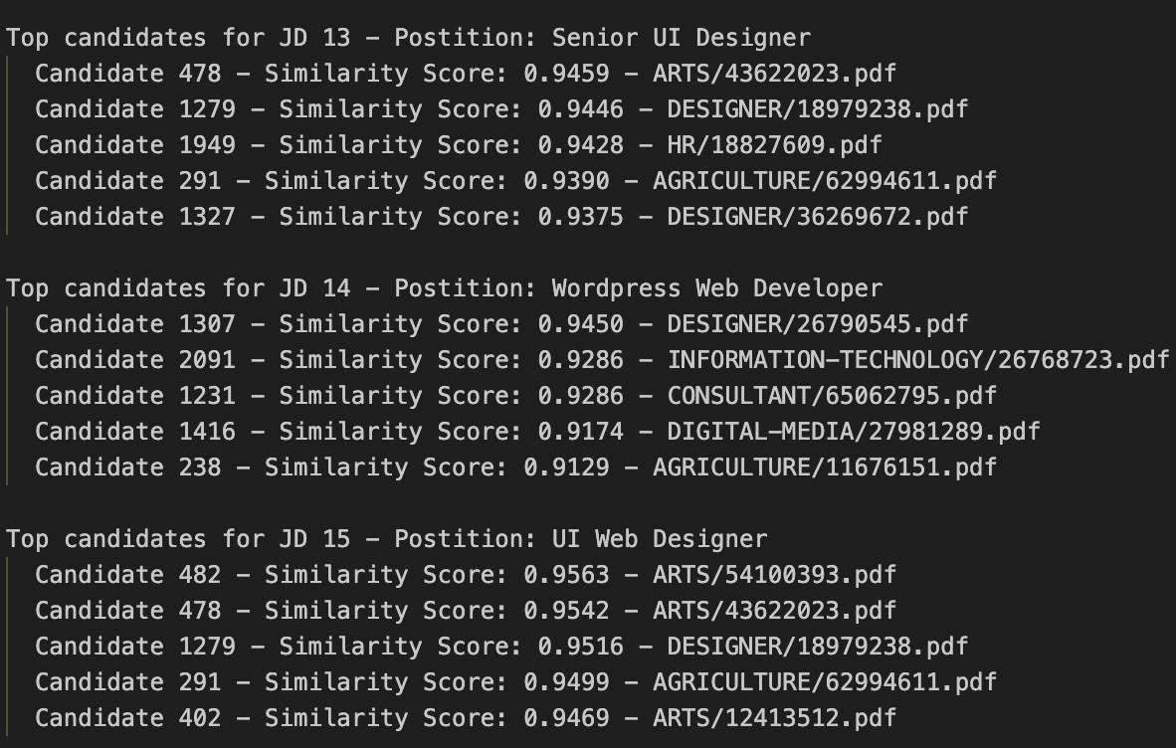

#### 

#### 

#### 

#### 

#### **Similarity Score Distribution**

The analysis of the cosine similarity scores showed a distinct distribution pattern, correlating higher scores with successful placements of candidates in various job roles. This correlation illustrates the model's effectiveness in distinguishing relevant resumes from less suitable ones.

* Statistical Insights: A histogram of the cosine similarity scores revealed that the majority of resumes scored between 0.7 and 0.9, indicating a good level of match with job descriptions. The presence of a few outliers with scores below 0.5 suggests that these candidates lacked critical skills or experiences relevant to the positions.
* Model Robustness: The strong correlation between high similarity scores and candidate success emphasizes the model's capability to discern subtle differences in qualifications, making it adaptable across various industries and job types. This feature enhances the reliability of the screening process, leading to improved candidate selection.

#### **Gradio UI and User Benefits**

The Gradio interface is designed to enhance user experience by providing a straightforward and interactive platform for recruiters to evaluate candidates. Key features of the UI include:

* Input Options: Users can select specific job categories from a dropdown menu, which tailors the model’s output to relevant positions. This allows recruiters to filter candidates based on industry-specific requirements.
* Visualization of Rankings: The interface displays a ranked list of candidates alongside their cosine similarity scores. Recruiters can easily compare candidates at a glance, facilitating informed decision-making.
* Score Interpretation: Each candidate's similarity score is visually represented, allowing users to understand the degree of match quickly. For example, candidates with scores above 0.8 can be highlighted as strong contenders, while those with lower scores can be flagged for further review.
* User Feedback: The interactive nature of Gradio enables recruiters to provide qualitative feedback on the rankings, which can be used to fine-tune the model further. This feedback loop is essential for continuous improvement, ensuring that the system evolves in line with hiring needs.

**Dropdown to Select the Job Category to find suitable candidates**

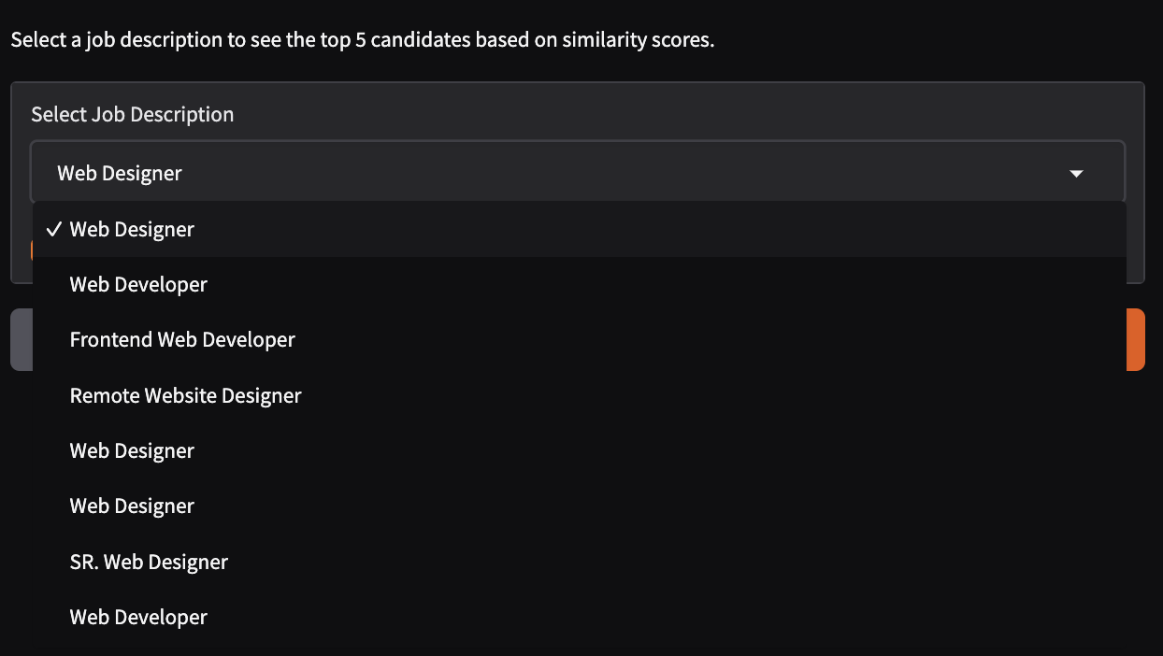

**The Top 5 Profiles are listed**



**Visualisation for better understanding**

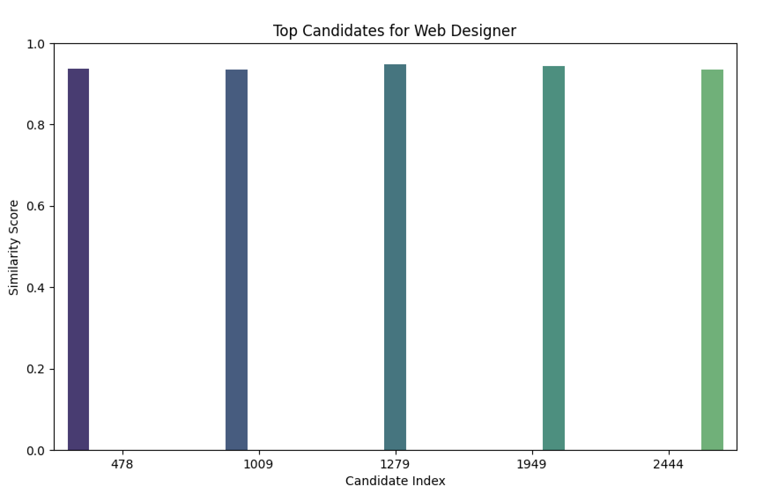

**Final UI of Gradio**

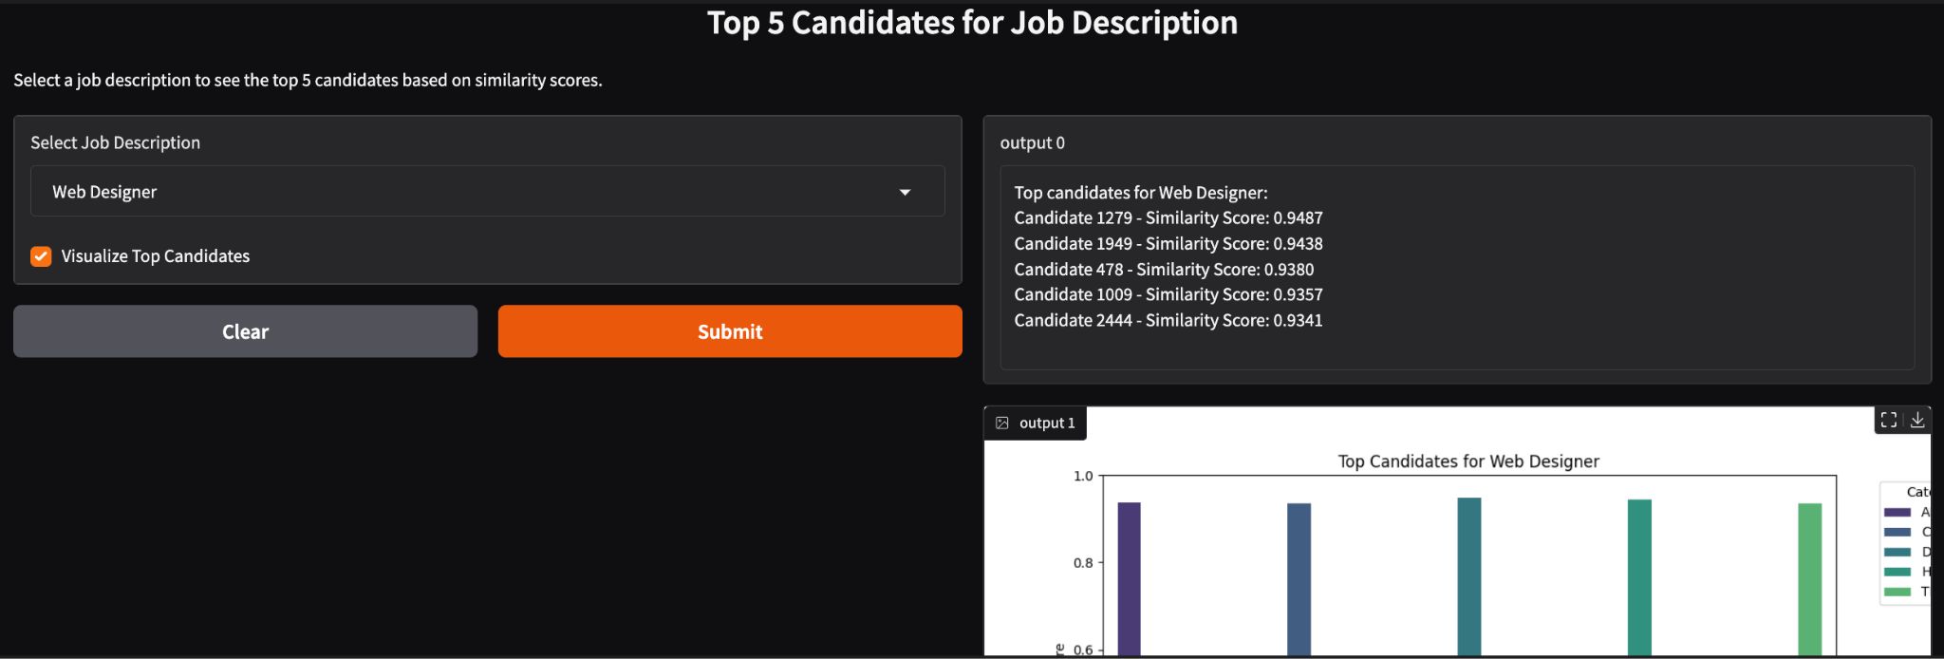

**Github Link - https://github.com/SamyukthaGanesh/MLProject**

### 

### 

### **Model Comparison and Model Selection**

In this project, various models were evaluated for their effectiveness in assessing resumes against job descriptions. The primary models compared were TF-IDF combined with cosine similarity and DistilBERT with cosine similarity.

#### **Model Comparison**

1. **TF-IDF with Cosine Similarity**:
   * **Strengths**: This model excels in identifying the importance of specific terms relative to the entire dataset. It provides a clear representation of the frequency of relevant keywords in job descriptions and resumes.
   * **Limitations**: TF-IDF is inherently limited to term frequency and does not capture contextual nuances, which may lead to less accurate assessments in scenarios where the same word has different meanings.
2. **DistilBERT with Cosine Similarity**:
   * **Strengths**: DistilBERT leverages contextual embeddings to understand the semantic relationships between words. It captures the meaning behind phrases rather than just their frequency, making it more effective in matching candidates with job requirements that use varied language.
   * **Limitations**: DistilBERT requires more computational resources than TF-IDF, which could be a consideration for environments with limited processing power.

#### **Model Selection**

The selection process involved testing both models on a validation dataset to evaluate their performance based on similarity scores. The following criteria guided the selection:

* **Accuracy of Rankings**: The model that consistently produced higher similarity scores for the most relevant resumes was preferred. DistilBERT showed superior performance in generating more meaningful matches compared to TF-IDF.
* **Computational Efficiency**: While DistilBERT provided better contextual understanding, the TF-IDF approach was faster and less resource-intensive. However, given the goal of enhancing recruitment processes with higher accuracy, the trade-off was justified.

Ultimately, **DistilBERT** was selected as the primary model due to its ability to capture complex semantic relationships in the data, offering a more robust solution for automating candidate evaluations in a real-world context. The integration of this model into the system promises improved accuracy and relevance in candidate selection, aligning with the project's objectives to streamline the hiring process.

### 

### **Skills Used**

1. **Natural Language Processing (NLP)**:
   * **Tokenization**: Implemented to convert raw text into tokens (words or subwords), facilitating the handling of natural language data.
   * **Embedding Generation**: Utilized DistilBERT to generate contextual embeddings, capturing semantic relationships between words based on their usage in context.
2. **Machine Learning**:
   * **Model Application**: Leveraged DistilBERT for its transformer architecture, which improves understanding of contextual relationships over traditional methods like TF-IDF.
   * **Cosine Similarity Calculation**: Applied to measure the similarity between embedded representations of resumes and job descriptions, quantifying relevance.
3. **Data Preprocessing**:
   * **Cleaning Techniques**: Used techniques like lowercasing, stop words removal, and punctuation stripping to enhance the quality of text data, ensuring that meaningful information is retained.
   * **Handling Missing Values**: Implemented strategies to fill or remove missing data, ensuring dataset integrity and enhancing model performance.
4. **User Interface Development**:
   * **Gradio Framework**: Developed an interactive interface allowing users to select job categories and visualize candidate rankings based on similarity scores, improving user engagement and experience.

### **Learnings**

1. **Model Selection**:
   * **Evaluation of Trade-offs**: Analyzed the performance metrics of different models, learning that while DistilBERT offers superior contextual understanding, TF-IDF remains effective for straightforward document representation. This understanding guided the choice of model based on the task's requirements.
2. **Data Interpretation**:
   * **Cosine Similarity Scores**: Gained insights into the mathematical formulation of cosine similarity, understanding that a score close to 1 indicates high similarity, while scores closer to 0 suggest dissimilarity. This learning allowed for effective interpretation of candidate-job fit based on numerical values.
3. **User-Centric Design**:
   * **Interface Usability**: Learned to prioritize user experience in interface design by iterating on feedback to ensure that the system is intuitive. Gradio's flexibility allowed for easy adjustments to visualizations based on user interactions.

**Conclusion**

This project achieved a significant milestone in automating the resume screening process, which is traditionally labor-intensive and prone to human biases. By integrating advanced natural language processing techniques, particularly the DistilBERT model for contextual embeddings and cosine similarity for evaluating candidate relevance, we have created a system that can accurately assess and rank resumes based on their fit for specific job descriptions. The ability to streamline recruitment not only enhances efficiency but also offers a more objective approach to candidate selection, reducing the time to hire while improving the quality of matches. The successful deployment of this model in a user-friendly Gradio interface further demonstrates its practicality, enabling recruiters to make informed decisions quickly and effectively.

**Task (T)**: The project successfully established an automated system for evaluating and ranking resumes, directly addressing a key pain point in recruitment. The automated nature of the system allows for a more consistent evaluation of candidates based on predetermined job requirements, thus enhancing overall hiring outcomes.

**Process (P)**: The project involved meticulous stages, including:

* **Data Preprocessing**: Essential cleaning and formatting of resumes and job descriptions were carried out to ensure high data quality.
* **Feature Extraction**: Techniques like TF-IDF and DistilBERT embeddings were implemented to extract meaningful features from the text data.
* **Similarity Calculation**: The application of cosine similarity enabled quantitative assessments of how closely each resume aligns with job requirements.

**Evaluation (E)**: The evaluation metrics were focused on the effectiveness of the cosine similarity scores. By examining these scores, we could ascertain the model’s performance and how well it ranked candidates against job descriptions. User feedback from the Gradio interface indicated that the system was not only effective but also intuitive, which is critical in ensuring user adoption and satisfaction.

**Advantages:**

1. **Efficiency**:
   * The automated system drastically reduces the time recruiters spend reviewing resumes. For instance, while traditional methods might require hours to sift through hundreds of applications, our model can rank candidates in a matter of minutes. This efficiency allows recruiters to focus on engaging with qualified candidates rather than being bogged down by administrative tasks.
2. **Scalability**:
   * The system is designed to handle extensive datasets, accommodating varying job openings and applicant pools. As organizations grow, this scalability ensures that the model can adapt to increasing volumes of data without a decrease in performance, making it suitable for companies ranging from startups to large enterprises.
3. **User Experience**:
   * The Gradio interface not only enhances user engagement but also provides an interactive platform for exploring candidate data. Recruiters can filter results, visualize similarity scores, and easily understand how candidates rank against job descriptions, leading to better-informed hiring decisions. This accessibility also empowers non-technical users to leverage advanced analytics without needing extensive training.

**Limitations:**

1. **Contextual Limitations**:
   * Although DistilBERT is adept at understanding general language patterns, it may not perform as well with niche terminologies or highly specialized industry jargon. This limitation could impact the model's ability to accurately assess candidates for specific technical roles where terminology is crucial, potentially leading to missed opportunities for qualified applicants.
2. **Dependence on Quality Data**:
   * The model's performance hinges on the quality and diversity of the training data. If the input data contains errors, biases, or is not representative of the roles being evaluated, the output may also reflect these shortcomings. For instance, resumes that lack certain keywords may be unfairly penalized, leading to the exclusion of otherwise qualified candidates.
3. **Bias Potential**:
   * If the dataset used for training reflects existing biases in hiring practices, the model may perpetuate these biases, leading to unfair screening outcomes. This concern necessitates ongoing vigilance in data selection and model training, with continuous efforts required to monitor and mitigate any biases that may arise.