A Project Report
On
Traffic Rules Violation
Submitted to
JAWAHARLAL NEHRU TECHNOLOGICAL UNIVERSITY ANANTAPUR, ANANTHAPURAMU
In Partial Fulfillment of the Requirements for the Award of the Degree of
BACHELOR OF TECHNOLOGY
In
ELECTRONICS & COMMUNICATION ENGINEERING
Submitted By

D.Lavanya - (16691A0462)
T.Mohammad Babji - (16691A0470)
R.Moulya - (16691A0474)
Y.Samyuktha - (16691A04B1)

Under the Guidance of

Dr.Sumit Gupta, _{Ph.D.}
Assistant Professor
Department of Electronics & Communication Engineering



MADANAPALLE INSTITUTE OF TECHNOLOGY & SCIENCE
(UGC – AUTONOMOUS)
(Affiliated to JNTUA, Ananthapuramu)
Accredited by NBA, Approved by AICTE, New Delhi
AN ISO 9001:2008 Certified Institution
P. B. No: 14, Angallu, Madanapalle – 517325


DEPARTMENT OF ELECTRONICS & COMMUNICATION ENGINEERING

BONAFIDE CERTIFICATE

This is to certify that the project work entitled “Traffic Rules Violation
” is a bonafide work carried out by
D.Lavanya - (16691A0462)
T.Mohammad Babji - (16691A0470)
R.Moulya - (16691A0474)
Y.Samyuktha - (16691A04B1)

Submitted in partial fulfillment of the requirements for the award of degree Bachelor of Technology in the stream of Electronics & Communication Engineering in Madanapalle Institute of Technology & Science, Madanapalle, affiliated to Jawaharlal Nehru Technological University Anantapur, Ananthapuramu during the academic year 2017-2018.

Guide Head of the Department
Dr.Sumit Gupta , _{Ph.D.} Dr.S.Rajasekaran_{, Ph.D,}
Assistant Professor Head of the
Department of ECE Department-ECE

Submitted for the University examination held on:

Internal Examiner External Examiner
Date: Date:
ACKNOWLEDGEMENT

I express my sincere and heartfelt gratitude to Dr.Sumit Gupta, Assistant Professor in Dept. of E.C.E, M.I.T.S, Madanapalle who has guided me in completing the Project with his/her cooperation, valuable guidance and immense help in giving the project a shape and success. I am very much indebted to him/her for suggesting a challenging and interactive project and his valuable advice at every stage of this work.
We are extremely grateful to Dr.S.Rajasekaran_{, Ph.D.,} Head of ECE for her valuable guidance and constant encouragement given to us during this work.

We sincerely thank Dr. C. Yuvaraj, _{M.E., Ph.D.,} Principal for guiding and providing facilities for the successful completion of our project at Madanapalle Institute of Technology & Science, Madanapalle.

We sincerely thank the MANAGEMENT of Madanapalle Institute of Technology & Science for providing excellent infrastructure and lab facilities that helped me to complete this project.

We would like to say thanks to other Faculty of ECE Department and also to our friends and our parents for their help and cooperation during our project work.

DECLARATION

We hereby declare that the results embodied in this project “ Traffic Rules Violation ” by us under the guidance of Dr.Sumit Gupta , Assistant Professor, Dept. of ECE in partial fulfillment of the award of Bachelor of Technology in Electronics and Communication Engineering, MITS, Madanapalle from Jawaharlal Nehru Technological University Anantapur, Ananthapuramu and we have not submitted the same to any other University/institute for award of any other degree.

Date :
Place :

PROJECTASSOCIATES
D.Lavanya
T.Mohammad Babji
R.Moulya
Y.Samyuktha

I certify that above statement made by the students is correct to the best of my knowledge.

Date : Guide Dr.Sumit Gupta

INDEX

S.NO Topic Page No
1 | Introduction | 10-11
2  3  4  5  6  7  8  9  10  11 | Literature Survey  2.1 Existing System  2.2 Proposed System  2.3 Features of Proposed System  2.4 Advantages  2.5 Applications  Embedded system implementation  3.1 Introduction  3.2 Embedded System  3.3 Embedded System Hardware  3.4 Microcontroller vs Microprocessor  3.5 Embedded System Software  3.6 Applications  Block Diagram  Hardware Requirements  5.1 Raspberry pi  5.2 LED  5.3 RFID  Software Requirements  6.1 Python  6.2 Python Features  6.3 Python History  6.4 Python Version  6.5 Python Application Area  6.6 NOOBS  6.7 Install Raspberry Pi  Working  Design  8.1 using proteus Software  8.2 PHP server  Implementation  9.1 Hardware Out Sketch  9.2 Programming Raspberry pi  9.3 Results  Conclusion  References | 12-13  12  12  12  13  13  14-19  14  14  15  15  16  18  19  20-36  20-27  27-32  32-36  37-47  37  37  38  39  40-41  42-45  45-47  47-48  49-52  49  50-52  53-56  53  54-55  56  57  57

ABSTRACT
Road turned parking lot is an inflexible issue over the world and it has become a terrible encounter for the day by day voyager. In the majority of the metropolitan game plans to make traffic light controllers increasingly smart. The advancement of new innovations, for example, correspondence systems and picture handling is being utilized guideline of the traffic request at every convergence in the system is the key highlights engaged with this strategy. So we need to keep away from car crashes and abbreviate the length of the line at the traffic signal .The fundamental goal of the framework is to screen the traffic sign and control traffic light arrangement. In the vast majority of nations the mishaps are caused because of red sign breaking. The framework will ceaselessly screen traffic signal. On the off chance that any individual or vehicle breaks the red sign, at that point the tag of the bicycle will be perused by the RFID Reader and the vehicle number will be send to PHP Server which is working by the RTO. At that point a SMS will be send to the bicycle proprietor with respect to the fine he needs to pay for bouncing the sign. Hence framework will distinguish traffic rule break and furthermore screen traffic light succession.

List of Figures

S.NO. | Figure | Name of the figure | Page Number
1 | 1.1 | Traffic of India | 10
2 | 3.1 | Overview of Embedded System | 12
3 | 3.2 | Embedded Systems | 13
4 | 3.3 | Flow of source code to processor | 15
5 | 4 | Block Diagram | 18
6 | 5.1 | Hardware Layout | 19
7 | 5.2 | Block Diagram of Rasberry Pi | 19
8 | 5.3 | GPIO | 20
9 | 5.4 | RCA Video Connector | 21
10 | 5.5 | Status LEDs | 22
11 | 5.6 | Gertboard &Rasberry Pi | 26
12 | 5.7 | LED | 27
13 | 5.8 | Working of LED | 27
14 | 5.9 | LED | 28
15 | 5.10 | Working of LED | 32
16 | 5.11 | Optocoupler schematic of Led | 33
17 | 5.12 | RFID Tag | 35
18 | 5.13 | RFID Reader | 36
19  20 | 5.14  6.1 | RFID Communication  Software Installation | 38  45
21  22 | 6.2  6.3 | SDFormatter V4.0  SDFormatter Check | 46  47
23 | 6.4 | Rasberry Pi Installation | 48
22 | 6.5 | Config Editor | 48
23 | 7.1 | Working | 50
24  25 | 8.1  8.2 | Design Part  Webpage | 51  52
S.NO. | Figure | Name of the figure | Page Number
26 | 8.3 | Registration | 52
27 | 8.4 | View Users | 53
28 | 8.5 | Unpaid List | 53
29 | 9.1 | Hardware Sketch | 54
30 | 9.2 | Rasberry Network Connection | 55
31  32  33 | 9.3  9.4  9.5 | Rasberry Pi Window  Opening Python IDLE  Message Received | 55  56  56

List of Tables

S.NO. | Figure | Name of the figure | Page Number
1 | 5.1 | Rasberry Pi Specifications | 25
2 | 5.2 | RFID Frequencies | 34

- Introduction
The quantity of vehicles has been expanded definitely in India, in as indicated by that auto collisions have likewise been expanded. So as to diminish these mishaps different advances have been started by the legislature yet these commencements have been bombed various occasions and residents defying traffic norms have been expanded. To stay away from this different activities and coordination have been started. One of the coordination is forcing punishment for those individuals who damage traffic manages particularly signal bounces. In this title the thought which has been proposed will diminish the car crashes and shirking.

As per the expanding populace of people groups and vehicles out and about utilized by those people groups, there are numerous issues made like petty criminal offense, security of people groups, expanding mishaps on street side and furthermore expanding the remaining task at hand of traffic police and government as well. This undertaking will decrease every one of these issues happened in all through the world. In this task there is programmed traffic rules infringement recognition framework, message sending, accepting and programmed fine getting from client's financial balance.

In this undertaking, sensor will detect the RFID label number which is given to the individual vehicle while buying or passing the vehicle for the number plate got by RTO. The camera will likewise be there for catching the picture of vehicle who have disrupted the norm. RFID peruser will peruse the RFID label number, most recent picture catch by camera and send this data to the server database. Server Database will send the Information identified with RFID label number and related picture from server and related insights concerning that specific vehicle, for example, name of proprietor, address of proprietor, permit number, plate number, photograph of vehicle client, versatile number, their ledger number and furthermore the rundown of past standards broke by that vehicle proprietor or driver with the date, time, fine and the sort of rule. This application will got the fine naturally from the proprietor's ledger as indicated by the standard broken by vehicle driver and its real fine chose by government.

This application will likewise send the message to vehicle proprietor about the sort of rule broken by vehicle client, fine as per that standard, evidence of defying the norm as picture taken by camera, date and time of disrupting the guideline and exact sum getting by their ledger as fine paid for disrupting the guideline. Because of this entire procedure there will be decrease in the remaining burden of traffic police and government and furthermore decrease in mishaps and defilement as well.

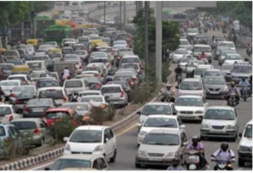

Figure 1: Traffic of India

2. LITERATURE SURVEY

As per the expanding populace of people groups and vehicles out and about utilized by those people groups, there are numerous issues made like criminal traffic offense on street, security of people groups from mishaps, expanding mishaps on street side and furthermore expanding the remaining task at hand of traffic police and government as well. In this study we have referenced distinctive Traffic rule Violation identification Devices.

2.1 Existing System:
• In present situations there is no framework for programmed treatment of the vehicles which defies the traffic norms and guideline. We have just Manual obstruction to stop vehicles in the sign. The individual's can break the red flag and can move if police isn't there at the signs.
• Due to this mishaps may happen in light of the fact that the vehicle from another side may hit the vehicles originating from the opposite side i.e., from the sign breaking side. So we moved to the proposed framework with headways.

2.2 Proposed System:
In this framework we are utilizing RFID Reader and labels. At the point when the vehicle breaks the sign. The subtleties read by the per user will be sent to the PHP server which is worked by the RTO authorities. From that point a SMS will be sent to the proprietor of the vehicle with respect to the punishment.

2.3 Features of proposed framework:

The various highlights in this proposed framework are:-

1) Application Interface

2) Corruption Avoidance

3) Automatic fine authority

4) Reduce remaining task at hand of Traffic Police

2.4 Applications:

➢ Useful to control the traffic productively and lessen mishaps

2.5 Advantages:

• Highly Sensitive

• Visual Identification With LED

• Low Cost And Reliable Circuit

• Sensitivity Can Be Adjusted

3. Embedded system implementation

3.1 Introduction:

An implanted framework is one sort of a PC framework for the most part intended to play out a few errands like to access, procedure, and store and furthermore control the information in different gadgets based frameworks. Implanted frameworks are a blend of equipment and programming where programming is generally known as firmware that is installed into the equipment. One of its most significant attributes of these frameworks is, it gives the o/p inside as far as possible. Implanted frameworks backing to make the work progressively great and advantageous. Along these lines, we as often as possible utilize inserted frameworks in straightforward and complex gadgets as well. The uses of inserted frameworks chiefly include in our genuine for a few gadgets like microwave, mini-computers, TV remote control, home security and neighborhood traffic control frameworks, and so on.

User interface

Embedded system

Software
Hardware

Inputs
Output

Link to other systems

Fig 3.1: Overview of embedded system

3.2 Embedded system:

Embedded system includes mainly two sections, they are

1. Hardware
2. Software

Input devices interfacing
and driver circuits
Timers
Memory
Processor
Serial communication ports
Interrupt controller
Parallel ports
Output devices interfacing

Power supply and oscillator circuits

Application specific circuits

Block diagram of embedded system

Fig 3.2: Embedded Systems

3.3 Embedded System Hardware:
Similarly as with any electronic framework, an installed framework requires an equipment stage on which it plays out the activity. Implanted framework equipment is worked with a chip or microcontroller. The inserted framework equipment has components like info yield (I/O) interfaces, UI, memory and the showcase. Typically, an inserted framework comprises of:
• Power Supply
• Processor
• Memory
• Timers
• Serial correspondence ports
• Output/Output circuits
• System application explicit circuits
Inserted frameworks utilize various processors for its ideal activity. a portion of the processors utilized are
1. Chip
2. Microcontroller
3. Advanced sign processor
3.4 Microprocessor vs. Microcontroller
Microprocessor
- CPU on a chip.
- We can attach required amount of ROM, RAM and I/O ports.
- Expensive due to external peripherals.
- Large in size
- general-purpose
Microcontroller
- Computer on a chip
- fixed amount of on-chip ROM, RAM, I/O ports
- Low cost.
- Compact in size.
- Specific –purpose

3.5 Embedded System Software:
The implanted framework programming is composed to play out a particular capacity. It is normally written in a significant level arrangement and afterward aggregated down to give code that can be held up inside a non-unstable memory inside the equipment. An inserted framework programming is intended to keep taking into account as far as possible:
• Availability of framework memory
• Availability of processor's speed
• When the framework runs constantly, there is a need to constrain power dissemination for occasions like stop, run and wake up.
Uniting programming and equipment for inserted framework:
To make programming to work with installed frameworks we have to unite programming and equipment .for this reason we have to consume our source code into chip or microcontroller which is an equipment segment and which deals with all tasks to be finished by inserted framework as indicated by our code.
For the most part we compose source codes for inserted frameworks in low level computing construct, however the processors run just executable records. The way toward changing over the source code portrayal of your inserted programming into an executable double picture includes three unmistakable advances:
1. Each of the source documents must be ordered or amassed into an item record.
2. All of the item documents that outcome from the initial step must be connected together to create a solitary article record, called the re-locatable program.
3. Physical memory delivers must be allocated to the relative balances inside the re-locatable program in a procedure called movement.
The consequence of the last advance is a document containing an executable twofold picture that is prepared to run on the inserted framework
.

Assembler
Linker

Locator

Processor

Executable file

Fig 3.3: Flow of source code to processor

3.6 Applications:
Inserted frameworks have various applications. A couple of select utilizations of installed frameworks are shrewd cards, broadcast communications, satellites, rockets, computerized shopper hardware, PC organizing, and so forth.

Inserted Systems in Automobiles

• Motor Control System
• Engine or Body Safety
• Robotics in Assembly Line
• Mobile and E-Com Access

Inserted frameworks in Telecommunications

• Mobile registering
• Networking
• Wireless Communications

Inserted Systems in Smart Cards
• Banking
• Telephone
• Security Systems

Execution stream:
Stage 1:
Thinking about the issues of existing strategies and offering answer for that issue by thinking about the essential necessities for our proposed framework
Stage 2:
Considering the equipment prerequisite for the proposed framework
For this we have to choose the beneath segments:
1. Microcontroller
2. Contributions for the proposed framework (ex: sensors, drivers etc..,)
3. Yields (ex: transfers, loads)
Stage 3:
In the wake of thinking about equipment necessities, presently we have to look at the product prerequisites. In view of the microcontroller we select there exists diverse programming for coding, assembling, investigating. we have to compose source code for that proposed framework dependent on our necessities and incorporate, troubleshoot the code in that product .
Subsequent to finishing all the prerequisites of programming and equipment we have to unite both to work our framework. For this we have to consume our source code into microcontroller, in the wake of consuming our source code to microcontroller then associate all information and yield modules according to our prerequisite.

4 Block Diagram
Raspberry Pi
Red LED
Green LED
RFID Reader
PHP Server
RFID Tags

Fig 4: Block Diagram

5.Hardware Requirements

5.1 Raspberry Pi:
INTRODUCTION OF RASPBERRY PI:
Raspberry Pi is a credit-card sized computer manufactured and designed in the United Kingdom by the Raspberry Pi foundation with the intention of teaching basic computer science to school students and every other person interested in computer hardware, programming and DIY-Do-it Yourself projects.
The Raspberry Pi is manufactured in three board configurations through licensed manufacturing deals with Newark element 14(Premier Farnell), RS Components and Egoman. These companies sell the Raspberry Pi online. Egoman produces a version for distribution solely in China and Taiwan, which can be distinguished from other Pi’s by their red coloring and lack of FCC/CE marks. The hardware is the same across all manufacturers.
The Raspberry Pi has a Broadcom BCM2835 system on a chip (SoC), which includes an ARM1176JZF-S 700 MHz processor, Video Core IV GPU and was originally shipped with 256 megabytes of RAM, later upgraded (Model B & Model B+) to 512 MB. It does not include a built-in hard disk or solid-state drive, but it uses an SD card for booting and persistent storage, with the Model B+ using a MicroSD.
The Foundation provides Debian and Arch Linux ARM distributions for download. Tools are available for Python as the main programming language, with support for BBC BASIC (via the RISC OS image or the Brandy Basic clone for Linux), C, Java and Perl.
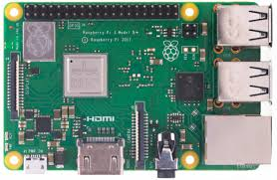
Fig 5.1: HARDWARE LAYOUT

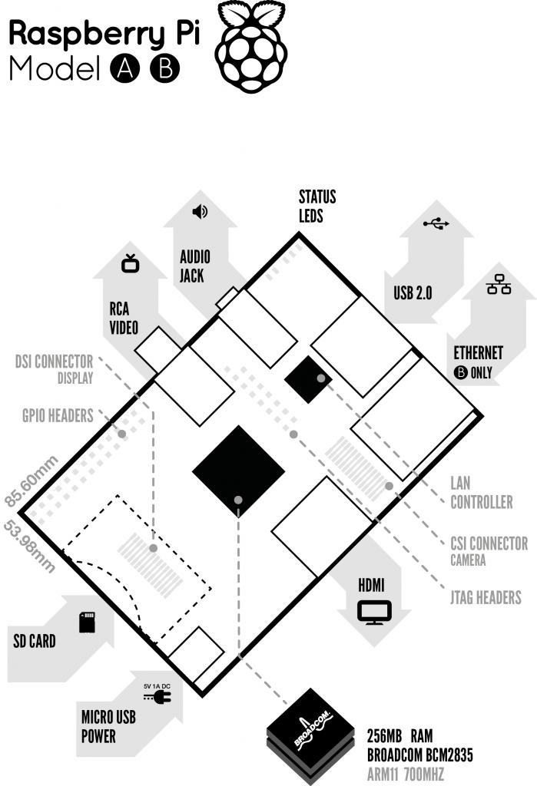

Fig 5.2: Block Diagram of Raspberry Pi

DESCRIPTION OF THE COMPONENTS ON THE RASPBERRY PI:
1) Processor/SoC(System on Chip):
The Raspberry Pi has a Broadcom BCM2835 System on Chip module. It has a ARM1176JZF-S processor. The Broadcom SoC used in the Raspberry Pi is equivalent to a chip used in an old smart phone. While operating at 700 MHz by default, the Raspberry Pi provides a real world performance roughly equivalent to the 0.041GFLOPS. The Raspberry Pi chip operating at 700 MHz by default, will not become hot enough to need a heat sink or special cooling.

2) Power source:
The Pi is a device which consumes 700mA or 3W or power. It is powered by a Micro USB charger or the GPIO header. Any good smart phone charger will do the work of powering the Pi.

3) SD Card:
The Raspberry Pi does not have any onboard storage available. The operating system is loaded on a SD card which is inserted on the SD card slot on the Raspberry Pi. The operating system can be loaded on the card using a card reader on any computer.

4) GPIO:
General-purpose input/output (GPIO) is a generic pin on an integrated circuit whose behavior, including whether it is an input or output pin, can be controlled by the user at run time. GPIO pins have no special purpose defined, and go unused by default. The idea is that sometimes the system designer building a full system that uses the chip might find it useful to have a handful of additional digital control lines, and having these available from the chip can save the hassle of having to arrange additional circuitry.
The production Raspberry Pi board has a 26-pin 2.54 mm expansion header, marked as P1, arranged in a 2x13 strip. They provide 8 GPIO pins plus access to I²C, SPI, UART), as well as +3.3 V, +5 V and GND supply lines. Pin one is the pin in the first column and on the bottom row.
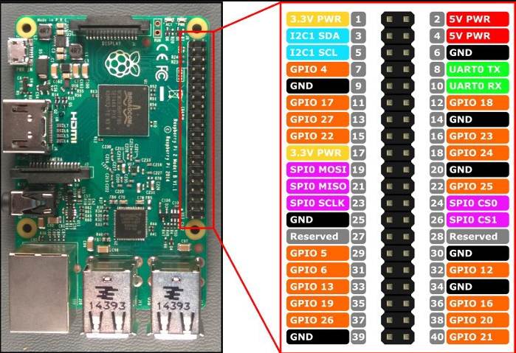
Fig 5.3: GPIO

5) DSI connector:
The Display Serial Interface (DSI) is a specification by the Mobile Industry Processor Interface (MIPI) Alliance aimed at reducing the cost of display controllers in a mobile device. It is commonly targeted at LCD and similar display technologies. It defines a serial bus and a communication protocol between the host and the device. A DSI compatible LCD screen can be connected through the DSI connector, although it may require additional drivers to drive the display.

6) RCA Video:
RCA Video outputs (PAL and NTSC) are available on all models of Raspberry Pi. Any television or screen with a RCA jack can be connected with the RPi.

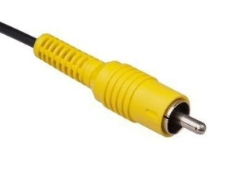

Fig 5.4: RCA Video Connector

7) Audio Jack:
A standard 3.5 mm TRS connector is available on the RPi for stereo audio output. Any headphone or 3.5mm audio cable can be connected directly. Although this jack cannot be used for taking audio input, USB mics or USB sound cards can be used.

8) Status LEDs:
There are 5 status LEDs on the RPi that show the status of various activities. They are “OK” ,"ACT" ,,“POWER” (PWR),Full Duplex ("FDX"),“LNK” ( Link/Activity), “10M/100” which are shown in figure below.

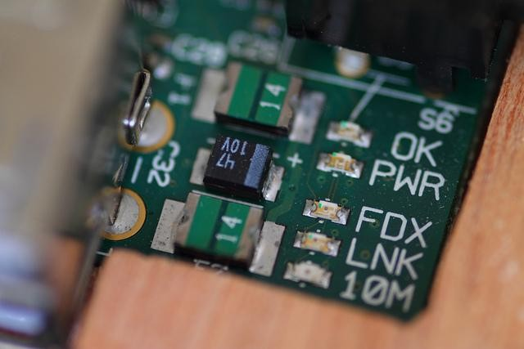

Figure 7: Status LEDs

Fig 5.5: Status LEDs
9) USB 2.0 Port:
USB 2.0 ports are the means to connect accessories such as mouse or keyboard to the Raspberry Pi. There is 1 port on Model A, 2 on Model B and 4 on Mo del B+. The number of ports can be increased by using an external powered USB hub which is available as a standard Pi accessory.

10) Ethernet:
Ethernet port is available on Model B and B+. It can be connected to a network or internet using a standard LAN cable on the Ethernet port. The Ethernet ports are controlled by Microchip LAN9512 LAN controller chip.

11) CSI connector:
CSI – Camera Serial Interface is a serial interface designed by MIPI (Mobile Industry Processor Interface) alliance aimed at interfacing digital cameras with a mobile processor. The RPi foundation provides a camera specially made for the Pi which can be connected with the Pi using the CSI connector.

12) JTAG headers:
JTAG is an acronym for ‘Joint Test Action Group', an organization that started back in the mid 1980's to address test point access issues on PCB with surface mount devices. The organization devised a method of access to device pins via a serial port that became known as the TAP (Test Access Port). In 1990 the method became a recognized international standard (IEEE Std 1149.1). Many thousands of devices now include this standardized port as a feature to allow test and design engineers to access pins.

13) HDMI:
HDMI –High Definition Multimedia Interface
HDMI 1.3 a type A port is provided on the RPi to connect with HDMI screens.
SPECIFICATIONS:
 | Model A | Model B | Model B+
Target price: | US$25 | US$35
SoC: | Broadcom BCM2835 (CPU, GPU, DSP, SDRAM, and single USB port)
CPU: | 700 MHz ARM1176JZF-S core (ARM11 family, ARMv6 instruction set)
GPU: | Broadcom Video Core IV @ 250 MHz
Memory  (SDRAM): | 256 MB  GPU) | 512 MB (shared with GPU)
USB 2.0 ports: | 1 (direct from BCM2835 chip)  BCM2835 chip) | 2 (via the on-board 3- port USB hub) | 4 (via the on-board 5- port USB hub)
Video input: | 15-pin MIPI camera interface (CSI) connector, used with the Raspberry Pi  Camera Addon.
Video outputs: | Composite RCA (PAL and NTSC) –in model B+ via 4-pole 3.5 mm jack, HDMI (rev 1.3 & 1.4), raw LCD Panels via DS
Audio outputs: | 3.5 mm jack, HDMI, and, as of revision 2 boards, I²S audio (also potentially  for audio input)
Onboard storage: | SD / MMC / SDIO card slot (3.3 V card power support only)  support only) |  | MicroSD
Onboard network: | None | 10/100 Mbit/s Ethernet (8P8C) USB adapter on the third/fifth port of the USB hub
Low-level peripherals: | 8× GPIO, UART, I²C bus, SPI bus with two chip selects, I²S audio +3.3 V, +5 V, ground |  | 17× GPIO

Power ratings: | 300 mA (1.5 W) | 700 mA (3.5 W) | 600 mA (3.0 W)
Power source: | 5 V via Micro USB or GPIO header
Size: | 85.60 mm × 56 mm (3.370 in × 2.205 in) – not including protruding  Connectors
Weight: | 45 g (1.6 oz)
Table 5.1 Raspberry Pi Specifications

BRIEF DESCRIPTION OF SYSTEM ON CHIP (SoC):
Since smart phones and tablets are basically smaller computers, they require pretty much the same components we see in desktops and laptops in order to offer us all the amazing things they can do (apps, music and video playing, 3D gaming support, advanced wireless features, etc). But smart phones and tablets do not offer the same amount of internal space as desktops and laptops for the various components needed such as the logic board, the processor, the RAM, the graphics card, and others. That means these internal parts need to be as small as possible, so that device manufacturers can use the remaining space to fit the device with a long-lasting battery life. A system on a chip or system on chip is an integrated circuit (IC) that integrates all components of a computer or other electronic system into a single chip. It may contain digital, analog, mixed-signal, and often radio-frequency functions—all on a single chip substrate. SoCs are very common in the mobile electronics market because of their low power consumption. A typical application is in the area of embedded systems.
The contrast with a microcontroller is one of degree. Microcontrollers typically have under 100 kB of RAM (often just a few kilobytes) and often really are single-chip- systems, whereas the term SoC is typically used for more powerful processors, capable of running software such as the desktop versions of Windows and Linux, which need external memory chips (flash, RAM) to be useful, and which are used with various external peripherals. In short, for larger systems, the term system on a chip is a hyperbole, indicating technical direction more than reality: increasing chip integration to reduce manufacturing costs and to enable smaller systems. Many interesting systems are too complex to fit on just one chip built with a process optimized for just one of the system's tasks.
ACCESSORIES:
Raspberry Pi being a very cheap computer has attracted millions of users around the world. Thus it has a large user base. Many enthusiasts have created accessories and peripherals for the Raspberry Pi. This range from USB hubs, motor controllers to temperature sensors. There are some official accessories for the RPi as follows:
Camera – The Raspberry Pi camera board contains a 5 MPixel sensor, and connects via a ribbon cable to the CSI connector on the Raspberry Pi. In Raspbian support can be enabled by the installing or upgrading to the latest version of the OS and then running Raspi-config and selecting the camera option.
Gertboard – A Raspberry Pi Foundation sanctioned device designed for educational purposes, and expands the Raspberry Pi's GPIO pins to allow interface with and control of LEDs, switches, analog signals, sensors and other devices. It also includes an optional Arduino compatible controller to interface with the Pi. The Gertboard can be used to control motors, switches etc. for robotic projects.

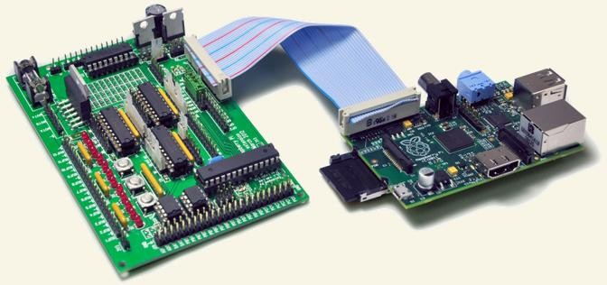

Fig 5.6: Gertboard(left) & Raspberry Pi(Right)

USB Hub – Although not an official accessory, it is a highly recommended accessory for the Pi. A powered USB Hub with 7 extra ports is available at almost all online stores. It is compulsory to use a USB Hub to connect external hard disks or other accessories that draw power from the USB ports, as the Pi cannot give power to them.

5.2 Light Emitting Diodes (LEDs)

The Light Emitting diode is a two-lead semiconductor light source. In 1962, Nick Holonyak has concocted a thought of light radiating diode, and he was working for the general electric organization. The LED is an uncommon sort of diode and they have comparable electrical qualities of a PN intersection diode. Thus the LED permits the progression of current the forward way and hinders the current in the converse course. The LED possesses the little zone which is not exactly the 1 mm2. The utilizations of LEDs used to make different electrical and electronic activities. In this article, we will examine the working guideline of the LED and its applications.

What is a Light Emitting Diode?
The lighting emitting diode is a p-n junction diode. It is a specially doped diode and made up of a special type of semiconductors. When the light emits in the forward biased, then it is called as a light emitting diode.

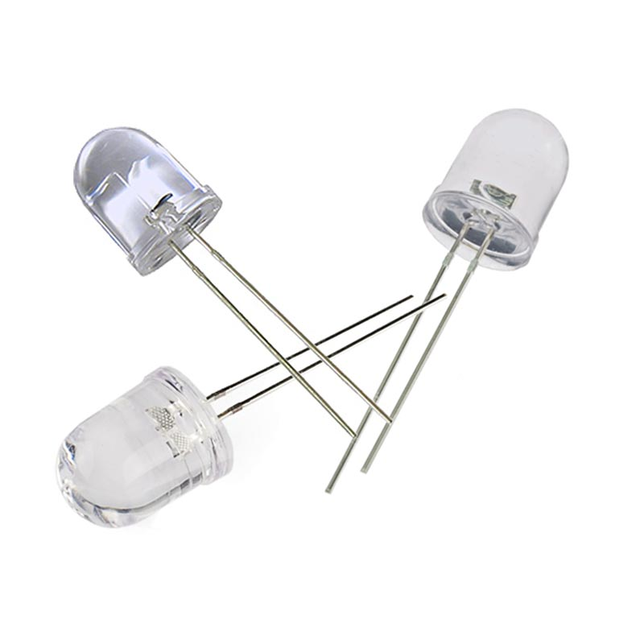

Fig 5.7: LED

How does the Light Emitting Diode work?
The light emitting diode simply, we know as a diode. When the diode is forward biased, then the electrons & holes are moving fast across the junction and they are combining constantly, removing one another out. Soon after the electrons are moving from the n-type to the p-type silicon, it combines with the holes, then it disappears. Hence it makes the complete atom & more stable and it gives the little burst of energy in the form of a tiny packet or photon of light.

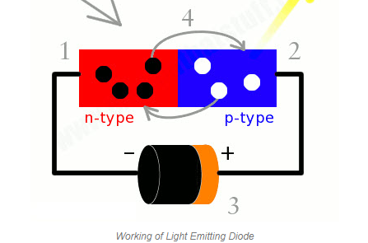

Fig 5.8: Working of LED

Schematic:

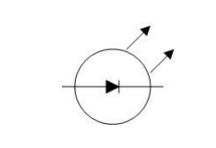

Fig 5.9: LED

- A Light emitting diode (LED) is essentially a pn junction diode. When carriers are injected across a forward-biased junction, it emits incoherent light.

- Most of the commercial LEDs are realized using a highly doped n and a p Junction.

LED Materials:
A critical class of business LEDs that cover the unmistakable range. Ternary composites in view of alloying GaAs and GaP which are signified by GaAs1-yPy. InGaAlP is a case of a quaternary (four component) III-V compound with an immediate band crevice. The LEDs acknowledged utilizing two diversely doped semiconductors that are the same material is known as a homojunction. When they are acknowledged utilizing diverse bandgap materials they are known as a heterostructure gadget heterostructure LED is brighter than a homoJunction LED.
LED Structure:
The LED structure accept an imperative part in transmitting light from the LED surface. The LEDs are composed to ensure most of the recombinations occurs from the start by the going with two different ways. • By growing the doping gathering of the substrate, with the goal that additional free minority charge transporters electrons move to the top, recombine and radiate light at the surface. • By extending the spread length L = √ Dτ, where D is the scattering coefficient and τ is the carrier life time. Regardless, when extended past an essential length there is a chance of re-maintenance of the photons into the device. The LED must be sorted out so the photons created from the device are transmitted without being reabsorbed. One course of action is to make the p layer on the top, adequately feeble to make a fatigue layer. Taking after picture shows the layered structure. There are assorted ways to deal with structure the vault for capable transmitting.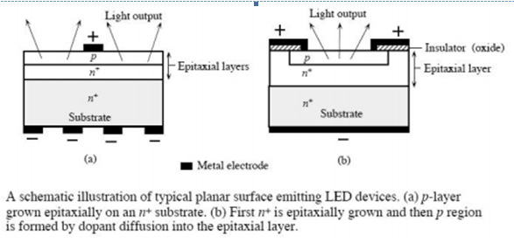
Fig 5.10 Working of LED
LEDs are normally based on a n-sort substrate, with a terminal joined to the p-sort layer saved on its surface. P-sort substrates, while less basic, happen too. Numerous business LEDs, particularly GaN/InGaN, likewise utilize sapphire substrate. Driven productivity: A vital metric of a LED is the outside quantum proficiency next. It measures the efficiency of the transformation of electrical vitality into transmitted optical vitality. It is characterized as the light yield isolated by the electrical information power.

It is likewise characterized as the result of Internal radiative proficiency and Extraction productivity. ηext = Pout(optical)/IV For backhanded band gap semiconductors ηext is for the most part under 1%, where concerning an immediate band hole material it could be generous. ηint = rate of radiation recombination/Total recombination The interior effectiveness is an element of the nature of the material and the structure and arrangement of the layer.
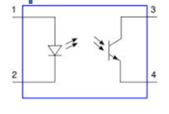
Fig 5.11 Optocoupler Schematic showing LED and photoresistor
Applications:
LED have a lot of applications. Following are few examples.
• Devices, medical applications, clothing, toys
• Remote Controls (TVs, VCRs)
• Lighting
• Indicators and signs
• Optoisolators and optocouplers
• Swimming pool lighting
Advantages of using LEDs
• LEDs deliver more light per watt than radiant knobs; this is valuable in battery fueled or vitality sparing gadgets.
• LEDs can radiate light of a planned shading without the utilization of shading channels that customary lighting techniques require. This is more effective and can bring down introductory expenses.
• The strong bundle of the LED can be intended to center its light. Glowing and fluorescent sources frequently require an outside reflector to gather light and direct it in a usable way.
• When utilized as a part of utilizations where darkening is required, LEDs don't change their shading tint as the present going through them is brought down, not at all like radiant lights, which turn yellow.
• LEDs are perfect for use in applications that are liable to visit on-off cycling, not at all like fluorescent lights that copy out all the more immediately when cycled much of the time, or High Intensity Discharge (HID) lights that require quite a while before restarting.
• LEDs, being strong state segments, are hard to harm with outer stun. Fluorescent and radiant globules are effectively broken if dropped on the ground.
• LEDs can have a moderately long valuable life. A Philips LUXEON k2 LED has an existence time of around 50,000 hours, though Fluorescent tubes commonly are appraised at around 30,000 hours, and brilliant lights at 1,000–2,000 hours.
• LEDs generally fall flat by darkening after some time, as opposed to the unexpected wear out of brilliant globules.
• LEDs illuminate rapidly. A run of the mill red marker LED will accomplish full brilliance in microseconds; Philips Lumileds specialized datasheet DS23 for the Luxeon Star states "under 100ns." LEDs utilized as a part of specialized gadgets can have significantly quicker reaction times.
• LEDs can be little and are effortlessly populated onto printed circuit sheets.
• LEDs don't contain mercury, not at all like conservative fluorescent lights.

5.3 RFID Reader

Introduction
- Radio frequency Identification (RFID) is a wireless identification technology that uses radio waves to identify the presence of RFID tags.
- Just like Bar code reader, RFID technology is used for identification of people, object etc. presence.
- In barcode technology, we need to optically scan the barcode by keeping it in front of reader, whereas in RFID technology we just need to bring RFID tags in range of readers. Also, barcodes can get damaged or unreadable, which is not in the case for most of the RFID.
- RFID is used in many applications like attendance system in which every person will have their separate RFID tag which will help identify person and their attendance.
- RFID is used in many companies to provide access to their authorized employees.
- It is also helpful to keep track of goods and in automated toll collection system on highway by embedding Tag (having unique ID) on them.
RFID based system has two basic elements
1. RFID Tag:
RFID tag includes microchip with radio antenna mounted on substrate which carries 12 Byte unique Identification number.
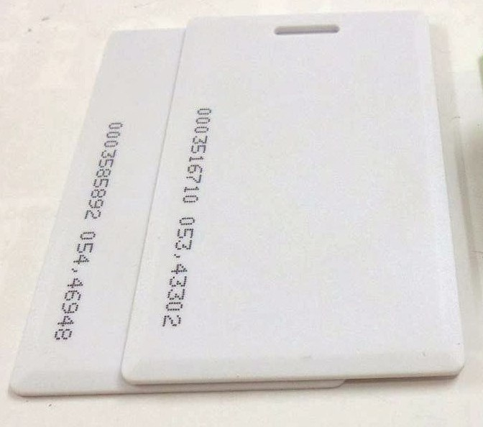

Fig 5.12: RFID Tag
2. RFID Reader:
It is used to read unique ID from RFID tags. Whenever RFID tags comes in range, RFID reader reads its unique ID and transmits it serially to the microcontroller or PC. RFID reader has transceiver and an antenna mounted on it. It is mostly fixed in stationary position.
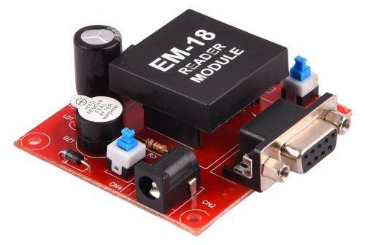
Fig 5.13 RFID Reader
EM18 RFID Reader Module

Basically, RFID systems categorised as active and passive based on how they are powered and their range.
1. Active RFID system
Active RFID tags have their own transmitter and power source (Mostly battery operated). They operate at 455 MHz, 2.45 GHz, or 5.8 GHz, and they typically have a read range of 60 feet to 300 feet (20 meters to 100 meters).
2. Passive RFID system
Passive RFID tags do not have a transmitter, they simply reflect energy (radio waves) back coming from the RFID reader antenna. They operate in Low frequency (~125 KHz) as well as High frequency (~13 MHz) band and have limited read range of up to ~1m.
There are two modes of coupling for communication used in RFID as,
Inductive coupling, in which RFID reader emits magnetic field and whenever RFID tags enters the magnetic field which creates energy response from RFID tags and is detected by RFID reader. As the magnetic field drops sharply with distance, it is used for short distance applications.
Capacitive coupling, where reader emits electromagnetic waves and whenever that waves encounters RFID tags, RFID tag reflects signal containing information of ID.

2.How RFID system works?
RFID Reader has transceiver which generates a radio signal and transmits it through antenna. This signal itself is in the form of energy which is used to activate and power the tag.
When RFID tag comes in range of signal transmitted by the reader, transponder in the tag is hit by this signal. A tag draws power from the electromagnetic field created by reader. Then, the transponder converts that radio signal into the usable power. After getting power, transponder sends all the information it has stored in it, such as unique ID to the RFID reader in the form of RF signal. Then, RFID reader puts this unique ID data in the form of byte on serial Tx (transmit) pin. This data can be used or accessed by PC or microcontroller serially using UART communication.
There are various RFID readers available according to their frequency are shown as follows,

Frequency | Range | Different modules | Applications
120-150 kHz | 5-20 cm | EM-18, ILA-12, etc. | Factory data collection, identifying animals etc.
13.56 MHz | 10 cm – 1m | MFRC522, SM130 | Smart cards
Table 5.2: RFID Frequencies
3. EM18 RFID Reader

EM18 is a RFID reader which is used to read RFID tags of frequency 125 kHz.
After reading tags, it transmits unique ID serially to the PC or microcontroller using UART communication or Wiegand format on respective pins.
EM18 RFID reader reads the data from RFID tags which contains stored ID which is of 12 bytes.
EM18 RFID reader doesn’t require line-of-sight. Also, it has identification range which is short i.e. in few centimetres.
RFID reader EM-18 features:
1. Serial RS232/TTL output
2. Operating Frequency is 125KHz.
3. Range is 5-8 cm.

RFID Reader to PC/Laptop communication
We can see RFID reader output on serial terminal of PC/Laptop.
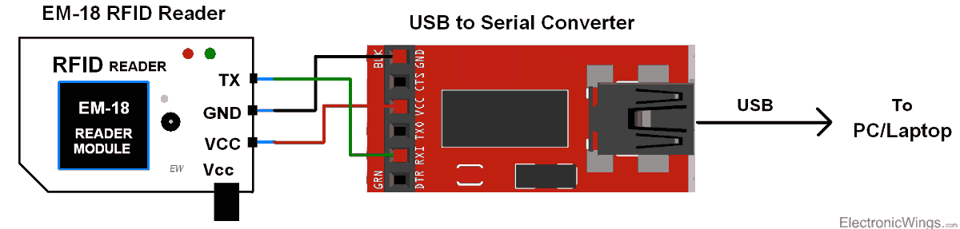
Fig 5.14: RFID Communication
RFID Serial Interface
When we bring RFID tag near to the reader, it reads the data from the tag and immediately transmits 12-byte unique ID on the serial port.
12 Byte Unique Identification Number
RFID Tags contain 12 Byte unique ID.

6. Software Requirements

6.1 PYTHON:
Python is a general purpose, dynamic, high level and interpreted programming language. It supports Object Oriented programming approach to develop applications. It is simple and easy to learn and provides lots of high-level data structures. It is easy to learn yet powerful and versatile scripting language which makes it attractive for Application Development. It's syntax and dynamic typing with its interpreted nature, makes it an ideal language for scripting and rapid application development. It supports multiple programming patterns, including object oriented, imperative and functional or procedural programming styles. It is not intended to work on special area such as web programming. That is why it is known as multipurpose because it can be used with web, enterprise, 3D CAD etc. We don't need to use data types to declare variable because it is dynamically typed so we can write a=10 to assign an integer value in an integer variable.It makes the development and debugging fast because there is no compilation step included in python development and edit-test-debug cycle is very fast.

6.2 Python Features
Python provides lots of features that are listed below.

1) Easy to Learn and Use
Python is easy to learn and use. It is developer-friendly and high level programming language.

2) Expressive Language
Python language is more expressive means that it is more understandable and readable.

3) Interpreted Language
Python is an interpreted language i.e. interpreter executes the code line by line at a time. This makes debugging easy and thus suitable for beginners.

4) Cross-platform Language
Python can run equally on different platforms such as Windows, Linux, Unix and Macintosh etc. So, we can say that Python is a portable language.

5) Free and Open Source
Python language is freely available at address. The source-code is also available. Therefore it is open source.

6) Object-Oriented Language
Python supports object oriented language and concepts of classes and objects come into existence.

7) Extensible
It implies that other languages such as C/C++ can be used to compile the code and thus it can be used further in our python code.

8) Large Standard Library
Python has a large and broad library and provides rich set of module and functions for rapid application development.

9) GUI Programming Support
Graphical user interfaces can be developed using Python.

10) Integrated
It can be easily integrated with languages like C, C++, JAVA etc.

6.3 Python History
- Python laid its foundation in the late 1980s.
- The implementation of Python was started in the December 1989 by Guido Van Rossum at CWI in Netherland.
- In February 1991, van Rossum published the code (labeled version 0.9.0) to alt.sources.
- In 1994, Python 1.0 was released with new features like: lambda, map, filter, and reduce.
- Python 2.0 added new features like: list comprehensions, garbage collection system.
- On December 3, 2008, Python 3.0 (also called "Py3K") was released. It was designed to rectify fundamental flaw of the language.
- ABC programming language is said to be the predecessor of Python language which was capable of Exception Handling and interfacing with Amoeba Operating System.
- Python is influenced by following programming languages:
  - ABC language.
  - Modula-3
6.4 Python Version
Python programming language is being updated regularly with new features and supports. There are lots of updations in python versions, started from 1994 to current release.
A list of python versions with its released date is given below.
Python Version Released Date
Python 1.0 January 1994
Python 1.5 December 31, 1997
Python 1.6 September 5, 2000
Python 2.0 October 16, 2000
Python 2.1 April 17, 2001
Python 2.2 December 21, 2001
Python 2.3 July 29, 2003
Python 2.4 November 30, 2004
Python 2.5 September 19, 2006
Python 2.6 October 1, 2008
Python 2.7 July 3, 2010
Python 3.0 December 3, 2008
Python 3.1 June 27, 2009
Python 3.2 February 20, 2011
Python 3.3 September 29, 2012
Python 3.4 March 16, 2014
Python 3.5 September 13, 2015
Python 3.6 December 23, 2016
Python 3.6.4 December 19, 2017

6.5 Python Applications Area
Python is known for its general purpose nature that makes it applicable in almost each domain of software development. Python as a whole can be used in any sphere of development.
Here, we are specifying applications areas where python can be applied.

1) Web Applications
We can use Python to develop web applications. It provides libraries to handle internet protocols such as HTML and XML, JSON, Email processing, request, beautifulSoup, Feedparser etc. It also provides Frameworks such as Django, Pyramid, Flask etc to design and develop web based applications. Some important developments are: PythonWikiEngines, Pocoo, PythonBlogSoftware etc.

2) Desktop GUI Applications
Python provides Tk GUI library to develop user interface in python based application. Some other useful toolkits wxWidgets, Kivy, pyqt that are useable on several platforms. The Kivy is popular for writing multitouch applications.

3) Software Development
Python is helpful for software development process. It works as a support language and can be used for build control and management, testing etc.

4) Scientific and Numeric
Python is popular and widely used in scientific and numeric computing. Some useful library and package are SciPy, Pandas, IPython etc. SciPy is group of packages of engineering, science and mathematics.

5) Business Applications
Python is used to build Bussiness applications like ERP and e-commerce systems. Tryton is a high level application platform.

6) Console Based Application
We can use Python to develop console based applications. For example: IPython.

7) Audio or Video based Applications
Python is awesome to perform multiple tasks and can be used to develop multimedia applications. Some of real applications are: TimPlayer, cplay etc.

8) 3D CAD Applications
To create CAD application Fandango is a real application which provides full features of CAD.

9) Enterprise Applications
Python can be used to create applications which can be used within an Enterprise or an Organization. Some real time applications are: OpenErp, Tryton, Picalo etc.

10) Applications for Images
Using Python several application can be developed for image. Applications developed are: VPython, Gogh, imgSeek etc. There are several such applications which can be developed using Python.
6.6 NOOBS (New Out Of Box Software) :
Despite its success, there is something about the Raspberry Pi that might just put people off: until now, setting it up has not been particularly user friendly. NOOBS aims to change that!
Intended for youngsters to get to grips with computing in countries where IT skills are a rarity, the Raspberry Pi has proved to be a surprisingly popular device – especially considering the relatively low specification.
Setting up a Raspberry Pi isn’t difficult – however it is unnecessarily involved, requiring SD card writing software. Wouldn’t it be much easier if the tools for installing the Pi could be simply copied to an SD card and the computer launched?
The Raspberry Pi Foundation obviously thought so as they have released NOOBS, a tool for streamlining installation, running multiple operating systems and easily configuring your OS options.
What is NOOBS?
Provided as a free download from the Raspberry Pi website, NOOBS (New Out Of Box Software) is a user interface enabling the easy installation of a choice of operating systems for your Raspberry Pi. Two downloads are available: a bulky offline installer that downloads all of the available operating systems and a slimline, Lite option, which is configured for network installation.
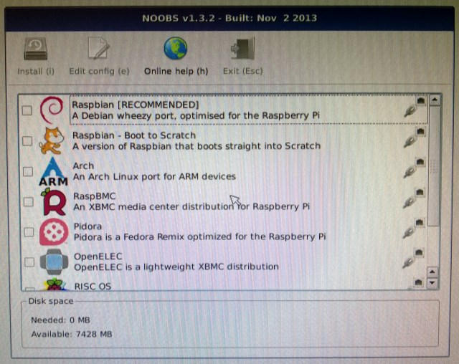
Fig 6.1: Software Installation
Once installation is complete (see below), NOOBS also provides the means to configure your Pi; previously this would have been something you would do by opening a text file or – in the case of Raspbian – in a command line menu. With NOOBS, configuration is made far easier.
Setting up NOOBS is deceptively simple, but before you start, let’s take a look at the available Raspberry Pi operating systems that can be installed:
- Raspbian – Debian release for Raspberry Pi
- OpenELEC – streamlined XBMC release
- RISC OS – the classic British operating system
- Raspbian – Version configured to boot to Desktop
- Arch – Arch Linux build for Raspberry Pi
- RaspBMC – Raspbian with XBMC
- Pidora – Raspberry Pi fork of Fedora
You might want to install one; you might prefer several. Like BerryBoot, NOOBS allows dual booting, and session data is maintained in each OS image. This means that you will be able to work on developing a basic computer game in Raspbian, save your data then boot into OpenELEC to watch a movie before switching back to Raspbian to carry on where you left off.
By now you should have downloaded the NOOBS installer – the Lite version is best to get started with, especially if space on your chosen SD card is limited.
Configuring your SD Card:
You’ll need to use your desktop computer to configure the SD card for NOOBS.
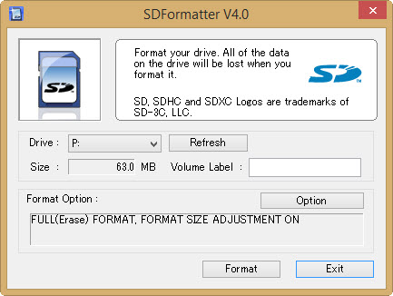
Fig 6.2: SDFormatter V4.0
After using the download link above (we’ll be focusing on the Lite online installer here) you’ll also need to grab the SD Card Association formatting tool from www.sdcard.org/downloads/formatter_4.
Once downloaded, install and insert your SD card into your card reader. Use the formatting tool to erase and reformat your card (any data on it already will be lost), ensuring that the correct drive letter is selected.
Ensure you have a card that is over 4 GB. When selecting options, use Format Size Adjustment on Windows; Overwrite Format if you’re using a Mac OS X. If you’re on Linux, use gparted instead.
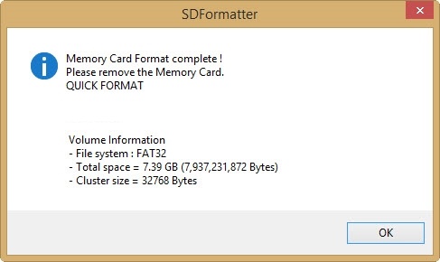
Fig 6.3: SDFormatter Check
When you’re done, the software will confirm the reformat. Now it’s time to unzip the NOOBS download onto the SD card. This means that the contents of the NOOBS zip file should be at the root of the SD card, opposed to a folder called NOOBS_lite_X_X_X.
You should then safely eject the SD card, insert it into your Raspberry Pi and boot up the little computer!
6.7 Install Raspberry pi
With your Pi powered up and a network cable connected, it should take just a few moments for NOOBS to launch, displaying a list of available operating systems.
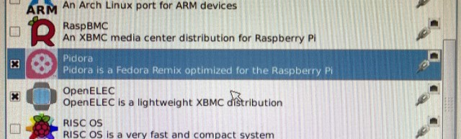
Fig 6.4: Rasberry Pi installation
Installation is fiendishly simple: click the operating system(s) you want, and click Install or press i. You will then see a warning message explaining that data on the card is about to be overwritten. All you need to do then is agree to proceed and wait as the selected operating systems are downloaded and extracted!
Note that there is also the option to add an empty 512 MB ext4 format partition to the card, which you might use to share data between several installed OSes.
SetUp:
NOOBS provides the user with some easy to use post-installation options.
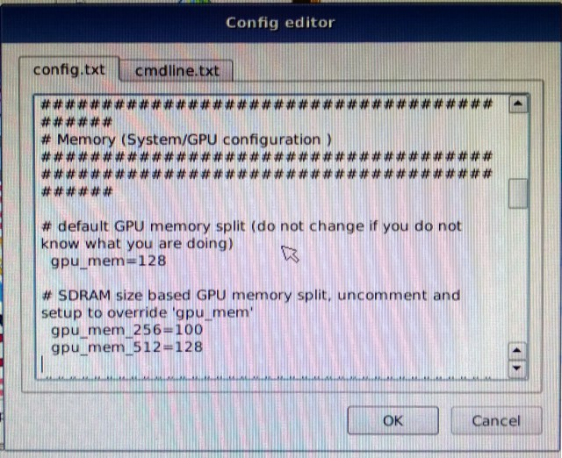
Fig 6.5: Config editor
To access these, you will need to hold Shift as the computer boots. This will return you to the NOOBS screen where you can highlight your chosen OS and use the Edit configbutton (or e key) to configure your OSes.
You’ll see a couple of tabs, config.txt and cmdline.txt which you can use to configure how a particular Raspberry Pi operating system boots and runs. Memory options, HDMI overscan, etc., can be set here. Note that you shouldn’t make any changes here unless you know what you are doing.
Click OK to return to the main NOOBS screen, and select Exit (Esc on your keyboard) to launch the OS selection menu.
Note that you can also add operating systems from this screen after the initial installation.

7. Working

The project will reduce all the issues related to traffic rule violation on road. In this system there are automatic traffic rules violation detection devices, message sending and automatic fine receiving from owner’s bank account. In this system, RFID reader will read the RFID tag number which is given to the individual vehicle while purchasing or passing the vehicle for the number plate received by RTO which will be mandatory. The camera will also be there for capturing the image of vehicle that has broken the rule. RFID reader will read the RFID tag number, latest image capture by digital camera and send this information to the server database. Server Database will send the Information from its stored database related to RFID tag number and image will received the RFID tag number and related image from server and related details about that particular vehicle such as name of owner, address, license number, passing number, photo, mobile number, their bank account number and also the list of previous rules broke by that vehicle owner or driver with the date, time, fine and the type of rule. This application will received the fine automatically from the owner’s bank account according to the rule broken by vehicle driver and its actual fine decided by government. This application will also send the message to vehicle owner about the type of rule broken by them, fine according to that rule, proof of breaking the rule in the form of image capture by digital camera, date and time of breaking the rule and accurate amount receiving by their bank account as fine paid for breaking the rule. According to this whole process done, there will be reduction in the workload of traffic police and government and also reduction in accidents and corruption too in world.

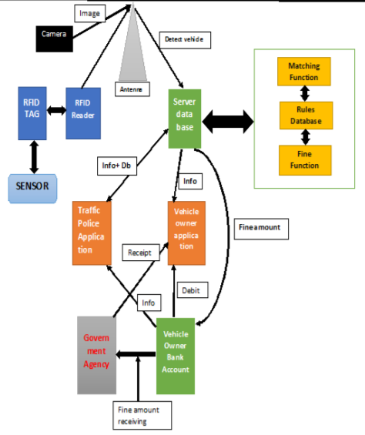
Fig 7.1 : Working

8.Design
8.1 Using proteus
By using proteus Software, Designed this
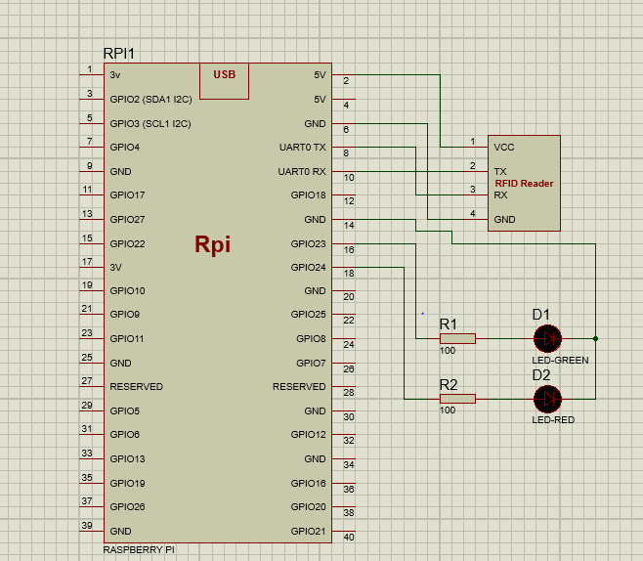

Fig 8.1 Design part

8.2 PHP Server:
We have designed a webpage which contains home ,login, registration ,admin login, and all other information required for this project.
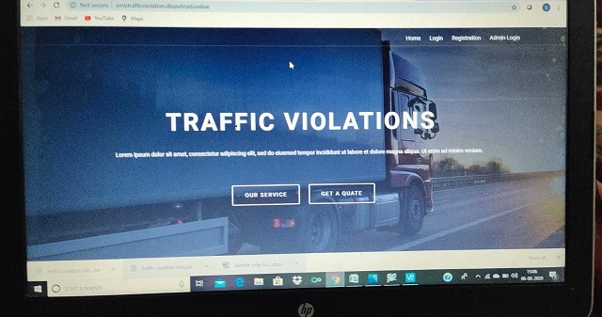

Fig 8.2 Webpage
User should register in this website by giving their vehicle details and personal information required by the authorities .so that it will be saved in the server and whenever if that vehicle number vehicle is violating the traffic rules penalty will be implemented and a message will be sent to the registered mobile number to pay the penalty for the following violations of traffic rules
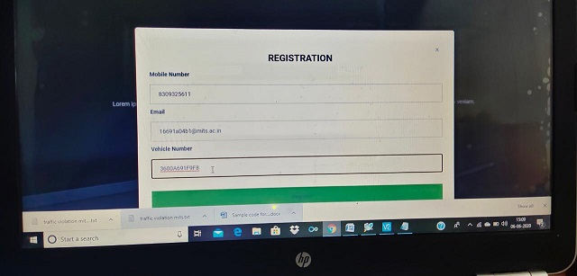
Fig 8.3 Registration
After registration we can able to see the data of the user in this way and it will be saved in server
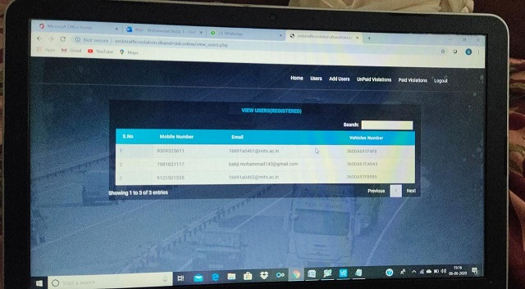
Fig 8.4 View Users
The admin will get the details of the unpaid users and he can again send a warn message to the registered mobile number and ask them to pay the penalty if not appropriate actions will be taken.
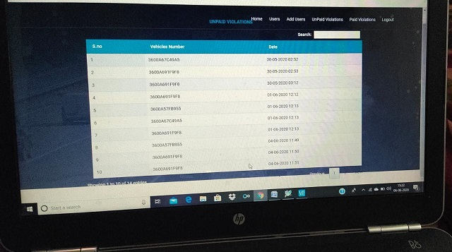
Fig 8.5 Unpaid list

9. Implementation and Results

9.1: Hardware Out Sketch:
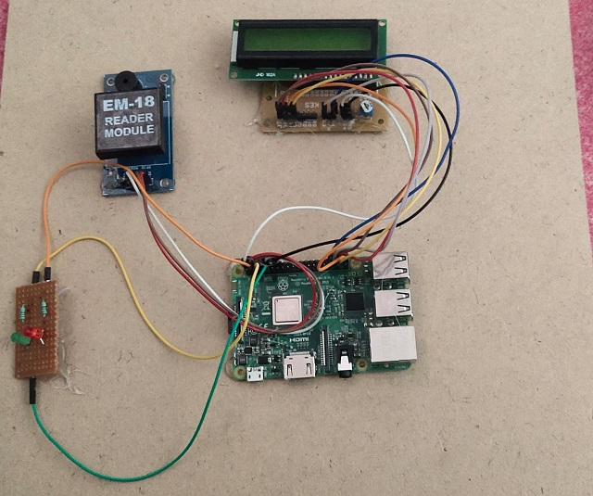
fig 9.1 Hardware Sketch

9.2 programming Raspberry pi

We should scan the raspberry pi IP address and paste it in the scanner which has been downloaded in the system so that raspberry pi will be connected to the network.

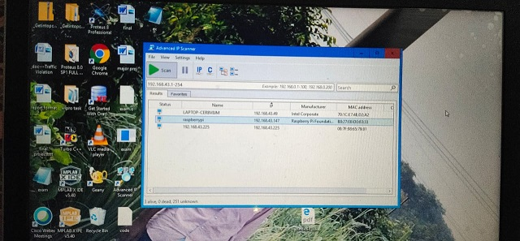
fig 9.2 Raspberry network connection

after connecting raspberry pi window will be viewed in the VNC viewer.

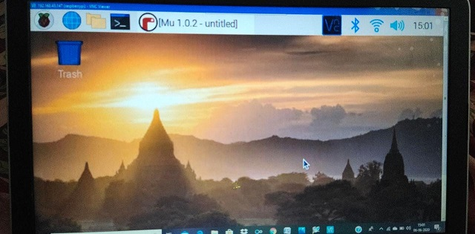
Fig 9.3 Raspberry pi window

Opening Python IDLE and programming the raspberry pi with necessary instructions for the project.
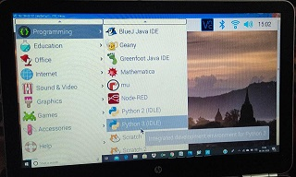
Fig 9.4 opening python IDLE
9.3 Results:
If any person violates the traffic rules RFID reader reads the RFID tag of the vehicle and it send the information to server and then the server sends a penalty message to the appropriate registered mobile number of the vehicle which has violates the traffic rules.
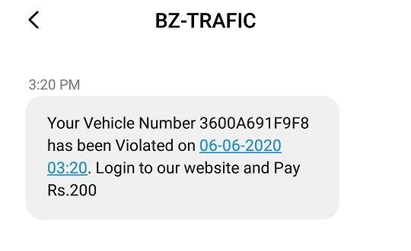
Fig 9.5 message received

10. Conclusion:
In this project we have used advanced technology to detect and control the signal brake system by the vehicles and to control the traffic lights automatically

References
[1] Bilal Ghazal, Khaled EIKhatib, Khaled Chahine, Mohamad Kieran, " Smart traffic Light Control System ", IEEE 2016,PP 21-25 .
[2] Abashed C, Mukul Kumar and Kumar Padmanabh "City Traffic Congestion Control in Indian Scenario using Wireless Sensors Network" ,PP 7-8 , 2015
[3] Ayush Kr. Mittal and Deepika Bhandari, " A Novel Approach to Implement Green Wave system and Detection of Stolen Vehicles", 978-1-4673-4529- 3/12/$31.00_c 2012 IEEE
[4] Rahul B. Pendor , P. P. Tasgaonkar " An IoT Framework for Intelligent vehicle monitoring System ", International Conference on Communication and Signal Processing, April 6- 8, 2016, India

