Annex-I




Monthly Review

on


Price Indices

August 2026

(Base Year 2015-16)
Government of Pakistan
Ministry of Planning, Development & Special Initiatives
Pakistan Bureau of Statistics
Islamabad

PRICE STATISTICS TEAM

S# | Name |  | Designation
- 1 | Dr. Naeem Uz Zafar (S.I) |  | Chief Statistician
 | Syed Abdul Qader Shah |  | Director General
 | Mr. Naseer Ahmad |  | Director
- 2 | Dr. Ahtasham Gul |  | Chief Statistical Officer
- 3 | Mr. Kashif Ali |  | Statistical Officer
- 6 | Miss. Umaira Zareen |  | Statistical Officer
 | Mr. Abdul Qadir |  | Statistical Officer
 | Mrs. Safia Akram |  | Statistical Officer
 | Mrs. Faiza Razzaq |  | Statistical Officer
 | Mr. Umer Farooq |  | Statistical Officer
11. | Mr. Ansar Mahmood |  | Statistical Assistant
12. | Mrs. Madiha Gulfraz |  | Statistical Assistant
13. Mrs. Humail Fatima |  | Statistical Assistant

IT & SOFTWARE TEAM
1.  2.  3. | Mr. Muhammad Ehtesham  Mr. Arsalan Bashir  Mr. Muhammad Kibria | Director (DP)  Chief System Analyst  Data Processing Officer
4. | Mr. Irfan Bajwa | Data Processing Officer

Inflation in Brief
- CPI inflation General, increased by 11.1% on year-on-year basis in August 2026 as compared to an increase of 9.2% in the previous month and 3.1% in August 2025. On month-on-month basis, it remained unchanged at 1.2% in August 2026 as compared to the previous month and a decrease of 0.6% in August 2025.

- CPI inflation Urban, increased by 10.4% on year-on-year basis in August 2026 as compared to an increase of 8.7% in the previous month and an increase of 3.5% in August 2025. On month-on-month basis, it increased by 0.9% in August 2026 as compared to an increase of 1.2% in the previous month and a decrease of 0.7% in August 2025.

- CPI inflation Rural, increased by 12.2% on year-on-year basis in August 2026 as compared to an increase of 9.9% in the previous month and an increase of 2.5% observed in August 2025. On month-on-month basis, it increased by 1.6% in August 2026 as compared to an increase of 1.2 in the previous month and a decrease of 0.5% in August 2025.

- SPI inflation on YoY basis increased by 9.5% in August 2026 as compared to an increase of 12.0% in the previous month and an increase of 2.6% in August 2025. On MoM basis, it increased by 0.9% in August 2026 as compared to 2.4% in the previous month and an increase of 3.2% in August 2025.

- WPI inflation on YoY basis increased by 11.8% in August 2026 as compared to an increase of 9.4% in the previous month and a decrease of 1.0% in August 2025. On month-on-month basis, it increased by 2.0% in August 2026 as compared to no change in the previous month and a decrease of 0.2% in August 2025.
- Figures 1 and 2 show graphically the yearly data of Table 1.a for Urban and Rural CPI while Table 1.1 shows “Period Average” and “YoY” percentage changes in indices.

Table 1.a General Inflation (%) (Base 2015-16)
PERIOD | CPI |  |  |  |  |  |  |  |  |  |  |  |  |  | SPI* |  | WPI
PERIOD | General |  |  |  |  |  | Food |  |  |  | Non-Food
PERIOD | National |  | Urban |  | Rural |  | Urban |  | Rural |  | Urban |  | Rural
PERIOD | YoY | MoM | YoY | MoM | YoY | MoM | YoY | MoM | YoY | MoM | YoY | MoM | YoY | MoM | YoY | MoM | YoY | MoM
Nov-24 | 4.9 | 0.5 | 5.2 | 0.5 | 4.3 | 0.5 | 1.7 | -0.2 | -0.2 | 0.2 | 7.8 | 1.0 | 9.1 | 0.8 | 7.3 | 1.0 | 2.3 | -0.1
Dec-24 | 4.1 | 0.1 | 4.4 | -0.1 | 3.6 | 0.3 | 2.5 | 0.1 | -0.2 | 0.1 | 5.7 | -0.2 | 7.6 | 0.5 | 4.2 | 0.8 | 1.9 | -0.4
Jan-25 | 2.4 | 0.2 | 2.7 | 0.2 | 1.9 | 0.2 | -0.6 | -0.3 | -2.9 | -0.4 | 5.0 | 0.5 | 7.0 | 0.9 | 0.7 | -1.4 | 0.6 | 0.2
Feb-25 | 1.5 | -0.8 | 1.8 | -0.7 | 1.1 | -1.1 | -0.9 | -1.8 | -4.3 | -2.5 | 3.6 | 0.1 | 6.6 | 0.3 | -0.2 | -1.6 | -0.7 | -0.2
Mar-25 | 0.7 | 0.9 | 1.2 | 0.8 | 0.0 | 1.1 | -1.7 | 1.6 | -5.4 | 1.6 | 3.1 | 0.2 | 5.6 | 0.5 | -2.3 | -0.1 | -1.6 | 0.3
Apr-25 | 0.3 | -0.8 | 0.5 | -0.7 | -0.1 | -1.0 | -1.9 | -1.6 | -4.6 | -1.8 | 2.2 | -0.1 | 4.4 | -0.4 | -3.6 | -2.1 | -2.2 | -1.3
May-25 | 3.5 | -0.2 | 3.5 | 0.1 | 3.4 | -0.5 | 5.3 | 0.6 | 2.1 | -1.0 | 2.4 | -0.3 | 4.6 | -0.1 | -0.6 | -1.0 | 0.4 | 0.0
June-25 | 3.2 | 0.2 | 3.0 | 0.1 | 3.6 | 0.5 | 4.2 | -0.6 | 2.4 | 0.1 | 2.2 | 0.5 | 4.7 | 0.8 | -1.9 | 0.0 | 0.6 | 0.6
July-25 | 4.1 | 2.9 | 4.4 | 3.4 | 3.5 | 2.2 | 2.2 | 2.4 | 1.5 | 2.7 | 5.9 | 4.1 | 5.4 | 1.6 | -0.9 | 3.1 | -0.5 | 1.2
Aug-25 | 3.1 | -0.6 | 3.5 | -0.7 | 2.5 | -0.5 | -0.5 | -1.3 | -0.5 | -0.7 | 6.1 | -0.3 | 5.3 | -0.3 | 2.6 | 3.2 | -1.0 | -0.2
Sep-25 | 5.8 | 2.1 | 5.7 | 1.6 | 5.9 | 2.8 | 4.4 | 4.0 | 6.0 | 5.5 | 6.5 | 0.1 | 5.8 | 0.4 | 4.5 | 2.0 | 0.6 | 0.5
Oct-25 | 6.2 | 1.7 | 6.0 | 1.4 | 6.6 | 2.1 | 4.5 | 1.7 | 6.8 | 3.0 | 7.0 | 1.1 | 6.4 | 1.3 | 4.8 | 0.9 | 1.1 | 0.5
Nov-25 | 6.1 | 0.4 | 6.1 | 0.5 | 6.3 | 0.2 | 5.0 | 0.3 | 5.9 | -0.7 | 6.7 | 0.7 | 6.7 | 1.0 | 4.2 | 0.4 | 1.1 | -0.2
Dec-25 | 5.6 | -0.4 | 5.8 | -0.4 | 5.4 | -0.6 | 3.2 | -1.7 | 3.8 | -1.9 | 7.5 | 0.5 | 6.9 | 0.7 | 2.5 | -0.8 | 0.6 | -0.9
Jan-26 | 5.8 | 0.4 | 5.8 | 0.2 | 5.8 | 0.6 | 3.3 | -0.2 | 4.7 | 0.4 | 7.4 | 0.5 | 6.9 | 0.8 | 3.3 | -0.8 | 0.2 | -0.2
Feb-26 | 7.0 | 0.3 | 6.8 | 0.3 | 7.3 | 0.3 | 4.4 | -0.8 | 6.8 | -0.5 | 8.3 | 0.9 | 7.7 | 1.0 | 4.8 | -0.1 | 1.0 | 0.7
Mar-26 | 7.3 | 1.2 | 7.4 | 1.3 | 7.2 | 1.0 | 2.9 | 0.1 | 4.5 | -0.6 | 10.3 | 2.1 | 9.7 | 2.4 | 5.6 | 0.7 | 6.7 | 5.9
Apr-26 | 10.9 | 2.5 | 11.1 | 2.7 | 10.6 | 2.1 | 6.9 | 2.3 | 7.3 | 0.9 | 13.8 | 3.0 | 13.6 | 3.2 | 10.1 | 2.0 | 13.6 | 5.1
May-26 | 11.7 | 0.5 | 11.8 | 0.7 | 11.5 | 0.3 | 6.5 | 0.2 | 8.5 | 0.2 | 15.2 | 1.0 | 14.2 | 0.4 | 12.0 | 0.7 | 12.7 | -0.8
June-26 | 11.1 | -0.3 | 11.2 | -0.5 | 10.9 | 0.0 | 8.2 | 1.0 | 9.4 | 0.9 | 13.1 | -1.4 | 12.3 | -0.9 | 12.8 | 0.7 | 10.7 | -1.2
July-26 | 9.2 | 1.2 | 8.7 | 1.2 | 9.9 | 1.2 | 9.6 | 3.7 | 10.2 | 3.4 | 8.2 | -0.4 | 9.7 | -0.7 | 12.0 | 2.4 | 9.4 | 0.0
Aug-26 | 11.1 | 1.2 | 10.4 | 0.9 | 12.2 | 1.6 | 12.1 | 1.0 | 13.2 | 2.1 | 9.4 | 0.9 | 11.3 | 1.1 | 9.5 | 0.9 | 11.8 | 2.0
* SPI for quintile 1. Digits 0.0* are due to rounding off.

Core inflation (NFNE)

- Measured by non-food non-energy Urban increased by 8.8% on (YoY) basis in August 2026 as compared to an increase of 8.6% in the previous month and an increase of 6.9% in August 2025. On (MoM) basis, it increased by 0.5% in August 2026 as compared to an increase of 0.7% in the previous month and an increase of 0.3% in the corresponding month of last year i.e. August 2025.

- Measured by non-food non-energy Rural increased by 8.5% on (YoY) basis in August 2026 as compared to an increase of 8.1% in the previous month and an increase of 7.8% in August 2025. On (MoM) basis, it increased by 0.6% in August 2026 as compared to 0.9% in the previous month and an increase of 0.2% in the corresponding month of last year i.e. August 2025.

Core inflation (Trimmed)
- Measured by 20% weighted trimmed mean Urban increased by 8.9% on (YoY) basis in August 2026 as compared to an increase of 7.5% in the previous month and 4.2% in August 2025. On (MoM) basis, it increased by 0.4% in August 2026 as compared to an increase of 0.6% a month earlier and no change in the corresponding month of last year i.e. August 2025.

- Measured by 20% weighted trimmed mean Rural increased by 9.1% on (YoY) basis in August 2026 as compared to an increase of 8.0% in the previous month and 3.5% in August 2025. On (MoM) basis, it increased by 1.1% in August 2026 as compared to an increase of 1.0% in the previous month and an increase of 0.3% in the corresponding month of last year i.e. August 2025.

Table 1.b Core Inflation (%) (Base 2015-16)
Period | NFNE |  |  |  | Trimmed
Period | Urban |  | Rural |  | Urban |  | Rural
Period | YoY | MoM | YoY | MoM | YoY | MoM | YoY | MoM
Aug-25 | 6.9 | 0.3 | 7.8 | 0.2 | 4.2 | 0.0 | 3.5 | 0.3
Sep-25 | 7.0 | 0.3 | 7.8 | 0.6 | 5.7 | 0.3 | 6.5 | 0.7
Oct-25 | 7.5 | 1.1 | 8.4 | 1.3 | 6.0 | 0.9 | 6.8 | 1.2
Nov-25 | 6.6 | 0.3 | 8.2 | 0.5 | 5.3 | 0.3 | 6.4 | 0.4
Dec-25 | 6.9 | 0.5 | 8.1 | 0.6 | 5.5 | 0.3 | 6.0 | 0.4
Jan-26 | 7.2 | 1.0 | 8.3 | 1.1 | 4.9 | 0.5 | 5.4 | 0.7
Feb-26 | 7.1 | 0.2 | 8.3 | 0.4 | 5.1 | 0.2 | 5.6 | 0.3
Mar-26 | 7.4 | 0.7 | 8.4 | 0.8 | 5.9 | 0.6 | 6.3 | 0.5
Apr-26 | 8.0 | 1.9 | 8.5 | 1.1 | 9.2 | 1.1 | 8.9 | 1.0
May-26 | 9.0 | 1.3 | 8.4 | 0.2 | 9.8 | 0.6 | 9.6 | 0.8
June-26 | 8.7 | -0.1 | 7.9 | 0.2 | 9.6 | 0.3 | 9.3 | 0.5
July-26 | 8.6 | 0.7 | 8.1 | 0.9 | 7.5 | 0.6 | 8.0 | 1.0
Aug-26 | 8.8 | 0.5 | 8.5 | 0.6 | 8.9 | 0.4 | 9.1 | 1.1

Table 1.1 Y-o-Y % Change

INDEX | Average July - August  % Changes |  |  | August over August  % Changes
INDEX | 2026-2027 | 2025-2026 | 2024-2025 | 2026-2027 | 2025-2026 | 2024-2025
CPI (National) | 10.17 | 3.56 | 10.36 | 11.15 | 3.06 | 9.64
CPI (Urban) | 9.57 | 3.94 | 12.44 | 10.43 | 3.46 | 11.71
CPI (Rural) | 11.07 | 3.01 | 7.43 | 12.22 | 2.48 | 6.73
SPI | 10.72 | 0.88 | 13.24 | 9.46 | 2.63 | 10.85
WPI | 10.62 | -0.74 | 8.28 | 11.82 | -1.00 | 6.28

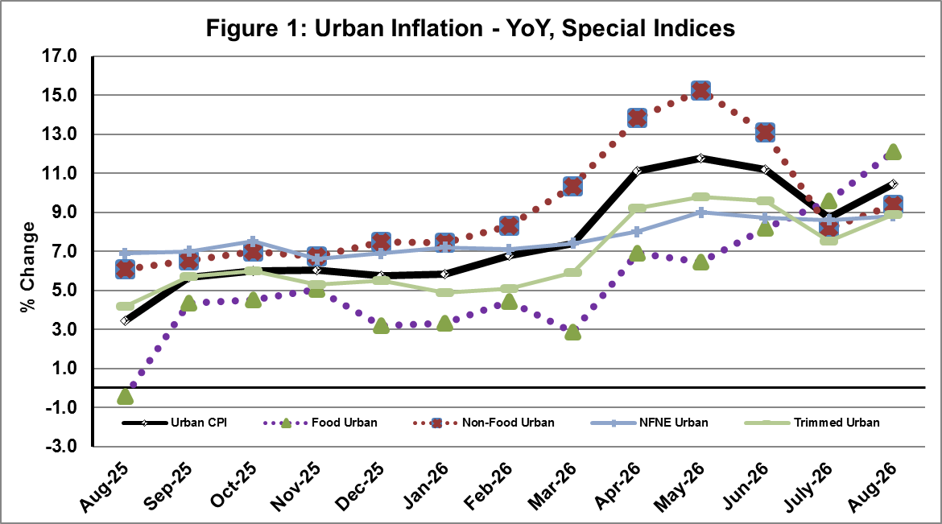
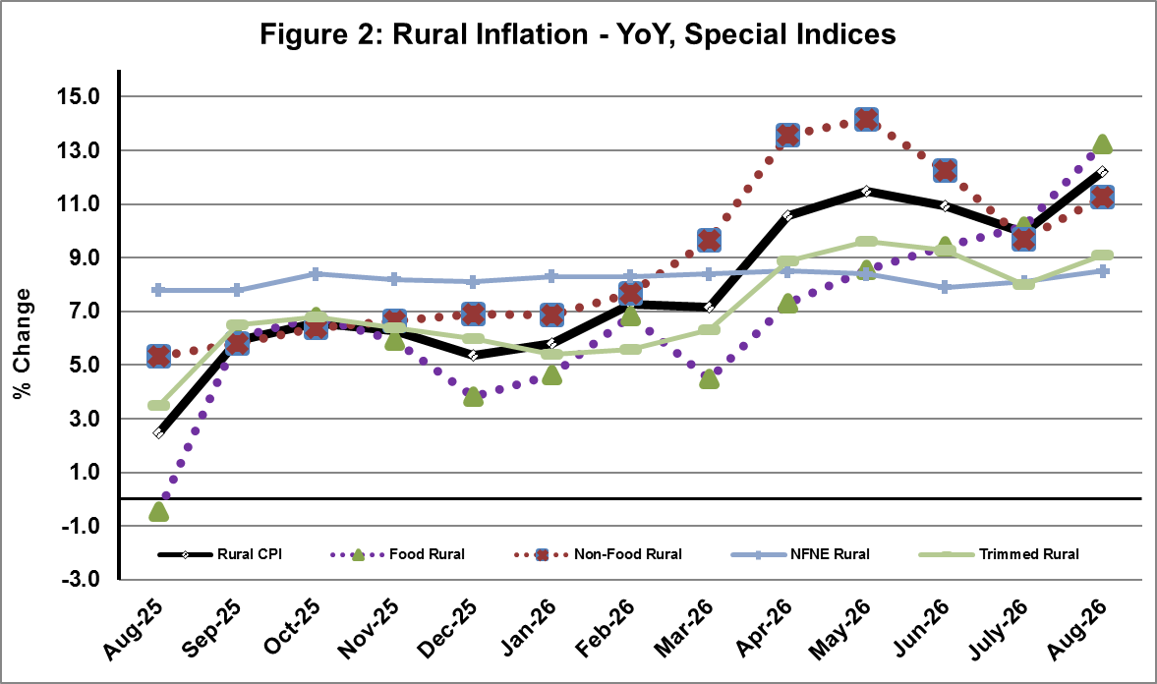

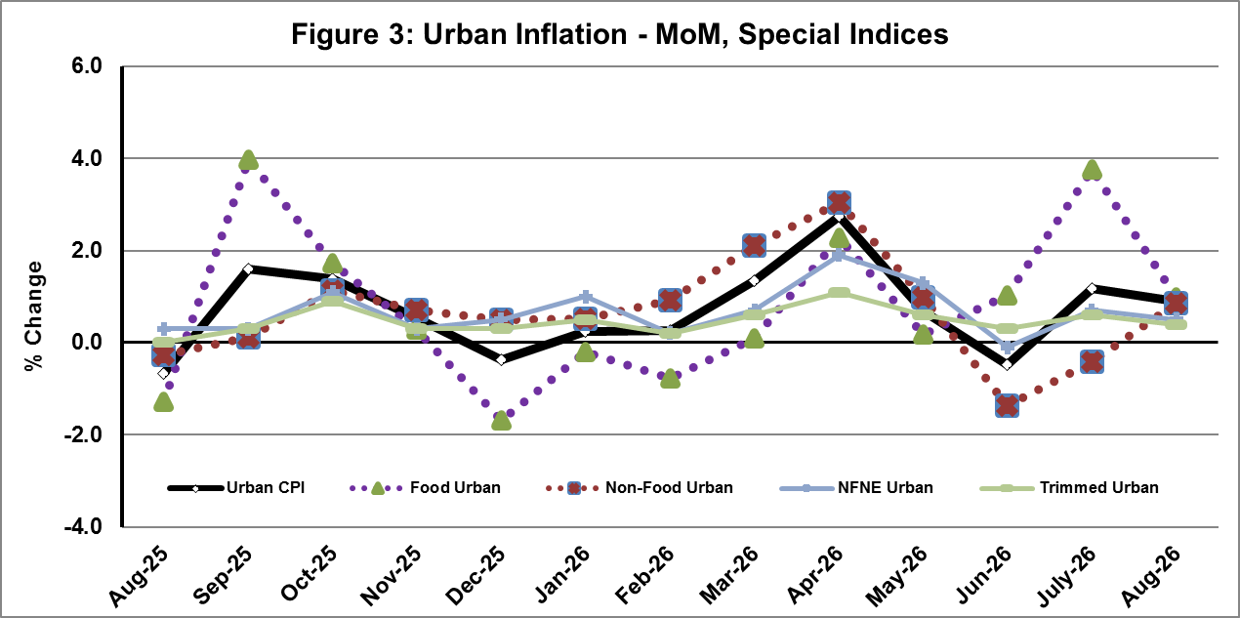
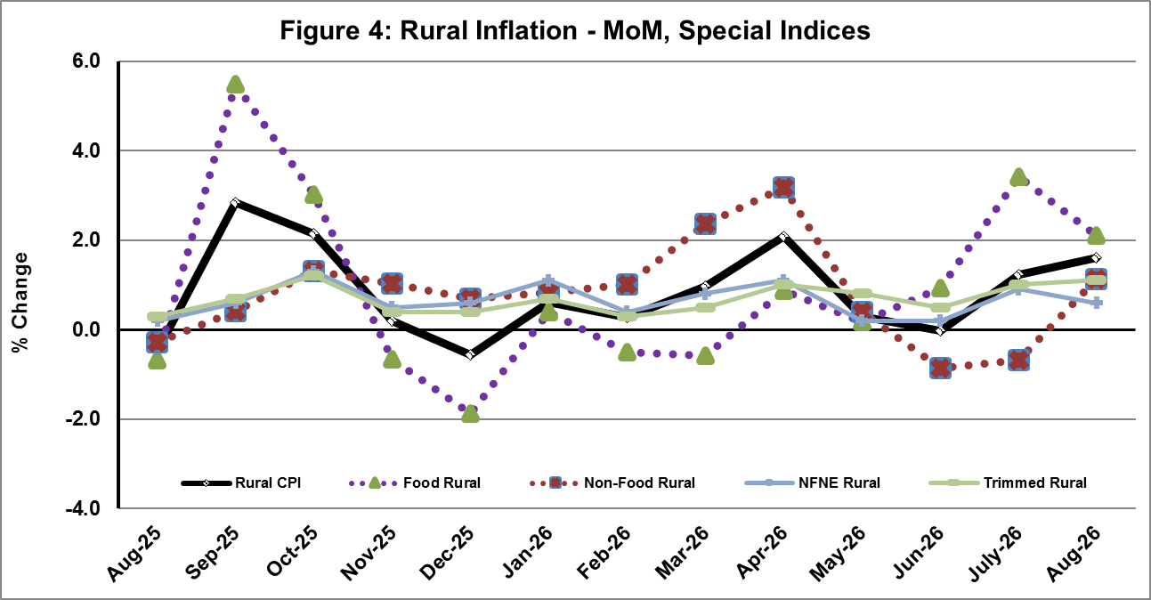

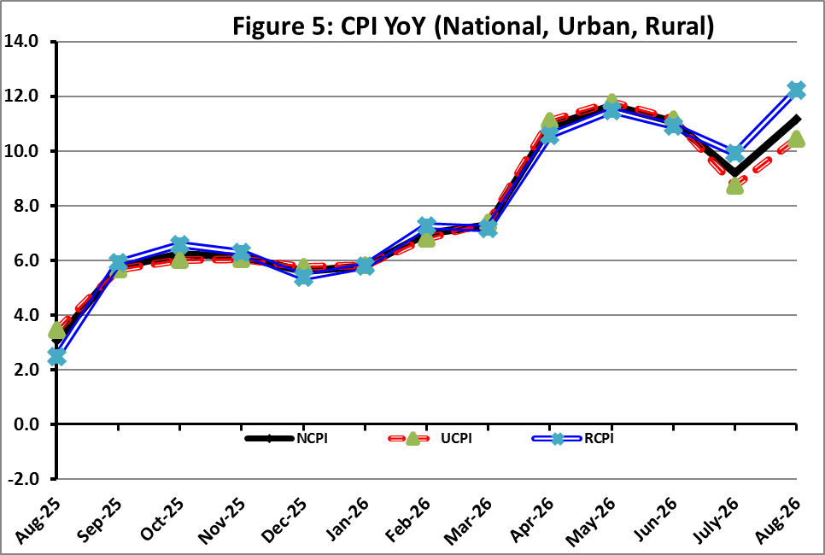

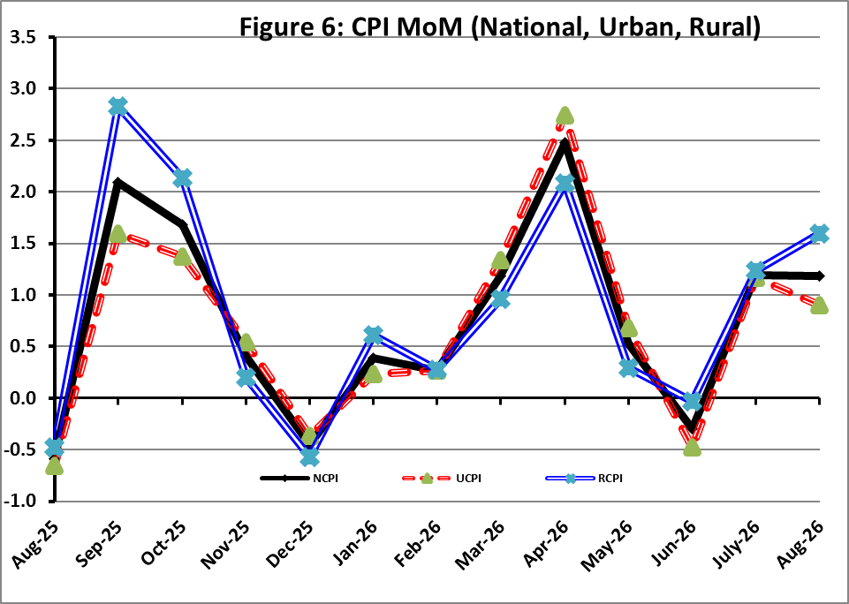

I. National Consumer Price Index (NCPI)

The National Consumer Price Index for August 2026 is increased by 1.19% over July 2026 and increased by 11.15% over corresponding month of the last year i.e. August 2025.

Table 1: Consumer Price Index (National) by Group of Commodities and Services (Base 2015-16)
No | Group | Group  Weight  (%) | Indices |  |  | % Change  Aug 2026  Over |  | Impact  (In % points)  Aug 2026 Over
No | Group | Group  Weight  (%) | Aug 26 | July 26 | Aug 25 | July 26 | Aug 25 | July 26 | Aug 25
No | General | 100.00 | 300.50 | 296.97 | 270.35 | 1.19 | 11.15 | 1.19 | 11.15
1. | Food & Non-alcoholic Bev. | 34.58 | 313.99 | 308.86 | 275.70 | 1.66 | 13.89 | 0.60 | 4.90
 | Non-perishable Food Items | 29.60 | 315.74 | 311.90 | 281.20 | 1.23 | 12.28 | 0.38 | 3.78
 | Perishable Food Items | 4.99 | 303.63 | 290.78 | 243.08 | 4.42 | 24.91 | 0.22 | 1.12
2. | Alcoholic Bev. & Tobacco | 1.02 | 410.53 | 410.11 | 397.79 | 0.10 | 3.20 | 0.00 | 0.05
3. | Clothing & Footwear | 8.60 | 289.14 | 288.42 | 264.70 | 0.25 | 9.23 | 0.02 | 0.78
4. | Housing, Water, Electricity, Gas & Fuels | 23.63 | 268.09 | 266.63 | 246.24 | 0.55 | 8.87 | 0.12 | 1.91
5. | Furnishing & Household Equipment Maintenance | 4.10 | 299.49 | 298.01 | 279.69 | 0.50 | 7.08 | 0.02 | 0.30
6. | Health | 2.79 | 299.44 | 296.71 | 277.20 | 0.92 | 8.02 | 0.03 | 0.23
7. | Transport | 5.91 | 382.06 | 369.45 | 317.93 | 3.41 | 20.17 | 0.25 | 1.40
8. | Communication | 2.21 | 153.72 | 153.69 | 135.31 | 0.02 | 13.60 | 0.00 | 0.15
9. | Recreation & Culture | 1.59 | 268.62 | 269.83 | 267.34 | -0.45 | 0.48 | -0.01 | 0.01
10. | Education | 3.79 | 240.41 | 239.97 | 222.97 | 0.18 | 7.82 | 0.01 | 0.24
11. | Restaurants & Hotels | 6.92 | 308.22 | 306.49 | 290.50 | 0.56 | 6.10 | 0.04 | 0.45
12. | Miscellaneous | 4.87 | 374.06 | 367.13 | 333.52 | 1.89 | 12.15 | 0.11 | 0.73

II. Urban Consumer Price Index (UCPI)

The Urban Consumer Price Index for August 2026 is increased by 0.91% over July 2026 and increased by 10.43% over corresponding month of the last year i.e. August 2025.

Table 2: Consumer Price Index (Urban) by Group of Commodities and Services (Base 2015-16)
No | Group | Group  Weight  (%) | Indices |  |  | % Change  Aug 2026  Over |  | Impact  (In % points)  Aug 2026 Over
No | Group | Group  Weight  (%) | Aug 26 | July 26 | Aug 25 | July 26 | Aug 25 | July 26 | Aug 25
 | General | 100.00 | 296.24 | 293.58 | 268.26 | 0.91 | 10.43 | 0.91 | 10.43
1. | Food & Non-alcoholic Bev. | 30.42 | 311.32 | 307.98 | 274.74 | 1.08 | 13.31 | 0.35 | 4.15
 | Non-perishable Food Items | 25.97 | 312.13 | 309.98 | 280.77 | 0.69 | 11.17 | 0.19 | 3.04
 | Perishable Food Items | 4.46 | 306.61 | 296.29 | 239.65 | 3.48 | 27.94 | 0.16 | 1.11
2. | Alcoholic Bev. & Tobacco | 0.85 | 435.49 | 435.24 | 420.23 | 0.06 | 3.63 | 0.00 | 0.05
3. | Clothing & Footwear | 8.01 | 283.87 | 283.31 | 255.32 | 0.20 | 11.18 | 0.02 | 0.85
4. | Housing, Water, Electricity, Gas & Fuels | 27.03 | 273.36 | 272.48 | 256.33 | 0.32 | 6.64 | 0.08 | 1.72
5. | Furnishing & Household Equip. & Maintenance | 4.09 | 287.75 | 286.60 | 269.71 | 0.40 | 6.69 | 0.02 | 0.28
6. | Health | 2.31 | 299.75 | 297.03 | 278.71 | 0.92 | 7.55 | 0.02 | 0.18
7. | Transport | 6.14 | 380.97 | 367.98 | 312.80 | 3.53 | 21.79 | 0.27 | 1.56
8. | Communication | 2.35 | 159.90 | 159.86 | 138.68 | 0.03 | 15.30 | 0.00 | 0.19
9. | Recreation & Culture | 1.73 | 253.70 | 253.84 | 251.61 | -0.06 | 0.83 | 0.00 | 0.01
10. | Education | 4.88 | 231.89 | 231.32 | 216.13 | 0.25 | 7.29 | 0.01 | 0.29
11. | Restaurants & Hotels | 7.41 | 302.29 | 300.67 | 284.54 | 0.54 | 6.24 | 0.04 | 0.49
12. | Miscellaneous | 4.77 | 361.27 | 354.91 | 323.39 | 1.79 | 11.71 | 0.10 | 0.67
Main contributors to month-on-month and year-on-year percentage changes are given below and detail is given in Annexure-A.
MONTH-ON-MONTH: Top few commodities which varied from previous month i.e. July, 2026 are given below:
FOOD
Increased: Onions (45.87%), Eggs (11.51%), Potatoes (6.82%), Fresh Vegetables (5.50%), Wheat (5.25%), Pulse Gram (4.77%), Besan (3.74%), Wheat Flour (2.03%), Wheat Products (1.67%), Tea (1.24%), Gram Whole (1.06%), Pulse Masoor (0.99%), Vegetable Ghee (0.64%), Readymade Food (0.61%) and Meat (0.54%).
Decreased: Fresh Fruits (12.49%), Beans (4.54%), Pulse Moong (2.47%), Chicken (1.88%), Sugar (0.77%), Tomatoes (0.67%), Fish (0.53%), Bakery and Confectionary (0.36%), Milk Powder (0.01%) and Sweetmeat (0.01%).

NON-FOOD:
Increased: Motor Fuel (5.61%), Water Supply (4.15%), Mechanical Services (1.81%), Electricity Charges (1.70%), Appliances/Articles/Products (1.42%), Transport Services (1.35%), Medical Tests (1.11%), Hospitals Services (1.10%), Tailoring (1.02%), Doctor (MBBS) Clinic Fee (0.85%), Drugs & Medicines (0.85%) and Construcion Input Items (0.78%).
Decreased: Liquified Hydrocarbons (1.31%), Text Books (0.25%), Motor Vehicle Accessories (0.24%) and Footware (0.04%).

YEAR-ON-YEAR: Top few commodities, which varied from corresponding month of previous year i.e. August 2025, are given below:
FOOD:
Increased: Tomatoes (128.13%), Onions (124.28%), Wheat (86.72%), Wheat Flour (73.12%), Wheat Products (22.04%), Fresh Vegetables (16.78%), Fresh Fruits (16.18%), Meat (14.69%), Ice Cream (12.09%), Bakery and Confectionary (10.31%), Dry Fruits (9.27%) and Milk Products (8.97%).
Decreased: Potatoes (23.14%), Chicken (18.51%), Sugar (17.01%), Besan (13.87%), Pulse Gram (13.80%), Gram Whole (12.64%), Pulse Masoor (12.03%), Beans (11.41%), Eggs (11.36%), Pulse Moong (6.86%) and Gur (3.21%).

NON-FOOD:
Increased: Liquified Hydrocarbons (55.89%), Motor Vehicle Tax (38.68%), Postal Services (34.88%), Footware (29.29%), Transport Services (28.72%), Motor Fuel (24.43%), Personal Effects (23.36%), Communication Services (19.30%) and Newspapers (14.84%).
Decreased: Text Books (1.96%).
III. Rural Consumer Price Index (RCPI)

The Rural Consumer Price Index for August 2026 is increased by 1.60% over July 2026 and increased by 12.22% over corresponding month of the last year i.e. August 2025.

Table 3: Consumer Price Index (Rural) by Group of Commodities and Services (Base 2015-16)
No | Group | Group  Weight  (%) | Indices |  |  | % Change  Aug 2026  Over |  | Impact  (In % points)  Aug 2026 Over
No | Group | Group  Weight  (%) | Aug 26 | July 26 | Aug 25 | July 26 | Aug 25 | July 26 | Aug 25
 | General | 100.00 | 306.92 | 302.09 | 273.51 | 1.60 | 12.22 | 1.60 | 12.22
1. | Food & Non-alcoholic Bev. | 40.87 | 316.99 | 309.84 | 276.77 | 2.31 | 14.53 | 0.97 | 6.01
 | Non-perishable Food Items | 35.08 | 319.77 | 314.05 | 281.68 | 1.82 | 13.52 | 0.66 | 4.89
 | Perishable Food Items | 5.79 | 300.17 | 284.37 | 247.06 | 5.56 | 21.50 | 0.30 | 1.12
2. | Alcoholic Bev. & Tobacco | 1.28 | 385.37 | 384.77 | 375.17 | 0.16 | 2.72 | 0.00 | 0.05
3. | Clothing & Footwear | 9.48 | 295.85 | 294.93 | 276.67 | 0.31 | 6.93 | 0.03 | 0.66
4. | Housing, Water, Electricity, Gas & Fuels | 18.49 | 256.46 | 253.73 | 223.98 | 1.08 | 14.50 | 0.17 | 2.20
5. | Furnishing & Household Equip. & Maintenance | 4.10 | 317.17 | 315.19 | 294.70 | 0.63 | 7.62 | 0.03 | 0.34
6. | Health | 3.51 | 299.13 | 296.40 | 275.70 | 0.92 | 8.50 | 0.03 | 0.30
7. | Transport | 5.56 | 383.88 | 371.91 | 326.48 | 3.22 | 17.58 | 0.22 | 1.17
8. | Communication | 1.99 | 142.71 | 142.71 | 129.31 | 0.00 | 10.36 | 0.00 | 0.10
9. | Recreation & Culture | 1.38 | 296.94 | 300.18 | 297.17 | -1.08 | -0.08 | -0.01 | 0.00
10. | Education | 2.13 | 269.84 | 269.84 | 246.57 | 0.00 | 9.44 | 0.00 | 0.18
11. | Restaurants & Hotels | 6.19 | 318.93 | 317.01 | 301.25 | 0.61 | 5.87 | 0.04 | 0.40
12. | Miscellaneous | 5.02 | 392.41 | 384.67 | 348.07 | 2.01 | 12.74 | 0.13 | 0.81
Main contributors to month-on-month and year-on-year percentage changes are given below and detail is given in Annexure-B.
MONTH-ON-MONTH Top few commodities which varied from previous month i.e. July, 2026 are given below:

FOOD
Increased: Onions (48.35%), Potatoes (10.57%), Eggs (10.38%), Tomatoes (8.86%), Wheat (7.71%), Pulse Gram (6.89%), Fresh Vegetables (6.67%), Besan (4.59%), Wheat Flour (4.42%), Meat (2.33%), Wheat Products (1.87%), Mustard oil (1.28%) and Chicken (1.25%).
Decreased: Fresh fruits (18.76%), Beans (4.51%), Pulse Moong (2.64%), Sugar (1.52%) and Fish (0.08%).

NON-FOOD

Increased: Water Supply (8.39%), Motor Fuels (5.76%), Liquified Hydrocarbons (5.14%), Personal Effects (3.20%), Construction Input Items (2.00%), Medical Tests (1.86%), Electricity Charges (1.70%), Appliances/Articles/Products for Personal Care (1.44%), Mechanical Services (1.14%) and Doctor Clinic Fee (1.12%).

Decreased: Text Books (2.80%) and Furniture & Furnishing (0.08%).

Year-On-Year: Top few commodities which varied from corresponding month of previous year i.e. August, 2025 are given below:
FOOD
Increased: Tomatoes (143.47%), Onions (117.57%), Wheat (84.41%), Wheat Flour (77.50%), Wheat Products (23.52%), Meat (10.76%), Ice Cream (10.02%), Butter (9.99%), Fresh Vegetables (9.76%), Dry Fruits (9.01%), Vegetable Ghee (8.65%), Sweetmeat (8.21%), Mustard Oil (7.82%) and Milk Fresh (7.61%).
Decreased: Potatoes (30.34%), Sugar (18.99%), Chicken (16.24%), Gram Whole (14.87%), Eggs (14.00%), Pulse Gram (13.87%), Besan (13.58%), Pulse Masoor (10.75%), Gur (4.53%), Pulse Moong (4.23%), Beans (4.16%), Pulse Mash (1.76%), Condiments & Spices (1.38%) and Honey (1.06%).

Non-Food
Increased: Liquified Hydrocarbons (47.06%), Motor Vehicle Tax (34.32%), Newspapers (29.16%), Motor Fuels (25.76%), Personal Effects (21.10%), Construction Input Items (18.54%), Solid Fuel (16.73%), Doctor Clinic Fee (14.84%), Plastic Products (13.44%), Transport Services (12.66%), Communication Services (12.43%) and Electricity Charges (12.34%).
Decreased: Text Books (4.30%).

IV. Sensitive Price Indicator (SPI)

Quintile-wise percentage changes YoY and MoM are given below in Table 4. The series from
August 2025 to August 2026 is also graphed below in Figure 7.

Table 4: Sensitive Price Indicator (Base 2015-16)
Quintiles | Indices |  |  | % Change Aug 2026  Over
Quintiles | Aug 2026 | July 2026 | Aug 2025 | July 2026 | Aug 2025
1 | 348.70 | 345.72 | 318.57 | 0.86 | 9.46
2 | 349.68 | 347.16 | 318.16 | 0.73 | 9.91
3 | 371.01 | 367.80 | 341.34 | 0.87 | 8.69
4 | 358.24 | 354.54 | 329.26 | 1.04 | 8.80
5 | 358.29 | 354.32 | 328.73 | 1.12 | 8.99
Combined | 359.84 | 356.43 | 329.29 | 0.96 | 9.28

Table 4.1: Weekly Percentage Change of SPI During August 2026
Quintiles | % Change over Previous week
Quintiles | 06-08-2026 | 13-08-2026 | 20-08-2026 | 27-08-2026
Quintile 1 | 0.43 | 0.46 | 0.38 | -0.17
Combined | 0.28 | 0.15 | 0.49 | 0.05

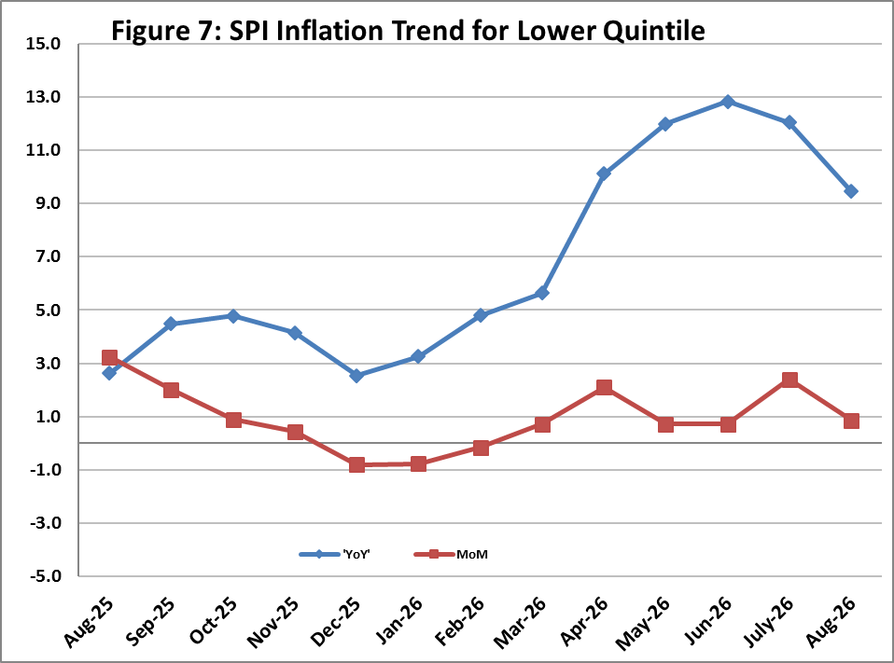

V. Wholesale Price Index
The Wholesale Price Index for August 2026 increased by 1.98% over July 2026 and increased by 11.82% over the corresponding month of the last year i.e. August, 2025. YoY and MoM movements from August, 2025 to August, 2026 are also graphed below in Figure 8.

Table 5: Wholesale Price Index by Group of Commodities (Base 2015-16)
No | Group | Group  Weight  (%) | Indices |  |  | % Change  Aug 2026  Over |  | Impact  (In % points)  Aug 2026 Over
No | Group | Group  Weight  (%) | Aug 26 | July 26 | Aug 25 | July 26 | Aug 25 | July 26 | Aug 25
 | General | 100.00 | 350.77 | 343.96 | 313.68 | 1.98 | 11.82 | 1.98 | 11.82
1 | Agriculture Forestry & Fishery | 25.77 | 304.57 | 302.08 | 278.18 | 0.82 | 9.49 | 0.19 | 2.17
2 | Ores/Minerals, Elec., Gas & Water | 12.01 | 358.89 | 357.79 | 352.31 | 0.31 | 1.87 | 0.04 | 0.25
3 | Food, Beverages, Tobacco, Textiles & Leather Products | 31.11 | 308.04 | 304.47 | 284.96 | 1.17 | 8.10 | 0.32 | 2.29
 | i. Food Products, Beverages & Tobacco | 20.07 | 332.91 | 328.63 | 301.25 | 1.30 | 10.51 | 0.25 | 2.03
 | ii. Textiles & Apparels | 10.33 | 266.26 | 263.81 | 260.63 | 0.93 | 2.16 | 0.07 | 0.19
 | iii. Leather Products | 0.71 | 212.86 | 212.86 | 178.56 | 0.00 | 19.21 | 0.00 | 0.08
4 | Other Transportable Goods | 22.40 | 434.07 | 412.30 | 342.32 | 5.28 | 26.80 | 1.42 | 6.55
5 | Metal Product, Machinery & Equipment | 8.72 | 414.61 | 414.13 | 394.27 | 0.12 | 5.16 | 0.01 | 0.57

Main contributors to month-on-month and year-on-year percentage changes are given below and detail is given in Annexure-C.

MONTH-ON-MONTH: Top few commodities which varied from previous month are given below:
Increased: Diesel Oil (14.08%), Kerosene Oil (13.27%), Vegetables (13.21%), Tobacco Products (9.71%), Other Cereal Flour (7.52%), Wheat (7.23%), Chemicals (6.49%), Motor Spirit (6.41%), Eggs (5.93%) and Sugar Confectionary (5.74%).
Decreased: Sorghum / Jowar (19.20%), Fresh Fruits (5.51%), Dry Fruits (3.63%), Poultry (3.42%), Sugar Refined (1.09%), Millet / Bajra (0.77%), Dried Fruits & Nuts (0.70%), Beverages (0.60%), Auto Tyres (0.56%), Oil Cakes (0.40%), Cotton Seeds (0.30%), Fibre Crops (0.29%), Natural Gas Liquefied (0.22%), Stimulant & Spice Crops (0.16%), Paints & Varnishes (0.08%) and Spices (0.04%).

YEAR-ON-YEAR: Top few commodities which varied from previous year are given below:
Increased: Wheat (92.64%), Wheat Flour (74.10%), Kerosene Oil (62.84%), Footwears (51.86%), Vegetables (48.84%), Diesel Oil (46.05%), Sorghum / Jowar (38.13%), Furnace Oil (33.33%), Mobil Oil (27.59%), Motor Spirit (27.02%), Woven Fabrics (25.04%), Dried Fruits & Nuts (22.67%), Maize (20.83%), Raw Animal Materials / Wool (19.36%) and Chemicals (18.87%).
Decreased: Edible Roots / Potatoes (36.63%), Stimulant & Spice Crops (26.13%), Sugar Refined (19.65%), Poultry (18.58%), Other Cereal Flour (16.83%), Pulses (15.47%), Eggs (15.41%), Millet / Bajra (14.24%), Dry Fruits (11.31%), Sugar Crops (3.52%), Timber (1.74%), Cotton Seeds (1.57%) and Synthetic Carpets (1.44%).
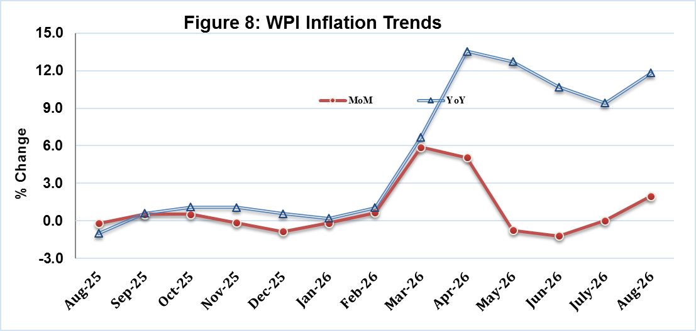

Annexure A: CPI (Urban) Index Numbers by Commodity Groups & Commodities (2015-16=100)
Item and Specification |  | Weight | Index Numbers  Aug 26 Jul 26 Aug 25 |  |  | % Change in Aug 2026 over  Jul 2026 Aug 2025
 | General | 100.0000 | 296.24 | 293.58 | 268.26 |  | + | 0.91 |  | + | 10.43
 | Food and non-alcoholic Beverages | 30.4215 | 311.32 | 307.98 | 274.74 |  | + | 1.08 |  | + | 13.31
01 | Wheat | 0.6120 | 353.55 | 335.92 | 189.35 |  | + | 5.25 |  | + | 86.72
02 | Wheat flour | 3.0075 | 335.72 | 329.03 | 193.92 |  | + | 2.03 |  | + | 73.12
03 | Wheat products | 0.0936 | 320.21 | 314.96 | 262.39 |  | + | 1.67 |  | + | 22.04
04 | Besan | 0.0830 | 216.69 | 208.88 | 251.59 |  | + | 3.74 |  | - | 13.87
05 | Rice | 1.1804 | 339.52 | 339.35 | 321.76 |  | + | 0.05 |  | + | 5.52
06 | Bakery and confectionary | 0.4770 | 297.24 | 298.31 | 269.45 |  | - | 0.36 |  | + | 10.31
07 | Nimco | 0.1224 | 318.24 | 313.51 | 300.77 |  | + | 1.51 |  | + | 5.81
08 | Meat | 2.0411 | 396.70 | 394.55 | 345.89 |  | + | 0.54 |  | + | 14.69
09 | Chicken | 1.3631 | 252.20 | 257.02 | 309.48 |  | - | 1.88 |  | - | 18.51
10 | Fish | 0.3855 | 223.66 | 224.85 | 210.99 |  | - | 0.53 |  | + | 6.01
11 | Milk fresh | 7.1070 | 288.21 | 287.56 | 265.95 |  | + | 0.23 |  | + | 8.37
12 | Milk products | 0.6407 | 292.28 | 292.01 | 268.22 |  | + | 0.09 |  | + | 8.97
13 | Milk powder | 0.3106 | 338.60 | 338.65 | 317.07 |  | - | 0.01 |  | + | 6.79
14 | Eggs | 0.5083 | 306.63 | 274.98 | 345.94 |  | + | 11.51 |  | - | 11.36
15 | Butter | 0.0932 | 501.84 | 505.09 | 460.75 |  | - | 0.64 |  | + | 8.92
16 | Mustard oil | 0.0120 | 320.06 | 318.98 | 308.24 |  | + | 0.34 |  | + | 3.83
17 | Cooking oil | 1.1016 | 348.28 | 347.80 | 324.73 |  | + | 0.14 |  | + | 7.25
18 | Vegetable ghee | 1.0324 | 370.25 | 367.89 | 343.22 |  | + | 0.64 |  | + | 7.88
19 | Dry fruits | 0.3299 | 326.14 | 326.12 | 298.48 |  | + | 0.01 |  | + | 9.27
20 | Fresh fruits | 1.4363 | 253.85 | 290.09 | 218.50 |  | - | 12.49 |  | + | 16.18
21 | Pulse masoor | 0.1624 | 176.19 | 174.47 | 200.28 |  | + | 0.99 |  | - | 12.03
22 | Pulse moong | 0.1697 | 222.05 | 227.68 | 238.41 |  | - | 2.47 |  | - | 6.86
23 | Pulse mash | 0.1152 | 193.86 | 193.75 | 187.97 |  | + | 0.06 |  | + | 3.13
24 | Pulse gram | 0.1660 | 213.83 | 204.10 | 248.07 |  | + | 4.77 |  | - | 13.80
25 | Gram whole | 0.0912 | 236.55 | 234.06 | 270.77 |  | + | 1.06 |  | - | 12.64
26 | Beans | 0.0408 | 324.68 | 340.13 | 366.50 |  | - | 4.54 |  | - | 11.41
27 | Potatoes | 0.4496 | 249.13 | 233.23 | 324.13 |  | + | 6.82 |  | - | 23.14
28 | Onions | 0.5928 | 360.50 | 247.14 | 160.74 |  | + | 45.87 |  | + | 124.28
29 | Tomatoes | 0.3459 | 560.89 | 564.65 | 245.86 |  | - | 0.67 |  | + | 128.13
30 | Fresh vegetables | 1.5306 | 296.82 | 281.35 | 254.16 |  | + | 5.50 |  | + | 16.78
31 | Sugar | 1.1130 | 237.45 | 239.30 | 286.12 |  | - | 0.77 |  | - | 17.01
32 | Gur | 0.0379 | 264.65 | 263.39 | 273.43 |  | + | 0.48 |  | - | 3.21
33 | Honey | 0.1017 | 222.74 | 222.74 | 222.69 |  | + | 0.00 |  | + | 0.02
34 | Sweetmeat | 0.3535 | 351.80 | 351.83 | 331.14 |  | - | 0.01 |  | + | 6.24
35 | Ice cream | 0.1044 | 223.83 | 223.83 | 199.68 |  | + | 0.00 |  | + | 12.09
36 | Condiments and Spices | 1.3340 | 385.98 | 384.74 | 372.15 |  | + | 0.32 |  | + | 3.72
37 | Dessert preparation | 0.0419 | 314.29 | 314.01 | 297.85 |  | + | 0.09 |  | + | 5.52
38 | Tea | 0.8427 | 286.89 | 283.38 | 273.67 |  | + | 1.24 |  | + | 4.83
39 | Beverages | 0.8906 | 272.62 | 271.94 | 261.06 |  | + | 0.25 |  | + | 4.43
 | Alcoholic Beverages, Tobacco | 0.8540 | 435.49 | 435.24 | 420.23 |  | + | 0.06 |  | + | 3.63
40 | Cigarettes | 0.7167 | 423.27 | 423.15 | 411.55 |  | + | 0.03 |  | + | 2.85
41 | Pan prepared | 0.1373 | 499.28 | 498.34 | 465.58 |  | + | 0.19 |  | + | 7.24
 | Clothing and footwear | 8.0096 | 283.87 | 283.31 | 255.32 |  | + | 0.20 |  | + | 11.18
42 | Cotton cloth | 2.2227 | 315.60 | 315.48 | 298.53 |  | + | 0.04 |  | + | 5.72
43 | Woollen cloth | 0.8361 | 267.76 | 267.09 | 243.55 |  | + | 0.25 |  | + | 9.94
44 | Readymade garments | 1.3196 | 233.98 | 233.52 | 222.92 |  | + | 0.20 |  | + | 4.96
45 | Woollen readymade garments | 0.4307 | 273.87 | 273.87 | 256.71 |  | + | 0.00 |  | + | 6.68
46 | Tailoring | 1.0741 | 268.50 | 265.79 | 237.76 |  | + | 1.02 |  | + | 12.93
47 | Hosiery | 0.4070 | 249.07 | 248.73 | 239.41 |  | + | 0.14 |  | + | 4.03
48 | Dupatta | 0.1713 | 220.49 | 220.01 | 205.28 |  | + | 0.22 |  | + | 7.41
49 | Cleaning and laundering | 0.0665 | 299.35 | 298.47 | 276.51 |  | + | 0.29 |  | + | 8.26
50 | Footware | 1.4816 | 320.02 | 320.14 | 247.53 |  | - | 0.04 |  | + | 29.29
 | Housing, water, Elec., Gas and Other Fuels | 27.0332 | 273.36 | 272.48 | 256.33 |  | + | 0.32 |  | + | 6.64
51 | House rent | 19.2558 | 183.56 | 183.56 | 172.97 |  | + | 0.00 |  | + | 6.12
52 | Construction input items | 0.3765 | 285.89 | 283.69 | 268.48 |  | + | 0.78 |  | + | 6.48
53 | Construction wage rates | 0.2025 | 248.82 | 248.58 | 227.64 |  | + | 0.10 |  | + | 9.30
54 | Water supply | 0.5269 | 260.00 | 249.63 | 230.44 |  | + | 4.15 |  | + | 12.83
55 | Garbage collection | 0.1064 | 275.69 | 275.69 | 265.81 |  | + | 0.00 |  | + | 3.72
56 | Electricity charges | 4.5562 | 269.35 | 264.84 | 239.76 |  | + | 1.70 |  | + | 12.34
57 | Gas charges | 1.0807 | 1817.96 | 1817.96 | 1817.96 |  | + | 0.00 |  | + | 0.00
58 | Liquefied Hydrocarbons | 0.5064 | 460.46 | 466.58 | 295.37 |  | - | 1.31 |  | + | 55.89
59 | Solid Fuel | 0.4218 | 250.77 | 250.76 | 225.46 |  | + | 0.00 |  | + | 11.23
 | Furnishing and household equipments | 4.0937 | 287.75 | 286.60 | 269.71 |  | + | 0.40 |  | + | 6.69
60 | Furniture and furnishing | 0.4750 | 276.47 | 275.44 | 262.63 |  | + | 0.37 |  | + | 5.27
61 | Carpets | 0.0308 | 159.60 | 159.49 | 154.14 |  | + | 0.07 |  | + | 3.54
62 | Household textiles | 0.3420 | 216.87 | 216.82 | 210.31 |  | + | 0.02 |  | + | 3.12
63 | Household equipments | 1.0032 | 292.78 | 291.57 | 273.66 |  | + | 0.41 |  | + | 6.99
64 | Plastic products | 0.0536 | 248.70 | 248.37 | 233.56 |  | + | 0.13 |  | + | 6.48
65 | Major tools & equipments | 0.0084 | 287.60 | 286.42 | 251.27 |  | + | 0.41 |  | + | 14.46
66 | Washing soap/detergents/match | 1.4112 | 348.44 | 346.34 | 322.82 |  | + | 0.61 |  | + | 7.94
67 | Household servant | 0.7695 | 216.22 | 216.22 | 205.26 |  | + | 0.00 |  | + | 5.34
 | Health | 2.3098 | 299.75 | 297.03 | 278.71 |  | + | 0.92 |  | + | 7.55
68 | Drugs and medicines | 1.0735 | 322.24 | 319.51 | 298.59 |  | + | 0.85 |  | + | 7.92
69 | Therapeutic Appliances and Equipments | 0.0054 | 158.31 | 158.31 | 155.67 |  | + | 0.00 |  | + | 1.70
70 | Doctor (MBBS) clinic fee | 0.4044 | 379.47 | 376.28 | 351.91 |  | + | 0.85 |  | + | 7.83
71 | Dental services | 0.0156 | 242.89 | 242.33 | 230.24 |  | + | 0.23 |  | + | 5.49
72 | Medical tests | 0.2367 | 237.18 | 234.57 | 215.91 |  | + | 1.11 |  | + | 9.85
73 | Hospitals services | 0.5742 | 230.23 | 227.72 | 218.35 |  | + | 1.10 |  | + | 5.44
 | Transport | 6.1368 | 380.97 | 367.98 | 312.80 |  | + | 3.53 |  | + | 21.79
74 | Motor vehicles | 0.8097 | 268.13 | 267.80 | 267.19 |  | + | 0.12 |  | + | 0.35
75 | Motor vehicle accessories | 0.1941 | 274.30 | 274.95 | 265.92 |  | - | 0.24 |  | + | 3.15
76 | Motor fuel | 2.9088 | 448.20 | 424.38 | 360.20 |  | + | 5.61 |  | + | 24.43
77 | Mechanical services | 0.4290 | 271.52 | 266.70 | 238.72 |  | + | 1.81 |  | + | 13.74
78 | Motor vehicle tax | 0.0482 | 553.65 | 553.65 | 399.23 |  | + | 0.00 |  | + | 38.68
79 | Transport services | 1.7470 | 355.31 | 350.59 | 276.04 |  | + | 1.35 |  | + | 28.72
 | Communication | 2.3536 | 159.90 | 159.86 | 138.68 |  | + | 0.03 |  | + | 15.30
80 | Postal services | 0.0190 | 298.88 | 298.48 | 221.59 |  | + | 0.13 |  | + | 34.88
81 | Communication apparatus | 0.4524 | 196.17 | 195.96 | 189.85 |  | + | 0.11 |  | + | 3.33
82 | Communication Services | 1.8822 | 149.78 | 149.78 | 125.55 |  | + | 0.00 |  | + | 19.30
 | Recreation and culture | 1.7301 | 253.70 | 253.84 | 251.61 |  | - | 0.06 |  | + | 0.83
83 | Recreation and culture | 0.6478 | 157.84 | 157.84 | 155.07 |  | + | 0.00 |  | + | 1.79
84 | Text books | 0.6655 | 300.64 | 301.40 | 306.66 |  | - | 0.25 |  | - | 1.96
85 | Newspapers | 0.0716 | 278.85 | 278.85 | 242.82 |  | + | 0.00 |  | + | 14.84
86 | stationery | 0.3452 | 337.87 | 337.12 | 328.45 |  | + | 0.22 |  | + | 2.87
 | Education | 4.8807 | 231.89 | 231.32 | 216.13 |  | + | 0.25 |  | + | 7.29
87 | Education | 4.8807 | 231.89 | 231.32 | 216.13 |  | + | 0.25 |  | + | 7.29
 | Restaurants and hotels | 7.4050 | 302.29 | 300.67 | 284.54 |  | + | 0.54 |  | + | 6.24
88 | Readymade food | 5.5235 | 313.92 | 312.01 | 291.51 |  | + | 0.61 |  | + | 7.69
89 | Marriage Hall Charges | 1.7514 | 273.56 | 272.74 | 270.21 |  | + | 0.30 |  | + | 1.24
90 | Accommodation Services | 0.1301 | 195.04 | 195.04 | 181.32 |  | + | 0.00 |  | + | 7.57
 | Misc. goods and services | 4.7720 | 361.27 | 354.91 | 323.39 |  | + | 1.79 |  | + | 11.71
91 | Personal Grooming Services | 0.8001 | 284.45 | 282.43 | 272.28 |  | + | 0.72 |  | + | 4.47
92 | Electrical Appliances for Per | 0.0465 | 199.18 | 199.14 | 190.81 |  | + | 0.02 |  | + | 4.39
93 | Appliances/Articles/Products | 2.9807 | 305.41 | 301.14 | 284.81 |  | + | 1.42 |  | + | 7.23
94 | Personal Effects n.e.c. | 0.9447 | 610.56 | 593.61 | 494.93 |  | + | 2.86 |  | + | 23.36

Annexure B: CPI (Rural) Index Numbers by Commodity Groups & Commodities (2015-16=100)
Item and Specification |  | Weight | Index Numbers  Aug 26 Jul 26 Aug 25 |  |  | % Change in Aug 2026 over  Jul 2026 Aug 2025
 | General | 100.0000 | 306.92 | 302.09 | 273.51 |  | + | 1.60 |  | + | 12.22
 | Food and non-alcoholic Beverages | 40.8668 | 316.99 | 309.84 | 276.77 |  | + | 2.31 |  | + | 14.53
01 | Wheat | 3.4736 | 367.23 | 340.94 | 199.14 |  | + | 7.71 |  | + | 84.41
02 | Wheat Flour | 3.4297 | 356.36 | 341.28 | 200.77 |  | + | 4.42 |  | + | 77.50
03 | Wheat Products | 0.1068 | 324.37 | 318.42 | 262.60 |  | + | 1.87 |  | + | 23.52
04 | Besan | 0.0728 | 234.53 | 224.23 | 271.37 |  | + | 4.59 |  | - | 13.58
05 | Rice | 1.5501 | 430.67 | 429.90 | 419.78 |  | + | 0.18 |  | + | 2.59
06 | Bakery and Confectionary | 0.3702 | 334.26 | 333.96 | 313.81 |  | + | 0.09 |  | + | 6.52
07 | Nimco | 0.0774 | 321.92 | 321.23 | 303.32 |  | + | 0.21 |  | + | 6.13
08 | Meat | 1.7146 | 409.56 | 400.23 | 369.76 |  | + | 2.33 |  | + | 10.76
09 | Chicken | 1.4641 | 270.81 | 267.47 | 323.31 |  | + | 1.25 |  | - | 16.24
10 | Fish | 0.2640 | 240.19 | 240.38 | 224.82 |  | - | 0.08 |  | + | 6.84
11 | Milk fresh | 10.3803 | 286.52 | 284.83 | 266.26 |  | + | 0.59 |  | + | 7.61
12 | Milk products | 0.9624 | 279.37 | 279.37 | 263.17 |  | + | 0.00 |  | + | 6.16
13 | Milk powder | 0.1062 | 309.07 | 308.72 | 289.96 |  | + | 0.11 |  | + | 6.59
14 | Eggs | 0.5665 | 283.88 | 257.19 | 330.10 |  | + | 10.38 |  | - | 14.00
15 | Butter | 0.3333 | 342.08 | 340.91 | 311.00 |  | + | 0.34 |  | + | 9.99
16 | Mustard oil | 0.0136 | 347.57 | 343.19 | 322.36 |  | + | 1.28 |  | + | 7.82
17 | Cooking oil | 0.6011 | 383.19 | 381.75 | 361.82 |  | + | 0.38 |  | + | 5.91
18 | Vegetable ghee | 2.3764 | 407.19 | 404.62 | 374.77 |  | + | 0.64 |  | + | 8.65
19 | Dry fruits | 0.2496 | 396.96 | 395.98 | 364.14 |  | + | 0.25 |  | + | 9.01
20 | Fresh fruits | 1.4505 | 251.77 | 309.90 | 237.41 |  | - | 18.76 |  | + | 6.05
21 | Pulse Masoor | 0.2076 | 201.40 | 199.81 | 225.67 |  | + | 0.80 |  | - | 10.75
22 | Pulse Moong | 0.2510 | 243.42 | 250.01 | 254.18 |  | - | 2.64 |  | - | 4.23
23 | Pulse Mash | 0.1465 | 197.14 | 196.74 | 200.68 |  | + | 0.20 |  | - | 1.76
24 | Pulse Gram | 0.2751 | 222.90 | 208.54 | 258.80 |  | + | 6.89 |  | - | 13.87
25 | Gram Whole | 0.1116 | 251.17 | 248.73 | 295.03 |  | + | 0.98 |  | - | 14.87
26 | Beans | 0.0896 | 383.80 | 401.94 | 400.44 |  | - | 4.51 |  | - | 4.16
27 | Potatoes | 0.7437 | 251.22 | 227.20 | 360.65 |  | + | 10.57 |  | - | 30.34
28 | Onions | 0.8965 | 332.73 | 224.28 | 152.93 |  | + | 48.35 |  | + | 117.57
29 | Tomatoes | 0.5069 | 554.30 | 509.20 | 227.67 |  | + | 8.86 |  | + | 143.47
30 | Fresh Vegetables | 2.0947 | 276.87 | 259.56 | 252.24 |  | + | 6.67 |  | + | 9.76
31 | Sugar | 2.0296 | 239.25 | 242.95 | 295.32 |  | - | 1.52 |  | - | 18.99
32 | Gur | 0.1522 | 265.28 | 262.82 | 277.87 |  | + | 0.94 |  | - | 4.53
33 | Honey | 0.0296 | 227.63 | 226.36 | 230.07 |  | + | 0.56 |  | - | 1.06
34 | Sweetmeat | 0.3967 | 318.47 | 318.47 | 294.30 |  | + | 0.00 |  | + | 8.21
35 | Ice Cream | 0.0568 | 219.77 | 219.77 | 199.76 |  | + | 0.00 |  | + | 10.02
36 | Condiments and Spices | 1.4919 | 295.11 | 294.67 | 299.23 |  | + | 0.15 |  | - | 1.38
37 | Dessert Preparation | 0.0133 | 308.08 | 307.46 | 288.87 |  | + | 0.20 |  | + | 6.65
38 | Tea | 1.2566 | 275.32 | 274.97 | 273.01 |  | + | 0.13 |  | + | 0.85
39 | Beverages | 0.5537 | 262.87 | 262.87 | 253.54 |  | + | 0.00 |  | + | 3.68
 | Alcoholic Beverages, Tobacco | 1.2786 | 385.37 | 384.77 | 375.17 |  | + | 0.16 |  | + | 2.72
40 | Cigarettes | 1.2364 | 384.65 | 384.18 | 375.17 |  | + | 0.12 |  | + | 2.53
41 | Pan Prepared | 0.0422 | 406.47 | 402.00 | 375.27 |  | + | 1.11 |  | + | 8.31
 | Clothing and footwear | 9.4826 | 295.85 | 294.93 | 276.67 |  | + | 0.31 |  | + | 6.93
42 | Cotton Cloth | 2.8381 | 321.20 | 320.60 | 304.32 |  | + | 0.19 |  | + | 5.55
43 | Woollen Cloth | 1.0959 | 291.60 | 288.70 | 264.16 |  | + | 1.00 |  | + | 10.39
44 | Readymade Garments | 1.1345 | 272.83 | 272.39 | 255.84 |  | + | 0.16 |  | + | 6.64
45 | Woollen Readymade Garments | 0.5401 | 334.48 | 334.48 | 309.66 |  | + | 0.00 |  | + | 8.02
46 | Tailoring | 1.2999 | 283.66 | 282.53 | 260.89 |  | + | 0.40 |  | + | 8.73
47 | Hosiery | 0.4322 | 366.55 | 364.24 | 350.64 |  | + | 0.63 |  | + | 4.54
48 | Dupatta | 0.2078 | 285.36 | 285.23 | 254.08 |  | + | 0.05 |  | + | 12.31
49 | Cleaning and Laundering | 0.0176 | 270.22 | 270.02 | 261.25 |  | + | 0.07 |  | + | 3.43
50 | Footware | 1.9165 | 257.16 | 256.74 | 242.54 |  | + | 0.16 |  | + | 6.03
 | Housing, water, Elec., Gas and Other Fuels | 18.4853 | 256.46 | 253.73 | 223.98 |  | + | 1.08 |  | + | 14.50
51 | House Rent | 8.6110 | 195.20 | 195.20 | 181.11 |  | + | 0.00 |  | + | 7.78
52 | Construction Input Items | 0.6306 | 302.80 | 296.86 | 255.45 |  | + | 2.00 |  | + | 18.54
53 | Construction Wage Rates | 0.2526 | 265.78 | 264.88 | 245.28 |  | + | 0.34 |  | + | 8.36
54 | Water Supply | 0.0645 | 365.56 | 337.27 | 325.72 |  | + | 8.39 |  | + | 12.23
55 | Garbage Collection | 0.0080 | 225.10 | 225.10 | 204.36 |  | + | 0.00 |  | + | 10.15
56 | Electricity Charges | 3.4431 | 269.35 | 264.84 | 239.76 |  | + | 1.70 |  | + | 12.34
57 | Liquefied Hydrocarbons | 0.9994 | 421.76 | 401.16 | 286.79 |  | + | 5.14 |  | + | 47.06
58 | Solid Fuel | 4.4761 | 318.94 | 317.01 | 273.24 |  | + | 0.61 |  | + | 16.73
 | Furnishing and household equipments | 4.1031 | 317.17 | 315.19 | 294.70 |  | + | 0.63 |  | + | 7.62
59 | Furniture and Furnishing | 0.5786 | 306.63 | 306.88 | 292.32 |  | - | 0.08 |  | + | 4.90
60 | Household Textiles | 0.4382 | 265.14 | 264.01 | 242.11 |  | + | 0.43 |  | + | 9.51
61 | Household Equipments | 1.2774 | 311.93 | 310.08 | 295.51 |  | + | 0.60 |  | + | 5.56
62 | Plastic Products | 0.0776 | 343.22 | 341.48 | 302.56 |  | + | 0.51 |  | + | 13.44
63 | Major Tools and Equipments | 0.0324 | 258.68 | 257.50 | 247.13 |  | + | 0.46 |  | + | 4.67
64 | Washing Soaps, Detergents and | 1.6989 | 338.05 | 334.95 | 309.02 |  | + | 0.93 |  | + | 9.39
 | Health | 3.5141 | 299.13 | 296.40 | 275.70 |  | + | 0.92 |  | + | 8.50
65 | Drugs and Medicines | 1.5792 | 339.86 | 337.55 | 324.57 |  | + | 0.68 |  | + | 4.71
66 | Doctor Clinic Fee | 0.5128 | 376.44 | 372.26 | 327.80 |  | + | 1.12 |  | + | 14.84
67 | Dental Services | 0.0181 | 274.10 | 274.10 | 253.02 |  | + | 0.00 |  | + | 8.33
68 | Medical Tests | 0.3967 | 259.28 | 254.55 | 234.32 |  | + | 1.86 |  | + | 10.65
69 | Hospitals Services | 1.0073 | 212.08 | 210.14 | 189.28 |  | + | 0.92 |  | + | 12.05
 | Transport | 5.5580 | 383.88 | 371.91 | 326.48 |  | + | 3.22 |  | + | 17.58
70 | Motor Vehicles | 0.7305 | 194.99 | 194.99 | 194.73 |  | + | 0.00 |  | + | 0.13
71 | Motor Vehicles Accessories | 0.1572 | 278.75 | 277.04 | 272.28 |  | + | 0.62 |  | + | 2.38
72 | Motor Fuels | 2.4932 | 455.33 | 430.53 | 362.05 |  | + | 5.76 |  | + | 25.76
73 | Mechanical Services | 0.3645 | 240.18 | 237.47 | 232.83 |  | + | 1.14 |  | + | 3.16
74 | Motor Vehicle Tax | 0.0174 | 459.43 | 459.43 | 342.03 |  | + | 0.00 |  | + | 34.32
75 | Transport Services | 1.7952 | 399.16 | 397.24 | 354.30 |  | + | 0.48 |  | + | 12.66
 | Communication | 1.9940 | 142.71 | 142.71 | 129.31 |  | + | 0.00 |  | + | 10.36
76 | Postal Services | 0.0070 | 179.32 | 179.32 | 179.32 |  | + | 0.00 |  | + | 0.00
77 | Communication Apparatus | 0.3362 | 170.46 | 170.46 | 165.35 |  | + | 0.00 |  | + | 3.09
78 | Communication Services | 1.6508 | 136.90 | 136.90 | 121.76 |  | + | 0.00 |  | + | 12.43
 | Recreation and culture | 1.3764 | 296.94 | 300.18 | 297.17 |  | - | 1.08 |  | - | 0.08
79 | Recreation and Culture | 0.4763 | 260.43 | 260.43 | 256.83 |  | + | 0.00 |  | + | 1.40
80 | Text Books | 0.5047 | 307.09 | 315.92 | 320.88 |  | - | 2.80 |  | - | 4.30
81 | Newspapers | 0.0230 | 323.36 | 323.36 | 250.36 |  | + | 0.00 |  | + | 29.16
82 | Stationery | 0.3724 | 328.24 | 328.24 | 319.53 |  | + | 0.00 |  | + | 2.73
 | Education | 2.1342 | 269.84 | 269.84 | 246.57 |  | + | 0.00 |  | + | 9.44
83 | Education | 2.1342 | 269.84 | 269.84 | 246.57 |  | + | 0.00 |  | + | 9.44
 | Restaurants and hotels | 6.1895 | 318.93 | 317.01 | 301.25 |  | + | 0.61 |  | + | 5.87
84 | Readymade Food | 3.8001 | 346.57 | 343.79 | 327.99 |  | + | 0.81 |  | + | 5.66
85 | Marriage Hall Charges | 2.2525 | 284.78 | 284.20 | 267.55 |  | + | 0.20 |  | + | 6.44
86 | Accommodation Services | 0.1369 | 113.48 | 113.48 | 113.40 |  | + | 0.00 |  | + | 0.07
 | Misc. goods and services | 5.0174 | 392.41 | 384.67 | 348.07 |  | + | 2.01 |  | + | 12.74
87 | Personal Grooming Services | 1.5363 | 352.54 | 349.08 | 316.85 |  | + | 0.99 |  | + | 11.26
88 | Appliances/Articles/Products | 2.2746 | 280.53 | 276.55 | 267.29 |  | + | 1.44 |  | + | 4.95
89 | Personal Effects n.e.c. | 1.2065 | 654.10 | 633.84 | 540.14 |  | + | 3.20 |  | + | 21.10

Annexure C: Wholesale Price Indices by Major Groups & Commodities (2015-16=100)
Item and Specification |  | Weight | Index Numbers  Aug 26 Jul 26 Aug 25 |  |  | % Change in Aug 2026 over  Jul 2026 Aug 2025
 | General | 100.0000 | 350.77 | 343.96 | 313.68 |  | + | 1.98 |  | + | 11.82
 | Agriculture Forestry & Fishery | 25.7674 | 304.57 | 302.08 | 278.18 |  | + | 0.82 |  | + | 9.49
001 | Wheat | 0.6297 | 359.57 | 335.34 | 186.65 |  | + | 7.23 |  | + | 92.64
002 | Maize | 0.6764 | 324.56 | 307.72 | 268.60 |  | + | 5.47 |  | + | 20.83
003 | Rice | 2.4413 | 330.79 | 329.81 | 320.55 |  | + | 0.30 |  | + | 3.19
004 | Sorghum / Jowar | 0.0214 | 491.17 | 607.88 | 355.59 |  | - | 19.20 |  | + | 38.13
005 | Millet / Bajra | 0.0374 | 289.41 | 291.65 | 337.48 |  | - | 0.77 |  | - | 14.24
006 | Vegetables | 1.2441 | 461.84 | 407.95 | 310.30 |  | + | 13.21 |  | + | 48.84
007 | Fresh Fruits | 1.5144 | 297.51 | 314.85 | 268.85 |  | - | 5.51 |  | + | 10.66
008 | Dry Fruits | 0.2478 | 349.79 | 362.96 | 394.38 |  | - | 3.63 |  | - | 11.31
009 | Cotton Seeds | 1.1511 | 186.88 | 187.44 | 189.86 |  | - | 0.30 |  | - | 1.57
010 | Other Oil Seeds | 0.0722 | 295.94 | 288.75 | 282.61 |  | + | 2.49 |  | + | 4.72
011 | Edible Roots / Potatoes | 0.2540 | 253.54 | 249.02 | 400.08 |  | + | 1.82 |  | - | 36.63
012 | Stimulant & Spice Crops | 0.1634 | 307.84 | 308.33 | 416.76 |  | - | 0.16 |  | - | 26.13
013 | Pulses | 0.4901 | 223.73 | 222.82 | 264.68 |  | + | 0.41 |  | - | 15.47
014 | Sugar Crops | 1.0725 | 355.12 | 355.12 | 368.06 |  | + | 0.00 |  | - | 3.52
015 | Fibre Crops | 5.3169 | 351.23 | 352.24 | 310.05 |  | - | 0.29 |  | + | 13.28
016 | Unmanufactured Tobacco | 0.0742 | 584.62 | 582.15 | 551.17 |  | + | 0.42 |  | + | 6.07
017 | Poultry | 0.5633 | 242.54 | 251.13 | 297.87 |  | - | 3.42 |  | - | 18.58
018 | Raw Milk from Bovine Animals | 7.0279 | 279.53 | 279.46 | 254.46 |  | + | 0.03 |  | + | 9.85
019 | Eggs | 0.5034 | 293.87 | 277.43 | 347.40 |  | + | 5.93 |  | - | 15.41
020 | Raw Animal Materials / Wool | 0.0351 | 307.13 | 307.13 | 257.31 |  | + | 0.00 |  | + | 19.36
021 | Hides, Skins & Fur Skins, Raw | 0.4834 | 64.11 | 64.06 | 59.44 |  | + | 0.08 |  | + | 7.86
022 | Fuel Wood in Logs | 0.0179 | 246.57 | 246.57 | 215.00 |  | + | 0.00 |  | + | 14.68
023 | Fish Live Fresh or Chilled | 1.7295 | 239.14 | 239.14 | 219.65 |  | + | 0.00 |  | + | 8.87
 | Ores/Minerals, Elec., Gas & Water | 12.0069 | 358.89 | 357.79 | 352.31 |  | + | 0.31 |  | + | 1.87
024 | Coal not Agglomerated | 0.7508 | 227.51 | 227.51 | 219.17 |  | + | 0.00 |  | + | 3.81
025 | Natural Gas Liquefied | 5.7065 | 455.48 | 456.47 | 443.56 |  | - | 0.22 |  | + | 2.69
026 | Salt & Pure Sodium Chloride | 0.0584 | 475.55 | 474.45 | 422.36 |  | + | 0.23 |  | + | 12.59
027 | Electrical Energy | 5.4912 | 275.22 | 271.81 | 274.95 |  | + | 1.25 |  | + | 0.10
 | Food,Beverages,Tobacco,Textile | 31.1122 | 308.04 | 304.47 | 284.96 |  | + | 1.17 |  | + | 8.10
 | Food Products, Beverages & Tobacco | 20.0718 | 332.91 | 328.63 | 301.25 |  | + | 1.30 |  | + | 10.51
028 | Meat of Animals | 3.4559 | 385.01 | 383.67 | 340.84 |  | + | 0.35 |  | + | 12.96
029 | Vegetables & Fruit Juice | 0.0058 | 260.70 | 260.70 | 253.05 |  | + | 0.00 |  | + | 3.02
030 | Dried Fruits & Nuts | 0.1733 | 483.61 | 487.00 | 394.23 |  | - | 0.70 |  | + | 22.67
031 | Fruit Juices | 0.3880 | 296.82 | 296.61 | 282.73 |  | + | 0.07 |  | + | 4.98
032 | Vegetable Oils Refined | 1.9242 | 319.02 | 316.23 | 289.59 |  | + | 0.88 |  | + | 10.16
033 | Vegetable Ghee | 1.5632 | 386.28 | 384.16 | 363.79 |  | + | 0.55 |  | + | 6.18
034 | Oil Cakes | 0.9611 | 280.03 | 281.16 | 238.09 |  | - | 0.40 |  | + | 17.62
035 | Processed Liquid Milk | 4.4437 | 339.47 | 339.46 | 331.48 |  | + | 0.00 |  | + | 2.41
036 | Milk & Cream in Solid Form | 0.0316 | 325.18 | 325.18 | 303.46 |  | + | 0.00 |  | + | 7.16
037 | Ice Cream | 0.0047 | 211.52 | 211.49 | 200.56 |  | + | 0.01 |  | + | 5.46
038 | Dairy Products N.E.C | 0.0117 | 351.20 | 349.02 | 334.90 |  | + | 0.62 |  | + | 4.87
039 | Wheat Flour | 2.3034 | 349.67 | 332.80 | 200.85 |  | + | 5.07 |  | + | 74.10
040 | Other Cereal Flour | 0.0604 | 223.85 | 208.20 | 269.14 |  | + | 7.52 |  | - | 16.83
041 | Sugar Refined | 1.7975 | 237.05 | 239.67 | 295.02 |  | - | 1.09 |  | - | 19.65
042 | Chocolate | 0.0139 | 159.86 | 155.20 | 144.31 |  | + | 3.00 |  | + | 10.78
043 | Sugar Confectionary | 0.0738 | 367.52 | 347.58 | 315.42 |  | + | 5.74 |  | + | 16.52
044 | Coffee & Tea | 0.7303 | 275.78 | 275.68 | 269.45 |  | + | 0.04 |  | + | 2.35
045 | Spices | 0.1449 | 339.01 | 339.15 | 301.78 |  | - | 0.04 |  | + | 12.34
046 | Other Food Products | 0.0336 | 375.16 | 364.27 | 356.94 |  | + | 2.99 |  | + | 5.10
047 | Mineral Water | 0.0207 | 223.07 | 223.07 | 215.51 |  | + | 0.00 |  | + | 3.51
048 | Beverages | 0.6303 | 267.60 | 269.22 | 260.52 |  | - | 0.60 |  | + | 2.72
049 | Tobacco Products | 1.2998 | 330.44 | 301.20 | 301.20 |  | + | 9.71 |  | + | 9.71
 | Textiles & Apparels | 10.3289 | 266.26 | 263.81 | 260.63 |  | + | 0.93 |  | + | 2.16
050 | Cotton Yarn | 5.2491 | 239.61 | 239.61 | 239.61 |  | + | 0.00 |  | + | 0.00
051 | Nylon Yarn | 0.1719 | 95.24 | 95.24 | 95.24 |  | + | 0.00 |  | + | 0.00
052 | Blended Yarn | 0.1689 | 148.12 | 148.12 | 148.12 |  | + | 0.00 |  | + | 0.00
053 | Woven Fabrics | 0.0128 | 333.15 | 333.15 | 266.43 |  | + | 0.00 |  | + | 25.04
054 | Cotton Fabrics | 0.6343 | 400.26 | 378.84 | 376.61 |  | + | 5.65 |  | + | 6.28
055 | Other Fabrics | 1.1016 | 293.06 | 293.06 | 281.09 |  | + | 0.00 |  | + | 4.26
056 | Silk & Reyon Fabrics | 0.7350 | 422.35 | 414.76 | 401.46 |  | + | 1.83 |  | + | 5.20
057 | Towels | 0.1235 | 209.23 | 209.23 | 205.30 |  | + | 0.00 |  | + | 1.91
058 | Blankets | 0.0029 | 168.88 | 168.88 | 158.72 |  | + | 0.00 |  | + | 6.40
059 | Bed Sheets | 0.0913 | 225.37 | 225.37 | 208.16 |  | + | 0.00 |  | + | 8.27
060 | Quilts | 0.0019 | 243.70 | 243.70 | 243.00 |  | + | 0.00 |  | + | 0.29
061 | Woolen Carpets | 0.0383 | 184.00 | 184.00 | 177.15 |  | + | 0.00 |  | + | 3.87
062 | Synthetic Carpets | 0.0566 | 160.49 | 160.49 | 162.83 |  | + | 0.00 |  | - | 1.44
063 | Hosiery Products | 0.8832 | 218.73 | 217.84 | 213.93 |  | + | 0.41 |  | + | 2.24
064 | Readymade Garments | 1.0576 | 286.44 | 281.38 | 279.50 |  | + | 1.80 |  | + | 2.48
 | Leather Products | 0.7115 | 212.86 | 212.86 | 178.56 |  | + | 0.00 |  | + | 19.21
065 | Leather Without Hair | 0.2973 | 175.98 | 175.98 | 174.84 |  | + | 0.00 |  | + | 0.65
066 | Other Leather N.E.C | 0.2567 | 156.53 | 156.53 | 141.18 |  | + | 0.00 |  | + | 10.87
067 | Footwears | 0.1575 | 374.30 | 374.30 | 246.48 |  | + | 0.00 |  | + | 51.86
 | Other Transportable Goods | 22.3979 | 434.07 | 412.30 | 342.32 |  | + | 5.28 |  | + | 26.80
068 | Timber | 0.0165 | 243.42 | 243.42 | 247.74 |  | + | 0.00 |  | - | 1.74
069 | Printing Paper | 0.4279 | 305.81 | 305.81 | 258.64 |  | + | 0.00 |  | + | 18.24
070 | Hard Board | 0.1579 | 261.62 | 261.62 | 261.62 |  | + | 0.00 |  | + | 0.00
071 | Motor Spirit | 1.6268 | 476.71 | 447.99 | 375.31 |  | + | 6.41 |  | + | 27.02
072 | Diesel Oil | 5.4849 | 516.93 | 453.14 | 353.93 |  | + | 14.08 |  | + | 46.05
073 | Kerosene Oil | 0.2151 | 580.80 | 512.77 | 356.68 |  | + | 13.27 |  | + | 62.84
074 | Furnace Oil | 3.2664 | 645.14 | 645.14 | 483.86 |  | + | 0.00 |  | + | 33.33
075 | Mobil Oil | 0.7114 | 321.21 | 315.47 | 251.76 |  | + | 1.82 |  | + | 27.59
076 | Chemicals | 1.7720 | 335.34 | 314.89 | 282.11 |  | + | 6.49 |  | + | 18.87
077 | Dyeing Material | 0.1539 | 335.16 | 335.16 | 335.16 |  | + | 0.00 |  | + | 0.00
078 | Fertilizers | 2.8657 | 318.11 | 314.89 | 275.33 |  | + | 1.02 |  | + | 15.54
079 | Pesticides | 0.2763 | 250.52 | 244.06 | 217.59 |  | + | 2.65 |  | + | 15.13
080 | Insecticides | 0.1276 | 197.82 | 197.82 | 197.82 |  | + | 0.00 |  | + | 0.00
081 | Paints & Varnishes | 0.1916 | 282.33 | 282.55 | 278.00 |  | - | 0.08 |  | + | 1.56
082 | Medicines | 1.1428 | 438.43 | 430.54 | 387.05 |  | + | 1.83 |  | + | 13.27
083 | Soaps & Detergents | 0.8168 | 261.31 | 259.01 | 241.72 |  | + | 0.89 |  | + | 8.10
084 | Auto Tyres | 0.2703 | 266.75 | 268.25 | 262.78 |  | - | 0.56 |  | + | 1.51
085 | Plastic Products | 0.4550 | 224.83 | 224.58 | 208.73 |  | + | 0.11 |  | + | 7.71
086 | Glass sheets | 0.2089 | 411.46 | 401.75 | 388.07 |  | + | 2.42 |  | + | 6.03
087 | Other Glass Articles | 0.1635 | 242.73 | 242.73 | 228.06 |  | + | 0.00 |  | + | 6.43
088 | Ceramics & Sanitary Fixture | 0.0244 | 250.32 | 250.32 | 229.65 |  | + | 0.00 |  | + | 9.00
089 | Bricks, Blocks & Tiles | 0.1566 | 228.54 | 226.63 | 209.62 |  | + | 0.84 |  | + | 9.03
090 | Cement | 1.8145 | 298.27 | 291.51 | 282.26 |  | + | 2.32 |  | + | 5.67
091 | Bed Foam | 0.0006 | 334.66 | 334.66 | 329.14 |  | + | 0.00 |  | + | 1.68
092 | Matches | 0.0505 | 3382.02 | 3382.02 | 3348.99 |  | + | 0.00 |  | + | 0.99
 | Metal Product, Machinery & Equipments | 8.7156 | 414.61 | 414.13 | 394.27 |  | + | 0.12 |  | + | 5.16
093 | Steel Bar & Sheets | 1.4615 | 333.12 | 331.20 | 316.14 |  | + | 0.58 |  | + | 5.37
094 | Pipe Fittings | 0.0780 | 511.20 | 511.20 | 506.89 |  | + | 0.00 |  | + | 0.85
095 | Steel Products | 0.3879 | 286.41 | 286.41 | 285.30 |  | + | 0.00 |  | + | 0.39
096 | Engines & Motors | 0.0046 | 242.26 | 242.26 | 216.19 |  | + | 0.00 |  | + | 12.06
097 | Vacuum Pumps | 0.0155 | 107.56 | 107.56 | 107.56 |  | + | 0.00 |  | + | 0.00
098 | Air Conditioners | 0.0049 | 310.77 | 310.77 | 310.77 |  | + | 0.00 |  | + | 0.00
099 | Cultivators | 0.0551 | 361.67 | 361.67 | 361.67 |  | + | 0.00 |  | + | 0.00
100 | Chuff Cutter | 0.1293 | 519.00 | 519.00 | 519.00 |  | + | 0.00 |  | + | 0.00
101 | Tractors | 0.0028 | 356.87 | 356.87 | 344.29 |  | + | 0.00 |  | + | 3.65
102 | Lathe Machines | 0.0525 | 555.59 | 553.66 | 535.99 |  | + | 0.35 |  | + | 3.66
103 | Concrete Mixture | 0.0107 | 462.05 | 462.05 | 445.73 |  | + | 0.00 |  | + | 3.66
104 | Fridge,WashM,SewM,Fans,Iron | 1.1645 | 321.66 | 321.14 | 310.92 |  | + | 0.16 |  | + | 3.45
105 | Electric Wires | 0.0912 | 429.39 | 429.39 | 377.24 |  | + | 0.00 |  | + | 13.82
106 | Lighting Equipments | 1.4431 | 757.41 | 757.41 | 757.41 |  | + | 0.00 |  | + | 0.00
107 | Radio & Television | 0.1843 | 192.13 | 192.13 | 190.54 |  | + | 0.00 |  | + | 0.83
108 | Motor Vehicles | 0.0244 | 271.56 | 270.55 | 266.69 |  | + | 0.37 |  | + | 1.83
109 | Motorcycles | 0.2570 | 274.04 | 271.57 | 271.29 |  | + | 0.91 |  | + | 1.01
110 | Bicycles | 3.3483 | 367.38 | 367.38 | 327.97 |  | + | 0.00 |  | + | 12.02

***********************

