Annex-I




Monthly Review

on


Price Indices

September 2026

(Base Year 2015-16)
Government of Pakistan
Ministry of Planning, Development & Special Initiatives
Pakistan Bureau of Statistics
Islamabad

PRICE STATISTICS TEAM

S# | Name |  | Designation
- 1 | Dr. Muhammad Tahir Noor |  | Secretary/Chief Statistician
 | Syed Abdul Qader Shah |  | Director General
 | Mr. Naseer Ahmad |  | Director
- 2 | Dr. Ahtasham Gul |  | Chief Statistical Officer
- 3 | Mr. Kashif Ali |  | Statistical Officer
- 6 | Miss. Umaira Zareen |  | Statistical Officer
 | Mr. Abdul Qadir |  | Statistical Officer
 | Mrs. Safia Akram |  | Statistical Officer
 | Mrs. Faiza Razzaq |  | Statistical Officer
 | Mr. Umer Farooq |  | Statistical Officer
11. | Mr. Ansar Mahmood |  | Statistical Assistant
12. | Mrs. Madiha Gulfraz |  | Statistical Assistant
13. Mrs. Humail Fatima |  | Statistical Assistant

IT & SOFTWARE TEAM
1.  2.  3. | Mr. Muhammad Ehtesham  Mr. Arsalan Bashir  Mr. Muhammad Kibria | Director (DP)  Chief System Analyst  Data Processing Officer
4. | Mr. Irfan Bajwa | Data Processing Officer

Inflation in Brief
- CPI inflation General, increased by 10.3% on year-on-year basis in September 2026 as compared to an increase of 11.1% in the previous month and 5.8% in September 2025. On month-on-month basis, it increased by 1.3% in September 2026 as compared to an increase of 1.2% in the previous month and an increase of 2.1% in September 2025.

- CPI inflation Urban, increased by 10.1% on year-on-year basis in September 2026 as compared to an increase of 10.4% in the previous month and an increase of 5.7% in September 2025. On month-on-month basis, it increased by 1.3% in September 2026 as compared to an increase of 0.9% in the previous month and an increase of 1.6% in September 2025.

- CPI inflation Rural, increased by 10.5% on year-on-year basis in September 2026 as compared to an increase of 12.2% in the previous month and an increase of 5.9% observed in September 2025. On month-on-month basis, it increased by 1.2% in September 2026 as compared to an increase of 1.6% in the previous month and an increase of 2.8% in September 2025.

- SPI inflation on YoY basis increased by 8.4% in September 2026 as compared to an increase of 9.5% in the previous month and an increase of 4.5% in September 2025. On MoM basis, it increased by 1.0% in September 2026 as compared to an increase of 0.9% in the previous month and an increase of 2.0% in September 2025.

- WPI inflation on YoY basis increased by 13.3% in September 2026 as compared to an increase of 11.8% in the previous month and an increase of 0.6% in September 2025. On month-on-month basis, it increased by 1.9% in September 2026 as compared to an increase of 2.0% in the previous month and an increase of 0.5% in September 2025.
- Figures 1 and 2 show graphically the yearly data of Table 1.a for Urban and Rural CPI while Table 1.1 shows “Period Average” and “YoY” percentage changes in indices.

Table 1.a General Inflation (%) (Base 2015-16)
PERIOD | CPI |  |  |  |  |  |  |  |  |  |  |  |  |  | SPI* |  | WPI
PERIOD | General |  |  |  |  |  | Food |  |  |  | Non-Food
PERIOD | National |  | Urban |  | Rural |  | Urban |  | Rural |  | Urban |  | Rural
PERIOD | YoY | MoM | YoY | MoM | YoY | MoM | YoY | MoM | YoY | MoM | YoY | MoM | YoY | MoM | YoY | MoM | YoY | MoM
Dec-24 | 4.1 | 0.1 | 4.4 | -0.1 | 3.6 | 0.3 | 2.5 | 0.1 | -0.2 | 0.1 | 5.7 | -0.2 | 7.6 | 0.5 | 4.2 | 0.8 | 1.9 | -0.4
Jan-25 | 2.4 | 0.2 | 2.7 | 0.2 | 1.9 | 0.2 | -0.6 | -0.3 | -2.9 | -0.4 | 5.0 | 0.5 | 7.0 | 0.9 | 0.7 | -1.4 | 0.6 | 0.2
Feb-25 | 1.5 | -0.8 | 1.8 | -0.7 | 1.1 | -1.1 | -0.9 | -1.8 | -4.3 | -2.5 | 3.6 | 0.1 | 6.6 | 0.3 | -0.2 | -1.6 | -0.7 | -0.2
Mar-25 | 0.7 | 0.9 | 1.2 | 0.8 | 0.0 | 1.1 | -1.7 | 1.6 | -5.4 | 1.6 | 3.1 | 0.2 | 5.6 | 0.5 | -2.3 | -0.1 | -1.6 | 0.3
Apr-25 | 0.3 | -0.8 | 0.5 | -0.7 | -0.1 | -1.0 | -1.9 | -1.6 | -4.6 | -1.8 | 2.2 | -0.1 | 4.4 | -0.4 | -3.6 | -2.1 | -2.2 | -1.3
May-25 | 3.5 | -0.2 | 3.5 | 0.1 | 3.4 | -0.5 | 5.3 | 0.6 | 2.1 | -1.0 | 2.4 | -0.3 | 4.6 | -0.1 | -0.6 | -1.0 | 0.4 | 0.0
June-25 | 3.2 | 0.2 | 3.0 | 0.1 | 3.6 | 0.5 | 4.2 | -0.6 | 2.4 | 0.1 | 2.2 | 0.5 | 4.7 | 0.8 | -1.9 | 0.0 | 0.6 | 0.6
July-25 | 4.1 | 2.9 | 4.4 | 3.4 | 3.5 | 2.2 | 2.2 | 2.4 | 1.5 | 2.7 | 5.9 | 4.1 | 5.4 | 1.6 | -0.9 | 3.1 | -0.5 | 1.2
Aug-25 | 3.1 | -0.6 | 3.5 | -0.7 | 2.5 | -0.5 | -0.5 | -1.3 | -0.5 | -0.7 | 6.1 | -0.3 | 5.3 | -0.3 | 2.6 | 3.2 | -1.0 | -0.2
Sep-25 | 5.8 | 2.1 | 5.7 | 1.6 | 5.9 | 2.8 | 4.4 | 4.0 | 6.0 | 5.5 | 6.5 | 0.1 | 5.8 | 0.4 | 4.5 | 2.0 | 0.6 | 0.5
Oct-25 | 6.2 | 1.7 | 6.0 | 1.4 | 6.6 | 2.1 | 4.5 | 1.7 | 6.8 | 3.0 | 7.0 | 1.1 | 6.4 | 1.3 | 4.8 | 0.9 | 1.1 | 0.5
Nov-25 | 6.1 | 0.4 | 6.1 | 0.5 | 6.3 | 0.2 | 5.0 | 0.3 | 5.9 | -0.7 | 6.7 | 0.7 | 6.7 | 1.0 | 4.2 | 0.4 | 1.1 | -0.2
Dec-25 | 5.6 | -0.4 | 5.8 | -0.4 | 5.4 | -0.6 | 3.2 | -1.7 | 3.8 | -1.9 | 7.5 | 0.5 | 6.9 | 0.7 | 2.5 | -0.8 | 0.6 | -0.9
Jan-26 | 5.8 | 0.4 | 5.8 | 0.2 | 5.8 | 0.6 | 3.3 | -0.2 | 4.7 | 0.4 | 7.4 | 0.5 | 6.9 | 0.8 | 3.3 | -0.8 | 0.2 | -0.2
Feb-26 | 7.0 | 0.3 | 6.8 | 0.3 | 7.3 | 0.3 | 4.4 | -0.8 | 6.8 | -0.5 | 8.3 | 0.9 | 7.7 | 1.0 | 4.8 | -0.1 | 1.0 | 0.7
Mar-26 | 7.3 | 1.2 | 7.4 | 1.3 | 7.2 | 1.0 | 2.9 | 0.1 | 4.5 | -0.6 | 10.3 | 2.1 | 9.7 | 2.4 | 5.6 | 0.7 | 6.7 | 5.9
Apr-26 | 10.9 | 2.5 | 11.1 | 2.7 | 10.6 | 2.1 | 6.9 | 2.3 | 7.3 | 0.9 | 13.8 | 3.0 | 13.6 | 3.2 | 10.1 | 2.0 | 13.6 | 5.1
May-26 | 11.7 | 0.5 | 11.8 | 0.7 | 11.5 | 0.3 | 6.5 | 0.2 | 8.5 | 0.2 | 15.2 | 1.0 | 14.2 | 0.4 | 12.0 | 0.7 | 12.7 | -0.8
June-26 | 11.1 | -0.3 | 11.2 | -0.5 | 10.9 | 0.0 | 8.2 | 1.0 | 9.4 | 0.9 | 13.1 | -1.4 | 12.3 | -0.9 | 12.8 | 0.7 | 10.7 | -1.2
July-26 | 9.2 | 1.2 | 8.7 | 1.2 | 9.9 | 1.2 | 9.6 | 3.7 | 10.2 | 3.4 | 8.2 | -0.4 | 9.7 | -0.7 | 12.0 | 2.4 | 9.4 | 0.0
Aug-26 | 11.1 | 1.2 | 10.4 | 0.9 | 12.2 | 1.6 | 12.1 | 1.0 | 13.2 | 2.1 | 9.4 | 0.9 | 11.3 | 1.1 | 9.5 | 0.9 | 11.8 | 2.0
Sep-26 | 10.3 | 1.3 | 10.1 | 1.3 | 10.5 | 1.2 | 8.1 | 0.2 | 7.7 | 0.3 | 11.5 | 2.0 | 13.1 | 2.1 | 8.4 | 1.0 | 13.3 | 1.9
* SPI for quintile 1. Digits 0.0* are due to rounding off.

Core inflation (NFNE)

- Measured by non-food non-energy Urban increased by 8.6% on (YoY) basis in September 2026 as compared to an increase of 8.8% in the previous month and an increase of 7.0% in September 2025. On (MoM) basis, it increased by 0.2% in September 2026 as compared to an increase of 0.5% in the previous month and an increase of 0.3% in the corresponding month of last year i.e. September 2025.

- Measured by non-food non-energy Rural increased by 8.1% on (YoY) basis in September 2026 as compared to an increase of 8.5% in the previous month and an increase of 7.8% in September 2025. On (MoM) basis, it increased by 0.2% in September 2026 as compared to 0.6% in the previous month and an increase of 0.6% in the corresponding month of last year i.e. September 2025.

Core inflation (Trimmed)
- Measured by 20% weighted trimmed mean Urban increased by 9.4% on (YoY) basis in September 2026 as compared to an increase of 8.9% in the previous month and 5.7% in September 2025. On (MoM) basis, it increased by 0.3% in September 2026 as compared to an increase of 0.4% a month earlier and an increase of 0.3% in the corresponding month of last year i.e. September 2025.

- Measured by 20% weighted trimmed mean Rural increased by 9.4% on (YoY) basis in September 2026 as compared to an increase of 9.1% in the previous month and 6.5% in September 2025. On (MoM) basis, it increased by 0.4% in September 2026 as compared to an increase of 1.1% in the previous month and an increase of 0.7% in the corresponding month of last year i.e. September 2025.

Table 1.b Core Inflation (%) (Base 2015-16)
Period | NFNE |  |  |  | Trimmed
Period | Urban |  | Rural |  | Urban |  | Rural
Period | YoY | MoM | YoY | MoM | YoY | MoM | YoY | MoM
Sep-25 | 7.0 | 0.3 | 7.8 | 0.6 | 5.7 | 0.3 | 6.5 | 0.7
Oct-25 | 7.5 | 1.1 | 8.4 | 1.3 | 6.0 | 0.9 | 6.8 | 1.2
Nov-25 | 6.6 | 0.3 | 8.2 | 0.5 | 5.3 | 0.3 | 6.4 | 0.4
Dec-25 | 6.9 | 0.5 | 8.1 | 0.6 | 5.5 | 0.3 | 6.0 | 0.4
Jan-26 | 7.2 | 1.0 | 8.3 | 1.1 | 4.9 | 0.5 | 5.4 | 0.7
Feb-26 | 7.1 | 0.2 | 8.3 | 0.4 | 5.1 | 0.2 | 5.6 | 0.3
Mar-26 | 7.4 | 0.7 | 8.4 | 0.8 | 5.9 | 0.6 | 6.3 | 0.5
Apr-26 | 8.0 | 1.9 | 8.5 | 1.1 | 9.2 | 1.1 | 8.9 | 1.0
May-26 | 9.0 | 1.3 | 8.4 | 0.2 | 9.8 | 0.6 | 9.6 | 0.8
June-26 | 8.7 | -0.1 | 7.9 | 0.2 | 9.6 | 0.3 | 9.3 | 0.5
July-26 | 8.6 | 0.7 | 8.1 | 0.9 | 7.5 | 0.6 | 8.0 | 1.0
Aug-26 | 8.8 | 0.5 | 8.5 | 0.6 | 8.9 | 0.4 | 9.1 | 1.1
Sep-26 | 8.6 | 0.2 | 8.1 | 0.2 | 9.4 | 0.3 | 9.4 | 0.4

Table 1.1 Y-o-Y % Change

INDEX | Average July - September  % Changes |  |  | September over September  % Changes
INDEX | 2026-2027 | 2025-2026 | 2024-2025 | 2026-2027 | 2025-2026 | 2024-2025
CPI (National) | 10.20 | 4.30 | 9.19 | 10.26 | 5.76 | 6.93
CPI (Urban) | 9.75 | 4.52 | 11.37 | 10.12 | 5.66 | 9.29
CPI (Rural) | 10.87 | 3.97 | 6.14 | 10.47 | 5.91 | 3.65
SPI | 9.92 | 2.07 | 11.87 | 8.36 | 4.47 | 9.21
WPI | 11.53 | -0.30 | 6.10 | 13.33 | 0.59 | 1.95

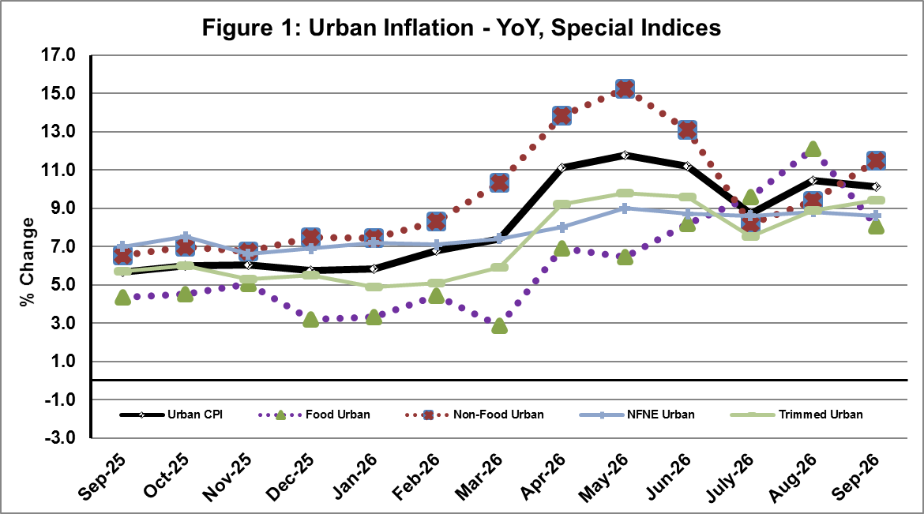

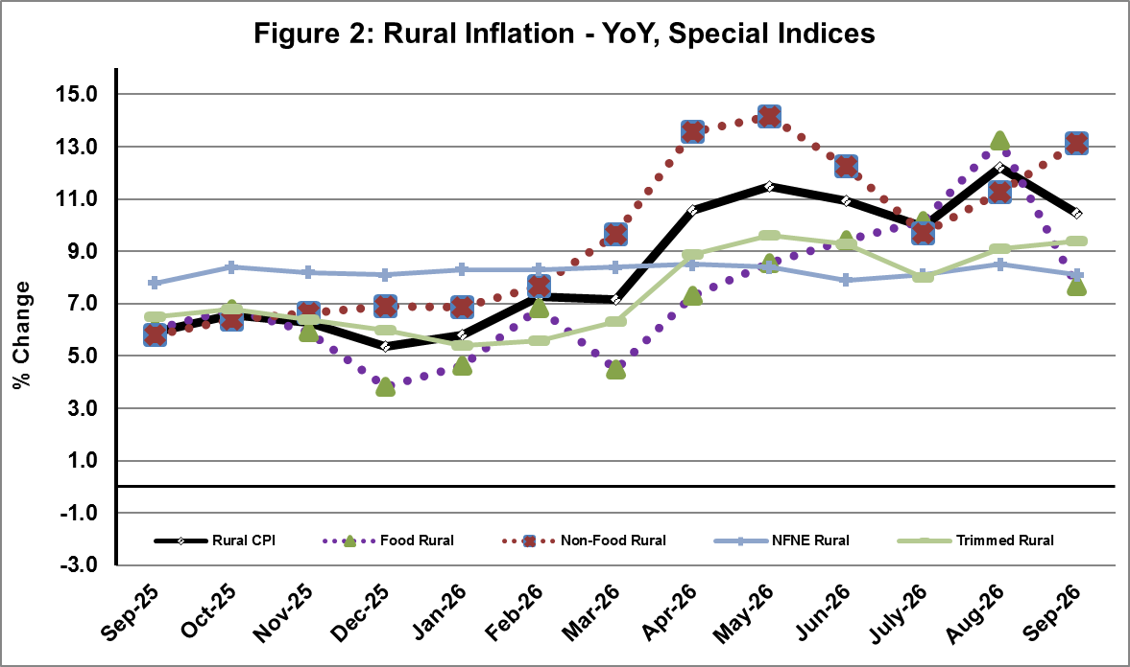

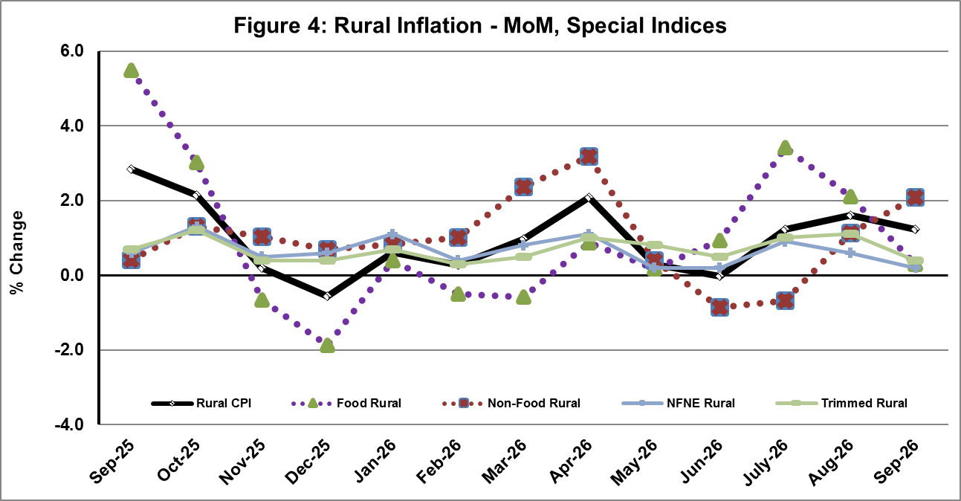
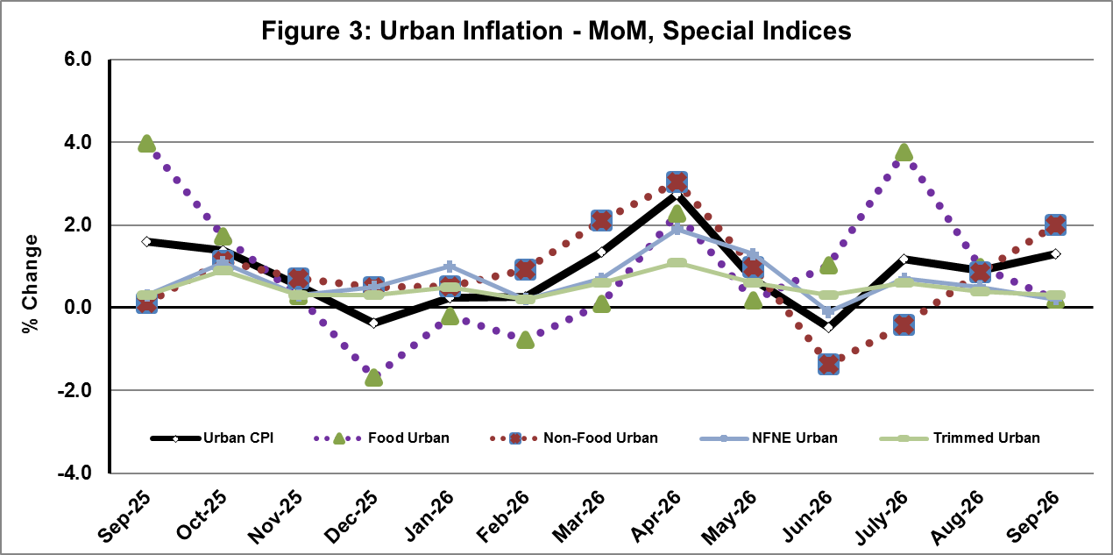

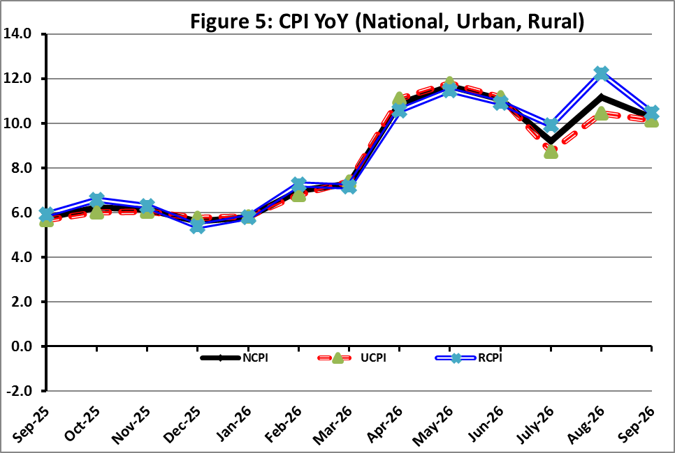

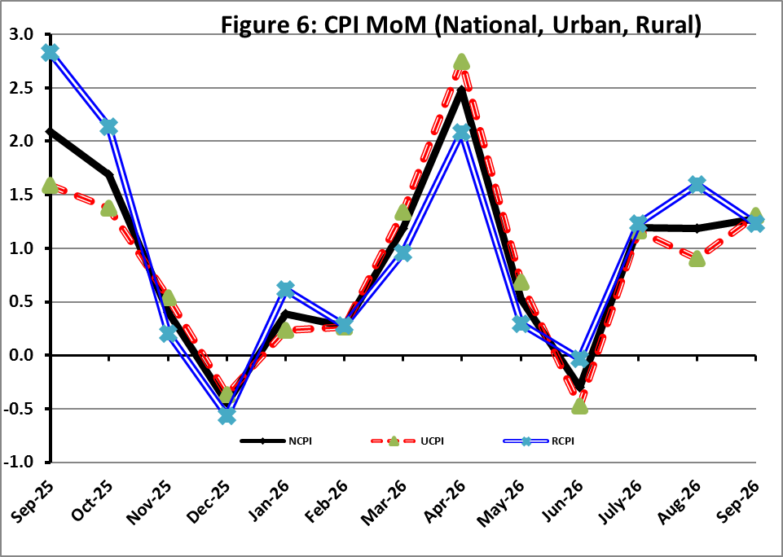

I. National Consumer Price Index (NCPI)

The National Consumer Price Index for September 2026 is increased by 1.27% over August 2026 and increased by 10.26% over corresponding month of the last year i.e. September 2025.

Table 1: Consumer Price Index (National) by Group of Commodities and Services (Base 2015-16)
No | Group | Group  Weight  (%) | Indices |  |  | % Change  Sep 2026  Over |  | Impact  (In % points)  Sep 2026 Over
No | Group | Group  Weight  (%) | Sep 26 | Aug 26 | Sep 25 | Aug 26 | Sep 25 | Aug 26 | Sep 25
No | General | 100.00 | 304.33 | 300.50 | 276.01 | 1.27 | 10.26 | 1.27 | 10.26
1. | Food & Non-alcoholic Bev. | 34.58 | 314.58 | 313.99 | 290.74 | 0.19 | 8.20 | 0.07 | 2.99
 | Non-perishable Food Items | 29.60 | 316.01 | 315.74 | 293.59 | 0.09 | 7.64 | 0.03 | 2.40
 | Perishable Food Items | 4.99 | 306.08 | 303.63 | 273.83 | 0.81 | 11.78 | 0.04 | 0.58
2. | Alcoholic Bev. & Tobacco | 1.02 | 410.23 | 410.53 | 398.28 | -0.07 | 3.00 | 0.00 | 0.04
3. | Clothing & Footwear | 8.60 | 289.66 | 289.14 | 265.79 | 0.18 | 8.98 | 0.02 | 0.74
4. | Housing, Water, Electricity, Gas & Fuels | 23.63 | 276.26 | 268.09 | 245.81 | 3.05 | 12.39 | 0.64 | 2.61
5. | Furnishing & Household Equipment Maintenance | 4.10 | 300.81 | 299.49 | 280.52 | 0.44 | 7.23 | 0.02 | 0.30
6. | Health | 2.79 | 301.51 | 299.44 | 279.49 | 0.69 | 7.88 | 0.02 | 0.22
7. | Transport | 5.91 | 404.02 | 382.06 | 317.05 | 5.75 | 27.43 | 0.43 | 1.86
8. | Communication | 2.21 | 153.72 | 153.72 | 135.38 | 0.00 | 13.54 | 0.00 | 0.15
9. | Recreation & Culture | 1.59 | 268.05 | 268.62 | 266.50 | -0.21 | 0.58 | 0.00 | 0.01
10. | Education | 3.79 | 240.79 | 240.41 | 223.43 | 0.16 | 7.77 | 0.00 | 0.24
11. | Restaurants & Hotels | 6.92 | 310.30 | 308.22 | 292.46 | 0.68 | 6.10 | 0.05 | 0.45
12. | Miscellaneous | 4.87 | 375.97 | 374.06 | 339.02 | 0.51 | 10.90 | 0.03 | 0.65

II. Urban Consumer Price Index (UCPI)

The Urban Consumer Price Index for September 2026 is increased by 1.31% over August 2026 and increased by 10.12% over corresponding month of the last year i.e. September 2025.

Table 2: Consumer Price Index (Urban) by Group of Commodities and Services (Base 2015-16)
No | Group | Group  Weight  (%) | Indices |  |  | % Change  Sep 2026  Over |  | Impact  (In % points)  Sep 2026 Over
No | Group | Group  Weight  (%) | Sep 26 | Aug 26 | Sep 25 | Aug 26 | Sep 25 | Aug 26 | Sep 25
 | General | 100.00 | 300.11 | 296.24 | 272.53 | 1.31 | 10.12 | 1.31 | 10.12
1. | Food & Non-alcoholic Bev. | 30.42 | 311.67 | 311.32 | 287.74 | 0.11 | 8.32 | 0.04 | 2.67
 | Non-perishable Food Items | 25.97 | 312.51 | 312.13 | 291.08 | 0.12 | 7.36 | 0.03 | 2.04
 | Perishable Food Items | 4.46 | 306.81 | 306.61 | 268.30 | 0.07 | 14.35 | 0.00 | 0.63
2. | Alcoholic Bev. & Tobacco | 0.85 | 436.38 | 435.49 | 420.57 | 0.20 | 3.76 | 0.00 | 0.05
3. | Clothing & Footwear | 8.01 | 284.36 | 283.87 | 255.85 | 0.17 | 11.14 | 0.01 | 0.84
4. | Housing, Water, Electricity, Gas & Fuels | 27.03 | 280.79 | 273.36 | 255.72 | 2.72 | 9.80 | 0.68 | 2.49
5. | Furnishing & Household Equip. & Maintenance | 4.09 | 289.03 | 287.75 | 270.65 | 0.44 | 6.79 | 0.02 | 0.28
6. | Health | 2.31 | 301.57 | 299.75 | 280.61 | 0.61 | 7.47 | 0.01 | 0.18
7. | Transport | 6.14 | 403.03 | 380.97 | 311.84 | 5.79 | 29.24 | 0.46 | 2.05
8. | Communication | 2.35 | 159.90 | 159.90 | 138.78 | 0.00 | 15.22 | 0.00 | 0.18
9. | Recreation & Culture | 1.73 | 253.22 | 253.70 | 250.70 | -0.19 | 1.01 | 0.00 | 0.02
10. | Education | 4.88 | 232.18 | 231.89 | 216.28 | 0.13 | 7.35 | 0.00 | 0.28
11. | Restaurants & Hotels | 7.41 | 304.12 | 302.29 | 286.84 | 0.61 | 6.02 | 0.05 | 0.47
12. | Miscellaneous | 4.77 | 363.67 | 361.27 | 328.68 | 0.66 | 10.65 | 0.04 | 0.61
Main contributors to month-on-month and year-on-year percentage changes are given below and detail is given in Annexure-A.
MONTH-ON-MONTH: Top few commodities which varied from previous month i.e. August, 2026 are given below:
FOOD
Increased: Onions (29.17%), Wheat (3.86%), Besan (2.74%), Wheat Flour (2.28%), Pulse Gram (1.82%), Wheat Products (1.60%), Pulse Masoor (1.56%), Dry Fruits (1.27%), Mustard Oil (0.98%), Meat (0.78%), Bakery and Confectionary (0.77%), Readymade Food (0.74%) and Cooking Oil (0.55%).
Decreased: Tomatoes (24.67%), Chicken (8.14%), Eggs (5.92%), Potatoes (4.19%), Pulse Moong (2.09%), Fresh Vegetables (1.49%), Beans (1.11%), Sugar (0.88%), Fresh Fruits (0.32%) and Honey (0.03%).

NON-FOOD:
Increased: Electricity Charges (15.28%), Motor Fuel (10.76%), Liquified Hydrocarbons (5.37%), Accommodation Services (2.26%), Personal Effects (1.24%), Drugs & Medicines (0.98%) and Woolen Cloth (0.80%).
Decreased: Transport Services (0.81%) and Text Books (0.60%).

YEAR-ON-YEAR: Top few commodities, which varied from corresponding month of previous year i.e. September 2025, are given below:
FOOD:
Increased: Onions (125.48%), Wheat (40.96%), Wheat Flour (31.71%), Wheat Products (16.03%), Fresh Fruits (14.75%), Meat (14.68%), Bakery and Confectionary (10.63%), Dry Fruits (10.48%), Milk Products (9.12%), Milk Fresh (8.16%), Vegetable Ghee (7.96%) and Cooking Oil (7.85%).
Decreased: Potatoes (30.34%), Chicken (20.92%), Eggs (20.19%), Sugar (19.94%), Pulse Gram (13.49%), Besan (12.37%), Gram Whole (12.04%), Beans (11.81%), Pulse Masoor (10.69%), Pulse Moong (8.61%), Gur (4.30%) and Honey (0.02%).

NON-FOOD:
Increased: Liquified Hydrocarbons (57.14%), Motor Vehicle Tax (38.68%), Motor Fuel (37.73%), Postal Services (33.07%), Electricity Charges (32.46%), Transport Services (29.56%), Footware (29.27%), Personal Effects (19.54%), Communication Services (19.30%), Newspapers (14.84%), Major Tools & Equipments (14.26%) and Mechanical Services (13.54%).
Decreased: Text Books (1.55%).
III. Rural Consumer Price Index (RCPI)

The Rural Consumer Price Index for September 2026 is increased by 1.23% over August 2026 and increased by 10.47% over corresponding month of the last year i.e. September 2025.

Table 3: Consumer Price Index (Rural) by Group of Commodities and Services (Base 2015-16)
No | Group | Group  Weight  (%) | Indices |  |  | % Change  Sep 2026  Over |  | Impact  (In % points)  Sep 2026 Over
No | Group | Group  Weight  (%) | Sep 26 | Aug 26 | Sep 25 | Aug 26 | Sep 25 | Aug 26 | Sep 25
 | General | 100.00 | 310.69 | 306.92 | 281.25 | 1.23 | 10.47 | 1.23 | 10.47
1. | Food & Non-alcoholic Bev. | 40.87 | 317.85 | 316.99 | 294.12 | 0.27 | 8.07 | 0.11 | 3.45
 | Non-perishable Food Items | 35.08 | 319.93 | 319.77 | 296.40 | 0.05 | 7.94 | 0.02 | 2.94
 | Perishable Food Items | 5.79 | 305.24 | 300.17 | 280.25 | 1.69 | 8.92 | 0.10 | 0.51
2. | Alcoholic Bev. & Tobacco | 1.28 | 383.87 | 385.37 | 375.81 | -0.39 | 2.14 | -0.01 | 0.04
3. | Clothing & Footwear | 9.48 | 296.42 | 295.85 | 278.46 | 0.19 | 6.45 | 0.02 | 0.61
4. | Housing, Water, Electricity, Gas & Fuels | 18.49 | 266.26 | 256.46 | 223.93 | 3.82 | 18.90 | 0.59 | 2.78
5. | Furnishing & Household Equip. & Maintenance | 4.10 | 318.54 | 317.17 | 295.37 | 0.43 | 7.84 | 0.02 | 0.34
6. | Health | 3.51 | 301.46 | 299.13 | 278.38 | 0.78 | 8.29 | 0.03 | 0.29
7. | Transport | 5.56 | 405.66 | 383.88 | 325.74 | 5.67 | 24.53 | 0.39 | 1.58
8. | Communication | 1.99 | 142.71 | 142.71 | 129.33 | 0.00 | 10.35 | 0.00 | 0.09
9. | Recreation & Culture | 1.38 | 296.19 | 296.94 | 296.47 | -0.25 | -0.09 | 0.00 | 0.00
10. | Education | 2.13 | 270.54 | 269.84 | 248.13 | 0.26 | 9.03 | 0.00 | 0.17
11. | Restaurants & Hotels | 6.19 | 321.47 | 318.93 | 302.60 | 0.80 | 6.24 | 0.05 | 0.42
12. | Miscellaneous | 5.02 | 393.63 | 392.41 | 353.86 | 0.31 | 11.24 | 0.02 | 0.71
Main contributors to month-on-month and year-on-year percentage changes are given below and detail is given in Annexure-B.
MONTH-ON-MONTH Top few commodities which varied from previous month i.e. August, 2026 are given below:

FOOD
Increased: Onions (39.38%), Pulse Gram (2.42%), Wheat Flour (1.72%), Gram Whole (1.10%), Wheat (1.00%), Fresh Vegetables (0.87%), Mustard Oil (0.86%), Pulse Masoor (0.85%), Readymade Food (0.81%), Wheat Products (0.70%), Vegetable Ghee (0.60%) and Tea (0.57%).
Decreased: Tomatoes (27.87%), Chicken (7.57%), Pulse Moong (3.41%), Eggs (2.92%), Fresh Fruits (2.56%), Potatoes (2.30%), Milk Powder (1.98%), Dessert Preparation (1.92%), Sugar (1.70%), Rice (0.70%), Beans (0.58%), Pulse Mash (0.43%), Honey (0.42%), Condiments & Spices (0.24%) and Besan (0.22%).

NON-FOOD

Increased: Electricity Charges (15.28%), Motor Fuels (11.13%), Liquified Hydrocarbons (7.58%), Medical Tests (1.64%), Doctor Clinic Fee (1.41%), Furniture and Furnishing (1.11%), Plastic Products (0.82%), Marriage Hall Charges (0.78%), Construction Input Items (0.76%) and Drugs & Medicines (0.70%).

Decreased: Transport Services (0.75%) and Text Books (0.67%).

Year-On-Year: Top few commodities which varied from corresponding month of previous year i.e. September, 2025 are given below:
FOOD
Increased: Onions (136.70%), Wheat (37.46%), Wheat Flour (34.31%), Wheat Products (15.31%), Meat (10.13%), Vegetable Ghee (9.36%), Sweetmeat (8.81%), Dry Fruits (8.06%), Milk Fresh (7.67%), Mustard Oil (7.53%), Fresh Fruits (6.99%), Fish (6.88%) and Milk Products (6.54%).
Decreased: Potatoes (34.47%), Sugar (21.82%), Chicken (21.31%), Eggs (19.27%), Besan (14.29%), Gram Whole (13.05%), Pulse Gram (11.99%), Pulse Moong (10.04%), Pulse Masoor (10.01%), Gur (7.95%), Tomatoes (7.18%), Beans (3.95%), Honey (1.47%), Condiments & Spices (1.00%) and Pulse Mash (0.42%).

Non-Food
Increased: Liquified Hydrocarbons (53.98%), Motor Fuels (39.70%), Motor Vehicle Tax (34.32%), Electricity Charges (32.46%), Construction Input Items (18.08%), Personal Effects (16.88%), Solid Fuel (16.45%) and Doctor Clinic Fee (15.97%).
Decreased: Text Books (3.53%) and Postal Services (1.43%).

IV. Sensitive Price Indicator (SPI)

Quintile-wise percentage changes YoY and MoM are given below in Table 4. The series from
September 2025 to September 2026 is also graphed below in Figure 7.

Table 4: Sensitive Price Indicator (Base 2015-16)
Quintiles | Indices |  |  | % Change Sep 2026  Over
Quintiles | Sep 2026 | Aug 2026 | Sep 2025 | Aug 2026 | Sep 2025
1 | 352.18 | 348.70 | 325.00 | 1.00 | 8.36
2 | 353.90 | 349.68 | 323.52 | 1.21 | 9.39
3 | 375.25 | 371.01 | 346.52 | 1.14 | 8.29
4 | 362.80 | 358.24 | 333.88 | 1.27 | 8.66
5 | 365.14 | 358.29 | 331.33 | 1.91 | 10.20
Combined | 365.71 | 359.84 | 332.83 | 1.63 | 9.88

Table 4.1: Weekly Percentage Change of SPI During September 2026
Quintiles | % Change over Previous week
Quintiles | 03-09-2026 | 10-09-2026 | 17-09-2026 | 24-09-2026
Quintile 1 | 0.91 | -0.30 | -0.14 | 0.85
Combined | 0.65 | 0.23 | 0.49 | 0.99

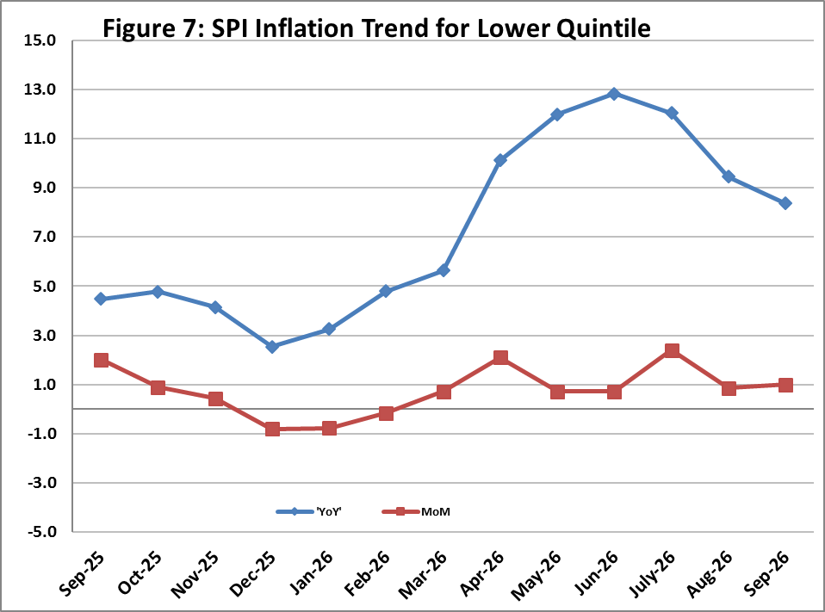

V. Wholesale Price Index
The Wholesale Price Index for September 2026 increased by 1.88% over August 2026 and increased by 13.33% over the corresponding month of the last year i.e. September, 2025. YoY and MoM movements from September, 2025 to September, 2026 are also graphed below in Figure 8.

Table 5: Wholesale Price Index by Group of Commodities (Base 2015-16)
No | Group | Group  Weight  (%) | Indices |  |  | % Change  Sep 2026  Over |  | Impact  (In % points)  Sep 2026 Over
No | Group | Group  Weight  (%) | Sep 26 | Aug 26 | Sep 25 | Aug 26 | Sep 25 | Aug 26 | Sep 25
 | General | 100.00 | 357.38 | 350.77 | 315.34 | 1.88 | 13.33 | 1.88 | 13.33
1 | Agriculture Forestry & Fishery | 25.77 | 304.16 | 304.57 | 283.50 | -0.13 | 7.29 | -0.03 | 1.69
2 | Ores/Minerals, Elec., Gas & Water | 12.01 | 374.51 | 358.89 | 349.10 | 4.35 | 7.28 | 0.53 | 0.97
3 | Food, Beverages, Tobacco, Textiles & Leather Products | 31.11 | 309.43 | 308.04 | 290.38 | 0.45 | 6.56 | 0.12 | 1.88
 | i. Food Products, Beverages & Tobacco | 20.07 | 335.09 | 332.91 | 310.15 | 0.65 | 8.04 | 0.12 | 1.59
 | ii. Textiles & Apparels | 10.33 | 266.01 | 266.26 | 259.63 | -0.09 | 2.46 | -0.01 | 0.21
 | iii. Leather Products | 0.71 | 215.99 | 212.86 | 179.03 | 1.47 | 20.64 | 0.01 | 0.08
4 | Other Transportable Goods | 22.40 | 453.96 | 434.07 | 338.00 | 4.58 | 34.31 | 1.27 | 8.24
5 | Metal Product, Machinery & Equipment | 8.72 | 414.12 | 414.61 | 393.89 | -0.12 | 5.14 | -0.01 | 0.56

Main contributors to month-on-month and year-on-year percentage changes are given below and detail is given in Annexure-C.

MONTH-ON-MONTH: Top few commodities which varied from previous month are given below:
Increased: Motor Spirit (12.40%), Electrical Energy (11.40%), Kerosene Oil (7.78%), Diesel Oil (7.36%), Raw Animal Materials / Wool (6.32%), Furnace Oil (6.25%), Fibre Crops (2.96%), Wheat (2.71%), Wheat Flour (2.69%), Other Oil Seeds (2.20%), Oil Cakes (2.01%), Other Cereal Flour (1.78%) and Stimulant & Spice Crops (1.68%).
Decreased: Sorghum / Jowar (8.54%), Edible Roots / Potatoes (8.54%), Fresh Fruits (8.46%), Poultry (6.30%), Vegetables (2.80%), Maize (2.71%), Cement (2.05%), Eggs (1.46%) and Sugar Refined (1.44%).

YEAR-ON-YEAR: Top few commodities which varied from previous year are given below:
Increased: Kerosene Oil (78.93%), Diesel Oil (61.45%), Footwears (51.86%), Furnace Oil (47.82%), Wheat (44.49%), Motor Spirit (42.77%), Wheat Flour (39.13%), Mobil Oil (27.76%), Raw Animal Materials / Wool (26.90%), Woven Fabrics (25.04%), Sorghum / Jowar (24.90%), Fibre Crops (21.66%) and Dried Fruits & Nuts (20.52%).
Decreased: Edible Roots / Potatoes (44.38%), Stimulant & Spice Crops (24.02%), Sugar Refined (21.62%), Eggs (20.43%), Poultry (17.48%), Dry Fruits (16.49%), Other Cereal Flour (16.30%), Millet / Bajra (15.26%), Pulses (14.76%), Sugar Crops (3.52%), Cotton Seeds (2.79%), Timber (1.74%) and Synthetic Carpets (1.71%).
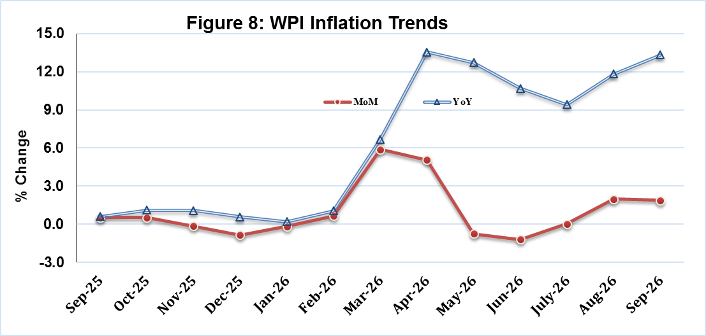

Annexure A: CPI (Urban) Index Numbers by Commodity Groups & Commodities (2015-16=100)
Item and Specification |  | Weight | Index Numbers  Sep 26 Aug 26 Sep 25 |  |  | % Change in Sep 2026 over  Aug 2026 Sep 2025
 | General | 100.0000 | 300.11 | 296.24 | 272.53 |  | + | 1.31 |  | + | 10.12
 | Food and non-alcoholic Beverages | 30.4215 | 311.67 | 311.32 | 287.74 |  | + | 0.11 |  | + | 8.32
01 | Wheat | 0.6120 | 367.21 | 353.55 | 260.50 |  | + | 3.86 |  | + | 40.96
02 | Wheat flour | 3.0075 | 343.36 | 335.72 | 260.69 |  | + | 2.28 |  | + | 31.71
03 | Wheat products | 0.0936 | 325.32 | 320.21 | 280.38 |  | + | 1.60 |  | + | 16.03
04 | Besan | 0.0830 | 222.63 | 216.69 | 254.06 |  | + | 2.74 |  | - | 12.37
05 | Rice | 1.1804 | 339.72 | 339.52 | 330.09 |  | + | 0.06 |  | + | 2.92
06 | Bakery and confectionary | 0.4770 | 299.53 | 297.24 | 270.74 |  | + | 0.77 |  | + | 10.63
07 | Nimco | 0.1224 | 319.08 | 318.24 | 301.17 |  | + | 0.26 |  | + | 5.95
08 | Meat | 2.0411 | 399.80 | 396.70 | 348.63 |  | + | 0.78 |  | + | 14.68
09 | Chicken | 1.3631 | 231.68 | 252.20 | 292.98 |  | - | 8.14 |  | - | 20.92
10 | Fish | 0.3855 | 224.28 | 223.66 | 211.35 |  | + | 0.28 |  | + | 6.12
11 | Milk fresh | 7.1070 | 288.42 | 288.21 | 266.65 |  | + | 0.07 |  | + | 8.16
12 | Milk products | 0.6407 | 293.04 | 292.28 | 268.56 |  | + | 0.26 |  | + | 9.12
13 | Milk powder | 0.3106 | 339.53 | 338.60 | 317.55 |  | + | 0.27 |  | + | 6.92
14 | Eggs | 0.5083 | 288.49 | 306.63 | 361.49 |  | - | 5.92 |  | - | 20.19
15 | Butter | 0.0932 | 503.47 | 501.84 | 477.26 |  | + | 0.32 |  | + | 5.49
16 | Mustard oil | 0.0120 | 323.21 | 320.06 | 310.45 |  | + | 0.98 |  | + | 4.11
17 | Cooking oil | 1.1016 | 350.19 | 348.28 | 324.71 |  | + | 0.55 |  | + | 7.85
18 | Vegetable ghee | 1.0324 | 371.23 | 370.25 | 343.87 |  | + | 0.26 |  | + | 7.96
19 | Dry fruits | 0.3299 | 330.27 | 326.14 | 298.95 |  | + | 1.27 |  | + | 10.48
20 | Fresh fruits | 1.4363 | 253.04 | 253.85 | 220.51 |  | - | 0.32 |  | + | 14.75
21 | Pulse masoor | 0.1624 | 178.93 | 176.19 | 200.35 |  | + | 1.56 |  | - | 10.69
22 | Pulse moong | 0.1697 | 217.40 | 222.05 | 237.88 |  | - | 2.09 |  | - | 8.61
23 | Pulse mash | 0.1152 | 194.52 | 193.86 | 185.78 |  | + | 0.34 |  | + | 4.70
24 | Pulse gram | 0.1660 | 217.73 | 213.83 | 251.67 |  | + | 1.82 |  | - | 13.49
25 | Gram whole | 0.0912 | 237.23 | 236.55 | 269.69 |  | + | 0.29 |  | - | 12.04
26 | Beans | 0.0408 | 321.07 | 324.68 | 364.08 |  | - | 1.11 |  | - | 11.81
27 | Potatoes | 0.4496 | 238.69 | 249.13 | 342.66 |  | - | 4.19 |  | - | 30.34
28 | Onions | 0.5928 | 465.66 | 360.50 | 206.52 |  | + | 29.17 |  | + | 125.48
29 | Tomatoes | 0.3459 | 422.53 | 560.89 | 405.76 |  | - | 24.67 |  | + | 4.13
30 | Fresh vegetables | 1.5306 | 292.41 | 296.82 | 277.14 |  | - | 1.49 |  | + | 5.51
31 | Sugar | 1.1130 | 235.35 | 237.45 | 293.97 |  | - | 0.88 |  | - | 19.94
32 | Gur | 0.0379 | 265.59 | 264.65 | 277.53 |  | + | 0.36 |  | - | 4.30
33 | Honey | 0.1017 | 222.68 | 222.74 | 222.73 |  | - | 0.03 |  | - | 0.02
34 | Sweetmeat | 0.3535 | 352.26 | 351.80 | 332.76 |  | + | 0.13 |  | + | 5.86
35 | Ice cream | 0.1044 | 224.30 | 223.83 | 199.68 |  | + | 0.21 |  | + | 12.33
36 | Condiments and Spices | 1.3340 | 386.29 | 385.98 | 373.17 |  | + | 0.08 |  | + | 3.52
37 | Dessert preparation | 0.0419 | 314.44 | 314.29 | 297.93 |  | + | 0.05 |  | + | 5.54
38 | Tea | 0.8427 | 286.89 | 286.89 | 273.67 |  | + | 0.00 |  | + | 4.83
39 | Beverages | 0.8906 | 272.78 | 272.62 | 261.09 |  | + | 0.06 |  | + | 4.48
 | Alcoholic Beverages, Tobacco | 0.8540 | 436.38 | 435.49 | 420.57 |  | + | 0.20 |  | + | 3.76
40 | Cigarettes | 0.7167 | 422.19 | 423.27 | 411.79 |  | - | 0.26 |  | + | 2.53
41 | Pan prepared | 0.1373 | 510.46 | 499.28 | 466.38 |  | + | 2.24 |  | + | 9.45
 | Clothing and footwear | 8.0096 | 284.36 | 283.87 | 255.85 |  | + | 0.17 |  | + | 11.14
42 | Cotton cloth | 2.2227 | 315.65 | 315.60 | 299.83 |  | + | 0.02 |  | + | 5.28
43 | Woollen cloth | 0.8361 | 269.91 | 267.76 | 243.92 |  | + | 0.80 |  | + | 10.66
44 | Readymade garments | 1.3196 | 234.76 | 233.98 | 223.24 |  | + | 0.33 |  | + | 5.16
45 | Woollen readymade garments | 0.4307 | 274.02 | 273.87 | 256.71 |  | + | 0.05 |  | + | 6.74
46 | Tailoring | 1.0741 | 268.73 | 268.50 | 238.22 |  | + | 0.09 |  | + | 12.81
47 | Hosiery | 0.4070 | 249.15 | 249.07 | 239.53 |  | + | 0.03 |  | + | 4.02
48 | Dupatta | 0.1713 | 224.27 | 220.49 | 205.48 |  | + | 1.71 |  | + | 9.14
49 | Cleaning and laundering | 0.0665 | 299.42 | 299.35 | 276.51 |  | + | 0.02 |  | + | 8.29
50 | Footware | 1.4816 | 320.03 | 320.02 | 247.57 |  | + | 0.00 |  | + | 29.27
 | Housing, water, Elec., Gas and Other Fuels | 27.0332 | 280.79 | 273.36 | 255.72 |  | + | 2.72 |  | + | 9.80
51 | House rent | 19.2558 | 183.56 | 183.56 | 172.97 |  | + | 0.00 |  | + | 6.12
52 | Construction input items | 0.3765 | 286.73 | 285.89 | 269.90 |  | + | 0.29 |  | + | 6.24
53 | Construction wage rates | 0.2025 | 250.48 | 248.82 | 228.36 |  | + | 0.67 |  | + | 9.69
54 | Water supply | 0.5269 | 260.19 | 260.00 | 230.44 |  | + | 0.07 |  | + | 12.91
55 | Garbage collection | 0.1064 | 275.90 | 275.69 | 265.81 |  | + | 0.08 |  | + | 3.80
56 | Electricity charges | 4.5562 | 310.50 | 269.35 | 234.41 |  | + | 15.28 |  | + | 32.46
57 | Gas charges | 1.0807 | 1817.96 | 1817.96 | 1817.96 |  | + | 0.00 |  | + | 0.00
58 | Liquefied Hydrocarbons | 0.5064 | 485.19 | 460.46 | 308.77 |  | + | 5.37 |  | + | 57.14
59 | Solid Fuel | 0.4218 | 250.77 | 250.77 | 226.86 |  | + | 0.00 |  | + | 10.54
 | Furnishing and household equipments | 4.0937 | 289.03 | 287.75 | 270.65 |  | + | 0.44 |  | + | 6.79
60 | Furniture and furnishing | 0.4750 | 277.31 | 276.47 | 263.17 |  | + | 0.30 |  | + | 5.37
61 | Carpets | 0.0308 | 159.67 | 159.60 | 154.28 |  | + | 0.04 |  | + | 3.49
62 | Household textiles | 0.3420 | 217.00 | 216.87 | 212.08 |  | + | 0.06 |  | + | 2.32
63 | Household equipments | 1.0032 | 293.74 | 292.78 | 274.22 |  | + | 0.33 |  | + | 7.12
64 | Plastic products | 0.0536 | 250.52 | 248.70 | 233.65 |  | + | 0.73 |  | + | 7.22
65 | Major tools & equipments | 0.0084 | 287.60 | 287.60 | 251.70 |  | + | 0.00 |  | + | 14.26
66 | Washing soap/detergents/match | 1.4112 | 351.08 | 348.44 | 323.90 |  | + | 0.76 |  | + | 8.39
67 | Household servant | 0.7695 | 216.22 | 216.22 | 206.41 |  | + | 0.00 |  | + | 4.75
 | Health | 2.3098 | 301.57 | 299.75 | 280.61 |  | + | 0.61 |  | + | 7.47
68 | Drugs and medicines | 1.0735 | 325.40 | 322.24 | 301.47 |  | + | 0.98 |  | + | 7.94
69 | Therapeutic Appliances and Eq | 0.0054 | 158.42 | 158.31 | 155.97 |  | + | 0.07 |  | + | 1.57
70 | Doctor (MBBS) clinic fee | 0.4044 | 381.02 | 379.47 | 353.04 |  | + | 0.41 |  | + | 7.93
71 | Dental services | 0.0156 | 243.33 | 242.89 | 231.05 |  | + | 0.18 |  | + | 5.31
72 | Medical tests | 0.2367 | 237.45 | 237.18 | 217.37 |  | + | 0.11 |  | + | 9.24
73 | Hospitals services | 0.5742 | 230.44 | 230.23 | 219.20 |  | + | 0.09 |  | + | 5.13
 | Transport | 6.1368 | 403.03 | 380.97 | 311.84 |  | + | 5.79 |  | + | 29.24
74 | Motor vehicles | 0.8097 | 268.13 | 268.13 | 267.42 |  | + | 0.00 |  | + | 0.27
75 | Motor vehicle accessories | 0.1941 | 274.79 | 274.30 | 266.36 |  | + | 0.18 |  | + | 3.16
76 | Motor fuel | 2.9088 | 496.41 | 448.20 | 360.42 |  | + | 10.76 |  | + | 37.73
77 | Mechanical services | 0.4290 | 271.52 | 271.52 | 239.15 |  | + | 0.00 |  | + | 13.54
78 | Motor vehicle tax | 0.0482 | 553.65 | 553.65 | 399.23 |  | + | 0.00 |  | + | 38.68
79 | Transport services | 1.7470 | 352.44 | 355.31 | 272.03 |  | - | 0.81 |  | + | 29.56
 | Communication | 2.3536 | 159.90 | 159.90 | 138.78 |  | + | 0.00 |  | + | 15.22
80 | Postal services | 0.0190 | 298.88 | 298.88 | 224.60 |  | + | 0.00 |  | + | 33.07
81 | Communication apparatus | 0.4524 | 196.17 | 196.17 | 190.24 |  | + | 0.00 |  | + | 3.12
82 | Communication Services | 1.8822 | 149.78 | 149.78 | 125.55 |  | + | 0.00 |  | + | 19.30
 | Recreation and culture | 1.7301 | 253.22 | 253.70 | 250.70 |  | - | 0.19 |  | + | 1.01
83 | Recreation and culture | 0.6478 | 158.11 | 157.84 | 155.07 |  | + | 0.17 |  | + | 1.96
84 | Text books | 0.6655 | 298.85 | 300.64 | 303.56 |  | - | 0.60 |  | - | 1.55
85 | Newspapers | 0.0716 | 278.85 | 278.85 | 242.82 |  | + | 0.00 |  | + | 14.84
86 | stationery | 0.3452 | 338.39 | 337.87 | 329.89 |  | + | 0.15 |  | + | 2.58
 | Education | 4.8807 | 232.18 | 231.89 | 216.28 |  | + | 0.13 |  | + | 7.35
87 | Education | 4.8807 | 232.18 | 231.89 | 216.28 |  | + | 0.13 |  | + | 7.35
 | Restaurants and hotels | 7.4050 | 304.12 | 302.29 | 286.84 |  | + | 0.61 |  | + | 6.02
88 | Readymade food | 5.5235 | 316.24 | 313.92 | 294.01 |  | + | 0.74 |  | + | 7.56
89 | Marriage Hall Charges | 1.7514 | 273.68 | 273.56 | 272.07 |  | + | 0.04 |  | + | 0.59
90 | Accommodation Services | 0.1301 | 199.44 | 195.04 | 181.46 |  | + | 2.26 |  | + | 9.91
 | Misc. goods and services | 4.7720 | 363.67 | 361.27 | 328.68 |  | + | 0.66 |  | + | 10.65
91 | Personal Grooming Services | 0.8001 | 284.74 | 284.45 | 272.47 |  | + | 0.10 |  | + | 4.50
92 | Electrical Appliances for Per | 0.0465 | 199.18 | 199.18 | 190.99 |  | + | 0.00 |  | + | 4.29
93 | Appliances/Articles/Products | 2.9807 | 306.77 | 305.41 | 286.20 |  | + | 0.45 |  | + | 7.19
94 | Personal Effects n.e.c. | 0.9447 | 618.14 | 610.56 | 517.10 |  | + | 1.24 |  | + | 19.54

Annexure B: CPI (Rural) Index Numbers by Commodity Groups & Commodities (2015-16=100)
Item and Specification |  | Weight | Index Numbers  Sep 26 Aug 26 Sep 25 |  |  | % Change in Sep 2026 over  Aug 2026 Sep 2025
 | General | 100.0000 | 310.69 | 306.92 | 281.25 |  | + | 1.23 |  | + | 10.47
 | Food and non-alcoholic Beverages | 40.8668 | 317.85 | 316.99 | 294.12 |  | + | 0.27 |  | + | 8.07
01 | Wheat | 3.4736 | 370.92 | 367.23 | 269.83 |  | + | 1.00 |  | + | 37.46
02 | Wheat Flour | 3.4297 | 362.48 | 356.36 | 269.89 |  | + | 1.72 |  | + | 34.31
03 | Wheat Products | 0.1068 | 326.64 | 324.37 | 283.28 |  | + | 0.70 |  | + | 15.31
04 | Besan | 0.0728 | 234.02 | 234.53 | 273.04 |  | - | 0.22 |  | - | 14.29
05 | Rice | 1.5501 | 427.67 | 430.67 | 425.55 |  | - | 0.70 |  | + | 0.50
06 | Bakery and Confectionary | 0.3702 | 336.11 | 334.26 | 315.81 |  | + | 0.55 |  | + | 6.43
07 | Nimco | 0.0774 | 321.02 | 321.92 | 305.77 |  | - | 0.28 |  | + | 4.99
08 | Meat | 1.7146 | 410.89 | 409.56 | 373.08 |  | + | 0.32 |  | + | 10.13
09 | Chicken | 1.4641 | 250.32 | 270.81 | 318.11 |  | - | 7.57 |  | - | 21.31
10 | Fish | 0.2640 | 240.90 | 240.19 | 225.39 |  | + | 0.30 |  | + | 6.88
11 | Milk fresh | 10.3803 | 287.11 | 286.52 | 266.65 |  | + | 0.21 |  | + | 7.67
12 | Milk products | 0.9624 | 280.39 | 279.37 | 263.17 |  | + | 0.37 |  | + | 6.54
13 | Milk powder | 0.1062 | 302.96 | 309.07 | 288.95 |  | - | 1.98 |  | + | 4.85
14 | Eggs | 0.5665 | 275.58 | 283.88 | 341.34 |  | - | 2.92 |  | - | 19.27
15 | Butter | 0.3333 | 343.53 | 342.08 | 313.67 |  | + | 0.42 |  | + | 9.52
16 | Mustard oil | 0.0136 | 350.56 | 347.57 | 326.00 |  | + | 0.86 |  | + | 7.53
17 | Cooking oil | 0.6011 | 384.55 | 383.19 | 362.86 |  | + | 0.35 |  | + | 5.98
18 | Vegetable ghee | 2.3764 | 409.64 | 407.19 | 374.58 |  | + | 0.60 |  | + | 9.36
19 | Dry fruits | 0.2496 | 397.19 | 396.96 | 367.55 |  | + | 0.06 |  | + | 8.06
20 | Fresh fruits | 1.4505 | 245.32 | 251.77 | 229.29 |  | - | 2.56 |  | + | 6.99
21 | Pulse Masoor | 0.2076 | 203.12 | 201.40 | 225.71 |  | + | 0.85 |  | - | 10.01
22 | Pulse Moong | 0.2510 | 235.11 | 243.42 | 261.36 |  | - | 3.41 |  | - | 10.04
23 | Pulse Mash | 0.1465 | 196.29 | 197.14 | 197.11 |  | - | 0.43 |  | - | 0.42
24 | Pulse Gram | 0.2751 | 228.29 | 222.90 | 259.38 |  | + | 2.42 |  | - | 11.99
25 | Gram Whole | 0.1116 | 253.94 | 251.17 | 292.04 |  | + | 1.10 |  | - | 13.05
26 | Beans | 0.0896 | 381.59 | 383.80 | 397.29 |  | - | 0.58 |  | - | 3.95
27 | Potatoes | 0.7437 | 245.44 | 251.22 | 374.54 |  | - | 2.30 |  | - | 34.47
28 | Onions | 0.8965 | 463.76 | 332.73 | 195.93 |  | + | 39.38 |  | + | 136.70
29 | Tomatoes | 0.5069 | 399.83 | 554.30 | 430.77 |  | - | 27.87 |  | - | 7.18
30 | Fresh Vegetables | 2.0947 | 279.28 | 276.87 | 277.11 |  | + | 0.87 |  | + | 0.78
31 | Sugar | 2.0296 | 235.18 | 239.25 | 300.83 |  | - | 1.70 |  | - | 21.82
32 | Gur | 0.1522 | 266.04 | 265.28 | 289.02 |  | + | 0.29 |  | - | 7.95
33 | Honey | 0.0296 | 226.68 | 227.63 | 230.07 |  | - | 0.42 |  | - | 1.47
34 | Sweetmeat | 0.3967 | 320.24 | 318.47 | 294.30 |  | + | 0.56 |  | + | 8.81
35 | Ice Cream | 0.0568 | 219.77 | 219.77 | 199.76 |  | + | 0.00 |  | + | 10.02
36 | Condiments and Spices | 1.4919 | 294.39 | 295.11 | 297.35 |  | - | 0.24 |  | - | 1.00
37 | Dessert Preparation | 0.0133 | 302.16 | 308.08 | 292.45 |  | - | 1.92 |  | + | 3.32
38 | Tea | 1.2566 | 276.90 | 275.32 | 273.01 |  | + | 0.57 |  | + | 1.42
39 | Beverages | 0.5537 | 262.98 | 262.87 | 253.91 |  | + | 0.04 |  | + | 3.57
 | Alcoholic Beverages, Tobacco | 1.2786 | 383.87 | 385.37 | 375.81 |  | - | 0.39 |  | + | 2.14
40 | Cigarettes | 1.2364 | 383.09 | 384.65 | 375.70 |  | - | 0.41 |  | + | 1.97
41 | Pan Prepared | 0.0422 | 406.83 | 406.47 | 379.08 |  | + | 0.09 |  | + | 7.32
 | Clothing and footwear | 9.4826 | 296.42 | 295.85 | 278.46 |  | + | 0.19 |  | + | 6.45
42 | Cotton Cloth | 2.8381 | 321.81 | 321.20 | 305.70 |  | + | 0.19 |  | + | 5.27
43 | Woollen Cloth | 1.0959 | 293.41 | 291.60 | 269.54 |  | + | 0.62 |  | + | 8.86
44 | Readymade Garments | 1.1345 | 272.92 | 272.83 | 258.67 |  | + | 0.03 |  | + | 5.51
45 | Woollen Readymade Garments | 0.5401 | 334.48 | 334.48 | 309.66 |  | + | 0.00 |  | + | 8.02
46 | Tailoring | 1.2999 | 284.43 | 283.66 | 260.89 |  | + | 0.27 |  | + | 9.02
47 | Hosiery | 0.4322 | 366.61 | 366.55 | 350.64 |  | + | 0.02 |  | + | 4.55
48 | Dupatta | 0.2078 | 285.72 | 285.36 | 255.32 |  | + | 0.13 |  | + | 11.91
49 | Cleaning and Laundering | 0.0176 | 270.41 | 270.22 | 264.16 |  | + | 0.07 |  | + | 2.37
50 | Footware | 1.9165 | 257.43 | 257.16 | 244.46 |  | + | 0.10 |  | + | 5.31
 | Housing, water, Elec., Gas and other Fuels | 18.4853 | 266.26 | 256.46 | 223.93 |  | + | 3.82 |  | + | 18.90
51 | House Rent | 8.6110 | 195.20 | 195.20 | 181.11 |  | + | 0.00 |  | + | 7.78
52 | Construction Input Items | 0.6306 | 305.09 | 302.80 | 258.37 |  | + | 0.76 |  | + | 18.08
53 | Construction Wage Rates | 0.2526 | 267.20 | 265.78 | 245.93 |  | + | 0.53 |  | + | 8.65
54 | Water Supply | 0.0645 | 365.56 | 365.56 | 325.72 |  | + | 0.00 |  | + | 12.23
55 | Garbage Collection | 0.0080 | 225.10 | 225.10 | 204.36 |  | + | 0.00 |  | + | 10.15
56 | Electricity Charges | 3.4431 | 310.50 | 269.35 | 234.41 |  | + | 15.28 |  | + | 32.46
57 | Liquefied Hydrocarbons | 0.9994 | 453.71 | 421.76 | 294.65 |  | + | 7.58 |  | + | 53.98
58 | Solid Fuel | 4.4761 | 320.19 | 318.94 | 274.95 |  | + | 0.39 |  | + | 16.45
 | Furnishing and household equipments | 4.1031 | 318.54 | 317.17 | 295.37 |  | + | 0.43 |  | + | 7.84
59 | Furniture and Furnishing | 0.5786 | 310.02 | 306.63 | 295.19 |  | + | 1.11 |  | + | 5.02
60 | Household Textiles | 0.4382 | 266.75 | 265.14 | 244.14 |  | + | 0.61 |  | + | 9.26
61 | Household Equipments | 1.2774 | 312.24 | 311.93 | 296.62 |  | + | 0.10 |  | + | 5.27
62 | Plastic Products | 0.0776 | 346.03 | 343.22 | 306.39 |  | + | 0.82 |  | + | 12.94
63 | Major Tools and Equipments | 0.0324 | 258.68 | 258.68 | 247.13 |  | + | 0.00 |  | + | 4.67
64 | Washing Soaps, Detergents and | 1.6989 | 339.42 | 338.05 | 308.11 |  | + | 0.41 |  | + | 10.16
 | Health | 3.5141 | 301.46 | 299.13 | 278.38 |  | + | 0.78 |  | + | 8.29
65 | Drugs and Medicines | 1.5792 | 342.24 | 339.86 | 327.21 |  | + | 0.70 |  | + | 4.59
66 | Doctor Clinic Fee | 0.5128 | 381.76 | 376.44 | 329.20 |  | + | 1.41 |  | + | 15.97
67 | Dental Services | 0.0181 | 274.10 | 274.10 | 254.82 |  | + | 0.00 |  | + | 7.57
68 | Medical Tests | 0.3967 | 263.54 | 259.28 | 235.99 |  | + | 1.64 |  | + | 11.67
69 | Hospitals Services | 1.0073 | 212.08 | 212.08 | 193.08 |  | + | 0.00 |  | + | 9.84
 | Transport | 5.5580 | 405.66 | 383.88 | 325.74 |  | + | 5.67 |  | + | 24.53
70 | Motor Vehicles | 0.7305 | 194.99 | 194.99 | 194.75 |  | + | 0.00 |  | + | 0.12
71 | Motor Vehicles Accessories | 0.1572 | 278.88 | 278.75 | 273.35 |  | + | 0.05 |  | + | 2.02
72 | Motor Fuels | 2.4932 | 506.01 | 455.33 | 362.20 |  | + | 11.13 |  | + | 39.70
73 | Mechanical Services | 0.3645 | 240.24 | 240.18 | 232.83 |  | + | 0.02 |  | + | 3.18
74 | Motor Vehicle Tax | 0.0174 | 459.43 | 459.43 | 342.03 |  | + | 0.00 |  | + | 34.32
75 | Transport Services | 1.7952 | 396.17 | 399.16 | 351.72 |  | - | 0.75 |  | + | 12.64
 | Communication | 1.9940 | 142.71 | 142.71 | 129.33 |  | + | 0.00 |  | + | 10.35
76 | Postal Services | 0.0070 | 179.32 | 179.32 | 181.92 |  | + | 0.00 |  | - | 1.43
77 | Communication Apparatus | 0.3362 | 170.46 | 170.46 | 165.43 |  | + | 0.00 |  | + | 3.04
78 | Communication Services | 1.6508 | 136.90 | 136.90 | 121.76 |  | + | 0.00 |  | + | 12.43
 | Recreation and culture | 1.3764 | 296.19 | 296.94 | 296.47 |  | - | 0.25 |  | - | 0.09
79 | Recreation and Culture | 0.4763 | 260.43 | 260.43 | 257.56 |  | + | 0.00 |  | + | 1.11
80 | Text Books | 0.5047 | 305.04 | 307.09 | 316.19 |  | - | 0.67 |  | - | 3.53
81 | Newspapers | 0.0230 | 323.36 | 323.36 | 282.94 |  | + | 0.00 |  | + | 14.29
82 | Stationery | 0.3724 | 328.24 | 328.24 | 320.33 |  | + | 0.00 |  | + | 2.47
 | Education | 2.1342 | 270.54 | 269.84 | 248.13 |  | + | 0.26 |  | + | 9.03
83 | Education | 2.1342 | 270.54 | 269.84 | 248.13 |  | + | 0.26 |  | + | 9.03
 | Restaurants and hotels | 6.1895 | 321.47 | 318.93 | 302.60 |  | + | 0.80 |  | + | 6.24
84 | Readymade Food | 3.8001 | 349.38 | 346.57 | 329.27 |  | + | 0.81 |  | + | 6.11
85 | Marriage Hall Charges | 2.2525 | 287.01 | 284.78 | 269.10 |  | + | 0.78 |  | + | 6.66
86 | Accommodation Services | 0.1369 | 113.48 | 113.48 | 113.40 |  | + | 0.00 |  | + | 0.07
 | Misc. goods and services | 5.0174 | 393.63 | 392.41 | 353.86 |  | + | 0.31 |  | + | 11.24
87 | Personal Grooming Services | 1.5363 | 352.70 | 352.54 | 317.27 |  | + | 0.05 |  | + | 11.17
88 | Appliances/Articles/Products | 2.2746 | 281.32 | 280.53 | 267.88 |  | + | 0.28 |  | + | 5.02
89 | Personal Effects n.e.c. | 1.2065 | 657.50 | 654.10 | 562.56 |  | + | 0.52 |  | + | 16.88

Annexure C: Wholesale Price Indices by Major Groups & Commodities (2015-16=100)
Item and Specification |  | Weight | Index Numbers  Sep 26 Aug 26 Sep 25 |  |  | % Change in Sep 2026 over  Aug 2026 Sep 2025
 | General | 100.0000 | 357.38 | 350.77 | 315.34 |  | + | 1.88 |  | + | 13.33
 | Agriculture Forestry & Fishery | 25.7674 | 304.16 | 304.57 | 283.50 |  | - | 0.13 |  | + | 7.29
001 | Wheat | 0.6297 | 369.31 | 359.57 | 255.60 |  | + | 2.71 |  | + | 44.49
002 | Maize | 0.6764 | 315.77 | 324.56 | 298.19 |  | - | 2.71 |  | + | 5.90
003 | Rice | 2.4413 | 331.77 | 330.79 | 331.33 |  | + | 0.30 |  | + | 0.13
004 | Sorghum / Jowar | 0.0214 | 449.22 | 491.17 | 359.66 |  | - | 8.54 |  | + | 24.90
005 | Millet / Bajra | 0.0374 | 291.38 | 289.41 | 343.84 |  | + | 0.68 |  | - | 15.26
006 | Vegetables | 1.2441 | 448.92 | 461.84 | 395.75 |  | - | 2.80 |  | + | 13.44
007 | Fresh Fruits | 1.5144 | 272.33 | 297.51 | 269.56 |  | - | 8.46 |  | + | 1.03
008 | Dry Fruits | 0.2478 | 354.62 | 349.79 | 424.65 |  | + | 1.38 |  | - | 16.49
009 | Cotton Seeds | 1.1511 | 187.32 | 186.88 | 192.70 |  | + | 0.24 |  | - | 2.79
010 | Other Oil Seeds | 0.0722 | 302.46 | 295.94 | 295.38 |  | + | 2.20 |  | + | 2.40
011 | Edible Roots / Potatoes | 0.2540 | 231.89 | 253.54 | 416.90 |  | - | 8.54 |  | - | 44.38
012 | Stimulant & Spice Crops | 0.1634 | 313.02 | 307.84 | 411.95 |  | + | 1.68 |  | - | 24.02
013 | Pulses | 0.4901 | 223.72 | 223.73 | 262.47 |  | + | 0.00 |  | - | 14.76
014 | Sugar Crops | 1.0725 | 355.12 | 355.12 | 368.06 |  | + | 0.00 |  | - | 3.52
015 | Fibre Crops | 5.3169 | 361.61 | 351.23 | 297.23 |  | + | 2.96 |  | + | 21.66
016 | Unmanufactured Tobacco | 0.0742 | 574.98 | 584.62 | 554.55 |  | - | 1.65 |  | + | 3.68
017 | Poultry | 0.5633 | 227.27 | 242.54 | 275.40 |  | - | 6.30 |  | - | 17.48
018 | Raw Milk from Bovine Animals | 7.0279 | 279.52 | 279.53 | 254.61 |  | + | 0.00 |  | + | 9.78
019 | Eggs | 0.5034 | 289.57 | 293.87 | 363.93 |  | - | 1.46 |  | - | 20.43
020 | Raw Animal Materials / Wool | 0.0351 | 326.53 | 307.13 | 257.31 |  | + | 6.32 |  | + | 26.90
021 | Hides, Skins & Fur Skins, Raw | 0.4834 | 64.41 | 64.11 | 59.44 |  | + | 0.47 |  | + | 8.36
022 | Fuel Wood in Logs | 0.0179 | 246.57 | 246.57 | 215.22 |  | + | 0.00 |  | + | 14.57
023 | Fish Live Fresh or Chilled | 1.7295 | 239.05 | 239.14 | 217.71 |  | - | 0.04 |  | + | 9.80
 | Ores/Minerals, Elec., Gas & Water | 12.0069 | 374.51 | 358.89 | 349.10 |  | + | 4.35 |  | + | 7.28
024 | Coal not Agglomerated | 0.7508 | 227.51 | 227.51 | 219.17 |  | + | 0.00 |  | + | 3.81
025 | Natural Gas Liquefied | 5.7065 | 458.09 | 455.48 | 444.79 |  | + | 0.57 |  | + | 2.99
026 | Salt & Pure Sodium Chloride | 0.0584 | 481.18 | 475.55 | 421.76 |  | + | 1.18 |  | + | 14.09
027 | Electrical Energy | 5.4912 | 306.60 | 275.22 | 266.65 |  | + | 11.40 |  | + | 14.98
 | Food,Beverages,Tobacco,Textile | 31.1122 | 309.43 | 308.04 | 290.38 |  | + | 0.45 |  | + | 6.56
 | Food Products, Beverages & Tobacco | 20.0718 | 335.09 | 332.91 | 310.15 |  | + | 0.65 |  | + | 8.04
028 | Meat of Animals | 3.4559 | 388.59 | 385.01 | 347.69 |  | + | 0.93 |  | + | 11.76
029 | Vegetables & Fruit Juice | 0.0058 | 260.70 | 260.70 | 252.95 |  | + | 0.00 |  | + | 3.06
030 | Dried Fruits & Nuts | 0.1733 | 483.05 | 483.61 | 400.81 |  | - | 0.12 |  | + | 20.52
031 | Fruit Juices | 0.3880 | 296.73 | 296.82 | 283.70 |  | - | 0.03 |  | + | 4.59
032 | Vegetable Oils Refined | 1.9242 | 321.23 | 319.02 | 290.25 |  | + | 0.69 |  | + | 10.67
033 | Vegetable Ghee | 1.5632 | 389.46 | 386.28 | 363.68 |  | + | 0.82 |  | + | 7.09
034 | Oil Cakes | 0.9611 | 285.65 | 280.03 | 249.76 |  | + | 2.01 |  | + | 14.37
035 | Processed Liquid Milk | 4.4437 | 339.47 | 339.47 | 332.40 |  | + | 0.00 |  | + | 2.13
036 | Milk & Cream in Solid Form | 0.0316 | 324.78 | 325.18 | 303.46 |  | - | 0.12 |  | + | 7.03
037 | Ice Cream | 0.0047 | 211.52 | 211.52 | 200.56 |  | + | 0.00 |  | + | 5.46
038 | Dairy Products N.E.C | 0.0117 | 355.11 | 351.20 | 335.07 |  | + | 1.11 |  | + | 5.98
039 | Wheat Flour | 2.3034 | 359.07 | 349.67 | 258.09 |  | + | 2.69 |  | + | 39.13
040 | Other Cereal Flour | 0.0604 | 227.83 | 223.85 | 272.21 |  | + | 1.78 |  | - | 16.30
041 | Sugar Refined | 1.7975 | 233.63 | 237.05 | 298.06 |  | - | 1.44 |  | - | 21.62
042 | Chocolate | 0.0139 | 159.86 | 159.86 | 144.31 |  | + | 0.00 |  | + | 10.78
043 | Sugar Confectionary | 0.0738 | 367.52 | 367.52 | 315.42 |  | + | 0.00 |  | + | 16.52
044 | Coffee & Tea | 0.7303 | 277.50 | 275.78 | 269.57 |  | + | 0.62 |  | + | 2.94
045 | Spices | 0.1449 | 339.16 | 339.01 | 301.87 |  | + | 0.04 |  | + | 12.35
046 | Other Food Products | 0.0336 | 375.16 | 375.16 | 360.19 |  | + | 0.00 |  | + | 4.16
047 | Mineral Water | 0.0207 | 222.49 | 223.07 | 215.51 |  | - | 0.26 |  | + | 3.24
048 | Beverages | 0.6303 | 267.35 | 267.60 | 259.43 |  | - | 0.09 |  | + | 3.05
049 | Tobacco Products | 1.2998 | 330.44 | 330.44 | 301.20 |  | + | 0.00 |  | + | 9.71
 | Textiles & Apparels | 10.3289 | 266.01 | 266.26 | 259.63 |  | - | 0.09 |  | + | 2.46
050 | Cotton Yarn | 5.2491 | 239.61 | 239.61 | 239.61 |  | + | 0.00 |  | + | 0.00
051 | Nylon Yarn | 0.1719 | 95.24 | 95.24 | 95.24 |  | + | 0.00 |  | + | 0.00
052 | Blended Yarn | 0.1689 | 148.12 | 148.12 | 148.12 |  | + | 0.00 |  | + | 0.00
053 | Woven Fabrics | 0.0128 | 333.15 | 333.15 | 266.43 |  | + | 0.00 |  | + | 25.04
054 | Cotton Fabrics | 0.6343 | 400.26 | 400.26 | 376.37 |  | + | 0.00 |  | + | 6.35
055 | Other Fabrics | 1.1016 | 293.06 | 293.06 | 272.47 |  | + | 0.00 |  | + | 7.56
056 | Silk & Reyon Fabrics | 0.7350 | 422.62 | 422.35 | 401.79 |  | + | 0.06 |  | + | 5.18
057 | Towels | 0.1235 | 209.23 | 209.23 | 205.30 |  | + | 0.00 |  | + | 1.91
058 | Blankets | 0.0029 | 168.88 | 168.88 | 158.92 |  | + | 0.00 |  | + | 6.27
059 | Bed Sheets | 0.0913 | 225.37 | 225.37 | 207.57 |  | + | 0.00 |  | + | 8.58
060 | Quilts | 0.0019 | 243.87 | 243.70 | 243.21 |  | + | 0.07 |  | + | 0.27
061 | Woollen Carpets | 0.0383 | 184.00 | 184.00 | 177.15 |  | + | 0.00 |  | + | 3.87
062 | Synthetic Carpets | 0.0566 | 160.49 | 160.49 | 163.28 |  | + | 0.00 |  | - | 1.71
063 | Hosiery Products | 0.8832 | 218.73 | 218.73 | 213.93 |  | + | 0.00 |  | + | 2.24
064 | Readymade Garments | 1.0576 | 283.81 | 286.44 | 278.68 |  | - | 0.92 |  | + | 1.84
 | Leather Products | 0.7115 | 215.99 | 212.86 | 179.03 |  | + | 1.47 |  | + | 20.64
065 | Leather Without Hair | 0.2973 | 183.46 | 175.98 | 175.98 |  | + | 4.25 |  | + | 4.25
066 | Other Leather N.E.C | 0.2567 | 156.53 | 156.53 | 141.18 |  | + | 0.00 |  | + | 10.87
067 | Footwears | 0.1575 | 374.30 | 374.30 | 246.48 |  | + | 0.00 |  | + | 51.86
 | Other Transportable Goods | 22.3979 | 453.96 | 434.07 | 338.00 |  | + | 4.58 |  | + | 34.31
068 | Timber | 0.0165 | 243.42 | 243.42 | 247.74 |  | + | 0.00 |  | - | 1.74
069 | Printing Paper | 0.4279 | 305.81 | 305.81 | 258.64 |  | + | 0.00 |  | + | 18.24
070 | Hard Board | 0.1579 | 261.62 | 261.62 | 261.62 |  | + | 0.00 |  | + | 0.00
071 | Motor Spirit | 1.6268 | 535.82 | 476.71 | 375.31 |  | + | 12.40 |  | + | 42.77
072 | Diesel Oil | 5.4849 | 555.00 | 516.93 | 343.75 |  | + | 7.36 |  | + | 61.45
073 | Kerosene Oil | 0.2151 | 625.99 | 580.80 | 349.85 |  | + | 7.78 |  | + | 78.93
074 | Furnace Oil | 3.2664 | 685.46 | 645.14 | 463.70 |  | + | 6.25 |  | + | 47.82
075 | Mobil Oil | 0.7114 | 321.65 | 321.21 | 251.76 |  | + | 0.14 |  | + | 27.76
076 | Chemicals | 1.7720 | 335.06 | 335.34 | 282.13 |  | - | 0.08 |  | + | 18.76
077 | Dyeing Material | 0.1539 | 335.16 | 335.16 | 335.16 |  | + | 0.00 |  | + | 0.00
078 | Fertilizers | 2.8657 | 320.72 | 318.11 | 279.72 |  | + | 0.82 |  | + | 14.66
079 | Pesticides | 0.2763 | 250.52 | 250.52 | 236.45 |  | + | 0.00 |  | + | 5.95
080 | Insecticides | 0.1276 | 197.82 | 197.82 | 197.82 |  | + | 0.00 |  | + | 0.00
081 | Paints & Varnishes | 0.1916 | 282.31 | 282.33 | 277.95 |  | - | 0.01 |  | + | 1.57
082 | Medicines | 1.1428 | 438.59 | 438.43 | 394.50 |  | + | 0.04 |  | + | 11.18
083 | Soaps & Detergents | 0.8168 | 261.55 | 261.31 | 241.76 |  | + | 0.09 |  | + | 8.19
084 | Auto Tyres | 0.2703 | 270.56 | 266.75 | 262.91 |  | + | 1.43 |  | + | 2.91
085 | Plastic Products | 0.4550 | 224.83 | 224.83 | 208.73 |  | + | 0.00 |  | + | 7.71
086 | Glass sheets | 0.2089 | 410.44 | 411.46 | 388.07 |  | - | 0.25 |  | + | 5.76
087 | Other Glass Articles | 0.1635 | 242.73 | 242.73 | 228.06 |  | + | 0.00 |  | + | 6.43
088 | Ceramics & Sanitary Fixture | 0.0244 | 250.32 | 250.32 | 229.85 |  | + | 0.00 |  | + | 8.91
089 | Bricks, Blocks & Tiles | 0.1566 | 232.03 | 228.54 | 209.62 |  | + | 1.53 |  | + | 10.69
090 | Cement | 1.8145 | 292.17 | 298.27 | 282.26 |  | - | 2.05 |  | + | 3.51
091 | Bed Foam | 0.0006 | 334.66 | 334.66 | 329.14 |  | + | 0.00 |  | + | 1.68
092 | Matches | 0.0505 | 3400.93 | 3382.02 | 3348.99 |  | + | 0.56 |  | + | 1.55
 | Metal Product, Machinery & Equipments | 8.7156 | 414.12 | 414.61 | 393.89 |  | - | 0.12 |  | + | 5.14
093 | Steel Bar & Sheets | 1.4615 | 330.09 | 333.12 | 313.52 |  | - | 0.91 |  | + | 5.29
094 | Pipe Fittings | 0.0780 | 510.90 | 511.20 | 506.89 |  | - | 0.06 |  | + | 0.79
095 | Steel Products | 0.3879 | 286.76 | 286.41 | 285.30 |  | + | 0.12 |  | + | 0.51
096 | Engines & Motors | 0.0046 | 242.26 | 242.26 | 216.19 |  | + | 0.00 |  | + | 12.06
097 | Vacuum Pumps | 0.0155 | 107.56 | 107.56 | 107.56 |  | + | 0.00 |  | + | 0.00
098 | Air Conditioners | 0.0049 | 310.77 | 310.77 | 310.77 |  | + | 0.00 |  | + | 0.00
099 | Cultivators | 0.0551 | 361.67 | 361.67 | 361.67 |  | + | 0.00 |  | + | 0.00
100 | Chuff Cutter | 0.1293 | 519.00 | 519.00 | 519.00 |  | + | 0.00 |  | + | 0.00
101 | Tractors | 0.0028 | 356.87 | 356.87 | 344.29 |  | + | 0.00 |  | + | 3.65
102 | Lathe Machines | 0.0525 | 555.59 | 555.59 | 535.99 |  | + | 0.00 |  | + | 3.66
103 | Concrete Mixture | 0.0107 | 462.05 | 462.05 | 445.73 |  | + | 0.00 |  | + | 3.66
104 | Fridge,WashM,SewM,Fans,Iron | 1.1645 | 321.65 | 321.66 | 311.34 |  | + | 0.00 |  | + | 3.31
105 | Electric Wires | 0.0912 | 429.39 | 429.39 | 377.24 |  | + | 0.00 |  | + | 13.82
106 | Lighting Equipments | 1.4431 | 757.41 | 757.41 | 757.41 |  | + | 0.00 |  | + | 0.00
107 | Radio & Television | 0.1843 | 192.13 | 192.13 | 190.54 |  | + | 0.00 |  | + | 0.83
108 | Motor Vehicles | 0.0244 | 271.56 | 271.56 | 266.69 |  | + | 0.00 |  | + | 1.83
109 | Motorcycles | 0.2570 | 274.04 | 274.04 | 271.29 |  | + | 0.00 |  | + | 1.01
110 | Bicycles | 3.3483 | 367.38 | 367.38 | 327.97 |  | + | 0.00 |  | + | 12.02

***********************

