

**Front - End UI/UX Mini Project**

**Charity Donation Website**

1. **Introduction :**

* **Project Title:** *Charity Donation Website*
* **Submitted By**: 
  + *2462324 – Deon Biju -* [*deon.biju@btech.christuniverityuniversity.in*](mailto:deon.biju@btech.christuniverityuniversity.in)
  + *2462357 - San Antony Saji -* [*san.antony@btech.christuniversity.in*](mailto:san.antony@btech.christuniversity.in)
  + *2462369 – Tom John Jimmy –* [*tom.john@btech.christuniversity.in*](mailto:tom.john@btech.christuniversity.in)

* **Course**:  *UI/UX Design Fundamentals*
* **Instructor Name**: *Mrs. Nagaveena*
* **Institution**:  *Christ (Deemed – to – be) University, Kengeri Campus*
* **Date of Submission**: *25/09/2025*

**2. Abstract**

This project focuses on designing and developing a responsive charity donation website aimed at encouraging online contributions for various social causes. The website showcases different causes with images and descriptions, a donation form for collecting donor information, and an impact stories section highlighting real-life testimonials to inspire donors. The primary objective is to create a user-friendly, visually appealing, and mobile-responsive platform using HTML5, CSS3, Bootstrap, JavaScript, and jQuery. The final outcome is a front-end website that makes it easier for donors to learn about causes and contribute online, ensuring accessibility across devices.

**3. Objectives**

* Design a user-friendly interface for browsing charity causes.
* Implement a responsive layout using HTML, CSS, and Bootstrap.
* Integrate a donation form with fields like name, email, amount, and payment options.
* Showcase impact stories and testimonials to motivate visitors.
* Apply modern UI/UX principles for accessibility and readability.
* Ensure cross-device usability with responsive design.

**4. Scope of the Project**

* The project focuses on front-end design and functionality of a donation platform.
* Users can browse causes, read stories, and fill in donation forms.
* No backend integration (actual payment processing not implemented).
* The design is optimized for desktop, tablet, and mobile devices.
* Built using open-source frameworks and libraries (Bootstrap, jQuery).

**5. Tools & Technologies Used**

|  |  |
| --- | --- |
| Tool/Technology | Purpose |
| HTML5 | Structuring the content and form fields |
| CSS3 | Styling, layout design, and responsiveness |
| JavaScript | Dynamic form interactions and validation |
| Bootstrap 5 | Responsive design, grid layout, and UI components |
| VS Code | Code editor |
| jQuery UI | Simplified DOM manipulation and event handling |
| Chrome DevTools | Testing and debugging |

**6. HTML Structure Overview**

* Used semantic tags: <header>, <nav>, <main>, <section>, <footer>.
* Sections include:
* Home (Introduction)
* Causes Section (Cards with images & descriptions)
* Donation Form Section
* Impact Stories Section
* Footer (Contact & Social Links)
* Navigation created using <ul> inside a <nav> with Bootstrap classes.

**7. CSS Styling Strategy**

* Used an external CSS file: style.css.
* Organized with clear comments and modular structure.
* Techniques applied:
* Bootstrap Grid System for layout.
* Flexbox for alignment of cards and form fields.
* Media Queries for screen responsiveness.
* CSS Variables for theme customization (colors, fonts).
* Hover Effects & Transitions on buttons and cards.
* Mobile-First Approach to ensure usability across devices.

**8. Key Features**

|  |  |
| --- | --- |
| Feature | Description |
| Causes Section | Displays multiple charity causes with images & short descriptions. |
| Donation Form | Collects donor name, email, donation amount, and payment option. |
| Impact Stories | Highlights real-life stories/testimonials for motivation. |
| Responsive Design | Seamlessly adapts to mobile, tablet, and desktop. |
| Bootstrap Components | Pre-styled navbar, buttons, and cards for clean UI. |
| jQuery Interactivity | Simple animations and form enhancements. |

**9. Challenges Faced & Solutions**

|  |  |
| --- | --- |
| Challenge | Solution |
| Aligning cards on different screen sizes | Used Bootstrap Grid + Flexbox. |
| Styling donation form consistently | Applied Bootstrap form classes with custom CSS overrides. |
| Overlapping elements in mobile view | Fixed using media queries. |
| Initial difficulty in managing responsiveness | Adopted mobile-first design with Bootstrap utilities. |

**10. Outcomes**

* Developed a clean, structured, and responsive donation website.
* All sections (Causes, Form, Impact Stories) are fully functional on the front end.
* Achieved cross-device usability through Bootstrap responsiveness.
* Strengthened understanding of front-end frameworks (Bootstrap, jQuery).

**11. Future Enhancements**

* Integrate backend with database for storing donor details.
* Implement secure payment gateway integration.
* Add interactive charts to display donation statistics.
* Include dark/light theme toggler.
* Add multilingual support for global reach.

**12. Sample Code**

* **HTML code:**

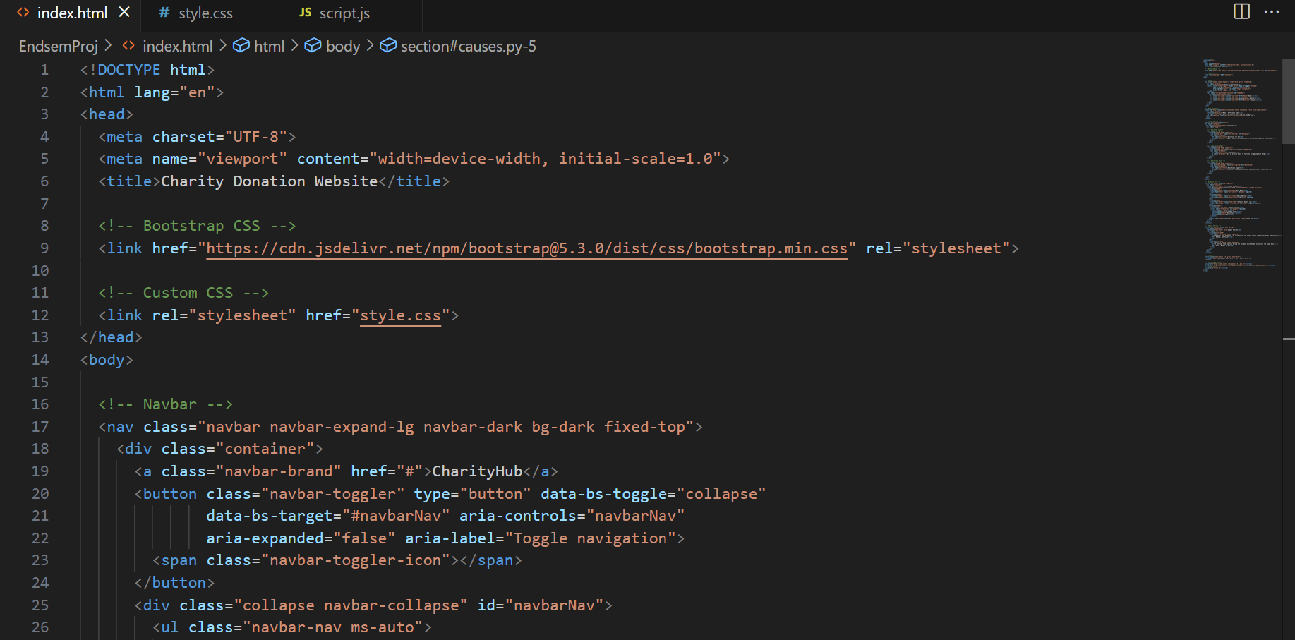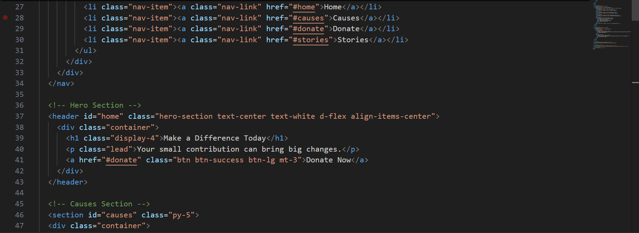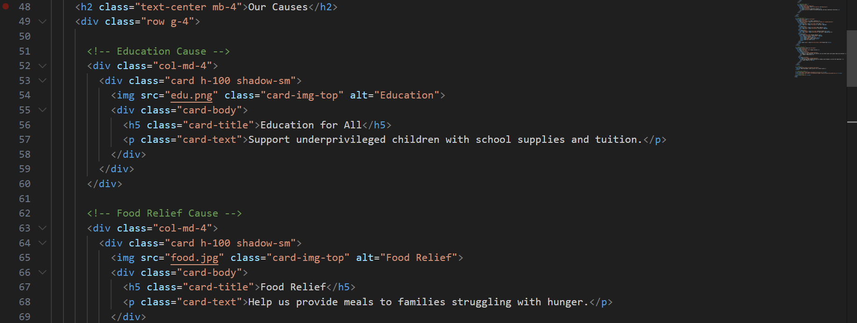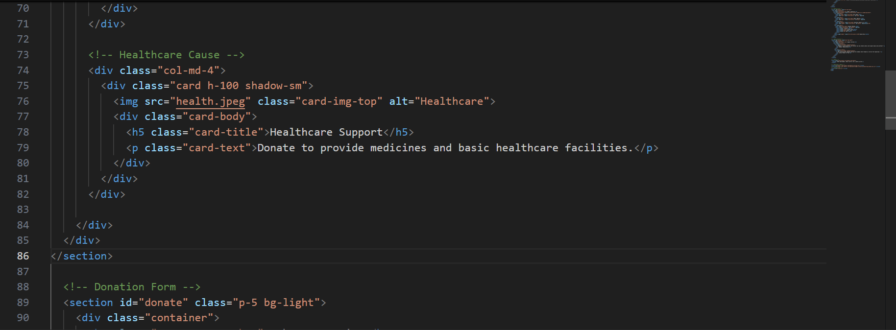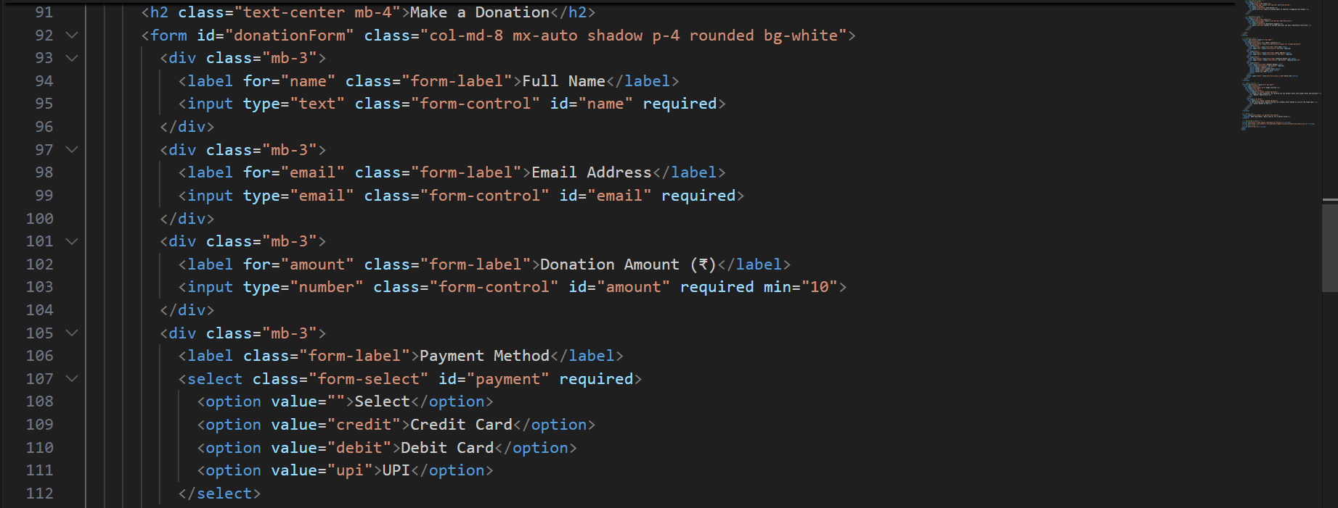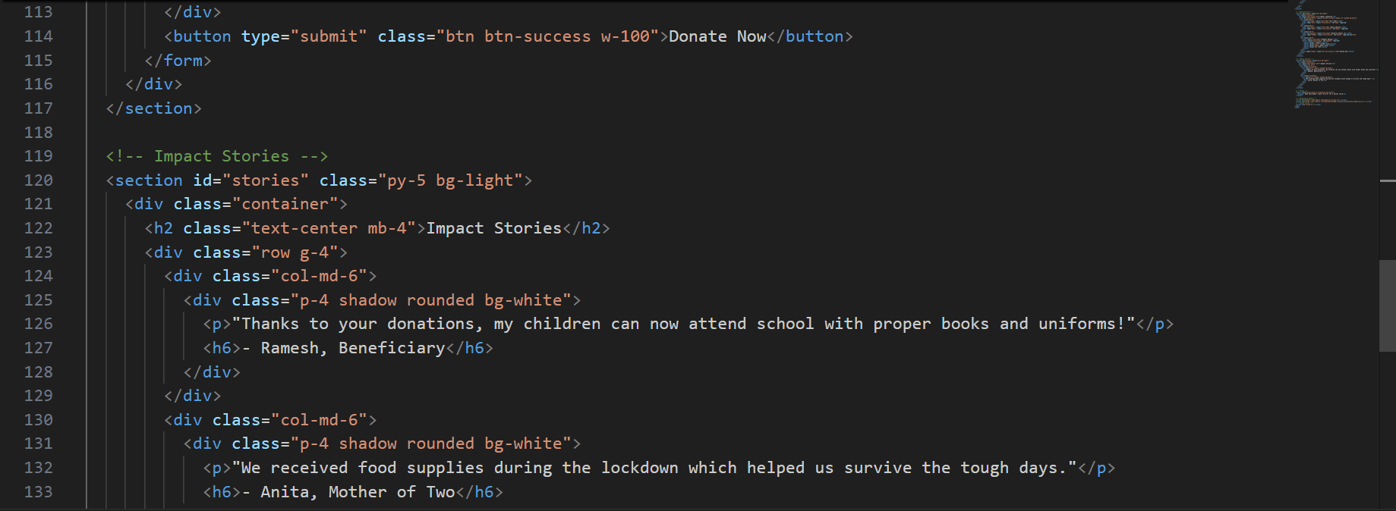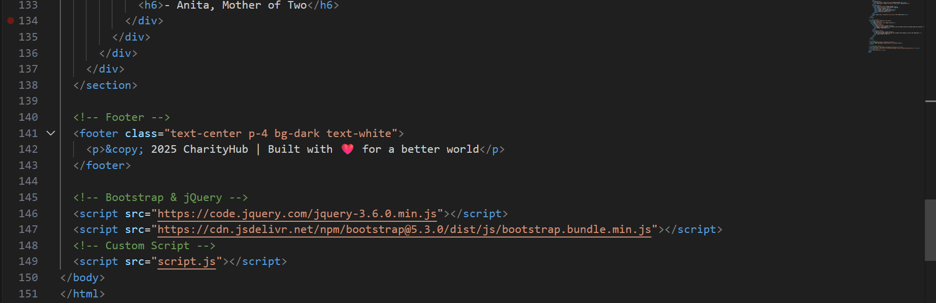

* **CSS Code:**

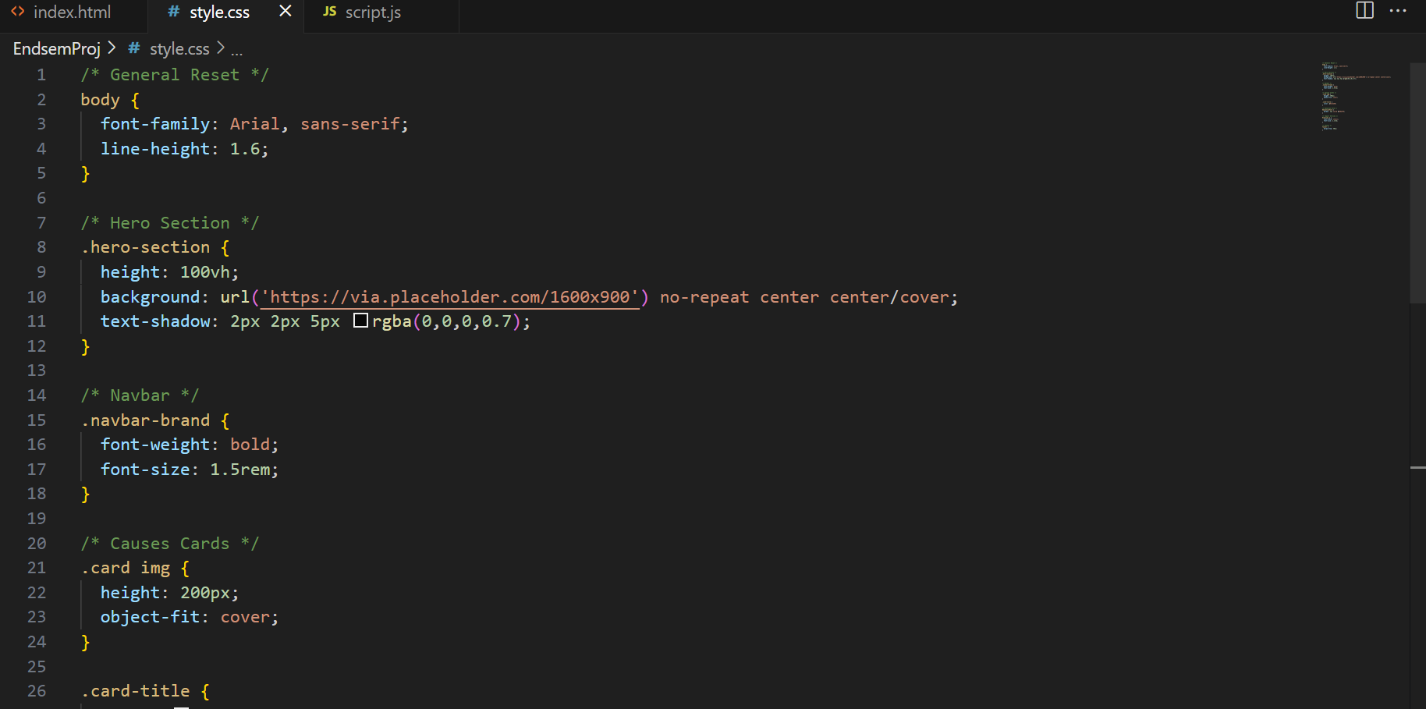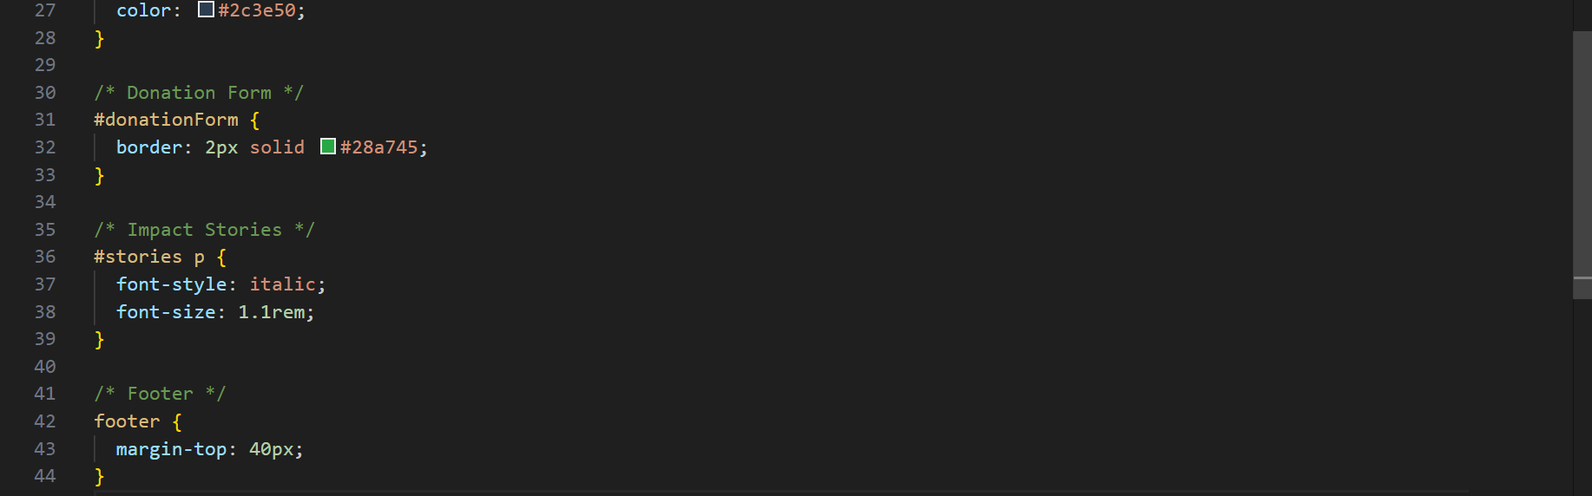

* **JavaScript Code:**

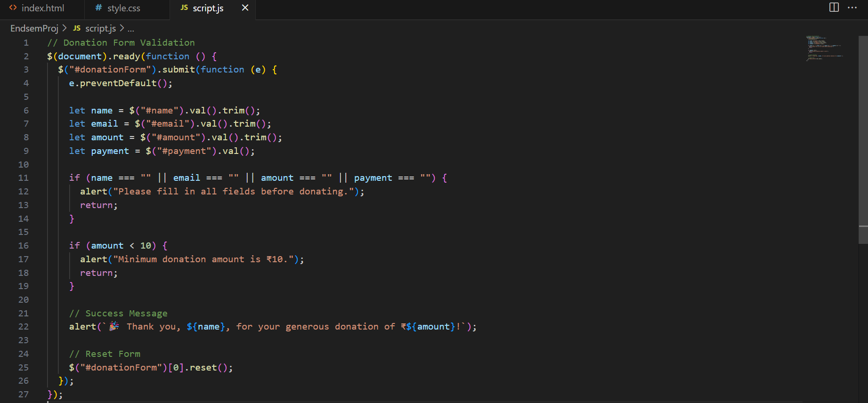

**16. Screenshots of Final Output Page :**

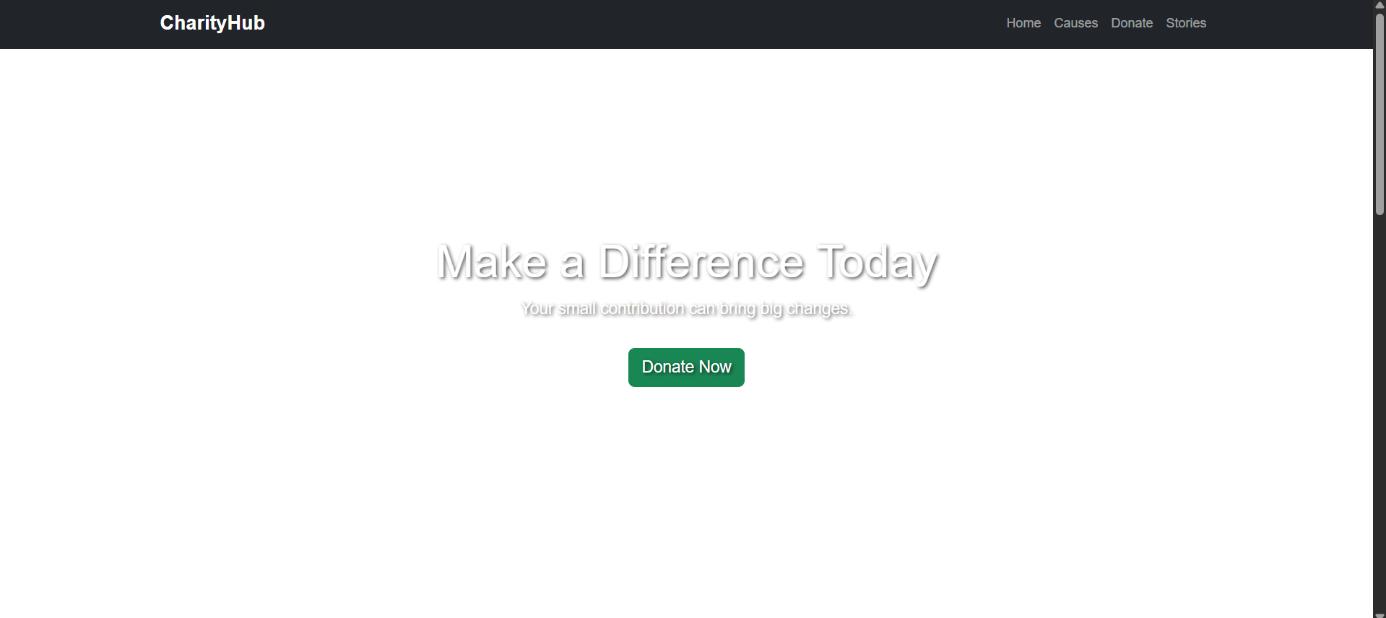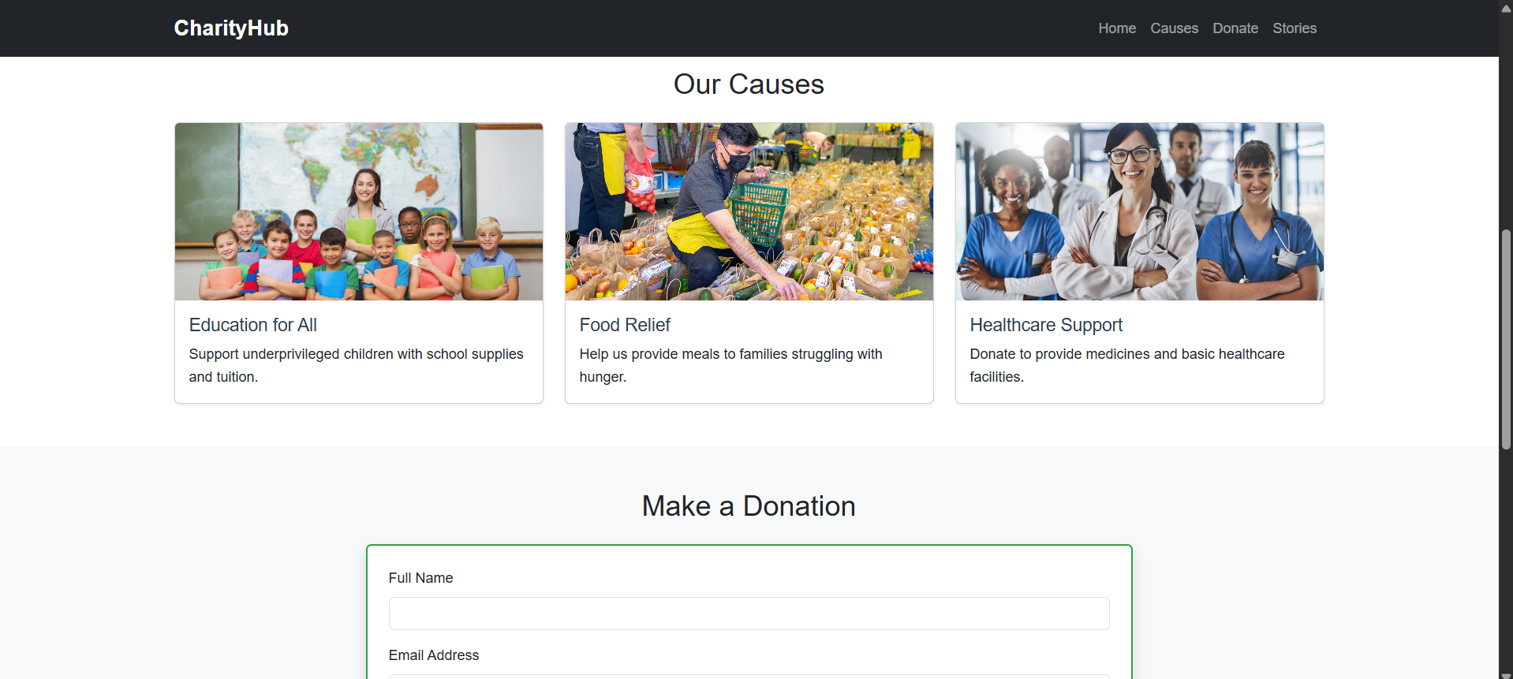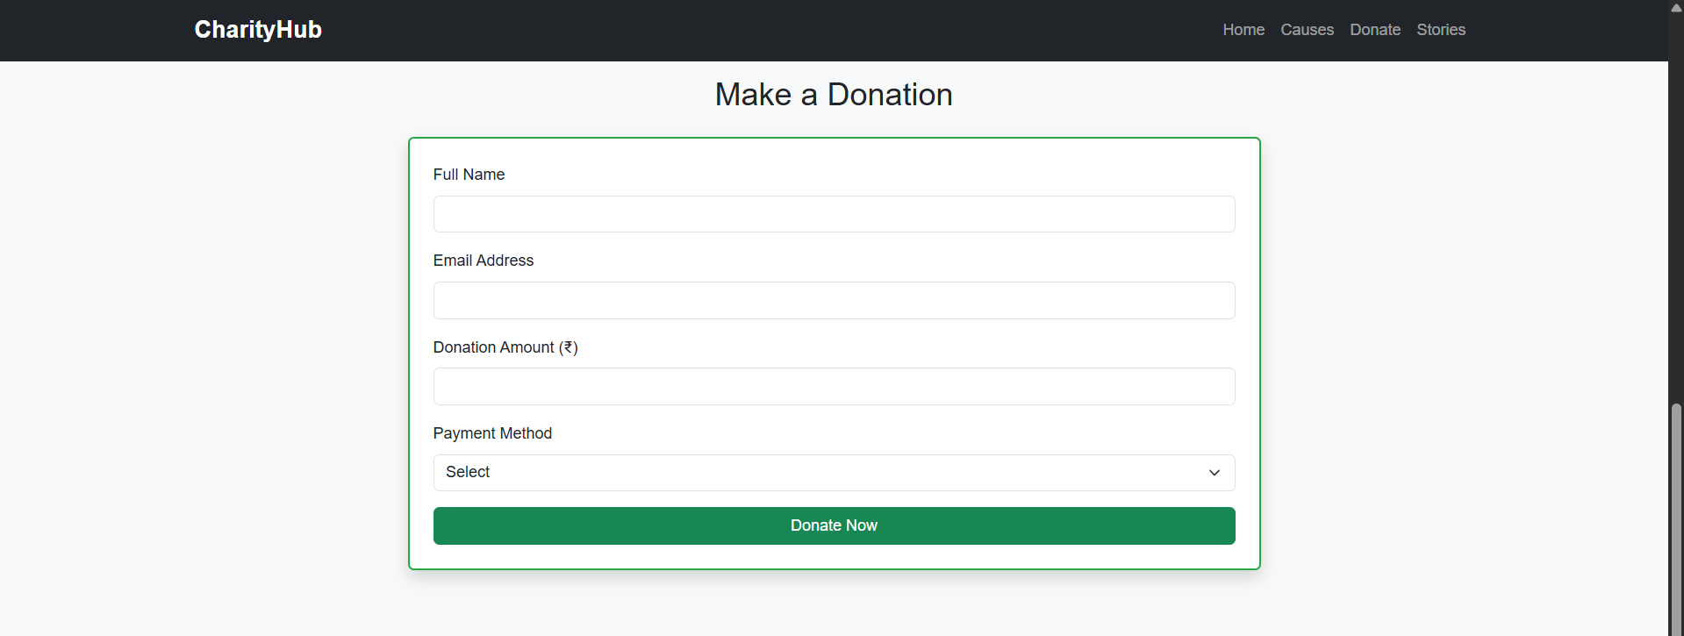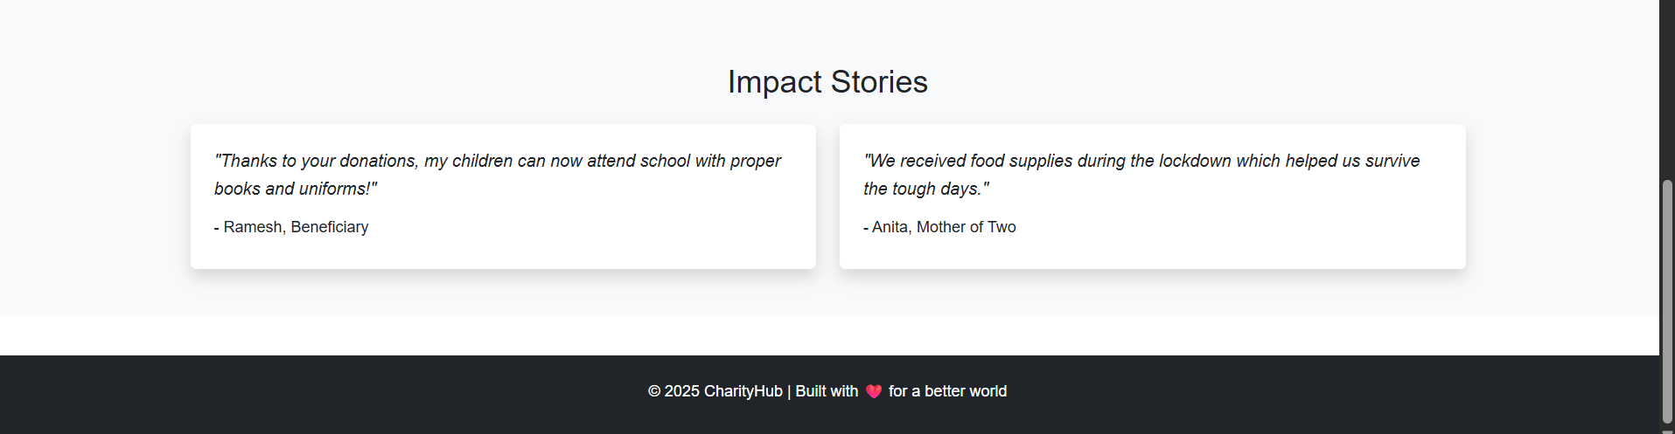

**17. Conclusion**

The Charity Donation Website project successfully demonstrates the use of front-end web technologies to create a responsive and user-friendly platform for online giving. Through this project, I enhanced my knowledge of HTML structure, Bootstrap layouts, CSS styling, and JavaScript/jQuery interactivity. The project reinforced the importance of responsive design and taught valuable lessons in layout structuring, accessibility, and user-centric design.

**18. References**

* L&T LMS: <https://learn.lntedutech.com/Landing/MyCours>
* Bootstrap Documentation: https://getbootstrap.com
* W3Schools HTML & CSS Guide: https://www.w3schools.com
* jQuery Documentation: https://api.jquery.com