

**Front - End UI/UX Mini Project**

**Virtual Art Exhibition Page**

1. **Introduction :**

* **Project Title:** *Virtual Art Exhibition Page*
* **Submitted By**: 
  + *2462324 – Deon Biju -* [*deon.biju@btech.christuniverityuniversity.in*](mailto:deon.biju@btech.christuniverityuniversity.in)
  + *2462357 - San Antony Saji -* [*san.antony@btech.christuniversity.in*](mailto:san.antony@btech.christuniversity.in)
  + *2462369 – Tom John Jimmy –* [*tom.john@btech.christuniversity.in*](mailto:tom.john@btech.christuniversity.in)
* **Course**:  *UI/UX Design Fundamentals*
* **Instructor Name**: *Mrs. Nagaveena*
* **Institution**:  *Christ (Deemed – to – be) University, Kengeri Campus*
* **Date of Submission**: *25/09/2025*

**2. Abstract**

This project aims to design and develop a Virtual Art Exhibition Page that allows artists to showcase their artworks in an online gallery. The system provides features like an art gallery grid, modal popups with detailed views, smooth image transitions, artist biography section, and filtering artworks by style or medium. The main goal is to simulate a real art exhibition experience in a digital format that is interactive, accessible, and responsive across devices. The project was built using HTML5, CSS3, Bootstrap, JavaScript, and jQuery. The final outcome is a responsive web page that enhances accessibility for artists and art enthusiasts worldwide.

**3. Objectives**

* Design a user-friendly, interactive interface simulating a real exhibition experience.
* Develop a responsive grid layout for displaying artworks.
* Implement modal popups to display full artwork with details.
* Add an artist biography section with introductions and portfolio links.
* Provide filter functionality by style or medium.
* Ensure smooth image transitions and responsive design across devices.

**4. Scope of the Project**

* Focused on front-end development only.
* No server-side backend or database integration included.
* Works across desktop, tablet, and mobile viewports.
* Uses open-source tools and libraries (Bootstrap, jQuery).
* Intended for use by artists, art enthusiasts, and institutions to display art virtually.

**5. Tools & Technologies Used**

|  |  |
| --- | --- |
| Tool/Technology | Purpose |
| HTML5 | Structure and content layout |
| CSS3 | Styling, layout, transitions |
| JavaScript | Interactivity, modal handling, filtering logic |
| Bootstrap | Responsive grid system and pre-built UI components |
| VS Code | Code editor |
| jQuery UI | Simplified DOM manipulation and animations |
| Chrome DevTools | Debugging and responsive testing |

**6. HTML Structure Overview**

* Used semantic tags: <header>, <nav>, <main>, <section>, <footer>.
* Sections created: Gallery Grid, Artist Bios, Filter Menu.
* Modal popups for artwork details structured with <div class="modal">.
* Navigation menu for switching between gallery and artist sections.

**7. CSS Styling Strategy**

* External CSS file (style.css) used for styling.
* Techniques used:
* Flexbox & Grid for artwork layout.
* Media Queries for responsiveness.
* CSS Transitions for hover effects on thumbnails.
* Bootstrap classes for modal popups and buttons.
* Theme consistency with fonts and colors for elegance.

**8. Key Features**

|  |  |
| --- | --- |
| Feature | Description |
| Art Gallery Grid | Displays thumbnails of all artworks in a structured layout |
| Modal View | Enlarged artwork with title, artist name, and description |
| Smooth Transitions | Navigation between artworks inside the modal |
| Filter by Style | Filter artworks by categories like Abstract, Watercolor, Digital |
| Artist Bio Section | Artist Bio Section |
| Responsive Design | Adapts beautifully to mobile, tablet, and desktop devices |

**12. Challenges Faced & Solutions**

|  |  |
| --- | --- |
| Challenge | Solution |
| Difficulty in aligning grid across devices | Used Bootstrap’s responsive grid system |
| Image stretching issues in modals | Applied object-fit: cover in CSS |
| Filter not updating dynamically | Implemented jQuery filtering with hide/show effects |
| Overlap of modal content on small screens | Applied media queries for font and layout adjustments |

**13. Outcomes**

* A clean, responsive, and visually engaging Virtual Art Exhibition Page was developed.
* Successfully integrated gallery grid, modal popups, and filter functionality.
* Achieved smooth user experience across all devices.
* Enhanced understanding of UI design, responsiveness, and interactivity.

**14. Future Enhancements**

* Add backend database to allow artists to upload artworks dynamically.
* Include user accounts for saving favorite artworks.
* Implement search bar for artworks by title/artist.
* Enable comments and feedback system.
* Add e-commerce integration for selling artworks online.
* Provide light/dark theme toggle for better personalization.

**15. Sample Code**

* **HTML code:** 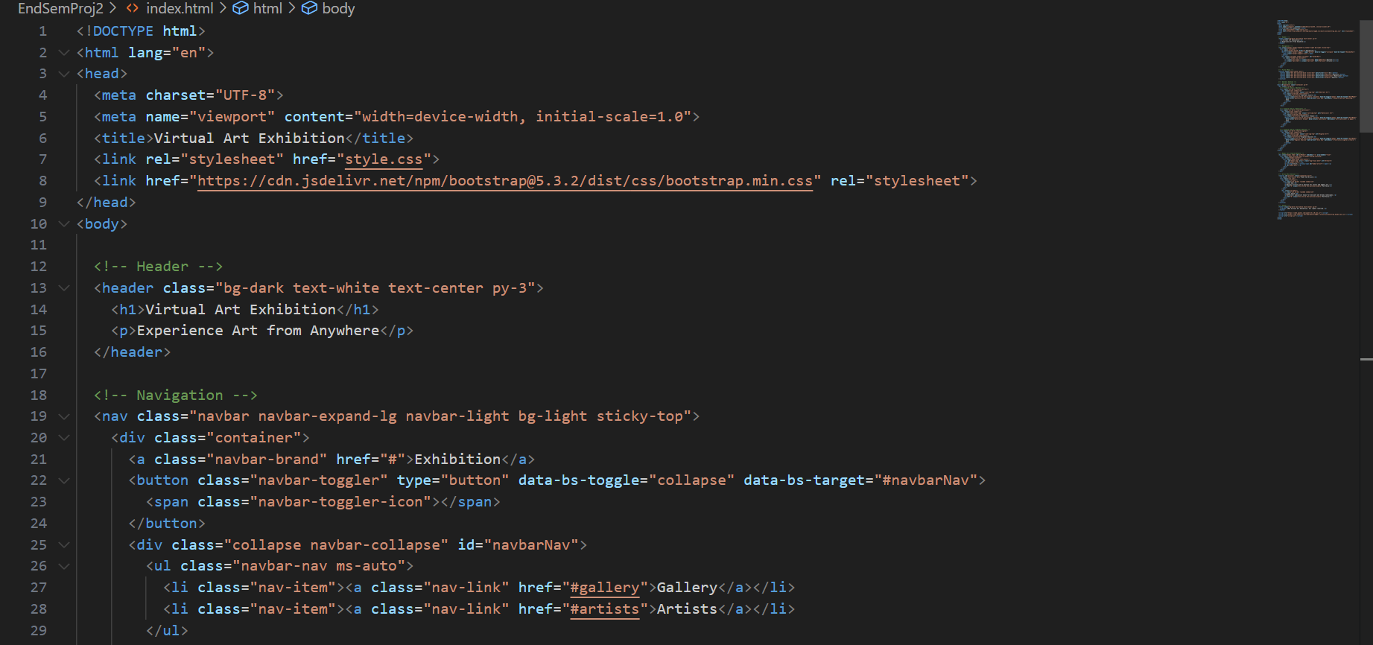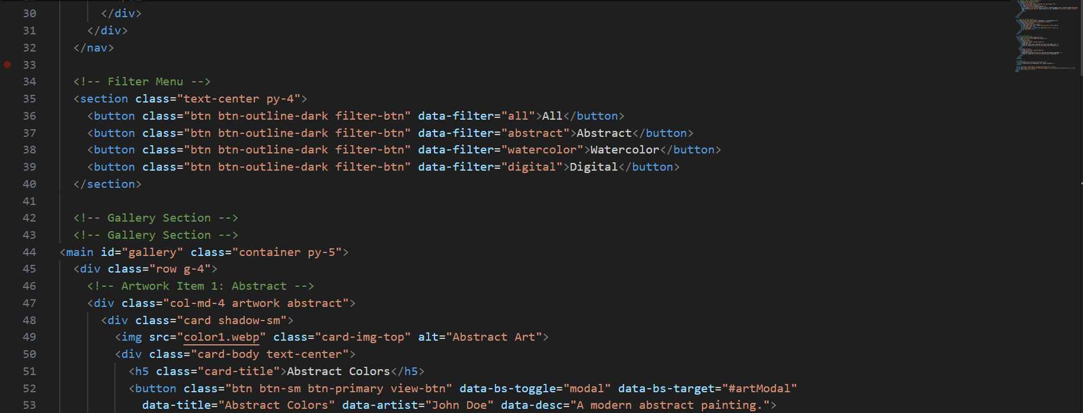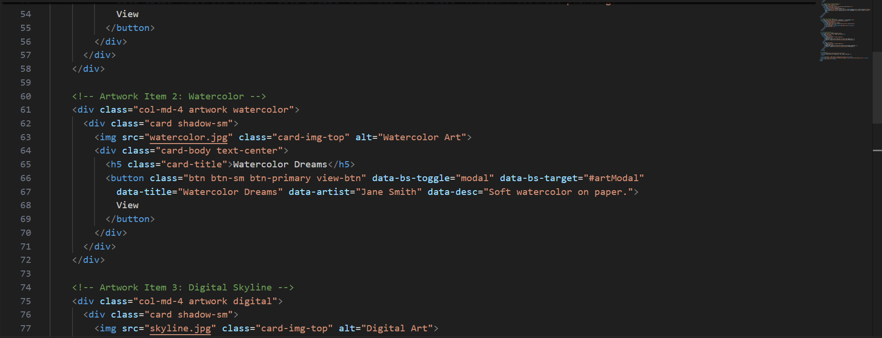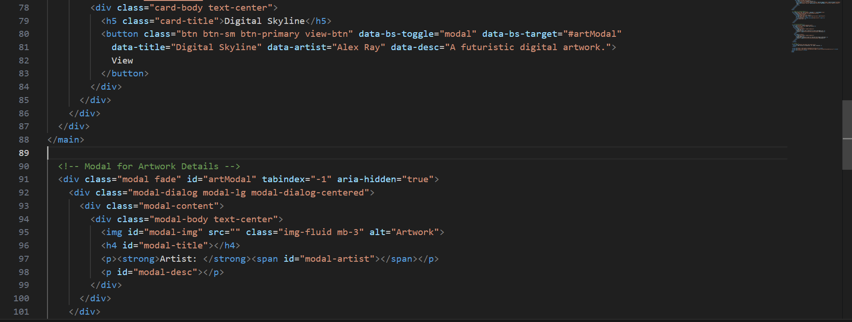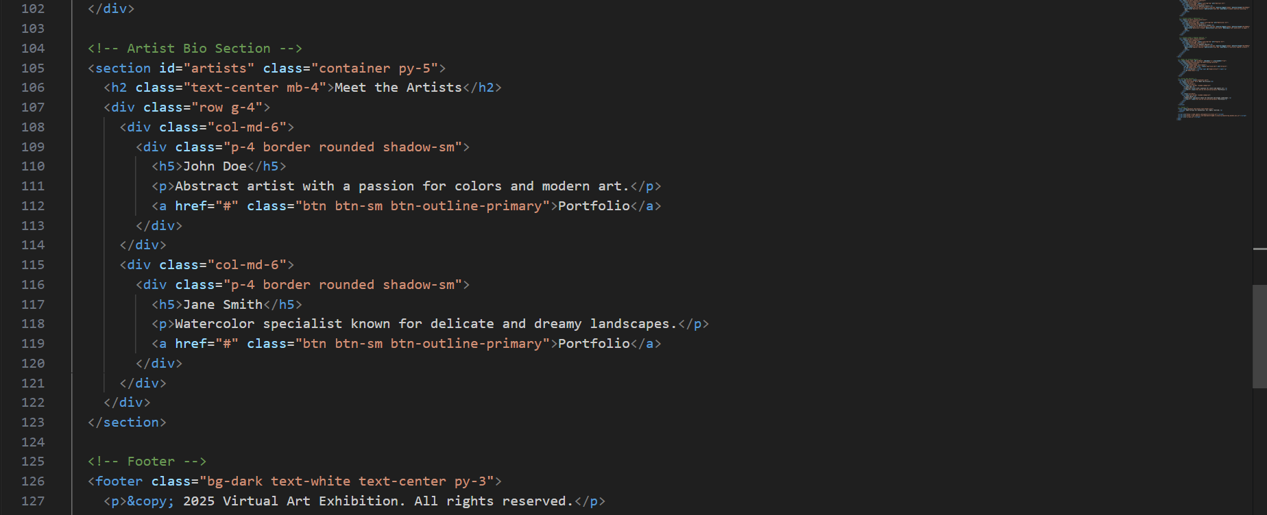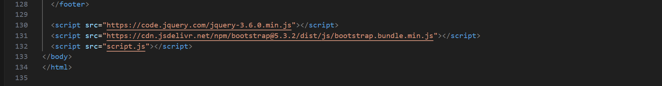
* **CSS Code:**

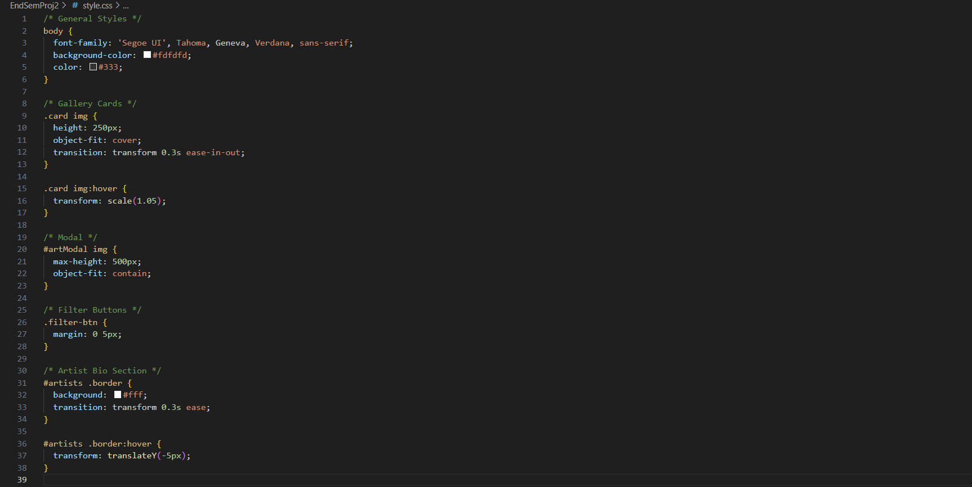

* **JavaScript Code:**

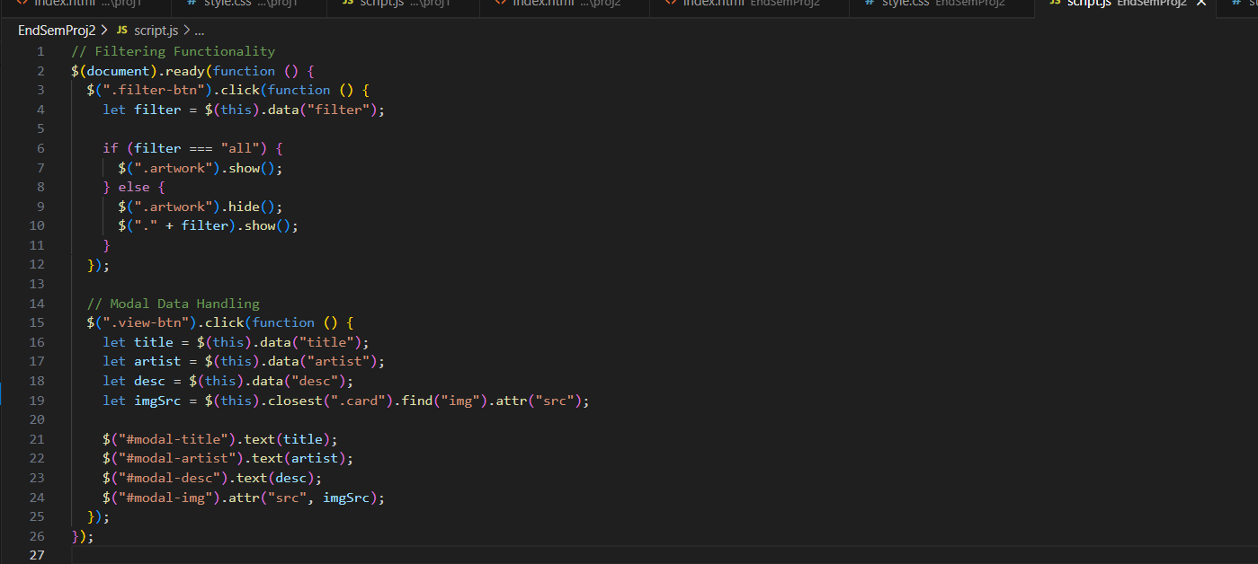

**16. Screenshots of Final Output Page :**

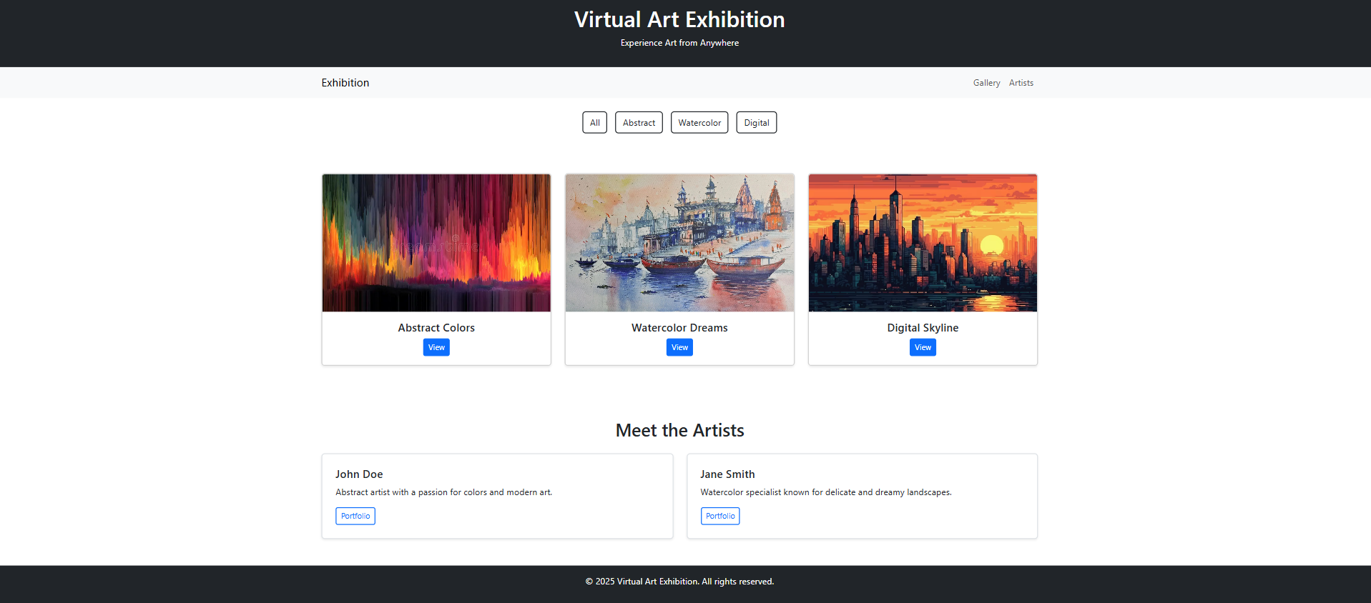

**17. Conclusion**

The Virtual Art Exhibition Page successfully simulates a real-world exhibition in an online environment. The project helped implement concepts of responsive web design, Bootstrap components, and jQuery interactivity. It enhanced practical skills in designing user-friendly, visually appealing interfaces. The outcome demonstrates how traditional exhibitions can be brought to a global audience using digital solutions.

**18. References**

* Bootstrap Documentation: https://getbootstrap.com/
* jQuery Documentation: https://jquery.com/
* W3Schools: https://www.w3schools.com/
* MDN Web Docs: https://developer.mozilla.org/