**SMART WATER MANAGEMENT**

**PROBLEM SOLUTION FIT:**



INTRODUTION:

Smart Water Management is the activity of planning, developing, distributing and managing the use of water resources using an array of IoT technologies which are designed to increase transparency, and make more reasonable and sustainable usage of these water resources.

It applies to multiple sectors: agriculture, farming, industry, services, cities… Monitoring water consumption in houses, checking water levels, checking the quality of drinking water, detecting chemical leakages in rivers around plants, tracking pressure variations along pipes or checking water quality in aquariums are a few examples of the many useful applications.

Microcontrollers and sensors —such as ultrasonic sensors, flow sensors, temperature, salinity, conductivity, humidity, pressure, or luminosity sensors— placed on pipes or pumps measure the water levels, flow, temperature and quality of the water in real time. Message alerts and data generated by the sensors are transmitted over the Internet to a cloud server, where it is processed, analyzed, sometimes with the help of AI, and sent to a terminal for the user to consult.   
The system can then control and regulate the usage and quality of water resources as well as facilitate the maintenance of the default equipment.

**IOT STARTUPS:**

SIGFOX:

Sigfox is a French global network operator founded in 2010 that built wireless networks to connect low-power objects such as electricity meters and smartwatches, which need to be continuously on and emitting small amounts of data. Sigfox is based in Labège near Toulouse, France, and had over 375 employees.

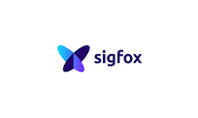

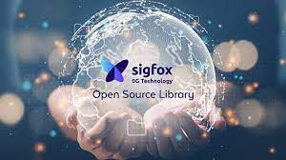

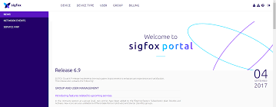

**SMART WATER LEAKAGE DETECTER:**

Smart leak detectors monitor the accurate condition of your assets. Some have audible alarms, while others use the Internet of Things (IoT) technology and wireless connectivity to send alerts in case of any leaks. These smart systems pinpoint the exact location of problems using water and temperature sensors.

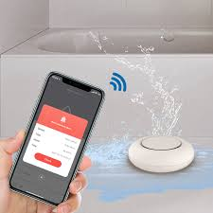

**STOP LEAKS:**

Smart water meters provide alerts for high water usage and suspected leaks. Acoustic Sensors: Highly sensitive acoustic sensors can detect even small leaks in service connections and distribution mains. Automatic Shut-off: Some meters can automatically shut off the water supply to prevent further leakage.



**SMART WATER MANAGEMENT PLATFORM:**

The SWAMP project is developing a high-precision smart irrigation system concept for agriculture. Within SWAMP, water management for agriculture is partitioned into three phases: water reserve, water distribution and water consumption. For Water Consumption SWAMP provides real-time responses for adapting irrigation as crop conditions change. On the other hand, changes in water distribution are performed in a longer timescale. Distribution and Consumption management systems are integrated, as water usage triggers water distribution. The management of water reserves is not considered.

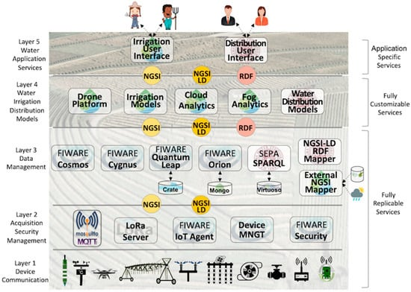

**CONCLUSION:**

The emergence of IoT is a phenomenon that owes to the conjunction of several factors and now starts to become real with huge effort both in research and business areas. In this context, the SWAMP project develops IoT-based methods for smart water management in precision irrigation, and pilots them in Italy, Spain, and Brazil. This paper introduced the SWAMP architecture, pilots and deployment scenarios for the four pilots using FIWARE as the underlying IoT platform.

A performance analysis of key FIWARE components personalized for each SWAMP pilot scenario was undertaken to understand the scalability limits of the system. The results show that this platform might be able to deal with the performance requirements of our pilots, even though requiring specially designed deployment configurations and the re-engineering of some components to provide higher scalability using less computational resources. Particularly, our experiments showed that MongoDB is CPU greedy, which negatively impacts system performance.

SWAMP is an ongoing project and therefore there are multiple paths for future work. Some examples are improving the platform deployment scenarios, reporting the overall working of the SWAMP approach in the pilots, including the experience with irrigation models and analytics and more advanced performance analysis.

**PROBLEM SOLUTION TEMPLATE:**

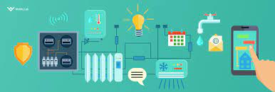

SYSTEMATIC REVIEW:

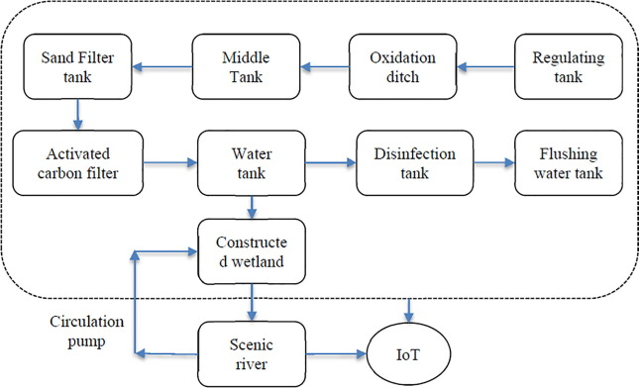

**SOLUTION ARCHITECTURE:**

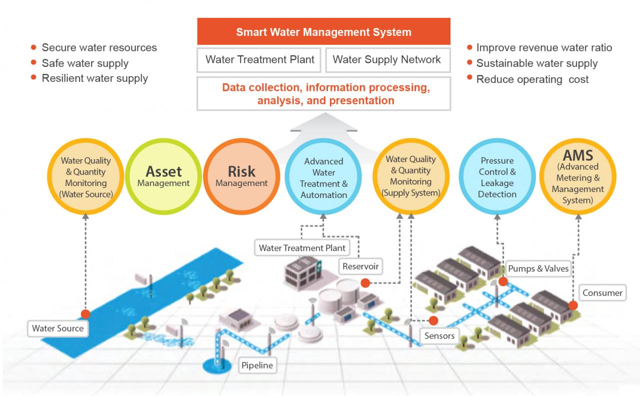

**CONCLUSION:**

This application will improve the water sustainability and management, as well as the policy of smart cities adequately adapted considering different constrains. The selected techniques and actions depend on the considered threshold, the capital investment, and the availability of techniques and equipment.