- What have we accomplished so far ?
Actors and RBAC Design
One of the early stages of Application or System development is identifying who develops the system and what are they allowed to do.
Understanding RBAC in OceanGuard:
Not all users should be given permissions for any interaction with the system. Instead, they should be given roles and specific permissions only.
So, Users are assigned with roles that has specific permissions which allows for system interaction.
Actors:
- Community Members :
Normal users like Resident, Tourists, Fishermen, Volunteer etc.
They interact with marine environments and contributes observations.
- Environmental Officer :
Governmental / Environmental Organization representative responsible for validating environmental incidents.
- Cleanup Coordinator :
Governmental / Charity / Environmental Organization representative responsible to convert verified environmental issues into actionable campaigns.
- Marine Biologist :
Researcher, Student or specific organization member studying marine patterns.
- System Administrator :
Admin responsible for maintaining security, configuration and data flow on the platform.

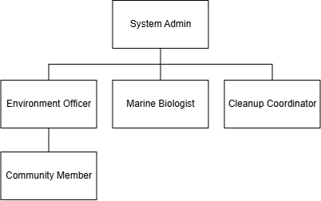
Fig : Role Hierarchy

RBAC Design Principle Used
The matrix follows the Least Privilege Principle:
- Community Members get only the permissions required for reporting and participation.
- Environmental Officers control validation and environmental decisions.
- Cleanup Coordinators manage operational cleanup activities only.
- Marine Biologists access research and analytical features.
- Administrators control governance and technical management.

System Architecture :
The three-tier architecture diagram represents the overall technical structure of OceanGuard. It follows a reliable software architecture pattern where the system is divided into three major layers:
- Presentation Layer (User Interface Layer)
- Logic / Application Layer (Backend Layer)
- Data Access Layer (Database + Analytics Layer
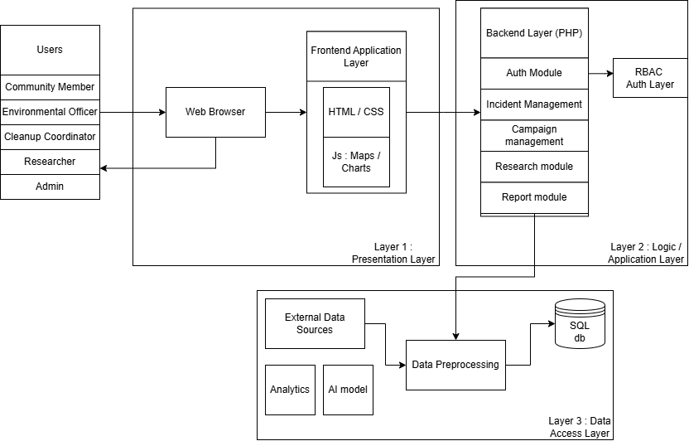
Fig : System Architecture for Ocean Guard
The Presentation Layer allows OceanGuard users to interact with the system. The Application Layer processes requests, applies business rules and manages workflows. The Data Access Layer stores OceanGuard information and integrates external marine datasets, analytics and AI services. Together, these three layers provide a scalable foundation for managing marine pollution monitoring, biodiversity analysis and environmental decision support.
Entity-relational Database :
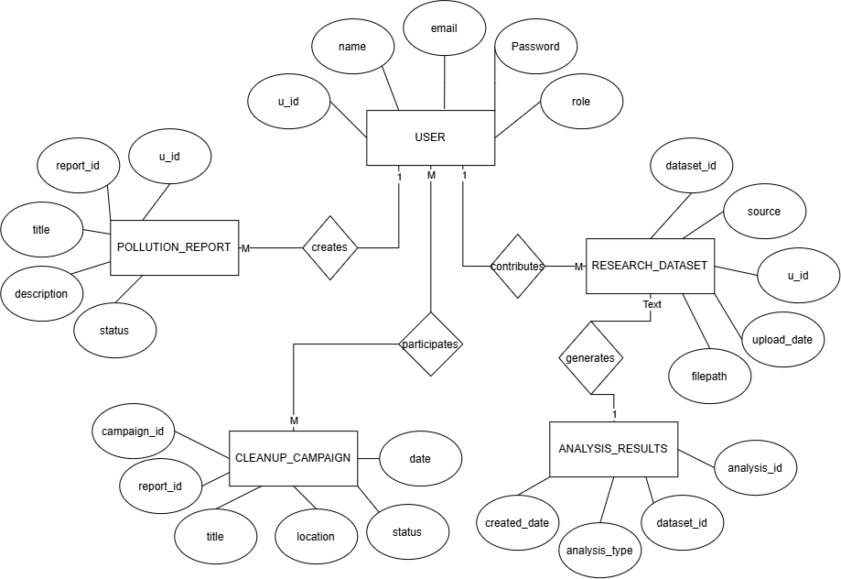
Fig : ERD for OceanGuard

- What are we working on until the next phase?
Before moving fully into Phase 3, we will focus on completing the remaining design review and preparing the foundation for development. This includes finalizing the database structure, confirming the relationships between tables, preparing the MySQL schema and planning the PHP project structure.
In coming phases of developing OceanGuard, we will begin implementation by creating the database connection, authentication system, user registration and login functionality, and role-based dashboards. We will also start developing the pollution reporting module where community members can submit environmental incidents and officers can review them. We will extend the system with environmental verification features, risk assessment, interactive maps, and integration of marine datasets such as OBIS and ocean condition data.

- What is getting in our way or keeping us from doing our job?
The main challenge currently is managing the scope of OceanGuard because the original idea represents a large-scale environmental management platform. Implementing every feature at a professional industry level would require much more time, resources and technical complexity than available in a twelve-week development period. Another challenge is the complexity of external marine datasets, as some datasets contain large volumes of scientific information and require specialised processing. Additionally, integrating AI into the system can become challenging because reliable environmental prediction models require large datasets and extensive training. These challenges could slow development and make the system difficult to complete within the given timeframe.
- What are the problems faced and how do we mitigate them?
S.N | Challenges | Description | Mitigation
1. | Large Scope Project | Possible features similar to a professional environmental platform. The application could have a lot of features than we could manage. | Minimizing the application scope to minimal viable product for the instance
2. | External Dataset Complexity | External datasets for the application are real-life dataset with is complex to understand. | No Integration of all raw data, instead using only minimal / optimal amount for the application
3. | Balancing requirements and implementations | The project needs to demonstrate AI, Data analytics, External datasets but these can become too large. | We treat the system as decision support system rather than fully automated decision making.
4. | Database Design Complexity | A marine management system naturally has many relationships and requires huge amount of tables. | Simplification of database tables to match for MVP

