# **Name- Sayandeep Dey (SupersetID:** **6363427)**

# **WEEK – 6 (Handson- Exercises)**

**React:**

**LAB-1:** **ReactJS-HOL:-**

### **Code:**

1. Running in terminal to check my node version: **node -v**
2. Running in terminal to check my npm version: **npm -v**
3. Running **npm install -g create-react-app** command
4. **npx create-react-app myfirstreact**
5. **cd myfirstreact**
6. change the whole **app.js** code with:

function App() {

  return (

    <div>

      <h1>Welcome to the first session of React</h1>

    </div>

  );

}

export default App;

1. **npm start to run:**

**Output:**

**LAB-2:** **ReactJS-HOL:-**

**Code:**

**Created a studentapp:**

npx create-react-app studentapp

**In Src:**

**Creating a Component named folder:**

**In Home.js:**

import React, { Component } from 'react';

class Home extends Component {

  constructor() {

    super();

  }

  render() {

    return (

      <div>

        <h2>Welcome to the Home page of Student Management Portal</h2>

      </div>

    );

  }

}

export default Home;

**In About.js:**

import React, { Component } from 'react';

class About extends Component {

  constructor() {

    super();

  }

  render() {

    return (

      <div>

        <h2>Welcome to the About page of the Student Management Portal</h2>

      </div>

    );

  }

}

export default About;

**In Contact.js:**

import React, { Component } from 'react';

class Contact extends Component {

  constructor() {

    super();

  }

  render() {

    return (

      <div>

        <h2>Welcome to the Contact page of the Student Management Portal</h2>

      </div>

    );

  }

}

export default Contact;

**In App.js:**

import React from 'react';

import Home from './Components/Home';

import About from './Components/About';

import Contact from './Components/Contact';

function App() {

  return (

    <div className="App">

      <Home />

      <About />

      <Contact />

    </div>

  );

}

export default App;

**Output:**

**npm start:**

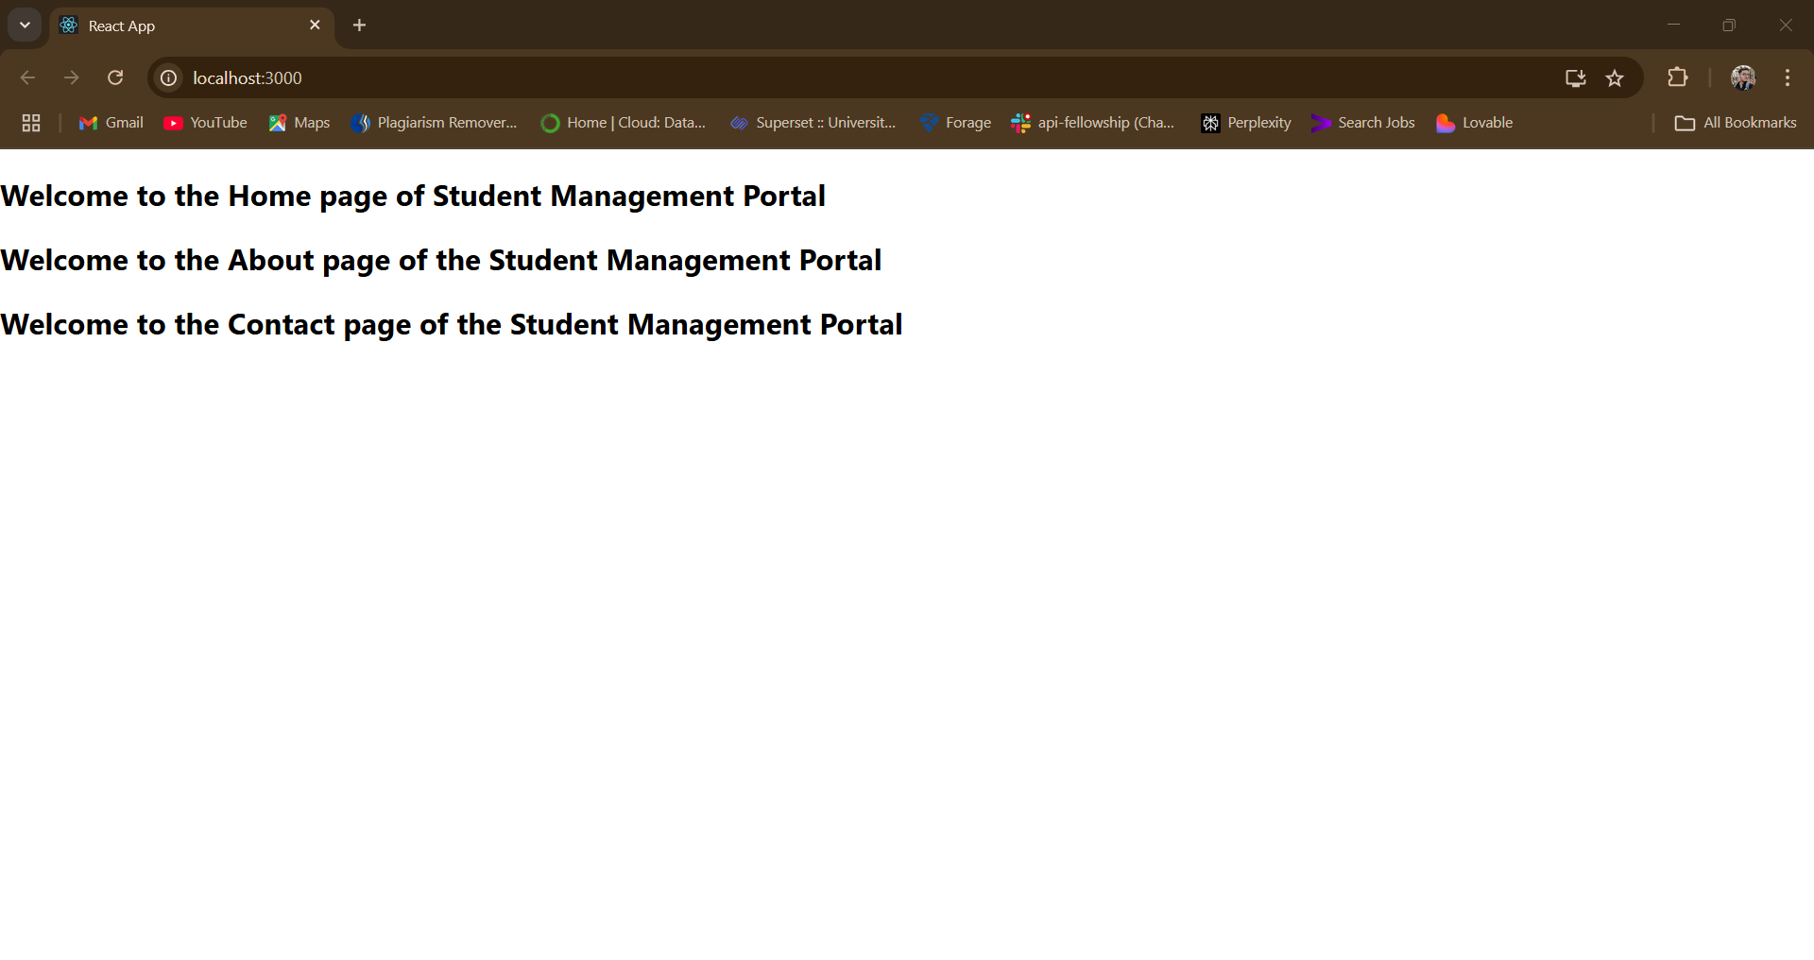

**LAB-3:** **ReactJS-HOL:-**

**Code:**

**npx create-react-app scorecalculatorapp:**

**cd scorecalculatorapp:**

**In Src:**

**In Components:**

**CalculateScore.js:**

import '../Stylesheets/mystyle.css';

const percentToDecimal = (decimal) => {

  return (decimal.toFixed(2) + '%');

};

const calcScore = (total, goal) => {

  return percentToDecimal(total / goal);

};

export const CalculateScore = ({ Name, School, total, goal }) => (

  <div className="formatstyle">

    <h1><font color="Brown">Student Details:</font></h1>

    <div className="Name">

      <b><span> Name: </span></b>

      <span>{Name}</span>

    </div>

    <div className="School">

      <b><span> School: </span></b>

      <span>{School}</span>

    </div>

    <div className="Total">

      <b><span> Total: </span></b>

      <span>{total}</span>

      <span> Marks</span>

    </div>

    <div className="Score">

      <b>Score: </b>

      <span>

        {calcScore(total, goal)}

      </span>

    </div>

  </div>

);

**In Stylesheets:**

**MyStyle.css:**

.Name {

  font-weight: 300;

  color: blue;

}

.School {

  color: crimson;

}

.Total {

  color: darkmagenta;

}

.formatstyle {

  text-align: center;

  font-size: large;

}

.Score {

  color: forestgreen;

}

**In App.js:**

import React from 'react';

import { CalculateScore } from './Components/CalculateScore';

function App() {

  return (

    <div>

      <CalculateScore

        Name="Sayandeep Dey"

        School="Taldangra Fulmati High School"

        total={440}

        goal={5}

      />

    </div>

  );

}

export default App;

**Output:**

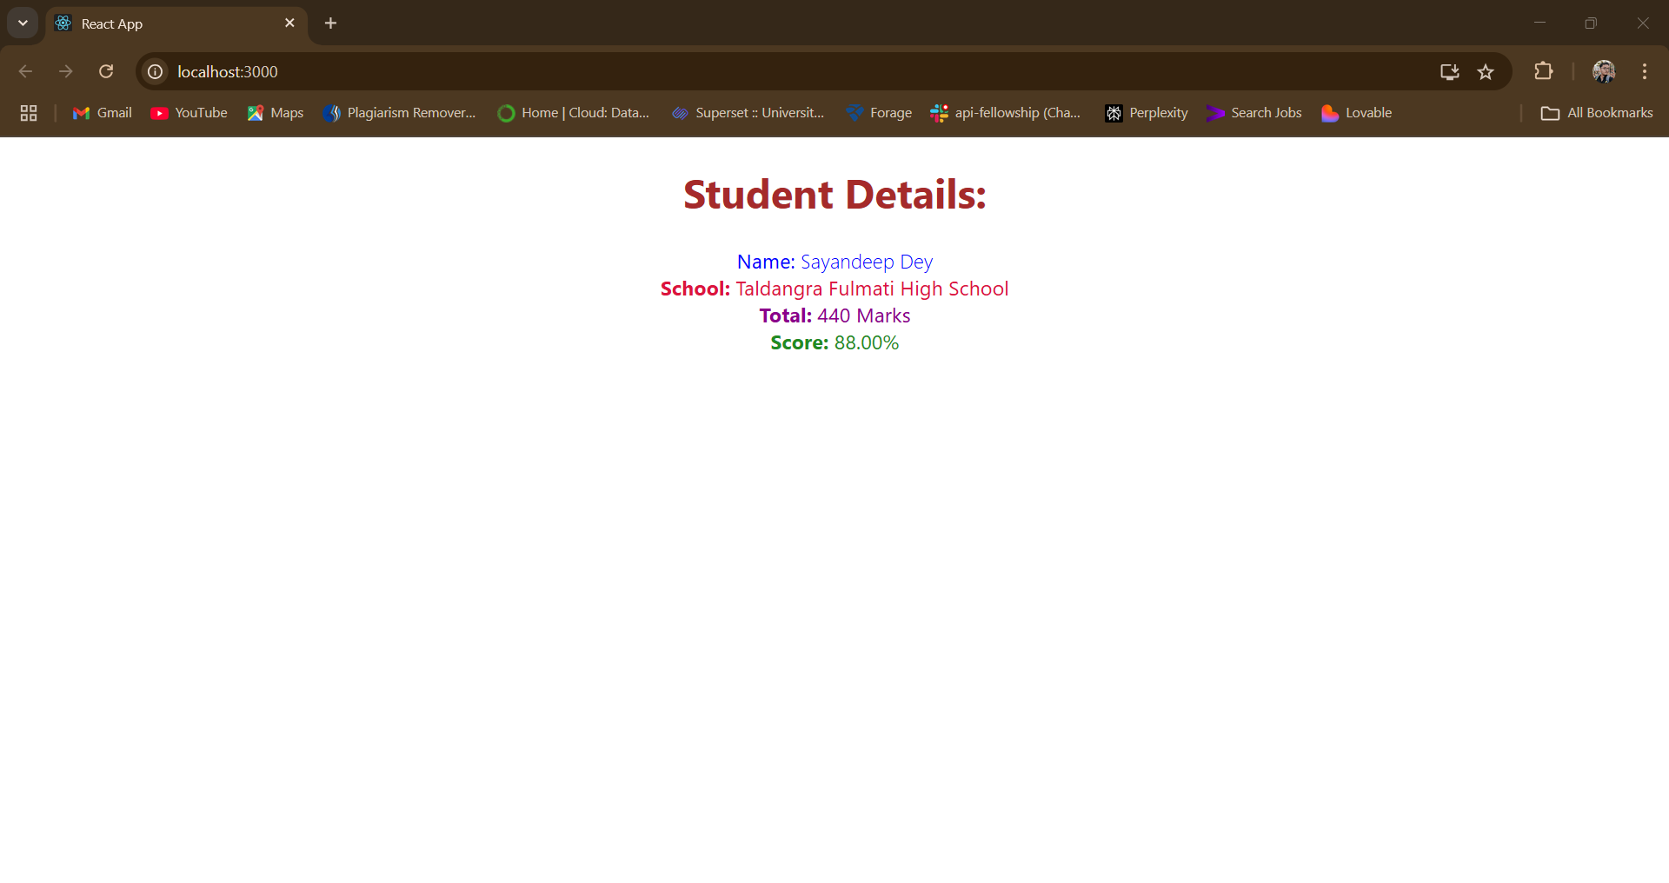

**LAB-4:ReactJS-HOL:-**

**Code:**

**npx create-react-app blogapp**

**cd blogapp**

**In SRC/ Post.js:**

class Post {

  constructor(id, title, body) {

    this.id = id;

    this.title = title;

    this.body = body;

  }

}

export default Post;

**In SRC/Posts.js:**

import React from 'react';

import Post from './Post';

class Posts extends React.Component {

  constructor(props) {

    super(props);

    this.state = {

      posts: [],

      error: null

    };

  }

  loadPosts() {

    fetch('https://jsonplaceholder.typicode.com/posts')

      .then(response => {

        if (!response.ok) throw new Error("Network response was not ok");

        return response.json();

      })

      .then(data => {

        const postList = data.map(post => new Post(post.id, post.title, post.body));

        this.setState({ posts: postList });

      })

      .catch(error => {

        this.setState({ error });

      });

  }

  componentDidMount() {

    this.loadPosts();

  }

  componentDidCatch(error, info) {

    alert('An error occurred: ' + error.message);

  }

  render() {

    const { posts, error } = this.state;

    return (

      <div>

        <h2>Blog Posts</h2>

        {error && <p style={{ color: 'red' }}>Error: {error.message}</p>}

        {posts.length > 0 ? (

          posts.map(post => (

            <div key={post.id}>

              <h3>{post.title}</h3>

              <p>{post.body}</p>

              <hr />

            </div>

          ))

        ) : (

          <p>Loading posts...</p>

        )}

      </div>

    );

  }

}

export default Posts;

**In App.js:**

import React from 'react';

import Posts from './Posts';

function App() {

  return (

    <div className="App">

      <Posts />

    </div>

  );

}

export default App;

**Output:**

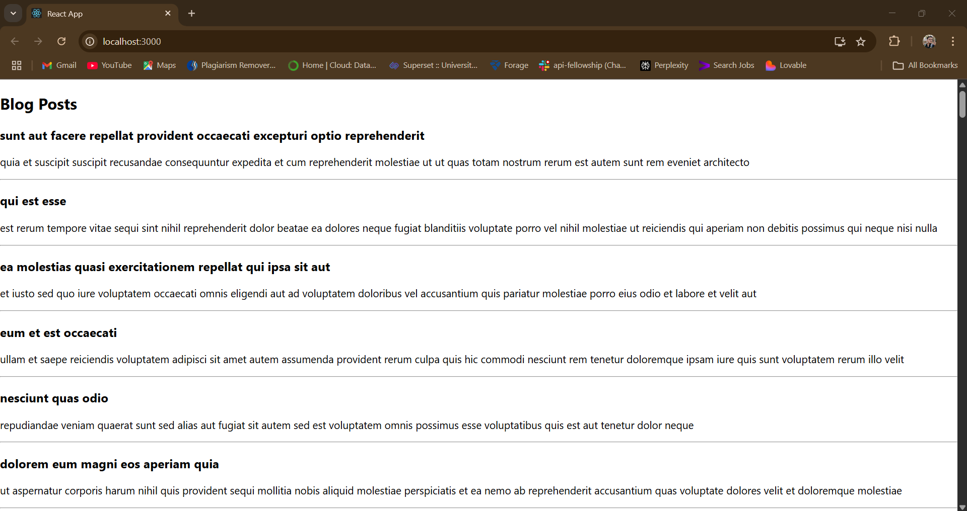

**LAB-5:ReactJS-HOL:-**

**Code:**

**In SRC/** **CohortDetails.module.css:**

.box {

  width: 300px;

  display: inline-block;

  margin: 10px;

  padding: 10px 20px;

  border: 1px solid black;

  border-radius: 10px;

}

dt {

  font-weight: 500;

}

**In CohortDetails.js:**

import React from 'react';

import styles from './CohortDetails.module.css'; // CSS Module import

function CohortDetails(props) {

  const { cohort } = props;

  // Set h3 color based on status

  const headingStyle = {

    color: cohort.currentStatus.toLowerCase() === 'ongoing' ? 'green' : 'blue'

  };

  return (

    <div className={styles.box}>

      <h3 style={headingStyle}>

        {cohort.cohortCode} - <span>{cohort.technology}</span>

      </h3>

      <dl>

        <dt>Started On</dt>

        <dd>{cohort.startDate}</dd>

        <dt>Current Status</dt>

        <dd>{cohort.currentStatus}</dd>

        <dt>Coach</dt>

        <dd>{cohort.coachName}</dd>

        <dt>Trainer</dt>

        <dd>{cohort.trainerName}</dd>

      </dl>

    </div>

  );

}

export default CohortDetails;

**In App.js:**

import logo from './logo.svg';

import './App.css';

import { CohortsData} from './Cohort'

import CohortDetails from './CohortDetails';

function App() {

  return (

  <div>

    <h1>Cohorts Details</h1>

    {CohortsData.map(cohort => <CohortDetails cohort={cohort}/>)}

  </div>

  );

}

export default App;

**Output:**

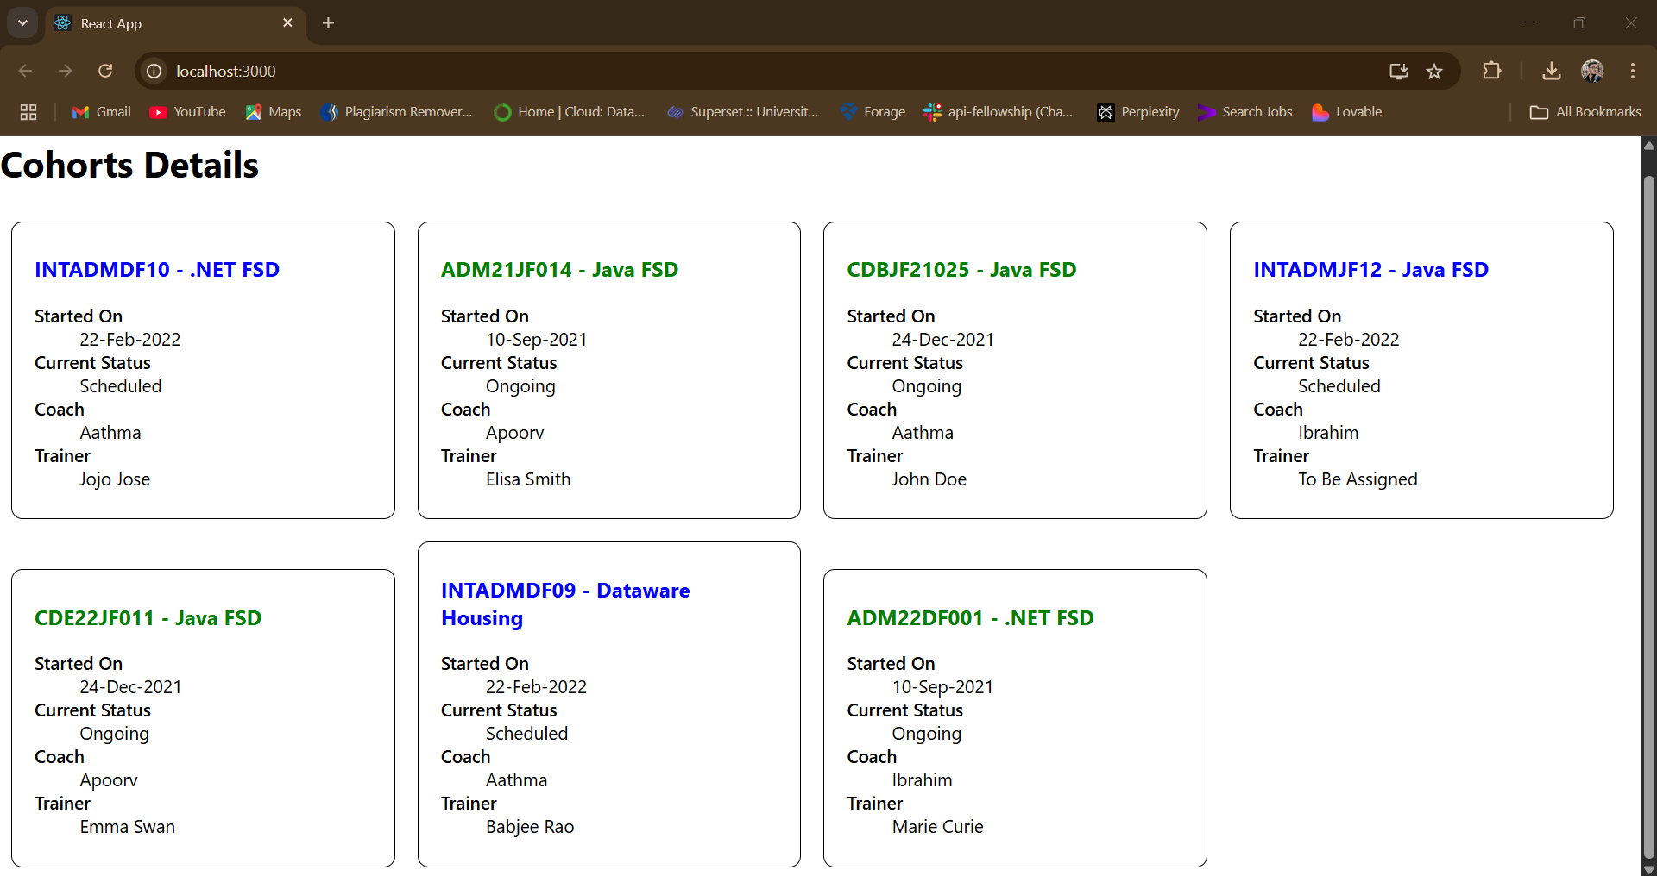

**LAB-6 :ReactJS-HOL(Extra):-**

**Code:**

**In SRC/Trainer.js:**

class Trainer {

  constructor(trainerId, name, email, phone, technology, skills) {

    this.trainerId = trainerId;

    this.name = name;

    this.email = email;

    this.phone = phone;

    this.technology = technology;

    this.skills = skills;

  }

}

export default Trainer;

**In SRC/TrainersMock.js:**

import Trainer from "./Trainer";

const trainersMock = [

  new Trainer('t-syed8', 'Syed Khaleelullah', 'khaleelullah@cognizant.com', '97676516962', '.NET', ['C#', 'SQL Server', 'React', '.NET Core']),

  new Trainer('t-jojo', 'Jojo Jose', 'jojo@cognizant.com', '9897199231', 'Java', ['Java', 'JSP', 'Angular', 'Spring']),

  new Trainer('t-elisa', 'Elisa Jones', 'elisa@cognizant.com', '9871212235', 'Python', ['Python', 'Django', 'Angular']),

];

export default trainersMock;

**In SRC/Home.js:**

function Home() {

  return (

    <div>

      <h2>Welcome to My Academy trainers page</h2>

    </div>

  );

}

export default Home;

**In SRC/TrainerList.js:**

import { Link } from 'react-router-dom';

import trainersMock from './TrainersMock';

function TrainerList() {

  return (

    <div>

      <h2>Trainers List</h2>

      <ul>

        {trainersMock.map(trainer => (

          <li key={trainer.trainerId}>

            <Link to={`/trainer/${trainer.trainerId}`}>{trainer.name}</Link>

          </li>

        ))}

      </ul>

    </div>

  );

}

export default TrainerList;

**In SRC/TrainerDetails.js:**

import { useParams } from 'react-router-dom';

import trainersMock from './TrainersMock';

function TrainerDetails() {

  const { id } = useParams();

  const trainer = trainersMock.find(t => t.trainerId === id);

  if (!trainer) {

    return <h2>Trainer not found.</h2>;

  }

  return (

   <div className="trainer-detail">

  <h2>Trainers Details</h2>

  <h3>{trainer.name} ({trainer.technology})</h3>

  <p>{trainer.email}</p>

  <p>{trainer.phone}</p>

  <ul>

    {trainer.skills.map((skill, index) => (

      <li key={index}>{skill}</li>

    ))}

  </ul>

</div>

  );

}

export default TrainerDetails;

**In SRC/AppStyle.css:**

body {

  font-family: 'Segoe UI', Tahoma, Geneva, Verdana, sans-serif;

  background-color: #f8f9fa;

  margin: 0;

  padding: 0;

}

.app-container {

  max-width: 800px;

  margin: 20px auto;

  background: #ffffff;

  border-radius: 10px;

  padding: 20px;

  box-shadow: 0 0 10px rgba(0, 0, 0, 0.1);

}

nav {

  margin-bottom: 20px;

}

nav a {

  margin-right: 20px;

  text-decoration: none;

  color: #007bff;

  font-weight: bold;

}

nav a:hover {

  text-decoration: underline;

}

h1 {

  color: #343a40;

  text-align: center;

}

h2 {

  color: #495057;

  border-bottom: 2px solid #dee2e6;

  padding-bottom: 5px;

  margin-bottom: 20px;

}

ul {

  list-style-type: none;

  padding: 0;

}

ul li {

  padding: 10px 0;

}

ul li a {

  color: #212529;

  font-size: 16px;

  text-decoration: none;

}

ul li a:hover {

  color: #0d6efd;

}

.trainer-detail {

  background-color: #f1f3f5;

  padding: 15px;

  border-radius: 8px;

}

.trainer-detail h3 {

  color: #198754;

}

.trainer-detail p {

  margin: 6px 0;

}

.trainer-detail ul {

  margin-top: 10px;

}

.trainer-detail ul li {

  background: #e9ecef;

  padding: 5px 10px;

  border-radius: 5px;

  margin-bottom: 5px;

  display: inline-block;

  margin-right: 5px;

}

**In SRC/App.js:**

import { BrowserRouter, Routes, Route, Link } from 'react-router-dom';

import Home from './Home';

import TrainerList from './TrainerList';

import TrainerDetails from './TrainerDetails';

import './AppStyles.css';

function App() {

  return (

    <BrowserRouter>

      <div className="app-container">

        <h1>My Academy Trainers App</h1>

        <nav>

          <Link to="/">Home</Link> | <Link to="/trainers">Show Trainers</Link>

        </nav>

        <Routes>

          <Route path="/" element={<Home />} />

          <Route path="/trainers" element={<TrainerList />} />

          <Route path="/trainer/:id" element={<TrainerDetails />} />

        </Routes>

      </div>

    </BrowserRouter>

  );

}

export default App;

**Output:**

**Home page:**

**Show Trainers:**

**Clicked On Jojo Jose:**

**LAB-7 :ReactJS-HOL(Extra):-**

**Code:**

**In SRC/Cart.js:**

import React from 'react';

import './App.css';

class Cart extends React.Component {

  render() {

    return (

      <table className="cart-table">

        <thead>

          <tr>

            <th>Name</th>

            <th>Price (₹)</th>

          </tr>

        </thead>

        <tbody>

          {this.props.item.map((item, index) => (

            <tr key={index}>

              <td>{item.itemname}</td>

              <td>{item.price}</td>

            </tr>

          ))}

        </tbody>

      </table>

    );

  }

}

export default Cart;

**In SRC/OnlineShopping.js:**

import React from 'react';

import Cart from './Cart';

import './App.css';

class OnlineShopping extends React.Component {

  render() {

    const CartInfo = [

      { itemname: "Laptop", price: 80000 },

      { itemname: "TV", price: 120000 },

      { itemname: "Washing Machine", price: 50000 },

      { itemname: "Mobile", price: 30000 },

      { itemname: "Fridge", price: 70000 }

    ];

    return (

      <div className="container-box">

        <h1 className="green-heading">Items Ordered :</h1>

        <Cart item={CartInfo} />

      </div>

    );

  }

}

export default OnlineShopping;

**In SRC/App.js:**

import React from 'react';

import './App.css';

import OnlineShopping from './OnlineShopping';

function App() {

  return (

    <div className="App">

      <OnlineShopping />

    </div>

  );

}

export default App;

**In SRC/App.css:**

body {

  font-family: Arial, sans-serif;

  background-color: #f8f9fa;

}

.container-box {

  max-width: 600px;

  margin: 50px auto;

  padding: 20px 30px;

  background-color: #ffffff;

  border: 2px solid #dee2e6;

  border-radius: 12px;

  box-shadow: 0px 2px 8px rgba(0, 0, 0, 0.1);

}

.green-heading {

  color: green;

  text-align: center;

  margin-bottom: 20px;

}

.cart-table {

  width: 100%;

  border-collapse: collapse;

}

.cart-table th,

.cart-table td {

  border: 1px solid #dee2e6;

  padding: 10px;

  text-align: center;

}

.cart-table th {

  background-color: #f1f1f1;

}

**Output:**

**LAB-8 :ReactJS-HOL(Extra):-**

**Code:**

**In Src/CountPeople.js:**

import React from "react";

class CountPeople extends React.Component {

  constructor(props) {

    super(props);

    this.state = {

      entrycount: 0,

      exitcount: 0,

    };

  }

  UpdateEntry = () => {

    this.setState((prevState) => ({

      entrycount: prevState.entrycount + 1,

    }));

  };

  UpdateExit = () => {

    this.setState((prevState) => ({

      exitcount: prevState.exitcount + 1,

    }));

  };

  render() {

    return (

      <div style={{ textAlign: "center", marginTop: "100px" }}>

        <div style={{ display: "flex", justifyContent: "center", gap: "50px" }}>

          <div>

            <button

              onClick={this.UpdateEntry}

              style={{

                backgroundColor: "lightgreen",

                border: "1px solid green",

                padding: "8px 16px",

                marginRight: "10px",

              }}

            >

              Login

            </button>

            <span style={{ fontWeight: "bold" }}>

              {this.state.entrycount} People Entered!!!

            </span>

          </div>

          <div>

            <button

              onClick={this.UpdateExit}

              style={{

                backgroundColor: "lightgreen",

                border: "1px solid green",

                padding: "8px 16px",

                marginRight: "10px",

              }}

            >

              Exit

            </button>

            <span style={{ fontWeight: "bold" }}>

              {this.state.exitcount} People Left!!!

            </span>

          </div>

        </div>

      </div>

    );

  }

}

export default CountPeople;

**In SRC/App.js:**

import React from "react";

import CountPeople from "./CountPeople";

function App() {

  return (

    <div>

      <CountPeople />

    </div>

  );

}

export default App;

**Output:**

