# **Name- Sayandeep Dey (SupersetID:** **6363427)**

# **WEEK – 7 (Handson- Exercises)**

**React:**

**LAB-9:** **ReactJS-HOL:-**

### **Code:**

**In Components/ListOfPlayers.js:**

import React from 'react';

const ListofPlayers = () => {

  const players = [

    { name: "Virat", score: 99 },

    { name: "Rohit", score: 45 },

    { name: "Dhoni", score: 88 },

    { name: "Rahul", score: 80 },

    { name: "Jadeja", score: 34 },

    { name: "Gill", score: 71 },

    { name: "Surya", score: 56 },

    { name: "Shami", score: 23 },

    { name: "Bumrah", score: 90 },

    { name: "Pandya", score: 60 },

    { name: "Kuldeep", score: 44 }

  ];

  const below70 = players.filter(p => p.score < 70);

  return (

    <div style={{ border: '2px solid black', padding: '20px', margin: '20px' }}>

      <h2>All Players</h2>

      {players.map((player, index) => (

        <p key={index}>{player.name} - {player.score}</p>

      ))}

      <h3>Players with Score below 70</h3>

      {below70.map((player, index) => (

        <p key={index}>{player.name} - {player.score}</p>

      ))}

    </div>

  );

};

export default ListofPlayers;

**In Components/IndianPlayers.js:**

import React from 'react';

const IndianPlayers = () => {

  const T20players = ["Kohli", "Rohit", "Surya"];

  const RanjiPlayers = ["Pujara", "Iyer", "Ashwin"];

  const allPlayers = [...T20players, ...RanjiPlayers];

  const oddTeam = allPlayers.filter((_, i) => i % 2 === 0);

  const evenTeam = allPlayers.filter((_, i) => i % 2 !== 0);

  return (

    <div style={{ border: '4px solid green', padding: '40px', margin: '40px' }}>

      <h2>All Indian Players</h2>

      {allPlayers.map((name, index) => (

        <p key={index}>{name}</p>

      ))}

      <h3>Odd Team Players</h3>

      {oddTeam.map((name, index) => (

        <p key={index}>{name}</p>

      ))}

      <h3>Even Team Players</h3>

      {evenTeam.map((name, index) => (

        <p key={index}>{name}</p>

      ))}

    </div>

  );

};

export default IndianPlayers;

**In App.js:**

import React from 'react';

import ListofPlayers from './components/ListofPlayers';

import IndianPlayers from './components/IndianPlayers';

function App() {

  const flag = true; // change this to false to see IndianPlayers component

  return (

    <div>

      <h1 style={{ textAlign: "center" }}>Welcome to Cricket App</h1>

      {flag ? <ListofPlayers /> : <IndianPlayers />}

    </div>

  );

}

export default App;

**Output:**

**When Flag = true;**

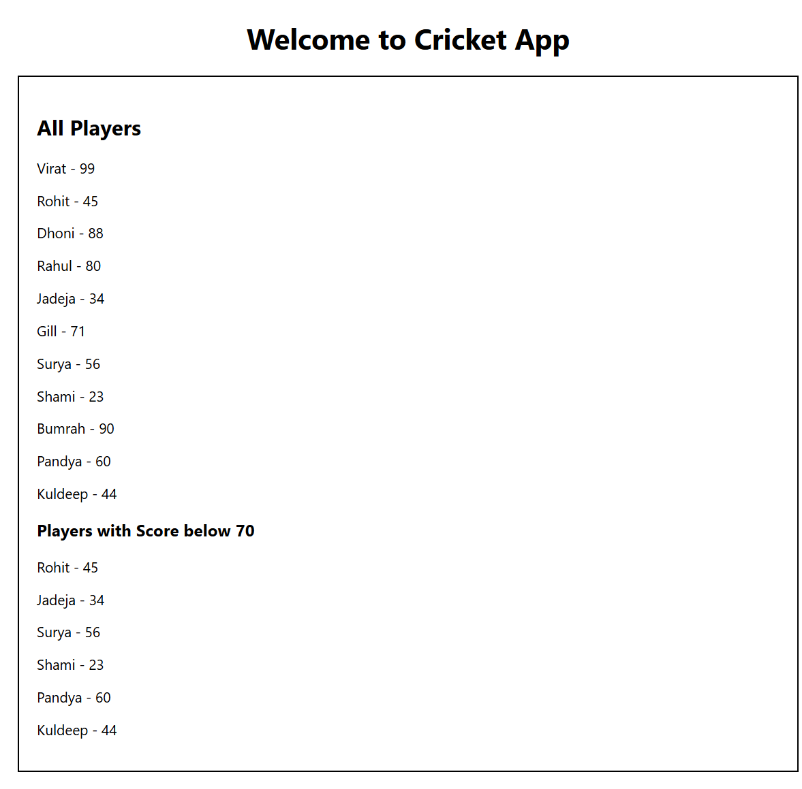

**When flag = false;**

**LAB-10:** **ReactJS-HOL:-**

**Code:**

**In SRC/App.js:**

import React from "react";

function App() {

  const heading = <h1 style={{ textAlign: "center" }}>Office Space Rentals</h1>;

  const officeImage = "https://officebanao.com/wp-content/uploads/2024/05/bright-office-interior-with-city-view-1200x675.jpg";

  const officeList = [

    {

      name: "Tech Park",

      rent: 50000,

      address: "Bangalore"

    },

    {

      name: "Cyber Tower",

      rent: 75000,

      address: "Hyderabad"

    },

    {

      name: "Eco Space",

      rent: 60000,

      address: "Chennai"

    },

    {

      name: "Business Bay",

      rent: 85000,

      address: "Pune"

    }

  ];

  const rentStyle = (rent) => {

    return {

      color: rent < 60000 ? "red" : "green",

      fontWeight: "bold"

    };

  };

  return (

    <div style={{ padding: "20px", fontFamily: "Arial" }}>

      {heading}

      <div style={{ textAlign: "center", marginBottom: "20px" }}>

        <img src={officeImage} alt="Office" width="400" height="200" />

      </div>

      <h2 style={{ textDecoration: "underline" }}>Available Office Spaces:</h2>

      {officeList.map((office, index) => (

        <div

          key={index}

          style={{

            border: "1px solid black",

            padding: "15px",

            margin: "10px 0",

            borderRadius: "10px"

          }}

        >

          <p>

            <strong>Name:</strong> {office.name}

          </p>

          <p>

            <strong>Rent:</strong>{" "}

            <span style={rentStyle(office.rent)}>{office.rent}</span>

          </p>

          <p>

            <strong>Address:</strong> {office.address}

          </p>

        </div>

      ))}

    </div>

  );

}

export default App;

**Output:**

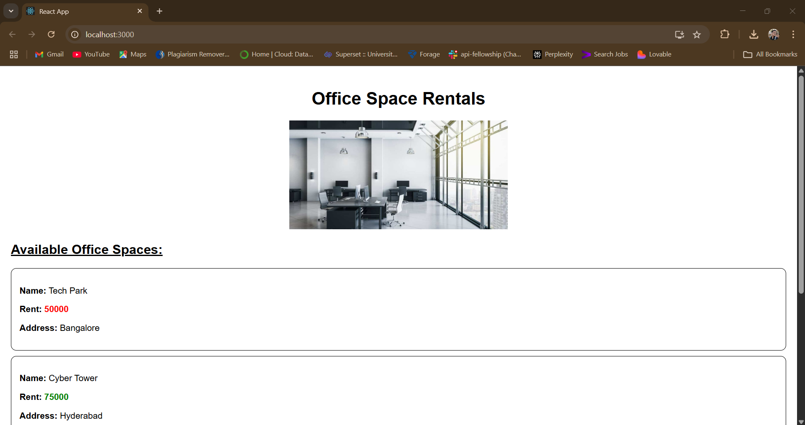

**LAB-11:** **ReactJS-HOL:-**

**Code:**

**In SRC/App.js:**

import React, { Component } from "react";

import CurrencyConvertor from "./components/CurrencyConvertor";

class App extends Component {

  constructor(props) {

    super(props);

    this.state = {

      count: 0,

    };

  }

  increment = () => {

    this.setState({ count: this.state.count + 1 });

  };

  sayHello = () => {

    alert("Hello! This is an increment message.");

  };

  handleMultiple = () => {

    this.increment();

    this.sayHello();

  };

  decrement = () => {

    this.setState({ count: this.state.count - 1 });

  };

  sayWelcome = (message) => {

    alert(`Say Welcome: ${message}`);

  };

  handleSynthetic = (event) => {

    event.preventDefault();

    alert("I was clicked");

  };

  render() {

    return (

      <div style={{ padding: "30px", fontFamily: "Arial" }}>

        <h1>React Event Handling Lab</h1>

        <h2>Counter: {this.state.count}</h2>

        <button onClick={this.handleMultiple}>Increase</button>{" "}

        <button onClick={this.decrement}>Decrease</button>

        <hr />

        <h2>Say Welcome Button</h2>

        <button onClick={() => this.sayWelcome("Welcome")}>Say Welcome</button>

        <hr />

        <h2>Synthetic Event Example</h2>

        <button onClick={this.handleSynthetic}>OnPress</button>

        <hr />

        <CurrencyConvertor />

      </div>

    );

  }

}

export default App;

**In Components/CurrencyConvertor.js:**

import React, { Component } from "react";

class CurrencyConvertor extends Component {

  constructor(props) {

    super(props);

    this.state = {

      rupees: "",

      euro: "",

    };

  }

  handleChange = (event) => {

    this.setState({ rupees: event.target.value });

  };

  handleSubmit = (event) => {

    event.preventDefault();

    const euroValue = (this.state.rupees / 90).toFixed(2); // assuming 1 euro = 90 INR

    this.setState({ euro: euroValue });

  };

  render() {

    return (

      <div style={{ marginTop: "30px" }}>

        <h2>Currency Convertor (INR → Euro)</h2>

        <form onSubmit={this.handleSubmit}>

          <input

            type="number"

            placeholder="Enter amount in ₹"

            value={this.state.rupees}

            onChange={this.handleChange}

          />{" "}

          <button type="submit">Convert</button>

        </form>

        {this.state.euro && (

          <h3>Converted Amount: €{this.state.euro}</h3>

        )}

      </div>

    );

  }

}

export default CurrencyConvertor;

**Output:**

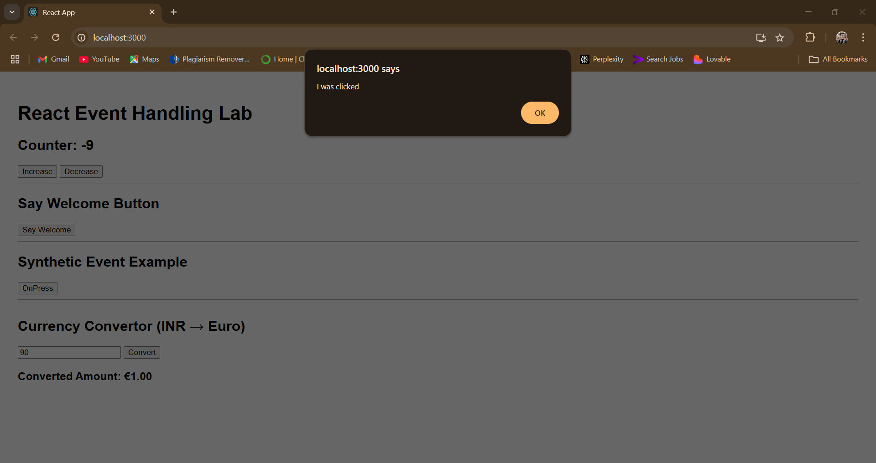

**LAB-12 :ReactJS-HOL:-**

**Code:**

**In Components/GuestPage.js:**

import React from "react";

const GuestPage = () => {

  return (

    <div style={{ padding: "20px", border: "1px solid black" }}>

      <h2>Welcome, Guest!</h2>

      <p>You can browse available flights but must log in to book tickets.</p>

      <h3>Available Flights:</h3>

      <ul>

        <li>Flight A - Delhi to Mumbai</li>

        <li>Flight B - Bangalore to Kolkata</li>

        <li>Flight C - Chennai to Hyderabad</li>

      </ul>

    </div>

  );

};

export default GuestPage;

**In Components/UserPage.js:**

import React from "react";

const UserPage = () => {

  return (

    <div style={{ padding: "20px", border: "1px solid green" }}>

      <h2>Welcome, User!</h2>

      <p>You are logged in. You can book your flight tickets below.</p>

      <h3>Book Your Flight:</h3>

      <ul>

        <li>Flight A - <button>Book Now</button></li>

        <li>Flight B - <button>Book Now</button></li>

        <li>Flight C - <button>Book Now</button></li>

      </ul>

    </div>

  );

};

export default UserPage;

**In App.js:**

import React, { Component } from "react";

import GuestPage from "./Components/GuestPage";

import UserPage from "./Components/UserPage";

class App extends Component {

  constructor(props) {

    super(props);

    this.state = {

      isLoggedIn: false,

    };

  }

  handleLogin = () => {

    this.setState({ isLoggedIn: true });

  };

  handleLogout = () => {

    this.setState({ isLoggedIn: false });

  };

  render() {

    const { isLoggedIn } = this.state;

    let pageContent;

    if (isLoggedIn) {

      pageContent = <UserPage />;

    } else {

      pageContent = <GuestPage />;

    }

    return (

      <div style={{ padding: "20px", fontFamily: "Arial" }}>

        <h1>Ticket Booking App</h1>

        {isLoggedIn ? (

          <button onClick={this.handleLogout}>Logout</button>

        ) : (

          <button onClick={this.handleLogin}>Login</button>

        )}

        <hr />

        {pageContent}

      </div>

    );

  }

}

export default App;

**Output:**

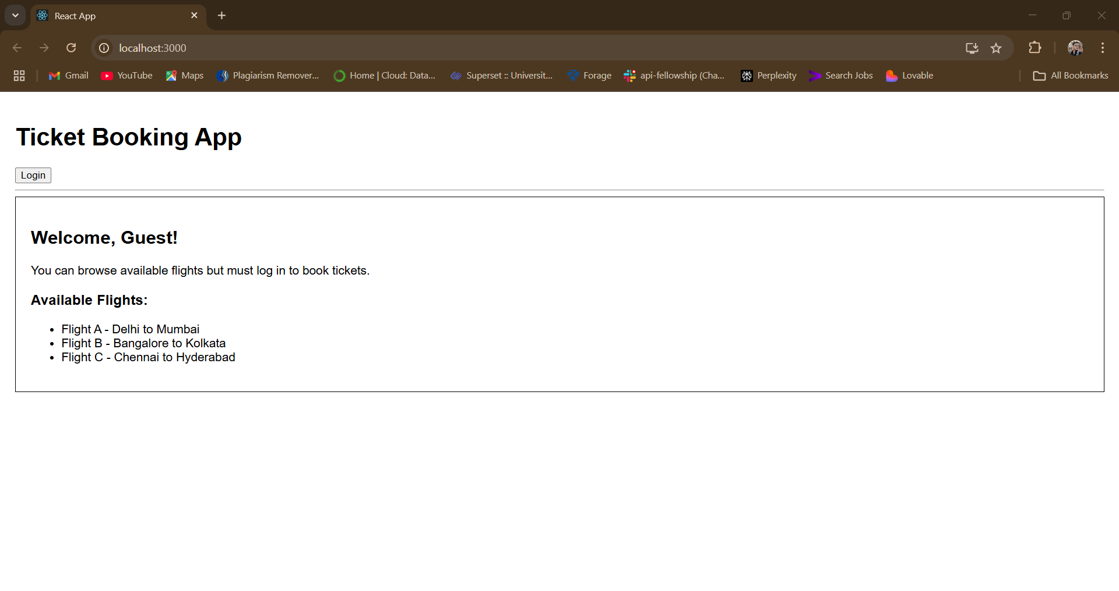

**LAB-13 :ReactJS-HOL:-**

**Code:**

**In Components/BookDetails.js:**

import React from "react";

function BookDetails() {

  const books = [

    { title: "Master React", price: 670 },

    { title: "Deep Dive into Angular 11", price: 800 },

    { title: "Mongo Essentials", price: 450 }

  ];

  return (

    <div style={{ flex: 1, borderRight: "3px solid green", padding: "0 20px" }}>

      <h2>Book Details</h2>

      {books.map((book, i) => (

        <div key={i}>

          <strong>{book.title}</strong>

          <p>{book.price}</p>

        </div>

      ))}

    </div>

  );

}

export default BookDetails;

**In Components/BlogDetails.js:**

import React from "react";

function BlogDetails() {

  const blogs = [

    {

      title: "React Learning",

      author: "Stephen Biz",

      content: "Welcome to learning React!"

    },

    {

      title: "Installation",

      author: "Schwezdenier",

      content: "You can install React from npm."

    }

  ];

  return (

    <div style={{ flex: 1, padding: "0 20px" }}>

      <h2>Blog Details</h2>

      {blogs.map((blog, i) => (

        <div key={i}>

          <strong>{blog.title}</strong>

          <p><b>{blog.author}</b></p>

          <p>{blog.content}</p>

        </div>

      ))}

    </div>

  );

}

export default BlogDetails;

**In Components/CourseDetails.js:**

import React from "react";

function CourseDetails() {

  const courses = [

    { name: "Angular", date: "4/5/2021" },

    { name: "React", date: "6/3/20201" }

  ];

  return (

    <div style={{ flex: 1, borderRight: "3px solid green", padding: "0 20px" }}>

      <h2>Course Details</h2>

      {courses.map((course, i) => (

        <div key={i}>

          <strong>{course.name}</strong>

          <p>{course.date}</p>

        </div>

      ))}

    </div>

  );

}

export default CourseDetails;

**In App.js:**

import React, { useState } from "react";

import CourseDetails from "./Components/CourseDetails";

import BookDetails from "./Components/BookDetails";

import BlogDetails from "./Components/BlogDetails";

function App() {

  const [section, setSection] = useState(""); // nothing selected at start

  return (

    <div style={{ padding: "30px", fontFamily: "Arial" }}>

      <h1>Blogger App</h1>

      {/* Navigation Buttons */}

      <div style={{ marginBottom: "20px" }}>

        <button onClick={() => setSection("course")}>Show Course</button>{" "}

        <button onClick={() => setSection("book")}>Show Book</button>{" "}

        <button onClick={() => setSection("blog")}>Show Blog</button>

      </div>

      {/* Conditionally Render Section */}

      <div style={{ display: "flex", justifyContent: "center" }}>

        {section === "course" && <CourseDetails />}

        {section === "book" && <BookDetails />}

        {section === "blog" && <BlogDetails />}

      </div>

    </div>

  );

}

export default App;

**Output:**

