**SQL_Activity_7th (Using MSSQL 2022)**

**q1:Database Name school**

**Solution---**

CREATE DATABASE school;

USE school;

**Problem Statement**

You are given a table student with following attribute:

• rollno varchar(10)

• name varchar(5)

• class varchar(5)

Your task is to change name varchar size to 25 and make rollno as a primary key.

**Solution---**

CREATE TABLE student (

rollno VARCHAR(10),

name VARCHAR(5),

class VARCHAR(5)

);

--------------------------------------------------------------------------------------------------------------------------------------------------

**1.ALTER TABLE student MODIFY name varchar(25);**

**2. ALTER TABLE student ADD PRIMARY KEY(rollno);**

**-- Modify the name column to VARCHAR(25)**

ALTER TABLE student ALTER COLUMN name VARCHAR(25);

GO

**-- Add PRIMARY KEY to rollno**

ALTER TABLE student ALTER COLUMN rollno VARCHAR(10) NOT NULL;

GO

ALTER TABLE student ADD PRIMARY KEY (rollno);

GO

--------------------------------------------------------------------------------------------------------------------------------------------------

**Write a SQL query to add a new column age (integer) to the student table.**

**Solution---**

ALTER TABLE student ADD age INT;

GO

--------------------------------------------------------------------------------------------------------------------------------------------------

**Modify the class column in the student table to have a size of 10 characters.**

**Solution---**

ALTER TABLE student ALTER COLUMN class VARCHAR(10);

GO

--------------------------------------------------------------------------------------------------------------------------------------------------

**Remove the primary key constraint from the student table.**

**Solution---**

ALTER TABLE student DROP CONSTRAINT PK_student;

GO

--------------------------------------------------------------------------------------------------------------------------------------------------

**Change the data type of rollno to INT and set it as an AUTO_INCREMENT primary key.**

**Solution---**

ALTER TABLE student ALTER COLUMN rollno INT;

GO

ALTER TABLE student ADD CONSTRAINT PK_student PRIMARY KEY (rollno);

GO

--------------------------------------------------------------------------------------------------------------------------------------------------

**Drop the column age from the student table.**

**Solution---**

ALTER TABLE student DROP COLUMN age;

GO

--------------------------------------------------------------------------------------------------------------------------------------------------

**Retrieve all students whose names start with the letter 'A'.**

**Solution---**

SELECT * FROM student WHERE name LIKE 'A%';

GO

**Visualization—**

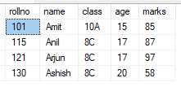

--------------------------------------------------------------------------------------------------------------------------------------------------

**Display all students who belong to class '10A'.**

**Solution---**

SELECT * FROM student WHERE class = '10A';

GO

**Visualization—**

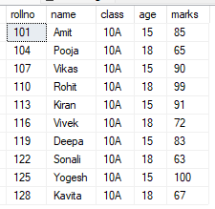

--------------------------------------------------------------------------------------------------------------------------------------------------

**Fetch the total number of students in each class.**

**Solution---**

SELECT class, COUNT(*) AS total_students FROM student GROUP BY class;

GO

**Visualization—**

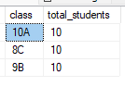

--------------------------------------------------------------------------------------------------------------------------------------------------

**Select students whose roll number contains '123' anywhere in it.**

**Solution---**

SELECT * FROM student WHERE CAST(rollno AS VARCHAR) LIKE '%123%';

GO

**Visualization—**



--------------------------------------------------------------------------------------------------------------------------------------------------

**Retrieve distinct class names from the student table.**

**Solution---**

SELECT DISTINCT class FROM student;

GO

**Visualization—**



--------------------------------------------------------------------------------------------------------------------------------------------------

**Retrieve the highest marks obtained by any student.**

**Solution---**

SELECT MAX(marks) AS highest_marks FROM student;

GO

**Visualization—**



--------------------------------------------------------------------------------------------------------------------------------------------------

**List the students who scored more than 80 marks.**

**Solution---**

SELECT * FROM student WHERE marks > 80;

GO

**Visualization—**

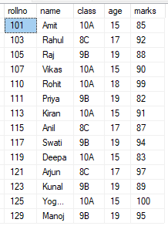

--------------------------------------------------------------------------------------------------------------------------------------------------

**Find the average marks of students in each class.**

**Solution---**

SELECT class, AVG(marks) AS avg_marks FROM student GROUP BY class;

GO

**Visualization—**

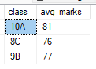

--------------------------------------------------------------------------------------------------------------------------------------------------

**Retrieve the details of students who do not have marks recorded in the marks table.**

**Solution---**

SELECT * FROM student

WHERE rollno NOT IN (SELECT rollno FROM marks);

GO

--------------------------------------------------------------------------------------------------------------------------------------------------

**SUBQUERIES & ORDER BY:**

**Find the students who have the second-highest marks.**

**Solution---**

SELECT * FROM student

WHERE marks = (SELECT MAX(marks) FROM student WHERE marks < (SELECT MAX(marks) FROM student));

GO

**Visualization—**



--------------------------------------------------------------------------------------------------------------------------------------------------

**Retrieve the top 5 students based on their marks.**

**Solution---**

SELECT TOP 5 * FROM student ORDER BY marks DESC;

GO

**Visualization—**

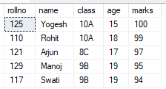

--------------------------------------------------------------------------------------------------------------------------------------------------

**Display students sorted by their name in ascending order and class in descending order.**

**Solution---**

SELECT * FROM student ORDER BY name ASC, class DESC;

GO

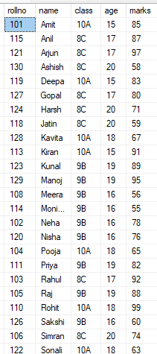**Visualization—**



