Finance Research Letters — Preprint submission
Can a Tokenized InvIT Close an Infrastructure Viability Gap? Evidence and a Design Proposal from Bengaluru’s Metro and Peripheral Ring Road
Sandeep S
University of Mysore (PhD Research Scholar); WorldQuant University (MScFE).
Repository: github.com/SanKabira/P1-TInvIT-Bengaluru-RWA-Tokenization
Highlights
- ADB’s own analysis puts Bengaluru Metro Phase 2A/2B FIRR at 1.921% versus a 2.629% WACC.
- We reproduce that WACC from disclosed components to within a rounding error (2.6288%).
- A credible “+10% ridership, −10% cost” tokenization scenario lifts FIRR only to ~2.35% — still below WACC.
- Tokenization is a subsidy-reducing lever, not a route to unsubsidized viability, on these numbers.
- SEBI’s 2025 ₹25-lakh minimum is the regulatory precondition for a retail-accessible T-InvIT.
Abstract
Urban infrastructure in India is caught in a familiar bind: the projects with the largest social returns struggle to clear a private cost-of-capital hurdle. The Asian Development Bank’s financial analysis of the Bengaluru Metro Rail Project (Phase 2A/2B) puts the project’s post-tax financial internal rate of return (FIRR) at 1.921% against a real weighted-average cost of capital (WACC) of 2.629% — a viability gap of −0.708 percentage points closed only by sovereign concessional debt and equity subsidy. We reproduce ADB’s WACC from its disclosed JICA/ADB/equity weights and costs to within a rounding error (2.6288% versus 2.629%). We then ask whether a tokenized infrastructure investment trust (a “T-InvIT”) could narrow this gap. Using ADB’s published ridership anchors for FY2025 and FY2031 and its stated 4.11% post-2031 growth, we build a transparent ridership-and-revenue forecast and a sensitivity surface around the base FIRR. A combined “+10% ridership, −10% cost” scenario lifts the indicative FIRR to about 2.35% — materially better, but still short of the 2.629% WACC. Tokenization is a financing-access and cost-of-equity lever, not a magic wand: it plausibly compresses the gap but does not, on these numbers, eliminate it. We connect this to SEBI’s September 2025 reform cutting the InvIT minimum investment to ₹25 lakh, and to the ₹27,000 crore Peripheral Ring Road as a second candidate asset whose ~₹21,000 crore land-acquisition burden is the dominant cost driver.
Keywords: infrastructure finance; tokenization; InvIT; FIRR; WACC; Namma Metro; Peripheral Ring Road; SEBI
JEL: G23; G18; H54; R42
1. Introduction
Every few years a new financing technology is offered as the answer to India’s urban-infrastructure funding shortfall, and tokenization is the current candidate. The pitch is seductive: fractionalize the equity in a metro line or a ring road, put it on a distributed ledger, and a deep pool of retail and global capital will price the asset more efficiently and demand a lower return. Whether that pitch survives contact with an actual project’s economics is an empirical question, and this paper answers it for two concrete Bengaluru assets.
The starting point is a number that should give any tokenization enthusiast pause. ADB’s financial analysis of Bengaluru Metro Phase 2A/2B reports a project post-tax FIRR of 1.921% against a real WACC of 2.629% (Asian Development Bank, 2020). A project whose return sits below its cost of capital does not get built by the private sector; it gets built because sovereign and multilateral lenders supply capital at concessional rates. ADB itself estimates BMRCL needs roughly ₹83.6 billion of sponsor support across FY2021–FY2033 to keep its debt-service-coverage ratio at 1.0.
The relevant question for tokenization is therefore not “can it make this project profitable?” — nothing short of a structural change in ridership or cost does that — but “can it lower the blended cost of capital enough to shrink the subsidy bill, and by how much?”
We make three contributions. First, we independently reproduce ADB’s WACC from its disclosed components, confirming the viability gap is real and consistent. Second, we build a transparent, reproducible ridership and revenue forecast anchored entirely on ADB’s published figures, plus a sensitivity analysis showing how far plausible tokenization-driven improvements move the FIRR. Third, we set out a concrete T-InvIT design for the metro and the Peripheral Ring Road, grounded in the regulatory reality created by SEBI’s September 2025 InvIT amendment.
2. Institutional background
2.1. The two assets
Namma Metro Phase 2A/2B is the analytical core because it comes with a published, auditable financial model: total project cost ₹139,088.8 million at April-2020 prices, funded by JICA loan (17.24% of WACC weight), ADB loan (27.10%), and equity (55.66%). A subsequent JICA ODA loan for Phase 3, signed 24 March 2026, adds ¥102,480 million at TORF + 80 basis points over a 30-year tenor with a 10-year grace period (JICA, 2026). These long-dated, low-coupon, sovereign-backed liabilities are precisely why the metro’s blended cost of capital is low.
The Peripheral Ring Road / Bengaluru Business Corridor (BBC) is the second candidate. The most current public figures put the total project at about ₹27,000 crore, of which land acquisition alone is roughly ₹21,000 crore, with Package 1 awarded to SNC at an estimated ₹3,348 crore (Moneycontrol, 2026). We were unable to locate a completed primary DPR or Government Order — a February-2024 BDA tender to prepare the PRR-2 DPR confirms the southern stretch was still being scoped — so PRR figures are drawn from current bid results and government statements, with that limitation flagged.
2.2. The regulatory enabler
A tokenized InvIT presupposes that infrastructure units can be held by a broad investor base. Until late 2025 that was effectively blocked for privately placed structures by a ₹1 crore minimum subscription. SEBI’s InvIT (Third Amendment) Regulations, 2025, gazetted 2 September 2025, cut that minimum to ₹25 lakh and removed the ₹25 crore proviso (SEBI, 2025). This is the single most important regulatory precondition for a retail-accessible T-InvIT.
3. Data and provenance
Every figure traces to a committed source or a logged retrieval. The metro economics come from the ADB Financial Analysis (ADB Project 53326-001). ADB’s server returns HTTP 403 to automated download, so the canonical URL and the full extracted figure set are logged in data/raw/JICA_loans/ADB/ADB_FA_download_status.md rather than redistributed as a PDF. JICA Phase-3 loan terms come from JICA’s Ex-Ante Evaluation PDF, committed in full. PRR/BBC cost figures come from committed news and tender HTML. The SEBI amendment text is committed in the companion repository. BMRCL’s own FY2023-24 statutory filing is committed, but we note candidly that the document BMRCL publishes under “Annual Report 2023-24” is its Right-to-Information Act §25 yearly return — request-disposal statistics, not financial statements — so it supplies provenance but no usable financial data. The full register is in DATA_SOURCES.md.
4. Method
4.1. WACC reproduction (integrity check)
We recompute the real WACC as the weight-weighted sum of disclosed real component costs (Table 1). The result, 2.6288%, matches ADB’s reported 2.629% to four significant figures, confirming the disclosed components are internally consistent and the −0.708 pp viability gap is not an extraction error.
4.2. Ridership and revenue forecast
We anchor a 21-year (FY2025–FY2045) ridership path on ADB’s two published daily-ridership points and its stated 4.11% post-2031 growth. Between FY2025 and FY2031 we interpolate on the compound growth implied by ADB’s own anchors; after FY2031 we apply ADB’s 4.11% figure. Revenue is built from ADB’s fare assumption of ₹2.85 per passenger-km with non-farebox revenue at 10% of farebox after a two-year ramp; we apply a 12 km average trip length, flagged explicitly as our own assumption. Every forecast cell is labelled an “ADB-parameterised projection.”
4.3. FIRR sensitivity and the tokenization scenario
We perturb the base FIRR with an elasticity-style adjustment, scaling by a ridership factor and dividing by a cost factor, across ±20% shocks and a combined “+10% ridership, −10% cost” tokenization scenario. The scenario is deliberately modest: tokenization’s plausible channels are a lower cost of equity from a broader investor base and cost discipline from a deeper demand pool — not a doubling of ridership.
5. Results
5.1. The gap is real and consistent
FIRR (1.921%) sits 0.708 percentage points below WACC (2.629%), and our component-level reconstruction reproduces the WACC almost exactly (Table 1, Figure 1). Without concessional capital the project does not clear its hurdle — which is why it is financed by JICA and ADB at near-zero real cost.
Table 1. WACC components (real terms) and reproduction check, from ADB-disclosed weights and costs.
Source | Weight | Nominal cost | Real cost
JICA loan | 17.24% | 1.42% | 0.00%
ADB loan | 27.10% | 2.58% | 0.54%
Equity | 55.66% | 8.64% | 4.46%
WACC (reproduced) | 100% | — | 2.6288%
WACC (ADB reported) | — | — | 2.629%
Source: data/processed/wacc_components.csv, firr_wacc_recompute.csv.
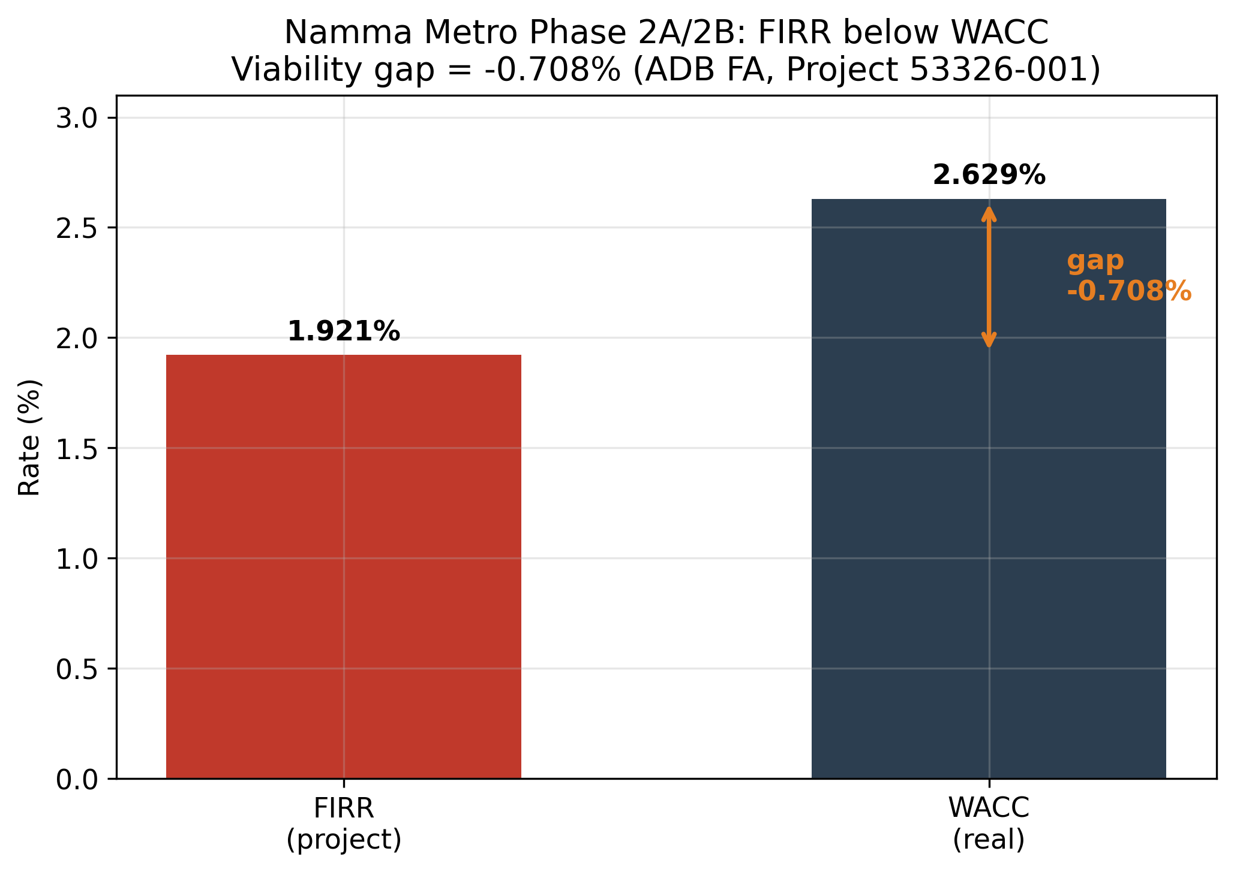
Figure 1. FIRR (1.921%) versus real WACC (2.629%) for Namma Metro Phase 2A/2B; the −0.708 pp viability gap.
5.2. Ridership and revenue trajectory
The ADB-parameterised forecast takes total daily ridership from about 157,594 in FY2025 to roughly 600,651 by FY2031 — matching ADB’s anchors by construction — and to just over 1.05 million by FY2045 under the 4.11% post-2031 path (Figure 2). Corresponding operating revenue rises from about ₹197 crore in FY2025 to ₹825 crore by FY2031 and ₹1,450 crore by FY2045 on ADB’s fare assumptions (Figure 3). These are the cash flows any tokenized equity claim would be priced against.
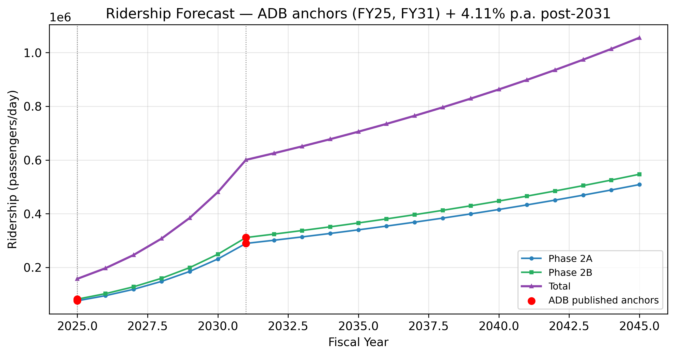
Figure 2. Ridership forecast: ADB anchors (FY2025, FY2031, red markers) plus 4.11% p.a. post-2031.
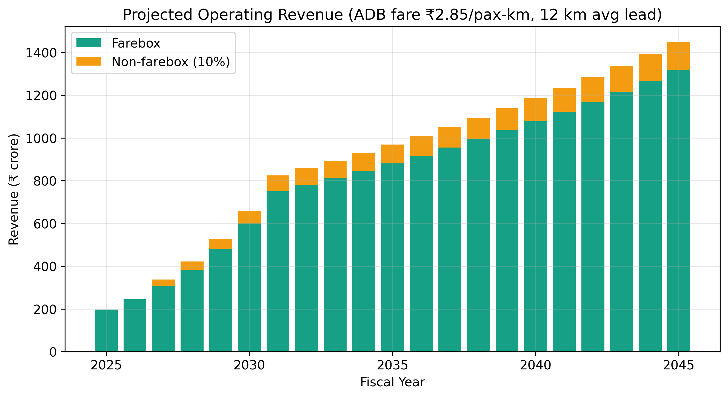
Figure 3. Projected operating revenue (₹ crore) on ADB fare assumptions (₹2.85/pax-km, 12 km average lead).
5.3. How far tokenization can move the needle
The sensitivity analysis is the paper’s sobering centrepiece (Table 2, Figure 4). A 20% ridership uplift alone lifts FIRR to about 2.31%; a 20% cost reduction to about 2.40%; the combined tokenization scenario to about 2.35%. Every scenario remains below the 2.629% WACC. Even optimistic tokenization-driven improvements compress the viability gap from −0.708 pp to roughly −0.28 pp but do not close it. The policy reading: tokenization is a subsidy-reducing instrument, not a route to an unsubsidized, market-viable metro.
Table 2. FIRR sensitivity (model simulation around the ADB base FIRR of 1.921%).
Scenario | FIRR | vs WACC (2.629%)
Base case (ADB) | 1.921% | Needs subsidy
Ridership +20% | 2.305% | Needs subsidy
Ridership −20% | 1.537% | Needs subsidy
Cost +20% | 1.601% | Needs subsidy
Cost −20% | 2.401% | Needs subsidy
T-InvIT (+10% rid, −10% cost) | 2.348% | Needs subsidy
Source: data/processed/firr_sensitivity_table.csv.
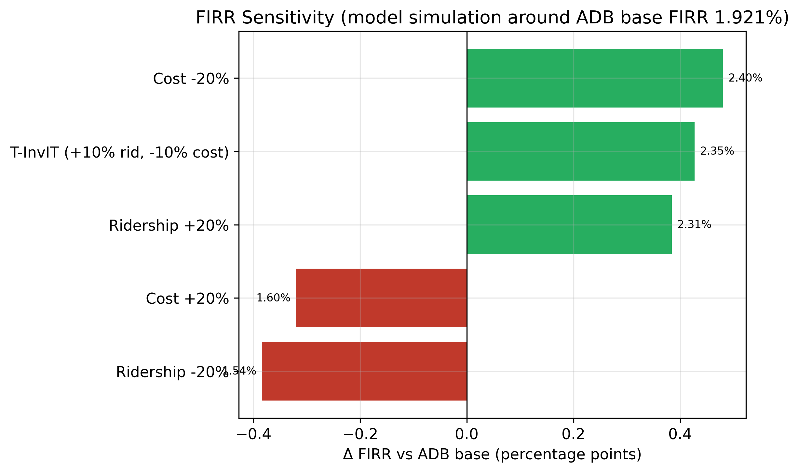
Figure 4. FIRR sensitivity tornado: change in FIRR (percentage points) versus the ADB base, by scenario.
5.4. Why PRR may be the better tokenization candidate
The metro’s cost of capital is already extraordinarily low because of concessional sovereign debt; there is little room for tokenized equity to undercut a 0% real JICA loan. The PRR/BBC is different. Its dominant cost is land acquisition (~₹21,000 crore of ~₹27,000 crore), it is financed substantially through HUDCO borrowing, and a betterment-levy or land-value-capture structure maps naturally onto a tokenized unit backed by toll and monetized-land cash flows. We cannot complete the PRR viability arithmetic — no primary DPR is public — but the structure of its cost base is where a T-InvIT’s access and pricing advantages would bite hardest.
6. A T-InvIT design proposal
Building on the SEBI September-2025 reform, we sketch a compliance-feasible structure: a SEBI-registered InvIT holding the operating asset (metro fare/non-fare revenue, or PRR toll plus land-value-capture receipts), with units recorded on a permissioned ledger for transfer and beneficial-ownership tracking while remaining within the dematerialized-securities and InvIT regulatory perimeter. The ₹25 lakh minimum (post-amendment) is the enabling threshold for a privately placed tranche; a publicly listed tranche follows the standard InvIT route. We stop short of claiming on-chain settlement against SEBI’s current rails — no such structure is live in India today — and treat the ledger layer as a register-and-transfer overlay, not a replacement for the existing depository system.
7. Limitations
Three caveats. First, the FIRR sensitivity is a model simulation, not a re-estimation of ADB’s full cash-flow model, which is not public at line-item granularity. Second, our 12 km average-trip assumption drives the revenue scale and is ours, not ADB’s. Third, the PRR analysis is qualitative because no primary DPR is publicly available, and the practitioner survey envisaged for this project has not been fielded — we report no survey results rather than invent any.
8. Conclusion
Tokenization will not, on the numbers, turn a sub-WACC metro into a market-viable one. What it can plausibly do — and what the SEBI 2025 reform now makes regulatorily feasible — is widen the investor base, lower the cost of the equity slice, and thereby reduce the sovereign subsidy required to keep these socially valuable assets financeable. For Bengaluru, the metro is the cleaner test of the concept because its economics are fully disclosed; the Peripheral Ring Road is the more promising application because its cost base leaves more room for a tokenized, land-value-capture-backed structure. The contribution here is to replace the conference-stage promise with a number: a credible tokenization scenario narrows the metro’s viability gap by roughly six-tenths, from −0.708 to about −0.28 percentage points — meaningful, but not the whole distance.
Data availability
All figures and tables are generated by notebooks/02_firr_wacc_forecast.py from committed inputs in the public repository at https://github.com/SanKabira/P1-TInvIT-Bengaluru-RWA-Tokenization. Where a publisher restricts redistribution (ADB), the retrieval URL and access date are logged in DATA_SOURCES.md with the extracted figures in a status file. No data were fabricated; the survey arm is marked pending. Run from the repo root: python3 notebooks/02_firr_wacc_forecast.py.
Declaration of competing interest
The author declares no competing financial interests or personal relationships that could have influenced this work.
References
Amihud, Y. (2002). Illiquidity and stock returns: cross-section and time-series effects. Journal of Financial Markets, 5(1), 31–56. https://doi.org/10.1016/S1386-4181(01)00024-6
Asian Development Bank. (2020). Financial Analysis: India — Bengaluru Metro Rail Project (Phase 2A/2B). Linked Document IND-53326-001-FA. Manila. https://www.adb.org/sites/default/files/linked-documents/ind-53326-001-fa.pdf
AZB & Partners. (2025). SEBI Amends InvIT Regulations and REIT Regulations. https://www.azbpartners.com/bank/sebi-amends-invit-regulations-and-reit-regulations/
Deccan Herald. (2026). Bengaluru: in bid to complete PRR, govt to offer higher compensation for 948 acres.
Deloitte Center for Financial Services. (2025). Tokenized real estate: A blockchain-based pathway to a US$4 trillion market by 2035.
El Jaouhari, A., et al. (2025). Tokenization and the future of property investment. International Journal of Strategic Property Management, 29(4), 297–315. https://doi.org/10.3846/ijspm.2025.24814
Esty, B. C. (2004). Modern Project Finance: A Casebook. John Wiley & Sons.
Japan International Cooperation Agency. (2026). Signing of Japanese ODA Loan for the Bangalore Metro Rail Project (Phase 3): Ex-Ante Evaluation. https://www.jica.go.jp/english/information/press/2025/20260324_11.html
Mirdala, R. (2025). Tokenization of Real-World Assets: Legal Frameworks and Market Implications. Journal of Applied Economic Sciences, 20(2(88)). https://doi.org/10.57017/jaes.v20.2(88).09
Moneycontrol. (2026). Bengaluru Business Corridor: Package 1 awarded; total project ~₹27,000 crore, land acquisition ~₹21,000 crore.
Securities and Exchange Board of India. (2025). SEBI (Infrastructure Investment Trusts) (Third Amendment) Regulations, 2025. Gazette of India, 2 September 2025. https://www.sebi.gov.in/sebi_data/attachdocs/sep-2025/1757046936652.pdf
Swinkels, L. (2023). Empirical evidence on the ownership and liquidity of real estate tokens. Financial Innovation, 9(1). https://doi.org/10.1186/s40854-022-00427-5
Xia, Y., et al. (2025). Exploration on Real World Assets and Tokenization. arXiv:2503.01111.
Anonymous. (2025). Tokenize Everything, But Can You Sell It? On the Liquidity of Real-World Asset Tokens. arXiv:2508.11651.
Yescombe, E. R. (2017). Public-Private Partnerships in Infrastructure: Principles of Policy and Finance (2nd ed.). Butterworth-Heinemann.

