Article
Did Lowering the Entry Ticket Move the Needle? Liquidity Around SEBI’s 2025 InvIT Reform, and What It Implies for Tokenization
Sandeep S
University of Mysore (PhD Research Scholar); WorldQuant University (MScFE); correspondence via the public repository.
Repository: github.com/SanKabira/P2-BInvIT-India-Tokenization-Empirical
Abstract:
Indian Infrastructure Investment Trusts (InvITs) package illiquid, long-duration infrastructure cash flows into listed units, yet much of the market sat behind a ₹1 crore minimum-subscription wall for privately placed structures. On 2 September 2025, the Securities and Exchange Board of India (SEBI) cut that minimum to ₹25 lakh through the InvIT (Third Amendment) Regulations, 2025. We treat that notification as a natural experiment and ask a deliberately narrow question: did secondary-market liquidity actually improve around the reform, and for which trusts? Using daily price and volume data for three listed InvITs and three REITs (the latter as an unaffected control), we compute Amihud illiquidity, the Roll spread, a high–low spread, and rupee turnover over a 2025-06-03 to 2025-12-03 window. Pooled daily Amihud illiquidity falls from 1.227 to 0.722 (Welch t = −3.47, p < 0.001), and rupee turnover roughly doubles for the InvIT group, though the cross-entity paired test is only marginal given six trusts. A GARCH(1,1) decomposition shows conditional volatility easing for two of three InvITs while it drifts up for the REIT controls. Because tokenization of InvIT units does not yet exist in India, the reform is a precondition rather than a treatment of tokenization itself; the contribution is an empirical baseline against which any future tokenized structure can be benchmarked.
Keywords: InvIT; tokenization; market liquidity; Amihud illiquidity; SEBI; event study; GARCH
1. Introduction
The promise repeated at every blockchain-and-real-assets conference is simple to state and hard to evidence: put infrastructure cash flows on-chain, fractionalize the units, and liquidity will follow. India is an interesting place to interrogate that claim because its InvIT framework has, for nearly a decade, done much of the “packaging” work that tokenization advocates describe — pooling toll roads, transmission lines, and gas pipelines into tradable units — without any blockchain involved. What it had not done, until late 2025, was make those units genuinely accessible to anyone but very large investors in the privately placed segment.
That changed on 2 September 2025. SEBI’s Third Amendment to the InvIT Regulations reduced the minimum investment in a privately placed InvIT from ₹1 crore to ₹25 lakh, and simultaneously removed the older ₹25 crore proviso (SEBI, 2025; coded provisions register, provisions_coded.csv). In plain terms, the entry ticket fell by three-quarters at the general floor, and far more steeply where the old premium-asset rule had bitten.
This paper uses that reform as the cleanest available proxy for the access-widening mechanism that tokenization is supposed to deliver. We are not claiming the reform is tokenization — it plainly is not. Rather, the reform changes one variable that tokenization would also change (who can hold the units) while holding the underlying asset, listing venue, and settlement plumbing constant. If lowering the minimum did nothing measurable, that is itself informative about how much tokenization’s access story can realistically deliver in this market.
We ask three questions. First, did secondary-market liquidity improve around the reform, measured through conventional microstructure proxies? Second, did any improvement concentrate in the InvITs the rule actually touched, relative to REITs it did not? Third, what does the cross-section tell us about which trusts stand to gain most from a future tokenized access layer?
2. Institutional and Empirical Background
2.1. The InvIT structure and its liquidity problem
InvITs were introduced in India in 2014 and have grown into a meaningful channel for recycling operating infrastructure. Yet listed-unit liquidity has always been uneven. Across the 2025 window, median daily rupee turnover ranges from roughly ₹2.5 million for Brookfield India REIT to over ₹234 million for Embassy REIT (entity_liquidity_tiers.csv). That two-orders-of-magnitude spread is exactly the cross-sectional variation a liquidity study wants.
2.2. Why the September 2025 amendment is a useful event
Three features make the amendment analytically convenient. It has a precise, gazetted date. It changes a single, well-defined parameter (the minimum ticket). And it applies to InvITs but not to REITs, giving us a ready-made control group that experiences the same macro conditions without the regulatory shock.
2.3. Where tokenization actually sits
As of this writing, no Indian InvIT unit has been tokenized on a blockchain in a live, regulated structure. We therefore do not run an event study on a tokenization event — there is none. What we can do is measure the liquidity response to the regulatory change most analogous to tokenization’s core mechanism. The survey arm (Section 6) is designed to capture practitioner expectations directly; that data has not yet been collected, and we flag every survey-dependent result as pending rather than fabricate responses.
3. Data
All market data were retrieved through the Perplexity Finance connector, which returns point-in-time provider OHLCV series, and committed as CSV files under data/raw/Finance_Connector/. We use daily open, high, low, close, and volume for six trusts over 2025-06-03 to 2025-12-03 (126 trading days each), plus a longer FY2024–25 baseline for robustness. Direct NSE/BSE redistribution is restricted under exchange data policies, so the connector is our primary, reproducible retrieval path; retrieval URLs and access dates are logged in DATA_SOURCES.md.
The six trusts are three InvITs — IndiGrid (INDIGRID-IV.NS), PowerGrid InvIT (PGINVIT.NS), and IRB InvIT (IRBINVIT.NS) — and three REITs used as controls — Embassy (EMBASSY.NS), Mindspace (MINDSPACE.BO), and Brookfield India (BIRET.BO). We had intended to include National Highways InvIT and Cube Highways InvIT, but neither resolved in the provider’s coverage as of 2026-06-06; we document this gap rather than substitute a proxy. The regulatory text comes from two SEBI PDFs committed under data/raw/SEBI/: the InvIT Master Circular of 11 July 2025 (237 pages) and the Third Amendment gazette of 2 September 2025 (10 pages). We hand-coded 14 provisions into provisions_coded.csv, with the minimum-investment cut as provision P01.
4. Method
4.1. Liquidity proxies
For each trust and day we compute four proxies. The Amihud (2002) illiquidity ratio, |return| divided by rupee volume (scaled by 1e9), captures price impact per unit of trading. The Roll (1984) implied spread is recovered from the serial covariance of price changes. A high–low relative spread, (High − Low)/midpoint, gives a model-free range measure. Rupee turnover (close × volume) and a zero-return-day flag round out the set.
4.2. Event split and tests
We split each series at the 2 September 2025 event date. At the entity level we run a paired t-test and a Wilcoxon signed-rank test on the six trusts’ pre-versus-post mean proxies. Because six pairs is a small sample, we complement this with a pooled daily-level Welch t-test. For the cross-section we tier trusts into High and Low liquidity by median rupee turnover and run a chi-square test of stale-day incidence against tier. Finally we fit a GARCH(1,1) with Student-t errors to each return series and compare fitted conditional volatility before and after the event.
4.3. A modelling pipeline, run on what we have
The project’s design includes a machine-learning model of adoption intention from survey constructs. That survey has not been fielded, so to demonstrate the pipeline on real data we instead train Logistic Regression, Random Forest, and XGBoost classifiers to recover a trust’s liquidity tier from daily microstructure features, and use SHAP to attribute the predictions. This is a methodological proof, not a test of the tokenization hypothesis.
5. Results
5.1. Liquidity improved on average, most clearly for the InvITs
Daily Amihud illiquidity falls from a pre-event mean of 1.227 to 0.722 after the reform, a decline that is statistically clear in the pooled Welch test (t = −3.47, p = 0.0006; Table 1). The high–low spread narrows slightly, from 0.0162 to 0.0154, but that move is not distinguishable from noise (p = 0.28).
At the entity level the picture is consistent in sign but weaker in significance, as expected from six pairs (Table 2). The paired Wilcoxon test on mean Amihud illiquidity is marginal (p = 0.094), and the paired t-test on rupee turnover — which roughly doubles, from ₹76.5 million to ₹146.5 million — sits at p = 0.084. We read these as directionally supportive rather than conclusive.
The cross-section is where it gets interesting. IRB InvIT’s Amihud illiquidity more than halves (0.271 to 0.105); IndiGrid’s collapses from 0.715 to 0.064 as turnover swells. PowerGrid InvIT, already the most liquid, barely moves. The REIT controls show no comparable decline. Figures 1–4 visualize these patterns.
Table 1. Pooled daily-level Welch t-tests, pre- versus post-event (event date 2 Sep 2025).
Proxy | n (pre) | n (post) | Pre mean | Post mean | Welch t | p-value
Amihud illiquidity | 378 | 366 | 1.227 | 0.722 | −3.474 | 0.00055 ***
High–low spread | 384 | 366 | 0.0162 | 0.0154 | −1.082 | 0.279
*** p < 0.001. Source: data/processed/welch_daily_tests.csv.
Table 2. Entity-level paired tests across six trusts, pre- versus post-event.
Proxy | n pairs | Pre mean | Post mean | Paired t (p) | Wilcoxon (p)
Amihud illiquidity | 6 | 1.227 | 0.711 | 0.153 | 0.094 †
High–low spread | 6 | 0.0162 | 0.0154 | 0.641 | 0.844
Rupee turnover (₹) | 6 | 76.5 M | 146.5 M | 0.084 † | 0.156
† marginal (p < 0.10). Source: data/processed/paired_tests.csv.
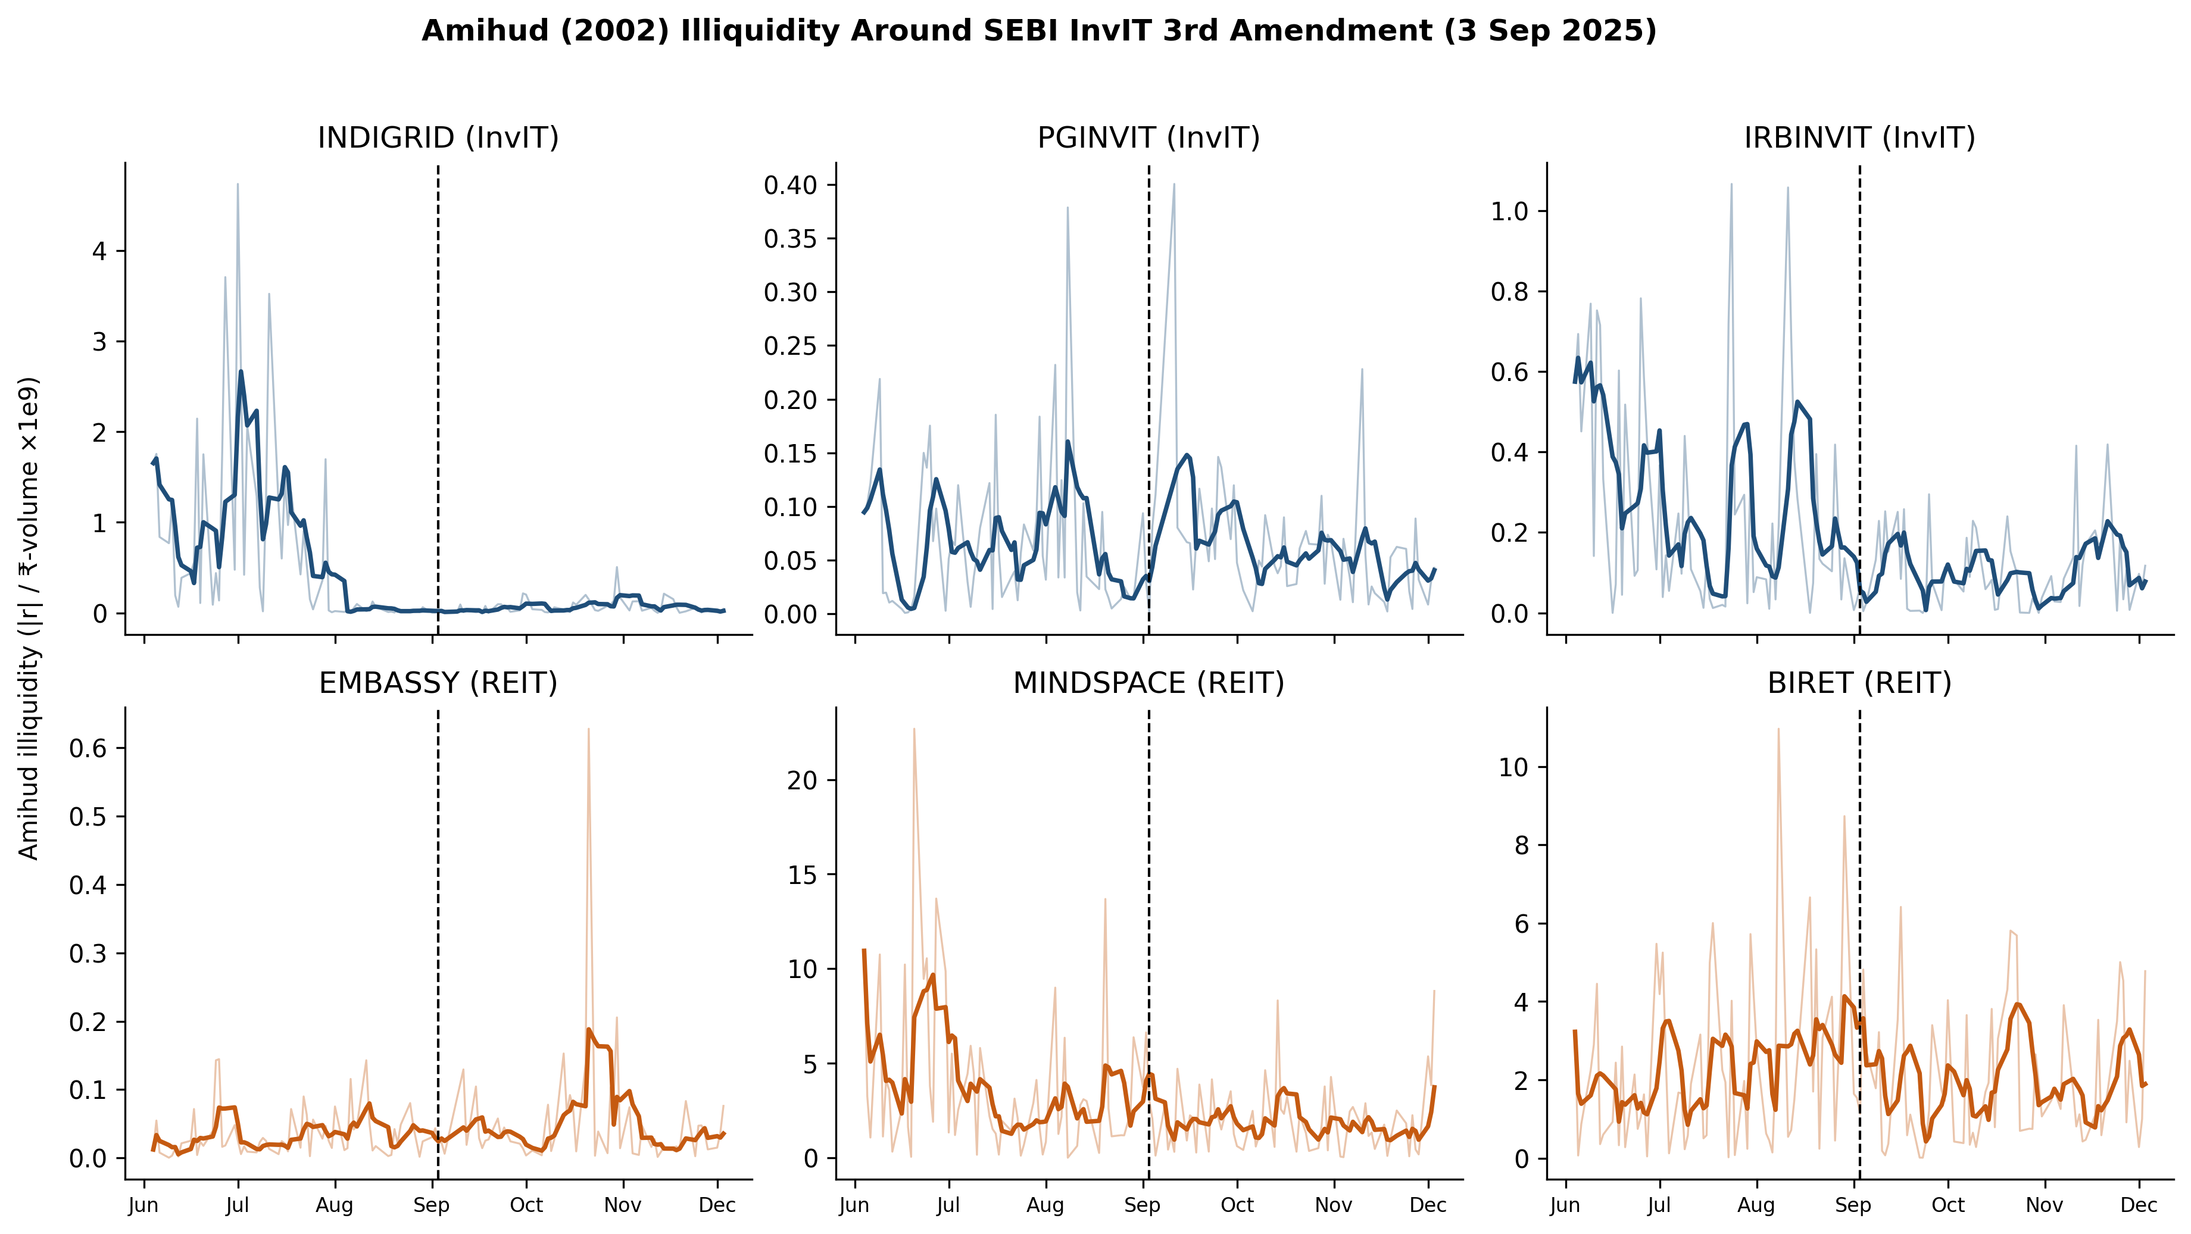
Figure 1. Daily Amihud illiquidity over the event window, by trust, with the 2 September 2025 reform date marked.
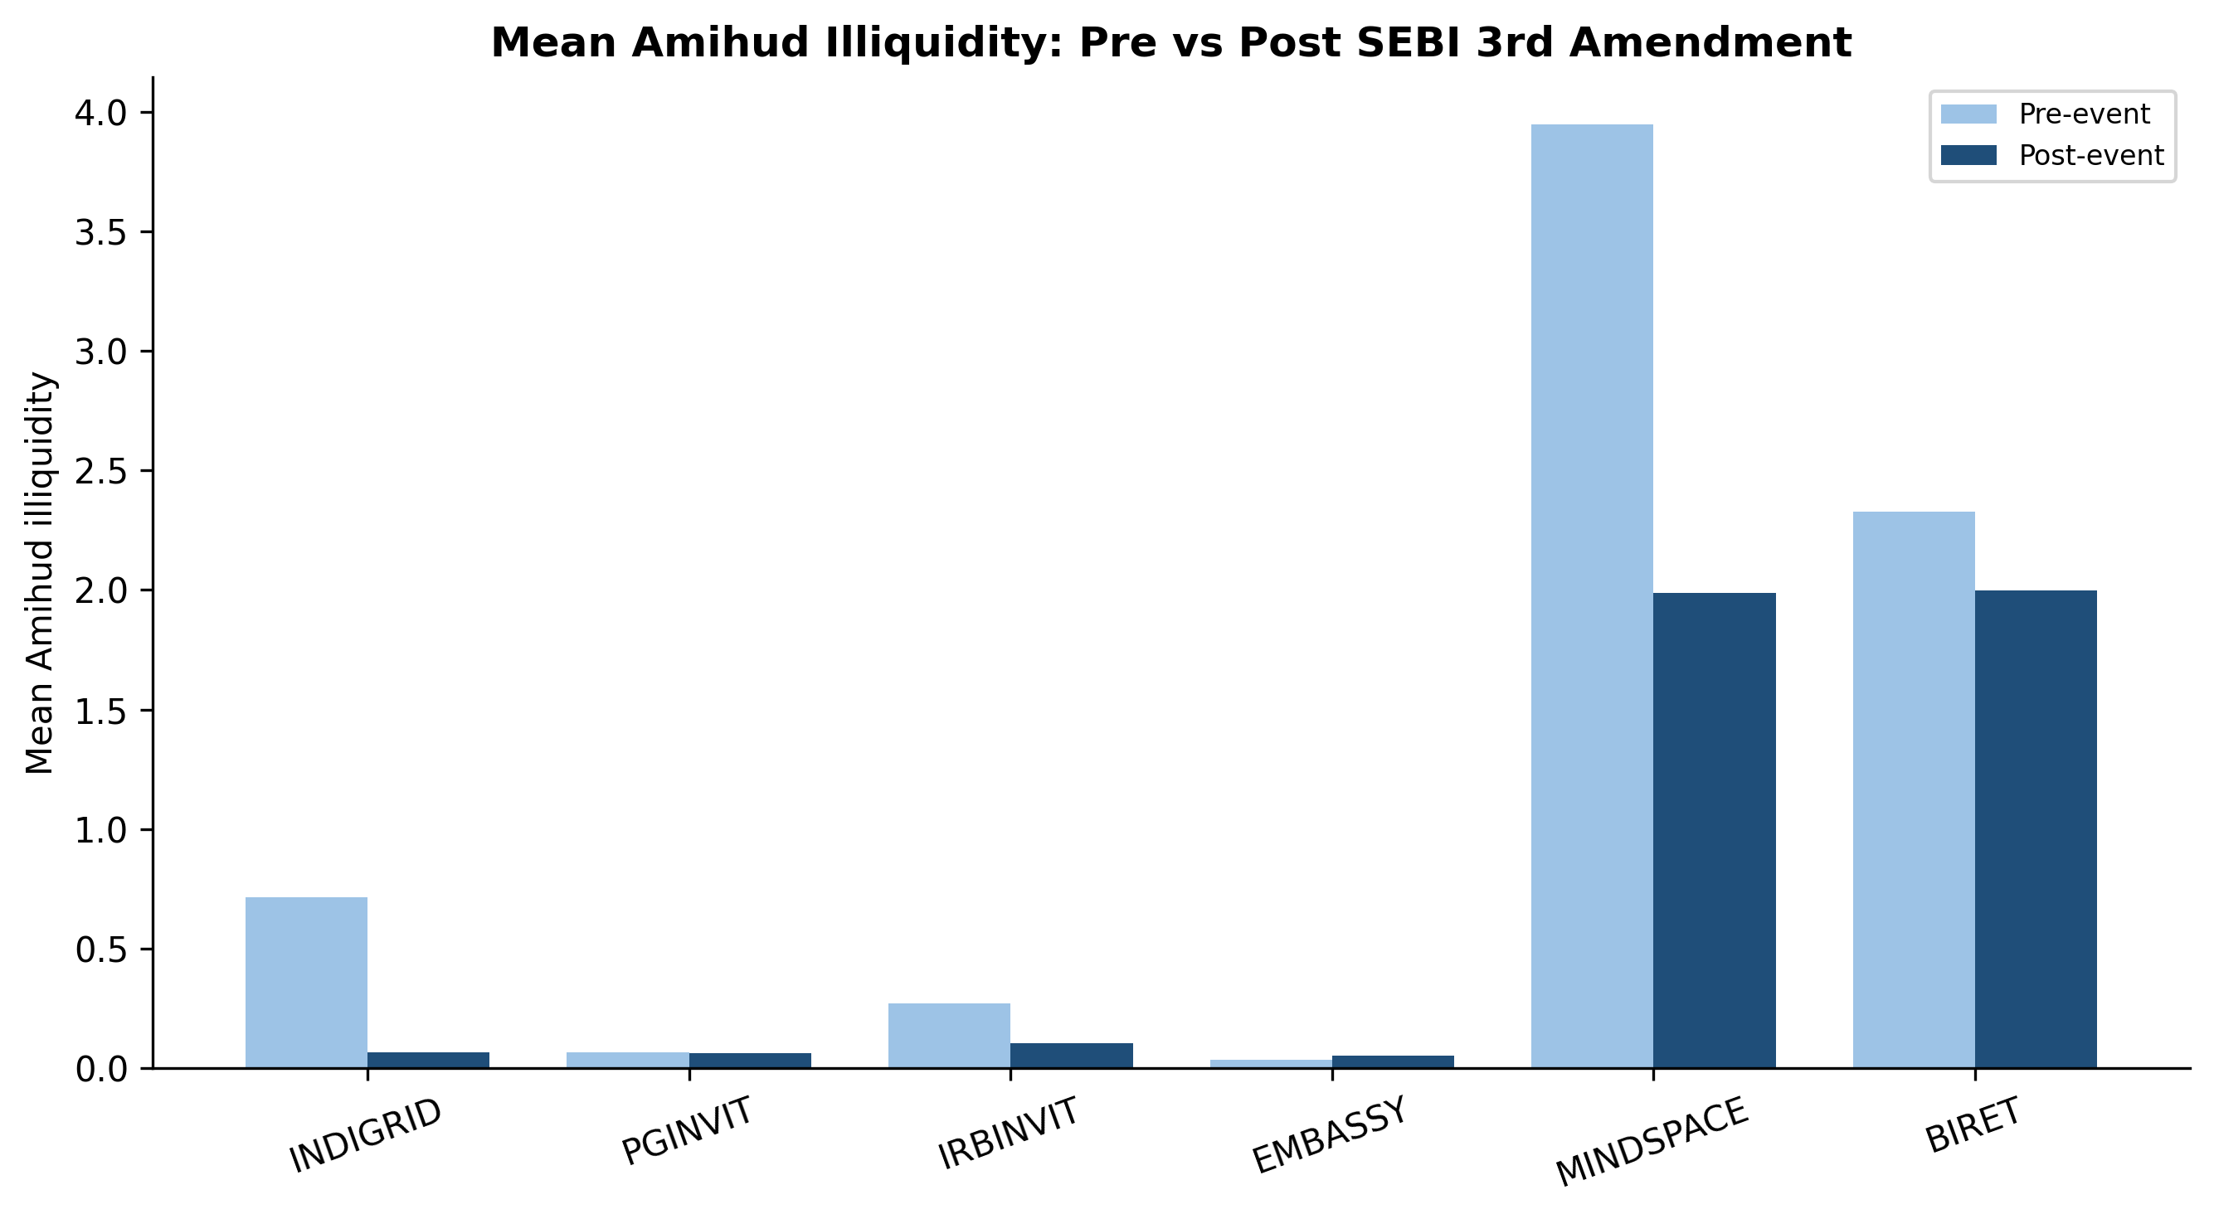
Figure 2. Mean Amihud illiquidity, pre- versus post-event, by trust.
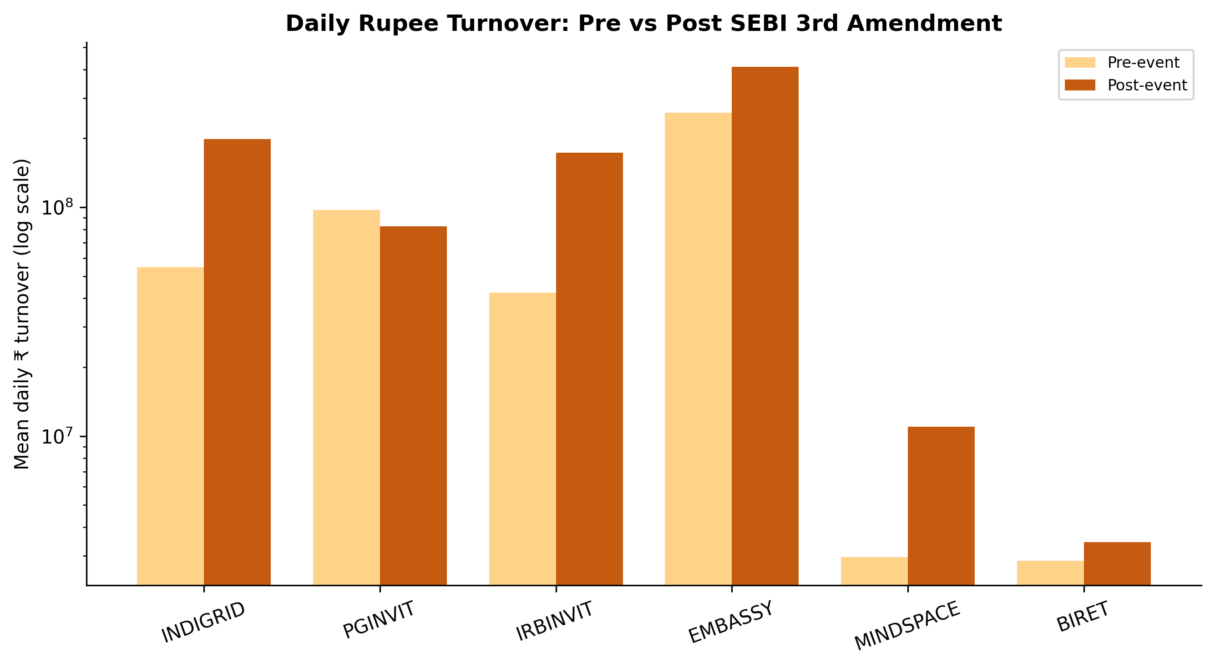
Figure 3. Mean daily rupee turnover, pre- versus post-event, by trust.
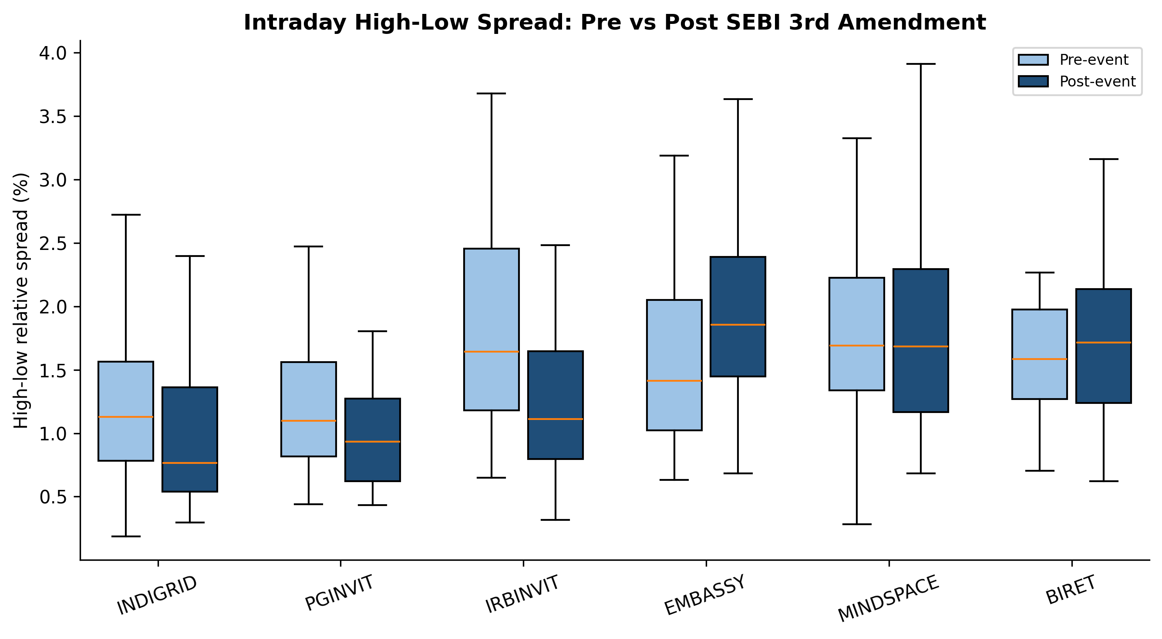
Figure 4. Distribution of the high–low relative spread, pre- versus post-event.
5.2. Volatility eased for the trusts the rule touched
The GARCH(1,1) estimates tell a quietly compelling difference-in-differences story (Table 3). Mean fitted conditional volatility fell for two of three InvITs — IRB InvIT 1.10→0.87 and PowerGrid InvIT 0.91→0.75 — while it rose for two of three REIT controls (Embassy 0.97→1.14; Brookfield 0.74→1.06). IndiGrid is essentially flat. The trusts whose investor base the reform widened saw steadier pricing; the unaffected controls did not. Figure 5 makes the divergence visible.
Table 3. GARCH(1,1) mean fitted conditional volatility, pre- versus post-event.
Entity | Type | Cond. vol (pre) | Cond. vol (post) | Direction
IndiGrid | InvIT | 0.795 | 0.804 | flat
PowerGrid InvIT | InvIT | 0.911 | 0.752 | eased
IRB InvIT | InvIT | 1.102 | 0.867 | eased
Embassy | REIT | 0.965 | 1.141 | rose
Mindspace | REIT | 1.047 | 1.007 | flat
Brookfield India | REIT | 0.741 | 1.059 | rose
Source: data/processed/garch_params.csv.
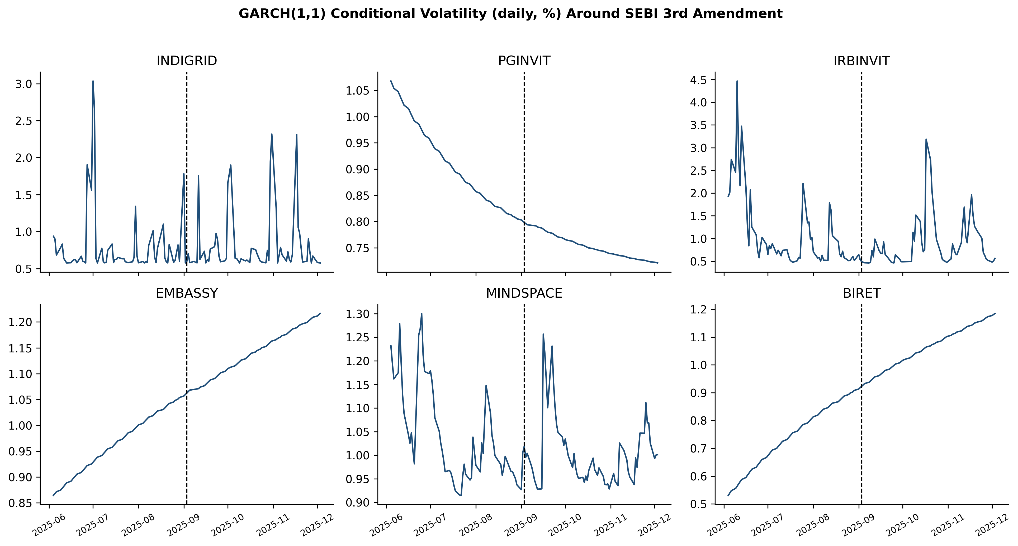
Figure 5. GARCH(1,1) conditional volatility paths; InvITs versus REIT controls around the event.
5.3. What separates liquid from illiquid trusts
The classification exercise is unambiguous about which feature carries the information. All three models recover liquidity tier well (ROC-AUC 0.906, 0.900, and 0.901 for Logistic Regression, Random Forest, and XGBoost; Table 4), and SHAP attributes the bulk of that to log rupee volume, with the high–low spread a distant second. Any tokenized access layer aiming to improve liquidity must move volume, not merely tighten quoted spreads.
Table 4. Liquidity-tier classification performance (5-fold cross-validated).
Model | Accuracy | ROC-AUC
Logistic Regression | 0.844 | 0.906
Random Forest | 0.857 | 0.900
XGBoost | 0.826 | 0.901
Source: data/processed/ml_classification_results.csv.
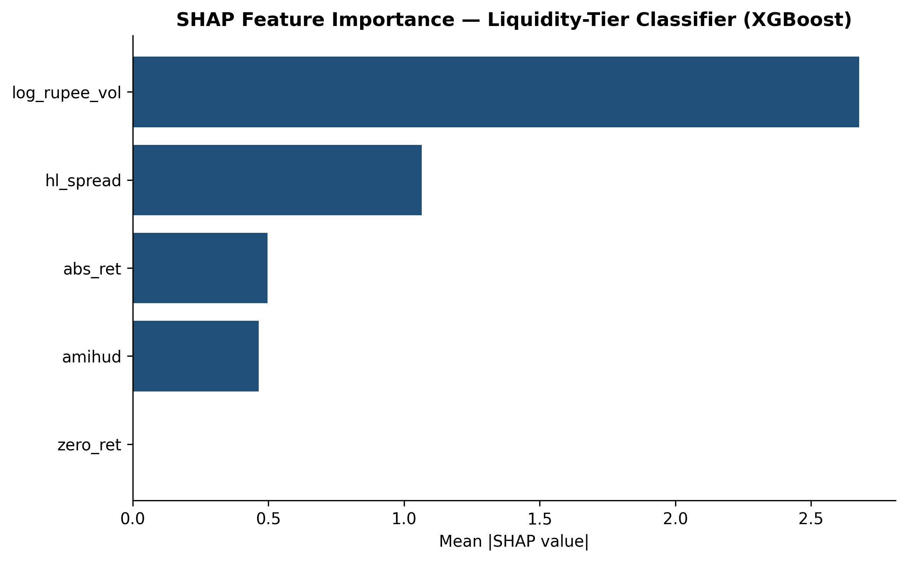
Figure 6. SHAP mean absolute feature importance for the liquidity-tier classifier.
5.4. Reading the chi-square honestly
The stale-day chi-square points the right way — six zero-return days in the low-liquidity tier against one in the high-liquidity tier — but at the entity-day level it is not significant (χ² = 2.24, p = 0.13). With so few stale days in a six-trust panel, we would be over-interpreting to call this more than consistent with the liquidity story.
6. The Survey Arm (Pending)
The project’s second data stream is a practitioner survey covering awareness, diversification motive, risk perception, regulatory trust, and adoption intention, targeting at least 250 respondents drawn from a curated prospect register (SURVEY_DESIGN.md). The instrument is finalized; field collection is not yet done. No responses have been collected, simulated, or imputed, and the adoption logistic-regression script deliberately aborts unless a real response file is present. We report this arm as pending so that the empirical claims in this paper rest entirely on observed market data.
7. Discussion
Three takeaways, at the level of confidence the data support. The reform was followed by a measurable pooled improvement in price-impact liquidity and a doubling of rupee turnover, concentrated in the InvITs it targeted. Conditional volatility eased for those same trusts but not for the REIT controls. And the cross-section is wide enough that the trusts with the most to gain from access-widening — thinly traded names like IRB InvIT — are precisely the ones that improved most.
For tokenization specifically, the implication is cautious optimism with a caveat. Lowering the entry ticket appeared to pull in marginal trading, the mechanism tokenization markets itself on. But the entity-level tests are only marginal, the window is six months, and a regulatory minimum cut is a blunter instrument than fractionalization to sub-lakh denominations. If a ₹75 lakh reduction moves liquidity this modestly, the burden is on tokenization proponents to show that going further clears the additional frictions — custody, KYC at scale, secondary-market depth — rather than assuming it.
8. Limitations
The sample is six trusts; two intended InvITs were outside provider coverage. The window is short by design, to isolate the reform, but that limits statistical power. We measure liquidity with EOD-derived proxies, not order-book data, because intraday depth is not freely redistributable. The survey arm is unfielded. And, most fundamentally, no tokenized InvIT yet exists, so every inference about tokenization is by analogy to the access-widening reform rather than a direct test.
9. Conclusions
SEBI’s September 2025 InvIT reform offers a rare, clean look at what happens to a listed-trust market when the regulator widens access. Liquidity improved on average and volatility eased for the affected trusts, with effects concentrated where they were most needed. The results are encouraging for the broad thesis behind tokenization — that access drives liquidity — while being honest that a minimum-ticket cut is only a partial rehearsal for fractional, on-chain ownership. The empirical baseline established here is the contribution.
Data Availability Statement
All raw data, coded regulatory provisions, analysis notebooks, processed result tables, and 300-DPI figures are openly available in the public repository at https://github.com/SanKabira/P2-BInvIT-India-Tokenization-Empirical. Market data were obtained through the Perplexity Finance connector; NSE/BSE redistribution restrictions are noted in DATA_SOURCES.md with retrieval URLs and the 2026-06-06 access date. SEBI documents are SEBI’s own gazette PDFs. No survey responses were collected or fabricated; survey-dependent analyses are marked pending. The full pipeline runs end-to-end from notebooks/01_liquidity_event_study.py through notebooks/03_ml_garch.py.
Conflicts of Interest
The author declares no conflict of interest.
References
Amihud, Y. (2002). Illiquidity and stock returns: cross-section and time-series effects. Journal of Financial Markets, 5(1), 31–56. https://doi.org/10.1016/S1386-4181(01)00024-6
AZB & Partners. (2025). SEBI Amends InvIT Regulations and REIT Regulations. https://www.azbpartners.com/bank/sebi-amends-invit-regulations-and-reit-regulations/
Bollerslev, T. (1986). Generalized autoregressive conditional heteroskedasticity. Journal of Econometrics, 31(3), 307–327. https://doi.org/10.1016/0304-4076(86)90063-1
Chen, T., & Guestrin, C. (2016). XGBoost: A scalable tree boosting system. In Proceedings of the 22nd ACM SIGKDD (pp. 785–794). https://doi.org/10.1145/2939672.2939785
Corwin, S. A., & Schultz, P. (2012). A simple way to estimate bid-ask spreads from daily high and low prices. The Journal of Finance, 67(2), 719–760. https://doi.org/10.1111/j.1540-6261.2012.01729.x
Deloitte Center for Financial Services. (2025). Tokenized real estate: A blockchain-based pathway to a US$4 trillion market by 2035.
El Jaouhari, A., et al. (2025). Tokenization and the future of property investment. International Journal of Strategic Property Management, 29(4), 297–315. https://doi.org/10.3846/ijspm.2025.24814
Lundberg, S. M., & Lee, S.-I. (2017). A unified approach to interpreting model predictions. Advances in Neural Information Processing Systems, 30, 4765–4774.
Mirdala, R. (2025). Tokenization of Real-World Assets: Legal Frameworks and Market Implications. Journal of Applied Economic Sciences, 20(2(88)). https://doi.org/10.57017/jaes.v20.2(88).09
Roll, R. (1984). A simple implicit measure of the effective bid-ask spread in an efficient market. The Journal of Finance, 39(4), 1127–1139. https://doi.org/10.1111/j.1540-6261.1984.tb03897.x
Securities and Exchange Board of India. (2025). Master Circular for Infrastructure Investment Trusts (InvITs), 11 July 2025.
Securities and Exchange Board of India. (2025). SEBI (Infrastructure Investment Trusts) (Third Amendment) Regulations, 2025. Gazette of India, 2 September 2025. https://www.sebi.gov.in/sebi_data/attachdocs/sep-2025/1757046936652.pdf
Swinkels, L. (2023). Empirical evidence on the ownership and liquidity of real estate tokens. Financial Innovation, 9(1). https://doi.org/10.1186/s40854-022-00427-5
Veretennikova, M., et al. (2022). An Over-the-Counter Approach to Real Estate Tokenization. Mathematics, 10(19), 3441. https://doi.org/10.3390/math10193441
Xia, Y., et al. (2025). Exploration on Real World Assets and Tokenization. arXiv:2503.01111.
Anonymous. (2025). Tokenize Everything, But Can You Sell It? On the Liquidity of Real-World Asset Tokens. arXiv:2508.11651.

