* 1. A piece of paper with writing on it

     Description automatically generated

* 1. Given that wt = (wt,1 , wt,2 ) and the stochastic gradient update equation is , the stochastic gradient update formula in this case would become ,
  2. The reason this is a problem is because when we have a convex objective, we can usually determine if a point is a local/global minimum by checking if it stationary. However, if it non-convex, that is not necessarily the point, if at all. It cold either b a local minima or local maxima instead nor can we use the second derivate test to determine if said local min/max is a global min/max
  3. This is because we are using a different seed for each day which will give us a different set of data points and results due to the different seeds being used.
  4. A reason we would prefer to use the first model is because we are able to have different values for our standard deviation and variance as it is not a constant
  5. Done in Julia
  6. Done in Julia
  7. Done in Julia
  8. Done in Julia
  9. Done in Julia
  10. Done in Julia
  11. Done in Julia

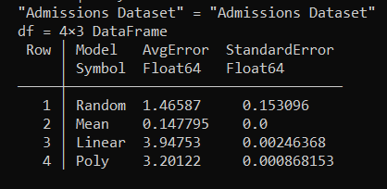

As we can see from this table, the average error for the Linear Model(3.94753) is 0.7 larger than the Polynomial Model(3.20122). However for the Synthetic Data, we see the opposite in that the Polynomial Model has a larger Average Error but lower Standard deviation than the Linear Model.

Comparing the three, we can see that the Constant Learning Rate has the lowest average error and standard error while AdaGrad has the highest mean and standard error. The Heuristic learning rate average error is only a 0.04 below the AdaGrads error and 0.005 below its standard error.

* 1. =

= = + + = p2 + 2p3

= = + + = 2p1 + p3

= = + + = 4p1 + 2p2

* 1. PseudoCode:

min_val=

min_index=0

for int i in range 1 to 3:

temp=

if temp<min_val:

min_val=temp

min_index=i

return min_index