**Table1: Demographic and clinical characteristics among neonates with respiratory distress at Muhimbili National Hospital from June to December 2022 (n=179).**

|  |  |  |
| --- | --- | --- |
| **Variable** | **Frequency** | **Percentage** |
| **Sex of the child** |  |  |
| Male | 107 | 59.78 |
| Female | 72 | 40.22 |
| **Body weight (kg)** |  |  |
| Overweight (>4) | 35 | 19.55 |
| Normal (2.5 – 4) | 46 | 25.70 |
| Low birth weight (1.5 – 2.5) | 57 | 31.84 |
| Very Low birth weight (1.0 – 1.5) | 39 | 21.79 |
| Extreme birth weight (< 1.0) |  |  |
| **Gestation age** |  |  |
| Preterm (<28 weeks) | 30 | 16.76 |
| Preterm (28-32 weeks) | 67 | 37.43 |
| Preterm (33-36 weeks) | 34 | 18.99 |
| Term (≥ 37 weeks) | 48 | 26.82 |
| **Parity** |  |  |
| Primiparity | 74 | 41.34 |
| Multiparity | 86 | 48.04 |
| Grandparity | 19 | 10.61 |
| **Mode of Delivery** |  |  |
| Vaginal delivery | 91 | 50.84 |
| Caesarean section | 88 | 49.16 |
| **Size of Gestation Age** |  |  |
| Small for Gestation age | 30 | 16.76 |
| Average for Gestation age | 149 | 83.24 |
| **Perinatal Asphyxia** |  |  |
| Yes | 35 | 19.55 |
| No | 144 | 80.45 |
| **Dexamethasone use** |  |  |
| Yes | 140 | 78.21 |
| No | 39 | 21.79 |
| **Respiratory Support** |  |  |
| CPAP | 118 | 65.92 |
| Oxygen therapy | 20 | 11.17 |
| Mechanical ventilation | 8 | 4.47 |
|  |  |  |
|  |  |  |

**Table2: Prevalence of RDS and other causes of respiratory distress among neonates at Muhimbili National Hospital from June to December 2022.**

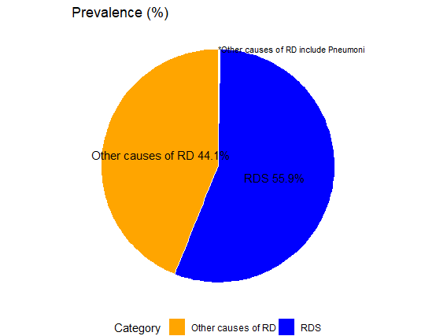

Table3: Factors associated with respiratory distress syndrome in neonates at Muhimbili National Hospital from June to December 2022 (n=179).

|  |  |  |  |  |
| --- | --- | --- | --- | --- |
| **Variable** | **Yes** | **Total** | **Chi-square** | **p-value** |
| **Sex** |  |  | 1.212 | 0.271 |
| Male | 58 (54.2%) | 107 (100%) |
| Female | 45 (62.5%) | 72 (100%) |
| **Gestation age** |  |  |  |  |
| Preterm (<28 weeks) | 28 (93.3%) | 30 (100%) | 104.991 | 0.000 |
| Preterm (28-32 weeks) | 60 (89.6%) | 67 (100%) |
| Preterm (33-36 weeks) | 13 (38.2%) | 34 (100%) |
| Term (≥ 37 weeks) | 2 (4.2%) | 48 (100%) |
| **Body Weight** |  |  |  |  |
| Below 2500 g | 19 (17.8%) | 107 (100%) | 70.035 | 0.000 |
| 2500 g and above | 16 (22.2%) | 72 (100%) |
| **Parity** |  |  |  |  |
| Primiparity | 48 (64.9%) | 74 (100%) | 3.008 | 0.222 |
| Multiparity | 46 (53.5%) | 86 (100%) |
| Grandparity | 9 (47.4%) | 19 (100%) |
| **Size of Gestation Age** |  |  |  |  |
| Small for Gestation age | 28 (93.3%) | 30 (100%) | 18.897 | 0.000 |
| Average for Gestation age | 75 (50.3%) | 149 (100%) |
| **Dexamethasone use** |  |  |  |  |
| Yes | 73 (52.1%) | 140 (100%) | 7.667 | 0.006 |
| No | 30 (76.9%) | 39 (100%) |
| **Dexamethasone use** |  |  |  |  |
| Yes | 25 (71.4%) | 35 (100%) | 3.434 | 0.064 |
| No | 78 (54.2%) | 144 (100%) |
| **Mode of Delivery** |  |  |  |  |
| Vaginal delivery | 61 (67%) | 91 (100%) | 6.825 | 0.009 |
| Caesarean section | 42 (47.7%) | 88 (100%) |
| **Respiratory Support** |  |  |  |  |
| Management by CPAP |  |  |  |  |
| Yes | 81 (68.6%) | 118 (100%) | 14.989 | 0.000 |
| No | 9 (30%) | 30 (100%) |
| Supplementary Oxygen |  |  |  |  |
| Yes | 6 (30%) | 20 (100%) | 9.212 | 0.002 |
| No | 84 (65.6%) | 128 (100%) |
| Ventilation |  |  |  |  |
| Yes | 5 (62.5%) | 8 (100%) | 0.01 | 0.92 |
| No | 85 (60.7%) | 140 (100%) |

Table4: Bivariable and multivariable logistic regression

| **Variables** | **COR (95% CI)** | **AOR (95% CI)** | **p-value COR** | **p-value AOR** |
| --- | --- | --- | --- | --- |
| Sex | 1.41 (0.77, 2.61) | 0.87 (0.28, 2.62) | 0.272 | 0.798 |
| Gestation age | 0.1 (0.05, 0.17) | 0.12 (0.03, 0.37) | 0.000 | 0.001 |
| Body weight | 0.19 (0.11, 0.3) | 1.25 (0.52, 3.07) | 0.000 | 0.611 |
| Parity | 0.67 (0.42, 1.06) | 0.91 (0.36, 2.33) | 0.090 | 0.839 |
| Size of gestation | 0.07 (0.01, 0.25) | 2.26 (0.08, 31.78) | 0.000 | 0.561 |
| Dexamethasone | 3.06 (1.4, 7.27) | 1.25 (0.34, 4.98) | 0.007 | 0.742 |
| Perinatal Asphyxia | 0.47 (0.2, 1.03) | 0.78 (0.14, 3.48) | 0.068 | 0.758 |
| Modality of Delivery | 0.45 (0.24, 0.82) | 1.26 (0.37, 4.43) | 0.009 | 0.714 |
| Prematurity | 0.01 (0, 0.04) | 0.22 (0.01, 2.5) | 0.000 | 0.254 |