**Factsheet**

|  |  |
| --- | --- |
| **Items** | **Description** |
| Knowledge product | Prediction and Prevention of Flood through pre-Flood water diversion to water-crisis areas |
| Innovation statement  [ within 20 words] | Strategic water diversion for different solutions at diverse timescales and points could be made available |
| Keywords (Max 5) | Flood prevention  Flow diversification |
| High-level definition of the product (within 100 words) | Flood prediction algorithm would be used for locating flooded areas. Mitigation algorithm will use previous timestaped data at higher elevation points in the same watershed as sources for water diversion points. Simultaneously sinks would be identified at nearby locations at nearby timestamps. Sinks would comprise of other streams or areas with water crisis (or droughts). Further iterations would be done to validate that no damaging after effects arise due to the solution implementation. |
| Related SDGs and targets | 17; Disaster Rish mitigation and aversion |
| Data provider (with the link) | Various sources (will be updated on GitHub) |
| Geographic coverage (Continental/region/country with relevant information) | Worldwide integration of an automated decision system for disaster mitigation could start by taking the first steps of developing similar mitigation algorithms for specific watersheds. |
| Spatial Resolution | As per data available: 0.00028 steps of Lat & Long |
| Data type (.tif/CSV/API, etc.) | Multi (.tif was converted to .csv for training) |
| Date or time period of observation and analysis | 2015 monsoons |
| Frequency of updates (if applicable) | Occassionally |
| Technical background (within 150 words) | Ghatal subdivision in West Medinipur district under West Bengal is considered to be the most vulnerable place to tremendous flooding. The frequency and magnitude of floods in Ghatal subdivision has increased considerably with the changing time and the effects get worse on the lives of people residing there. Targeting to contribute to disaster management, the objective of this project is to develop a flood prediction and flow diversification algorithm which will help us to divert the pre flood water before entering into Ghatal. |
| Related tool or portal (with the link, if any) | None |
| Availability of codes (source) | Public OpenSource |
| Accessibility of codes (credential+ read me file+ documentation) | GitHub Link would be updated dynamically: <https://github.com/SanTanBan/PreFlowd> |
| Cautions (or limitation to use) | This model is being trained on a limited scope of a watershed area without considering/integrating rainfall predictions. Future versions would include rainfall predictions for the extended watershed areas. |
| Potential users (Locally) [atleast three] | Central Governments Decision Makers State Irrigation and Water-way Departments |
| Potential users (Globally) [atleast three] | Governments Decision Makers and private entities in charge of water canals and discharge units Irrigation and Water-way Departments of various states |
| Contributors and point of contact for the product | * Santanu Banerjee (MS Operations Research, IITKGP) * Papia Das (MSc GeoInformatics, Adamas University) * Ranajit Adhikari (Masters in GeoSpatial, Burdwan University) * Manisha Baral (Assistant Professor, Adamas University) * Kasturi Mukherjee (Associate Professor, Adamas University) |

1. **Abstract**

Solving flooding problems within a basin should involve temporal solutions of intelligent flow channelling such that predicted flood water can be diverted earlier from upstream points into drought affected areas which may lie within other basins

1. **Introduction**

Ghatal subdivision in West Medinipur district under West Bengal is considered to be the most vulnerable place to tremendous flooding. The frequency and magnitude of floods in Ghatal subdivision has increased considerably with the changing time and the effects get worse on the lives of people residing there. Targeting to contribute to disaster management, the objective of this project is to develop a flood prediction and flow diversification algorithm which will help us to divert the pre flood water before entering into Ghatal.

We are to use spacio-temporal data for constraucting a Flood Prediction Algorithm (datssets discussed below) and alter some layers dynamically to sugegst possible solutions of the predicted events.

Feature layers used

1. DEM
2. TWI
3. Rainfall
4. Hydro-gauge (for safe and emergency levels of flows)
5. Slope
6. **Study area:**

* Ghatal CD block has an area of 216.05 km2.  
  Gram panchayats of Ghatal block/ panchayat samiti are: Ajabnagar I, Ajabnagar II, Birsingha, Dewanchak I, Dewanchak II, Irhpala, Mansuka I, Mansuka II, Mohanpur, Monoharpur I, Monoharpur II and Sultanpur.  
  Municipalities: Ghatal and Kharar
* The Shilabati River (also known as Shilai) originates near Chak Gopalpur village of Hura block in the Purulia district of the Indian state of West Bengal.  
  It flows almost southeasterly through the districts of Bankura and Paschim Medinipur.  
  The Shilabati joins the Dwarakeswar near Ghatal and afterward is known as Rupnarayan. It finally joins the Hooghly River, which empties into the Bay of Bengal.

1. **Methodology (Max 500 words with methodology flowchart)**

We are to use spacio-temporal data for constructing a Flood Prediction Algorithm (datasets discussed below) and alter some layers dynamically to suggest possible solutions of the predicted events.

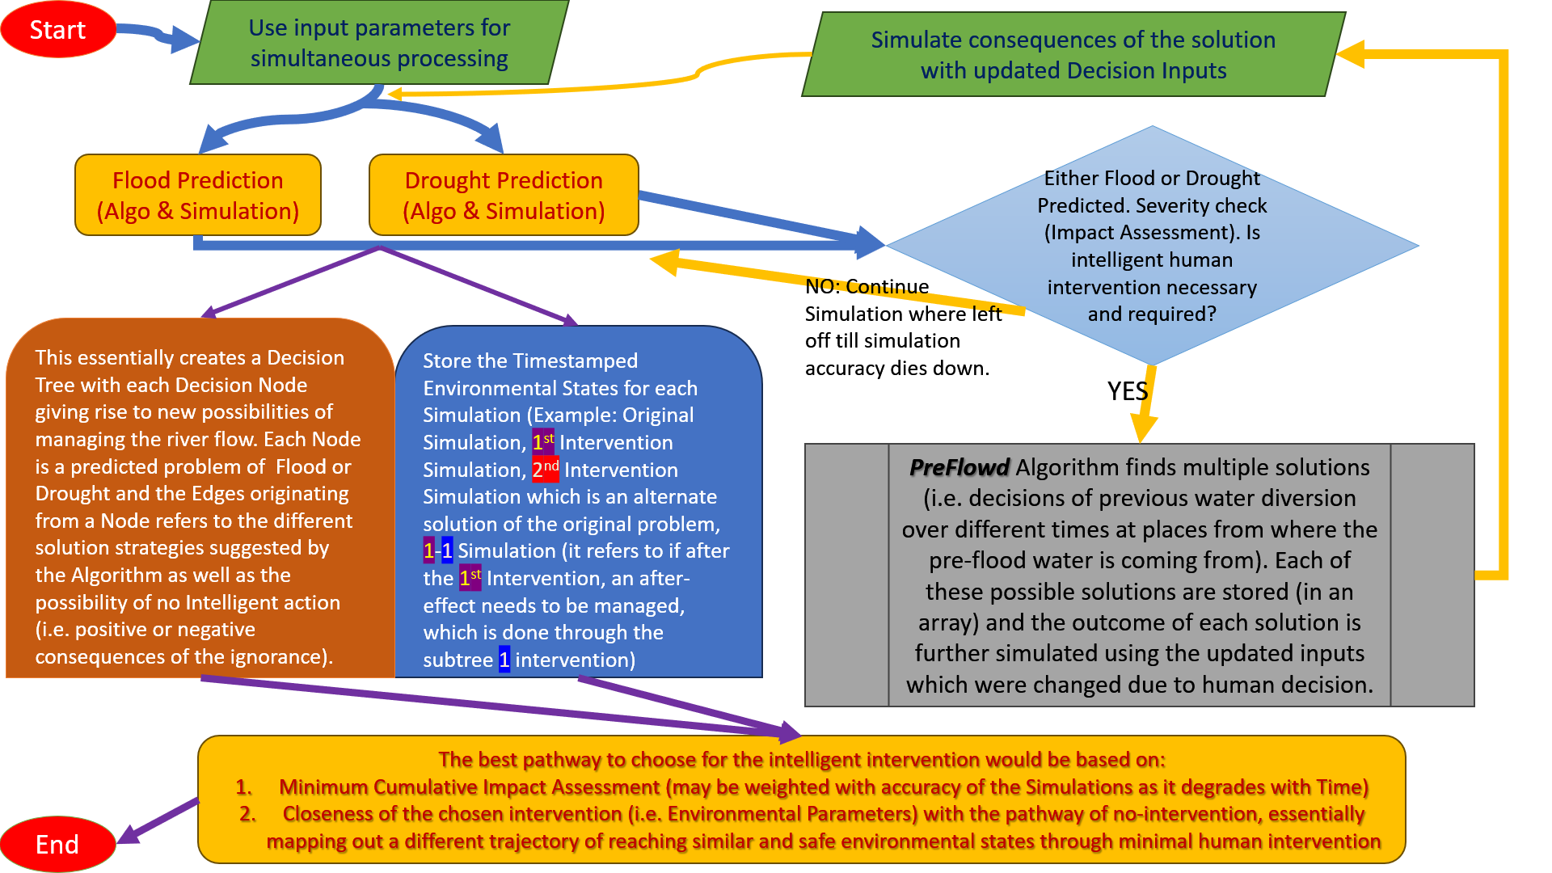

Methodology has been altered slightly due to currently limited knowledge of Conv-LSTM

1. **Results and Analysis:**

We have acquired various data sources and develop the stream-ordering of the concerned watershed:

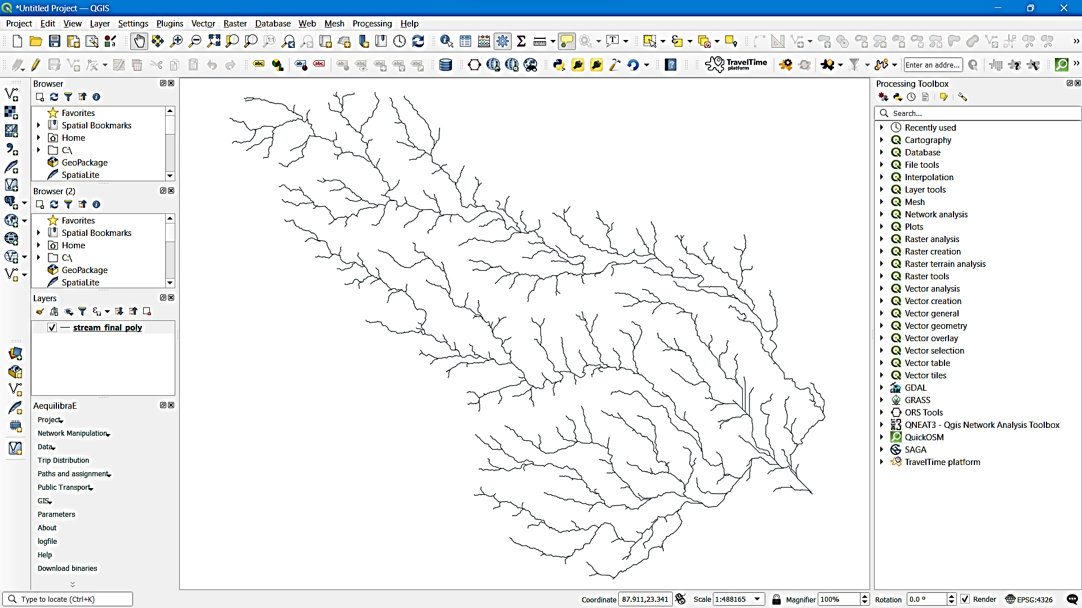

The spatio-temporal data of level and discharge at various gauge stations (to be used as the ground truth for flood occurrences) was very tough to obtain as it was manually scrapped from documents:

|  |  |  |  |  |  |  |  |  |  |  |  |  |
| --- | --- | --- | --- | --- | --- | --- | --- | --- | --- | --- | --- | --- |
| **Date** | **Dugapur Barrage** | | | **Massanjore Dam** | | | **Tilpara Barrage** | | | **Kangsabati Dam** | | |
|  | **Max Flood Level: 211.5** | **Lat, Lon: 23.476258, 87.304287** | **Downstream Flood Limit [cusecs]: 70000** | **Max Flood Level: 395** | **Lat, Lon: 23.999321, 87.433024** | **Downstream Flood Limit [cusecs]: 10000** | **Max Flood Level: 206** | **Lat, Lon: 23.946302, 87.524900** | **Downstream Flood Limit [cusecs]: 7000** | **Max Flood Level: 434** | **Lat, Lon: 22.398293, 87.344318** | **Downstream Flood Limit [cusecs]: 50000** |
|  | **Reservoir Level (ft)** | **Inflow (Cusecs)** | **Outflow (Cusecs)** | **Reservoir Level (ft)** | **Inflow (Cusecs)** | **Outflow (Cusecs)** | **Reservoir Level (ft)** | **Inflow (Cusecs)** | **Outflow (Cusecs)** | **Reservoir  Level (ft)** | **Inflow (Cusecs)** | **Outflow (Cusecs)** |
| 1-Jun-15 | 211.50 | 550 | 50 | 359.70 | 100 | 0 | 202.00 | 0 | 0 | 402.59 | 0 | 0 |
| 2-Jun-15 | 211.50 | 550 | 50 | 360.00 | 600 | 0 | 198.90 | 0 | 0 | 402.59 | 0 | 0 |
| 3-Jun-15 | 211.50 | 550 | 50 | 360.00 | 0 | 0 | 195.75 | 0 | 0 | 402.59 | 0 | 0 |
| … |  |  |  |  |  |  |  |  |  |  |  | … |
| 28-Sep-15 | 210.50 | 72573 | 63073 | 391.85 | 2298 | 0 | 205.70 | 3007 | 0 | 435.20 | 7540 | 0 |
| 29-Sep-15 | 210.50 | 61263 | 51763 | 392.00 | 1825 | 0 | 205.00 | 1992 | 0 | 435.15 | 7541 | 0 |
| 30-Sep-15 | 211.50 | 44725 | 35225 | 392.10 | 1568 | 0 | 205.20 | 2645 | 0 | 434.94 | 3847 | 0 |

**The final LSTM is being modelled using Convolutional layers to pin-point the flood locations from where water could be diverted.**

1. **Discussion:**

* Potential User(s):

Decision Makers and private entities in charge of water canals and discharge units  
(Central) Governments  
Decision Makers  
(State) Irrigation and Water-way Departments

* Scalability: Scalable depending on data availability, specific to each basin
* Major limitations of the solution

The final solution code is yet under development. This model is being trained on a limited scope of a watershed area without considering/integrating rainfall predictions. Future versions would include rainfall predictions for the extended watershed areas.

* Similar solution (s) [provide a link if available]:

No similar or close enough solution exists for the problem

1. **Conclusion:**

We have tried to develop a technique by which pre-flood water could be identified. However representing causal relationship within NN or similar ML models need more technical expertise than we could garner within the time frame. Therefore we would be eager to further develop the solution as PreFlowd 2.0 with improved datasets and requesting more technical expertise aiming to develop it as a research project. The final envisioned product would become an important tool for decision makers especially governments to prevent catastrophes (especially in the flood prone countries like India).

1. **References :**
2. [An Account of the Flood History in the Ghatal Region of West Bengal, India | SpringerLink](https://link.springer.com/chapter/10.1007/978-3-031-21086-0_14)
3. [India flood inventory: creation of a multi-source national geospatial database to facilitate comprehensive flood research | SpringerLink](https://link.springer.com/article/10.1007/s11069-021-04698-6)
4. [Spatial flood susceptibility prediction in Middle Ganga Plain: comparison of frequency ratio and Shannon’s entropy models: Geocarto International: Vol 36, No 18 (tandfonline.com)](https://www.tandfonline.com/doi/full/10.1080/10106049.2019.1687594)
5. [Quantitative assessment of check dam system impacts on catchment flood characteristics – a case in hilly and gully area of the Loess Plateau, China | SpringerLink](https://link.springer.com/article/10.1007/s11069-020-04441-7)
6. [Priority-flood: An optimal depression-filling and watershed-labeling algorithm for digital elevation models - ScienceDirect](https://www.sciencedirect.com/science/article/pii/S0098300413001337)

**Resources:**

* [Stream Order - River Network Using DEM Map in ArcGIS – GISRSStudy](https://gisrsstudy.com/stream-order-arcgis/)
* [obtain stream ordering for indian rivers - Search (bing.com)](https://www.bing.com/search?pglt=673&q=obtain+stream+ordering+for+indian+rivers&cvid=05df8fc14c95469ab130eda254f4158b&aqs=edge..69i57j0j69i64.6641j0j1&FORM=ANAB01&PC=EDGEDSE)
* [HAZARD ATLAS OF INDIA (imdpune.gov.in)](https://imdpune.gov.in/hazardatlas/droughtnew.html)
* [wris_time_series_data - INDIA WRIS WIKI](https://indiawris.gov.in/wiki/doku.php?id=wris_time_series_data)
* [River discharge data are now available online | GCOS (wmo.int)](https://gcos.wmo.int/en/news/river-discharge-data-are-now-available-online)
* [India-WRIS (indiawris.gov.in)](https://indiawris.gov.in/wris/)
* [Hydrological Data | Central Water Commission, Ministry of jal shakti, Department of Water Resources, River Development and Ganga Rejuvenation, GoI (cwc.gov.in)](https://cwc.gov.in/get-hydrological-data)
* [spatial flood prediction - Google Scholar](https://scholar.google.com/scholar?hl=en&as_sdt=0%2C5&q=spatial+flood+prediction&btnG=)
* [SubInfoSysLCC/River_StreamOrder (MapServer) (indiawris.gov.in)](https://arc.indiawris.gov.in/server/rest/services/SubInfoSysLCC/River_StreamOrder/MapServer)
* [ganga - INDIA WRIS WIKI](https://indiawris.gov.in/wiki/doku.php?id=ganga)
* [MIS WIMS (india-water.gov.in)](https://india-water.gov.in/mis/)
* [Water crisis in India’s Maharashtra | India News | WION Climate Tracker - Bing video](https://www.bing.com/videos/search?q=www.india-water.gov.in&docid=603507333927102826&mid=7A7F12B836C4086F27657A7F12B836C4086F2765&view=detail&FORM=VIRE)
* [Flood Forecast - Central Water Commision, Govt. Of India (india-water.gov.in)](https://ffs.india-water.gov.in/)
* [pib.gov.in/PressReleaseIframePage.aspx?PRID=1849954](https://www.pib.gov.in/PressReleaseIframePage.aspx?PRID=1849954)
* [Repository search results (github.com)](https://github.com/search?q=Flood%20Prediction&type=repositories)
* [Water Resources | Sector | Open Government Data (OGD) Platform India](https://data.gov.in/sector/Water%20Resources)
* [HAZARD ATLAS OF INDIA (imdpune.gov.in)](https://imdpune.gov.in/hazardatlas/droughtnew.html)