PROJECT REPORT
Indian Aviation Delay Analytics:
Delay Patterns, Drivers and Forecast
Data Visualisation – CA2
Dataset: Indian Flight Delay Dataset - 150,000 flights, 2023-2025

Prepared by: Sankari Pillai – 24BIT049

Introduction
This report explains a Power BI dashboard built using a dataset of 150,000 Indian domestic flights recorded between 2023 and 2025. The dataset covers 9 airlines and more than 80 airports. It includes information about flight schedules, delays, weather, airport congestion, and other operating conditions.
The goal of this dashboard is to explain, in a simple and clear way, when flights get delayed, where delays happen most, which airlines perform better or worse, and why delays happen. The dashboard also includes a page that looks at what the data suggests for the future.
The report is organised page by page, in the same order as the dashboard. Each section explains what the page shows, why it matters, and what story it tells. Screenshots of each page are included as placeholders and can be added later.

Page 1: Dashboard (Executive Summary)
This is the main landing page. It gives a quick, one-glance view of the whole dataset before going into details on the other pages.

What is shown
- Total number of flights, overall delay rate, average departure delay, and on-time rate, shown as summary cards at the top.
- A line chart showing how the delay rate changed month by month from 2023 to 2025.
- A donut chart showing the share of flights by weather condition.
- A bar chart showing delay rate for each airline.
- A table listing the ten worst-performing routes.
- A small matrix comparing delay rate during peak hours versus off-peak hours, and weekdays versus weekends.

Storytelling point
The headline finding on this page is that 86.6 percent of all flights in this dataset were delayed. This number stays almost the same across all three years, which tells us this is a steady pattern, not something that is getting worse over time.
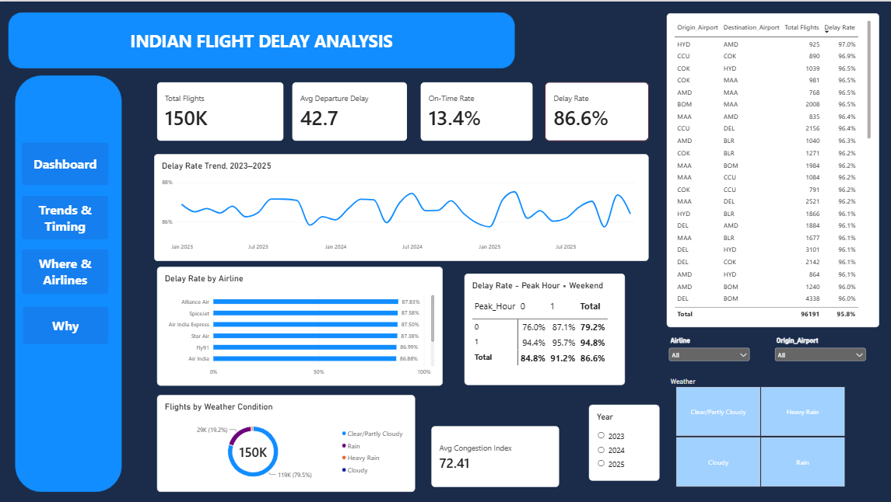

Page 2: Trends and Timing
This page answers two related questions: how did flight performance change from year to year, and at what times of day or week do delays happen most.

What is shown
- A summary table comparing total flights, delay rate, and average delay across 2023, 2024, and 2025.
- A line chart showing the delay rate pattern across months, with a separate line for each year.
- A column chart showing the number of flights flown each year.
- Three cards comparing delay rate during off-peak hours, peak hours, and weekends.
- A heatmap table showing delay rate for every combination of day of the week and hour of departure.
- A bar chart comparing weekday delay rate with weekend delay rate.

Storytelling point
The year-to-year numbers barely change, which means the calendar year is not the main reason flights get delayed. The bigger difference is the time of day. Flights during peak hours are delayed about 94.8 percent of the time, compared to 79.2 percent during off-peak hours. This is the single biggest factor found in the whole dataset.
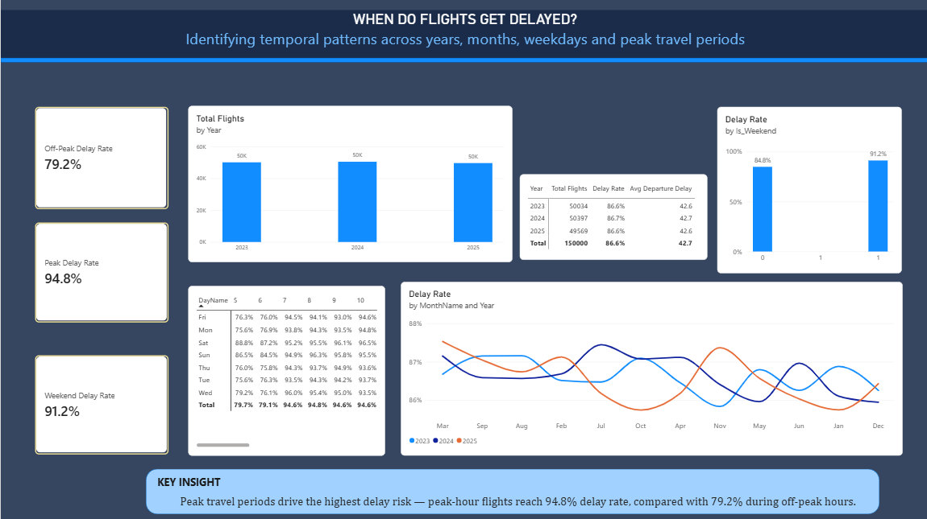

Page 3: Where and Airlines
This page looks at two questions together: which airports and routes have the worst delays, and which airlines perform better or worse than others.

What is shown
- A table of the ten worst routes, filtered to only include routes with at least 200 flights, so the results are reliable.
- A bar chart showing delay rate grouped by how congested the origin airport is (low, medium, high).
- A bar chart ranking every airline by delay rate, from worst to best.
- A scatter chart comparing each airline's average delay in minutes against its delay rate, with bubble size showing how many flights that airline operated.
- A small multiple line chart showing each airline's delay rate trend across the three years, side by side.

Storytelling point
Airport congestion matters more than distance or region. Routes from highly congested airports have delay rates near 97 percent, no matter where the flight is going. On the airline side, the difference between the best airline (Akasa Air, 85.4 percent) and the worst (Alliance Air, 87.8 percent) is only about 2.4 percentage points. This shows that delays are an industry-wide issue, not the fault of one specific airline.
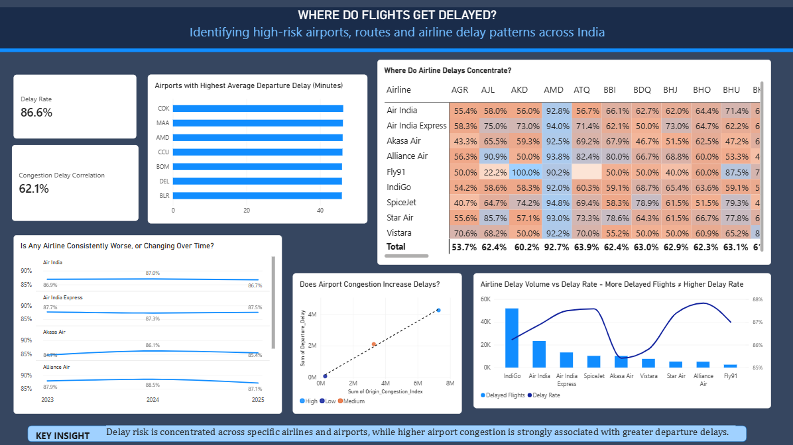

Page 4: Why - Delay Drivers
This page tries to explain the reasons behind delays by comparing weather conditions against operational factors like airport congestion and aircraft turnaround.

What is shown
- A bar chart showing delay rate for each weather condition: clear, cloudy, rain, and heavy rain.
- A bar chart showing delay rate grouped by turnaround risk level (low, medium, high).
- A bar chart comparing delay rate for flights where the previous flight using the same aircraft was also delayed, versus flights where it was not.

Storytelling point
Weather does have an effect, but it is smaller than expected. Moving from clear weather to heavy rain only raises the delay rate by about 5 percentage points. Airport congestion and aircraft turnaround risk have a much bigger effect. This means that if airlines and airports want to reduce delays, focusing on ground operations will likely help more than focusing on weather planning alone.
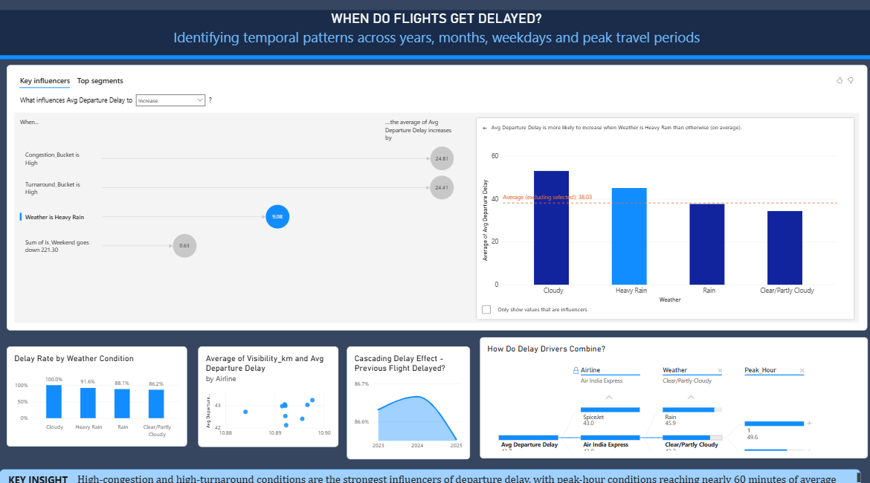

Overall Summary
Across all four pages, a few clear findings stand out from this dataset:
- The overall delay rate is high, at 86.6 percent, and it has remained steady across 2023, 2024, and 2025.
- Time of day is the strongest factor. Peak-hour flights are delayed far more often than off-peak flights, a gap of more than 15 percentage points.
- Airport congestion has a bigger effect than distance or destination. Congested airports show delay rates close to 97 percent.
- Airlines perform similarly to each other. No single airline stands out as much better or much worse, which points to industry-wide causes rather than one company's issue.
- Weather plays a role but is not the main cause. Ground operations, such as congestion and aircraft turnaround, matter more.
In short, this dataset tells a clear and consistent story: Indian flight delays are widespread but predictable, driven mainly by peak-hour scheduling and ground operations rather than by the calendar year, individual airlines, or weather alone.

